**Time Distributor Web App Version**

**Link:** <https://jm55dlsu.github.io/TimeDistributor/>

**Git Repo Link:** <https://github.com/jm55DLSU/TimeDistributor/>

**Notes:**

1. No data is being transmitted to the server. Any data inputted on the web-application is solely processed on the user’s computer.
2. The program suggests recommendations for more equitable time distribution if it detects a need for it.

**Steps to use:**

1. Set the time
   1. Total-Duration Mode
      1. Set time  
         Graphical user interface, application

         Description automatically generated
   2. Start-End Mode  
      Graphical user interface, application

      Description automatically generated
2. Open names file
   1. Sample content format of file. Names separated by a new line.  
      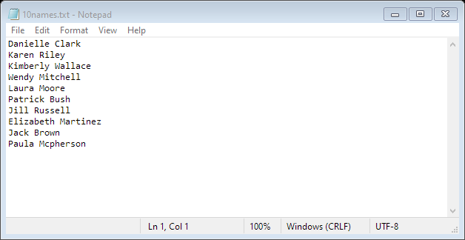
   2. Refer to instructions 1.a of this [file](https://github.com/jm55DLSU/TimeDistributor/blob/online/Java/.documentation/Time%20Distributor%20v2%20-%20PDF.pdf) when using a spreadsheet containing names.
   3. Open file  
      Graphical user interface

      Description automatically generated with medium confidence  
      Graphical user interface

      Description automatically generated with medium confidence
3. Click ‘Compute’ to determine time distribution

1. Sample Outputs
   1. Total-Duration Mode  
      Table

      Description automatically generated
   2. Start-End ModeTable

      Description automatically generated