One of the actions stemming from the 2011 Employee Satisfaction survey and approved by Jeff Gordon’s executive team is to ensure that all employees have a Development plan for 2012.

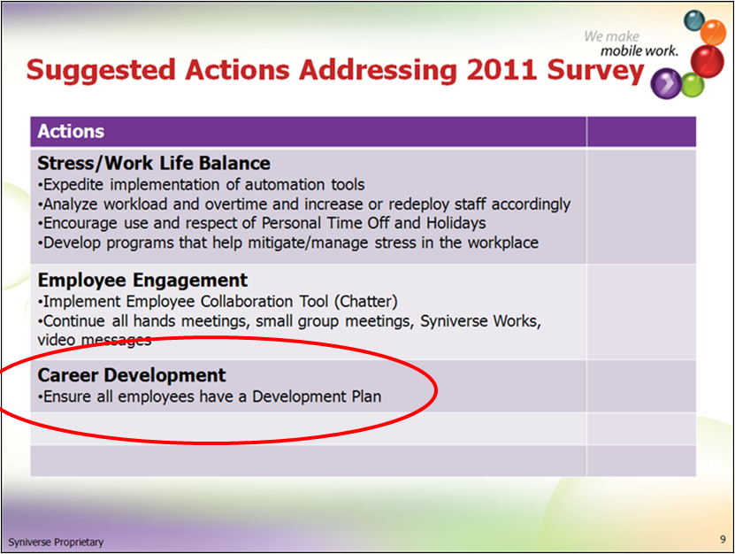

Please insure that you have development plans for yourself and your direct reports. A development plan is one development objective entered into the Success Factors application.

You can start by viewing the eLearnings mentioned at the bottom of this email or reach out to John Menken directly, 813.637.5466, [john.menken@syniverse.com](mailto:john.menken@syniverse.com), for assistance. Please have development objectives entered into Success Factors by 6/31/2012.

# Resources:

**SKR:**

Manager/Employee Worksheets and Sample Development plans

<http://skrcollab.syniverse.com/gm/folder-1.11.115876>

**Geo Learning Resources:**

Holding a Development Discussion

<https://gm1.geolearning.com/geonext/syniverse/coursesummary.CourseCatalog.geo?id=22506129390>

The Necessity for Career Development

<https://gm1.geolearning.com/geonext/syniverse/coursesummary.CourseCatalog.geo?id=22506129391>

Employee Development in Success Factors

<https://gm1.geolearning.com/geonext/syniverse/coursesummary.CourseCatalog.geo?id=22506129389>

John Menken, 813.637.5466 or [john.menken@syniverse.com](mailto:john.menken@syniverse.com)