One of the actions stemming from the 2011 Employee Satisfaction survey and approved by Jeff Gordon’s executive team is to ensure that all employees have a Development plan for 2012.

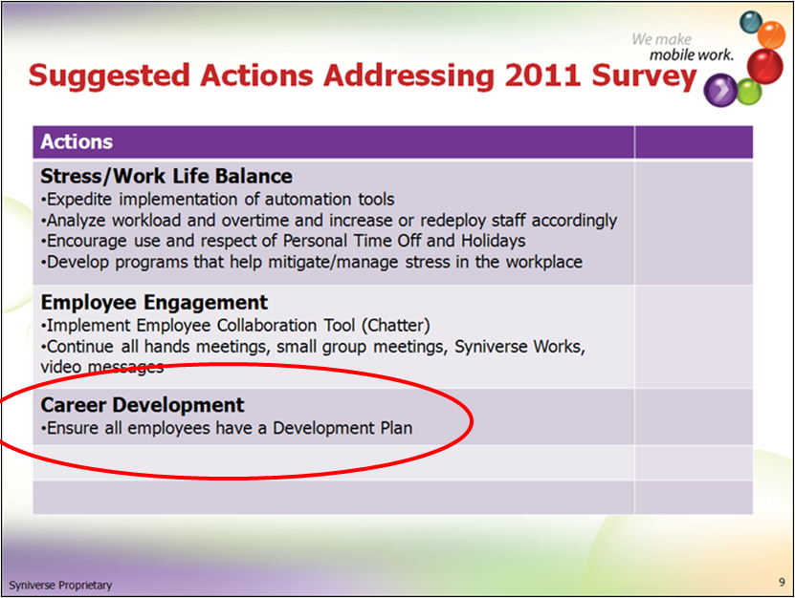

A development plan is a single development objective entered into the Success Factors application and is located in the Development tab.

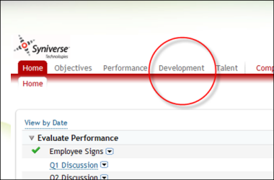

Please encourage your team to complete this by June 29, 2012. This gives the organization half the year to enact the plans and hold the manager discussions with their direct reports. The necessary resources to complete this task are shown below and John Menken, 813.637.5466, [john.menken@syniverse.com](mailto:john.menken@syniverse.com) stands ready to help and answer any questions for you or any part of your team.

Thank you.

Vena

# Resources:

**SKR:**

Manager/Employee Worksheets, Sample Development plans and a list of Syniverse 2012 Competencies (which can sometime be a source of development)

<http://skrcollab.syniverse.com/gm/folder-1.11.115876>

**Geo Learning Resources:**

Holding a Development Discussion

<https://gm1.geolearning.com/geonext/syniverse/coursesummary.CourseCatalog.geo?id=22506129390>

The Necessity for Career Development

<https://gm1.geolearning.com/geonext/syniverse/coursesummary.CourseCatalog.geo?id=22506129391>

Employee Development in Success Factors

<https://gm1.geolearning.com/geonext/syniverse/coursesummary.CourseCatalog.geo?id=22506129389>

John Menken, 813.637.5466 or [john.menken@syniverse.com](mailto:john.menken@syniverse.com)