Development Plans for your Group

Name,

One of the actions stemming from the 2011 Employee Satisfaction survey and approved by Jeff Gordon’s executive team is to ensure that all employees have a Development plan for 2012.

I would like to meet with you to show you how this is done and give you the resources empowering your direct reports to do the same.

Thanks.

John M.

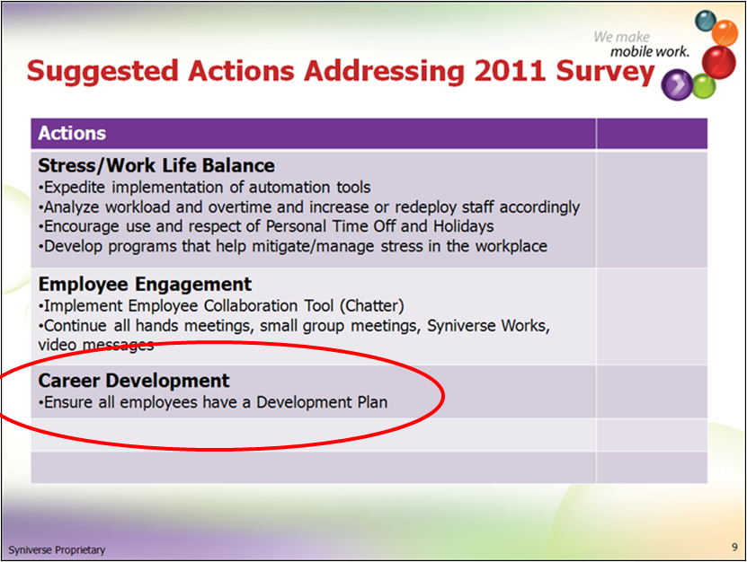

# Resources:

**SKR:**

Manager/Employee Worksheets, Sample Development plans and a list of Syniverse 2012 Competencies (which can sometime be a source of development)

<http://skrcollab.syniverse.com/gm/folder-1.11.115876>

**Geo Learning Resources:**

Holding a Development Discussion

<https://gm1.geolearning.com/geonext/syniverse/coursesummary.CourseCatalog.geo?id=22506129390>

The Necessity for Career Development

<https://gm1.geolearning.com/geonext/syniverse/coursesummary.CourseCatalog.geo?id=22506129391>

Employee Development in Success Factors

<https://gm1.geolearning.com/geonext/syniverse/coursesummary.CourseCatalog.geo?id=22506129389>

John Menken, 813.637.5466 or [john.menken@syniverse.com](mailto:john.menken@syniverse.com)