Development Plans for your Group

Name,

One of the actions stemming from the 2011 Employee Satisfaction survey and approved by Jeff Gordon’s executive team is to ensure that all employees have a Development plan for 2012.

I would like to meet with you to show you how this is done and suggest ways that this may be accomplished in a way that is the “least impactful on your time.”

Thanks.

John M.

Thanks.

John M.

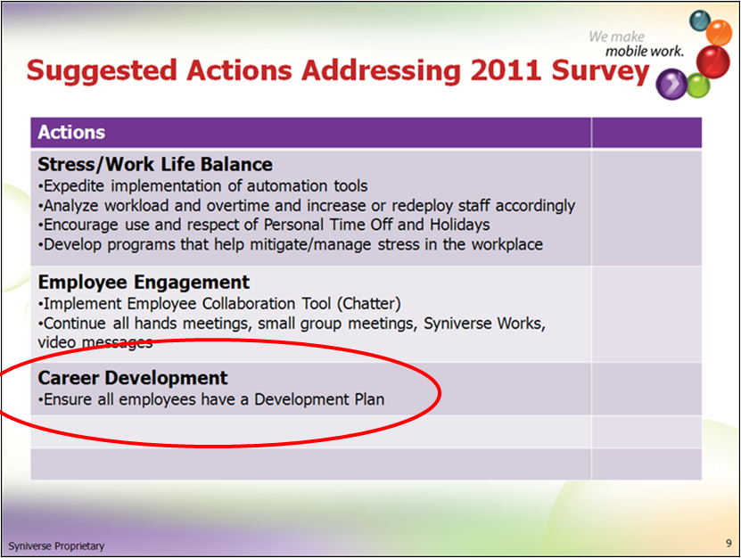

# Resources:

**SKR:**

Manager/Employee Worksheets and Sample Development plans

<http://skrcollab.syniverse.com/gm/folder-1.11.115876>

**Geo Learning Resources:**

Holding a Development Discussion

<https://gm1.geolearning.com/geonext/syniverse/coursesummary.CourseCatalog.geo?id=22506129390>

The Necessity for Career Development

<https://gm1.geolearning.com/geonext/syniverse/coursesummary.CourseCatalog.geo?id=22506129391>

Employee Development Success Factors

<https://gm1.geolearning.com/geonext/syniverse/coursesummary.CourseCatalog.geo?id=22506129389>