Sample email to direct reports

Name,

Thanks for meeting with me today on the subject of Development plans.

Below is an email that you can send to your direct reports regarding 2012 Development plans. Feel free to edit.

Thanks.

John M.

***************************************************************

One of the actions stemming from the 2011 Employee Satisfaction survey and approved by Jeff Gordon’s executive team is to ensure that all employees have a Development plan for 2012.

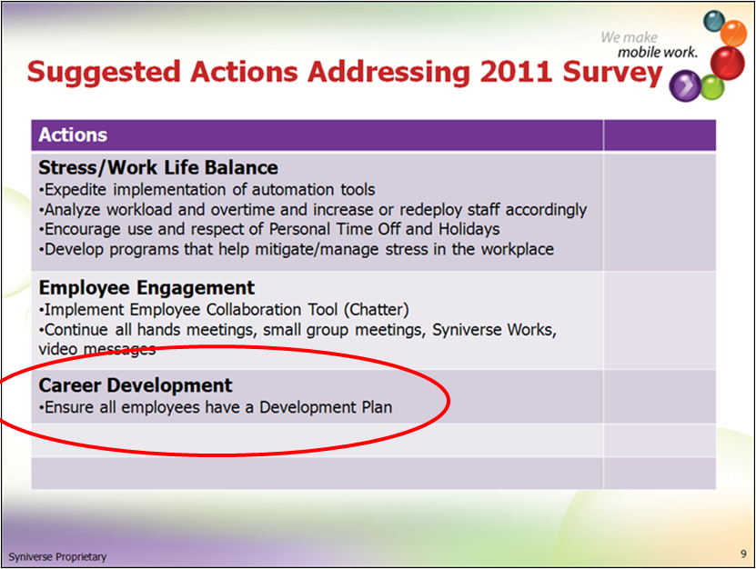

Please insure that you have development plans for yourself and your direct reports (if applicable). A development plan is one development objective entered into the Success Factors application.

You can start by viewing the eLearnings mentioned at the bottom of this email or reach out to John Menken directly, 813.637.5466, [john.menken@syniverse.com](mailto:john.menken@syniverse.com), for assistance. Please have development objectives entered into Success Factors by 6/29/2012.

# Resources:

**SKR:**

Manager/Employee Worksheets, Sample Development plans and a list of Syniverse 2012 Competencies (which can sometime be a source of development)

<http://skrcollab.syniverse.com/gm/folder-1.11.115876>

**Geo Learning Resources:**

Holding a Development Discussion

<https://gm1.geolearning.com/geonext/syniverse/coursesummary.CourseCatalog.geo?id=22506129390>

The Necessity for Career Development

<https://gm1.geolearning.com/geonext/syniverse/coursesummary.CourseCatalog.geo?id=22506129391>

Employee Development in Success Factors

<https://gm1.geolearning.com/geonext/syniverse/coursesummary.CourseCatalog.geo?id=22506129389>

John Menken, 813.637.5466 or [john.menken@syniverse.com](mailto:john.menken@syniverse.com)