eSalsa Tools User Guide

Version 1.0
Netherlands eScience Center
27 March 2013

Introduction

This package contains a collection of various tools developed as part of the eSalsa Project. The eSalsa Project is a cooperation between the Netherlands eScience Center (NLeSC), the Institute for Marine and Atmospheric Research (IMAU) at Utrecht University, and the Vrije Universiteit Amsterdam (VU).

The goal of the eSalsa project is to determine to what extent regional sea level in the eastern North Atlantic will be affected by changes in ocean circulation over the next decades.

To be able to perform the necessary simulations, we will use an existing high-resolution ocean model, the Parallel Ocean Model (POP) which can be found at:

http://climate.lanl.gov/Models/POP/

During the project we will improve and extend POP with support for distributed computing techniques and accelerators (GPUs). For more information on the eSalsa project see:

http://www.esciencecenter.nl/projects/project-portfolio/climate-research/

Details of the latest version can be found on the eSalsa Tools project web site at

https://github.com/NLeSC/eSalsa-Tools

Installation

The binary release of eSalsa Tools does not require any special installation. Simply unzip the distribution where you want. Then set the ESALSA_HOME environment variable to this location. For easy access you may also want to add ${ESALSA_HOME}/scripts location to your PATH.

This software requires Java SE 6.0 or higher (also known as Java 1.6). It has not been tested with older versions. A version of Java can be obtained from:

http://www.oracle.com/technetwork/java/javase/downloads/index.html

Overview of the tools

The current distribution contains the following tools:

LoadBalancing - a tool to generate work distribution files for POP.
DistributionViewer - a tool to view work distribution files in a GUI.
DistributionStatistics - a tool to print statistics about a distribution.
DistributionToText - a tool to convert a work distribution from binary format to text format.
TextToDistribution - a tool to convert a work distribution from text format to binary format.
TopographyViewer - a tool to view a POP topography file.

Each of the tools will be explained in more detail below. These tools are implemented using a generic library that contains various utility classes. This library can also be used by external software. Javadoc documentation for the library can be found at:

${ESALSA_HOME}/docs/javadoc/esalsa/index.html

LoadBalancing

The LoadBalancing tool is used to generate a block distribution for the Parallel Ocean Program (POP). This block distribution is based on the ocean topography, the desired block size, and the desired number of clusters, nodes per cluster, and cores per node. In addition the user may specify which heuristic the load balancing algorithm should use to determine the block distribution.

The LoadBalancer can be used as follows:

${ESALSA_HOME}/scripts/loadbalancing.sh topography_file [OPTION]*

where topography_file refers to file containing a POP bottom topography with the index of the deepest ocean level for each grid point. In addition, [OPTION]* is one or more of the following arguments:

Mandatory arguments:
--grid WIDTH HEIGHT dimensions of the topography file grid (WIDTHxHEIGHT).
--blocksize WIDTH HEIGHT dimensions of the blocks to use (WIDTHxHEIGHT).
--nodes NODES number of nodes for which the distribution must be calculated.
--cores CORES number of cores in each node.

Optional arguments:
--method METHOD method used to distribute the blocks. Valid values for METHOD are SIMPLE, ROUGHLYRECT (default), and SEARCH.
--clusters CLUSTERS number of clusters to calculate a distribution for (default is 1).
--output FILE output file name for the resulting distribution.
--statistics LAYER print statistics on the resulting distribution on layer LAYER.
Valid value for LAYER are CORES, NODES, CLUSTERS, ALL.
--showGUI show a GUI that allows the user to explore the distribution.
--image FILE output file name for an image of the resulting distribution.

The following command line shows an example invocation:

${ESALSA_HOME}/scripts/ loadbalancing.sh \
kmt_pbc.p1_tripole.s2.0-og.20060315.no_caspian_or_black \
--grid 3600 2400 --blocksize 30 30 \
--clusters 2 --nodes 10 --cores 8 \
--output test.distribution

This command produces a work distribution for 2 clusters of 10 nodes each, with 8 cores per node for the topography stored the file “kmt_pbc.p1_tripole.s2.0-og.20060315.no_caspian_or_black” using a 30x30 block size. The result is stored in the “test.distribution” file.

DistributionViewer

The DistributionViewer tool can be used to interactively explore a work distribution generated by the LoadBalancing tool. It can be used as follows:

${ESALSA_HOME}/scripts/distributionviewer.sh \
topography_file distribution_file

where topography_file refers to file containing a POP bottom topography and distribution_file refers to a work distribution file as generated by the LoadBalancing tool.

The distribution viewer will then show a GUI in which the work distribution can be explored interactively. An example is shown below (which used the test.distribution file described above).

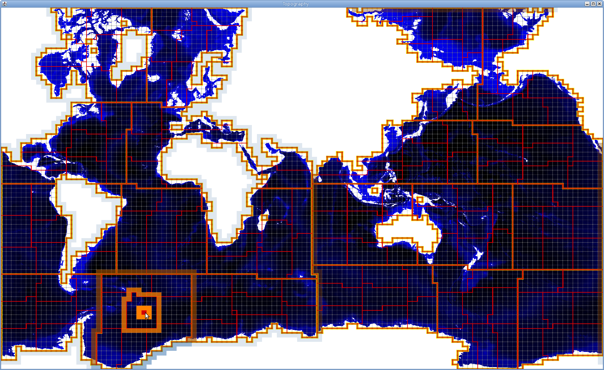
The work distribution is displayed as follows:

- block boundaries are shown using thin gray lines. Land blocks are omitted.
- blocks processed by the same core are surrounded by a thin red line.
- blocks processed by the same node are surrounded by a orange line.
- blocks processed by the same cluster are surrounded by a thick yellow line.

To get more information on a specific block, core, node, or cluster, simply select a block by clicking on it with the mouse. The core, node and cluster to which this block belongs will also be selected automatically.

The selected block is highlighted in red. The neighboring blocks will be highlighted in bright orange. In addition the neighboring blocks of the selected core, node and cluster will also be highlighted, as shown in the next screen shot.

In addition to highlighting the selected elements, information about the selection will also be printed on the console:

Selected cluster 0 node 1 core 12 block 1468 (28x12)
Communication on layer BLOCK 256
Communication on layer CORE 1872
Communication on layer NODE 3708
Communication on layer CLUSTER 18888

This information shows the number of the cluster, node, core and block that is selected. In addition, the required amount of neighborhood communication is also printed.

DistributionStatistics

The DistributionStatistics tool can be used to print statistics about a work distribution file. It can be used as follows:

${ESALSA_HOME}/scripts/distributionstatistics.sh \
topography_file distribution_file layer

where topography_file refers to file containing a POP bottom topography and distribution_file refers to a work distribution file as generated by the LoadBalancing tool.

The layer parameter indicates for which layer statistics should be printed. Valid values are:

CORES - print statistics about the work distribution and communication at the cores.
NODES - print statistics about the work distribution and communication at the nodes.
CLUSTERS - print statistics about the work distribution and communication at the clusters.
ALL - print all statistics

The following command line shows an example invocation:

${ESALSA_HOME}/scripts/distributionstatistics.sh \
kmt_pbc.p1_tripole.s2.0-og.20060315.no_caspian_or_black \
test.distribution NODES

This will result in the following output:

Statistics for layer: NODES
Sets: 20
0 335 3912
1 335 3708
2 335 3644
3 335 5300
4 334 4596
5 334 5404
6 334 4172
7 334 6148
8 334 6722
9 334 6518
10 335 3784
11 335 3968
12 335 3924
13 335 5284
14 334 5096
15 334 5008
16 334 4916
17 334 5164
18 334 9086
19 334 7166

DistributionToText and TextToDistribution

The DistributionToText tool can be used to convert a work distribution file from a binary format to an human-readable text representation. Similarly, the TextToDistribution tool converts a work distribution file from an text representation to the binary format. These can be used as follows:

${ESALSA_HOME}/scripts/distributiontotext.sh distribution_file

${ESALSA_HOME}/scripts/texttodistribution.sh distribution_file

TopographyViewer

The TopographyViewer tool can be used to explore a topography. It can be used as follows:

${ESALSA_HOME}/scripts/topographyviewer.sh \
topography_file width height [OPTION]*

where topography_file refers to file containing a POP bottom topography file. The width and height parameters specify the dimensions of the topography. In addition, [OPTION]* is one or more of the following arguments:
Optional arguments:

--blocks WIDTH HEIGHT display a block division on top of the topography using blocks of dimensions WIDTHxHEIGHT.
--image FILE save the output to an image file instead displaying it on screen.
--showWork color blocks according to work, black for no work, white for work.

The following command line shows an example invocation:

${ESALSA_HOME}/scripts/topographyviewer.sh \
kmt_pbc.p1_tripole.s2.0-og.20060315.no_caspian_or_black \
3600 2400 --blocks 30 30 –showWork --image out.png

This will result in the following image to be stored in “out.png”:



