PROJECT PROPOSAL

Campus Equipment & Laboratory Reservation Management System

By: Abarca, Albos, Faustino 8 – CAMIA

The Problem:
Schools and laboratories often have shared equipment and spaces that many students and faculty members need to use. When reservations are done manually, problems such as double-booking, equipment loss, and delays can occur.
The proposed system will provide a simple Python-based reservation system where users can check available equipment, make reservations, and manage equipment checkout and check-in.

The Objective of our Project
The project aims to:
- Create a simple system for reserving laboratory equipment and spaces.
- Prevent double-booking by checking for scheduling conflicts.
- Allow users to view available equipment.
- Track equipment checkout and check-in.
- Store and display reservation records.
- Provide different access options for students, faculty members, and laboratory custodians.
- Validate user inputs to reduce errors.
- Provides receipts to record equipment borrowing and returns

Planned Features of our Project
- Student reservation – Students can reserve available equipment.
- Faculty reservation – Faculty members can make reservations.
- Lab custodian management – Custodians can manage equipment and reservations.
- View available equipment – Users can see equipment that can be reserved.
- Conflict checking – The system checks if an equipment/time slot is already reserved.
- Checkout and check-in tracking – Tracks whether equipment has been borrowed or returned.
- Reservation records – Stores information about reservations.
- Reservation receipts – Generates receipts as proof of successful equipment and laboratory space bookings.
- Borrowing and return receipts – Provides receipts to record equipment borrowing and confirm equipment returns.
- Input validation – Checks whether the user's input is valid.
- Role-based access – Different options are available depending on the user's role.

Planned Inputs and Outputs:

Inputs
The system may ask the user for:
- User role o Student o Faculty o Lab Custodian
- User name
- Equipment to reserve
- Reservation date
- Time slot
- Checkout/check-in information
- Menu choice

Outputs
The system will display:
- Available equipment
- Reservation confirmation
- Reservation details
- Reservation status
- Equipment checkout/check-in status
- Error messages for invalid inputs
- Scheduling conflict messages
- Reservation Receipts
- Equipment borrowing and return receipts
- Confirmation of returned equipment

Example
Input:
Role: Student Name: John
Equipment: Microscope Date: 2026-09-01 Time: 10:00 AM

Output:
Checking availability... Reservation successful!
Equipment: Microscope
Reserved by: John
Date: 2026-09-01
Time: 10:00 AM
Status: Reserved
Receipt ID: RES-001

Logic Plan / Flowchart:
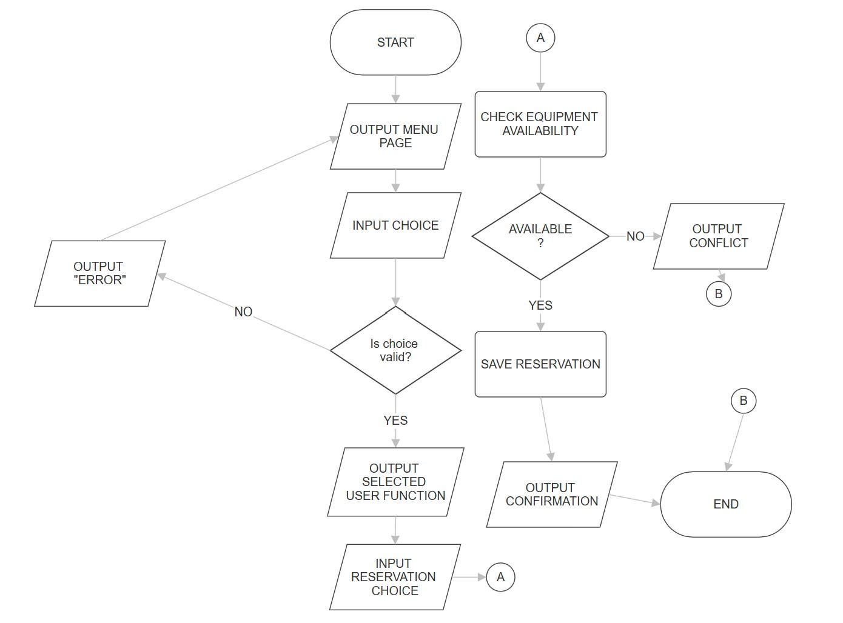

Contributors
- [FAUSTINO] — Reservation system and conflict-prevention logic
- [ALBOS] — Equipment checkout and check-in tracking
- [ABARCA] — Role-based access, testing, and documentation

