**KRABSOURCE USER MANUAL**

West Visayas State University  
College of Information and Communications Technology

KrabSource: Crab Identification and Monitoring System with CNN Algorithm Using ResNet-18 Model

**KrabSource User Manual**For the Crab Identification and Monitoring System

Developed by:

* John Marc M. Abogador
* Rizalie S. Belarmino
* Mizraem A. Calimutan
* Ireneo A. Catequista III
* Adrian Jan Y. Hernia
* Angelica A. Villar

West Visayas State University  
College of Information and Communications Technology  
La Paz, Iloilo City

**Disclaimer Page**

This user manual is intended solely for educational and operational use of the **KrabSource: Crab Identification and Monitoring System**. The developers and West Visayas State University are not liable for any misuse or damages resulting from the use of this system. Screenshots included are for demonstration purposes only and may differ slightly depending on future updates.

**Table of Contents**

1. Guide for Deploying and Using the System’s Main Functions
2. Getting Started
3. Introduction
4. System Requirements
5. Installation
6. Usage (Per Main Feature)
7. Troubleshooting
8. FAQ (Frequently Asked Questions)
9. Contact Details
10. Back Cover

**Guide for Deploying and Using the System’s Main Functions**

**Getting Started**

* Ensure your device has a stable internet connection.
* Allow the application to access your device’s camera, storage, and GPS location.
* Grant all necessary permissions when prompted for the app to function properly.

**Introduction**

KrabSource is a mobile application developed to automate the identification and monitoring of crab species in Panay Island, Philippines. By leveraging ResNet-18 CNN, the system can classify crab species based on image features and integrate GPS mapping for ecological tracking.

**System Requirements**

**Hardware:**

* Android phone (minimum Android 8.0)
* 3GB RAM or higher
* 32GB storage

**Software:**

* KrabSource mobile application (APK)
* Google Maps integration
* Internet connection

**Installation**

1. Download the APK file from the official distribution source.
2. Allow installation from unknown sources in your phone settings.
3. Install the application and launch it from your app drawer.

**Usage (Per Main Feature)**

* **Dashboard** – View crab species characteristics and interactive map.

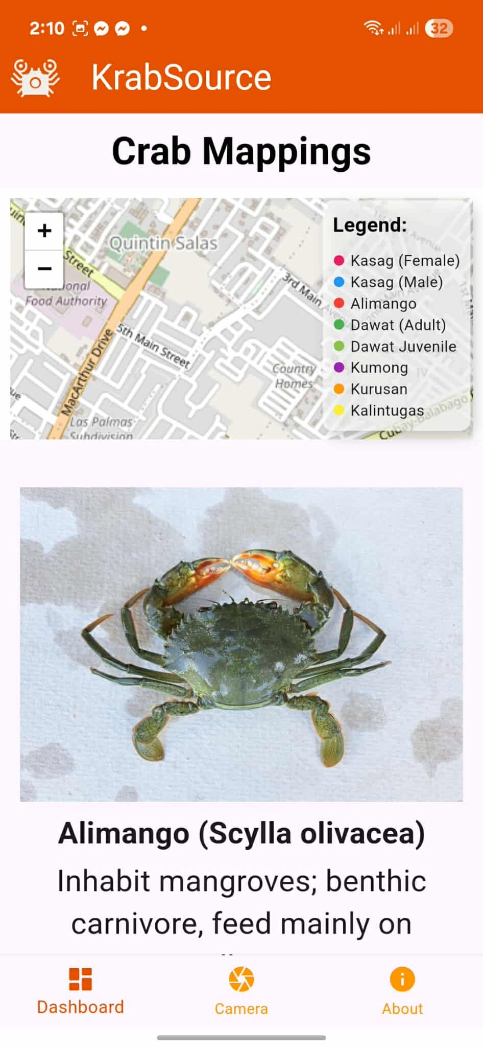

* **Camera** – Capture or upload crab images for identification.

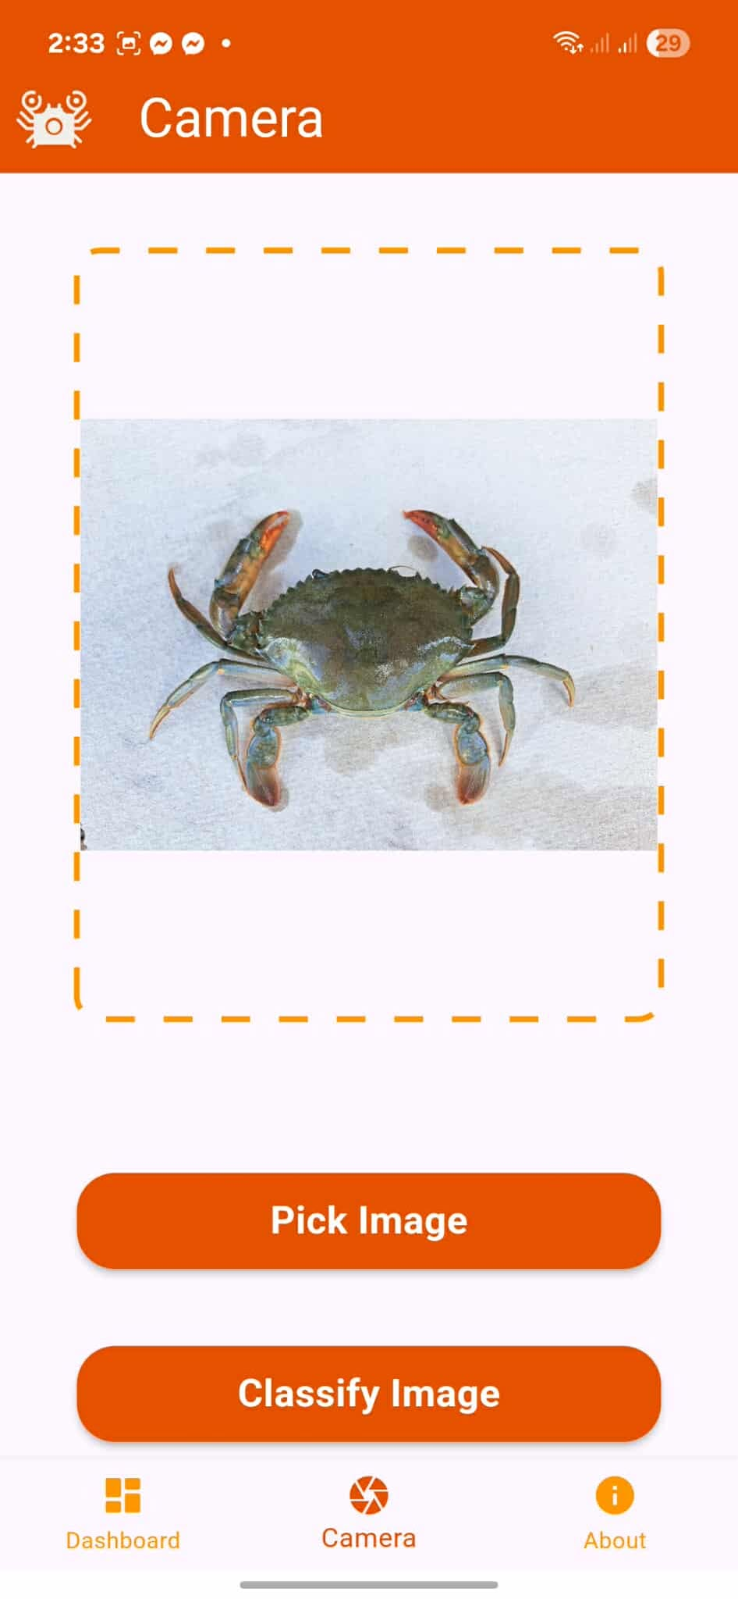

* **Classification Result** – Displays crab names (local, English, scientific) and species details.

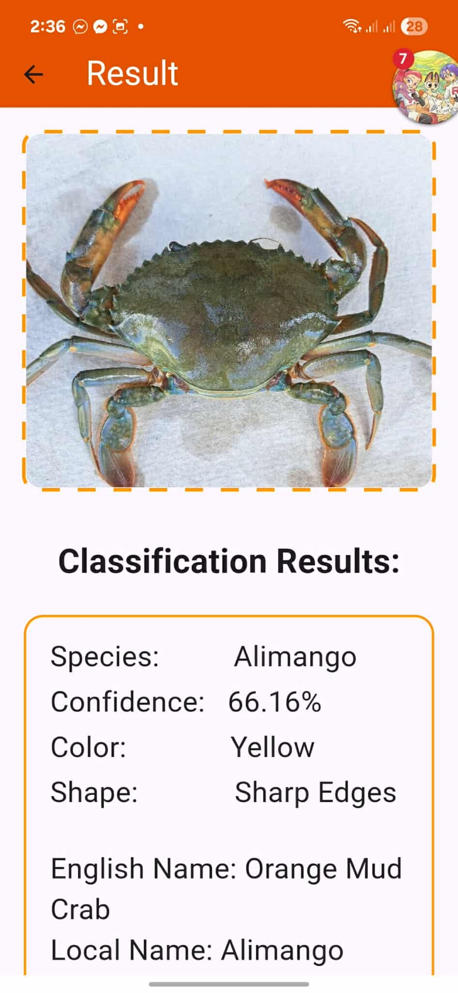

* **About** – Learn about the application and its development team.

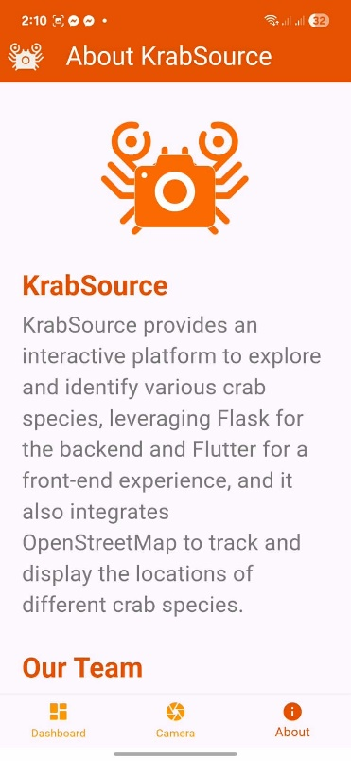 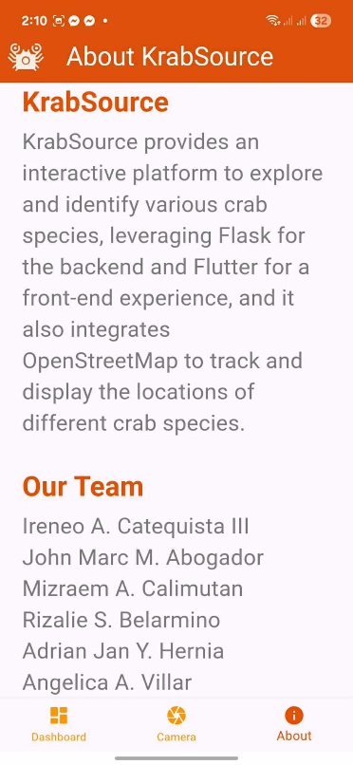

**Troubleshooting**

* **App not opening:** Restart device and reinstall application.
* **Camera not working:** Ensure camera permissions are enabled.
* **GPS not detecting location:** Enable location services and check internet connection.
* **Incorrect classification:** Ensure proper lighting and clear crab image capture.

**FAQ (Frequently Asked Questions)**

**Q1: Can the app identify all crab species in the Philippines?**  
No. Currently, it is trained on species from Panay Island such as *Kasag*, *Alimango*, *Kurusan*, *Kalintugas*, *Kumong*, and *Dawat*.

**Q2: Do I need internet access to use the app?**  
Yes. Internet is required for classification and GPS mapping.

**Q3: Can I use this system for research purposes?**  
Yes, but please cite the KrabSource system and West Visayas State University.

**Contact Details**

For inquiries, support, or feedback, please contact the development team:

**KrabSource Development Team (Thesis Group):**

* John Marc M. Abogador – abogadorjm@wvsu.edu.ph
* Rizalie S. Belarmino – belarminors@wvsu.edu.ph
* Mizraem A. Calimutan – calimutanma@wvsu.edu.ph
* Ireneo A. Catequista III – catequistaiiia@wvsu.edu.ph
* Adrian Jan Y. Hernia – herniaajy@wvsu.edu.ph
* Angelica A. Villar – villaraa@wvsu.edu.ph

**West Visayas State University**  
College of Information and Communications Technology  
La Paz, Iloilo City

© 2025 KrabSource Development Team. All Rights Reserved.