**Lifetables for Latin American countries**

**WHO**: <http://apps.who.int/gho/data/view.main.61060?lang=en>

**CEPAL**: Lifetables available in Boletin Demogragico, America Latina: tablas de mortalidad 1950-2025, file CEPAL_1.pdf. However, this is an old publication (2004). There is an update in 2010 CEPAL_2/pdf

**Lambda**

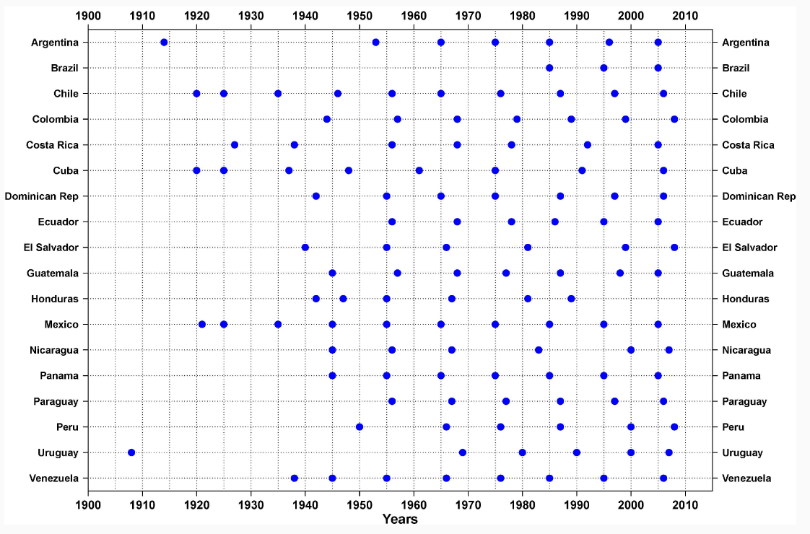

**National offices of statistics**

Cuba

1. Websites visited: Oficina Nacional de Estadistica e Informacion (Republica de Cuba) [http://www.one.cu/sitioone2006.asp]. Probability of dying by 5 year-age groups for 2003-05 in file Cuba_1.pdf. Lifetable for 2011-13 by sex and single age and five-year lifetable in Cuba_2.pdf and Cuba_3.pdf, respectively.

Dominican Republic

1. Website visited: Oficina Nacional de Estadistica [http://www.one.gob.do/Buscador/SearchMain]. Lifetables available for years 1950-2050 with 5-year age groups up to 80+ in 5 year intervals, and projected afterwards in file Dominican_Republic_1.pdf and Dominican_Republic_4.xls. Also lifetable available with 100+ in 5 year intervals in Dominican_Republic_2.xls, single age in Dominican_Republic_3.xls.

Haiti

1. Website visited: Institut Haitien de Statistique et d’infromatique [http://www.ihsi.ht/]. Lifetables available in 5-year intervals, 5-year age groups up to 80+ 1950-2015 in Haiti_1.pdf.

Jamaica

1. Website visited: Statistical Institute of Jamaica (STATIN) [http://statinja.gov.jm/]. No lifetables, but seems that they provide mid-year population by age and sex, and possible to get deaths upon request.

Puerto Rico

1. Website visited: Instituto de Estadisticas de Puerto Rico [http://www.estadisticas.gobierno.pr/iepr/]. Lifetables available in 5-year age groups up to 85+ for years 199-2001, 2000-2002, 2001-2003,…,2008-2010 in file Puerto_Rico_1.pdf

Trinidad and Tobago

1. Website visited: Central Statistical Office [http://cso.gov.tt/statistics/]. No information of lifetables in the website.

Costa Rica

1. Website visited: Instituto Nacional de Estadistica y Censos [http://www.inec.go.cr/poblacion/defunciones]. Life tables available by single age and year 1995-2015. Folder: Lifetables Costa Rica 1995-2015

El Salvador

1. Website visited: Direccion General de Estadistica y Censos [http://www.digestyc.gob.sv/]. No life tables available.

Guatemala

1. Website visited: Instituto Nacional de Estadistica Guatemala [http://www.ine.gob.gt/index.php/estadisticas]. No lifetables available. From CEPAL 1950-1955 to 2010-2015 in 5-year age groups and 80+ in file Guatemala_1.xls

Honduras

1. Website visited: Instituto Nacional de Estadistica Honduras [http://www.ine.gob.hn/]. ]. No lifetables available.

Mexico

1. Website visited: Instituto Nacional de Estadistica y Geografia [http://www.inegi.org.mx/]. Available at Population Council website [http://www.gob.mx/conapo]. 1990-2015

Nicaragua

1. Website visited: Instituto Nacional de Informacion de Desarrollo [http://www.inide.gob.ni/]. No lifetables available.

Panama

1. Website visited: Instituto Nacional de Estadistica y Censo [https://www.contraloria.gob.pa/inec/]. Lifetables in 5-year age groups up to 85+ for 2000, 2005, 2010, 2015 in file Panama_1.xls

Argentina

1. Website visited: Instituto Nacional de Estadistica y Censos [http://www.indec.gov.ar/]. Website not available.

Bolivia (Plurinational State of)

1. Website visited: Instituto Nacional de Estadistica [http://www.ine.gob.bo/]. No lifetables available.

Brazil

1. Website visited: Instituto Brasileiro de Geografia e Estatística [http://www.ibge.gov.br/home/]. Single age life tables for 1991, 1998--2015 in folder Lifetables Brazil 1991-2015.

Chile

1. Website visited: Instituto Nacional de Estadisticas [http://www.ine.cl/]. Only available for 2001-02 through the institute, file Chile_1.pdf. I think another office is in charge of producing lifetables.
2. Website visited: Superintendencia de Valores y Seguros [http://www.svs.cl/institucional/estadisticas/tmc_muestra_informacion.php].Lifetables 1960-2014 in 5-year age groups in folder Lifetables Chile 1960-2012

Colombia

1. Website visited: Departamento Administrativo Nacional de Estadistica [http://www.dane.gov.co/]. Lifetables in 5-year age groups up to 80+ from 1990-2015 in Colombia_1.pdf.

Ecuador

1. Website visited: Instituto Nacional de Estadistica y Censos [http://www.ecuadorencifras.gob.ec/institucional/home/]. No lifetables available. The website is not working properly.
2. Website visited: Sistema Nacional de Informacion [http://sni.gob.ec/inicio].The website is not working properly.

Paraguay

1. Website visited: Direccion General de Estadistica, Encuestas y Censos [http://www.dgeec.gov.py/]. Lifetables available 1950-2050 in 5-year age groups up to 80+ in file Paraguay_1.pdf.

Peru

### Website visited: [Instituto Nacional de Estadística e Informática](http://www.inei.gob.pe/) [http://www.inei.gob.pe/]. The website not working properly [http://series.inei.gob.pe:8080/sirtod-series/]. Lifetables from 1950-2050 in 5 year age groups up to 80+ for both sexes combined in file Peru_1.pdf and for separate sexes in Peru_2.pdf

Uruguay

1. Website visited: [Instituto Nacional de Estadística](http://www.ine.gub.uy/) [http://www.ine.gub.uy/]. No lifetables available.

Venezuela (Bolivarian Republic of)

1. Website visited: [Instituto Nacional de Estadística](http://www.ine.gub.uy/) [http://www.ine.gov.ve/]. No lifetables available.