Age- and Cause-Decomposition of the Difference in Life-Expectancy
in Latin American and Caribbean Countries:
Data Sources and Methodology.

Vladimir Canudas-Romo and José Manuel Aburto

The aim of this work is to carry out age- and cause-specific decompositions of differences in life-expectancy over time for Latin American and Caribbean (LAC) countries. The time of analysis is the period from 1990 to the most recent available year of mortality information. A second element of this comparison is for each LAC country with a group of European countries, denoted EU-15.
Based on population size and available mortality information 23 countries were selected. In the Caribbean 6 countries: Cuba, Dominican Republic, Haiti, Jamaica, Puerto Rico, and Trinidad and Tobago; In Central America 7 countries: Costa Rica, El Salvador, Guatemala, Honduras, México, Nicaragua, and Panamá; In South America 10 countries: Argentina, Bolivia, Brasil, Chile, Colombia, Ecuador, Paraguay, Perú, Uruguay, and Venezuela. Table 1 lists the population sizes and the years with cause of death information for all selected countries.

[Table 1 about here]

Sources of data
Two larger sources of data were needed in order to decompose the effects of different diseases on life expectancy changes: cause specific mortality data and life table data.
Cause of death information was taken from the World Health Organization mortality database (WHO), which has cause specific mortality rates over time for most countries. In order to increase observations and ensure comparability across countries, we used the same initial year of cause of death data for all countries, namely 1990, but allowed each country to have as last year its year with the most recent cause of death information. All LAC countries reported cause of death data using the International Classification of Diseases revisions 9 and 10, or ICD-9 and ICD-10 codes, for the analyzed period. Cause of death information was collected from this source for ages 0, 1-4, and then in five-year age groups until the open age-group which varied from country to country to be 80 and more, 85 and more, or 95 and more. Although, this could be thought as problematic, the great share of the changes in life expectancy in the region still happen at ages below 80. Thus, the main results are not affected by decisions made on the last age-interval. There was much greater variation in the years with available information in the LAC region. For example, Haiti only had causes of death information for the years 1997, 1999, and 2001-04, while Cuba had information for every single year from 1990 to 2014 (see Table 1). Also in Table 1 the WHO-code for each country is included, which we used in the country specific data archive repository.
Seventeen causes of death were selected corresponding to the mayor ICD chapters and one with other causes of death not included among the 17. The list of causes of death and their corresponding ICD-10 code is: (A00-B99) Certain infectious and parasitic diseases, (C00-D48) Neoplasms, (E00-E88) Endocrine, nutritional and metabolic diseases, (F01-F99) Mental and behavioural disorders, (G00-G98) Diseases of the nervous system, (I00-I99) Diseases of the circulatory system, (J00-J98) Diseases of the respiratory system, (K00-K92) Diseases of the digestive system, (N00-N98) Diseases of the genitourinary system, (P00-P96) Perinatal & (Q00-Q99) Congenital malformations, (R00-R99) Not elsewhere classified, (V01-Y89) Accidents and suicide, and (X85-Y09) Homicide. The year of the change of ICD code from 9 to 10 was different from country to country and it is found as a vertical dashed line in each country page in the interactive link:

https://wb-lac.shinyapps.io/CoD_App/

No significant ruptures from ICD-9 to ICD-10 codes were observed for any of the countries. However, Figure 1a and 1b show the contrasting results of the causes of death time trends for a country with uninterrupted annual data from 1990 to 2014 as Costa Rica, as opposed to Honduras where only one point is available in 1990 and then continuously from 2008 to 2013 (thus the linear trend from 1990 to 2008).

[Figures 1a and 1b about here]

Life table data were taken from a variety of sources with preference given to those reporting by sex and single calendar year. These included the UN yearbook, estimates from the Comisión Económica para América Latina y el Caribe (CEPAL, Economic Commission for Latin America and the Caribbean) for 2004 and 2010 (referred as CEPAL 2004 and CEPAL 2010 respectively), the life table collection of Lambda (Latin America Mortality Database), and finally, life tables elaborated at each of the national statistical offices (CEPAL has made a list of these statistical offices: http://www.cepal.org/es/temas/censos-de-poblacion-y-vivienda/enlaces-institutos-nacionales-estadistica-america-latina-caribe). The disparity between the sources varies from country to country, as can be observed in the different estimates of time trends in life expectancy at birth for females and males in the interactive link:

https://wb-lac.shinyapps.io/ex_App/

Figure 2a and 2b show the life expectancy at birth time trends for females and males from Honduras and Mexico respectively. While Figure 2a shows very coherent time trends among the different life table sources for Honduras, there is no matching in the Mexican trends. Furthermore, for the latter country, CEPAL and UN show overall increases in the measure in the first decade of the new millennium, 2000-2010, while researchers have documented the stagnation in the measure, particularly for males (Canudas-Romo et al. 2015; Aburto et al. 2016), also observed in the data published by the National Statistical Office. This shows that even when the same data is used for the life table calculations, resultant estimates in the region might differ and have to be studied with caution.

[Figures 2a and 2b about here]

In order to maximize comparability in the age and cause decomposition (summarized in the next section), life tables from CEPAL and UN were selected for years that had WHO cause of death information. Life tables were constructed following standard procedures (Preston et al. 2001) based on average death rates for five calendar years for the following periods: 1990-1994, 1995-1999, 2000-2004, 2005-2009 and 2010-2015 (or latest available year). Causes of death were also organized in these five calendar years. We were able to match life table and cause of death data for the same years for most countries.

Methodology
Age-Decomposition of Differences in Life Expectancies at Birth
The age- and cause-decomposition of the difference in life expectancies derive from the formulations of Arriaga (1984) and the simple exposition of the topic by Preston et al. (2001).
Differences in life expectancy at birth between two times, 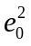 and 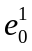, can be written as the sum of the age-specific contributions as

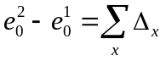,

where 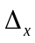 is the age-specific contribution to this difference. The age-specific contributions in equation (1.1) are derived from the life table functions: survivors at age x, 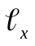, person-years lived in the interval x to x+1, 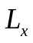, and person-years lived after age x, 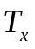, for the two given times:

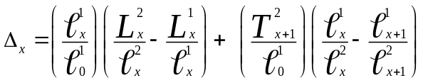.

Cause-Decomposition of Difference in Life Expectancies at Birth
The difference in life expectancy at birth between two populations can be further decomposed by causes of death, that is, we can estimate the contribution of the total difference in life expectancy attributable to specific causes of death by age.

In order to estimate cause specific mortality contributions we partition the age-specific contribution, , into the part that corresponds to each of the causes of death i of interest, or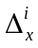.
Assuming that there are n independent causes of death we calculate the cause i contribution based on a set of all cause age-specific mortality rates and the proportions of deaths at each age attributable to cause of death i:

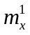= all-cause mortality rate at age x and time 1
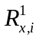= proportion of deaths from cause i, at age x and time 1,

A similar set of information is needed for time 2. All the above information is combined to calculate the age- and cause-contribution to the difference in life expectancy as

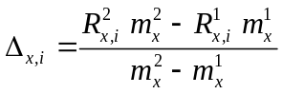.

Multiplying the previously derived mortality contribution for each age, , with the addition over all causes of the age- and cause-contribution in equation (1.3) returns the desired difference in life expectancy at birth due to changes in age-specific and cause-specific mortality:

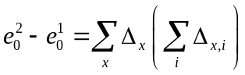.

The results of the age- and cause-decomposition (Figure and Table of results) are presented for each country in the interactive link:

https://wb-lac.shinyapps.io/Decomp_App/

Figures 3a and 3b show the age- and cause-decomposition to the change over time in female life expectancy at birth for Peru and Panama respectively. Values are classified as contributing positively or negatively (above or below the value of zero in the vertical axis) corresponding to contributions to the increase or decrease in life expectancy at birth. For each age a value above the age-axis indicates the contribution of that age-group to the change in life expectancy. This value is further disentangled into causes of death, shown in the Figure with different colors. While the Peruvian comparison is dominated by half of the deaths in the category of miss-classified (cause of death rest - colored in gray), in the case of Panama it is possible to appreciate clearly the vast contribution of cardiovascular diseases to the increase in life expectancy at ages above 45.

[Figures 3a and 3b about here]

A second page in the interactive link allows the user to obtain the specific contribution of causes of death to the difference in life expectancies. Tables 2a and 2b show the same information, namely the cause-contribution to the change in male life expectancy in Ecuador from 1990-94 to 1995-1999. While Table 2a is ordered alphabetically by ICD chapters, Table 2b is ordered from highest to lowest contribution to the change in life expectancy. This switch in order (available at a small arrow next to the word “Contribution”) allows to rapidly visualizing how neoplasms, respiratory diseases, and mental disorders are the main contributors to the increase in life expectancy, and opposing this trend is the negative value in homicides.

[Tables 2a and 2b about here]

Although the calculations presented in equations (1.1) to (1.4) refer to changes in life expectancies over time, analogous operations can be used for the comparison of two populations in one given time. For example, our interest might be to study which ages and causes of death help to explain the difference in male life expectancies at birth between Venezuela and EU-15 in 2010-15. In this case will correspond to the male life expectancy in Venezuela (=70.66), and the EU-15 life expectancy (= 80.24), both in 2010-2015, similarly for other life table functions in equations (1.1) to (1.4). The interactive link that allows the user to compare the different LAC countries by sex (based on the UN data) to their EU-15 counterparts in 2010-2015 are also found in:

https://wb-lac.shinyapps.io/Decomp_App/

Details of the EU-15 countries included in the analysis are found in Table 3. Figure 4a presents the male life expectancy comparison of the EU-15 and Venezuela in 2010-2015. The almost 10 years gap in life expectancy between the two populations highlights the lag in the south American country respect to the EU-15 countries. Here positive contributions are those that help explain the higher life expectancy of EU-15 opposed to the LAC countries. For Venezuela, while cardiovascular and diabetes (endocrine) mortality explain the old age gap for both females and males, homicides and other external causes (accidents and suicide) further increase the lagging of the Latin American male population.

[Table 3 and Figures 4a and 4b about here]

References
Aburto, J.M., H. Beltrán-Sánchez, V.M. García-Guerrero, V. Canudas-Romo. (2016). Homicides in Mexico Reversed Life Expectancy Gains for Men and Slowed Them for Women, 2000–10. Health Affairs 35(1):88-95.
Arriaga, Eduardo (1984). Measuring and explaining the change in life expectancies. Demography 21(1), 83-96.
Canudas-Romo, V., V.M. García-Guerrero, C.J. Echarri-Cánovas. (2015). The stagnation of the Mexican male life expectancy in the first decade of the 21st century: the impact of homicides and diabetes mellitus. JECH 69:28-34 doi:10.1136/jech-2014-204237
CEPAL 2004. Latin America and the Caribbean, Demographic Observatory. Mortality. http://repositorio.cepal.org/bitstream/handle/11362/39539/1/S2004011.pdf
CEPAL 2004. Latin America and the Caribbean, Demographic Observatory. Mortality. http://repositorio.cepal.org/bitstream/handle/11362/7125/1/S1000848_mu.pdf
Human Mortality Database. http://www.mortality.org/
Eurostat Database. http://appsso.eurostat.ec.europa.eu/nui/submitViewTableAction.do
Lambda. Latin America Mortality Database. http://www.ssc.wisc.edu/cdha/latinmortality/
Preston,S., Heuveline, P., & Guillot, M. (2001) Demography; Measuring and Modeling Population Processes. Oxford: Blackwell Publishers
World Health Organization Mortality Database. Retrieved March 1, 2017 from http://www.who.int/healthinfo/mortality_data/en/
United Nations Statistics Division (2011). Demographic Yearbook 2009-10. https://unstats.un.org/unsd/demographic/products/dyb/dybsets/2009-2010.pdf

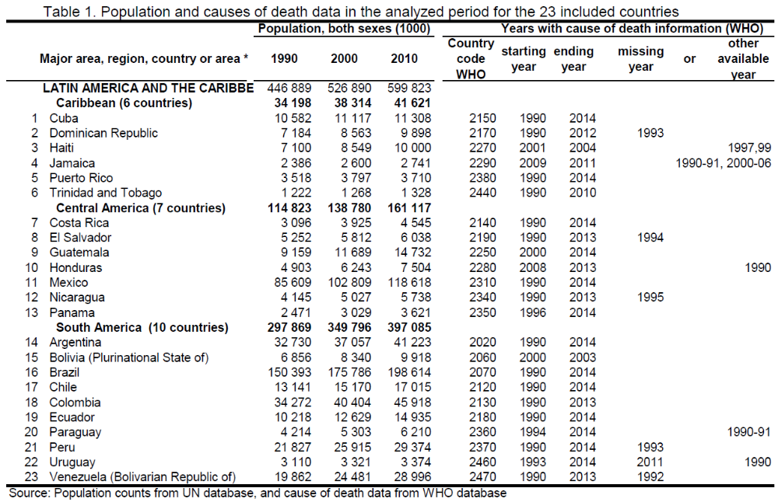
Table 2a. Cause-contribution to the change in male life expectancy in Ecuador from 1990-94 to 1995-1999. Ordered alphabetically by ICD chapters
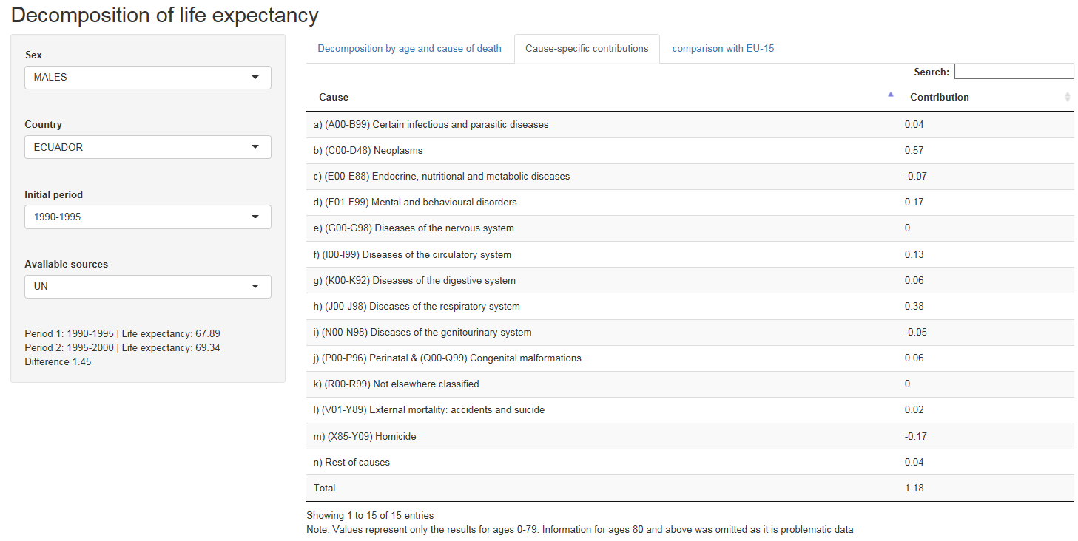
Table 2b. Cause-contribution to the change in male life expectancy in Ecuador from 1990-94 to 1995-1999. Ordered by relevance in the contribution to the change in life expectancy
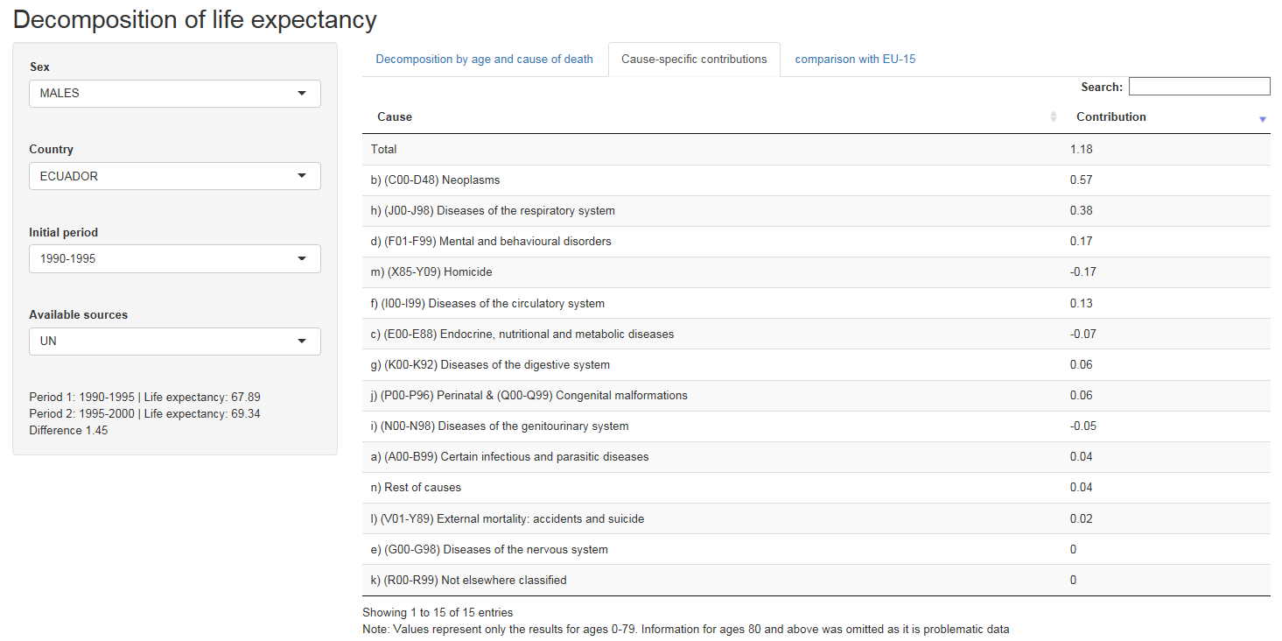

Table 3. Life table years and sources for EU-15 Countries
 | Country Code WHO | Year | Source
EU-15
Austria | 4010 | 2010-15 | HMD
Belgium | 4020 | 2010-15 | HMD
Denmark | 4050 | 2010-15 | HMD
Finland | 4070 | 2010-15 | HMD
France | 4080 | 2010-15 | HMD
Germany | 4085 | 2010-15 | HMD
Greece | 4140 | 2010-15 | Eurostat
Ireland | 4170 | 2010-15 | HMD
Italy | 4180 | 2010-15 | HMD
Luxembourg | 4190 | 2010-15 | HMD
Netherlands | 4210 | 2010-15 | HMD
Portugal | 4240 | 2010-15 | HMD
Spain | 4280 | 2010-15 | HMD
Sweden | 4290 | 2010-15 | HMD
UK | 4308 | 2010-15 | HMD
Source: Human Mortality Database as HMD and Eurostat database
Figure 1a. Trends over time in the proportions of causes of death, Costa Rica, 1990-2014
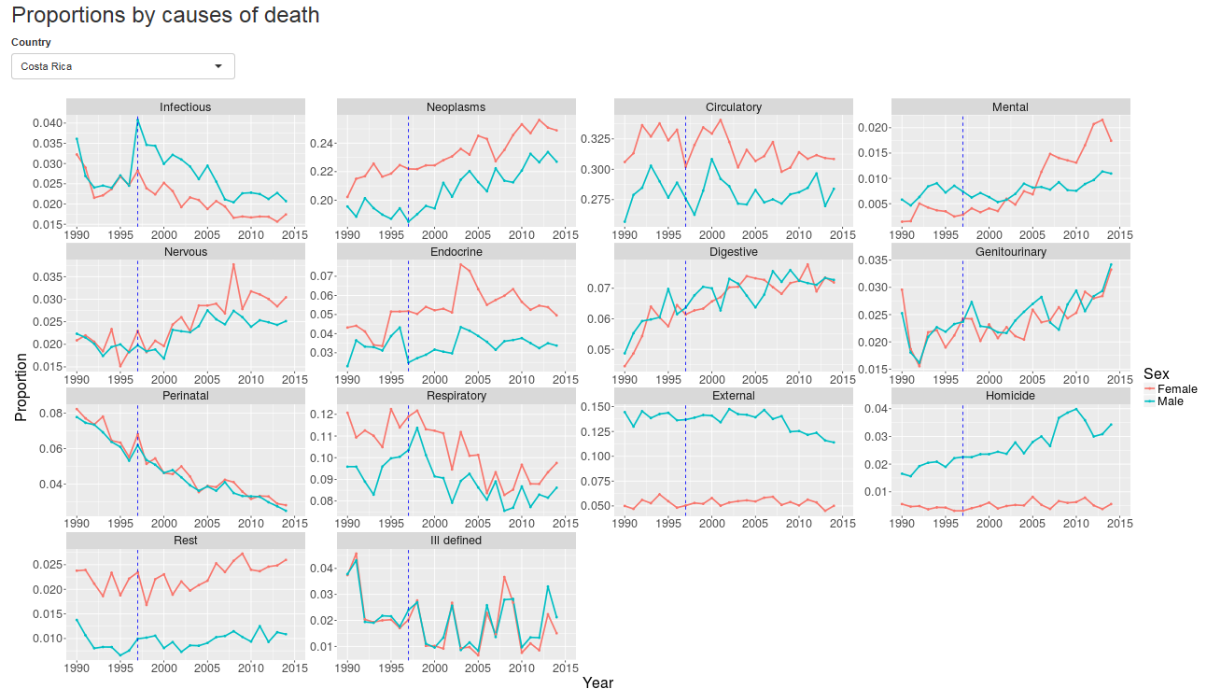
Figure 1a. Trends over time in the proportions of causes of death, Honduras, 1990-2013
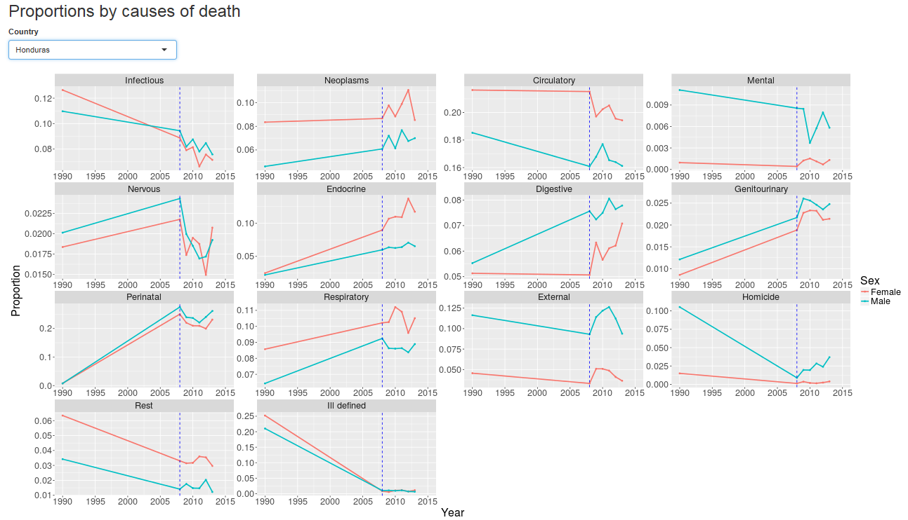

Figure 2a. Trends over time in the life expectancy at birth estimates, Honduras, 1990-2013
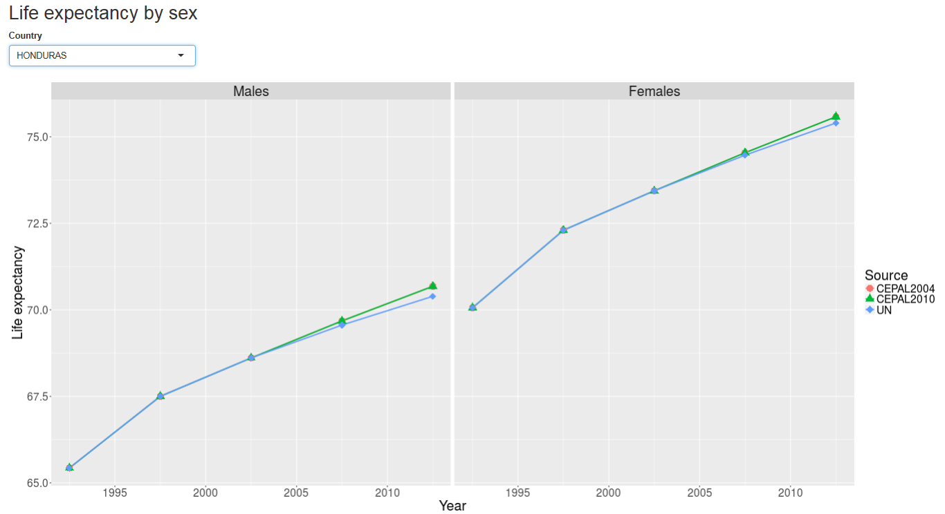

Figure 2b. Trends over time in the life expectancy at birth estimates, Mexico, 1990-2015
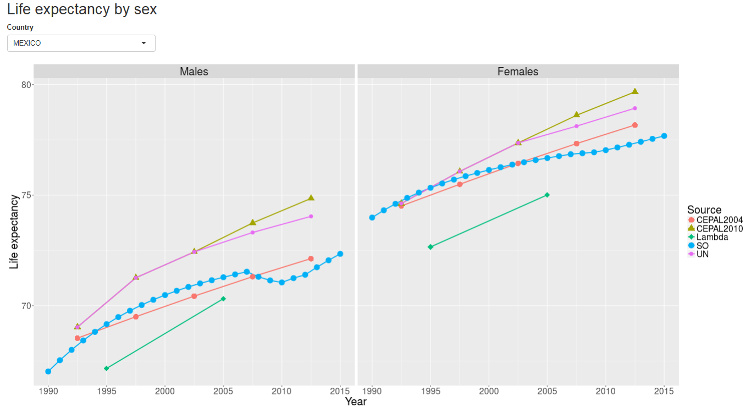
Figure 3a. Age- and cause-specific decomposition of the change in the female life expectancy at birth for Peru, 1990-1994 to 1995-1999
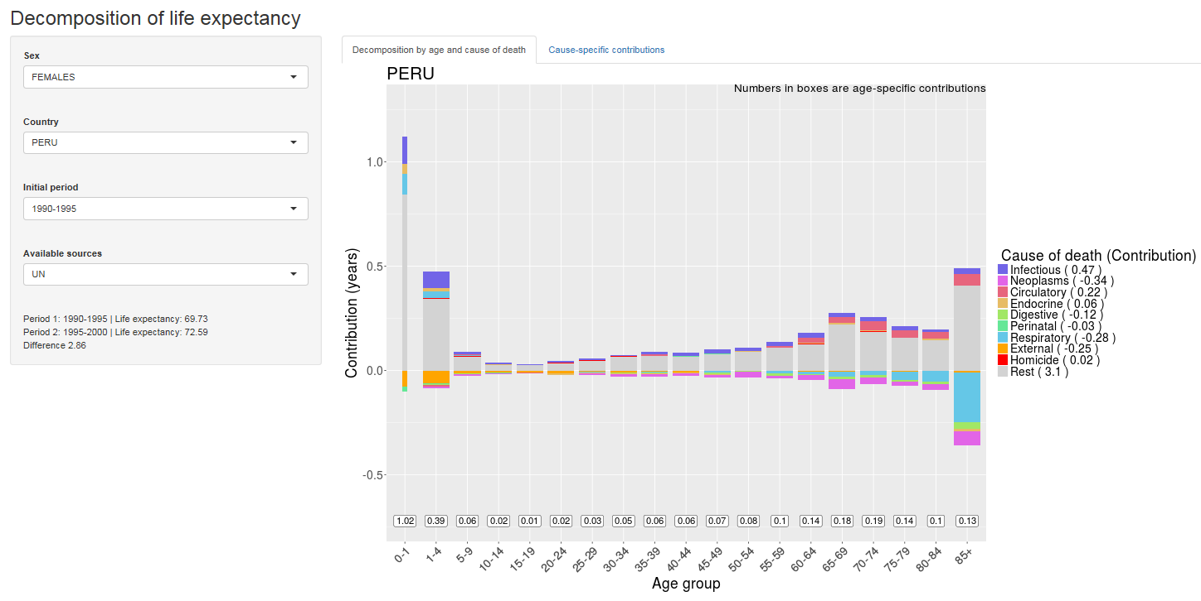
Figure 3b. Age- and cause-specific decomposition of the change in the female life expectancy at birth for Panama, 2005-2009 to 2010-2015
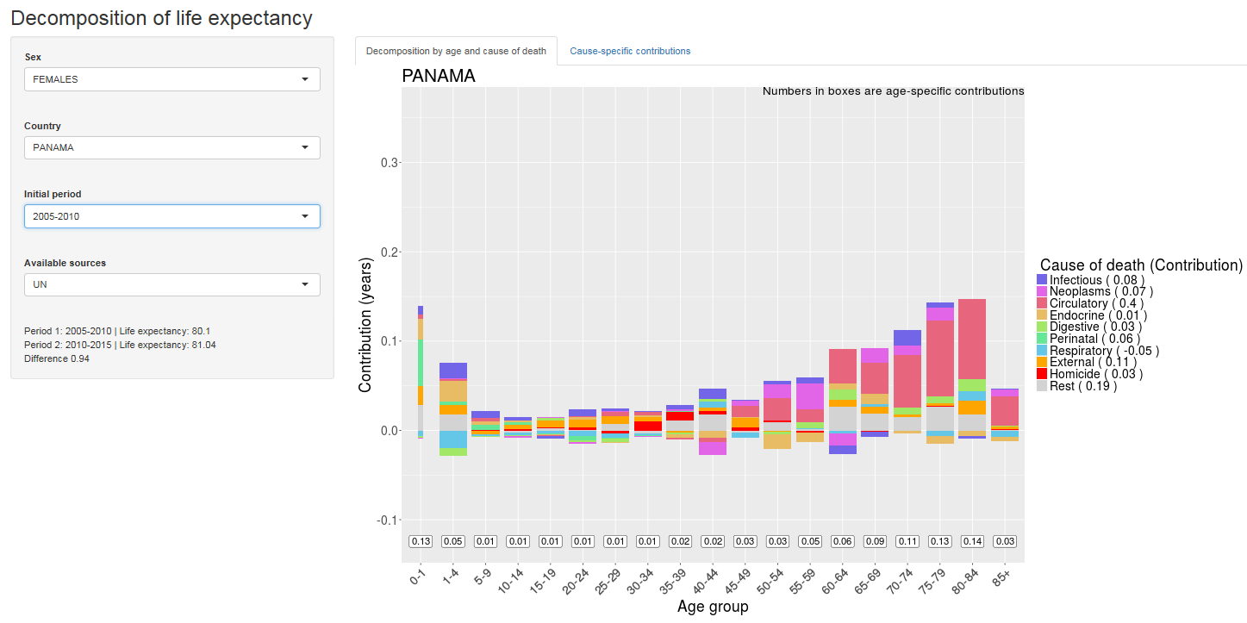
Figure 4a. Age- and cause-specific decomposition of the difference in the male life expectancy at birth between EU-15 (life expectancy e₀= 80.24) and Venezuela (e₀=70.66) in 2010-2015
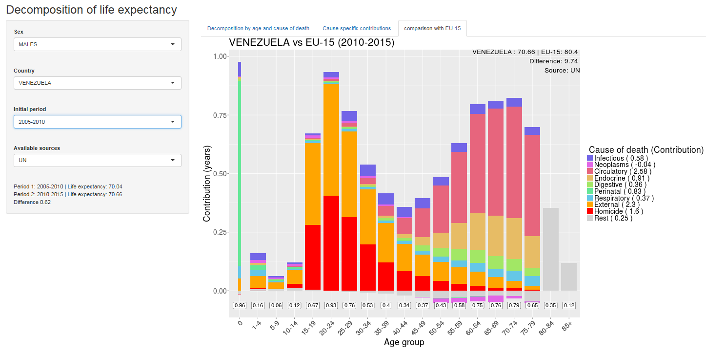

Figure 4b. Age- and cause-specific decomposition of the difference in the male life expectancy at birth between EU-15 (life expectancy e₀= 85.17) and Venezuela (e₀=78.62) in 2010-2015
