Extended Abstract: A Pace and Shape Perspective on Human Fertility

Annette Baudisch1*, Andrés Castro2, José Manuel Aburto1

1Interdisciplinary Center for Population Dynamics (CPop), Odense, Denmark

2Max Planck Institute for Demographic Research (MPIDR), Rostock, Germany

*Corresponding author

**Abstract**

**Quantum and tempo are central dimensions of fertility studies. Less attention has been devoted to the *shape* of fertility. Although the shape of a fertility curve over age might, at first sight, be over determined by quantum and tempo, two aspects make it a crucial dimension of human reproduction. First, shape summarizes the overall distribution of births’ timing providing a holistic indicator of how reproduction is spread over the life course. Second, the shape of fertility can be defined with respect to baseline patterns of various forms. This latter feature gives important flexibility capturing diverse patterns and opens the door for comparisons with biological baselines. Biodemographic research motivated the shape concept as part of the *pace shape framework* tailored to compare aging patterns of mortality across species. Comparing fertility patterns across human populations with the same methodology requires to deeply acknowledge that you are only born once. One can imagine a ‘population’ of unborn babies waiting along a ‘survival curve’ for the event of being born to a mother of uncertain age. With this radical shift in perspective, here we offer a new macro level perspective to study the development of human fertility patterns, which accounts for births of any parity. It also opens the floor to transfer other mortality concepts into the world of fertility applications.**

**Introduction**

The tempo and quantum of fertility have since long interested demographers (Bongaarts & Feeney, 1998). Less attention has been devoted to the shape of fertility curves over age that emerges from the interactions of these two dimensions. Although the shape of a fertility curve might, at first sight, be over determined by quantum and tempo, two aspects make it a crucial dimension of human reproduction. First, shape summarizes the overall distribution of births’ timing providing a holistic indicator of how reproduction is spread over the life course. Second, the shape of a fertility curve over age can be defined with respect to baseline patterns of various forms (e.g. even distribution over age). This latter feature gives important flexibility capturing diverse patterns and opens the door for comparisons with biological baselines, potentially including other species.

The concept of shape has been developed as part of *the pace shape framework* that was originally developed within the field of Evolutionary Biodemography and tailored to compare aging patterns of mortality across species (Baudisch 2011). In this framework, shape captures the distribution of the event of death relative to a relevant age-range. Shape distinguishes mortality patterns where death becomes more likely, less likely or evenly likely over the life course, corresponding to positive, negative, or non-aging. For mortality, shape measures are based on widely used statistical measures of relative spread. Pace captures the average duration until the event of death. One may have likewise called it the tempo of death. “Quantum” only indirectly enters in the original framework, as the quantum of death is standardized to the radix or the original size of a synthetic cohort in a lifetable.

Importantly, the original framework aims to compare pace and shape across species with vastly different timescales, i.e., species who count their lives in hours, days, years, or centuries. Hence, shape is time-standardized to disentangle confounding effects with pace. Across species, pace and shape constitute separate dimensions, as flat, rising or falling patterns over age can be observed independent of whether species count their life in days or centuries (Jones et al. 2014). However, within species, pace and shape are linked, and even within groups of species relationships are observed (Baudisch et al. 2013).

Recently, Baudisch and Stott (2019) extended the framework to compare the pace and shape of age-patterns of fertility across non-human species. Here, we take this framework and explore how studying the development of human fertility patterns across populations and over time could benefit from this novel macro level perspective.

**Data**

We used data from the Human Fertility Database (www.humanfertility.org) for 30 countries with completed cohort data available (total fertility): Austria (1939, 1961), Bulgaria (1935, 1953), Belarus (1952, 1960), Canada (1909, 1960), Switzerland (1920, 1960), Czech Republic (1938, 1961), East Germany (1944, 1961), Germany (1944, 1961), West Germany (1944, 1961), Denmark (1904, 1960), Spain (1910, 1960), Estonia (1947, 1961), Finland (1927, 1959), France (1934, 1961), England & Wales (1926, 1960), Scotland (1933, 1960), Hungary (1938, 1961), Iceland (1948, 1959), Italy (1942, 1958), Japan (1935, 1961), Lithuania (1947, 1961), Netherlands (1938, 1960), Norway (1955, 1958), Poland (1959, 1960), Portugal (1928, 1959), Russia (1947, 1958), Slovakia (1938, 1958), Sweden (1879, 1961), Ukraine (1947, 1957), and USA (1921, 1961).

For our analyses by parity we used data available for 18 countries: Bulgaria (1935, 1953), Belarus (1952, 1960), Canada (1932, 1960), Czech Republic (1938, 1961), Denmark (1956, 1960), Estonia (1947, 1961), Hungary (1940, 1961), Japan (1956, 1961), Lithuania (1958, 1961), Netherlands (1938, 1960), Norway (1955, 1958), Poland (1959, 1960), Portugal (1947, 1959), Russia (1947, 1958), Slovakia (1938, 1958) Sweden (1958, 1961), Ukraine (1947, 1957), and USA (1921, 1961).

**Method**

*Pace, Shape and Quantum*

Analog to the original framework, pace captures the typical duration until the event of birth, i.e., the tempo of fertility. Shape distinguishes populations where births concentrate at the beginning of life (positive shape value, corresponding to aging, meaning predominantly falling reproduction with age), at the end of life (negative shape, corresponding to negative aging, meaning predominantly rising reproduction with age), and populations where events spread symmetrically over the reproductive age range. Symmetrical distributions could be just flat or perfectly hump-shaped, but also e.g. bimodal. This is a weakness of the concept, as it does not distinguish these different forms. It could be resolved either by studying the shape over partial age ranges, or by considering subpopulations.

Quantum enters this framework as the total number of babies born to a population of mothers. Depending on the application of interest, shape values can, but do not have to, be standardized for quantum.

All quantities in the fertility framework will be defined solely based on reproduction. We do not account for survival to keep the dimensions of mortality and fertility separated on purpose. This enables studying relationships between the pace and shape of mortality and the pace and shape of fertility with minimum confounding effects in future applications. However, survivorship can easily be incorporated into the framework, if desired.

*Perspective shift to allow method transfer*

Translating a framework designed for mortality into a fertility tool is not trivial. Mortality research heavily rests on the fact that death happens once, and once for sure to everyone. In contrast, women can give birth many times or not at all, which limits applications to fertility analysis. Perhaps therefore fertility research has disproportionally focused on first births. This focus puts undesirable limitations on fertility methodology, because in the contexts of lowest and lowest-low fertility, understanding higher order births (specially second births) is crucial for overall demographic processes (Billari & Kohler, 2004).

Baudisch and Stott (2019) take a shift in perspective to overcome these limitations. The core insight to motivate this shift comes from the observation that every baby is only born once. One can then imagine a ‘population’ of unborn babies waiting along a ‘survival curve’ for the event of being born to a mother of uncertain age. Thus, Baudisch and Stott (2019) define the key variables of the pace shape framework not from the mother’s but *the child’s perspective*. Thereby, they analyze the total population of individuals exposed to experience the event of own birth. They assume the event of birth to be independent among individuals, because the birth of any one baby in the population is unrelated to the birth of almost all other babies in the population.

With this radical shift in perspective, the pace-shape framework provides tools that account for all births, which appeals to studies in the context of low and rapid declining fertility. It also opens the floor to transfer a range of other mortality methods into the world of fertility applications.

*Defining the “pace” and the “shape” of fertility.*

**Pace**

Just as life-expectancy captures the average waiting time to death, the pace of fertility captures the average waiting time to birth, or “birth-expectancy”[1]. With the perspective shift from mother to child, we can define a survivorship concept of fertility to calculate the resulting birth-expectancy.

Specifically, let *m(x)* denote the age-specific maternity function that captures the average number of offspring to a mother of age *x*, with first and last ages of reproduction denoted *α* and *β*. The function *B(x)* defines cumulative reproduction up to age *x* as the total number of births to all mothers in that population up to age *x*:

$$B\left(x\right)=\int_{α}^{x}{m\left(t\right)dt.}$$

Thus, *B(α)* is zero and *B(β*) is the lifetime reproduction. For brevity, we will denote the latter by *B(β*) = *B*.

Cumulative reproduction allows to construct a survivorship concept for birth. Instead of a population of living individuals awaiting their uncertain age at death, we consider a population of unborn children awaiting their event of being born to a mother of uncertain age. Instead of survival, we can speak of “birth delay”, and we define the *birth-delay function* *b(x)* as the percentage of unborn babies to mothers of age *x*:

$$b\left(x\right)=1-\frac{B\left(x\right)}{B}.$$

Pace of fertility is then calculated as the expected waiting time until birth for a child, given by

$$P=\int_{α}^{β}{b\left(x\right)dx.}$$

Adding to this pace value *P* the age at first birth in that population, α, the pace of fertility can be interpreted as the age of the mother at the birth of an average child[2].

**Shape**

The shape is constructed to distinguish among positive aging, non-aging and negative aging types. Though it seems a bit odd to speak about negative reproductive aging in human populations, in principle we can ask the question whether age patterns of fertility predominantly fall across the age range, and how much, or whether they predominantly rise across the age range, and how much.

Knowing that human fertility is typically hump-shaped, shape can also be interpreted as a measure of concentration. From this angle, the shape of fertility quantifies the concentration of reproduction within the reproductive age-range of a population, standardized for age and lifetime reproduction. Positive shape values imply concentrated reproduction early in the age range, while negative shape values imply concentrated reproduction late in the age range. Zero shape value corresponds to an even or symmetrical spread of reproduction over the age range.

Shape is calculated relative to a benchmark of constant age-specific fertility and is based on the cumulative reproduction function over age. The difference between the area under the observed and benchmark cumulative reproduction functions (standardized for age and quantum) gives the shape value of fertility for an observed population.

For brevity we denote the length of reproductive lifespan as $τ=(β-α)$. The shape of fertility is then given by

$$S=\frac{1}{τB}\left(\int_{α}^{β}{B(x)dx}-\frac{τB}{2}\right).$$

Within the parentheses, the integral is the area under the cumulative reproduction curve and the quotient is the area of the triangular space under the diagonal benchmark line of constant cumulative reproduction over reproductive ages. The entire term describes the difference between the two areas. The factor $1/τB$ standardises the difference between the two terms, so the dimensions of pace and quantum do not confound the dimension of shape.

Note that even though the rational of the formula is based on the benchmark of a constant age-specific fertility curve, it remains the same if instead we consider a perfectly symmetrical hump shaped fertility pattern over age. With this note, positive, nil and negative shape values can be read as follows:

* Positive shape values S>0: fertility predominantly falls across the age range, left-tilted hump-pattern; larger shape values correspond to more concentrated reproduction around one age
* Negative shape values S<0: fertility predominantly rises across the age range, right-tilted hump pattern; more negative values correspond to more concentrated reproduction at later ages
* Zero shape values S=0: reproduction is symmetrically distributed over the full age range

**Relationship between pace and shape**

From the formulas above, it follows that for populations with the same function *m(x)* and same age range $τ$, pace and shape are linearly related, given by

$$P= τ \left(0.5-S\right).$$

This relationship implies that for perfectly symmetric fertility patterns with shape values of zero pace is exactly half the value of the reproductive age range. Positive shape values locate the average waiting time to birth in the first half of the age range, negative shape values imply that babies are born on average to mothers in the second part of the reproductive age range.

**Preliminary Results**

**FIGURE 1 As a first snapshot of results, the figure shows a wealth of information within one graph. Columns one and two respectively show time trends in the pace and shape of fertility for different cohorts across countries with data available across the full age range from 12 to 55. For the same data, column three shows the respective pace-shape space, i.e. how the trends in pace and shape develop together. Further, the top row shows data for the total population, while from second to bottom rows we subdivide the population of babies by the final parity of their mothers. Size of data points is proportional to the quantum of fertility. 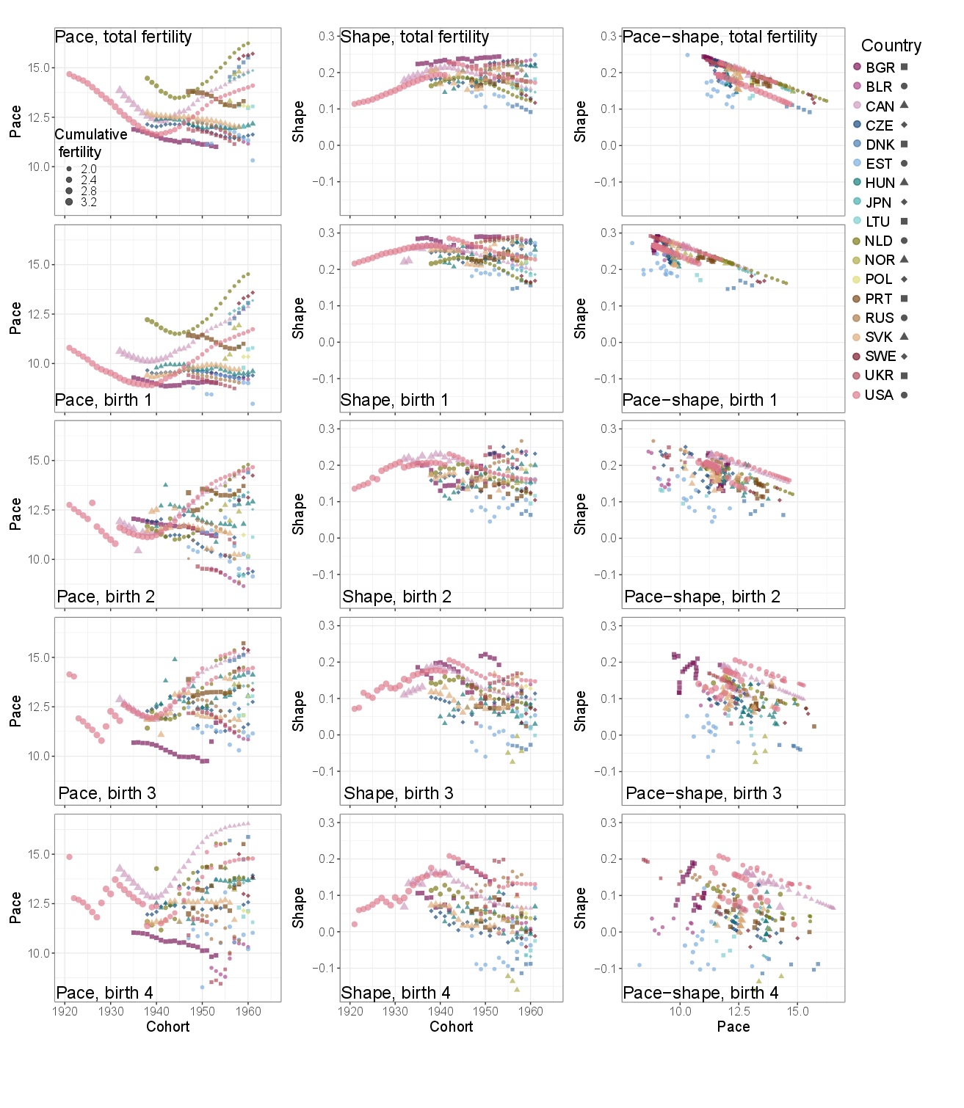**Figure 1 suggests the following preliminary findings:

**Wider range (all graphs):** the range of possible pace and shape values has substantially increased from older to younger cohorts across countries. Variation in pace (top left) for the last cohort with completed fertility observed is about 6 years. Variation in shape (top middle), that is the way in which births are distributed over the life course, has increased substantially over the last decades, today covering about 15% of the total range of the shape scale (-0.5 < S < 0.5 by the definition of shape).

**Diversity in time trends (first and second column):** trends in both pace and shape can strongly vary. Trends in pace as well as shape can increase, decrease, reverse or stagnate over cohorts, depending on the country.

**Pace shape relationship (right column)**:across all counties, the development of pace and shape together on the macro level form two main linear trends for total populations, though single countries, such as Slovakia, strongly diverge from these patterns, falling off or in between these main trends or extend the trends further to the extremes.

We will look more deeply into dynamics of single countries as well as groups of countries.

The mathematically linear relationship between pace and shape for similar functional forms of m(x), and similar age ranges of realized first and last reproduction forces some order on observed macro level patterns. However, observing two instead of one line indicates that two separate functional forms determine the age-patterns of all-parity fertility for the respective countries and cohorts forming those trends. Notably, as parity increases the number of trend lines that are recognizable by visual inspection increases.

One could argue that low and lowest low parities are “degenerate cases” from an evolutionary perspective as under natural fertility and mortality conditions populations with such low birth rates would go extinct. We will further look into whether we can find “biological baseline” points (or trend line if data permit) given by non-birth control high fertility populations, if possible, hunter gatherer populations and also primate fertility (chimpanzees) to make sense of these multiple trends lines for larger and evolutionary speaking more natural levels of parity, and to quantify the development of historical fertility from its natural curve up until birth control regimes.

**Parity:** We find that total pace shape patterns (top row) are dominated by parity one patterns (second row). Across parity (right column, from second to bottom rows) pace values rise and shape values fall and variance across countries in these pace and shape values increases with increasing parity. Parity four thus has the latest age at birth and widest spread of birth as well as largest variation in those values across countries.

This is expected as distributing more children over the reproductive age range holds more option of variation than distributing one or two children over the same age range. Also, pace is expected to shift to higher ages as it takes more time to give birth to more children.

Note that for recent cohorts, shape values for higher parities in some countries have crossed into negative shape values (EST, BLR, LTU, NOR, SWE), meaning that on average more babies are born in the second half of the reproductive life span than in the first half. Either due to country specific constraints and culture and/or due to assisted reproductive technology recent cohorts have moved towards what one may technically define as “negative fertility senescence”, fertility that on average rises rather than falls with age.

**Discussion**

With our framework we add the new dimension of shape to the current dimensions of tempo (pace) and quantum. What of the overall variation in the pace and shape of fertility are socially and biologically determined? How do the key determinants of fertility in the micro, meso and macro level influence the shape of fertility?

In general, shape of fertility could be used to study the manifold strategies of accommodating one or multiple births over the life course. The pace and shape space could help to quantify how much birth control can shift us from our biological baseline.

The perspective shift to defining a birth “survivorship” concept opens the door to import formal demographic methods from mortality research into fertility research, which may hold yet untapped potential.

The pace shape framework has been developed for both mortality and fertility along the same dimensions with comparable measures. This allows to study the intricate relationship between birth and death and their common determinants.

**References**

Baudisch, A. (2011). The pace and shape of ageing. Methods in Ecology and Evolution, 2(4), 375–382. doi.org/10.1111/j.2041-210X.2010.00087.x

Baudisch, A., Salguero-Gómez, R., Jones, O. R., Wrycza, T., Mbeau-Ache, C., Franco, M., & Colchero, F. (2013). The pace and shape of senescence in Angiosperms. Journal of Ecology, 101(3), 596–606. doi.org/10.1111/1365-2745.12084

Baudisch and Stott (2019) A pace and shape perspective on fertility. Methods in Ecology and Evolution, 1-11. doi.org/10.1111/2041-210X.13289

Billari, F. C., & Kohler, H.-P. (2004). Patterns of Low and Lowest-low Fertility in Europe. Population Studies, 58(2), 161–176. doi.org/10.1080/00324720500099843

Bongaarts, J., & Feeney, G. (1998) On the Quantum and Tempo of Fertility. Population and Development Review, 24(2 ), 271-291. www.jstor.org/stable/2807974

Human Fertility Database. Max Planck Institute for Demographic Research (Germany) and Vienna Institute of Demography (Austria). Available at www.humanfertility.org (data downloaded on [date]).

Jones, O. R., Scheuerlein, A., Salguero-Gómez, R., Camarda, C. G., Schaible, R., Casper, B. B., … Vaupel, J. W. (2014). Diversity of ageing across the tree of life. Nature, 505(7482), 169–173.

Preston, S. (1976). Family sizes of children and family sizes of women. Demography 13(1): 105–114. doi:10.2307/2060423.

1. Note that the pace of fertility as defined here is not related to waiting time of the mother between two individual children of hers. Rather it is the expected age of the mother at the birth of a child, if one was to randomly draw this child among the total population of babies born to a population of mothers.
2. It should closely correlate with the average age of a mother in the population. It is not the same, however, just as the average number of babies for a mother differs from the average number of siblings (Preston 1976). Perspective from mother versus child changes the results.