Extended Abstract: A pace and shape perspective on human fertility
Annette Baudisch, Andrés Castro, José Manuel Aburto, Draft, 25.10.2019

Introduction
Given available data, insights are limited to the concepts and tools available to extract meaningful patterns about demographic processes. Central to fertility research, there are the two key dimensions that have been extensively considered when studying the total fertility rate (TFR): the tempo effects (changes in the timing of births) and the quantum (TFR that would have been observed in the absence of changes in timing of births) (cite Bongaart and Feeney). Here we offer a tool that, besides quantum and tempo, includes a potentially interesting third dimension – the shape of fertility. All three dimensions are integral parts of the pace and shape framework to compare fertility patterns across populations. The pace-shape framework was originally developed within the field of Evolutionary Biodemography and tailored to compare aging patterns of mortality across species (Baudisch 2011). Recently, Baudisch and Stott (2019) extended the framework to compare age-patterns of fertility across non-human species. Our approach opens a novel macro level perspective on the development of human fertility patterns and demonstrates how method transfer among fields can be mutually beneficial to study fertility across several populations.

Data
We used data from the Human Fertility Database (Ref HFD) for 30 countries with completed cohort available data (total fertility): Austria (1939, 1961), Bulgaria (1935, 1953), Belarus (1952, 1960), Canada (1909, 1960), Switzerland (1920, 1960), Czech Republic (1938, 1961), East Germany (1944, 1961), Germany (1944, 1961), West Germany (1944, 1961), Denmark (1904, 1960), Spain (1910, 1960), Estonia (1947, 1961), Finland (1927, 1959), France (1934, 1961), England & Wales (1926, 1960), Scotland (1933, 1960), Hungary (1938, 1961), Iceland (1948, 1959), Italy (1942, 1958), Japan (1935, 1961), Lithuania (1947, 1961), Netherlands (1938, 1960), Norway (1955, 1958), Poland (1959, 1960), Portugal (1928, 1959), Russia (1947, 1958), Slovakia (1938, 1958), Sweden (1879, 1961), Ukraine (1947, 1957), USA (1921, 1961).
For our analyses by parity we used data available for 18 countries: Bulgaria (1935, 1953), Belarus (1952, 1960), Canada (1932, 1960), Czech Republic (1938, 1961), Denmark (1956, 1960), Estonia (1947, 1961), Hungary (1940, 1961), Japan (1956, 1961), Lithuania (1958, 1961), Netherlands (1938, 1960), Norway (1955, 1958), Poland (1959, 1960), Portugal (1947, 1959), Russia (1947, 1958), Slovakia (1938, 1958) Sweden (1958, 1961), Ukraine (1947, 1957) USA (1921, 1961)
Method
Pace, Shape and Quantum
Pace, in the original mortality framework, captures the typical duration until the event of death. One could have likewise called it the tempo of death. Here in fertility, pace captures the typical duration until birth, i.e. the tempo of fertility.
Shape, in the original framework, captures the distribution of the event of death over the relevant age-range.
Shape broadly distinguishes patterns where events become less likely, more likely or broadly speaking evenly likely over the life course. Alternatively, one can say that shape distinguishes among events concentrated at the beginning of life, events concentrated at the end of life, and those symmetrically spread. In the original framework, these would be related to negative, positive or non-aging mortality patterns. Importantly, to disentangle confounding effects with pace, shape is age-standardized. In this sense,
shape measures concentration and distribution relative to an age range.
Quantum only indirectly enters in the original framework, as the quantum of death in a lifetable is standardized to the radix or the original size of a synthetic cohort. In fertility, quantum enters as the total number of babies born to a population of mothers. It can, but does not have to, be standardized for as needed in the application of interest.

Perspective shift to allow method transfer
Translating a framework designed for mortality into a fertility tool is not trivial. Mortality research heavily rests on the fact that death happens once, and once for sure to everyone. In contrast, women can give birth many times or not at all, which limits applications to fertility analysis. Baudisch and Stott (2019) therefore took a shift in the perspective of pace-shape defining the key variables of the framework not focused on the mother but from the perspective of the child.
Each child is born only once. One can imagine a ‘population’ of unborn babies waiting along a ‘survival curve’ for the event of being born to a mother of uncertain age.

Defining the “pace” and the “shape” of fertility.
Pace
Pace in the original framework (Baudisch 2011) captures the average waiting time to death, which is life-expectancy or average age at death. Similarly, pace of fertility captures the average waiting time to birth. This “birth-expectancy” for a child is the fertility analog to life-expectancy. With the perspective shift from mother to child, we can define a survivorship concept of fertility to calculate the resulting birth-expectancy.
Specifically, let m(x) denote the age-specific maternity function that captures the average number of offspring to a mother of age x, with first and last ages of reproduction denoted α and β. The function B(x) defines cumulative reproduction up to age x as the total number of births to all mothers in that population up to age x:
$$B\left(x\right)=\int_{α}^{x}{m(t)dt}$$
Thus, B(α) is zero and B(β) is the lifetime reproduction. For brevity, we will denote the latter by B(β) = B.
Cumulative reproduction allows to construct a survivorship concept for birth. Instead of a population of living individuals awaiting their uncertain age at death, we consider a population of unborn children awaiting their event of being born to a mother of uncertain age. Instead of survival, we can speak of “birth delay”, and we define the birth-delay function b(x) as the percentage of unborn babies to mothers of age x:
$$b\left(x\right)=1-\frac{B(x)}{B}$$
Pace of fertility is then calculated as the expected waiting time until birth for a child, given by
$$P=\int_{α}^{β}{b(x)dx}$$
Adding to this pace value P the age at first birth in that population, α, the pace of fertility can be interpreted as the age of the mother at the birth of an average child.
Shape
Shape in the original framework classifies species into aging, non-aging and negative aging types, corresponding to falling, constant or increasing mortality (Baudisch 2011). Though it seems a bit odd to speak about negative reproductive aging in human populations, in principle we can ask the question whether age patterns of fertility predominantly fall across the age range, and how much, or whether they predominantly rise across the age range, and how much.
Shape can also be interpreted as a measure of concentration or inequality. From this angle, the shape of fertility quantifies the concentration of reproduction within the reproductive age-range of a population, standardized for age and lifetime reproduction. Positive shape values imply concentrated reproduction early in the age range, while negative shape values imply concentrated reproduction late in the age range. Zero shape value corresponds to an even or symmetrical spread of reproduction over the age range.
Shape is calculated relative to a benchmark of constant age-specific fertility and is based on the cumulative reproduction function over age. The difference between observed and benchmark cumulative reproduction functions (standardized for age and quantum) gives the shape value of fertility for an observed population.
For brevity we denote the length of reproductive lifespan as $τ=(β-α)$. The shape of fertility is then given by
$$S=\frac{1}{τB}\left(\int_{α}^{β}{B(x)dx}-\frac{τB}{2}\right)$$
Within the parentheses, the integral is the area under the cumulative reproduction curve and the quotient is the area of the triangular space under the diagonal benchmark line of constant cumulative reproduction over reproductive ages. The entire term describes the difference between the two areas. The factor $1/τB$ standardises the difference between the two terms, so the dimensions of pace and quantum do not confound the dimension of shape.
Note that even though the rational of the formula is based on the benchmark of a constant age-specific fertility curve, it remains the same if instead we consider a perfectly symmetrical hump shaped fertility pattern over age. With this note, positive, nil and negative shape values can be read as follows:
- Positive shape values: fertility predominantly falls across the age range, left-tilted hump-pattern; larger shape values correspond to more concentrated reproduction around one age
- Negative shape values: fertility predominantly rises across the age range, right-tilted hump pattern; more negative values correspond to more concentrated reproduction at later ages
- Zero shape values: reproduction is symmetrically distributed over the full age range
Relationship between pace and shape
From the formulas above, it follows that for populations with the same function m(x) and same age range $τ$, pace and shape are linearly related, given by
$$P= τ (0.5-S)$$

Preliminary Results
Figures 1-4 show how pace and shape of fertility have developed for different cohorts over time across countries with data available across the full age range from 12 to 55.

FIGURE1
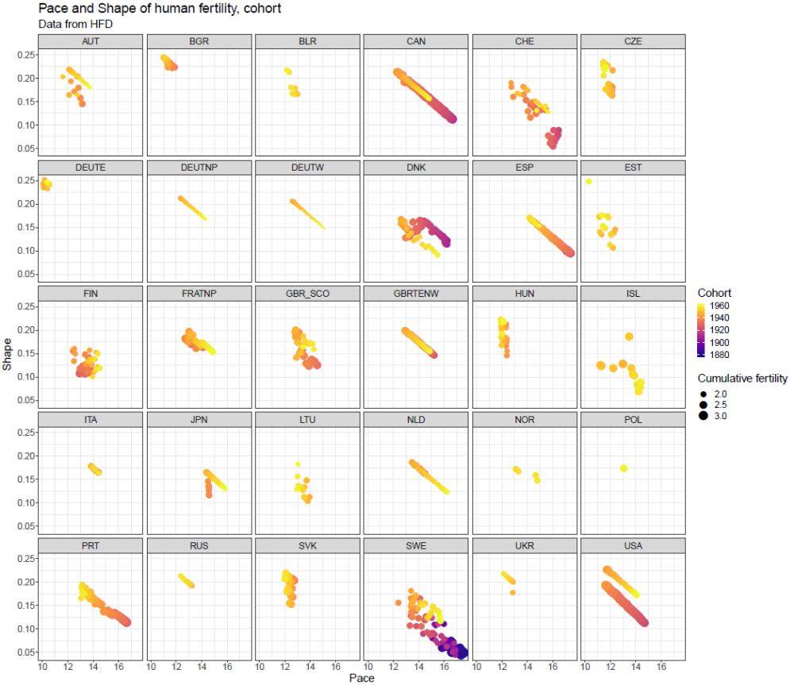
Though the linear relationship $P= τ (0.5-S)$ holds true, Figure 1 shows that within countries the relationship between pace and shape can strongly diverge from linear for a range of countries.
Further, Figure 1 shows that trends in both pace and shape can strongly vary. Some countries show clear trend reversals (USA, CAN, DK, SWE, recent reversals also ESP and PRT), others show stagnation or divergence.

To get a more detailed grasp of these time trends, Figures 4,5 and 6 depict shape patterns over time.

FIGURE 2
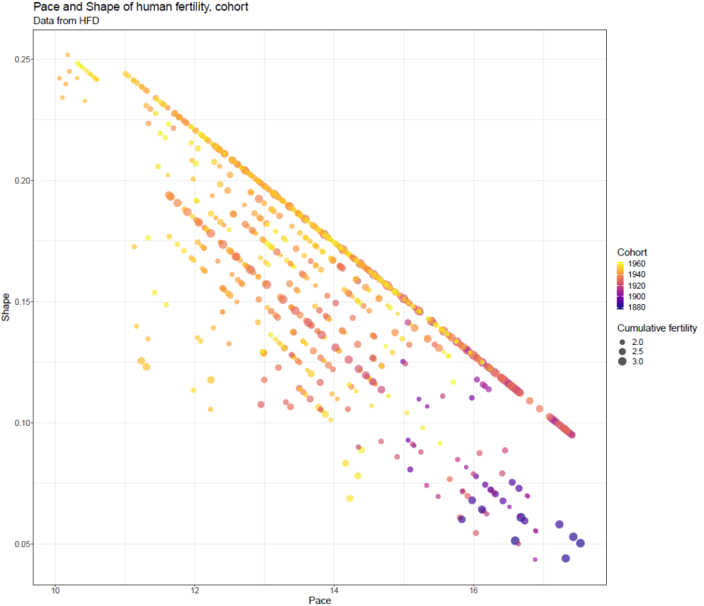
The pace shape space in Figure 2 shows that for all countries from Figure 1 combined, a pattern emerges that seems to collect different cohorts (color-coded), different countries (not differentiated by any means), and different TFRs (proportional to size of the dots) along almost parallel linear trends. Note that the top left separate little cluster depicts data for the regime of eastern Germany with exceptionally early, concentrated and static fertility patterns over time (compare Fig 1).
In contrast to single country variation and divergence from linear trends, across countries it seems that the mathematical relationship between pace and shape forces some order on observed macro level patterns. Notably, it is not a single line but many linear trends that emerge from data on all countries analyzed.
We will further look into whether we can find a “biological baseline” trend given by non-birth control high fertility populations, if possible, hunter gatherer populations and a benchmark of primate fertility (chimpanzees).

FIGURE 3
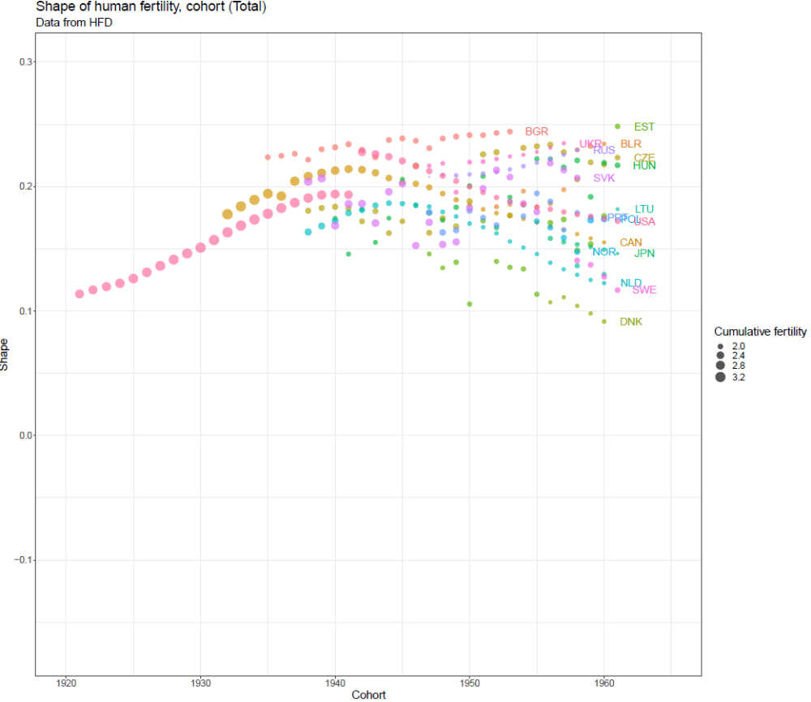
The trend in shape over time across countries reveals up- as well as downward trends as well as reversals. Though not shown here, pace typically mirrors these trends into the opposite direction.
We find strong variety in historical fertility change. Variation across countries in the shape of fertility, that is the way in which births are distributed over the life course, has increased substantially over the last decades, today covering about 15% of the total range of the shape scale (-0.5 < S < 0.5 by the definition of shape). Variation across countries in pace for the last cohort with competed fertility observed is about 6 years (not shown). Trends of shape (and pace, not shown) can be falling, flat, increasing as well has hump-shaped. This broadly classifies countries into those that tend towards earlier child birth (e.g. BGR, BLR, EST, UKR, RUS), those that move towards later child birth (DNK, JPN, NOR, SWE), and those that have gone through both trends together, coming from a declining and now being in an increasing regime (USA, CAN, NLD). Note that from Fig 1 we know that also DNK ,SWE,NOR and JPN went through a trend reversal, but data are not shown here, because Figure 3 only includes cohorts for which full parity information was available (related to Figure 4).

FIGURE 4
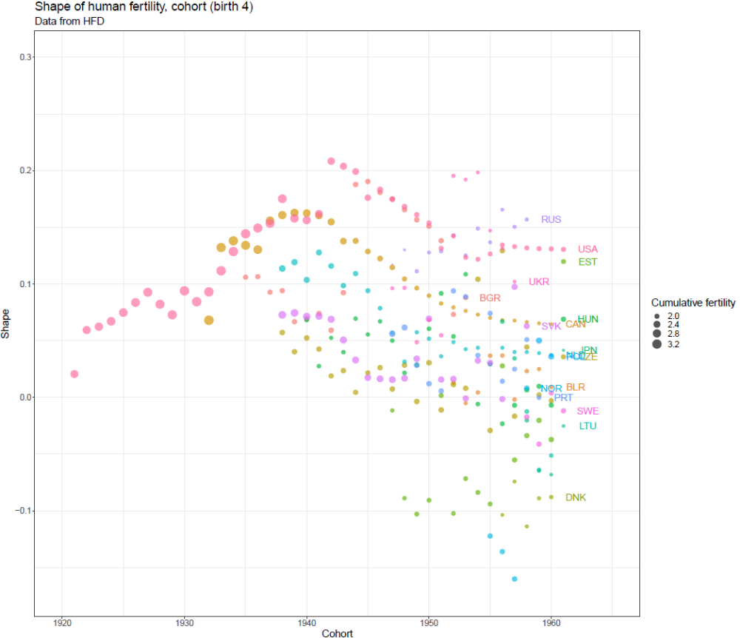

In Figure 4 we calculate parity specific shape. Parity specific pace and shape are calculated simply by considering the population of babies who are born of mothers with final parity four. Similarly, we looked at the pace and shape of lower parities. Though not shown, we find that the general pace and shape patterns for the data we studied (Figure 3) are strongly driven by the pace and shape patterns of parity 1 (not shown). Pace values rise and shape values fall and variance across countries in these pace and shape values increases with increasing parity. Parity 4 thus has the latest age at birth and widest spread of birth as well as largest variation in those values across countries as shown in Figure 4.
This is expected as distributing more children over the reproductive age range holds more option of variation than “distributing” one or two children over the same age range. Also, pace as well as tempo are expected to shift to higher ages as it takes more time to give birth to more children.
Note that for recent cohorts, shape values for parity 4 have crossed into negative shape values, meaning that on average more babies are born in the second half of the reproductive life span than in the first half. With the help of assisted reproductive technology recent cohorts have thus managed to achieve what one may technically define as “negative fertility senescence”, as fertility on average rises rather than falls with age.
Discussion
With our framework we add the new dimension of shape to the current dimensions of tempo (pace) and quantum. What of the overall variation in the pace and shape of fertility are socially and biologically determined? How do the key determinants of fertility in the micro, meso and macro level influence the shape of fertility?
In general, shape of fertility could be used to study the manifold strategies of accommodating one or multiple births over the life course. The pace and shape space could help to quantify how much birth control can shift us from our biological baseline.
From a technical side, the perspective shift to defining a birth “survivorship” concept opens the door to import formal demographic methods form mortality research into fertility research, which may hold yet untapped potential. The full trinity of survival-harzard-density, can directly be derived for fertility, and hence widely used concepts such as remaining life-expectancy, life-years lost, gini coefficient, life tbale entropy etc. can be applied to fertility research.
The pace and shape framework allows to quantify mortality and fertility along the same dimensions with comparable measures. This allows to study common determinants and gain new insights into how mortality and fertility might directly be linked.

Note that the pace of fertility as defined here is not related to waiting time of the mother between two individual children of hers. Rather it is the expected age of the mother at the birth of a child, if one was to randomly draw this child among the total population of babies born to a population of mothers.
It should closely correlate with the average age of a mother in the population. It is not the same, however, just as the average number of babies for a mother differs from the average number of siblings. Perspective from mother versus child changes the results.

