**Equality-efficiency tradeoffs in population health**

**Population health and health inequality tradeoffs**

**Equality and efficiency in the production of lifespans**

Iñaki Permanyer, Ilya Kashnitsky and José Manuel Aburto

**Introduction**

The unparalleled longevity gains recorded in virtually all countries during the last century (Oeppen and Vaupel 2002, Riley 2001, 2005) are a cause for celebration; individuals worldwide can now expect to survive to ages that were deemed unattainable only a few decades ago. While there is widespread agreement that increasing the average length of life in a population is a major social achievement, equity concerns have started to surface in the academic and policy-making arenas. Indeed, whenever general improvements are shared inequitably and benefit some groups to the detriment of others, it is difficult to speak about unequivocal social progress (Rawls 1971, Sen 1999). This is why the recent years have witnessed a surge in interest for the study of lifespan inequality (add references) and its implications for the implementation of fair and well-informed population health policies (Benach et al 2011, 2013, Bronnum-Hansen 2017). It is nowadays widely agreed that the latter should have the dual purpose of promoting health gains in the population as a whole *and* reducing health inequalities (Whitehead 2007).

In this paper, we present novel methods to assess how ‘efficiency’ (i.e. overall/mean attainment) and ‘inequality’ contribute to the overall health performance of societies. Such methods allow investigating whether, and to what extent, the improvements or deteriorations we observe in population health can be attributable to changes in the average number of years individuals are expected to live (i.e. ‘efficiency’) or to the way in which those years of life are distributed across individuals (i.e. ‘inequality’). These methods can be very useful to understand the determinants of population health and to identify those circumstances where the principles of ‘more efficiency’ and ‘less inequality’ go in the same or in opposite directions.

**Methods**

In order to measure the overall health performance of a given society, we use the following index derived from standard life tables

$$H_{ε}:=\left\{\begin{matrix}{\left(\sum_{i}{d_{i}{\left({age}_{i}+a_{i}\right)}^{1-ε}}\right)}^{\frac{1}{1-ε}} if ε≠1 \\ \prod_{i}{{\left({age}_{i}+a_{i}\right)}^{d_{i}}} if ε=1\end{matrix}\right. [1]$$

where ${age}_{i}$ is the age at the lower end of the age interval $i$ in a life table, $a_{i}$ is the average number of years lived in the interval by those who die in the interval, $d_{i}$ is the fraction of deaths in interval $i$, and $ε≥0$ is the so-called ‘inequality aversion parameter’. $H_{ε}$ is an inequality-adjusted measure of average length of life, that is: it measures the average length of life penalizing those distributions that have a relatively high variation in the length of lives. When $ε=0$, there is no aversion to inequality, and ${ H}_{0}$ reduces to the arithmetic mean, which corresponds to the standard life expectancy. When $ε=1$, $H_{1}$ is the geometric mean of the age-at-death distribution, which coincides with the ‘Human Life Indicator’ (HLI) recently proposed by Ghislandi et al (2019). In general, the higher the value of $ε$, the higher the aversion to inequality and the larger the corresponding correction for inequality. Following Atkinson (1970), one has that

$$H_{ε}=f\left(M,I_{ε}\right):=M\left(1-I_{ε}\right) [2]$$

where $M$ is the arithmetic mean of the age-at-death distribution (i.e. $M={ H}_{0}$) and $I_{ε}$ is the Atkinson index of (lifespan) inequality, which is defined as

$$I_{ε}=1-\frac{H_{ε}}{M} [3]$$

In the hypothetical case where all individuals died at the same age, $I_{ε}$ would take a value of 0. In general, larger levels of $I_{ε}$ indicate greater variation in the age-at-death distribution. Based on equations [1]–[3], we can now present the following decomposition formula:

$$∆H_{ε}=H_{ε}\left(t_{2}\right)-H_{ε}\left(t_{1}\right)=∆_{M}H_{ε}+∆_{I}H_{ε} [4]$$

where

$$∆_{M}H_{ε}:=\frac{1}{2}\left(f\left(M\left(t_{2}\right),I_{ε}\left(t_{2}\right)\right)-f\left(M\left(t_{1}\right),I_{ε}\left(t_{2}\right)\right)+f\left(M\left(t_{2}\right),I_{ε}\left(t_{1}\right)\right)-f\left(M\left(t_{1}\right),I_{ε}\left(t_{1}\right)\right)\right)$$

$$∆_{I}H_{ε}:=\frac{1}{2}\left(f\left(M\left(t_{2}\right),I_{ε}\left(t_{2}\right)\right)-f\left(M\left(t_{2}\right),I_{ε}\left(t_{1}\right)\right)+f\left(M\left(t_{1}\right),I_{ε}\left(t_{2}\right)\right)-f\left(M\left(t_{1}\right),I_{ε}\left(t_{1}\right)\right)\right)$$

Equation [4] shows how changes in overall population health (as measured with $H_{ε}$) can be decomposed in two clearly interpretable parts: $∆_{M}H_{ε}$ and $∆_{I}H_{ε}$. The first measures the absolute contribution of the efficiency component and the second one the absolute contribution of the inequality component. To measure the corresponding relative contributions, we simply define ${ C}_{M}=∆_{M}H_{ε}/∆H_{ε}$ and $C_{I}=∆_{I}H_{ε}/∆H_{ε}$.

The decomposition formula shown in [4] can be extended over several periods of time, so we can write

$$∆H_{t_{1},t_{n}}=\sum_{i=1}^{n-1}{∆H_{t_{i},t_{i+1}}}=\sum_{i=1}^{n-1}{∆_{μ}H_{t_{i},t_{i+1}}}+\sum_{i=1}^{n-1}{∆_{I}H_{t_{i},t_{i+1}}} [5]$$

Where t_i…

**Data**

We use the life tables from the Human Mortality Database (HMD), which contains high-quality mortality data for 49 populations and regions over a long time span (some of them starting in the 18th century, but most of them starting somewhere in the 20th century). Period life-tables for each country-year are available in the database, for women and men separately.

**Results**

Fig 1. Efficiency ($μ$) by inequality ( over time for values of $ϵ=0.5, 1, 2.$ 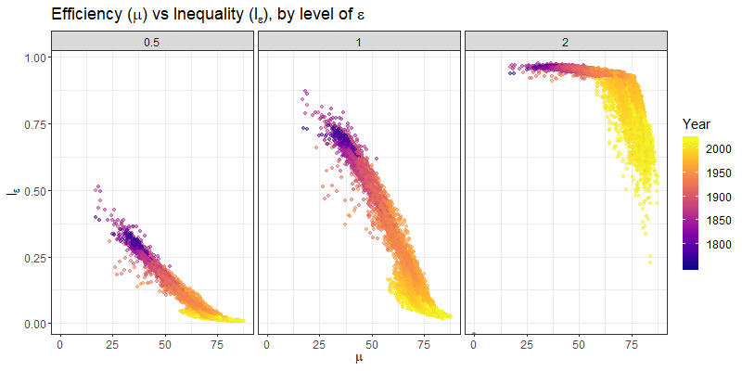

Fig 2. by contribution of inequality (vertical axis) over time for values of $ϵ=0.5, 1, 2.$

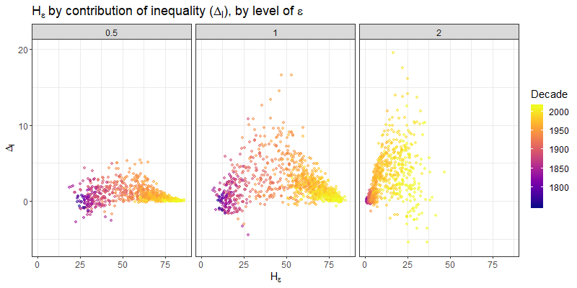

Fig 3. $H_{ε}$ by contribution of efficiency $Δ_{M}$ (vertical axis) over time for values of $ϵ=0.5, 1, 2.$

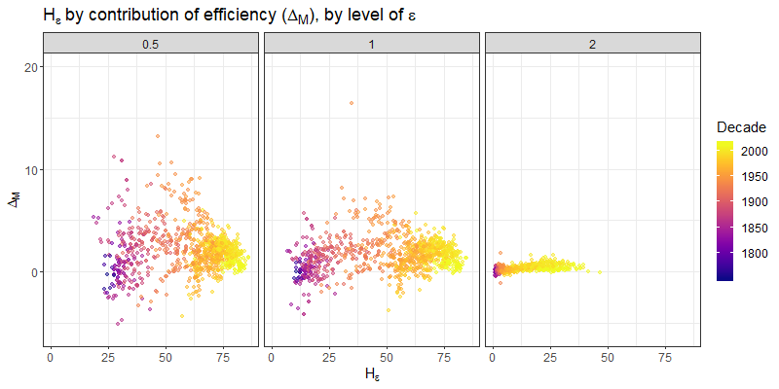

Fig 4. Contribution of efficiency $Δ_{M}$ by contribution of inequality $Δ_{I}$ over time for values of $ϵ=0.5, 1, 2.$ 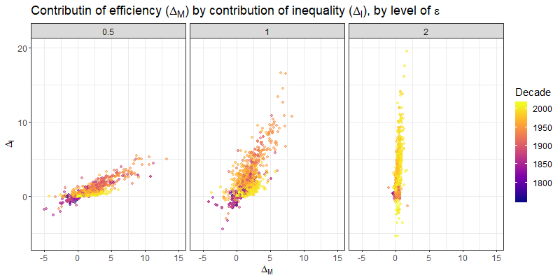

Scatterplot comparing $I$ (horizontal axis) vs $C_{I}$ (vertical axis) over time

Scatterplot comparing $μ$ (horizontal axis) vs $C_{μ}$ (vertical axis) over time

Sensitivity analysis wrt values of $≥0$. Find critical values / range of value of $ε$ for which a certain ranking holds

Plot $I$ with time in horizontal axis and low bound age in vertical axis…(à la PDR Engelman, Canudas & Agree 2010).

**Discussion and concluding remarks**

…If health improvements contribute to increase longevity *and* lifespan variability simultaneously, health care systems would be facing a difficult ethical dilemma (particularly in high-income countries) upon which it will be necessary to reflect…

**References**

Benach, J., Malmusi, D., Yasui, Y., Martinez, J.M. and Muntaner, C. (2011), “Beyond Rose’s strategies: A typology of scenarios of policy impact on population health and health inequalities”, *International Journal of Health Services* 41(1):1-9.

Benach, J., Malmusi, D., Yasui, Y. and Martinez, J.M. (2013), “A new typology of policies to tackle health inequalities and scenarios of impact based on Rose’s population approach”, *Journal of Epidemiology and Community Health* 67:286-291.

Brønnum-Hansen, H. (2017), “Socially disparate trends in lifespan variation: a trend study on income and mortality based on nationwide Danish register data”, *BMJ Open*, 7(5), e014489.

Oeppen, J. and Vaupel, J. (2002), “Broken limits to life expectancy”, *Science* 296:1029-1031.

Riley, J. (2001), *Rising life expectancy: A global history*. Cambridge: Cambridge University Press.

Riley, J. (2005), “Estimates of regional and global life expectancy, 1800-2001”, *Population and Development Review*, 31(3):537-543.

Rawls, J. *A Theory of Justice*. Cambridge, Massachusetts: The Belknap Press of Harvard University Press (1971).

Sen, A. *Development as freedom*. New York: Oxford University Press (1999).

Whitehead, M. (2007), “A typology of actions to tackle social inequalities in health”, *Journal of Epidemiology and Community Health* 61:473-478.