**Equality-efficiency tradeoffs in population health**

Iñaki Permanyer (Corresponding author: ipermanyer@ced.uab.es) & Ilya Kashnitsky

**Introduction**

The unparalleled longevity gains recorded in virtually all countries during the last century (Oeppen and Vaupel 2002, Riley 2001, 2005) are a cause for celebration; individuals worldwide can now expect to survive to ages that were deemed unattainable only a few decades ago. While there is widespread agreement that increasing the average length of life in a population is a major social achievement, equity concerns have started to surface in the academic and policy-making arenas. Indeed, whenever general improvements are shared inequitably and benefit some groups to the detriment of others, it is difficult to speak about unequivocal social progress (Rawls 1971, Sen 1999). This is why the recent years have witnessed a surge in interest for the study of lifespan inequality (see Van Raalte et al 2018) and its implications for the implementation of fair and well-informed population health policies (Benach et al 2011, 2013, Bronnum-Hansen 2017). It is nowadays widely agreed that the latter should have the dual purpose of promoting health gains in the population as a whole *and* reducing health inequalities (Whitehead 2007).

In this paper, we present novel methods to assess how ‘efficiency’ (i.e. overall/mean attainment) and ‘inequality’ contribute to the overall health performance of societies. Such methods allow investigating whether, and to what extent, the improvements or deteriorations we observe in population health can be attributable to changes in the average number of years individuals are expected to live (i.e. ‘efficiency’) or to the way in which those additional years of life are distributed across individuals (i.e. ‘inequality’). These methods can be very useful to understand the determinants of population health and to identify those circumstances where the principles of ‘more efficiency’ and ‘less inequality’ go in the same or in opposite directions.

**Methods**

In order to measure the *overall health performance* of a given society, we use the following index derived from standard life tables

$$H_{ε}:=\left\{\begin{matrix}{\left(\sum_{i}{d_{i}{\left({age}_{i}+a_{i}\right)}^{1-ε}}\right)}^{\frac{1}{1-ε}} if ε≠1 \\ \prod_{i}{{\left({age}_{i}+a_{i}\right)}^{d_{i}}} if ε=1\end{matrix}\right. [1]$$

where ${age}_{i}$ is the age at the lower end of the age interval $i$ in a life table, $a_{i}$ is the average number of years lived in the interval by those who die in the interval, $d_{i}$ is the fraction of deaths in interval $i$, and $ε≥0$ is the so-called ‘inequality aversion parameter’. $H_{ε}$ is an inequality-adjusted measure of average length of life, that is: it measures the average length of life penalizing those distributions that have a relatively high variation in the length of lives. When $ε=0$, there is no aversion to inequality, and ${ H}_{0}$ reduces to the arithmetic mean, which corresponds to the standard life expectancy at birth. When $ε=1$, $H_{1}$ is the geometric mean of the age-at-death distribution (which coincides with the ‘Human Life Indicator’ (HLI) recently proposed by Ghislandi et al 2019), and when $ε=2$, $H_{2}$ corresponds to the harmonic mean. In general, the higher the value of $ε$, the higher the aversion to inequality and the larger the corresponding correction for inequality. Following Atkinson (1970), one has that

$$H_{ε}=f\left(e_{0},I_{ε}\right):=e_{0}\left(1-I_{ε}\right) [2]$$

where $e_{0}$ is the arithmetic mean of the age-at-death distribution (i.e. $e_{0}={ H}_{0}$) and $I_{ε}$ is the Atkinson index of (lifespan) inequality, which is defined as

$$I_{ε}=1-\frac{H_{ε}}{e_{0}} [3]$$

In the hypothetical case where all individuals died at the same age, $I_{ε}$ would take a value of 0. In general, larger levels of $I_{ε}$ indicate greater variation in the age-at-death distribution. Based on equations [1]–[3], we can now present the following decomposition formula:

$$∆H_{ε}=H_{ε}\left(t_{2}\right)-H_{ε}\left(t_{1}\right)=∆_{e_{0}}H_{ε}+∆_{I}H_{ε} [4]$$

where

$$∆_{e_{0}}H_{ε}:=\frac{1}{2}\left(f\left(e_{0}\left(t_{2}\right),I_{ε}\left(t_{2}\right)\right)-f\left(e_{0}\left(t_{1}\right),I_{ε}\left(t_{2}\right)\right)+f\left(e_{0}\left(t_{2}\right),I_{ε}\left(t_{1}\right)\right)-f\left(e_{0}\left(t_{1}\right),I_{ε}\left(t_{1}\right)\right)\right)$$

$$∆_{I}H_{ε}:=\frac{1}{2}\left(f\left(e_{0}\left(t_{2}\right),I_{ε}\left(t_{2}\right)\right)-f\left(e_{0}\left(t_{2}\right),I_{ε}\left(t_{1}\right)\right)+f\left(e_{0}\left(t_{1}\right),I_{ε}\left(t_{2}\right)\right)-f\left(e_{0}\left(t_{1}\right),I_{ε}\left(t_{1}\right)\right)\right)$$

Equation [4] shows how changes in overall population health (as measured with $H_{ε}$) can be decomposed in two clearly interpretable parts: $∆_{e_{0}}H_{ε}$ and $∆_{I}H_{ε}$. The first measures the contribution of the efficiency component and the second one the contribution of the inequality component. In the full version of the paper, we will further decompose these contributions by age (i.e. what is the contribution of each age interval to changes in efficiency and inequality). The decomposition formula shown in [4] can be trivially extended over several periods of time.

**Data**

We use life tables from the Human Mortality Database (HMD), which contains high-quality mortality data for 49 populations and regions over a long time-span (some of them starting in the 18th century, but most of them starting somewhere in the 20th century). Period life-tables for each country-year are available in the database, for women and men separately.

**Results**

Figure 1 shows the values of life expectancy and lifespan inequality for all country-year combinations included in the HMD (women and men pooled together) for different values of the inequality-sensitivity parameter $ε$. We observe a strong negative relationship that has already been documented elsewhere (see Van Raalte et al 2018). Interestingly, when there is a strong preference for equality (i.e. $ε=2$), the indicator of inequality plateaus at a high level for a long time, and only in the recent decades starts declining abruptly.

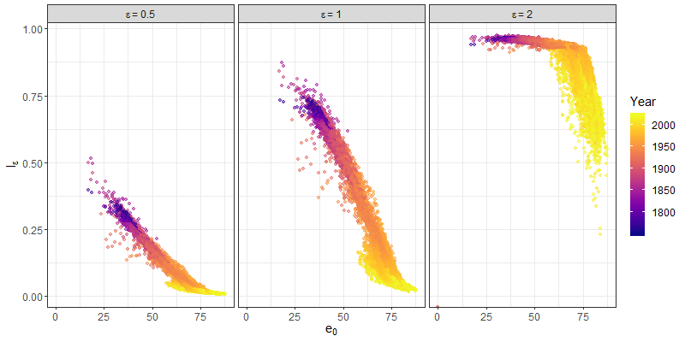

**Fig 1.** Efficiency ($e_{0}$) by inequality ( $I_{ε})$ over time for values of $ε=0.5, 1, 2.$ Source: Own elaboration based on HMD data.

In Figure 2 we plot the contributions of the efficiency and inquality components (see equation [4]) to all possible 10-year changes of the $H_{ε}$ indicator that can be computed in the HMD (women and men pooled together) for different values of $ε$. The results are highly dependent on the choice of the inequality-sensitivity parameter; the stronger the preference for equality, the larger the contribution of the inequality component. Yet, it is remarkable that, for the three values of $ε$ shown in the graph, the inequality component always plays a non-negligible role in determining changes in overall health performance – as opposed to what happens with the efficiency component when $ε=2$. Counting the number of points in the quadrants of Figure 2, we observe that in 84% of the cases, both the efficiency and inequality components contribute in the same direction to increase the values of $H_{1}$, in 8% of the cases they go in opposite directions (i.e. efficiency occurs at the expense of equality or vice-versa) while in the remaining 8% they both contribute in the normatively undesirable direction to decrease the values of $H_{1}$ (similar percentages found when $ε=0.5$ and $ε=2$).

Lastly, Figure 3 shows the decompositions for the changes in $H_{ε}$ between 1960 and 2010 by decades (indicated by different colors) and by the contribution of the efficiency (lighter hues) and inequality (darker hues) components for a selected group of 10 countries. For the group of top five performers, it is remarkable that improvements in overall health performance during the last 50 years tend to be larger when the preference for equality is stronger (i.e. for $ε=1$ and, particularly, $ε=2$), both for women and for men. For the group of bottom five performers, we observe important fluctuations over time (particularly for men), with some decades contributing to decrease overall health performance, both because of decreasing life expectancy and increasing lifespan inequality (specially for the years around the collapse of Communism).

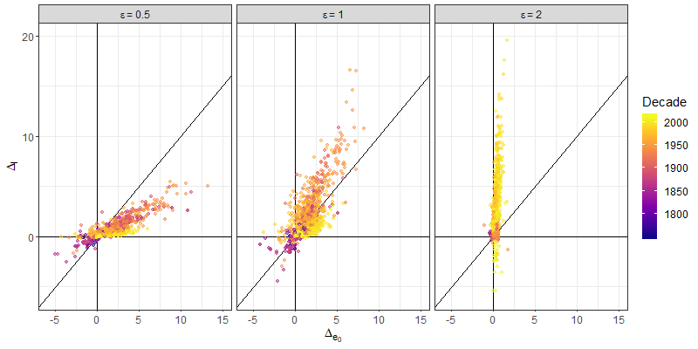

**Fig 2.** Contribution of efficiency $Δ_{e_{0}}$ by contribution of inequality $Δ_{I}$ over time for values of $ε=0.5, 1, 2.$ Source: Own elaboration based on HMD data.

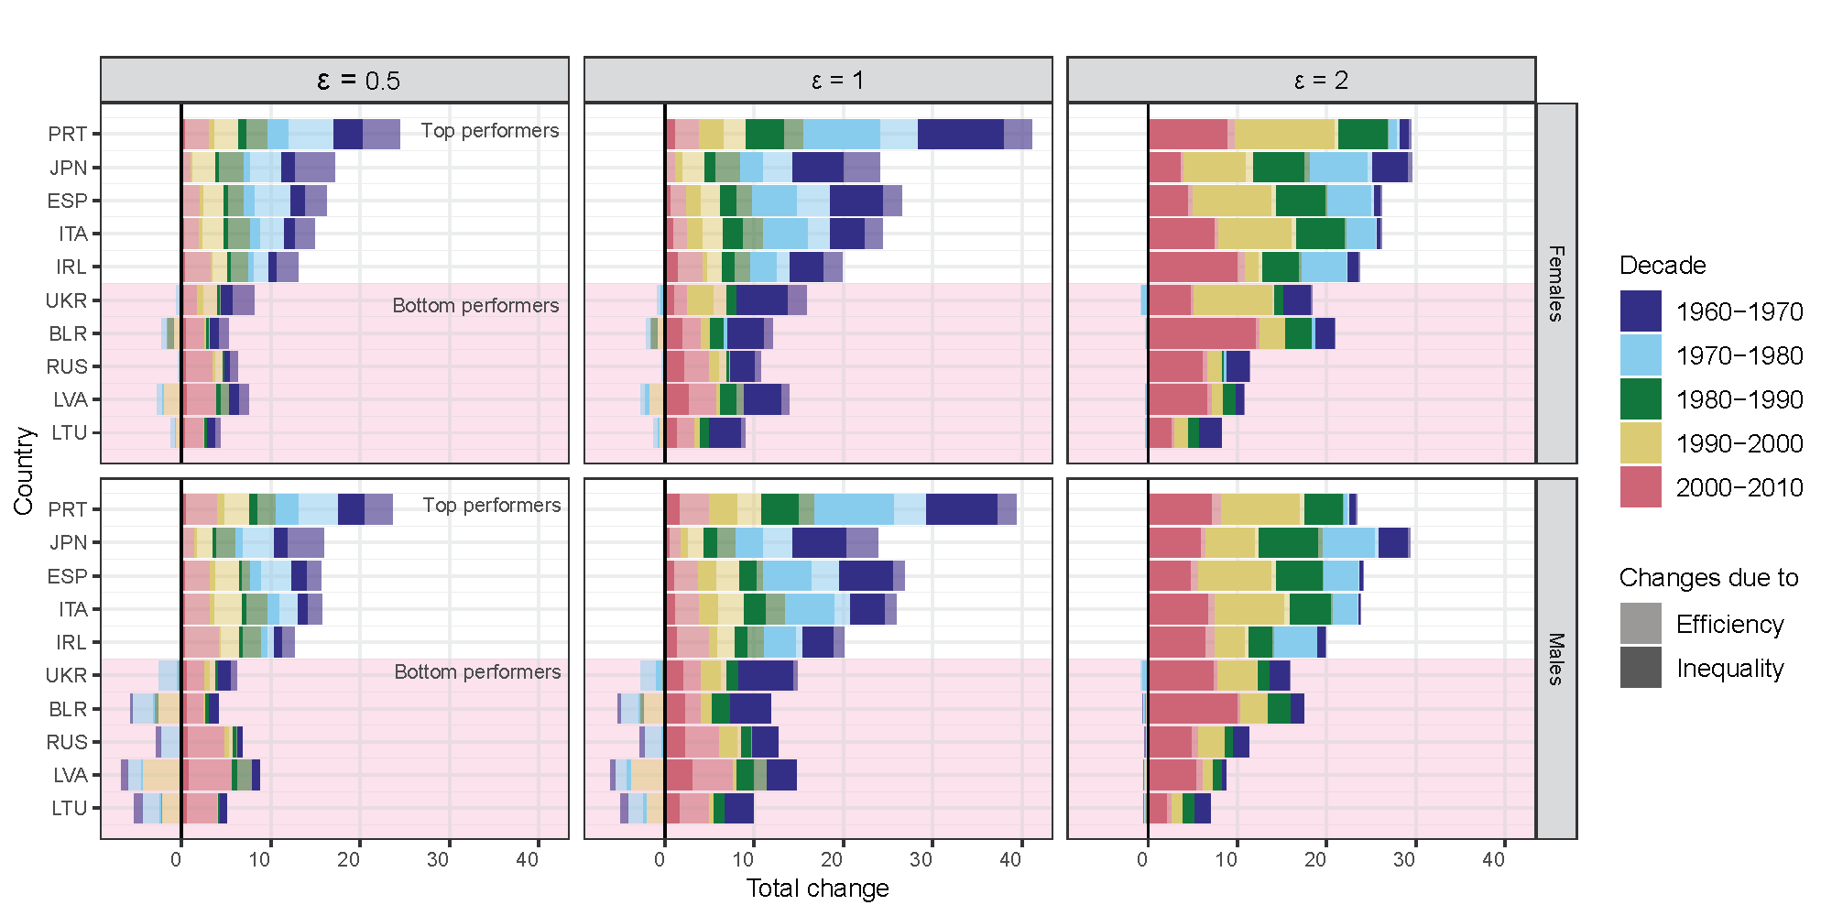

**Fig 3.** Time decompositions of changes in $H_{ε}$ between 1960-2010 by its efficiency and inequality components for the top- and bottom-five performers. Source: Own elaboration based on HMD data.

**Discussion**

‘A healthy population is one in which people live for a long time on average – and long lives are enjoyed by everyone’ (Van Raalte et al 2018:1004). The tools presented here allow investigating whether the efficiency and equality components underlying overall health performance operate in the same or in opposite directions. If one dimension improves at the expense of the other, health care systems and policy makers would be facing a difficult ethical dilemma upon which it will be necessary to reflect.

**References**

Benach, J., Malmusi, D., Yasui, Y., Martinez, J.M. and Muntaner, C. (2011), “Beyond Rose’s strategies: A typology of scenarios of policy impact on population health and health inequalities”, *International Journal of Health Services* 41(1):1-9.

Benach, J., Malmusi, D., Yasui, Y. and Martinez, J.M. (2013), “A new typology of policies to tackle health inequalities and scenarios of impact based on Rose’s population approach”, *Journal of Epidemiology and Community Health* 67:286-291.

Brønnum-Hansen, H. (2017), “Socially disparate trends in lifespan variation: a trend study on income and mortality based on nationwide Danish register data”, *BMJ Open*, 7(5), e014489.

Ghislandi, S., Sanderson, W. and Scherbov, S. (2019), “A simple measure of human development: The human life indicator”, *Population & Development Review* 45(1):219-233.

Oeppen, J. and Vaupel, J. (2002), “Broken limits to life expectancy”, *Science* 296:1029-1031.

Riley, J. (2001), *Rising life expectancy: A global history*. Cambridge: Cambridge University Press.

Riley, J. (2005), “Estimates of regional and global life expectancy, 1800-2001”, *Population and Development Review*, 31(3):537-543.

Rawls, J. *A Theory of Justice*. Cambridge, Massachusetts: The Belknap Press of Harvard University Press (1971).

Sen, A. *Development as freedom*. New York: Oxford University Press (1999).

Van Raalte AA, Sasson I, Martikainen P. (2018), “The case for monitoring life-span inequality”, *Science* 362(6418): 1002-4.

Whitehead, M. (2007), “A typology of actions to tackle social inequalities in health”, *Journal of Epidemiology and Community Health* 61:473-478.