**Title: Lifespan inequality in Denmark, Sweden and Norway: the inter-war female generations**

**Authors:** José Manuel Aburto a*, Maarten Wensink a*, James W. Vaupel a & Rune Lindahl-Jacobsen a

**Author affiliations:**

a Max-Planck Odense Center on the Biodemography of Aging, Department of Public Health- Epidemiology, Biostatistics and Biodemography, University of Southern Denmark, Odense 5000, Denmark.

* These authors contributed equally to the paper

**Corresponding authors:** José Manuel Aburto & Maarten Wensink

**Classification:** Social Sciences, Public Health – Demography

**Keywords:** Demography, life expectancy, lifespan variability, aging, mortality.

**Abstract [250 words]**

**Background**

**Methods**

**Results**

**Conclusions**

**Introduction [aimed to IJE] [3000 words]**

Female life expectancy in Denmark has followed an atypical pattern in the second half of the 20th century. While their Scandinavian counterparts showed continuous improvement, life expectancy stagnated among Danish women between the late-1970s and mid-1990s, to improve thereafter (1-3), while remaining lower than in Sweden and Norway (3). The stagnation of life expectancy and its current lower level resulted mainly from increased mortality of those born between the two World Wars (3), among which throughout life smoking habits were more prevalent (1, 2).

Life expectancy is commonly used to measure the overall health status of a population (reference: WHO). It

However, life expectancy conceals lifespan inequality, the variation in age at death in a population (4), which expresses fundamental differences among individuals (5). Lifespan inequality has become relevant for policy makers with the growing interest in reducing health inequalities (6), and is negatively associated with life expectancy (7). Studying lifespan inequality alongside life expectancy adds an important dimension to the study of population health because both indicators may affect individuals’ decisions. For instance, individuals may decide when to invest in education or when to retire based in their expected longevity, but also in the uncertainty surrounding their eventual time of death (8). This is particularly relevant for countries that have experienced a relative low level of life expectancy and a slow progress in reducing premature mortality like Denmark compared to other countries in the region such as Norway and Sweden.

Here we test the hypotheses that 1) Denmark has higher lifespan inequality relative to Sweden and Norway, and 2) that the period of stagnation in life expectancy of Danish women was accompanied by an stagnation in the decrease in lifespan inequality.

This paper makes three main contributions. Firstly, it contributes to the literature on health inequalities in the context of a developed country with a relative low life expectancy. We highlight the role of female mortality of the inter-war generations during life expectancy stagnation. Secondly, we analyze the contributions of smoking-related causes of death to changes in lifespan inequality over the last half century. The changing in the epidemiological profile of Denmark, Sweden and Norway in the last century underscores the need of cause-of-death analysis in determining the best future public health interventions. Finally, this paper contributes to our knowledge of lifespan inequality in the Scandinavian region and suggests scope of improvement for Denmark.

**Data and Methods**

Period life tables with one year age intervals were retrieved from the Human Mortality Database (9) for Denmark, Sweden and Norway from 1960 to 2014. These data contain high quality information on lifetable measures, such as the death distribution, survival function and life expectancy, by age and sex. We used causes of death data from the WHO Database to compute the proportion of deaths by cause, age, and sex in a given year for the same period (10). Causes of death data from the WHO mortality database is available in 5-year age and period categories (ref: Whoisis). Ungrouping into 1-year groups based on these 5-years groupings has previous been shown useful for the accuracy of the resulting estimates (ref silvias). Thus, we ungrouped the cause-of-death data into single year ages using efficient estimation of smooth distributions and used the proportions in the single-age lifetables (11).

***Cause-of-death classification***

Data on causes of death was classified using the seventh, eighth, ninth and tenth revisions of the International Classification of Diseases (ICD) during the period studied. For instance, in Denmark revision 7 in 1960-1968, then revision 8 until 1994, followed by the 10th revision thereafter (12), while Sweden and Norway did include the 9th revision to code deaths in the periods 1987-96 and 1986-95, respectively. To merge cause-of-death we used previously suggested bridge codes (13).

Deaths were grouped in nine major cause-of-death categories aiming at better capturing conditions that might have affected mortality in these of countries, such as 1) Infectious (non-respiratory), 2) Cancers amenable to smoking, 3) Cancers non-amenable to smoking, 4) Diabetes, 5) Cardiovascular diseases, 6) Respiratory infectious, 7) Respiratory non-infectious, 8) External, and 9) Rest of causes. For ICD codes and details on the classification see SI Table 1.

Cancers were classified as being amenable to smoking following a recent review article and a WHO report (14). Respiratory diseases were partitioned as infectious versus non-infectious. Although smokers are more prone to respiratory infections than non-smokers, when suffering from COPD, deaths from infections of the respiratory tract also very much depend on the discovery of antibiotics and their application through researched protocols: the discovery of penicillin was not a one-off effect, but a development that has reached maturity only relatively recently. External causes are likely to have an important effect on young-age mortality that could affect lifespan inequality, in men particularly (15). Finally, we aimed to find the optimal resolution for the grouping of causes of death. A resolution that is too fine is likely to run into the limits of classifying and partitioning causes of death, especially when tracking these causes of death over a large amount of time, while a resolution that is too coarse may leave important information undiscovered (Masters et al. 2017). With our classification, we have struck a good balance between these considerations.

We focus on cause-specific mortality below age 85 as 90% of the change in life expectancy from 1960 to 2014 was due to mortality changes below that age. also, cause-of-death classification is more reliable at younger ages (16, 17), the presence of several comorbities at ages above 84 could bias our results (16) and the presence of several competing causes of death there exists a smaller, less significant, step from one cause to the other (18) .

***Lifespan inequality measure***

Several dispersion measures have been proposed to analyze lifespan inequality (19). Here, we use the coefficient of variation (CoV), which is the standard deviation divided by the mean of the lifetable age-at-death distribution, i.e. life expectancy (see SI for a brief description). CoV has been found to be a good indicator to measure lifespan inequality (20). The strong correlation between lifespan inequality indicators suggests that main conclusions and results would not differ regardless of measure used (19, 21, 22).

***Decomposition techniques***

Lifespan inequality may increase or decrease while life expectancy is stagnating, depending on the balance between reducing (increasing) mortality at early ages, which compresses (expands) lifespan inequality, and saving lives at older ages, which increases (decreases) inequality in lifespans (23, 24). To get a better interpretation of the reasons behind changes in lifespan inequality over time, we decompose lifespan inequality differences before, during, and after the stagnation of life expectancy by age and causes of death using standard decomposition techniques (25). In addition, we quantify the cause-of-death contribution to the difference between Denmark and Sweden and provide an estimate of how long would it take for Denmark to catch up in the level of lifespan inequality.

**Limitations**

Changing insights in disease processes can affect classification. For instance, pneumonia may be increasingly classified as secondary cause of death. Similarly, a hip fracture may lead to immobilization and hospitalization, which increases the chance of getting pneumonia. As awareness of hospital acquired pneumonia increased, pneumonia got increasingly classified as secondary, not primary cause of death. The interaction of causes is a basic reality (26). Other limitation are the mentioned issues in grouping causes of death and problems in establishing a cause of death.

Despite these limitations, a cause of death classification can be useful in highlighting those aspects that one is interested in. Regardless of what drives the decline in respiratory infections as a cause of death, our partitioning of respiratory death in infectious versus non-infectious is likely to be robust. Moreover, to mitigate major changes due to the difference in coding, we focus on broad causes of death and performed a sensitivity analysis and did not find major ruptures using our classification (see SI).

**Results**

**Trends in lifespan inequality and life expectancy**

Life expectancy has been increasing continuously in the last 50 years in Norway and Sweden, in both females and males (figure 1). Danish females had a period of stagnation between 1980 and the mid-1990s, while males show a slow progress (figure 1). Paralleling the rise in life expectancy, lifespan inequality has fallen continuously (figure 1). Females experience less inequality in lifespan than males in all three countries. Tellingly, the period of life expectancy stagnation in Denmark was accompanied by a similar period of stagnation in lifespan inequality. It is worth noting that Norway has always been like Sweden for females, while for males both lifespan inequality and life expectancy have grown more similar to Sweden over the years fairly much in lockstep.

[Figure 1 about here]

**Age-cause specific decomposition of lifespan inequality**

Between 1960 and 1975, reductions in lifespan inequality were mainly driven by progress in mortality from cardiovascular diseases below age 85 (figure 2). In the following 20 years, the slow progress and stagnation in lifespan inequality were driven by an offsetting effect of cancers and respiratory non-infectious diseases, while major improvements continued to be made in cardiovascular diseases. Finally, in the most recent period (1995-2014) lifespan inequality has decreased substantially because of improving mortality from cancers and cardiovascular diseases.

[Figure 2 about here]

**Future work**

We will get results for Sweden and Norway and make comparisons to quantify how much Denmark should reduce mortality from specific causes of death to converge towards the levels of lifespan inequality and expectancy that Sweden and Norway show. In addition, we will look for cohort effects in specific causes of death since it has been found previously that cohort process are major determinants in life expectancy trends in Denmark.

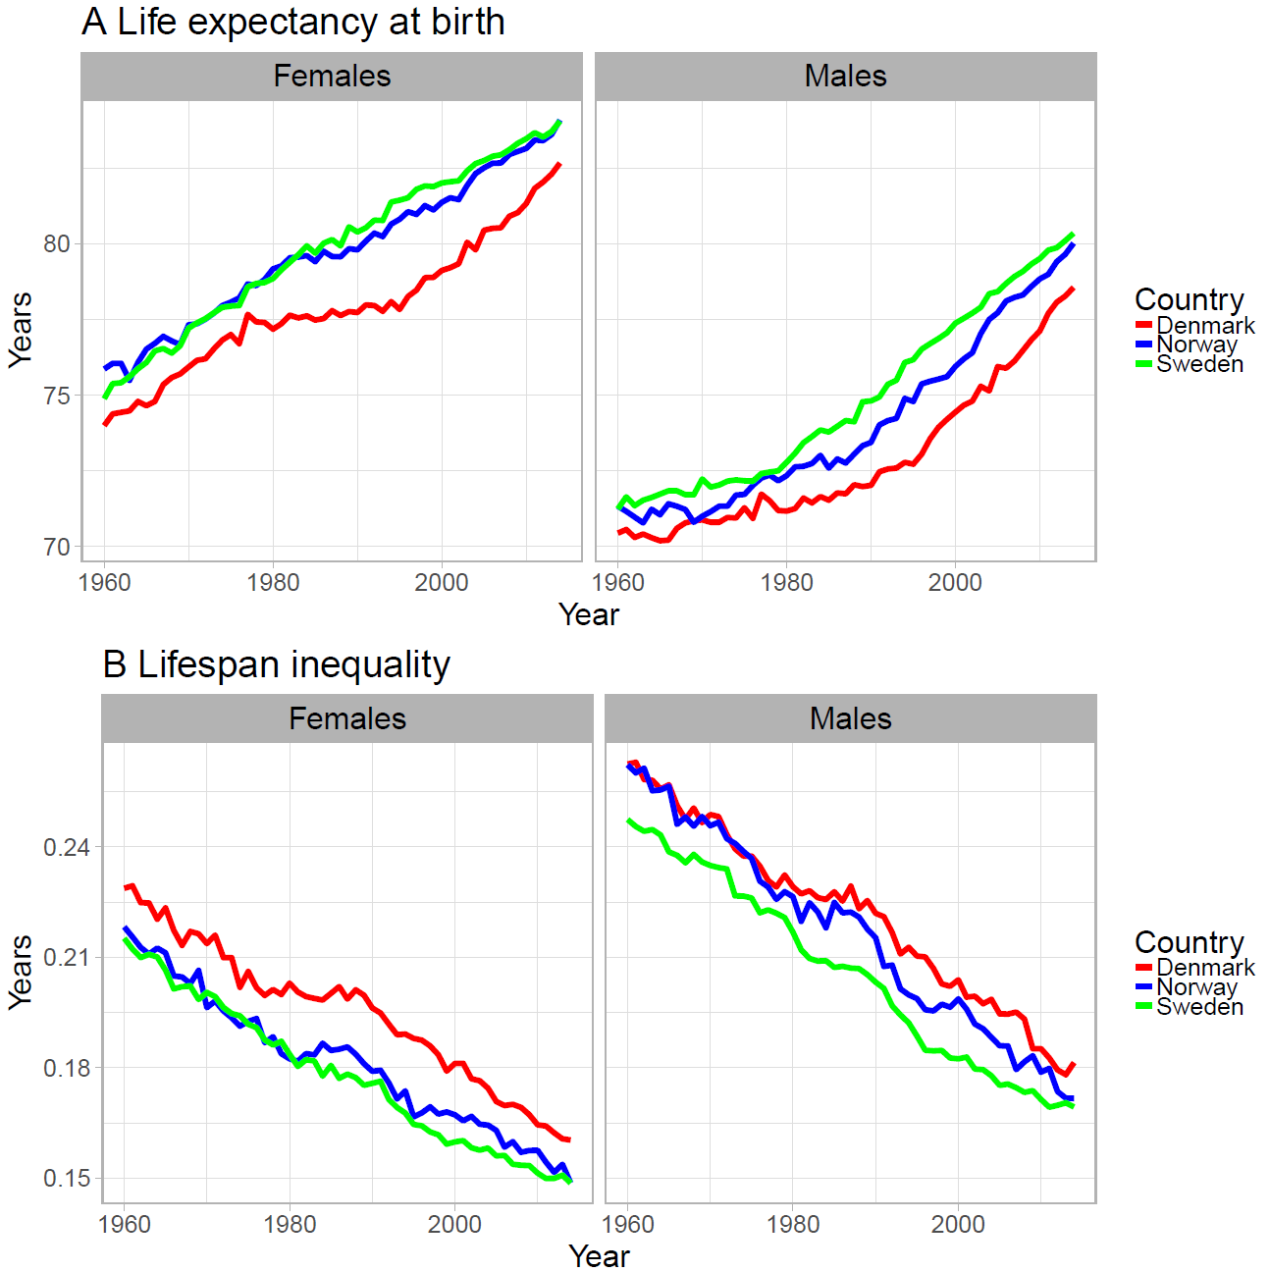**Figures and Tables**

Figure 1. Life expectancy (panel A) and lifespan inequality (panel B) trends from 1960 to 2015 for Denmark, Sweden and Norway by sex.

Figure 2. Age and cause contributions to changes in lifespan inequality between 1960-1975, 1975-1995 and 1995-2014 for Danish females.

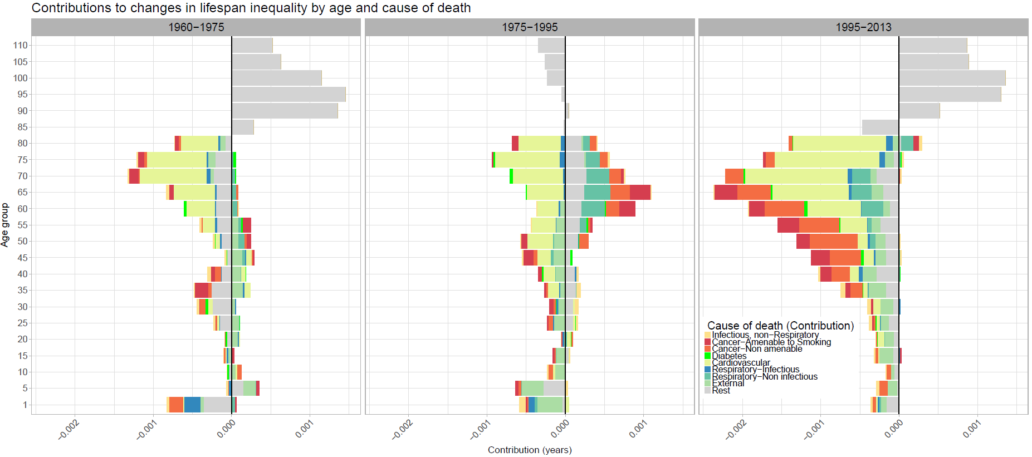

**References**

1. Jacobsen R, Von Euler M, Osler M, Lynge E, Keiding N. Women's death in Scandinavia—what makes Denmark different? European journal of epidemiology. 2004;19(2):117-21.

2. Lindahl-Jacobsen R, Oeppen J, Rizzi S, Möller S, Zarulli V, Christensen K, et al. Why did Danish women’s life expectancy stagnate? The influence of interwar generations’ smoking behaviour. European Journal of Epidemiology. 2016:1-5.

3. Lindahl-Jacobsen R, Rau R, Jeune B, Canudas-Romo V, Lenart A, Christensen K, et al. Rise, stagnation, and rise of Danish women’s life expectancy. Proceedings of the National Academy of Sciences. 2016;113(15):4015-20.

4. Edwards RD, Tuljapurkar S. Inequality in life spans and a new perspective on mortality convergence across industrialized countries. Population and Development Review. 2005;31(4):645-74.

5. Tuljapurkar S. The final inequality: variance in age at death. Demography and the Economy: University of Chicago Press; 2010. p. 209-21.

6. Marmot M. Inequalities in health. New England Journal of Medicine. 2001;345(2):134-5.

7. Vaupel JW, Zhang Z, van Raalte AA. Life expectancy and disparity: an international comparison of life table data. BMJ open. 2011;1(1):e000128.

8. van Raalte AA, Kunst AE, Deboosere P, Leinsalu M, Lundberg O, Martikainen P, et al. More variation in lifespan in lower educated groups: evidence from 10 European countries. International Journal of Epidemiology. 2011:dyr146.

9. Human Mortality Database. University of California BU, and Max Planck Institute for Demographic Research (Germany). Human Mortality Database. 2017.

10. Organization WH. Health statistics and information systems 2017 [Available from: <http://www.who.int/healthinfo/mortality_data/en/>.

11. Rizzi S, Gampe J, Eilers PH. Efficient estimation of smooth distributions from coarsely grouped data. American journal of epidemiology. 2015;182(2):138-47.

12. Erlangsen A, Fedyszyn I. Danish nationwide registers for public health and health-related research. Scandinavian Journal of Social Medicine. 2015;43(4):333-9.

13. Janssen F, Kunst AE. ICD coding changes and discontinuities in trends in cause-specific mortality in six European countries, 1950-99. Bulletin of the World Health Organization. 2004;82(12):904-13.

14. Whiteman DC, Wilson LF. The fractions of cancer attributable to modifiable factors: A global review. Cancer epidemiology. 2016;44:203-21.

15. Helweg-Larsen K, Juel K. Sex differences in mortality in Denmark during half a century, 1943-92. Scandinavian Journal of Social Medicine. 2000;28(3):214-21.

16. Gessert CE, Elliott BA, Haller IV. Dying of old age: an examination of death certificates of Minnesota centenarians. Journal of the American Geriatrics Society. 2002;50(9):1561-5.

17. Kohn RR. Cause of death in very old people. Jama. 1982;247(20):2793-7.

18. Mackenbach JP, Kunst AE, Lautenbach H, Oei Y, Bijlsma F. Competing causes of death: a death certificate study. Journal of clinical epidemiology. 1997;50(10):1069-77.

19. van Raalte AA, Caswell H. Perturbation analysis of indices of lifespan variability. Demography. 2013;50(5):1615-40.

20. Wrycza TF, Missov TI, Baudisch A. Quantifying the shape of aging. PloS one. 2015;10(3):e0119163.

21. Wilmoth JR, Horiuchi S. Rectangularization revisited: Variability of age at death within human populations*. Demography. 1999;36(4):475-95.

22. Colchero F, Rau R, Jones OR, Barthold JA, Conde DA, Lenart A, et al. The emergence of longevous populations. Proceedings of the National Academy of Sciences. 2016.

23. Gillespie DO, Trotter MV, Tuljapurkar SD. Divergence in age patterns of mortality change drives international divergence in lifespan inequality. Demography. 2014;51(3):1003-17.

24. Zhang Z, Vaupel JW. The age separating early deaths from late deaths. Demographic Research. 2009;20(29):721-30.

25. Horiuchi S, Wilmoth JR, Pletcher SD. A decomposition method based on a model of continuous change. Demography. 2008;45(4):785-801.

26. Rothman KJ. Causes. American journal of epidemiology. 1995;141(2):90-5.