**Rising violence against women and perceived vulnerability in Mexico, 2005-17**

Authors:

Marcia Pescador Jiménez: Post-doctoral Research Fellow at Harvard T.H. Chan School of Public Health.

Artemisa Flores Martínez: Assistant professor at Centro de Investigación y Docencia Económicas.

María Vignau-Loria: Doctoral fellow at University of Washington.

Tim Riffe: Research scientist at Max Planck Institute for Demographic Research.

Vladimir Canudas-Romo: Associate professor at the Department of Demography at the Australian National University.

José Manuel Aburto*: Doctoral fellow at the Interdisciplinary Centre On Population Dynamics, University of Southern Denmark & Max Planck Institute for Demographic Research.

J.B. Winsløws Vej 9, DK-5000 Odense C

T: [+45 65509416](tel:+4565509416)

[jmaburto@sdu.dk](mailto:jmaburto@sdu.dk)

*Corresponding author

**Introduction**

Homicide rates fell by 9.2% around the globe in the first decade of the 21st century, but only by 3.1% in developing countries.(1) In some Latin American countries homicide rates increased disproportionately.(2) Particularly, in Mexico, male homicide rates more than doubled between 2007 and 2012.(3, 4) As a result, male life expectancy was reduced between 2005-10.(5, 6) This epidemic of violence is related to specific policies trying to mitigate drug cartels operations and it has had unprecedented negative consequences in the last ten years on Mexico’s population health.(7-10) Nonetheless, little attention has been paid to the public health impact on women.

Over 31 thousand females have been victims of homicide in Mexico in the new century.(3) Homicides are the ultimate form of violence, but living in violent environments or experiencing other types of violence also has health and social burdens, particularly for children and women.(11) For example, victims of violence are at risk of depression, alcohol abuse, suicidal behavior, psychological problems, among other detrimental consequences over their life course.(12-15) Even witnessing violence can affect the wellbeing of the population. Those who witness violence have higher rates of post-traumatic stress disorder, depression, and are more likely to externalize violent behaviors.(16, 17) In particular, women who witnessed violent acts are twice as likely to experience depressive and anxiety symptoms compared to those who did not witness violence.(18)

Homicides, as the most comparable and accurate marker of violence,(11) have spread throughout the country unevenly(3, 19) and their share of overall mortality varies regionally.(20) Therefore, female homicide rates could have increased in tandem with an increase in emotional distress of those surviving after 2005, specially in states that have historically experienced the highest levels of violence in Mexico, such as Chihuahua (bordering the U.S. with Texas) and Guerrero (South).(21)

The aim of this study is to analyze the association between rising violence, as measured by homicides, and women’s emotional distress, as measured by fear to crime, across states in Mexico. Given the importance of the effect of rising violence and its cost on Mexican society and healthcare systems,(22, 23) understanding its consequences from a public health perspective is a step towards explaining the impact of Mexico’s epidemic of violence on women’s health.

**Study Data And Methods [650 including limitations]**

We used publicly available data on homicides from the Mexican National Institute of Statistics.(3) These files include information on cause of death using the International Classification of Diseases 10th revision (ICD-10), by age, sex, and state of residence in a given year. We also used population estimates corrected for completeness, age misstatement, and international migration from Mexico’s National Population Council (CONAPO).(24)

In order to cover the period before and after the upsurge of violence, data on perceived vulnerability come from two sources: the National Survey of Security (ENSI), and the National Survey of Victimization and Perception on Public Security (ENVIPE). Both are cross-sectional household surveys with a multistage, area-probability, city-stratified cluster sample design which are representative at the national and state levels.(25) (26)ENSI was conducted in 2005, 2009, and 2010. ENVIPE has been conducted each year since 2011. We use data on perceived vulnerability, or fear to crime, from ENSI 2005 (N=66,000 households), and from ENVIPE 2017 (N= 102,000 households). The exact question used, and available in both surveys, is ‘In terms of crime, how do you consider living in your state is?’ The response options were: ‘vulnerable’, and ‘safe’.

**Methods.** We computed annual age-standardized homicide rates (ICD-10 codes X85-Y09) per 100,000 population for women between ages 15 and 65 for the years 2002 to 2007, and 2011 to 2016 using the 2005 national female population as standard. In addition, we calculated the proportion of the population vulnerable of becoming a victim in 2005 and in 2017.

**Study Preliminary results**

Exhibit 1 shows the change in age-standardized homicide rates (x-axis) between 2002-07 and 2011-16 for females, and the change in the vulnerability of becoming a victim between 2005 and 2017 by region (North, Central, and South), and state.

Homicide rates increased in every Mexican state from 2002-07 to 2011-16. The largest increases occurred in the northern state of Chihuahua, bordering with Texas, USA, Guerrero in the South, and Colima in the central region. Over five more women were victims of homicides compared to the previous decade in these states. Paralleling the rise in homicide mortality, the proportion of population vulnerable of becoming a victim increased in 87.5% of the states. The largest increased happened in Colima, where 54.3% more (women?) declared to feel unsafe in 2017 compared to 2005. Apart from Colima, in other six states (Zacatecas, Veracruz, San Luis Potosí, Nayarit, Guanajuato and Tamaulipas) the increase in the proportion of the population feeling vulnerable was over 30%. In four states, the proportion of (female?) vulnerable population decreased despite rising female homicides: Yucatán in the South -which is still the safest state in the country, Mexico City in the Center, and Sinaloa and Baja California in the North.

Table 1 shows the levels of age-standardized homicide rates in 2002-07 and 2011-16 for females aged 15 to 65 years, and the proportion of the population vulnerable of becoming a victim in 2005 and 2017 by state and region.

Homicide rates vary from 0.5 to 3.0 per 100,000 population in 2002-07, and from 0.6 to 10.3 in 2011-16. The states with the highest female homicide rates in the latter period are Chihuahua in the North (10.3), Guerrero in the South (10.2), and Colima in the Central region (6.3). In contrast the safest states are Yucatán in the South, and Aguascalientes and Querétaro in the Central region.

Similarly, the proportions of population vulnerable of becoming a victim in 2005 vary from 20.1 in Colima to 88% in Mexico City, while in 2017 these vary from 27.2% in Yucatán to 90.7% in Mexico state.

**Next steps**

Our preliminary results provide clear evidence to suggest that the rise of violence and homicides in Mexico may have a severe impact on the well-being of Mexican women. Future research will examine the heterogeneity across states to uncover vulnerable populations and explore the association of the upsurge in violence with women’s mortality.

**Table 1. Age standardized homicide rates for females and proportion of population vulnerable of becoming a victim by state.**

|  |  |  |  |  |  |  |
| --- | --- | --- | --- | --- | --- | --- |
| **Region** | **State** | **Age-standardized female homicide rate per 100,000 population** | |  | **Proportion of the population with vulnerability** | |
|  |
| **2002-2007** | **2011-2016** |  | **2005** | **2017** |
|  |  |  |  |  |  |  |
| **North** | Chihuahua | 3.0 | 10.3 |  | 60.4 | 74.2 |
|  | Tamaulipas | 1.7 | 5.0 |  | 54.5 | 85.2 |
|  | Sinaloa | 1.7 | 4.6 |  | 78.7 | 74.5 |
|  | Coahuila | 1.3 | 4.6 |  | 40.1 | 56.4 |
|  | Baja California | 2.3 | 4.3 |  | 64.0 | 58.0 |
|  | Nuevo Leon | 0.7 | 4.1 |  | 41.1 | 71.1 |
|  | Zacatecas | 1.2 | 4.1 |  | 38.4 | 84.4 |
|  | Durango | 1.7 | 3.4 |  | 42.2 | 57.4 |
|  | Sonora | 1.6 | 3.0 |  | 42.8 | 57.4 |
|  | Baja California Sur | 1.7 | 3.0 |  | 33.5 | 60.9 |
|  | San Luis Potosi | 0.9 | 2.6 |  | 37.7 | 73.7 |
|  |  |  |  |  |  |  |
| **Central** | Colima | 1.4 | 6.3 |  | 20.1 | 74.5 |
|  | Mexico State | 2.9 | 3.6 |  | 68.7 | 90.7 |
|  | Nayarit | 2.2 | 3.4 |  | 23.9 | 58.6 |
|  | Michoacán | 2.3 | 3.3 |  | 52.7 | 77.6 |
|  | Jalisco | 1.2 | 2.5 |  | 56.4 | 65.7 |
|  | Mexico City | 1.9 | 2.4 |  | 88.0 | 85.7 |
|  | Guanajuato | 0.8 | 2.1 |  | 40.8 | 75.2 |
|  | Hidalgo | 0.7 | 2.0 |  | 42.4 | 55.1 |
|  | Tlaxcala | 1.4 | 1.8 |  | 30.2 | 59.1 |
|  | Queretaro | 1.0 | 1.6 |  | 41.9 | 54.4 |
|  | Aguascalientes | 0.9 | 1.0 |  | 39.5 | 43.7 |
|  |  |  |  |  |  |  |
| **South** | Guerrero | 3.7 | 10.2 |  | 58.3 | 83.1 |
|  | Morelos | 1.5 | 5.0 |  | 58.2 | 86.3 |
|  | Oaxaca | 2.9 | 3.8 |  | 47.4 | 74.1 |
|  | Quintana Roo | 2.1 | 2.7 |  | 59.1 | 68.5 |
|  | Veracruz | 1.0 | 2.4 |  | 46.7 | 89.9 |
|  | Chiapas | 1.7 | 2.0 |  | 54.0 | 61.1 |
|  | Tabasco | 1.2 | 1.9 |  | 63.4 | 88.8 |
|  | Campeche | 0.7 | 1.9 |  | 44.2 | 57.6 |
|  | Puebla | 1.5 | 1.9 |  | 56.7 | 68.1 |
|  | Yucatan | 0.5 | 0.6 |  | 34.0 | 27.2 |

**Exhibit 1. Change in female homicide rates by 100,000 population between 2002-07 and 2011-16, and change in the proportion of population vulnerable of becoming a victim between 2005 and 2017 by state.**

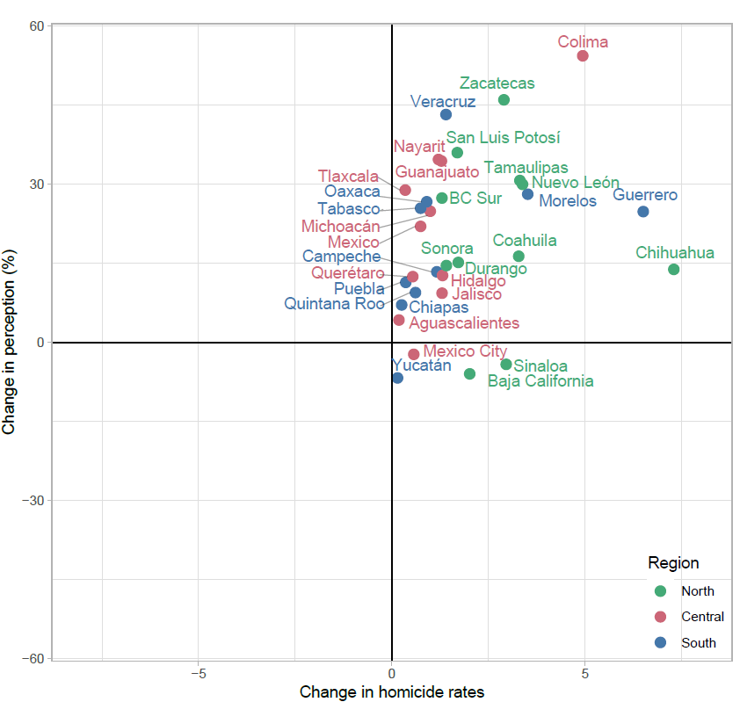

**References**

1. Institute of Health Metrics and Evaluation. GBD cause patterns- intentional injuries <https://vizhub.healthdata.org/gbd-compare/2018> [Available from: <https://vizhub.healthdata.org/gbd-compare/>.

2. United Nations Office on Drugs and Crime. Global study on homicide 2013: trends, contexts, data: UNODC; 2014.

3. Mexican National Institue of Statistics (INEGI). National Institute of Statistics: Micro-data files on mortality data 1995-2017 2018 [Available from: <http://www.beta.inegi.org.mx/proyectos/registros/vitales/mortalidad/default.html>.

4. Gamlin J. Violence and homicide in Mexico: a global health issue. The Lancet. 2015;385(9968):605-6.

5. Aburto JM, Beltrán-Sánchez H, García-Guerrero VM, Canudas-Romo V. Homicides in Mexico reversed life expectancy gains for men and slowed them for women, 2000–10. Health Affairs. 2016;35(1):88-95.

6. Canudas-Romo V, García-Guerrero VM, Echarri-Cánovas CJ. The stagnation of the Mexican male life expectancy in the first decade of the 21st century: the impact of homicides and diabetes mellitus. J Epidemiol Community Health. 2015;69(1):28-34.

7. Ríos V. Why did Mexico become so violent? A self-reinforcing violent equilibrium caused by competition and enforcement. Trends in organized crime. 2013;16(2):138-55.

8. Csete J, Kamarulzaman A, Kazatchkine M, Altice F, Balicki M, Buxton J, et al. Public health and international drug policy. The Lancet. 2016;387(10026):1427-80.

9. Heinle K, Ferreira OR, Shirk DA. Drug violence in Mexico. Data an. 2014.

10. Godlee F, Hurley R. The war on drugs has failed: doctors should lead calls for drug policy reform. BMJ: British Medical Journal (Online). 2016;355.

11. Mikton CR, Butchart A, Dahlberg LL, Krug EG. Global status report on violence prevention 2014. American journal of preventive medicine. 2016;50(5):652-9.

12. Davidson JR, Hughes DC, George LK, Blazer DG. The association of sexual assault and attempted suicide within the community. Archives of general psychiatry. 1996;53(6):550-5.

13. Fergusson DM, Horwood LJ, Lynskey MT. Childhood sexual abuse and psychiatric disorder in young adulthood: II. Psychiatric outcomes of childhood sexual abuse. Journal of the American Academy of Child & Adolescent Psychiatry. 1996;35(10):1365-74.

14. Heise L, Ellsberg M, Gottemoeller M. Ending violence against women. Population reports. 1999;27(4):1-.

15. Wiederman MW, Sansone RA, Sansone LA. History of trauma and attempted suicide among women in a primary care setting. Violence and Victims. 1998;13(1):3.

16. Buka SL, Stichick TL, Birdthistle I, Earls FJ. Youth exposure to violence: Prevalence, risks, and consequences. American Journal of Orthopsychiatry. 2001;71(3):298-310.

17. Brookmeyer KA, Henrich CC, Schwab‐Stone M. Adolescents who witness community violence: Can parent support and prosocial cognitions protect them from committing violence? Child development. 2005;76(4):917-29.

18. Clark C, Ryan L, Kawachi I, Canner MJ, Berkman L, Wright RJ. Witnessing community violence in residential neighborhoods: a mental health hazard for urban women. Journal of Urban Health. 2008;85(1):22-38.

19. Espinal-Enríquez J, Larralde H. Analysis of México’s Narco-War Network (2007–2011). PloS one. 2015;10(5):e0126503.

20. Romero Mendoza MP, Gómez-Dantés H, Manríquez Montiel Q, Saldívar Hernández GJ, Campuzano Rincón JC, Lozano R, et al. The invisible burden of violence against girls and young women in Mexico: 1990 to 2015. Journal of interpersonal violence. 2018:0886260517753851.

21. Corradi C, Marcuello-Servós C, Boira S, Weil S. Theories of femicide and their significance for social research. Current sociology. 2016;64(7):975-95.

22. Miller TR, Cohen MA, Rossman SB. Victim costs of violent crime and resulting injuries. Health Affairs. 1993;12(4):186-97.

23. Butchart A, Mikton C. Global status report on violence prevention, 2014. 2014.

24. CONAPO. Mexican Population Council: Population estimates. 2017 [Available from: <https://datos.gob.mx/busca/dataset/activity/proyecciones-de-la-poblacion-de-mexico>.

25. ENVIPE. Encuesta Nacional sobre Victimización y Percepción de la Seguridad: <http://www.beta.inegi.org.mx/app/biblioteca/ficha.html?upc=702825002408>; 2017 [

26. ENSI. Encuesta Nacional sobre Inseguridad: <http://internet.contenidos.inegi.org.mx/contenidos/Productos/prod_serv/contenidos/espanol/bvinegi/productos/metodologias/est/dm_ensi05.pdf>; 2005 [