**Rising violence against women in Mexico and fear of crime / perceived vulnerability to crime, 2005-17**

Authors:

Marcia Pescador Jiménez: Post-doctoral Research Fellow at Harvard T.H. Chan School of Public Health.

Artemisa Flores-Martínez: CONACYT Research Fellow at Centro de Investigación y Docencia Económicas.

María Vignau-Loria: Doctoral fellow at University of Washington.

Tim Riffe: Research scientist at Max Planck Institute for Demographic Research.

Vladimir Canudas-Romo: Associate professor at the Department of Demography at the Australian National University.

+Jonas ?

José Manuel Aburto*: Doctoral fellow at the Interdisciplinary Centre On Population Dynamics, University of Southern Denmark & Max Planck Institute for Demographic Research.

J.B. Winsløws Vej 9, DK-5000 Odense C

T: [+45 65509416](tel:+4565509416)

[jmaburto@sdu.dk](mailto:jmaburto@sdu.dk)

*Corresponding author

**Introduction**

Homicide rates fell by 9.2% around the globe in the first decade of the 21st century, but only by 3.1% in the developing world;(1) moreover, in some Latin American countries they increased disproportionately.(2) Particularly in Mexico, male homicide rates almost doubled between 2007 and 2012 -from 9.34 to 18.57 deaths per 100,000 people,(3, 4) such that male life expectancy declined between 2005-10.(5, 6) This epidemic of violence was related to specific policies trying to mitigate drug cartels operations, and it has had unprecedented negative consequences in the last ten years on Mexico’s population health.(7-10) Nonetheless, little attention has been paid to its public health impact on women.

Although fatal victims of Mexico’s Drug War -which started in late 2006, have mostly been young males (5), and homicides are the ultimate form of violence, living in violent environments or experiencing other types of violence also has health and social burdens, especially on children and women.(11) For instance, victims of violence are at a higher risk of depression, alcohol abuse, suicidal behavior and psychological problems, among other detrimental consequences over their life course.(12-15) Even those who witness violence may be affected.. In particular, they have higher rates of post-traumatic stress disorder and depression, and are more likely to externalize violent behaviors.(16, 17) More specifically, women who witnessed violent acts are twice as likely to experience depressive and anxiety symptoms compared to those who did not.(18)

Furthermore, over 31 thousand females have been murdered in Mexico in the new century;(3) but homicides, as the most comparable and accurate marker of violence,(11) have spread throughout the country unevenly,(3, 19) such that their share of overall mortality varies regionally.(20) Thus female homicide rates could have risen in tandem with an increase in emotional distress of those surviving after 2005, specially in states that have historically experienced the highest levels of violence, such as Chihuahua (bordering the U.S. with Texas) and Guerrero (South).(21)

This study aims to assess that relationship. In particular, we analyze the association between rising violence against women -as measured by homicides, and surviving women’s emotional distress -as measured by fear of crime, across Mexican states between 2005 and 2017. Given the importance of the effect of rising violence and its cost on Mexican society and healthcare systems,(22, 23) understanding its consequences from a public health perspective is a step towards explaining the impact of Mexico’s epidemic of violence on women’s health.

**Study Data And Methods [650 including limitations]**

We used publicly available data on homicides from the Mexican National Institute of Statistics.(3) These files include information on cause of death using the International Classification of Diseases 10th revision (ICD-10), by age, sex, and state of residence in a given year. We also used population estimates corrected for completeness, age misstatement, and international migration from Mexico’s National Population Council (CONAPO).(24)

Although the War on Drugs officially ended in 2012, the Mexican government followed the same repressive strategy until 2018, and drug-related violence has been on the rise since 2006. Thus in order to cover the period before and after the upsurge of violence, data on perceived vulnerability to crime come from two sources: The National Survey of Security (ENSI), and the National Survey of Victimization and Perception on Public Security (ENVIPE). Both are cross-sectional household surveys with a multistage, area-probability, city-stratified cluster sample design which are representative at the national and state levels.(25, 26) ENSI was conducted in 2005, 2009, and 2010, and ENVIPE . each year since 2011. We use data on fear of / perceived vulnerability to crime from ENSI 2005 (N=66,000 households), and from ENVIPE 2017 (N= 102,000 households). The exact question used in both surveys is: ‘In terms of crime, how do you consider living in your state is?’ The response options were: ‘vulnerable’, and ‘safe’.

**Methods.** We computed annual age-standardized homicide rates (ICD-10 codes X85-Y09) per 100,000 population for women between ages 15 and 65 for the years 2002 to 2007, and 2011 to 2016 using the 2005 national female population as standard. In addition, we calculated the proportion of the female population feeling vulnerable to crime in 2005 and in 2017 for each Mexican state.

**Study Preliminary results**

Exhibit 1 shows the change in age-standardized homicide rates (x-axis) between 2002-07 and 2011-16 for women, and the change in perceived vulnerability to crime between 2005 and 2017 by state, clustering the latter by region (North, Central, and South).

In 2002-07, the average state-level homicide rate for women was 1.6 deaths per 100,000 females; in 2011-16, it had more than doubled, reaching 3.5 murdered women. This results from growing homicide rates in eachstate between those two periods. The largest increases occurred in the northern state of Chihuahua, bordering with Texas, Guerrero in the South, and Colima in the central region. At least five more women were victims of homicides compared to the previous decade in these states. Paralleling the rise in homicide mortality, the proportion of femalesfearing becoming a victim went up in 28 out of the 32 Mexican states, or 87.5% of the total. The largest increment happened in Colima –the least populated state, with only about 700,000 people in 2015, where 54.4% more women declared to feel unsafe in 2017 compared to 2005. Apart from Colima, in other six states (Zacatecas, Veracruz, San Luis Potosí, Nayarit, Guanajuato and Tamaulipas) the proportion of females feeling vulnerable to crime grew by more than 30%. In contrast, the four states where thatx proportion fell -between 2.3 and 6.8 percent, despite homicide rates rising between 0.1 and 2.9 extra women murdered per 100,000 females were: Yucatán in the South, Mexico City in the Center, and Sinaloa and Baja California in the North. The former though is still the safest state for women, with less than one death per 100,000 females; and Mexico City’s rate fell below the country’s average, while it used to be above it. Sinaloa borders Chihuahua, where female homicide rates increased the most, so women in the former state may feel relatively safe. The case of Baja California might be trickier to explain.

Table 1 shows the levels of age-standardized homicide rates for women aged 15 to 65 years in 2002-07 and 2011-16, and the proportion of the female population fearing crime in 2005 and 2017 by state, then clustering the latter by region.

Homicide rates for women vary from 0.5 to 3.0 per 100,000 female population in 2002-07, and from 0.6 to 10.3 in 2011-16. In both periods, the safest state for women was Yucatan, and the most dangerous Chihuahua. In the second period, the latter was followed by Guerrero with 10.2 women murdered per 100,000 females, and Colima in the Central region with a rate of 6.3 deaths. In contrast, the central states of Aguascalientes and Querétaro were also safe.

Similarly, the proportion of women feeling vulnerable to crime vary from 20.1 in Colima to 88% in Mexico City in 2005, and from 27.2% in Yucatán to 90.7% in Mexico state in 2017.

**Next steps**

Our preliminary results provide clear evidence to suggest that the rise of violence and female homicides in Mexico may have a severe impact on the well-being of women. Future research will examine the heterogeneity across states to uncover vulnerable populations and explore the association of the upsurge in violence with women’s mortality.

**Table 1. Age standardized homicide rates for females and proportion of female population fearing crime by state.**

|  |  |  |  |  |  |  |
| --- | --- | --- | --- | --- | --- | --- |
| **Region** | **State** | **Age-standardized female homicide rate per 100,000 population** | |  | **Proportion of the female population with perceived vulnerability to crime** | |
|  |
| **2002-2007** | **2011-2016** |  | **2005** | **2017** |
|  |  |  |  |  |  |  |
| **North** | Chihuahua | 3.0 | 10.3 |  | 60.4 | 74.2 |
|  | Tamaulipas | 1.7 | 5.0 |  | 54.5 | 85.2 |
|  | Sinaloa | 1.7 | 4.6 |  | 78.7 | 74.5 |
|  | Coahuila | 1.3 | 4.6 |  | 40.1 | 56.4 |
|  | Baja California | 2.3 | 4.3 |  | 64.0 | 58.0 |
|  | Nuevo Leon | 0.7 | 4.1 |  | 41.1 | 71.1 |
|  | Zacatecas | 1.2 | 4.1 |  | 38.4 | 84.4 |
|  | Durango | 1.7 | 3.4 |  | 42.2 | 57.4 |
|  | Sonora | 1.6 | 3.0 |  | 42.8 | 57.4 |
|  | Baja California Sur | 1.7 | 3.0 |  | 33.5 | 60.9 |
|  | San Luis Potosi | 0.9 | 2.6 |  | 37.7 | 73.7 |
|  |  |  |  |  |  |  |
| **Central** | Colima | 1.4 | 6.3 |  | 20.1 | 74.5 |
|  | Mexico State | 2.9 | 3.6 |  | 68.7 | 90.7 |
|  | Nayarit | 2.2 | 3.4 |  | 23.9 | 58.6 |
|  | Michoacán | 2.3 | 3.3 |  | 52.7 | 77.6 |
|  | Jalisco | 1.2 | 2.5 |  | 56.4 | 65.7 |
|  | Mexico City | 1.9 | 2.4 |  | 88.0 | 85.7 |
|  | Guanajuato | 0.8 | 2.1 |  | 40.8 | 75.2 |
|  | Hidalgo | 0.7 | 2.0 |  | 42.4 | 55.1 |
|  | Tlaxcala | 1.4 | 1.8 |  | 30.2 | 59.1 |
|  | Queretaro | 1.0 | 1.6 |  | 41.9 | 54.4 |
|  | Aguascalientes | 0.9 | 1.0 |  | 39.5 | 43.7 |
|  |  |  |  |  |  |  |
| **South** | Guerrero | 3.7 | 10.2 |  | 58.3 | 83.1 |
|  | Morelos | 1.5 | 5.0 |  | 58.2 | 86.3 |
|  | Oaxaca | 2.9 | 3.8 |  | 47.4 | 74.1 |
|  | Quintana Roo | 2.1 | 2.7 |  | 59.1 | 68.5 |
|  | Veracruz | 1.0 | 2.4 |  | 46.7 | 89.9 |
|  | Chiapas | 1.7 | 2.0 |  | 54.0 | 61.1 |
|  | Tabasco | 1.2 | 1.9 |  | 63.4 | 88.8 |
|  | Campeche | 0.7 | 1.9 |  | 44.2 | 57.6 |
|  | Puebla | 1.5 | 1.9 |  | 56.7 | 68.1 |
|  | Yucatan | 0.5 | 0.6 |  | 34.0 | 27.2 |

**Country average 1.6 3.5**

**Exhibit 1. Change in female homicide rates by 100,000 population between 2002-07 and 2011-16, and change in the proportion of population feeling vulnerable to crime between 2005 and 2017 by state.**

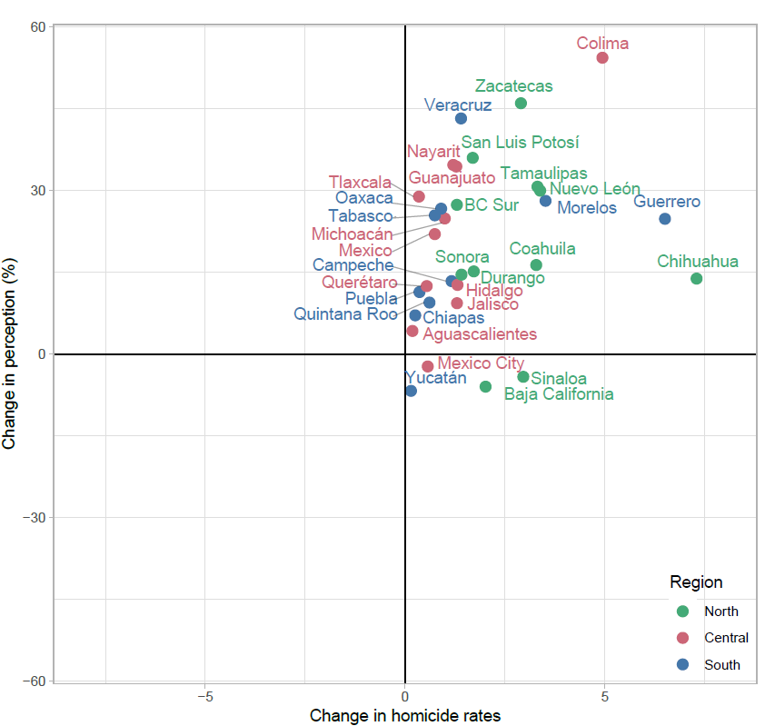

**References**

1. Institute of Health Metrics and Evaluation. GBD cause patterns- intentional injuries <https://vizhub.healthdata.org/gbd-compare/2018> [Available from: <https://vizhub.healthdata.org/gbd-compare/>.

2. United Nations Office on Drugs and Crime. Global study on homicide 2013: trends, contexts, data: UNODC; 2014.

3. Mexican National Institue of Statistics (INEGI). National Institute of Statistics: Micro-data files on mortality data 1995-2017 2018 [Available from: <http://www.beta.inegi.org.mx/proyectos/registros/vitales/mortalidad/default.html>.

4. Gamlin J. Violence and homicide in Mexico: a global health issue. The Lancet. 2015;385(9968):605-6.

5. Aburto JM, Beltrán-Sánchez H, García-Guerrero VM, Canudas-Romo V. Homicides in Mexico reversed life expectancy gains for men and slowed them for women, 2000–10. Health Affairs. 2016;35(1):88-95.

6. Canudas-Romo V, García-Guerrero VM, Echarri-Cánovas CJ. The stagnation of the Mexican male life expectancy in the first decade of the 21st century: the impact of homicides and diabetes mellitus. J Epidemiol Community Health. 2015;69(1):28-34.

7. Ríos V. Why did Mexico become so violent? A self-reinforcing violent equilibrium caused by competition and enforcement. Trends in organized crime. 2013;16(2):138-55.

8. Csete J, Kamarulzaman A, Kazatchkine M, Altice F, Balicki M, Buxton J, et al. Public health and international drug policy. The Lancet. 2016;387(10026):1427-80.

9. Heinle K, Ferreira OR, Shirk DA. Drug violence in Mexico. Data an. 2014.

10. Godlee F, Hurley R. The war on drugs has failed: doctors should lead calls for drug policy reform. BMJ: British Medical Journal (Online). 2016;355.

11. Mikton CR, Butchart A, Dahlberg LL, Krug EG. Global status report on violence prevention 2014. American journal of preventive medicine. 2016;50(5):652-9.

12. Davidson JR, Hughes DC, George LK, Blazer DG. The association of sexual assault and attempted suicide within the community. Archives of general psychiatry. 1996;53(6):550-5.

13. Fergusson DM, Horwood LJ, Lynskey MT. Childhood sexual abuse and psychiatric disorder in young adulthood: II. Psychiatric outcomes of childhood sexual abuse. Journal of the American Academy of Child & Adolescent Psychiatry. 1996;35(10):1365-74.

14. Heise L, Ellsberg M, Gottemoeller M. Ending violence against women. Population reports. 1999;27(4):1-.

15. Wiederman MW, Sansone RA, Sansone LA. History of trauma and attempted suicide among women in a primary care setting. Violence and Victims. 1998;13(1):3.

16. Buka SL, Stichick TL, Birdthistle I, Earls FJ. Youth exposure to violence: Prevalence, risks, and consequences. American Journal of Orthopsychiatry. 2001;71(3):298-310.

17. Brookmeyer KA, Henrich CC, Schwab‐Stone M. Adolescents who witness community violence: Can parent support and prosocial cognitions protect them from committing violence? Child development. 2005;76(4):917-29.

18. Clark C, Ryan L, Kawachi I, Canner MJ, Berkman L, Wright RJ. Witnessing community violence in residential neighborhoods: a mental health hazard for urban women. Journal of Urban Health. 2008;85(1):22-38.

19. Espinal-Enríquez J, Larralde H. Analysis of México’s Narco-War Network (2007–2011). PloS one. 2015;10(5):e0126503.

20. Romero Mendoza MP, Gómez-Dantés H, Manríquez Montiel Q, Saldívar Hernández GJ, Campuzano Rincón JC, Lozano R, et al. The invisible burden of violence against girls and young women in Mexico: 1990 to 2015. Journal of interpersonal violence. 2018:0886260517753851.

21. Corradi C, Marcuello-Servós C, Boira S, Weil S. Theories of femicide and their significance for social research. Current sociology. 2016;64(7):975-95.

22. Miller TR, Cohen MA, Rossman SB. Victim costs of violent crime and resulting injuries. Health Affairs. 1993;12(4):186-97.

23. Butchart A, Mikton C. Global status report on violence prevention, 2014. 2014.

24. CONAPO. Mexican Population Council: Population estimates. 2017 [Available from: <https://datos.gob.mx/busca/dataset/activity/proyecciones-de-la-poblacion-de-mexico>.

25. ENVIPE. Encuesta Nacional sobre Victimización y Percepción de la Seguridad: <http://www.beta.inegi.org.mx/app/biblioteca/ficha.html?upc=702825002408>; 2017 [

26. ENSI. Encuesta Nacional sobre Inseguridad: <http://internet.contenidos.inegi.org.mx/contenidos/Productos/prod_serv/contenidos/espanol/bvinegi/productos/metodologias/est/dm_ensi05.pdf>; 2005 [

**27. INEGI.** Encuesta Intercensal **2015**,