**A public health perspective on rising violence against women in Mexico, 2005-17**

Authors:

Artemisa Flores-Martínez: CONACYT Research Fellow at Centro de Investigación y Docencia Económicas.

Marcia Pescador Jiménez: Post-doctoral Research Fellow at Harvard T.H. Chan School of Public Health.

María Vignau-Loria: Doctoral fellow at University of Washington.

Tim Riffe: Research scientist at Max Planck Institute for Demographic Research.

Vladimir Canudas-Romo: Associate professor at the Department of Demography at the Australian National University.

José Manuel Aburto*: Doctoral fellow at the Interdisciplinary Centre On Population Dynamics, University of Southern Denmark & Max Planck Institute for Demographic Research.

J.B. Winsløws Vej 9, DK-5000 Odense C

T: [+45 65509416](tel:+4565509416)

[jmaburto@sdu.dk](mailto:jmaburto@sdu.dk)

*Corresponding author

**Introduction**

Homicide rates fell by 9.2% around the globe in the first decade of the 21st century, but only by 3.1% in the developing world.1 In some Latin American countries homicide rates increased disproportionately.2 Particularly in Mexico, male homicide rates doubled between 2007 and 2012 -from 9.3 to 18.6 deaths per 100,000 people,3 4 the impact was such that male life expectancy declined between 2005-10.5 6 This ongoing epidemic of violence is related to specific policies trying to mitigate drug cartels operations, and it has had unprecedented negative consequences in the last ten years on Mexico’s population health.7-10 Nonetheless, little attention has been paid to its public health impact on women.

Although fatal victims of Mexico’s Drug War -which started in late 2006, have mostly been young males.11 Over 31 thousand females have been victims of homicide in Mexico in the new century.3 Homicides are the ultimate form of violence, but there exist multiple ways in which the consequences of violence on population health can manifest. For instance, victims of violence are at a higher risk of depression, alcohol abuse, suicidal behavior and psychological problems, among other detrimental consequences over their life course.12-15 Even those who only witness violence have higher rates of post-traumatic stress disorder and depression, and are more likely to externalize violent behaviors and manifest anxiety symptoms compared to those who did not witness violence.16-18 Thus, living in violent environments has unquantifiable health and social burdens, particularly for children and women.19

In Mexico between 2000 and 2018, over 37 thousand females have been murdered. Homicides, as the most comparable and accurate marker of violence,19 have spread throughout the country unevenly,3 20 such that their share of overall mortality varies regionally.21 Thus female homicide rates could have risen in tandem with an increase in emotional distress of those surviving after 2005, specially in states that have historically experienced the highest levels of violence, such as Chihuahua (bordering the U.S. with Texas) and Guerrero (South).22

This study aims to assess whether the rise in violence in Mexico has led to a double burden among women: higher homicide rates together with increasing fear of crime as a proxy to emotional vulnerability, across Mexican states between 2005 and 2017. Given the importance of the effect of rising violence and its cost on Mexican society and healthcare systems,19 23 understanding its consequences from a public health perspective is a step towards explaining the impact of Mexico’s epidemic of violence on women’s health.

**Study Data And Methods [650 including limitations]**

We used publicly available data on homicides from the Mexican National Institute of Statistics from 1992 to 2017.3 These files include information on cause of death using the International Classification of Diseases 10th revision (ICD-10), by age, sex, and state of residence in a given year. We also used population estimates corrected for completeness, age misstatement, and international migration from Mexico’s National Population Council (CONAPO).24

Although the War on Drugs officially ended in 2012, the Mexican government followed the same repressive strategy until 2018, and drug-related violence has been on the rise since 2006. Thus, in order to cover the period before and after the upsurge of violence, data on perceived vulnerability to crime come from two sources: The National Survey of Security (ENSI), and the National Survey of Victimization and Perception on Public Security (ENVIPE). Both are cross-sectional household surveys with a multistage, area-probability, city-stratified cluster sample design which are representative at the national and state levels.25 26 ENSI was conducted in 2005, 2009, and 2010, and ENVIPE . each year since 2011. We use data on fear of crime from ENSI 2005 (N=66,000 households), and from ENVIPE 2017 (N= 102,000 households). The exact question used in both surveys is: ‘In terms of crime, how do you consider living in your state is?’ The response options were: ‘vulnerable’, and ‘safe’.

**Methods.** We computed annual age-standardized homicide rates (ICD-10 codes X85-Y09) per 100,000 population for women between ages 15 and 65 for the years from 1992 to 2017 using the 2005 national female population as standard. We broke down the period into three average time points in order to avoid random fluctuations in homicide counts: 1992-97, 2002-07 and 2012-17. The periods 1992-97 to 2002-07 capture a decrease in homicide rates at the national level, while the period 2002-07 to 2012-17 includes the onset of the unprecedented rise of violence in the country. In addition, we calculated the proportion of the female population feeling vulnerable to crime in 2005 and in 2017 for each Mexican state.

**Study results**

In 2002-07, the average state-level homicide rate for women was 1.6 deaths per 100,000 females; in 2012-17, it had more than doubled, reaching almost four murdered women. However, there exist large regional variations. For instance, in the period 2012-17 Aguascalientes, Yucatán, Campeche, Querétaro and Tlaxcala showed homicide rates of less than two per 100,000 people, while eight states experienced homicide rates larger than five homicides per 100,000 people, including Oaxaca (rate of 5 per 100,000), Zacatecas (5.3), Sinaloa (5.6), Tamaulipas (5.8), Chihuahua (6.4), Morelos (6.4), Colima (8.1) and Guerrero (12.7).

Exhibit 1 shows the change in age-standardized female homicide rates between 1992-17 and 2002-07 and from 2002-07 to the most recent period 2012-17 in Mexican states.

In the period from 1992-97 to 2002-07 most states (28 of 32) experienced a decline in female homicide rates. This progress was reversed as all except one (Aguascalientes) experienced an increase in homicide rates after the period 2002-07. The states with the largest worsening in female homicide rates were Guerrero and Morelos in the South with 8.3 and 4.8 more homicides per 100,000 people respectively, Colima in the Central region with 6.7 more homicides per 100,000 people, and Chihuahua in the North (bordering with Texas) with an increase of more than 4 homicides per 100,000 people.

The proportion of females fearing becoming a victim went up in 28 out of the 32 Mexican states, or 87.5% of the total. The largest increment happened in Colima –the least populated state, with only about 700,000 people in 2015, where 54.4% more women declared to feel unsafe in 2017 compared to 2005. Apart from Colima, in other six states (Zacatecas, Veracruz, San Luis Potosí, Nayarit, Guanajuato and Tamaulipas) the proportion of females feeling vulnerable to crime grew by more than 30%. In contrast, the four states where thatx proportion fell -between 2.3 and 6.8 percent, despite homicide rates rising between 0.1 and 2.9 extra women murdered per 100,000 females were: Yucatán in the South, Mexico City in the Center, and Sinaloa and Baja California in the North. The former though is still the safest state for women, with less than one death per 100,000 females; and Mexico City’s rate fell below the country’s average, while it used to be above it. Sinaloa borders Chihuahua, where female homicide rates increased the most, so women in the former state may feel relatively safe. The case of Baja California might be trickier to explain.

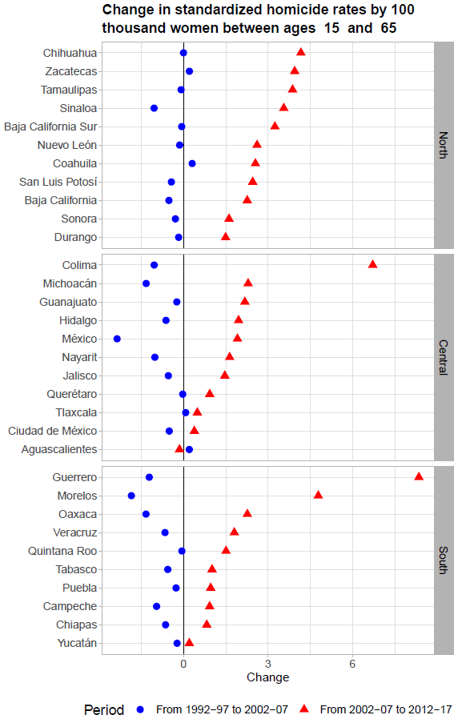

**Exhibit 1**

Similarly, the proportion of women feeling vulnerable to crime vary from 20.1 in Colima to 88% in Mexico City in 2005, and from 27.2% in Yucatán to 90.7% in Mexico state in 2017.

**Discussion**

Our preliminary results provide clear evidence to suggest that the rise of violence and female homicides in Mexico may have a severe impact on the well-being of women. Future research will examine the heterogeneity across states to uncover vulnerable populations and explore the association of the upsurge in violence with women’s

**References**

1. Institute of Health Metrics and Evaluation. GBD cause patterns- intentional injuries <https://vizhub.healthdata.org/gbd-compare/2018> [Available from: <https://vizhub.healthdata.org/gbd-compare/> accessed July 7 2018.

2. United Nations Office on Drugs and Crime. Global study on homicide 2013: trends, contexts, data: UNODC 2014.

3. Mexican National Institue of Statistics (INEGI). National Institute of Statistics: Micro-data files on mortality data 1995-2017 2018 [Available from: <http://www.beta.inegi.org.mx/proyectos/registros/vitales/mortalidad/default.html> accessed 10/07/2018 2018.

4. Gamlin J. Violence and homicide in Mexico: a global health issue. *The Lancet* 2015;385(9968):605-06.

5. Aburto JM, Beltrán-Sánchez H, García-Guerrero VM, et al. Homicides in Mexico reversed life expectancy gains for men and slowed them for women, 2000–10. *Health Affairs* 2016;35(1):88-95.

6. Canudas-Romo V, García-Guerrero VM, Echarri-Cánovas CJ. The stagnation of the Mexican male life expectancy in the first decade of the 21st century: the impact of homicides and diabetes mellitus. *J Epidemiol Community Health* 2015;69(1):28-34.

7. Ríos V. Why did Mexico become so violent? A self-reinforcing violent equilibrium caused by competition and enforcement. *Trends in organized crime* 2013;16(2):138-55.

8. Csete J, Kamarulzaman A, Kazatchkine M, et al. Public health and international drug policy. *The Lancet* 2016;387(10026):1427-80.

9. Heinle K, Ferreira OR, Shirk DA. Drug violence in Mexico. *Data an* 2014

10. Godlee F, Hurley R. The war on drugs has failed: doctors should lead calls for drug policy reform. *BMJ: British Medical Journal (Online)* 2016;355

11. Aburto JM, Beltrán-Sánchez H. Upsurge of homicides and its impact on life expectancy and life span inequality in Mexico, 2005–2015. *American journal of public health* 2019;109(3):483-89.

12. Davidson JR, Hughes DC, George LK, et al. The association of sexual assault and attempted suicide within the community. *Archives of general psychiatry* 1996;53(6):550-55.

13. Fergusson DM, Horwood LJ, Lynskey MT. Childhood sexual abuse and psychiatric disorder in young adulthood: II. Psychiatric outcomes of childhood sexual abuse. *Journal of the American Academy of Child & Adolescent Psychiatry* 1996;35(10):1365-74.

14. Heise L, Ellsberg M, Gottemoeller M. Ending violence against women. *Population reports* 1999;27(4):1-1.

15. Wiederman MW, Sansone RA, Sansone LA. History of trauma and attempted suicide among women in a primary care setting. *Violence and Victims* 1998;13(1):3.

16. Buka SL, Stichick TL, Birdthistle I, et al. Youth exposure to violence: Prevalence, risks, and consequences. *American Journal of Orthopsychiatry* 2001;71(3):298-310.

17. Brookmeyer KA, Henrich CC, Schwab‐Stone M. Adolescents who witness community violence: Can parent support and prosocial cognitions protect them from committing violence? *Child development* 2005;76(4):917-29.

18. Clark C, Ryan L, Kawachi I, et al. Witnessing community violence in residential neighborhoods: a mental health hazard for urban women. *Journal of Urban Health* 2008;85(1):22-38.

19. Mikton CR, Butchart A, Dahlberg LL, et al. Global status report on violence prevention 2014. *American journal of preventive medicine* 2016;50(5):652-59.

20. Espinal-Enríquez J, Larralde H. Analysis of México’s Narco-War Network (2007–2011). *PloS one* 2015;10(5):e0126503.

21. Romero Mendoza MP, Gómez-Dantés H, Manríquez Montiel Q, et al. The invisible burden of violence against girls and young women in Mexico: 1990 to 2015. *Journal of interpersonal violence* 2018:0886260517753851.

22. Corradi C, Marcuello-Servós C, Boira S, et al. Theories of femicide and their significance for social research. *Current sociology* 2016;64(7):975-95.

23. Miller TR, Cohen MA, Rossman SB. Victim costs of violent crime and resulting injuries. *Health Affairs* 1993;12(4):186-97.

24. CONAPO. Mexican Population Council: Population estimates. 2017 [Available from: <https://datos.gob.mx/busca/dataset/activity/proyecciones-de-la-poblacion-de-mexico> accessed 21/4/2017 2017.

25. ENVIPE. Encuesta Nacional sobre Victimización y Percepción de la Seguridad: <http://www.beta.inegi.org.mx/app/biblioteca/ficha.html?upc=702825002408>; 2017 [

26. ENSI. Encuesta Nacional sobre Inseguridad: <http://internet.contenidos.inegi.org.mx/contenidos/Productos/prod_serv/contenidos/espanol/bvinegi/productos/metodologias/est/dm_ensi05.pdf>; 2005 [

Encuesta Intercensal **2015**,