**DIY Canyon Model Kit**

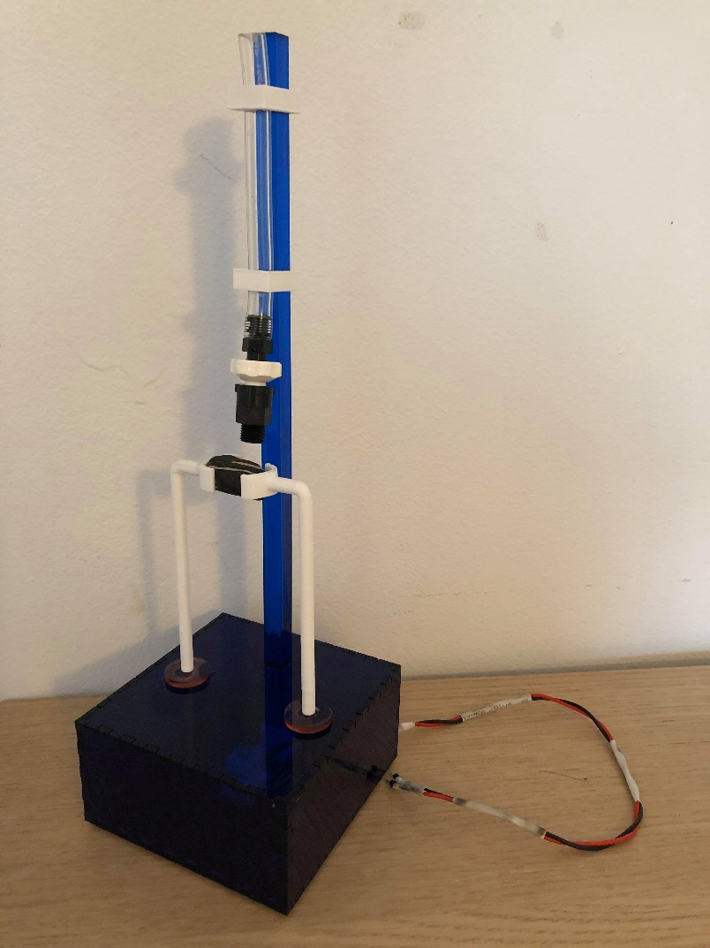

Like the flow of rivers that slowly carved away the Earth to create massive canyons, you too can create your own small scale canyon model by slowly dripping water onto the rock of your choosing! Put some water into the tube and let it go for your future ancestors to enjoy, if humans are still around then!

This device slowly drips water onto a rock, releasing all the water in the tube in about two minutes via a needle valve. The base contains an LED that “breathes,” lighting up the base, rock, and water that drips onto it. The enclosure is laser cut acrylic and all white plastic components (tube clips, rock holder), are made of 3D printed PLA.

Github.

I loved DIY kits and science sets when I was a kid. And rocks. Still love both. I wanted to create something that pays homage to all the kits I bought as a kid and to the *neat* process of erosion and weathering.

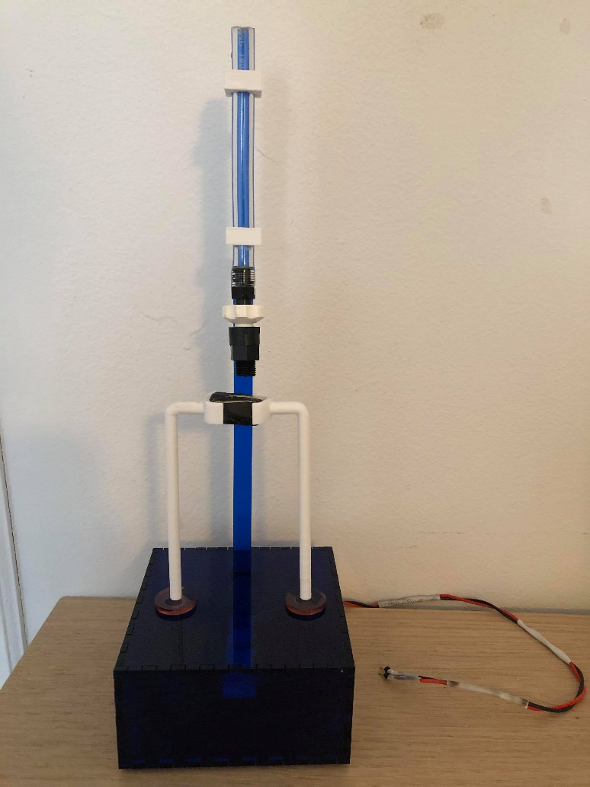

Clips

Needle Valve

Rock Holders

Base or Housing

Step 1: Acquire Rock

This is the rock I got:

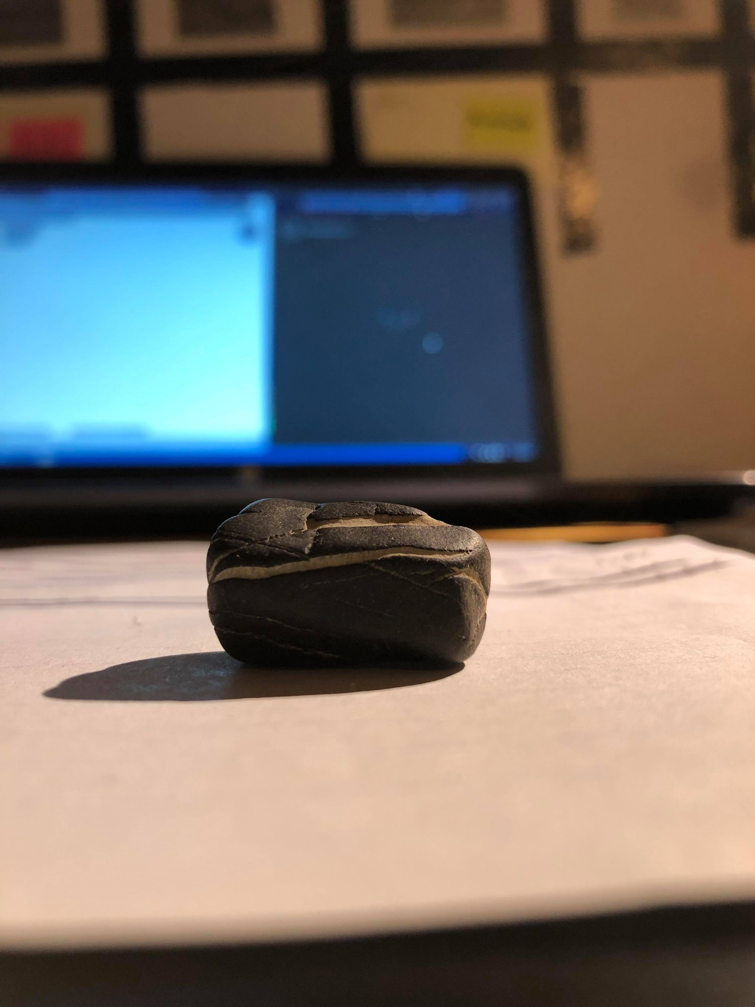

How nice! I picked this guy up from a beach along Lake Champlain in Burlington, Vermont. I didn’t get it for this specific project, I just got him because I liked him.

Step 2: Get Ghosted by Geologists

I wanted to know how long it would take to erode a hole into this rock. I thought this would be a simple enough question to answer, but like with most things I was terribly wrong.

I was able to find out the type of rock I *probably* had (iverville shale) but I couldn’t find anything that could give me a specific timeline of erosion. After researching for too long, I decided to just ask someone, that someone ideally being a geologist. Luckily, I stumbled upon [this](https://walrus.wr.usgs.gov/ask-a-geologist/) website that allowed me to do just that! It said I should get an answer in a few days, so I sent the email and waited.

And then I got ghosted by a bunch of rock nerds!!

Step 3: Rock Holder

While I waited to be disappointed, I 3D modeled two “hands” to hold up the rock. I tried to match the contours of the rock as best I could, then super glued the rock to the hands. For the connection from the base to the holders, I had two small circular pieces of acrylic that were left over from a friend’s project. I super glued those circles to the base, the super glued the holders to each of the circles. The picture below shows everything assembled.

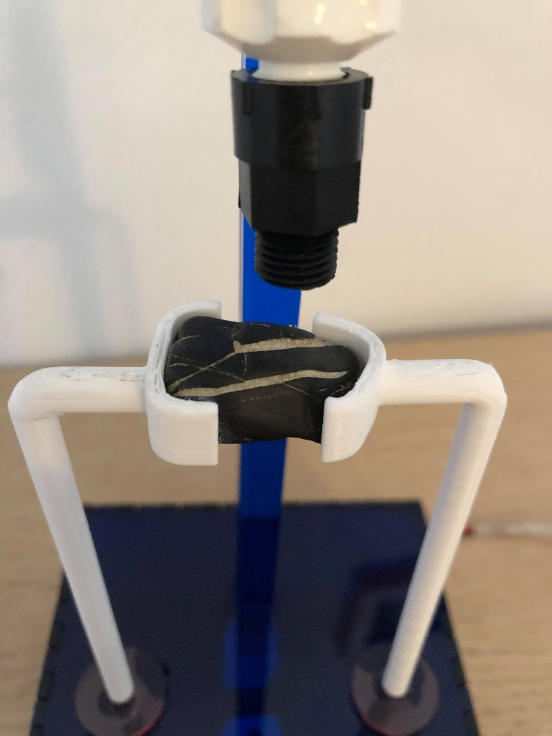

Step 4: Create Housing:

I used dark blue transparent acrylic for the base housing. Using [MakerCase](https://www.makercase.com/), I created a 4”x2”x4” box. On the back panel, I added a small circular hole in the corner for wires. On the top panel, I added a rectangular hole for the pole that holds up the valve and tubing. The panels were super glued together. Small rubber feet were added to the outside of the bottom panel

Step 5: LED and Pole Holder:

To stabilize the pole, I 3D printed a holder for it and super glued it to the inside of the bottom panel. For the LED, I 3D printed a similar shape to keep the LED pointed up towards the rock. A small slit was added to this to allow the wires to snake out of the holder, through the hole in the back of the housing and to the Arduino.

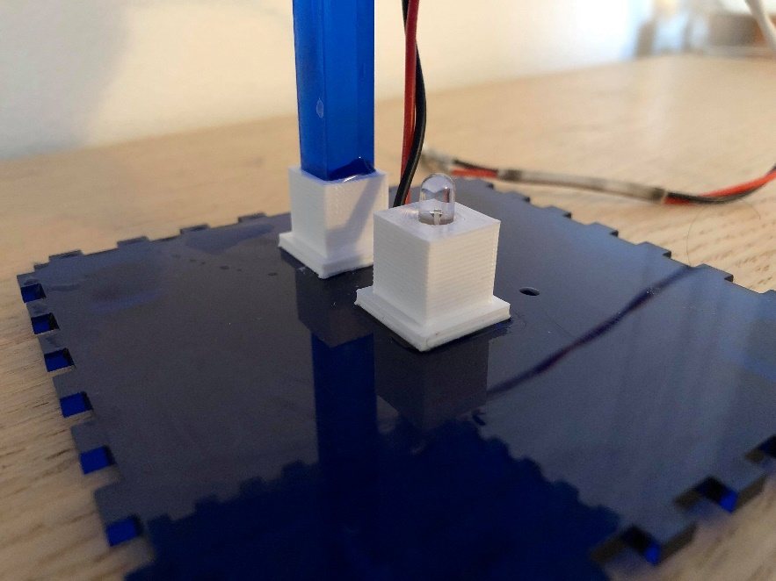

Step 6: Water Container and Dripping

Originally, I wanted to use a pump, specifically a peristaltic pump, to drip water onto the rock. But, my bank account and I agreed that we should work together to minimize the cost of this project as much as possible. So, I was directed towards a needle valve, which allowed me to control the dripping of the water. To actually hold the water, I designed a small water tank, seen below:

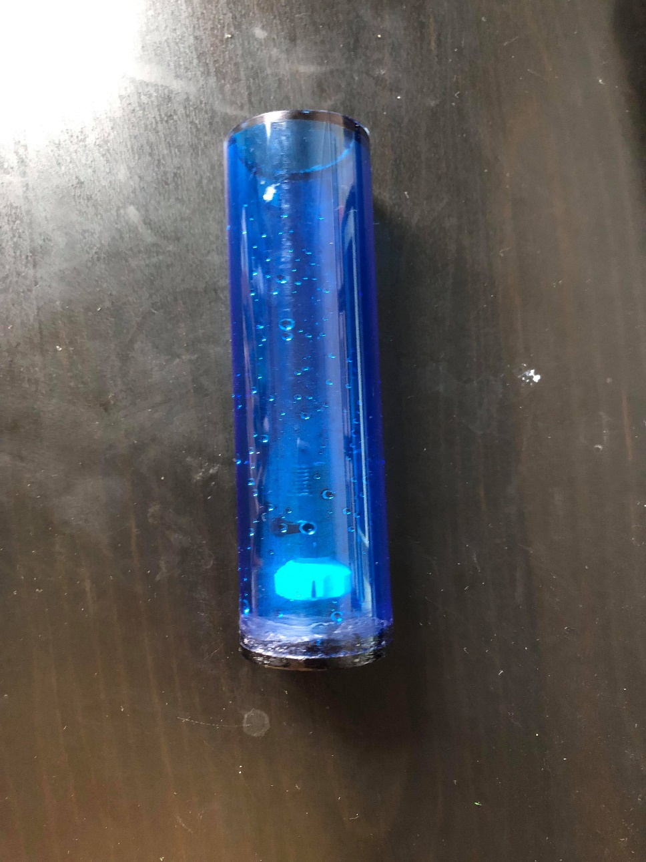

However, this had some issues: it wasn’t as waterproof as I liked, the waterproofing that I did manage was sloppy and ugly, and it was bulky. I decided to scrap it, mostly because it took a lot of the attention away from the rock.

Instead, I used a clear tube with a much smaller diameter and attached it directly to the valve. To hold it in place, I 3D printed some clips to hold the tube to the pole/support.

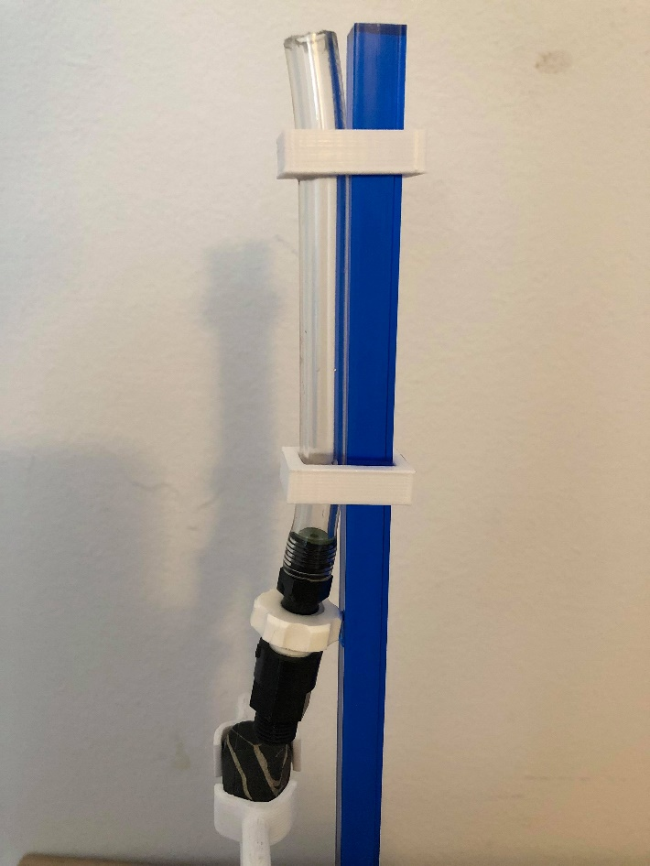 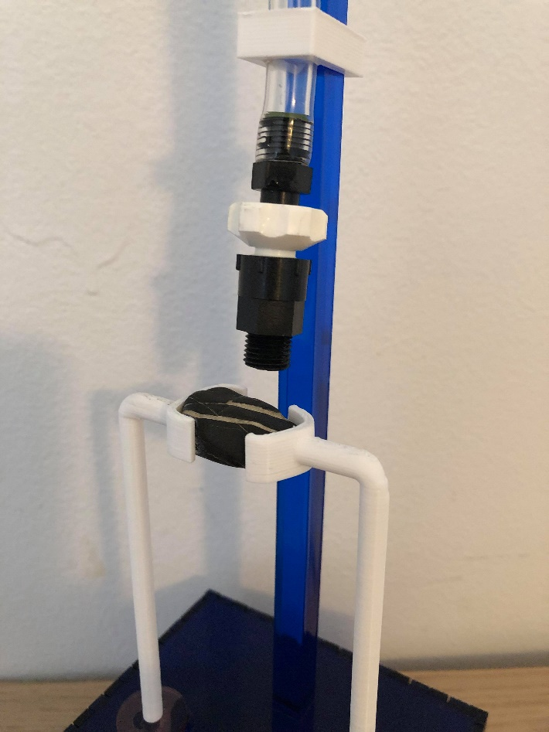

For future iterations:

* Use a better adhesive than superglue for creating the base/housing. Superglue stains were everywhere and were annoying to remove!
* Use a mini Arduino and possibly battery to contain all of the electronics inside the base. This wasn’t done for this iteration because I didn’t want to buy more components.