**Shell(don)**

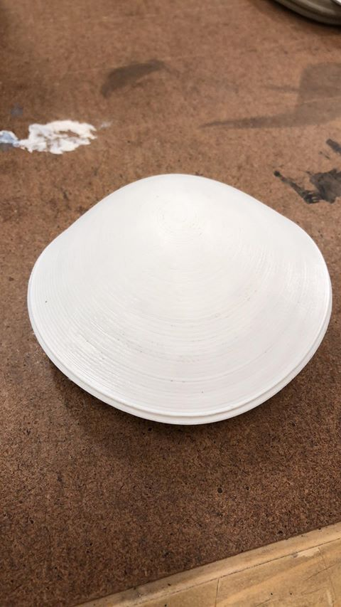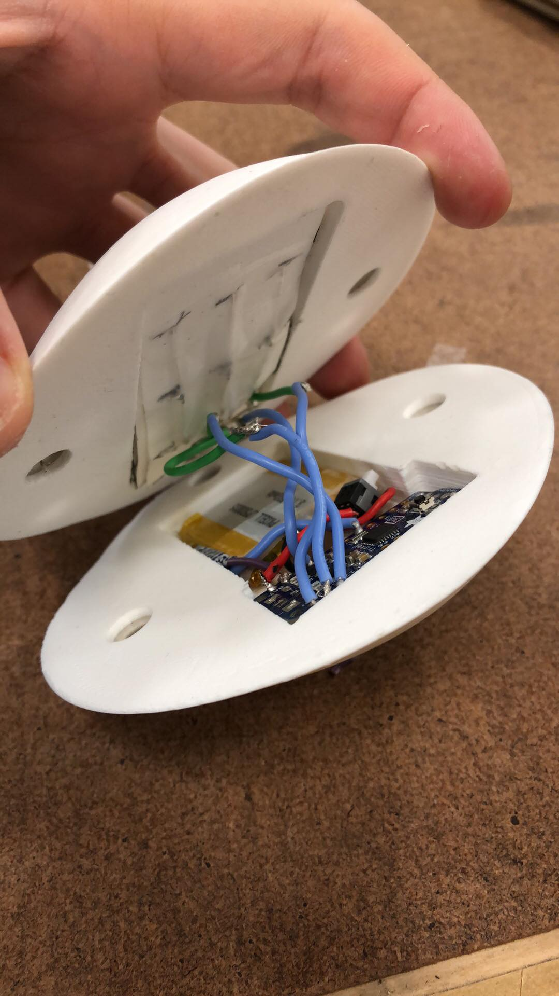

This is Shell(don). He was picked up from a NASA probe coming from Europa. To communicate with him, tap him and move him around and he’ll respond.

[Shell(don) is powered by a 3.7 volt lithium battery and is controlled by a 3V Arduino Pro Trinket. A small switch turns him on and off. Nine RGB LEDs in a matrix light him up. Depending on how many times the person has tapped on Shell(don) and when, Shell(don) respond with a certain light pattern representing his mood.]

I didn’t realize we didn’t need a whole write up until last night, but below is what I had until cutting it short.

This project was limited to buttons and LEDs as our only inputs and outputs. My first five ideas were narrowed down to one, called ‘Breathing Stone.’ The idea behind this was to create calming, river stone like object that would light up in time to 4 by 4 by 4 breathing. The original concept had the Stone ‘breathe in’ blue for four seconds, then turn green for another four, and ‘breathe out’ for the last four. This would repeat until the power switch turned the device off.

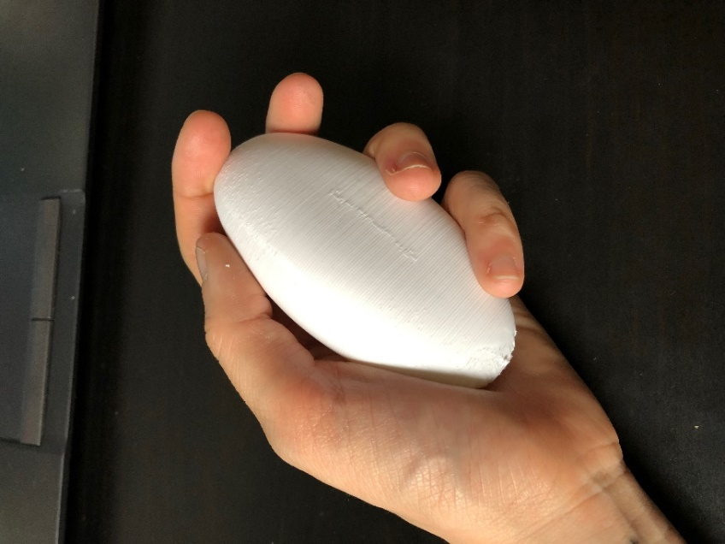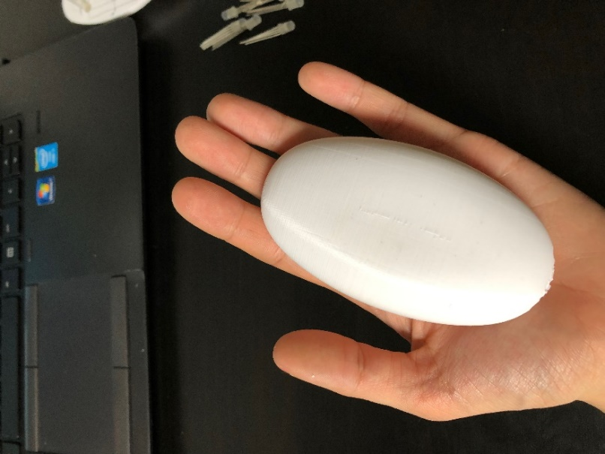

After modeling a shape in Fusion360, I 3D printed the solid to get a better idea of the dimensions and feel of the design. After bringing it around to some friends, I was satisfied with model and cut the shape in half in Fusion360 so that I could add holes for the LEDs.

While that was printing, I breadboarded the electronics. I chose to use RGB LEDs because to ease the color transition between breathing modes. I also chose smooth metal tactile buttons to match the feel of the model. I programmed the Arduino so that it would cycle through the breathing pattern as planned as well as a couple of other color modes I wanted to try out. By pressing the button, the Stone cycles through the different modes.

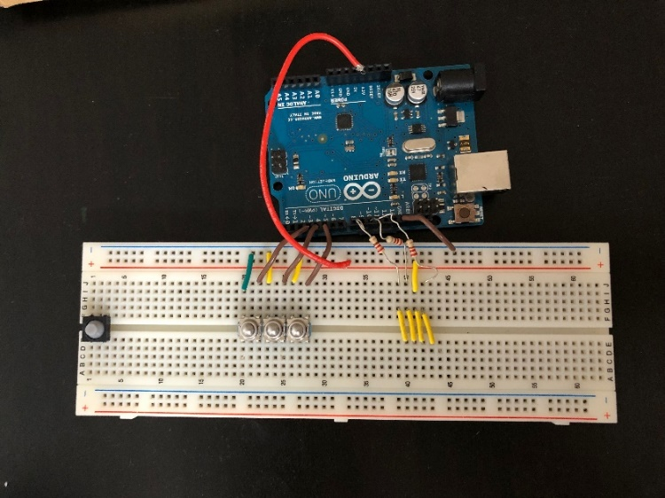

However, once the top half was finished printing, I realized that I hated the look of the breathing pattern and preferred the other modes that I created. So, I ditched the 4 by 4 by 4 breathing and stuck with just a calming, mesmerizing light patterns. I programmed the device to have even more patterns while I continued to tweak the model to be able to house all of the electronics.

In the end, I ditched the tactile button as well. I didn’t want anything to be sticking out of the Stone, I even shoved the power switch inside. In order to switch between the different light patterns, I found a “poor man’s” accelerometer: a switch that consisted of a pole and a very “wobbly” spring. Thus, whenever lightly tapped, the spring and the pole would connect and act as a switch connecting. Sadly, sometimes I’m a fool. I broke the *very thin* lead of the spring. To avoid having to pay another $10 for shipping on a $0.95 component, I just ripped it apart and made a “poor man’s – poor man’s” accelerometer. In this way, users can simply tap or move the Stone around to switch between the light patterns. Each time the “switch” was triggered, a random light pattern activated.

I had to make the model 10 cm taller than originally planned to fit all of the electrical components. This, along with the white PLA I was using, made the device look more like a bar of Dove soap than a river stone. Luckily the lights at least did what they were intended to do: when shown to friends, they were able elicit a lot of “ooo’s” and “ahhh’s,” which I guess indicate they were indeed mesmerizing.

However, I felt like I had lost touch a bit with my goal of an anti-anxiety or meditation piece and instead ended up with an electronic pet rock. This became especially clear when a friend said “It’s getting angry!” when she tapped it hard and an all red light pattern (randomly) activated. This idea was further mentioned by you, dear reader, in class. Why not run with it?

I started coming up with a story for my project, which I call the “Whoms’t?” stage. What is it? Where is it from? How does it behave?

I started with where. I chose Europa because it’s my favorite moon. It’s totally covered in ice with an internal water layer, [where life may potentially be chilling](https://www.sciencedaily.com/releases/2013/12/131203133809.htm) (pun intended)! So, maybe this thing was scooped up by a NASA probe and returned to Earth. What is it?

At that moment, it resembled some sort of shelled creature the most. I researched shelled deep sea creatures. Some of the things I saw have no business being alive. I also researched general shelled creatures. Since deep sea creatures tended to be colorless or white, and Europa is covered in ice, I decided to stick with the white PLA color. I also based the final shape on clams, but created a more circular/symmetrical shape to allow controlled rolling around to ease light pattern changes. Also, maybe it uses its shell to burry into the ice?

In addition, I took another look at the infill pattern of my Shell. Although I liked the look of the grid pattern, I wanted to find a pattern that looked more “natural.” I picked the tri-hexagon pattern because it would keep the same strong 2D infill structure while adding a honeycomb-like internal structure to be illuminated.

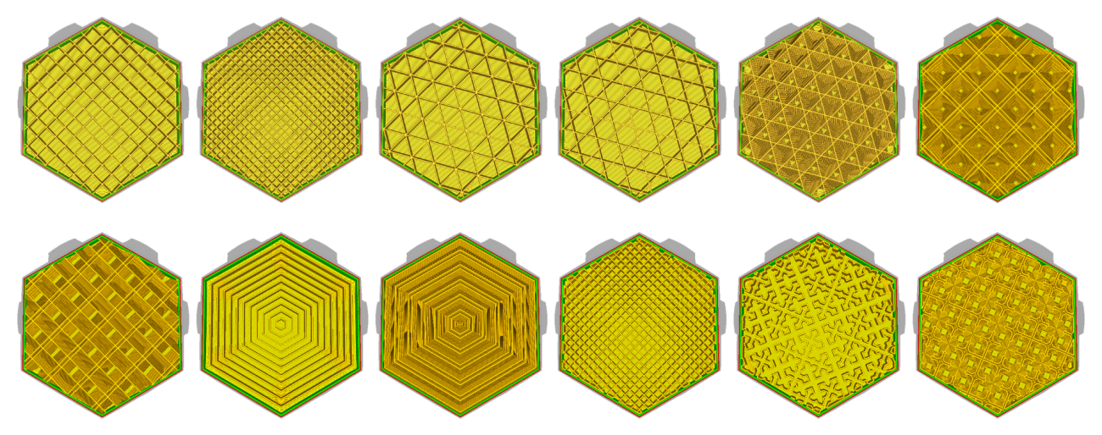

The hardest part was creating the creature’s, or the Shell’s, behavior. I did some research on bioluminescence: what animals light up and why? It’s usually for three reason: they’re looking for a mate, they’re looking for food, or they’re looking to not be food. I wanted more than three light modes, so I further researched animal behavior and based my first behavior light assignments on a cat body language chart I saw on Reddit. After doing some more research, I found that there are [six basic animal emotions researchers have identified](https://en.wikipedia.org/wiki/Emotion_in_animals#Basic_and_complex_human_emotions): fear, anger, happiness, disgust, sadness, and surprise. I thought disgust might be a bit out of scope of just lights and a “poor man’s – poor mans” accelerometer, so I tweaked it for my creature to “content.” Based on these six emotions, I finalized behavior to light pattern assignments and created a sloppy flow chart of how it should be programmed.

