OpenDRAC Admin Console User Guide

|  |  |
| --- | --- |
| Author: | André van der Ark |
| Version: | 0.1 |
| Date: | 21-11-2011 |
|  |  |
|  |  |

Table of Contents

1 Introduction 3

2 OpenDRAC 4

2.1 Dynamic light paths 4

2.2 Schedules and Services 4

3 Admin Console 6

3.1 Instaling and startup 6

3.2 Start-up 6

3.3 Administration 7

3.4 Network Elements 13

3.5 Event browser 14

3.6 Facilities 15

3.7 Link Utilisation 18

3.8 Scheduling 18

3.9 Service Alarms 19

3.10 Audit 20

3.11 Sites 21

3.12 Users 22

3.13 Topology 23

# Introduction

OpenDRAC is an open source project that aims to create a state-of-the-art piece of middle ware that allows network control by users and applications. It aims to be compatible with open standards, and where these don't exist it wants to be an appropriate proving ground.

The Dynamic Resource Allocation Controller, or OpenDRAC for short, is an implementation of a grid-like resource broker providing end application control of network resources. The primary goal of OpenDRAC is to expose network bandwidth to end user/application control while preventing unauthorized access and resource theft. OpenDRAC is capable of providing an application with bandwidth-on-demand, as well as guaranteed reservation of bandwidth for utilization at a later point in time. To this goal OpenDRAC offers the possibility to schedule services.

Originally conceived and prototyped back in 2000 by the Nortel Advanced Technology organization under the name CO2 (Content Over Optical), OpenDRAC was specifically designed to control hybrid Ethernet/optical networks for high-bandwidth scientific applications and storage area networks.

Production of OpenDRAC began in 2005 when SURFnet bv requested a deployable solution for their new SURFnet6 hybrid network. Development of the OpenDRAC product was then taken over by the Nortel Metro Ethernet Networks (MEN) organization, where support for the product continues today.

This document is the manual for one of the client components of OpenDRAC: the administration console. The administration console is a Java desktop application that functions as a client to the OpenDRAC server.

# OpenDRAC

This chapter describes some general paradigms of OpenDRAC.

## Dynamic light paths

Besides the standard routed IP-network SURFnet offers optical connections between two points. These are called light paths. Light paths offer high bandwidth (up to 10Gb/s) at high reliability. For one, this reliability is so high because a backup path is created for each light path. This backup takes over if the primary path fails.

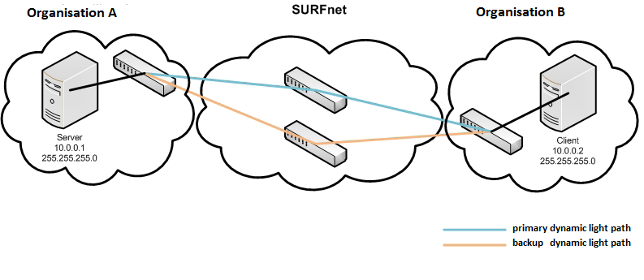

Figure 1: Light path between two organisations

SURFnet already uses static light paths in its network for high standard research tasks, but e.g. also for periodically creating backups. These light paths set up a connection between two points, e.g. two universities.

Dynamic light paths enable end users to temporarily set up a light path themselves. These paths can be with other users in the network of SURFnet. Once they’ve gotten the availability over resources, they can use these to their liking. This can be done with OpenDRAC.

## Schedules and Services

The primary goal of OpenDRAC is to enable users to temporarily reserve bandwidth on dedicated “lines” between two end points. At creation of the reservation the path between the two end points is computated and it is this physical path that is claimed during execution of the reservation.

A reservation is made as a schedule. A schedule has a duration and can repeat periodically. E.g. you can create a schedule that reserves 1000Mbit/sec between two endpoints every Monday between 12:00h and 13:00h for the coming year.

When a schedule is created one or more services are made, depending on the number of repetitions. It is this service that makes the actual reservation on the network.

# Admin Console

The Admin Console is a client to the server of OpenDRAC. It is a Java desktop application for provisioning the server and many of the features that are offered by the web client are also available in this console.

Provisioning includes adding or enrolling Network elements(s), assigning TNAs to eligible end points and adding manual topological links between end points if the network topology is not auto discovered.

## Instaling and start-up

### Instaling

The admin console runs in a Java virtual machine. Make sure you have java 6 or higher installed. The console is shipped as a single executable jar file (file with extension “.jar”) The jar can be loaded from the web client (menu Help → Downloads) or is the result of building the source code. The latter is described in the build manual that is available on the site of OpenDRAC.

Place the jar in the location of your choice. That’s it, the program is installed.

### Start-up

The console can be started from command line and for some operating systems from the GUI of your OS.

1. Command line: On Unix, Linux , Mac, MS windows: open a console, navigate to the folder with the jar file. Type in the following: “java –jar <filename>”.
2. On Mac and MS Windows you can double click on the file in your file browser to start the program

Contact your system administrator if you run into problems. Most likely problems that can occur are:

1. Wrong version of Java: Make sure you have version 6 or higher and that you use a VM of Oracle.
2. Java not configured properly: set your CLASSPATH and PATH system variables
3. Remote server not accessible: contact your system administrator to fix the problem.

## Start-up

Start the AdminConsole, provide the IP address of the OpenDRAC server and a admin class user name and password. By default the "admin" user has the password "myOpenDRAC" assigned to it. The AdminConsole can be run from the same machine as the OpenDRAC server (and is found in the OpenDRAC/client folder) or from a separately installed client that can remotely access the OpenDRAC server.

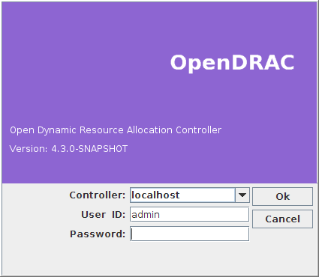

Figure 62: Login admin console

## Administration

After login the console opens with the Administration tab selected. This tab gives an overview of the network that is currently controlled by OpenDRAC.

In the console you see two panes. On The left side a map with managed network elements and on the right side a tabbed interface. In the tab “Administration” of this interface two block of data is displayed.

The block at the top displays static meta data of the Admin Console itself. In this block only the three times change.

The lower block displays meta data about the network connected to OpenDRAC. This block is updated every minute. The info in this block therefore lags to the actual situation in the network. E.g. if a new schedule is created, be it in this console or in the web client, the number of schedules and services are not immediately updated.

### 

Figure 63: Administration tab admin console

Viewing NE’s

In the left part of the console a map is shown with all NE's that are currently managed. With drag and drop actions the user can move the NE's to their physical location. Once the locations have been set, they can be saved with the save button in the top. If no NE is selected in the left pane right clicking shows a context menu with the following items:

* Add NE: Add an NE by proving the IP address of the NE, The protocol used for communicating with it, the port and user credentials in a pop up titled “Manage NE”.
* Graph properties: Set parameters controlling how the map with NE's is displayed in a pop up called “Graph properties”.

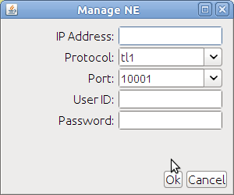

Figure 64: Change details NE

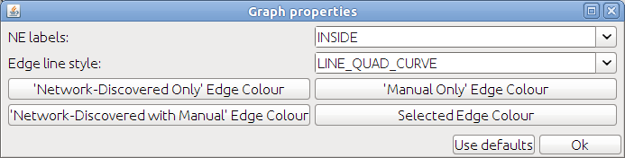

Figure 65: Change graph properties

Selecting an NE and right mouse click opens a context menu showing actions to perform on the selected NE. For some actions two NE's have to be selected first. This can be done by holding the shift-button while selecting two NE's. The available actions are:

Add Link, this option requires you select two NE's. Hold the shift-button while selecting the NE's you want to link.

* Remove NE:
* Create Schedule:
* Toggle Communications Link
* Properties

The following paragraphs give a detailed description of these options.

#### Add Link

Add manual topological links between unconnected ENNI or INNI designated facilities. The mediation layer will attempt to automatically link network elements together based on neighbour information. If this information is not available then linkages between NE's must be added manually.

To manually link two NE's together, select both NE's from the network graph on the left side of the AdminConsole by pressing Shift-click on both NE's and choose the "add Link" option from the left click menu. You will be prompted to select the facility on both ends to complete the link. You can only link ENNI or INNI endpoints, if you have not assigned any ENNI or INNI endpoints the list will be empty.

To remove a link, select the link in the network graph and left click and choose the "Remove link" option. You can only remove manually created links.  
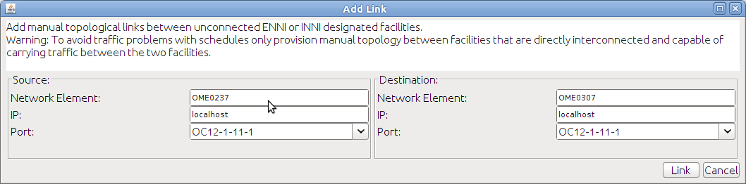

Figure 66: Add a link between two NE´s

#### Remove NE

This option removes the NE from list with managed NE's

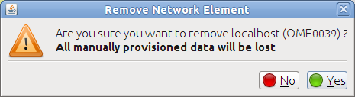

Figure 67: Confirmation popup for deleting an NE

#### Create Schedule

If you select two NE's in the left pane, you can choose “Create Schedule” from the context menu under the right mouse button. If you select this option the right pane shows a form in the tab “Scheduling”. This form holds the following fields:

* Group: The user group this schedule is created for.
* Resource Group: The resource group from which the termination points are selected.
* Source Termination Point
* Layer: Select which layer from the OSI stack to use for the connection.
* TNA: The termination point.
* Rate: The bit rate of the schedule. Depending on the selected layer, this options offers a different set of options:
* Layer 0 and 1: A list with SDH or SONET containers is offered. Which of the two container types is hardware dependent.
* Layer 2: A list of Mbit/s is offered.
* Wavelength: Only applicable to Layer 0 values. Select one of the values from the pull-down.
* Channel: In case of layer 1 a channel within a container can be chosen.
* VlanID: virtual LAN id the connection will be tagged with.
* Site: The physical location of the endpoint. E.g. University of Amsterdam.
* Destination Termination Point: The destination termination point holds the same fields as the source termination point.
* Start Date- and Time: Start moment of the schedule.
* End Date- and Time: End moment of the schedule.
* Schedule Type: This option offers the following values:
* Pre-reservation, automatic activation: The schedule is reserved, and is confirmed automatically at the given start time.
* Pre-reservation, manual activation: The schedule is reserved, but has to be confirmed. (via Schedule → List schedules).
* Reservation, automatic activation: The schedule is started automatically at the set start time.
* Reservation, manual activation: The schedule has to be activated manually (via Schedule → List schedules).
* Protection: Either unprotected or 1+1 path protected. The latter sets up a redundant path that takes over if the primary path fails.
* Metric: Metric for Constrained Shortest Path First path computation. The options to choose from are:
* Cost: Calculate by money.
* Metric2: Value you can fill out with anything you want. For example, how "green" is a specific link so you can minimize on environmental impact.
* Weighed Hop Count: Calculate by number of hops and a weighing factor for each hop.
* SRLG Exclusions: Shared Risk Link Groups, Links can be grouped in a risk group. With the value given in this field you tell path computation which links to avoid at determining a new path. Fill in the name of the group.
* VCAT: If this option is checked the system uses contiguous concatenation, virtual concatenation otherwise.

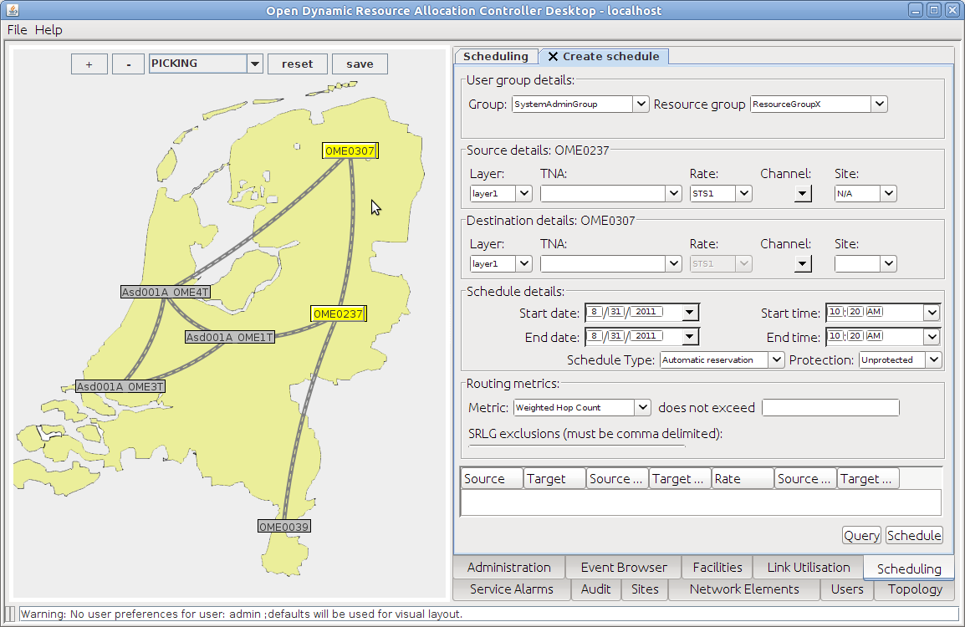

Figure 68: Schedule tab admin console

#### Toggle Communications Link

Toggling the communication link of an NE temporally breaks the communication link between OpenDRAC and the network element, this causes OpenDRAC to attempt to re-establish communications with the NE, and if successful, reload its cache of network element data. The user is warned for the temporary loss of communication and only after confirmation the link is actually toggled.

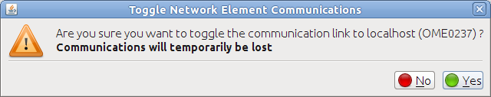

Figure 69: Confirmation popup for toggling a communication link

Properties

This option retrieves a series of properties of the selected NE and alter if required.

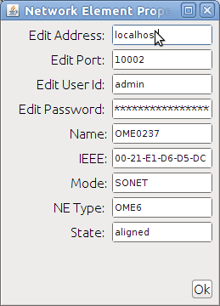

Figure 70: Changing properties network element

In the tab "Network Elements" these NE's are displayed in a table after clicking the button "Retrieve".

## Network Elements

Under the tab Network Elements you can retrieve a list of network elements that are currently managed by OpenDRAC. To get the list you must click on the button “Retrieve”

Use the "Add NE" button on the tab "Network Elements" of the Admin Console or left click on the network graph to add a network element. This functionality is equal to that described in the paragraph about the map with network elements.

By selecting an NE in the dropdown and clicking on the button “Find”, the selected NE is highlighted in the map on the left pane.

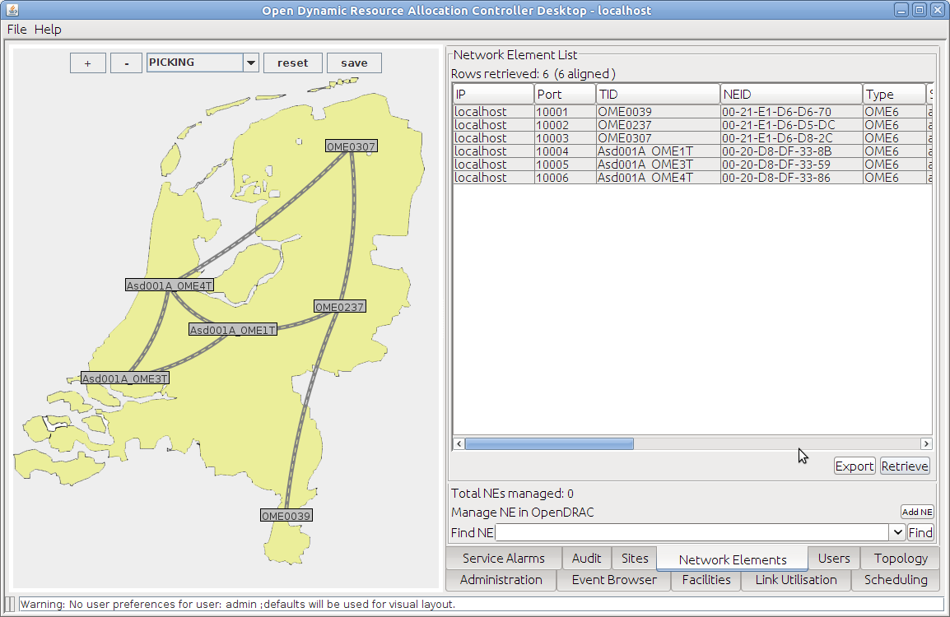

Figure 71: Network Elements tab admin console

By right clicking on a NE from this table a context menu opens with the following options:

* Remove NE: This option removes the NE from list with managed NE's
* Toggle Communications Link: Toggling the communication link of an NE temporally breaks the communication link between OpenDRAC and the network element, this causes OpenDRAC to attempt to re-establish communications with the NE, and if successful, reload its cache of network element data. The user is warned for the temporary loss of communication and only after confirmation the link is actually toggled.
* Find NE: Highlight the selected NE in the graphical presentation in the left pane.
* Properties: Retrieve a series of properties of the selected NE and alter if required.

## Event browser

In the tab Event Browser a list of all logged user actions can be displayed. Almost all user actions are logged so the list quickly becomes lengthy. To retrieve actions in a particular time period you can use a filter providing a start- and stop date.

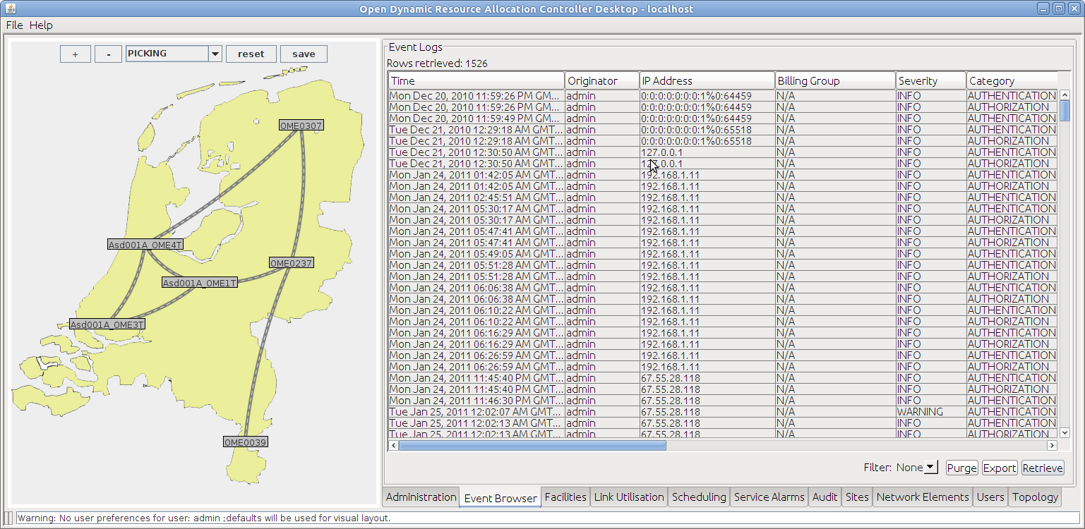

Figure 72: Event Browser tab admin console

## Facilities

Once one or more NE's have been enrolled into OpenDRAC, OpenDRAC will connect with those NE's and fetch basic information about the network element. The OpenDRAC mediation will populate all of the NE's endpoints or facilities into the facility table. A facility or endpoint is a software representation of a (normally physical) component of a NE that can be used to add or drop or switch traffic through an NE. It’s up to the device mediation code to determine what a facility or endpoint is and to hide or create facilities as required to expose the appropriate infrastructure.

Additional provisioning must be done before OpenDRAC will use a facility for carrying traffic.

Before OpenDRAC can route traffic through an endpoint that endpoint must be enabled. This approach permits OpenDRAC to coexist with other provisioning systems using different resources on the same NE. OpenDRAC will only provision or carry traffic across endpoints it is permitted to use. Once granted permission, OpenDRAC assumes it is the only one provisioning on the endpoint.

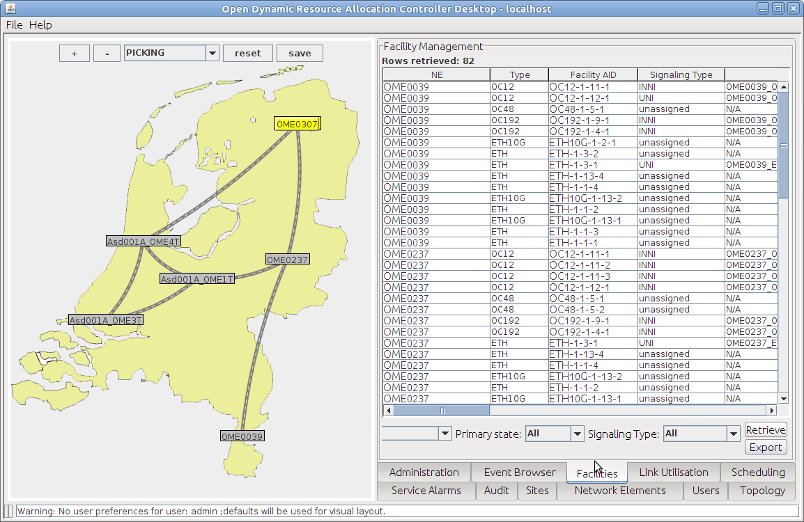

Figure 73: Facilities tab admin console

From the tab “facilities” retrieve the discovered facilities and select one, right click and select edit. You will then be presented with the facility edit dialog box. In order for OpenDRAC to use the selected facility it needs to be assigned a signalling type and a TNA.

The edit dialog contains the following items:

* Details: Opens a popup with a list of data about the selected facility.
* Find NE: Highlights the selected NE in the graphical presentation in the left pane.
* Edit: Edit the facility, this is described in detail in a sub paragraph.
* Find Services: Find services associated to the selected facility. Selecting this option switched to the tab "Scheduling".
* Delete: Remove the Facility from the NE.

#### Edit

If you select Edit from the context menu on a facility, a popup opens.

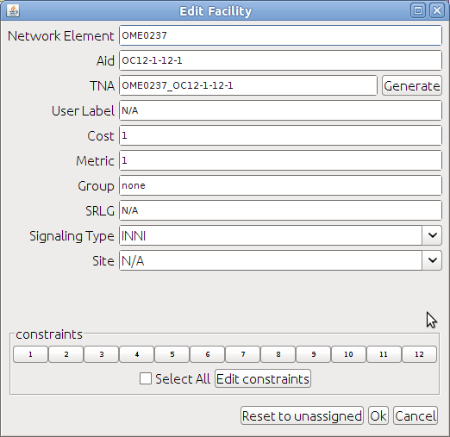

Figure 74: Edit a facility

The signalling type (UNI, ENNI, INNI or OS) determines what role the endpoint is used for. UNI endpoints are external to OpenDRAC and are where signals start and stop at. ENNI or INNI endpoints are internal endpoints connecting to other NE's within the network are assigned as ENNI or INNI and enable OpenDRAC to hop from node to node using either auto-discovered or manually entered topological links.

UNI endpoints need to have a unique TNA assigned to them to be usable. The TNA can be auto-generated or assigned a unique string. A user label field is also provided to provide additional information. Endpoints can also be assigned a cost or metric that will be considered when choosing a route through the network. SRLG stands for "Shared Risk Link Group" and can be used to assign endpoints into similar or different shared risk link groups, and is considered when looking for redundant routes.

ENNI or INNI endpoints can also have additional bandwidth constraints placed on them to prevent OpenDRAC from utilizing all of the available bandwidth of the link.

## Link Utilisation

To get an overview of the usage of links between NE's the tab "Link Utilisation" shows a table. This table shows a list of links, with for each link a percentage for the usage. A filter can be used to look at a particular period of time only.

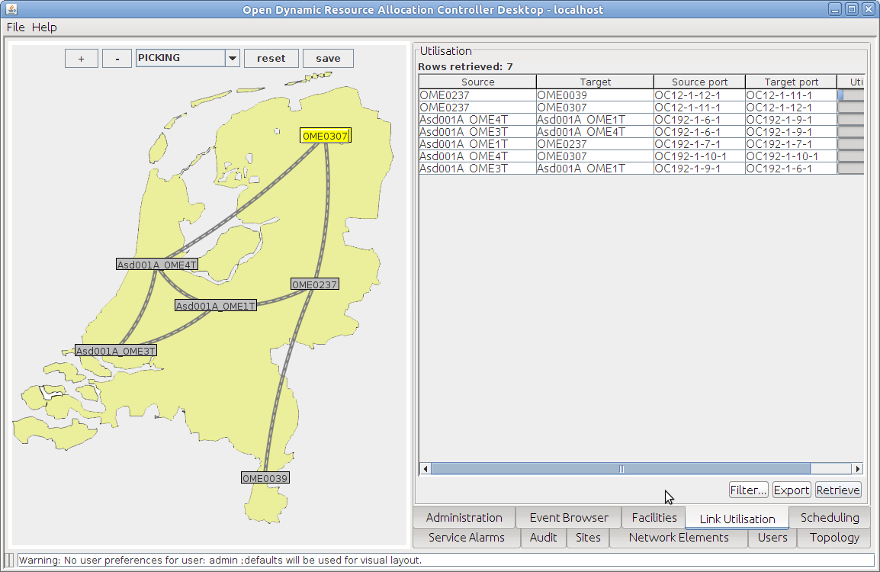

Figure 75: Link Utilisation tab admin console

In the list right clicking a link shows a context menu with one item. This item links to an overview of services in the tab "Scheduling".

## Scheduling

The tab scheduling gives an overview of all services, resulting from schedules, in OpenDRAC. By clicking on the button “Retrieve”, the table at the top of this view shows all known schedules. To limit the result set you can use a filter. This filter has the following options:

1. None: no filtering applied
2. Date: Show all services between a given start- and stop date
3. Service id: look for a particular service by id.

If in the top panel a service is selected, the bottom pane shows a list of channels that are in use for the selected service. The number of channels depends on the reserved bandwidth for the service and the type of the termination point i.e. the container types it offers.

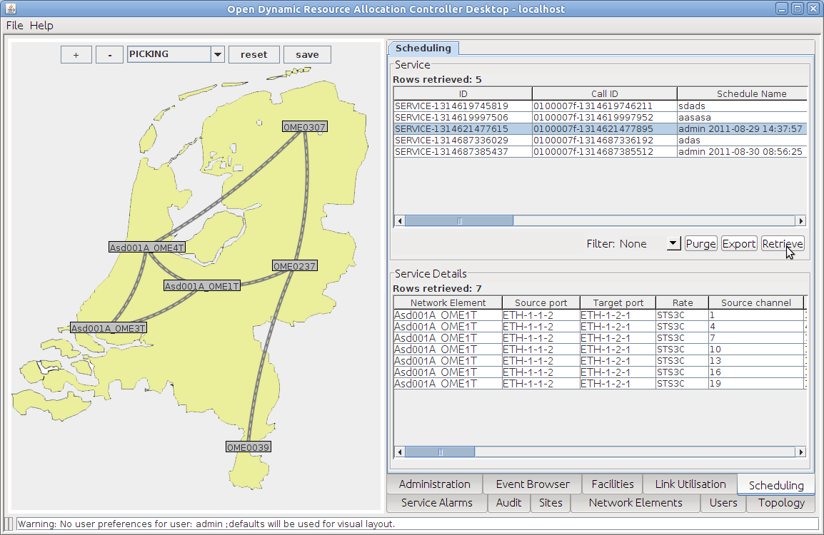

Figure 76: Scheduling tab admin console

## Service Alarms

To get an overview of all alarms the tab "Alarms" shows a table.

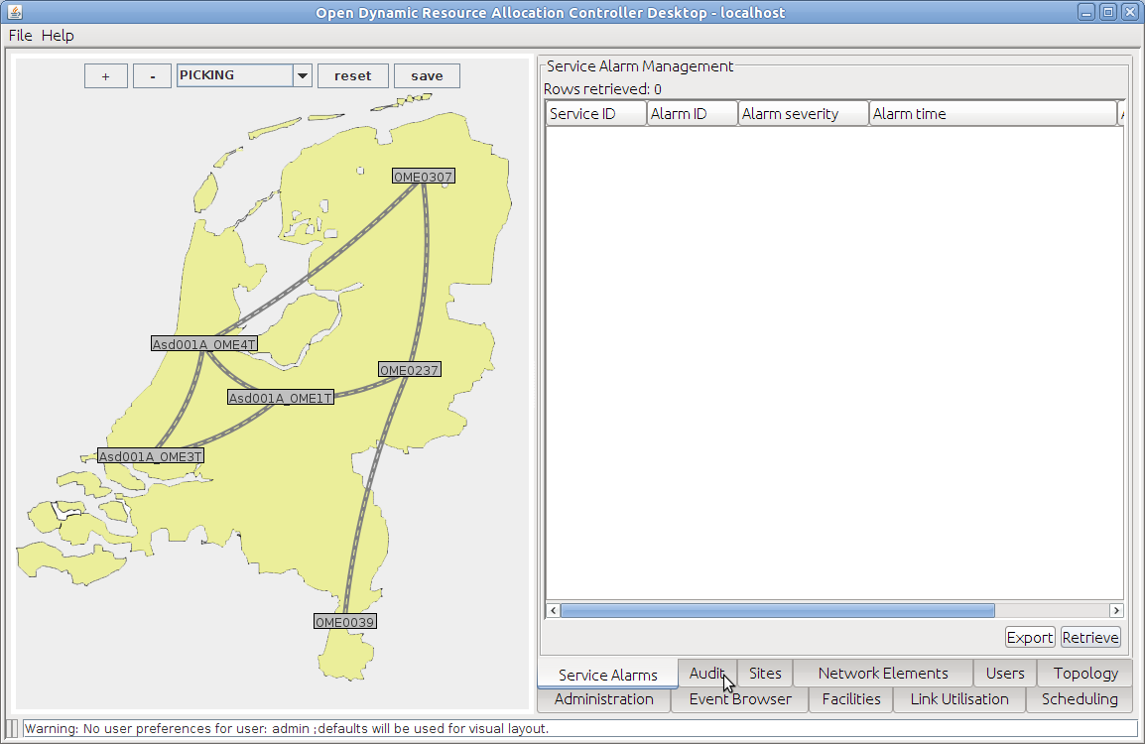

Figure 77: Service Alarms tab admin console

## Audit

To get an overview of all network connections the tab "Audit" shows a table. The client offers four settings for filtering the listed connections:

* All network connections: show all connections.
* Orphaned OpenDRAC connections: show connections that are registered by OpenDRAC but cannot be found in the actual network elements.
* OSS connections using OpenDRAC bandwidth: Operation Support System
* OpenDRAC to network mismatch: Opens a new dialog in which you can retrieve connections registered by OpenDRAC, but not found in the actual network and vice versa.

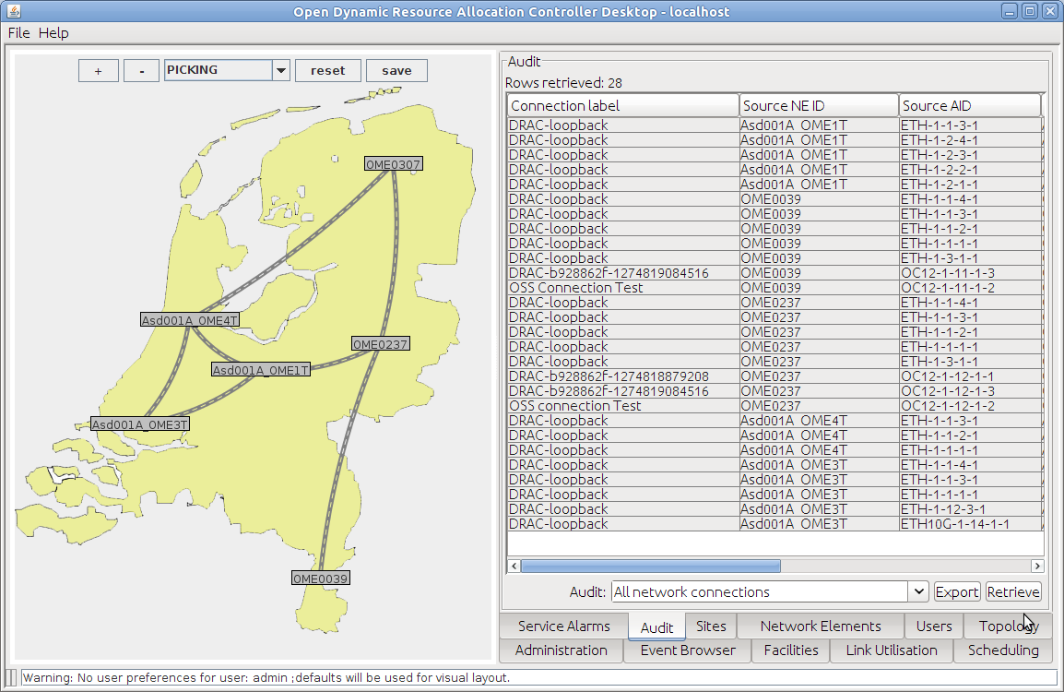

Figure 78: Audit tab admin console

Illustration 1

## Sites

In OpenDRAC a site is a physical place under which you can group endpoints. E.g. University Of Amsterdam. By grouping endpoints under sites it becomes easier to set up schedules.

To get an overview of all sites the tab "Sites" shows a table. From this tab new sites can be configured. Via the context menu (right mouse click on a site) a site can be modified.

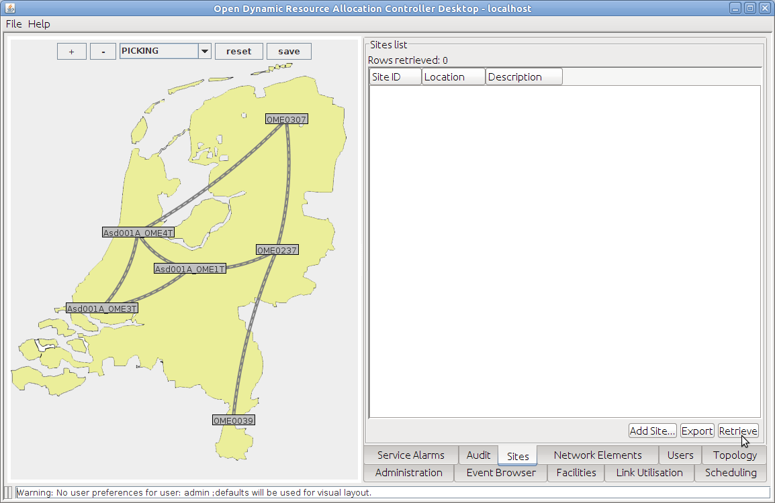

Figure 79: Site tab admin console

## Users

To get an overview of all users the tab "Users" shows a table. The Admin Console only offers read functionality of Users. Managing the users can be done in the web client.

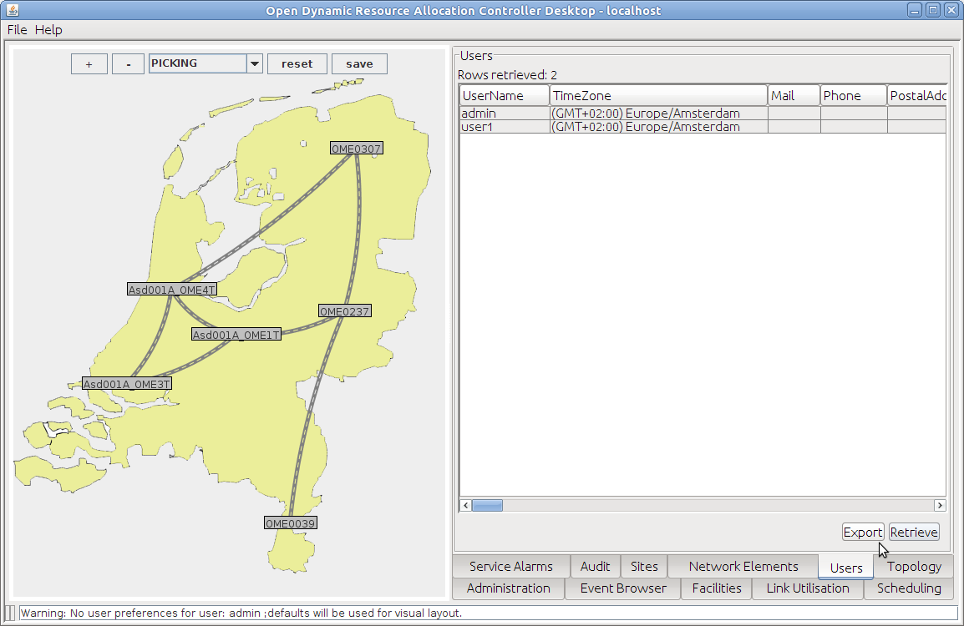

Figure 80: Users tab admin console

## Topology

The tab "Topology" shows three tables with network data.

Consolidated Links: Links that were created from a configuration file at startup of OpenDRAC. The context menu under the right mouse button has three options:

1. Find Link: highlight the link in the graphical network presentation in the left pane.
2. Remove Link: self-defining
3. Generate Manual Link: self-defining

Eclipsed Manual Links: Links that were created with user actions via a GUI. The context menu under the right mouse button has two options:

1. Find Network Link Overlay: highlight the link in the first table
2. Remove Link: self-defining

Network Adjacencies: All available termination points for the NE's that are managed by the Admin Console. The context menu has one option: Delete Adjacency.

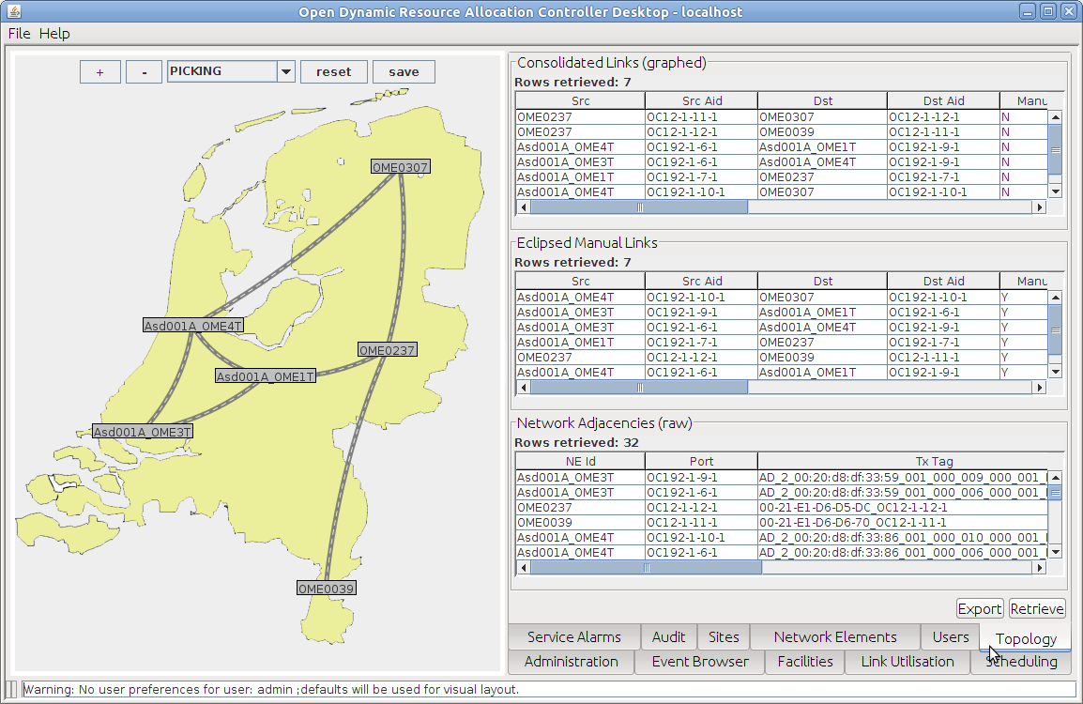

Figure 81: Topology tab admin console