Application Manual
OpenDRAC
Automation Tool

Open DRAC Automated setup of dynamic lightpaths

Name: Erno Turner
Organization: SURFnet
Date: November 25th 2010

Table of Contents

Table of Contents 2
1. Introduction 3
3
2. Configuration 4
2.1 Importing & building project into Netbeans IDE 4
2.2 Building the application via CLI 4
2.3 Authentication settings 5
2.4 Reservation settings 5
2.5 Misc. settings 6
3.Using the DRAC Automation Tool 6
3.1 How to run via the CLI 6
3.2 Usage options 7
9
3.3 CLI output 9
4.Using the DRAC Automation Tool 12
4.1 Simple mode on windows 12
4.2 Setting the PATH variable 12

1. Introduction

This document serves as a manual for Open DRAC Automation Tool. Its aim is to be a simple guide that can be used to get the user up and running quickly with Open DRAC Automation Tool. It describes building the application and configuring it. Next it will explain how the application is used and what _{options} are available. Then some example Windows batch scripts and Linux/Unix bash scripts will be shown to illustrate how they can be used in combination with the Automation Tool.

The Open DRAC Automation Tool is a web service client application used to send request to the Open DRAC web service. These requests can reserve dynamic lightpath schedules, cancel schedules, or view the status of schedules. Requests are first configured in a configuration file. Then Open DRAC Automation Tool sends these requests to Open DRAC and responses indicating if it was successful or not is sent back to the application.

2. Configuration

2.1 Importing & building project into Netbeans IDE

- Navigate to the http://www.netbeans.org/ and download the latest version of the Netbeans IDE, and install it. At the time of writing the latest version was 6.9.1. You can choose to download different Java versions with the IDE, the Java SE version is sufficient.
- Navigate to the OpenDRAC SVN repository (must sign up first for access) and download the source code OpenDRAC Automation Tool. This includes also a Netbeans project file.
- Once downloaded launch Netbeans, and choose File > Open Project, then navigate to the path where you stored the source and select the OpenDRAC Automation Tool project file. It will be distinguishable by its icon type which should appear as a Netbeans grey box.
- Now within the Netbeans IDE click the build button and your project should be successfully built.

2.2 Building the application via CLI

Once you have acquired the application source code from the OpenDRAC SVN repository, it is quite simple to get it up and running. Navigate to the parent folder and type: ant

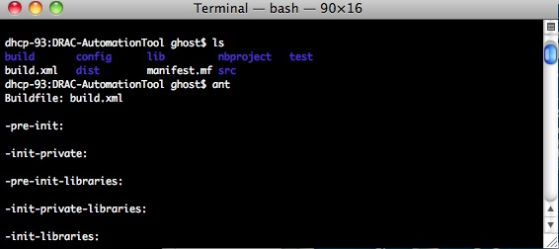
Figure 1. Building Open DRAC Automation Tool

Now Ant will build a Java jar file that can be executed. It will create a folder called ‘dist’ and store the jar file in it. You can also use a graphical IDE (e.g. Netbeans) to build the Automation Tool.

In the source code’s parent folder there is another folder called ‘config’, this folder must be copied to wherever the jar files is located. In this case this is the ‘dist’ folder. Only after copying this folder into the ‘dist’ folder can the Automation Tool be used, because this folder stores all of the configuration settings.

2.3 Authentication settings

Navigate to the ‘config’ folder that was just copied to the ‘dist’ folder. Open the ‘opendrac.properties’ file with any text editor of your liking. The format used for parameters in this file is key = value. For authentication purposes only 2 parameters need to be changed: Username and Pass. Replace the default values with your user credentials. The service URL parameter should not need to be changed. If this is the case SURFnet will inform you of this.
Authentication can be edited as follows:

Parameter | Value & Format
Username | Fill in your user username
Pass | Fill in your web service password
serviceURL | Fill in the service URL of Open DRAC’s resource allocation & scheduling service.

2.4 Reservation settings

Navigate to the ‘config’ folder that was just copied to the ‘dist’ folder. Open the ‘opendrac.properties’ file with any text editor of your liking. The reservation can be edited as follows:

Parameter | Value & Format
scheduleName | Specify a name that will be used to identify the schedule.
billingGroup | Specify the user group that is responsible for the creation of the light path.
startTime | Specify a start time in this date time format:  yyyy-mm-ddThh:mm:ss
endTime | Specify a end time in this date time format:  yyyy-mm-ddThh:mm:ss
serviceDuration | Specify for how long the connection should last for.
rate | Specify the speed in Mb/s (e.g. 1000 for 1Gb/s)
sourceUserGroup | Specify the user group that the user belongs to at the source endpoint.
sourceUserResourceGroup | Specify a resource group that the user has at the source endpoint.
sourceEndpoint | Specify the source endpoint.
destionationUserGroup | Specify the user group that the user belongs to at the destination endpoint.
destinationResourceUserGroup | Specify a resource group that the user has at the destination endpoint.
sourceVlanID | Specify the source endpoint VLAN id, if not required leave the default value: 4096.
destinationVlandID | Specify the destination endpoint VLAN id, if not required leave the default value: 4096.
protectionType | Specify the protection type, ‘1Plus1Path’ or ‘unprotected’. 1Plus1Path sets up a backup lightpath connection.
sourceChannel | Specify the source endpoint channel, if not required leave the default value: not_specified
destinationChannel | Specify the destination endpoint channel, if not required leave the default value: not_specified
routingAlgorithm¹ | Specify the concatenation type. Allowed types are VCAT or CCAT.

2.5 Misc. settings

Parameter | Value & Format
doSimpleFeedback | Used in the simple usage options to control whether XML or simple feedback is given to the user.

2.6 Keystore

As mentioned in the introduction of this document , the automationtool communicates with the server via webservices. To make sure this communication is secure, it uses a certificate that is stored in a keystore.

By default automationtool.(sh|bat) uses a keystore located at config/jssecacerts which works with
drac.surfnet.nl. It already contains the required certificate.

If you want to use another keystore, edit automationtool.(sh|bat) and point it to your keystore.
This is accomplished by editing the -Djavax.net.ssl.trustStore variable and pointing it to the correct keystore. The certificate for the prodcution server is
located at config/draccertificate_production

If you want to connect to an OpenDRAC instance which isn't located at drac.surfnet.nl or are having problems using
the provided keystore, the automation tool can try to retrieve the certificate from the server.
It will ask you if you want to load the certificate and store it in your keystore.
After confirmation and entering the password to your keystore,
it loads the certificate, puts it in your keystore and resumes executing the program.

If you would rather put it there by "by hand", we provided a small utility which retrieves the certificate and installs it
into a newly created keystore.

Example for doing it by hand:

Creating a new keystore named "keystore_bin" with password "changeit" and load the certificate from
localhost on port 8443

cd automationtool
java -jar contrib/util-cert-1.0-SNAPSHOT.jar localhost:8443 keystore_bin changeit

Copy the keystore_bin to config/jssecacerts or edit the automationtool.(sh|bat) and point it

to the newly generated keystore.

3.Using the DRAC Automation Tool

3.1 How to run via the CLI

Navigate to the ‘dist’ folder where the Java jar file and ‘config’ folder resides. And type: java –jar AutoTool.java –m. This will allow you to make a reservation with the settings specified in the ‘opendrac.properties’ file.

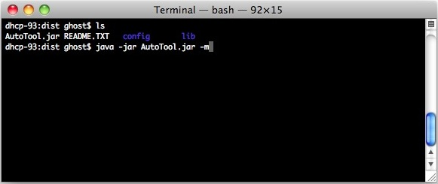
Figure 2. Command required to make a schedule

The format for executing the Automation Tool is: java –jar AutoTool.jar [-switch(s)]. At least one switch must be used.

3.2 Usage options

DRAC Automation Tool has a handful of options that can be specified as command line switches. Here is a list of them and their functions.
These are divided in two categories: Simple and Advanced.

The simple options deal with setting and resetting a schedule in a fashion similar to a light switch. The values for the schedule are read from the configuration file.

The advance options consists of a larger set and allow for extra parameters. Some of these options require to alter the configuration file.

Another difference between the simple and the advanced options is the format of the feedback to the user. The advanced options show the full XML message as sent from the server. The simple options show simpler feedback by default. If full feedback (XML) is required this can be arranged in the options.

Simple Options:
The simple options consist of the ones in the table below:
Option | Description
--info | Get info about a service defined by name, user and source and target endpoints from config file.  If there are multiple schedules that match, the one currently active is returned. If there is none currently active the schedule created last is returned.
--stop | Terminate a service defined by name, user and source and target endpoints from config file.  This is only done if there is currently a service running that matches the criteria.
--start | Recreate the service that starts now and lasts for the period as defined in the properties file. If the schedule is already running, nothing changes.
-h  -?  --help | The usage of the application will be listed.  This switch does not accept any values.

If a new schedule is created (-r), the start time is the current time, and the end time is the start time plus the duration mentioned in the properties file. Besides the duration the name, start- and end point of the schedule are read from the properties file.

For info and terminate the name, and termination points of the schedule are used to retrieve the schedule from the server. These values are read from the properties file.

Advanced Options:
The advanced options consist of the simple options plus the ones listed in the table below:
Option | Description
--create | Create a reservation schedule with the settings specified in the ‘opendrac.properties’ configuration file.  This switch does not accept any values.
--now | Make a reservation schedule with the settings specified in the ‘opendrac.properties’ configuration file. However the startTime parameter will be automatically overwritten to specify the current time as the startTime.  This switch does not accept any values.
--status [schedule id] | Show the status of a schedule. The schedule ID value must be filled in after this this switch.
--cancel [schedule id] | Cancel a reservation. The schedule ID value must be filled in after this switch.
--file [path to config] | Specify the path of the configuration file that will be used to authenticate and make reservations
--list [startTime]  [endTime]  or  –list propsfile | List reservations within the startTime and endTime interval specified by the user at the command line. This option allows you to view the schedule ID’s. That will be used later with the –s or –c option. Start time and end time must be entered as follows:  yyyy-mm-ddThh:mm:ss_yyyy-mm-ddThh:mm:ss  If the string “propsfile” is given as a parameter in stead of the start and stop time, the start and stop time are read from the properties file.
--extend <nr minutes> | Extend the service that is currently running for the schedule as defined by the properties file with a number of minutes given as command line parameter. The properties: path, schedule name and user are taken into account for this command.

Note for simple options:
The automation tool works only on schedules not on services.
This means that id a schedule that is recurring is terminated, all service, the future ones included, are canceled. There is no feedback to the user or warning about the number of services that are being canceled.
Therefore, the creation/resume of a schedule is targeted to non-recurring services.

3.3 CLI output

Authentication response

The user will most likely receive two types of authentication responses. This can be either a successful or failed authentication response. Possible responses are:

1) Successful

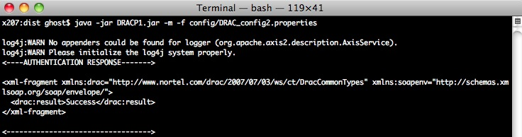
Figure 3. Successful authentication

The user is successfully authenticated username and password was correct.

2) Unsuccessful

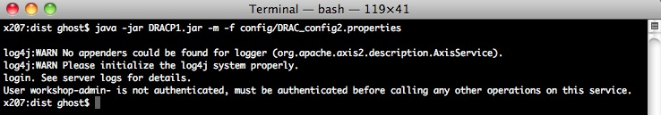
Figure 4. Unsuccessful authentication response

Reservation response

There are various responses possible when making a reservation, because of the amount of parameters that can be mistakenly set wrong. OpenDRAC web-services always displays detailed responses. Also the –s, -q and –l switches return responses that contain very useful info.

Here are a few noteworthy responses worth mentioning.

1) Schedule end time is in the past

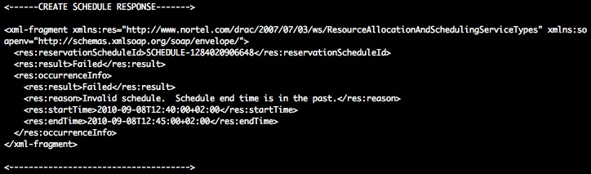
Figure 5. Incorrect start time and end time response

The reason for this is because the start time and end time were not specified correctly. This may happen when a user overlooks changing these parameters.
Once these are corrected this error will go away.

2) Incorrect billing group

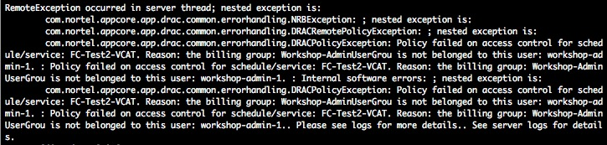
Figure 6. Incorrect billing group response

The user filled in the wrong billing group. The DRAC_configuration should be edited to correct this.

3) Querying the schedules within the date interval specified in the configuration
file with the –q switch.

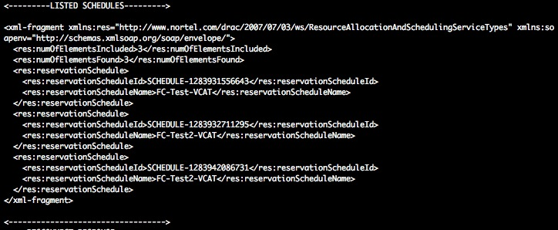
Figure 7. Querying schedules

The DRAC_configuration file contains two parameters called startTime and endTime. When the –q switch is used their corresponding values are used to query schedules.

4) List of schedules within a time interval specified via CLI.

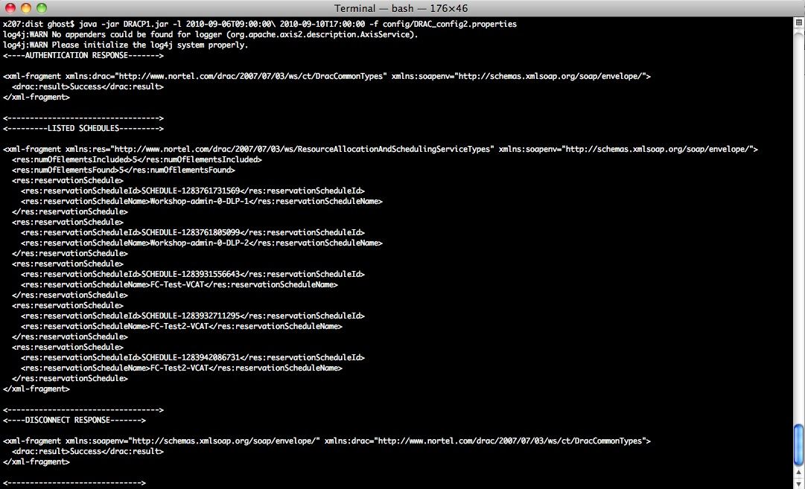
Figure 8. All schedules within a time interval

4.Using the DRAC Automation Tool

4.1 Simple mode on windows

For MS-Windows three shorthand executables were created. These can be activated with a double mouse-click so that the user needs not enter commands in a shell.

To activate these the following steps must be done to prepare windows.
- Copy the files from the microsoft directory from the unzipped directory-structure and copy the tree cmd-files to where you want to execute these from. e.g. the desktop.
- Extend the PATH variable in the configuration-screen with the path <pathttohautomationtool>\bin (substitute the right value for the varable between angles.

Once these steps are taken you can activate the three programs by double clicking with a mouse. This results the opening of a ms-dos shell showing feedback from the action that was activated.

4.2 Setting the PATH variable

The shell script contains code to resolve the directory holding that shell script. This was added to enable the Java program to find it's configuration files, regardless from where it was activated from.

By adding the path to the shell script (automationtool.sh/bat) to the PATH variable you can run it from anywhere simply by calling its name and proving the proper parameters. This is the same as you would do, calling it from the bin directory holding the script.

Every OpenDRAC user has two passwords. One used for accessing the various user interfaces and the other for accessing the web services.
This routing algorithm field is used to set the concatenation type VCAT or CCAT. However the name of this field should be renamed to something more appropriate. ² Please do not leave any whitespace behind values this may cause reservation errors.

