Design Patterns:
A formal means of capturing and transmitting experience

Steve Kaisler and Frank Armour

One of the key challenges in software engineering and development is how to successfully reuse knowledge, experience as well as the software itself. A primary goal is how to reuse solutions (e.g. software design, software modules) in new applications that were previously developed for other, possibly different applications? Specifically, how do we describe successful solutions to common software problems so that they can be successfully understood, customized and reapplied on succeeding development efforts? As Schmidt et al [Schmidt 1996] note, "the long term goal is to develop handbooks for software engineers". Patterns provide one step towards this goal.

“Design pattern” is a term that has come into widespread use to represent a set of partial, proven solutions to general software design problems. The term ‘design pattern’ was coined by the Gang of Four (GOF) – John Vlissides, Erich Gamma, Richard Helm, and Ralph Johnson [Gamma 1995] – to capture the design solutions of experienced developers that had been proven in many projects. Their intent was to begin codifying generic solutions to common problems that all developers encounter as they design and develop applications. Many others have contributed with their own patterns on everything from design to analysis to the software development process.

Christopher Alexander first introduced the concept of a pattern in a series of lectures he gave at Harvard University on urban planning and building architecture. These lectures were published in his book, Notes on the Synthesis of Form [Alexander 1964]. Subsequent books [Alexander 1977, Alexander 1979] have provided numerous examples of how to apply his methodology to real world problems. Although these books discuss architecture and urban planning, they have had a seminal influence on many other disciplines including software design and development [Lea 1993], user interface design [Tidwell 1999], and even education. In these books, Alexander argues that architecture has failed to improve the human condition because current architectural methods yield structures that fail to meet the requirements of communities and individuals. To rectify this condition and produce buildings that improve people’s comfort and quality of life, architects must work to produce structures that better fit and adapt to the needs of all their inhabitants and users and their respective communities [Appleton 2000].

The analogy of Alexander’s argument to software design and development is obvious. Early practitioners such as Beck and Cunningham [Beck 1989, Beck 1997], Coplien [Coplien 1991], Lea [Lea 1993], and Schmidt [Schmidt 1996a] saw the analogy immediately and began to apply it the process of describing solutions to software design problems.

What is a Pattern?

There are many definitions for patterns. Perhaps the best is the one Alexander gives in A Timeless Way of Building:

“Each pattern is a three-part rule, which expresses a relation between a certain context, a problem, and a solution.”

The pattern describes the problem and the spatial configuration of the solution that solves the problem. Most patterns work only in certain contexts or situations, so we must specify where and how the pattern can be used.

Another definition from Riehle and Zullighoven [Riehle 1996] is more widely applicable:

“A pattern is the abstraction from a concrete form which keeps recurring in specific non-arbitrary contexts.”

A pattern is only a specification for a solution, not the solution itself. From a design pattern, a programmer has to create the code and data structures that implement the specification within a particular context. But, a pattern also describes why the solution is needed.

The Role and Benefits of Design Patterns

A designer who is familiar with patterns can apply them immediately to design problems without having to rediscover the solutions. Thus, design patterns purport to make it easier to reuse successful designs and architectures. Expressing proven techniques as design patterns makes them more accessible to developers of new systems. Design patterns help you choose alternatives that make a system reusable and avoid alternatives that compromise reusability. For example, in the design pattern of Model-View-Controller (MVC) the presentation of information (View) is separated from the information itself (Model) and the control or manipulation of the information (Controller). This pattern provides flexibility and greater reuse of the information, since it is not integrated with a specific presentation format [Burbeck 1992]. This pattern is repeated again and again when developing software systems that use graphical user interfaces. Rather then have inexperienced developers stumble on this solution through trial and error or rely solely on the verbal transmission of the solution by an experienced developer, the MVC pattern provides a formal, written approach to institutionalizing this “best practice”.

Design patterns can also improve the documentation and maintenance of existing systems by furnishing an explicit specification of class and object interactions and their underlying 'intent'. Put simply, design patterns help a designer get a design 'right' faster.

The first uses of design patterns occurred in graphical user interfaces (GUIs). Both Gamma [Gamma 1991] and Vlissides [Vlissides 1990] focused on GUI frameworks that emphasized the use of patterns to facilitate the design of new applications. Many of their patterns are based on drawing tools and are motivated by concerns for simplicity and flexibility.

Other Views of Design Patterns

Many other researchers have extensively described design patterns. Although the GOF originally applied this concept to software design, it has now been extended to other areas of computer science as well as other disciplines.

Although not a book on patterns, Jones’ book on design methods [Jones 1981] is a seminal book on techniques and methods for designing systems. Jones examines methods for human design processes and gives prescriptions for how to kick-start the process. These methods represent patterns for problem solving, many of which are applicable to software engineering practices.

James Coplien compiled a catalog of C++ idioms which he published in Advanced C++ Programming Styles and Idioms [Coplien 1991]. This book presents many examples of Buschmann’s third type of pattern. Recently, Coplien has extended patterns to processes and organizations [http://portal.research.bell-labs.com/orgs/ssr/people/cope/index.html]. For example, a process pattern is De-Couple Stages. Here, Coplien notes that serializing the stages of a project with well-defined hand-offs between stages allows automation of individual stages. An organization structure pattern is Solo Virtuoso, where he notes that for small projects they can be done by one or two people. He has extended this effort to encompass many other organizational patterns [Coplien 2000].

Douglas Lea [Lea 1994] has applied patterns to the design of avionics systems as part of DARPA's Domain-Specific Software Architecture (DSSA) program. In [Lea 1996], he describes how to write design patterns in Java that exploit the inherent concurrency mechanisms of Java.

Buschmann et al [Buschmann 1996] described three types of patterns: architectural patterns, which express a fundamental structural organization or schema for software systems; design patterns, which provide a scheme for defining the structure and relationships among a set of components for a software system; and idioms, which are low-level patterns specific to a programming language. Riehle and Zullighoven [Riehle 1996] have a similar taxonomy, but slightly different definitions.

Douglas Schmidt [http://www.cs.wustl.edu/~schmidt/patterns.html] has focused on applying patterns to the description of telecommunications problems, including event demultiplexing [Schmidt 1997], asynchronous event handling [Schmidt 1996b], and concurrent and parallel programming [Schmidt 1995]. The complete description of patterns for telecommunications is presented in [Schmidt 2000]. The source code for these patterns is available as part of the ACE framework at http://www.cs.wustl.edu/~schmidt/ACE.html.

Mowbray et al have written a book entitled AntiPatterns: Refactoring Software, Architectures, and Projects in Crisis [Mowbray 1998] AntiPatterns represent lessons learned, e.g., how to recover from a bad situation with a satisfactory, if not the best solution. Andrew Koenig first coined the term “antipatterns” in a C++ Report article published in November 1995. He focused on bad solutions to problems, one on which an inherently bad choice of a solution led to a worse situation.

Fowler [Fowler 1997] has described numerous analysis patterns from conceptual business models such as trading, measurement, accounting and so forth, and a set of support patterns that are aimed at implementing these analysis patterns into operating software. Coad [Coad 1996] provides a set of patterns for modeling familiar business application using objects.

Finally, Carey et al [Carey 2000] describe the numerous patterns implemented in IBM’s San Francisco business software framework. One such pattern is the Business Entity Lifecycle, which allows a business object to accurately model the various lifecycle paths of the business entity it represents through a decoupled and configurable state management mechanism.

In addition, the notion of design patterns has been widely extended beyond computer science to other disciplines such as program management [Brown 2000] and education.

A Design Pattern Example

As an example of what a formal design pattern is and how it might be applied, we look at one design pattern that has received considerable attention. It is referred to as the composite pattern. The composite pattern is widely used in object-oriented programming to organize objects into a tree structure. In a composite pattern, the structure is one of whole-part, with the parts distinct from the whole. This pattern allows a user of the whole to treat the individual components and composition of the objects uniformly. In Java, a generic Abstract Window Toolkit (AWT) is a container that contains other containers. This can be represented in Figure 1:

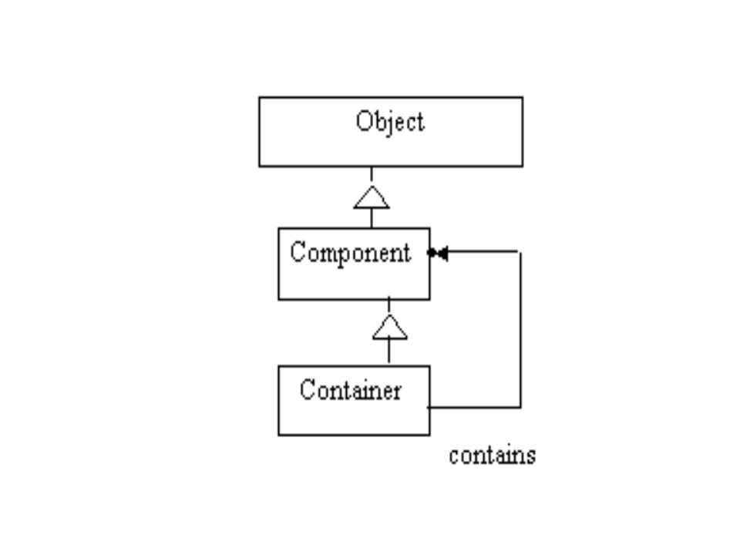
Figure 1. Composite Pattern as used in AWT

This diagram conceals some of essential information about the pattern, namely the generic operations used by each of the container and the component. A more detailed description of the Composite pattern is depicted in the following diagram (Figure 2):

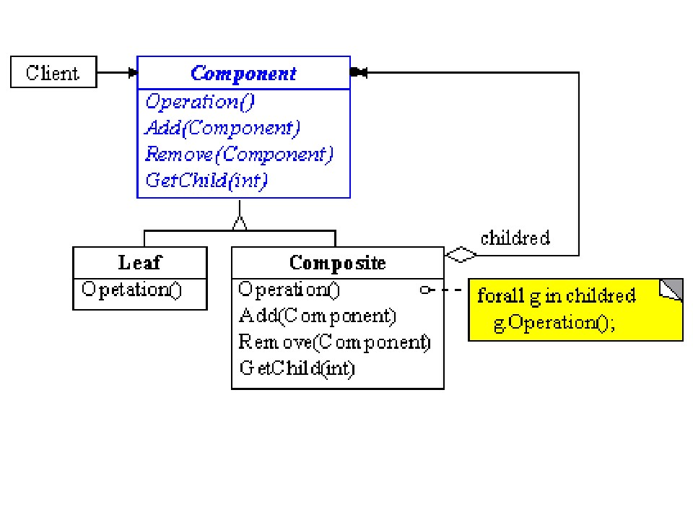
Figure 2. Formal Description of Composite Pattern [adopted from Gamma 1995]

The Composite pattern has application in multiple situations, including such examples as graphics applications like drawing editors and schematic capture systems that let users build complex diagrams out of simple components. In graphically applications, the user can typically group components to form larger components, which in turn can be grouped to form still larger components. A simple implementation could define classes for graphical primitives such as Text and Lines plus other classes that act as containers for these primitives.

There's a challenge, however, when using this approach: code that uses these classes must treat primitive and container objects differently, even if most of the time the user treats them identically. The application becomes more complex because it must distinguish between these objects. The Composite pattern provides a mechanism for using recursive composition so that clients don't have to make this distinction (Figure 3).

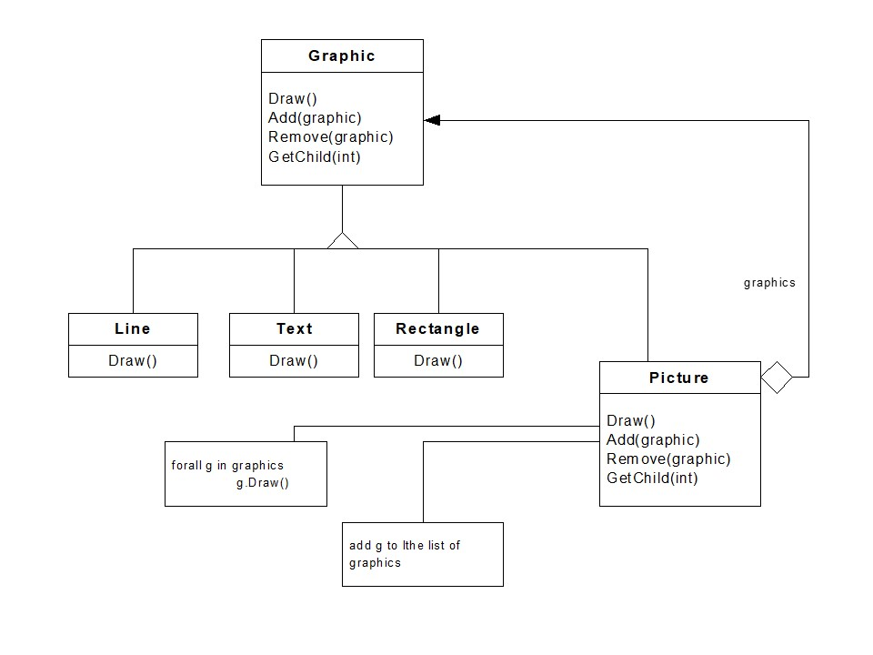

Figure 3: Composite pattern adopted for a graphic application [adopted from Gamma 1995]

The essential part of the Composite pattern is an abstract class that represents both primitives and their containers. For the graphics system partially illustrated above, this class is Graphic. Graphic declares operations like Draw that are specific to graphical objects. It also declares operations that all composite objects share, such as operations for accessing and managing its children.

The subclasses Line, Rectangle, and Text define primitive graphical objects. These classes implement Draw to draw lines, rectangles, and text strings, respectively. Since primitive graphics have no child graphics, none of these subclasses implements child-related operations.

The Picture class defines an aggregate of Graphic objects. Picture implements Draw to call Draw on its children and it implements child-related operations accordingly. Because the Picture interface conforms to the Graphic interface, Picture objects can compose other Pictures recursively. The following diagram (Figure 4) shows a typical composite object structure of recursively composed Graphic objects:
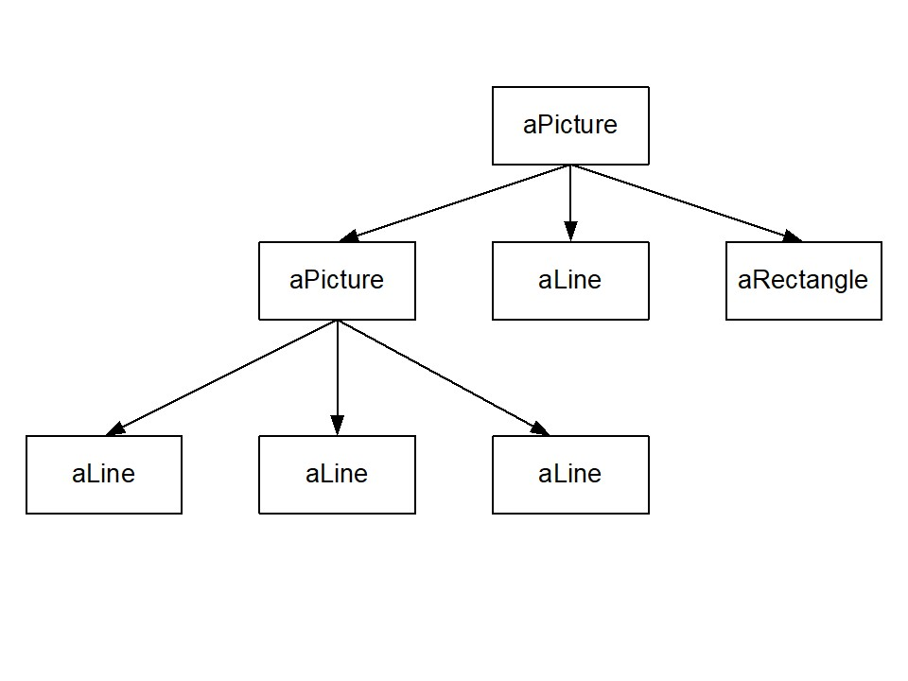
Figure 4: Aggregate of picture object in composite pattern [adopted from Gamma 1995]

Implementation of Design Patterns

Although design patterns are most often associated with object-oriented programming (most notably C++), they can be implemented in any programming language. The GOF describes design patterns as “descriptions of communicating objects and classes that are customized to solve a general design problem in a particular context”.

Perhaps a better language for implementing patterns is Java because of its closer adherence to object-oriented programming principles [Grand 1998]. Embedded in the Java AWT are several patterns that follow closely on the model originally described by Gamma for ET++ and Vlissides for Interviews.

More recently, as Neumann [Neumann 1999] points out, design patterns have been implemented in scripting languages as a natural use of patterns to solve filtering problems.

Describing Patterns

Describing patterns is a difficult process. One must capture the essence of the context, the problem, and the solution in a succinct form. The typical method used to describe design patterns is a mixture of informal and formal notations with annotated examples written in a particular programming language or in pseudocode.

Coplien and Appleton [Coplien 1997, Appleton 2000] believe that a good pattern does the following:

It solves a problem with a solution.
Its solution is proven in practice, many times over.
Its solution is often not immediately obvious; insight is required.
It describes a (complex) relationship among multiple structures.
It serves a useful purpose

With these attributes in mind, the elements of a pattern description include such information as: [Coplien 1997a] [Gamma 1995]:

Name: a descriptive phrase that captures the main characteristic of the pattern.

Problem: the nature of the typical problem that the pattern applies to.

Context: when and how the pattern can be used, e.g., the situation in which the pattern is most likely to be applicable.

Applicability: the constraints on when the pattern’s problem description matches a real situation.

Solution: the specification for how to solve the problem.

Examples: some actual uses of the pattern to solve real problems, sometimes accompanied by the actual code.

Sample Code: an example of an implementation of the pattern in a particular context.

Rationale: a brief explanation of why this solution applies (and is useful) to the problem described.

Related Patterns: other patterns that may be used with this pattern; they may share a context or constraints, and may be used conjointly.

There are several variations for describing design patterns, but the above list captures what most authors feel to be the essential elements.

Selecting and using a Pattern

Once we recognize that we have a problem that is amenable to using patterns, we must determine which patterns are applicable. First, we need to determine if a pattern fits the problem that we are trying to solve. Scanning the Problem section of each pattern will help us to determine whether it is relevant to the problem. choose one or more candidates that seem like they are applicable. Second, we must determine what relationships exist among the candidate patterns by reviewing the Related Patterns section. Our problem may be solved through the use of several patterns that fit together and interoperate with each other. Also, we need to study patterns from the same category as the candidate pattern. As Kerievsky [Kerievsky 2000] notes, patterns are rarely used in isolation. For example, the Iterator pattern is often used with the Composite pattern to map over the collection of objects comprising the composite object. And, the Singleton pattern is often used with Abstract Factory. Designing with patterns often requires combinations of patterns to solve complex problems.

Third, read the pattern(s) through once, but pay particular attention to the Applicability section as this describes the constraints on the use of the pattern. Compare the Applicability patterns of the candidate patterns to determine if the use of one pattern precludes the use of others. Not all patterns can be combined, nor do all patterns work together well. The Applicability section should note when one pattern conflicts with another.

Fourth, study the Sample Code section to see a concrete example of how to implement the pattern. Make sure you understand the classes and objects in the pattern and how they relate to one another. Examine the details of implementation to see where the variable elements of your problem can be accommodated. The GOF book provides detailed C++ code examples of how to use each pattern. Other web sites provide source code for these patterns in Java and Smalltalk.

Fifth, define the classes and identify existing classes in your application that the pattern will affect. Modify the existing classes to adapt to the pattern. Choose variable and operations names for pattern elements that are meaningful within the application context. Finally, implement the operations within your application.

[Huston 2000] has analyzed the GOF patterns and developed a set of design rules for using these patterns.

What is not a Pattern?

Most of what has been said about patterns could equally apply to algorithms and data structures. However, algorithms and data structure are often used to describe more fine-grained computational problems like sorting and searching, while patterns focus on more complex structures that have multiple uses and larger-scale effects. Algorithms and data structures are usually concerned with optimizing computational complexity (time) or resource consumption (space). The most compact and efficient algorithm leaves little room for compromises and tradeoffs because it is narrowly focused on a specific problem. While software developers also focus on finding appropriate architectures and appropriate solutions to computational problems, design patterns are used to implement software that can solve multiple problems

Future Uses of Patterns

As Coplien has noted [Coplien 1997] “Patterns have achieved the status as a must-have or must-do both in object-oriented circles and among software architects.” The concept of patterns has permeated many major disciplines, including organization theory and education. There’s a good reason for this. They provide a powerful cognitive tool for organizing the knowledge we already had about a problem in a way that is both easily visualizable and describable in a non-formal way.

The power of patterns lies in their ability to capture complex system structures and relationships unfettered by a particular paradigm. As Coplien has observed, rather than focusing on the individual parts in isolation, we can now see the larger picture that includes the relationships and the structure as well as the parts. In that respect, they offer a good alternative to today’s software architecture mechanisms which emphasize formal description (using Z for example) or pseudocode (using C-like languages) to capture the essence of software systems.

As we interconnect more systems through enterprise architectures, the Internet and Intranets, and the World Wide Web, the structures – both physical and logical – that arise will become exceedingly complex. Because the Web is so dynamic, using patterns to describe some of the logical structures that reside in it may mean that we need to extend the pattern concept from its static approach to one with dynamic capabilities.

Patterns will become useful in another context – architectural archaeology [Keller 1999]. Coplien [Coplien 1995] notes that at Bell Labs they are mining the patterns of classic embedded systems to capture the core competencies of our businesses. He notes that telecommunication systems have evolved to be the most reliable in the world. Patterns may help us find out why that is so, since it does not seem to have been documented elsewhere.

Summary

“Design pattern” is a term that has come into widespread use to represent a set of partial, proven solutions to general software design problems. Design patterns address one of the key challenges in software engineering and development: that of reusing the success experience of other developers. Patterns provide a means to capture successful solutions to common software problems in a formal written manner so that they can be successfully passed on to and understood by software developers. Developers can then customize and reapply the pattern on succeeding development efforts. Patterns are not limited to just design, however, they can be and are being applied on a host of domains including system analysis and the software development process itself

References

[Appleton 2000] Appleton, B. 2000. Patterns and Software: Essential Concepts and Terminology http://www.enteract.com/~bradapp/docs/patterns-intro.html

[Alexander 1964] Alexander, C. 1964. Notes on the Synthesis of Form, Harvard University Press, Cambridge, MA

[Alexander 1977] Alexander, C. 1977. A Pattern Language: Towns, Buildings, Construction, Oxford University Press, Oxford, England

[Alexander 1979] Alexander, C. 1979. The Timeless Way of Building, Oxford University Press, Oxford, England

[Alpert 1998] Alpert, S.R., Brown, K., and B. Woolf. 1998. The Design Patterns Smalltalk Companion, Addison-Wesley,

[Beck 1989] Beck K. and Cunningham, W. 1989. A Laboratory for Teaching Object-Oriented Thinking, OOPSLA’89 Conference Proceedings, SIGPLAN Notices, Vol. 24, No. 10, 1989

[Beck 1997] Beck, K. 1997. Smalltalk Best Practice Patterns Prentice Hall, Englewood Cliffs, NJ

[Brown 2000] Brown, W.J. and H.W. McCormick III. 2000. AntiPatterns in Project Management, John Wiley & Sons, New York, NY

[Burbeck 1992] Burbeck, S. 1992. Applications Programming in Smalltalk-80: How to use Model-View-Controller (MVC), http://st-www.cs.uiuc.edu/users/smarch/st-docs/mvc.html

[Buschmann 1996] Buschmann, F., Meunier, R. et al. 1996.. Pattern-Oriented Software Architecture: A System of Patterns, John Wiley & Sons, New York, NY

[Carey 2000] Carey, J., B. Carlson, and T. Graser. 2000. SanFrancisco(tm) Design Patterns: Blueprints for Business Software, Addison-Wesley Publishing Co., Reading, MA

[Coad 1992] Coad, P., Object-Oriented Patterns. Communications of the ACM, 35(9):152-159, September 1992

[Coad 1996] Coad, P. , M. Mayfield (Contributor), D. North (Contributor), Object Models : Strategies, Patterns and Applications, Yourdon Press Computing Series), 1996.

[Coplien 1991] Coplien, J. 1991. Advanced C++: Programming Styles and Idioms, Addison-Wesley,

[Coplien 1995] Coplien, J. and D. Schmidt, Eds. 1995. Pattern Languages of Program Design, Addison-Wesley, Reading, MA

[Coplien 1995] Coplien, J. The column without a name: Pattern Mining. C++ Report 7(8),October 1995

[Coplien 1997a] Coplien, J. 1997. “Software Patterns”, http://hillside.net/patterns/definition.html

[Coplien 1997b] Coplien, J. 1997. “Idioms and Patterns as Architectural Literature”, IEEE Software Special Issue on Objects, Patterns, and Architectures, January, 1997

[Coplien 2000] Coplien, J. et al. 2000. ‘Organizational Patterns” http://www.bell-labs.com/cgi-user/OrgPatterns/OrgPatterns?OrganizationalPatterns

[Fowler 1997] Fowler, M. 1997. Analysis Patterns: Reusable Object Models, Addison-Wesley, Reading, MA

[Gabriel 1996] Gabriel, R.P. 1996. Patterns of Software: Tales From the Software Community, Oxford University Press, Oxford, England

[Gamma 1991] Gamma, E. 1991. Object-Oriented Software Development Based on ET++: Design Patterns, Class Library, Tools. PhD Thesis, University of Zurich Institut fur Informatik

[Gamma 1995] Gamma, E. et al. 1995. Design Patterns, Elements of Reusable Object-Oriented Software, Addison Wesley, Reading, MA

[Grand 1998] Grand, M. 1998. Patterns in Java, Volume 1. John Wiley & Sons. New York, NY

[Huston 2000] Huston, V. 2000. Design Patterns, http://rampages.onramp.net/~huston/dp/patterns.html

[Jones 1981] Jones, J.C. 1981. Design Methods: Seeds of Human Futures, John Wiley, London, England

[Keller 1999] R. K. Keller, R. Schauer, S. Robitaille, P. Page. "Pattern-based Reverse Engineering of Design Components". In: Proceedings of the Twenty-First International Conference on Software Engineering, pages 226-235, Los Angeles, CA, May 1999. IEEE.

[Kerievsky 2000] Kerievsky, J. 2000. A Learning Guide to Design Patterns, http://www.industriallogic.com/papers/learning.html

[Lea 1993] Lea, D. 1993. “Christopher Alexander: An Introduction for Object-Oriented Designers”, http://gee.cs.oswego.edu/dl/ca/ca/ca.html

[Lea 1994] Lea, D. 1994. Design Patterns for Avionics Control Systems, DSSA Adage Project ADAGE-OSW-94-01, SUNY Oswego & NY CASE Center, Oswego, NY

[Lea 1996] Lea, D. 1996. Concurrent Programming in Java: Design Principles and Patterns, Addison-Wesley,

[Martin 1997] Martin, R., D. Riehle, and F. Buschmann. 1997. Pattern Languages of Program Design 3, Addison-Wesley, Reading, MA

Massingill 1999] Massingill, B., Mattson, T.G., and B.A. Sanders. 1999. “A Pattern Language for Parallel Application Programming”, Technical Report CISE TR 99-009, University of Florida

[Mowbray 1998] Mowbray, T.J., Brown, W.J., et al. 1998. AntiPatterns: Refactoring Software, Architectures, and Projects in Crisis, John Wiley & Sons, New York, NY

[Mowbray 1997] Mowbray, T.J. and Malveau, R. 1997. CORBA Design Patterns, Wiley Computer Publishing, New York, NY

[Neumann 1999] Neumann, G. and U. Zdun. 1999. Filters as a Language Support for Object-Oriented Scripting Languages, Proceedings of COOTS'99, 5th Conference on Object-Oriented Technologies and Systems, Diego, May 3-9 1999. Also, available at http://nestroy.wi-inf.uni-essen.de/xotcl/xotcl-patterns/

[Rechtin 1991] Rechtin, E. 1991. Systems Architecting: Creating and Building Complex Systems, Prentice Hall, Englwood Cliffs, NJ

[Riehle 1996] Riehle, D. and H. Züllighoven. 1996. "Understanding and Using Patterns in Software Development." Theory and Practice of Object Systems 2(1):3-13

[Riehle 1997] Riehle, D. 1997. "Composite Design Patterns." In Proceedings of the 1997 Conference on Object-Oriented Programming Systems, Languages and Applications (OOPSLA '97). ACM Press, p. 218-228

[Riehle 1997] Riehle, D. 1997. A role based design pattern catalog of atomic and composite patterns structured by pattern purpose. Technical Report 97-1-1, UbiLabs, 1997.

[Rising 1998] Rising, L. 1998. Patterns Handbook: Techniques, Strategies, and Applications, Cambridge University Press, Cambridge, England

[Schmidt 1995] Schmidt, D. 1995. Active Object -- An Object Behavioral Pattern for Concurrent Programming, Proceedings of the Second Pattern Languages of Programs conference in Monticello, Illinois, September 6-8, 1995

[Schmidt 1996a] Schmidt, D., Fayad, M., and R. Johnson. 1996. "Software Patterns", guest editorial for the Communications of the ACM, Special Issue on Patterns and Pattern Languages, 39(10), October 1996

[Schmidt 1996b] Schmidt, D. 1996. Asynchronous Completion Token -- An Object Behavioral Pattern for Efficient Asynchronous Event Handling, Presented at the 3rd annual Pattern Languages of Programming conference in Allerton Park, Illinois, September 4-6, 1996

[Schmidt 1997] Schmidt, D. 1997. Proactor -- An Object Behavioral Pattern for Demultiplexing and Dispatching Handlers for Asynchronous Events, 4th annual Pattern Languages of Programming conference in Allerton Park, Illinois, September 2-5, 1997

[Schmidt 2000] Schmidt, D., M. Stal, H. Rohnert, and F. Buschmann. 2000. Pattern-Oriented Software Architecture: Patterns for Concurrent and Networked Objects, John Wiley & Sons, New York, NY

[Tidwell 1999] Tidwell, J. 1999. Common Ground: A Pattern Language for Human-Computer Interface Design, http://www.cs.vu.nl/~martijn/patterns/index.html

[Vlissides 1990] Vlissides, J. and M. Linton. 1990. “Unidraw: A Framework for Building Domain-Specific Graphical Editors”, ACM Transactions on Information Systems, 8(3):237-268

[Vlissides 1996] Vlissides, J., Coplien, J., and N. Kerth. 1996. Pattern Languages of Program Design 2, Addison-Wesley, Reading, MA

[Vlissides 1998] Vlissides, J. 1998. Pattern Hatching : Design Patterns Applied, Addison-Wesley, Reading, MA

