§M. Metatron's Density Map
The necklace holds the shadow. The mathematics holds the chain. The measurements now hold both.
Metatron's Cube encodes all five Platonic solids as projections of a single thirteen-node, seventy-eight-line figure. The tradition drew the figure; the mathematics names its ancestry: E8 folds into two φ-scaled 600-cells, the 600-cell projects to icosahedral symmetry in three dimensions, the rhombic triacontahedron carries all five solids inside that symmetry on faces that are golden rhombi, and the whole descends to the plane as the Cube itself — φ governing every fold. This section documents what happened when the F_c system was run on every rung of that chain, and what the running revealed: a single dynamical law, indifferent to the dimension, symmetry, and connectivity of its container, holding one entropy across the very figures the framework was conceived from. The origin became the measurement. The circle closed.
M.1 The Chain Climbed
The instrument is the grid law: every vertex of a figure becomes a node, the figure's own connectivity becomes the coupling, and every node runs the F_c feedback under load. The measurement is spectral entropy — where the whole system settles between pure tone and pure noise. Engine identity was established before any new reading: the pipeline reproduces the published dimensional-control rows — 2D spiral, 600-cell, E8 — to four decimals (E8_Dimensional_Scaling_Test_v2.py, seed 42), so every new container below is measured by the same machine that produced the record.
Nine geometric families were run, spanning two dimensions to eight and thirteen nodes to six hundred: Metatron's Cube as its own complete graph on its own node positions; the icosahedron and dodecahedron; the rhombic triacontahedron built as the true polar dual of the icosidodecahedron, its golden rhombi verified to machine precision; the 64-tetrahedron grid — the star-tetrahedron assembly, derived and fixed at the isotropic-vector-matrix block after the two-frequency convention was shown to contain forty tetrahedra, not sixty-four; both four-dimensional golden polytopes, the 600-cell and the 120-cell; and the E8 root system. Every construction was verified before its first row was read. The 120-cell's six hundred vertices sit at radius √8 with edge 2/φ² exactly; the 64-grid's thirteen most-connected points are its center and kissing shell — the vector equilibrium, thirteen nodes at full coordination in the heart of the equilibrium figure, answering the thirteen nodes of the chaos figure across the pairing.
The result is the table. Every container attains the invariant band inside the operating envelope. Every container collapses at k = 0.225. The operating amplitude spans 0.000072 to 0.000078 across all of them — the same value to the sixth decimal from thirteen nodes in the plane to two hundred forty roots in eight dimensions.
container | N | dim | SE 0.221 | SE 2/9 | lock row 0.223 | cliff stab 0.225
2D phi-spiral | 100 | 2 | 0.4932 | 0.4847 | 0.3476 | 0.4510
Metatron's Cube K13 | 13 | 2 | 0.5595 | 0.4841 | 0.2996 | 0.3095
Icosahedron | 12 | 3 | 0.5522 | 0.4183 | 0.2997 | 0.4169
Dodecahedron | 20 | 3 | 0.5300 | 0.5089 | 0.2997 | 0.4661
Rhombic triacontahedron | 32 | 3 | 0.5258 | 0.5095 | 0.3174 | 0.4424
64-tetrahedron grid (IVM) | 63 | 3 | 0.5009 | 0.5042 | 0.3564 | 0.4682
600-cell | 120 | 4 | 0.4989 | 0.4940 | 0.3122 | 0.4766
120-cell | 600 | 4 | 0.4969 | 0.4844 | 0.3789 | 0.4621
E8 root system | 240 | 8 | 0.4996 | 0.4995 | 0.3005 | 0.4518
Table M.1. The chain under one engine, one seed. SE at the operating point and at 2/9; the lock row within the lock range documented in The Spine; stability at the 0.225 cliff. Small containers cross the band at their own gains per the documented node-count shift; every container reaches it inside the envelope.
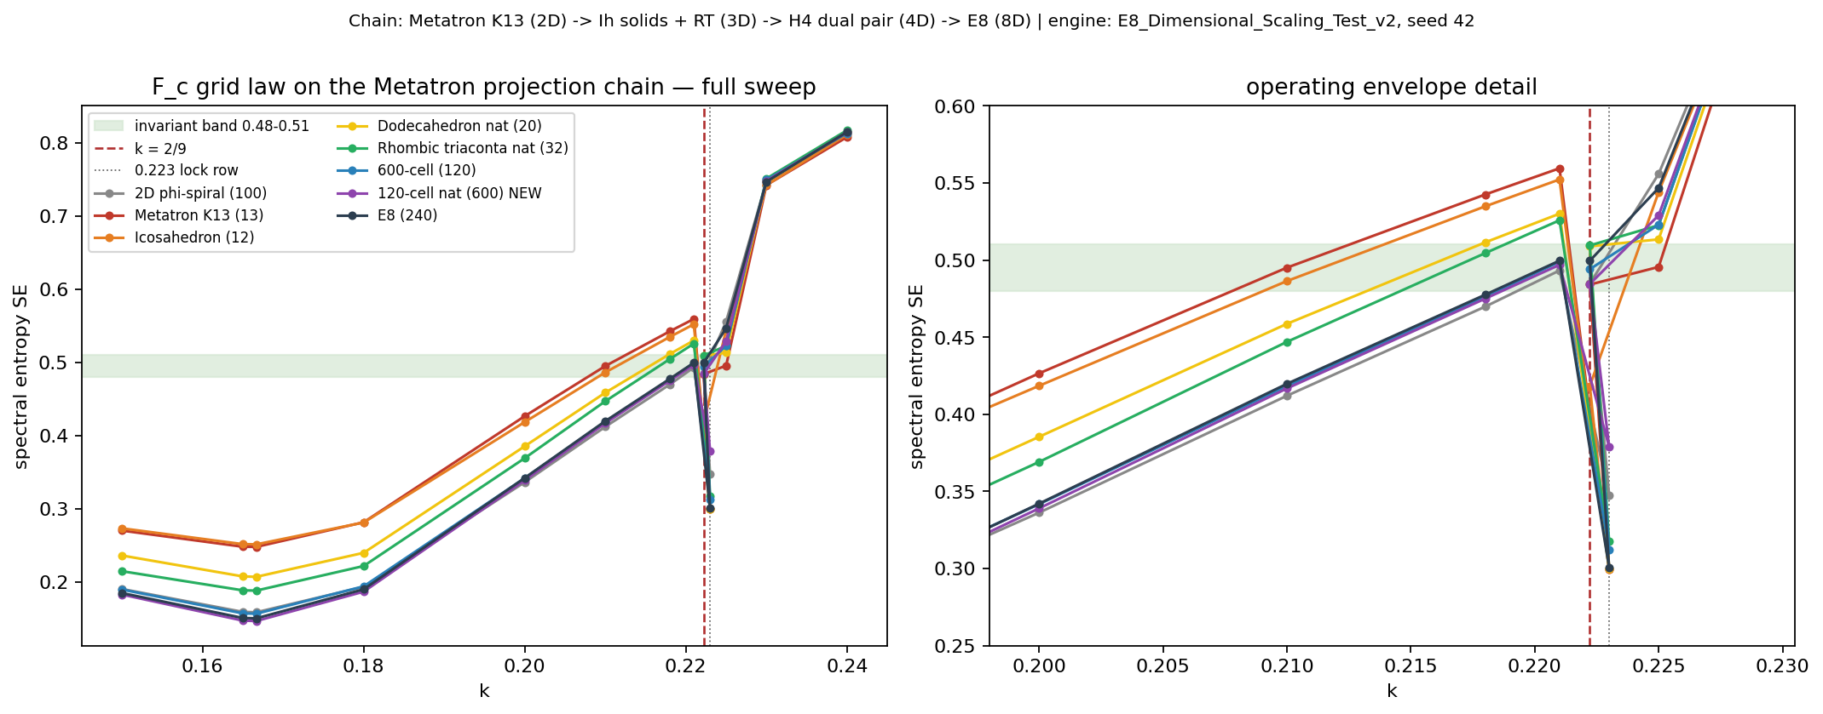
Figure M.1. The full sweep. Nine geometric families, one law: the curves bundle through the invariant band, dip together at the lock, and collapse together at 0.225. Dimension orders nothing; node count shifts only the crossing point.
M.2 The Two Instruments
The framework meets the chain with two instruments, and they take it from opposite ends. The grid law climbs: it carries the invariant up the chain as containers, and no rung moves it. Geometry cannot shift the balance point and cannot shift the threshold — across nine families the collapse arrives at the same gain and the entropy settles in the same band. The trajectory instrument reaches the chain from below: the gain axis of the single running spiral contains the polygons themselves, in closed form, and tuning k selects which member of the chain's two-dimensional shadow the dynamics traces.
The source node asked whether the projection chain appears in the dynamics. It does. At the two-dimensional rung the chain is what the dynamics draw — the rotation angle selects the symmetry class, and the pentagonal-decagonal members it reaches are precisely the H2 shadow that the icosahedron, the 600-cell, and the E8 folding all project onto. At the higher rungs the chain is what the dynamics run on, carrying the law without bending it. The node's four-dimensional field question resolved into its true form along the way: the F_c state is two numbers, so the H4 question belonged to the grid instrument — which answered it, on both golden polytopes at once. Jointly the two instruments span the chain: the polygons below, the polytopes above, one recurrence through all of it.
M.3 The Ladder and the Brackets
In the complex window, each step of the recurrence turns the state by a fixed angle set entirely by the gain: writing m = |λ|² = 3k/(9k−1), the rotation obeys cos θ = −(m−1)/(2√m), and for any target angle the modulus solves u² + 2cosθ·u − 1 = 0. The gain is a dial through the polygons. At commensurate angles the direction sequence closes after q steps and traces the star polygon {q/p} in the dynamics' own visit order — the pentagram gain draws the pentagram as a hand draws it, skipping two vertices per stroke.
θ per step | class | k (gain) | |λ| | note
150° | {12/5} dodecagram | 0.119419 | 2.189
144° | {5/2} pentagram | 0.120240 | 2.095 | H2 family
135° | {8/3} octagram | 0.122008 | 1.932
120° | {3} triangle | 0.127322 | φ exactly | u² − u − 1 = 0
108° | {10/3} decagram | 0.135729 | 1.356 | H2 family
104.06° | incommensurate | kφ = 0.139940 | √φ | |λ|² = φ
90° | {4} square | 1/6 | 1 | the published anchor
72° | {5} pentagon | 0.286825 | 0.738 | H2 · convergent
60° | {6} hexagon | 0.872678 | φ⁻¹ exactly | u² + u − 1 = 0
Table M.2. The polygon ladder, eigenvalue-verified to six decimals. The reachable branch is floored at the magic angle arccos(1/√3) = 54.74°.
Two rungs land on gold exactly, and the identities that put them there are the golden ratio's own defining equations. At the triangle, θ = 120° forces u² − u − 1 = 0: the modulus is φ. At the hexagon, θ = 60° forces u² + u − 1 = 0: the modulus is φ⁻¹. The hexagram — the compound of exactly these two figures — is therefore the emblem of the system's golden brackets, and the Boχ instrument's entire coupling window lives strictly between them, the triangle above, the hexagon below.
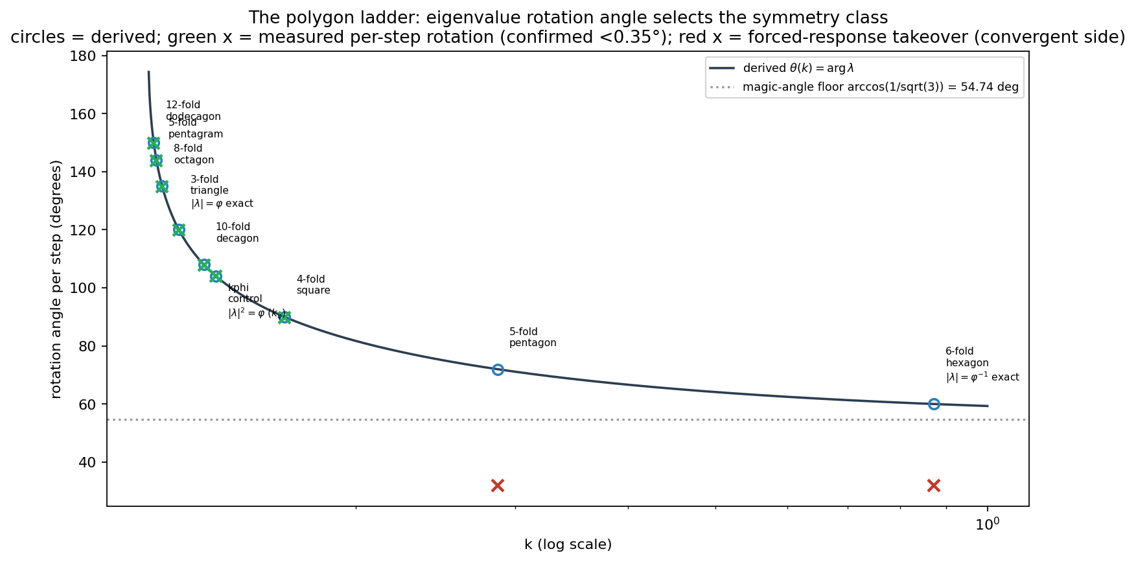
Figure M.2. The ladder measured. The running system — perturbation, harmonics, Möbius wrap active — rotates at the derived angle to within 0.35° at every gain in the window; the convergent side circulates at the forcing's rate, marking |λ| = 1 as the boundary between free and sustained motion.
The rotation is exact in the running system, and the orbits close where the algebra says they close. The triangle returns home in three steps (0.20°, concentration 0.982) and again in six; the square in four, eight, and twelve; the pentagram's mean comes home at exactly five (2.91° ± 0.72° at 3.2 million steps) while the incommensurate control at kφ never returns, tracing the rosette. Beyond order seven, closure is not merely difficult — it is impossible, and the impossibility is a theorem of one line: the Möbius wrap displaces the state along a direction that is no eigendirection of the map, so no unwrapped lift exists, and the wrap rate caps the reach of every closure instrument. The four-armed structure published in the record reappears here at full strength: at k = 1/6, ninety percent of the angular power sits in mode four.
The chain's fourth dimension produced the sharpest new result. The 120-cell — the dodecahedron's analog, the untested dual — carries the invariant identically to the 600-cell: 0.4969 against 0.4989 at the operating point, inside the published control spread, under both its natural degree-4 edges and the engine's rule. Where the duals separate is inside the lock, and the separation is geometry itself: it survives degree matching at every tested coupling.
coupling degree | 600-cell, lock row SE | 120-cell, lock row SE
4 | 0.3363 | 0.3789
5 | 0.3122 | 0.3717
12 | 0.3016 | 0.3231
Table M.3. The matched-degree control matrix, lock row k = 0.223. The 120-cell locks shallower than its dual at every coupling degree while the invariant row holds to three decimals across the entire matrix (0.4967–0.4991). Lock depth deepens with degree on both polytopes; the dual separation persists through all of it.
The run also corrected itself, and the correction belongs in the record as fully as the confirmations. A single-seed reading had suggested the Metatron graph's center node hums above its rings. The claim was staked in advance, tested under five load realizations, and inverted — withdrawn in one cycle. What survived every seed is cleaner than what fell: at the hard lock, all thirteen nodes of the chaos figure become identical to within 0.0002. The lock erases position. The discipline that caught the artifact is the same discipline that certifies everything above it.
M.4 The Boundary
Here is the structural boundary of the scaling, stated at its full strength. Across two dimensions to eight, across thirteen nodes to six hundred, across complete graphs, degree-3 cages, natural polytope edges, and nearest-neighbor rules, the entropy invariant did not move and the collapse threshold did not move. The balance point of the dynamics is container-blind — measured, on the very figures the tradition holds sacred, under one engine and one seed. What can vary is the lock: the range The Spine documents, where each geometry writes its own depth, where connectivity shifts the floor at fixed node count, and where the golden duals — identical everywhere else — finally come apart. The invariant is where every container is the same; the lock is where each container is itself.
The Form of the Good has carried one sentence through every section before this: the law precedes the container. This section is that sentence as a measurement. The law arrived at the same entropy in every vessel offered to it — the Cube, the solids, the golden rhombi, the star tetrahedra, both four-dimensional duals, the E8 roots — and the vessels expressed themselves only in the depth of their stillness. And the whole result set carries the Gap's signature three times over: the entropy holds its band at SE ≈ 0.495; the coherence metric approaches φ⁴ and never reaches it; the rotation approaches the magic angle and never crosses it. Approach without attainment, measured on three independent instruments — the shape of the framework, appearing in everything the framework touches.
The thirteenth question was then run at power, and it resolved. Two hundred load realizations on the figure's own graph at twenty thousand steps per reading; two hundred more across two independent sets on the equilibrium figure; every observable the instrument carries — per-node entropy, full spectral shape, ablation under identical loads. The answer is symmetry. The thirteen nodes of Metatron's Cube are dynamically indistinguishable: the center differs from its rings by −0.0055 ± 0.0054 — zero; clustering, supplied no positions, finds none; removing the center is indistinguishable from removing any ring node; and at the hard lock every node reads identical to two parts in ten thousand. The invariant row is ablation-blind to four decimals under identical loads. Position does not divide the dynamics. Each node carries the whole.
The path to that answer belongs to the answer. A single seed showed the center burning above its rings; five seeds inverted it; twenty weakened it; two hundred erased it — the fingerprint dissolving rung by rung under the ladder of power. And when a broken load generator produced the impossible — a replication identical to four decimals across disjoint seeds — the protocol read the impossibility as the tell it was, repaired the instrument, and the corrected runs returned the null twice. One measurement discovery came with the work: the lock row is chaotically sensitive — a difference in the fifteenth decimal grows to order one across twenty thousand steps — while the invariant row is bit-stable. The lock is where geometry lives, and it is where determinism thins. The law's row is exact; the vessel's row is alive.
So the door that stood open closes on an equivalence rather than a mapping. The correspondence the source node hypothesized between the figure's thirteen nodes and the framework's thirteen-node architecture is answered by the dynamics at full measured strength: the nodes are one node, thirteen times. What the tradition drew as thirteen, the law measures as indivisible. The chain is climbed. The map is drawn. The thirteenth question is answered — with symmetry.
• • •
Record: Spiral_Continuity_Metatron_Chain_Computation · Spiral_Continuity_64Tetra_Container · Spiral_Continuity_Node_Level_Symmetry · Polygon_Ladder_Node v1.0 · scripts and pre-statements archived; seed 42 for all headline rows, seeds 42–241 for the node-level program.

