Deploy Hold Music

Sample is a tailored 20 second sample with “fade-in/out” audio. Only needs to be .wav/.mp3

Deploy agent workstation audio alert sound

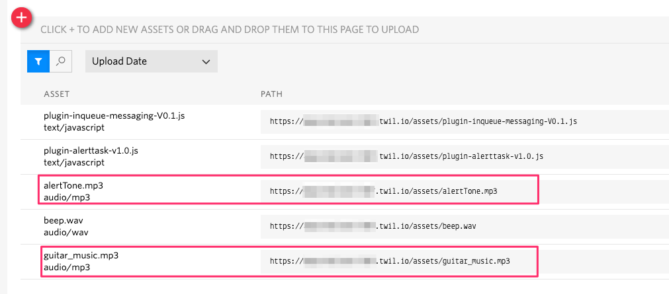

Create Task Channels

* Callback
* Voicemail

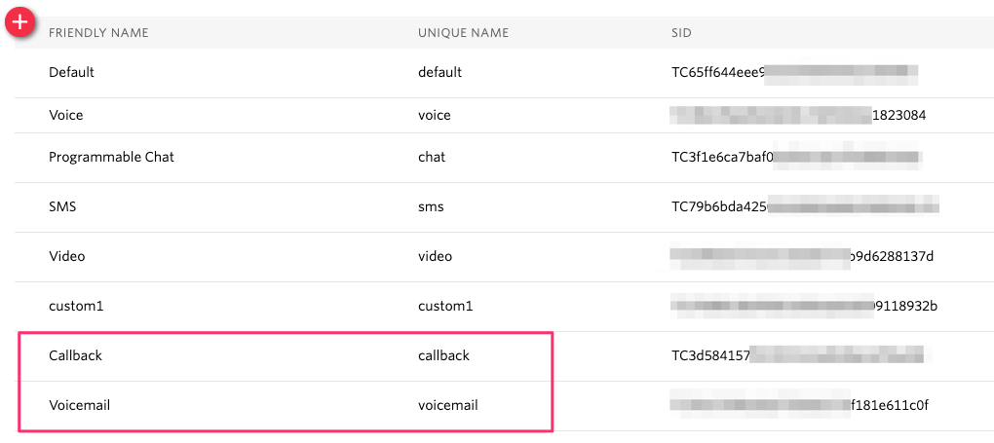

Create Task Queue: VoicemailCallbackQueue

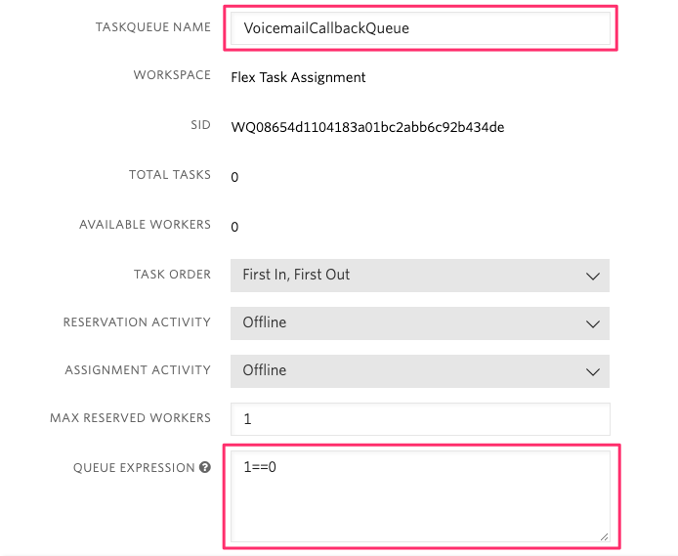

Workflow Filters:

* Callback_Voicemail – X Minute Hold – Attempt 1
* Callback_Voicemail – X Minute Hold – Attempt 2
* Callback_Voicemail – X Minute Hold – Attempt 3

Attempt 1

* Name: Callback_Voicemail – X Minute Hold – Attempt 1
* Matching Tasks:   
  (taskType=='callback' OR taskType=='voicemail') AND placeCallRetry==1
* Queue: VoicemailCallbackQueue
* Timeout: 10 sec ( configure to service level )
* Priority: Inherit ( default 50 (initial) )

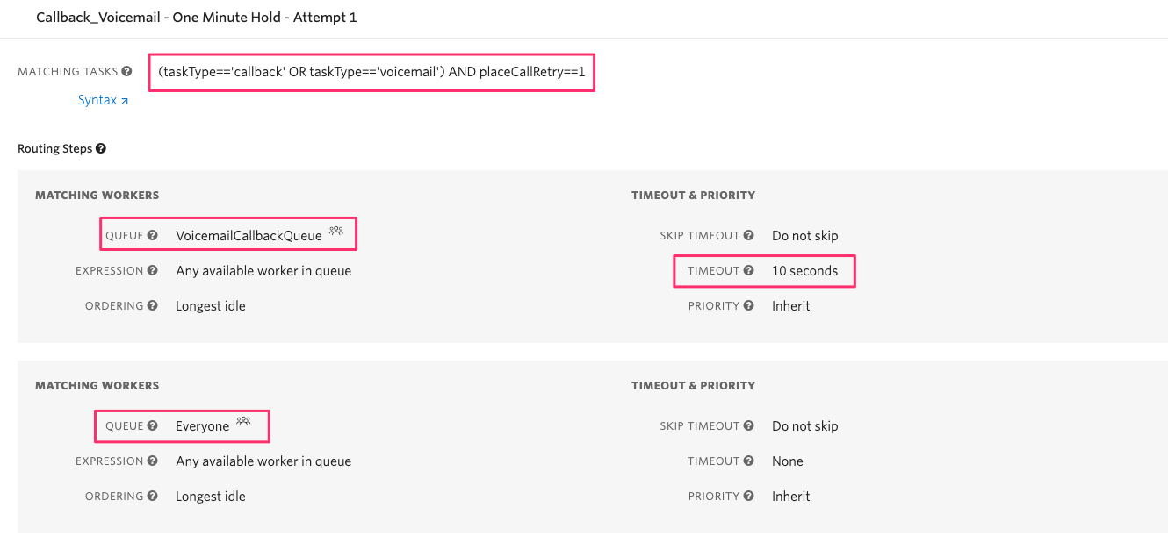

Attempt 2

* Name: Callback_Voicemail – X Minute Hold – Attempt 2
* Matching Tasks:   
  (taskType=='callback' OR taskType=='voicemail') AND placeCallRetry==2
* Queue: VoicemailCallbackQueue
* Timeout: 20 sec ( configure to service level )
* Priority: Inherit ( default 50 (initial) )

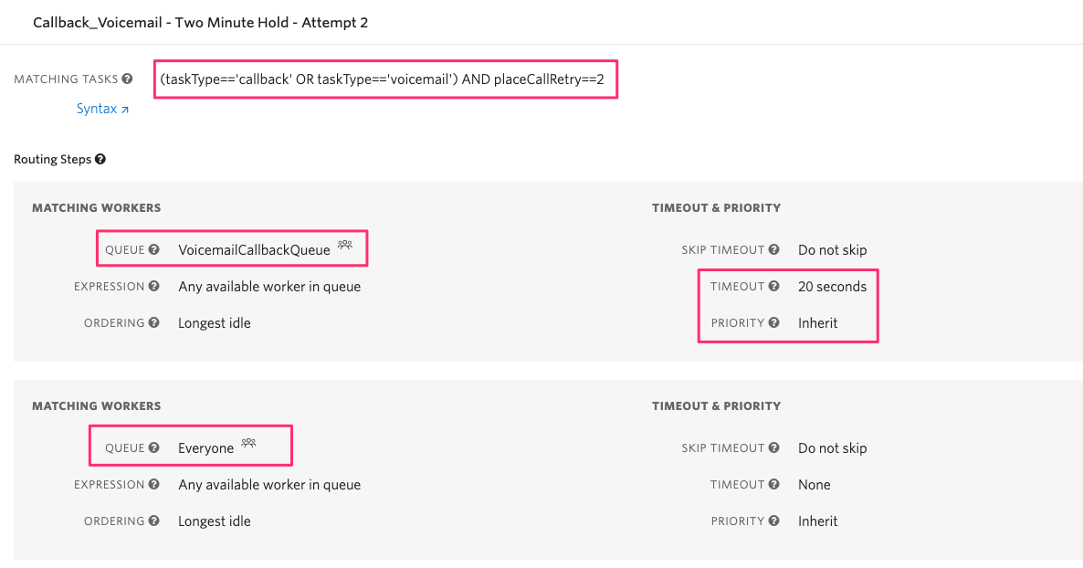

Attempt 3

* Name: Callback_Voicemail – X Minute Hold – Attempt 3
* Matching Tasks:   
  (taskType=='callback' OR taskType=='voicemail') AND placeCallRetry==3
* Queue: VoicemailCallbackQueue
* Timeout: 30 sec ( configure to service level )
* Priority: Inherit ( default 50 (initial) )

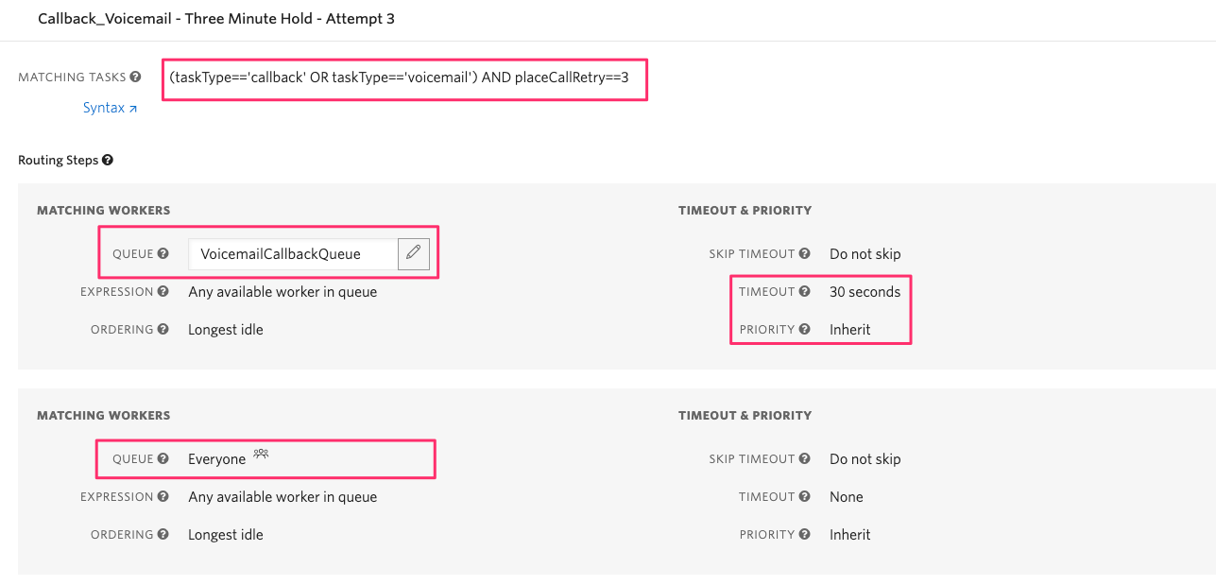

Function Environment Variables

Configure the following environment variable with the associated SIDs for your project.

* TWILIO_WORKSPACE_SID  
  This is your default workspace for Flex ( Flex Task Workspace) – Do not create a new workspace
* TWILIO_SYNC_SERVICE_SID (future)  
  Create a new Sync Service ( CallbackVoicemailService) – TBD

Function Code Deployment  
  
This Flex customization includes four (4) Twilio Functions that provide the following capabilities:

* Name: util_inQueueMenuMain  
  Synopsis: This is the entry point for the InQueue Messaging features that provide the “Main Menu” of in-queue options
* Name: util_InQueueCallBackMenu  
  Synopsis: This is the single function that include several methods supporting reception, processing and instantiation of Callback Tasks in Twilio Flex.
* Name: util_InQueueVoicemailMenu  
  Synopsis: This is the single function that include several methods supporting reception, processing and instantiation of Voicemail Tasks in Twilio Flex.
* Name: util_InQueueFlexUtils  
  Synopsis: This function provide utility methods consumed by the Twilio Flex plugin for user initiated actions in the Flex user interface (UI).

Details on the function properties (name, path, access control and configuration/customization) is provided in the comment header of each of the Twilio function code blocks.

Function Dependencies

Configure the following NPM dependencies.

* moment ( 2.24.0 )  
  Used in resolving callback/voicemail time/date/timezone
* moment-timezone ( 0.5.28 )  
  Used in resolving callback/voicemail time/date/timezone
* twilio-flex-token-validator ( * )  
  Used by Flex Plugin to securely authenticate access to utility function for plugin AJAX operations.

Studio Configuration

Configure your inbound “Send To Flex” widgets “HOLD MUSIC TWIML URL” with the URL for the primary function ( util_inQueueMenuMain ).

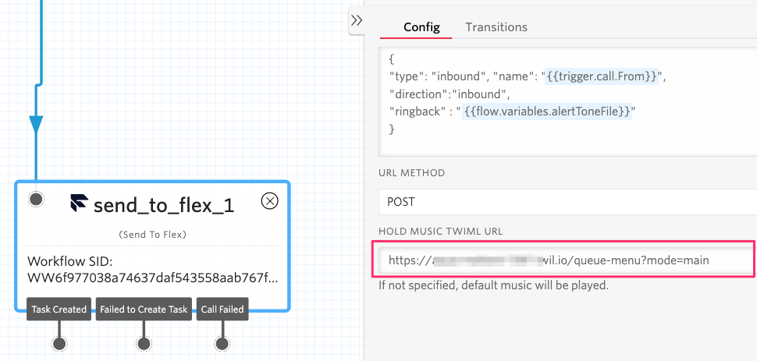

Flex/Plugin Build and Deploy

Managing Callbacks

Alerting Callback Task

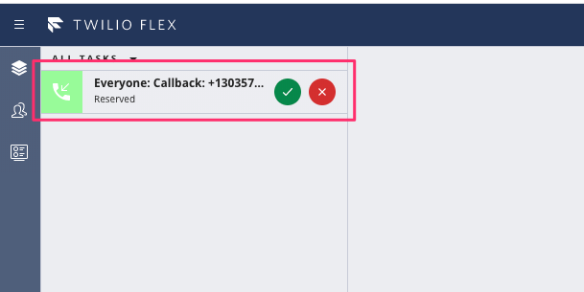

Callback UI Info Panel

|  |  |
| --- | --- |
|  |  |
|  |  |
|  |  |

Placing the Call ( Callback )

|  |  |
| --- | --- |
| Placing the Call ( Callback) | Callback Task View ( Call in-progress ) |
|  |  |
|  |  |

Re-Queuing a Callback

|  |  |  |
| --- | --- | --- |
| Initial Callback State | Second Attempt | Third Callback Attempt |
| (failed call attempt) | (prior to second Attempt) | (After third attempt) |
|  |  |  |
|  |  |  |

Managing a Voicemail

Alerting Voicemail

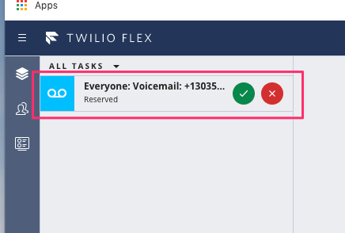

Voicemail Info Panel

|  |  |
| --- | --- |
|  |  |
|  |  |
|  |  |
|  |  |
|  |  |

Placing the Voicemail Callback

|  |  |  |
| --- | --- | --- |
| Initial Voicemail State | Second Call Attempt | Third Call Attempt |
| (failed call attempt) | (prior to second Attempt) | (After third attempt) |
|  |  |  |

Delete voicemail recordings

|  |  |
| --- | --- |
|  |  |