Analysis

Me

5/1/2019

# Our new analysis

data <- read_csv("https://raw.githubusercontent.com/jmadin/himbr/master/data/seed_root_herbivores.csv")

## Parsed with column specification:  
## cols(  
## Plot = col_character(),  
## `Seed herbivore` = col_logical(),  
## `Root herbivore` = col_logical(),  
## `No stems` = col_double(),  
## Height = col_double(),  
## Weight = col_double(),  
## `Seed heads` = col_double(),  
## `Seeds in 25 heads` = col_double()  
## )

data %>%  
 select(Height, Weight)

## # A tibble: 169 x 2  
## Height Weight  
## <dbl> <dbl>  
## 1 31 4.16  
## 2 41 5.82  
## 3 42 3.51  
## 4 64 7.16  
## 5 47 6.17  
## 6 52 5.32  
## 7 57 23.4   
## 8 27 1.76  
## 9 40 4.01  
## 10 33 2.58  
## # ... with 159 more rows

data[c("Height", "Weight")]

## # A tibble: 169 x 2  
## Height Weight  
## <dbl> <dbl>  
## 1 31 4.16  
## 2 41 5.82  
## 3 42 3.51  
## 4 64 7.16  
## 5 47 6.17  
## 6 52 5.32  
## 7 57 23.4   
## 8 27 1.76  
## 9 40 4.01  
## 10 33 2.58  
## # ... with 159 more rows

plot(Weight ~ Height, data)

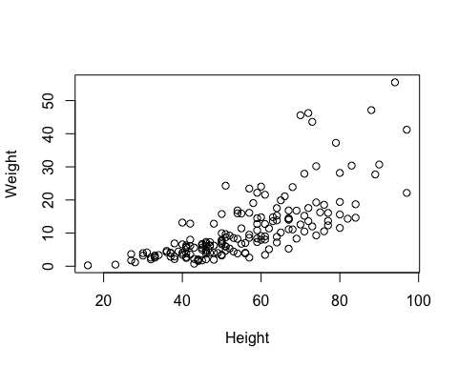

data <- data %>%  
 mutate(Height_log10 = log10(Height), Weight_log10 = log10(Weight))  
  
#pdf("output/figure1.pdf")  
  
 plot(Weight_log10 ~ Height_log10, data)  
   
 mod <- lm(Weight_log10 ~ Height_log10, data)  
 x <- sort(data$Height_log10)  
 pred <- predict(mod, list(Height_log10=x), interval="prediction")  
   
 lines(x, pred[,1])  
   
 polygon(c(x, rev(x)), c(pred[,2], rev(pred[,3])), col=rgb(0,0,0,0.1), border=NA)

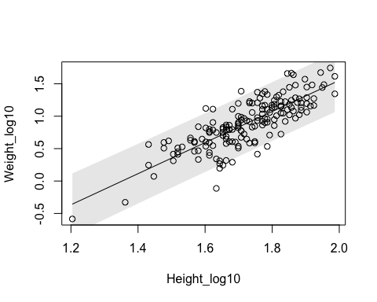

#dev.off()  
  
write.csv(summary(mod)$coef, "output/table1.csv")

## R Markdown

This is an R Markdown document. Markdown is a simple formatting syntax for authoring HTML, PDF, and MS Word documents. For more details on using R Markdown see <http://rmarkdown.rstudio.com>.

When you click the **Knit** button a document will be generated that includes both content as well as the output of any embedded R code chunks within the document. You can embed an R code chunk like this:

summary(cars)

## speed dist   
## Min. : 4.0 Min. : 2.00   
## 1st Qu.:12.0 1st Qu.: 26.00   
## Median :15.0 Median : 36.00   
## Mean :15.4 Mean : 42.98   
## 3rd Qu.:19.0 3rd Qu.: 56.00   
## Max. :25.0 Max. :120.00

## Including Plots

You can also embed plots, for example:

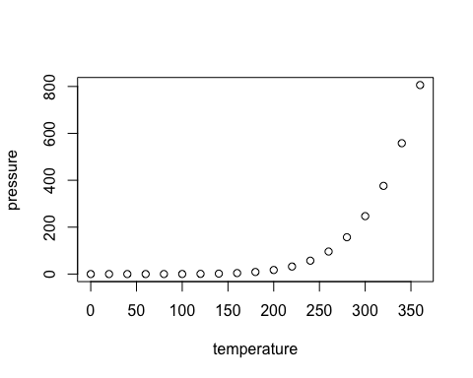

Note that the echo = FALSE parameter was added to the code chunk to prevent printing of the R code that generated the plot.