Selecting species for ecosystem restoration based on resilience, function and restorability

**Abstract**

Methods for protecting and restoring ecosystems traditionally focus on one or few species. Little consideration has been given to criteria for species selection in ecosystems with rich assemblages of foundational taxa, such as rainforests and coral reefs. Here we present a bet-hedging approach for the selection of multiple species by weighting species by ecological characteristics that are known to increase likelihood to resist, recover from, and adapt to adverse conditions, particularly those projected in a warming future. Weightings can also be reversed if protection aims to support species that are more likely to require human intervention. We then capture an even spread of life history strategies, given that inherent physiological trade-offs result in no one species having optimal fitness in every environment, and that different life histories tend to support particular ecosystem functions. Finally, the restorability of species (i.e., ease of husbandry) is considered, given that some species are easier to grow in nurseries, brood or propagate, or preserve via cryopreservation and in seed banks. Logistical practicalities are important for restoration initiatives to succeed. We give examples of the bet-hedging approach using a rich collation of phenotypic traits and ecological characteristics for scleractinian coral species found on the Great Barrier Reef. Reef building corals are the foundation of coral reef ecosystems, but are declining due of environmental change. We hope that a quantitative bet-hedging approach will help inform decisions for species protection and ecosystem restoration.

**Notes**

* There are more knowledgeable people in the group who might like to fill in the first few paragraphs of the Introduction. I’ve added some topic sentences and outlines I think might work.

**Introduction**

Topic: There is a long history of protection and restoration of species populations by humans.

* The objective of restoration is to repair disturbed ecosystems through human intervention.
* Some interesting examples?
* Protection is easier when one focusing on one species, such as the loss of a keystone predator or foundational / monoculture species.
* Protection is harder in species rich systems, like tropical rainforest and coral reefs, where species play numerous ecosystem roles, but their specific ecological roles are unknown, and they are differentially impacted by disturbance.

Topic: Selecting species for protection or restoration in biodiverse ecosystems might happen in various ways. For instance,

* focusing on species providing a certain service (carbon storage in rainforests or mangrove forests, or reef accretion on coral reefs for coastal protection).
* Focusing on keystone species to restore ecological functions (species serving as habitat for endangered species or ecosystem engineers, structurally complex species particularly suited to restoring the biodiversity of associated biota hence ecosystem functions).
* Assembling combinations of species that facilitate each other’s existence
* Focusing on weedy pioneer species to maximise initial speed of restoration or on particularly persistent species to maximise long-term restoration success
* Focusing on one or two species that are doing poorly. For example, restoring staghorn corals in the Caribbean that declined dramatically since the 1980s.
* However, approaches for objectively selecting larger numbers of foundational species based on clear ecological and logistical criteria are rare (but see?).

Topic: Environmental change is manipulating the playing field for species protection and restoration.

* Humans are not simply repairing a known ecosystem that has been disturbed, but must also anticipate future ecosystem states.
* We know that certain groups of species will struggle in coming years and decades. Therefore, ethical decisions must be made about supporting those most likely to do better to improve future persistence, or focus on those that will struggle and potentially push them through a period of elevated stress.

Selecting a group of foundational species for protection or restoration should capture at least three unique dimensions to be successful.

First, we know that species with certain ecological characteristics are better equipped to avoid sporadic disturbances and resist or recover from large-scale events like fires or marine heatwaves (refs). For example, species with larger range sizes are more likely to maintain populations following disturbance (ref). Ecologically dominant species tend to bounce back faster following an impact (refs). Furthermore, some species are already better at resisting the kinds of disturbances that are expected to become more regular or more intense in the future (e.g., coral bleaching; Loya et al. Hughes et al.). [genetic / faster adaptation example missing.]

Second, species selection should capture as much of the current phenotypic and demographic variation as possible. Indeed, species coexist because none are good in all situations and environments (Chesson, Sale, ), with a multitude of inter-specific co-dependencies. Moreover, species that contribute relatively more to ecosystem functions, like primary production and nutrient cycling, tend to have particular life history strategies (i.e., combinations of phenotypic and demographic traits; Darling et al. **, McWilliam et al. 2018; Goreau 1963). Many phenotypic traits are evolutionarily conserved, and so choosing an even spread of species across life history strategies will increase phylogenetic diversity (Westoby et al. ).

The third dimension is restorability, or ease of husbandry. If a protection effort is to include restoration, then it must focus on species that are suited to restoration to be successful. For example, restoration may be facilitated by the use of species that can be easily propagated in the laboratory via sexual reproduction, grown in nurseries and out-planted or manipulated in the field. Furthermore, some phenotypic traits and beneficial characteristics of species make them better candidates for restoration than others. For example, it easier to generate coral nubbins from branching species than it is with hemispherical species.

The aim of this paper was to develop a quantitative approach to select *n* species for protection and restoration based on the three dimensions outlined above. Our method has a high probability of maintaining ecosystem function and captures high levels of phylogenetic diversity, and it therefore hedges for a range of sensitivities to future stressors. We demonstrate this approach with reef building corals on the Great Barrier Reef. Although the data and results are only illustrative at this stage, and further scrutiny is required before making formal protection and restoration decisions regarding corals on the GBR, it provides a quantitative, reproducible and transparent basis for species selection.

**Methods**

*Beneficial ecological characteristics*

The species choice approach starts with a list of species for a given region or habitat, which defines the scale of the protection or restoration initiative. Characteristics of these species are collated that have been shown, or are expected, to improve population-level persistence; e.g., the ability of individuals to resist impacts or populations to recover quickly afterwards. We use the term characteristic to distinguish from phenotypic traits below. By way of demonstration, we focus broadly on three characteristics—ecological dominance, geographic range size and bleaching susceptibility—of reef building coral species on the Great Barrier Reef. GBR local abundance (Veron 2000) and geographic extent (Hughes et al. 2013) were downloaded for 396 species from the Coral Trait Database (Madin et al. 2016). GBR local abundance was categorized by Veron (2000) as common, uncommon and rare, which we normalized as 1, 0.25 and 0.1, respectively. Geographic extent was normalized to be between 0 and 1 by dividing each range size by the maximum range size for a GBR species. Bleaching susceptibility is an important characteristic for corals; however, it can be context dependent and poorly understood (Marshall & Baird?). Nonetheless, we use the Coral Bleaching Index (BI) from Swain et al. (2016) to demonstrate how this variable might be included in the analysis. BI is a value between 0 and 100, where higher values correspond with more thermally vulnerable species. Therefore, we normalized the index by dividing by 100 and subtracting the result from 1 (i.e., species with values closers to 1 are more resistant to bleaching based on Swain et al. [2016]). Normalized BI values were merged with the other ecological characteristics, reducing the number of species with complete data to 212 (~54% of GBR species according to the Coral Trait Database).

Weighting species by beneficial characteristics was done simply by multiplying normalized characteristics. Species with values closer to 1—i.e., large ranges, common and resistant to bleaching—were considered those most likely to resist or recover from change (i.e., “winners” using the Loya et al. 2001 terminology). To redirect focus of species selection to the most vulnerable species (i.e., the likely “losers” that are rare, small ranged and sensitive to thermal stress), normalized values were subtracted from 1.

*Spectrum of life histories*

The next step was to collate quantitative phenotypic traits for the species. These traits should capture as many life history trade-offs as possible to help discriminate the functional roles to be protected (Darling et al. 2012; something for other taxa). Examples for sessile taxa might include size, growth rate, fecundity, skeletal or wood density, photosynthetic capacity, nitrogen use, and so on (Diaz et al. Plants; McWIlliam et al. 2018; Madin et al TREE?). Ideally, traits should capture well-known life history characteristics that allow for the parameterization of trade-offs, such as acquisition-conservation and seed size-number (Westoby et al. 2000 AREES). Trait lists for various taxonomic groups have grown rapidly over the last decade (Gallagher et al. 2020). However, trait data are still lacking or are unreliable for many of these groups; yet our view here is that any trait data that can discriminate species based on organismal function will help the species selection process and avoids potentially subjective expert opinion (Gretch?). Gaps in species trait datasets can be filled using various statistical methods, such as phylogenetic imputation (refs). Ideally, the final dataset should have more than five continuous traits in order to tease apart various ecosystem roles (Diaz et al. 2016).

For our demonstration we use the dataset from McWilliam et al. (2018) with the following traits: growth rate, corallite width, rugosity/branch spacing, surface area per unit volume, colony height, maximum colony size/diameter, and skeletal density. Missing trait data were filled based on species growth form and taxonomic family as per McWilliam et al. (2018). The trait space was calculated using the *princomp* function in R (R Core Team 2020) and is presented in Fig. 1A for the remaining 212 species. To illustrate an ecosystem function, reef building, we classify corals as builders, fillers, and cementers as described in Goreau (1963). Within our trait space, builders are large in size (tall and wide) with voluminous skeleton, fillers are highly branching and large in size, and cementers are large and flat (Fig. 1B).

Species selection across trait space was done by iteratively removing the species closest to other species in the space defined by PC1 and PC2 until *n* species remained. We used two approaches to measure the proximity of species: (1) the areas of Voronoi cells using the *voronoi.mosaic* function in the *tripack* package (Renka et al.), and (2) the mean of three nearest neighbor distances using the *nndist* function in the *spatstat* package (Baddeley et al. 2015).

Beneficial characteristic weightings were included by multiplying trait space proximity values (areas or distances) by the normalized characteristics during the iterative species removal process.

*Restorability*

[Restorability is currently just based on growth form which might be enough for a demonstration paper like this, but needs work / thought.] Similar to beneficial characteristics of species, the restorability index was a multiplier in the iterative species choice approach based on trait space proximity values above. However, unlike beneficial species characteristics, it would not make sense to reverse this variable (i.e., focus on difficult-to-restore species).

**Results**

The nearest neighbor distance method gave the best even spread of species in trait space (Fig. 1B, black points) given that the Voronoi method could not calculate cell areas for peripheral points (Fig. 1B, red points) that were subsequently retained during the iterative species selection process. The spread of species captured the three reef building functions builders, fillers, and cementers and also included areas of trait space made up of coral species with high surface area to volume ratios that are likely to be important as habitat for associated species.

Considering “winners” (i.e., beneficial ecological characteristics) alone, tended to select for species in a partial region of trait space (Fig. 2A, black points and dotted area). For example, the “filler” region of trait space was not well represented. Considering “winners” and nearest neighbor distances together increasing the spread of species in trait space by 36% (Fig. 2A, blue points and dotted area). In doing so, several highly-ranked “winners” that occupied trait space containing other “winners” were dropped in favor of almost-as-highly-ranked “winners” in underrepresented parts of the trait space. Including the restorability dimension resulted in marginal changes in selection of species (Fig. 2C), primarily due to switching species that are difficult to restore with those more easily restored while retaining an even spread of species in trait space and weighting for ecological winners. By switching the focus to species that are likely to suffer in the future, a distinct suite of new species was selected and represented those that are evenly distributed in traits space and have high restorability metrics (Fig. 2C). Species lists at different stages of the selection process for winners are presented in Fig. 3 and for losers in Fig. 4. Finally, Fig. 5 shows species selection for winners as the *n* is varied from 1 to 25. Because analysis presented here is to demonstrate a process rather than make recommendation, species names are not given.

**Discussion**

In this paper we have developed an approach for selecting species for restoration that considers three key dimensions: species function, resistance to impacts and restorability.

*No point writing discussion until path forward and key points are agreed upon.

*Key points*

* Selecting species based on beneficial ecological, biogeographical and evolutionary characteristics will likely miss important ecosystem functions. In this example, “fillers” would have been missed.
* The approach allows for protection and restoration initiatives that focus on either supporting winners or trying to save losers or a balance of the two
* The approach considers broad data types that are useful for making protection and restoration decisions.
* **Reiterate**: this paper aimed to present a process for decision making using real data. However, the data and results presented here should not be used for decisions without further consideration and analysis.

**References**

Baddeley A, Rubak E, Turner R (2015) Spatial Point Patterns: Methodology and Applications with R. London: Chapman and Hall/CRC Press, 2015.

Peter L. Chesson and Robert R. Warner (1981) Environmental Variability Promotes Coexistence in Lottery Competitive Systems Author(s): Reviewed work(s): The American Naturalist 117:923–943

Chesson P (2000) Mechanisms of Maintenance of Species Diversity. Annual Review of Ecology and Systematics 31:343–366

Darling ES, Alvarez-Filip L, Oliver TA, McClanahan TR, Côté IM (2012) Evaluating life-history strategies of reef corals from species traits. Ecology Letters 15:1378–1386

Díaz S, Kattge J, Cornelissen JHC, Wright IJ, Lavorel S, Dray S, Reu B, Kleyer M, Wirth C, Colin Prentice I, Garnier E, Bönisch G, Westoby M, Poorter H, Reich PB, Moles AT, Dickie J, Gillison AN, Zanne AE, Chave J, Joseph Wright S, Sheremet’ev SN, Jactel H, Baraloto C, Cerabolini B, Pierce S, Shipley B, Kirkup D, Casanoves F, Joswig JS, Günther A, Falczuk V, Rüger N, Mahecha MD, Gorné LD (2016) The global spectrum of plant form and function. Nature 529:167–171

Goreau TF (1963) Calcium carbonate deposition by coralline algae and corals in relation to their roles as reef‐builders. Comparative Biology of Calcified Tissue, Volume 109, Issue1 pp. 127-167.

Hughes, T. P., Connolly, S. R., Keith, S. A. (2013) Geographic ranges of reef corals (Cnidaria: Anthozoa: Scleractinia) in the Indo-Pacific. Ecology 94, 1659

Loya Y, Sakai K, Yamazato K, Nakano Y, Sambali H, van Woesik R (2001) Coral bleaching: the winners and the losers. Ecology Letters 4:122–131

Madin JS, Anderson KD, Andreasen MH, Bridge TCL, Cairns SD, Connolly SR, Darling ES, Diaz M, Falster DS, Franklin EC, Gates RD, Hoogenboom MO, Huang D, Keith SA, Kosnik MA, Kuo C-Y, Lough JM, Lovelock CE, Luiz O, Martinelli J, Mizerek T, Pandolfi JM, Pochon X, Pratchett MS, Putnam HM, Roberts TE, Stat M, Wallace CC, Widman E, Baird AH (2016) The Coral Trait Database, a curated database of trait information for coral species from the global oceans. Scientific Data 3:160017

McWilliam M, Hoogenboom MO, Baird AH, Kuo C-Y, Madin JS, Hughes TP (2018) Biogeographical disparity in the functional diversity and redundancy of corals. Proceedings of the National Academy of Sciences 115:3084–3089

R Core Team (2020). R: A language and environment for statistical computing. R Foundation for Statistical Computing, Vienna, Austria. URL https://www.R-project.org/.

Renka RJ, Gebhardt A, Eglen S, Zuyev S, White D (2020) tripack: Triangulation of Irregularly Spaced Data. R package version 1.3-9.1

Swain et al. ()

Veron, J. E. N. (2000) Corals of the World. Australian Institute of Marine Science and CCR Qld Pty Ltd.

Mark Westoby, Daniel S. Falster, Angela T. Moles, Peter A. Vesk, Ian J. Wright (2002) Plant Ecological Strategies: Some Leading Dimensions of Variation between Species. Annual Review of Ecology and Systematics 3:125–159

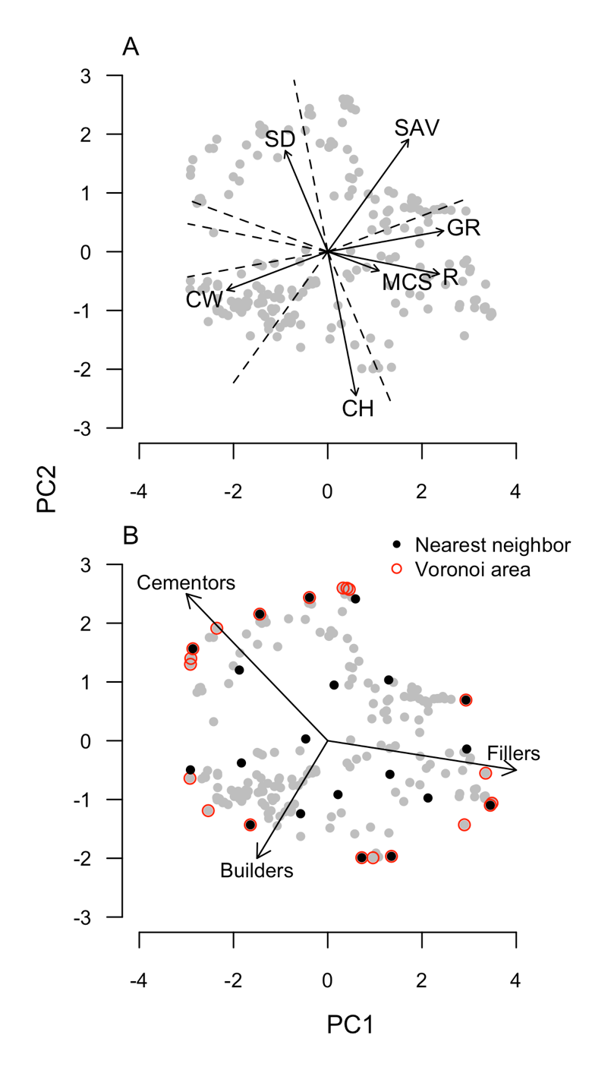

**Figure 1.** The phenotypic trait space for 212 coral species. (A) The trait loadings are as follows: growth rate (GR), corallite width (WD), rugosity/branch spacing (R), surface area per unit volume (SAV), colony height (CH), maximum colony size/diameter (MCS), and skeletal density (SD). (B) Goreau (1963) reef building categories superimposed onto selections of evenly spread species (*n*=20) calculated using Voronoi cell areas (red) and nearest neighbor distances (black).

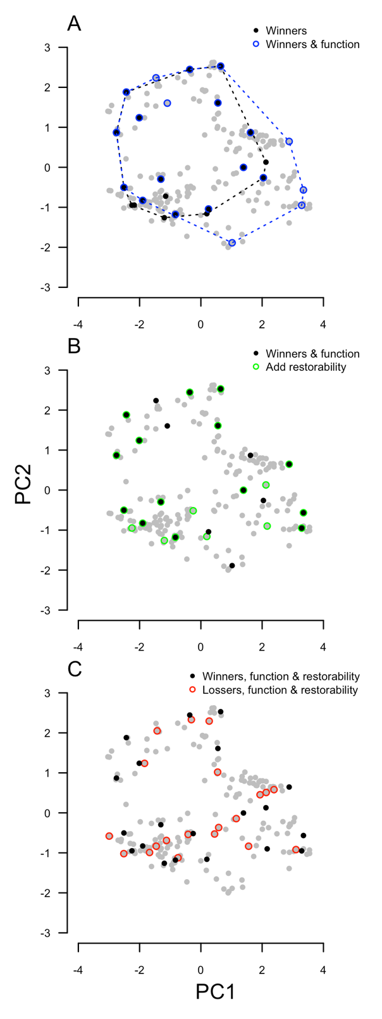

**Figure 2**. Species selection in trait space at different stages of the process. (A) Considering three beneficial ecological traits—ecological dominance, geographic range size and bleaching resistance—both alone (black points) and by spreading species evenly based on their traits (blue). Convex hulls (dotted lines) show difference in coverage of trait space. (B) Including restorability (green points) to the process of species selection. (C) Comparing species selection for species with large ranges, high abundances and high bleaching resistance (“winners”, black points) with the opposite (“losers”, red points).

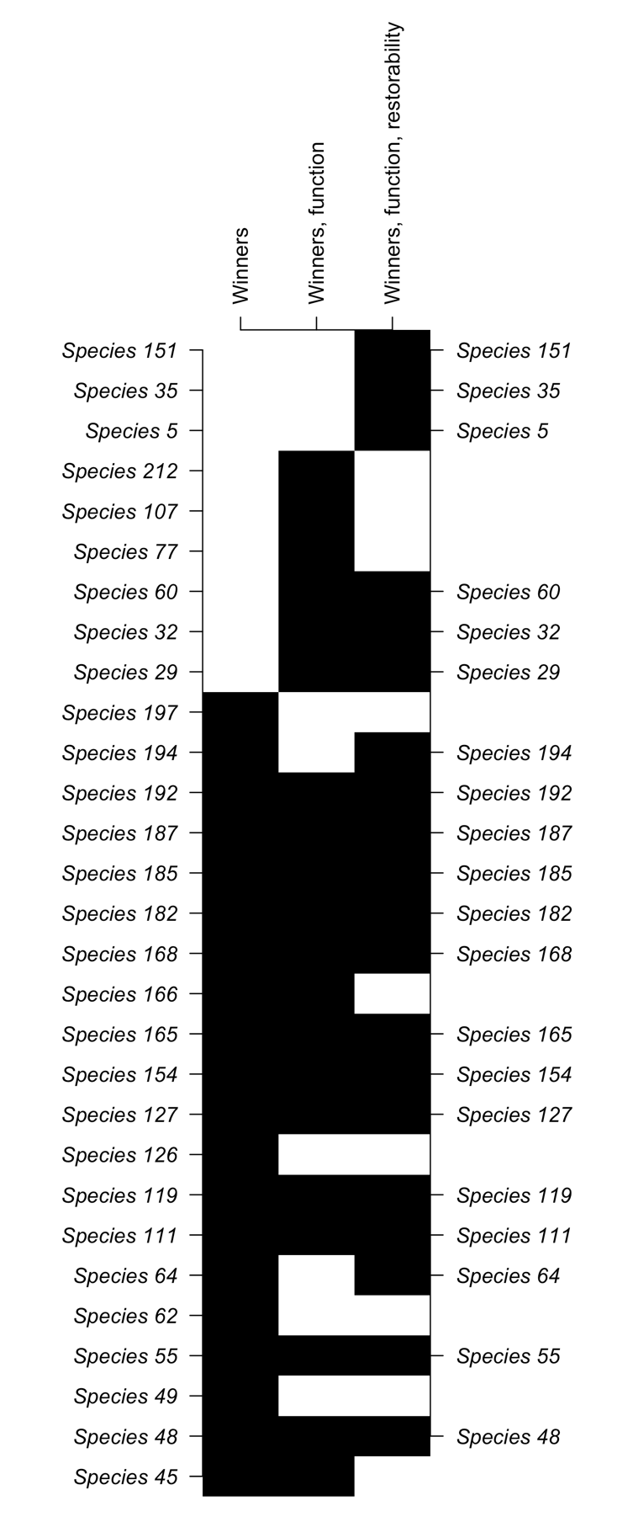

**Figure 3**. Changes in the species selection lists (*n*=20) at different stages of the process when focusing on ecological winners. If an initiative was only to focus on protection, and not restoration, then the middle list (“Winners, function”) might be the most appropriate.

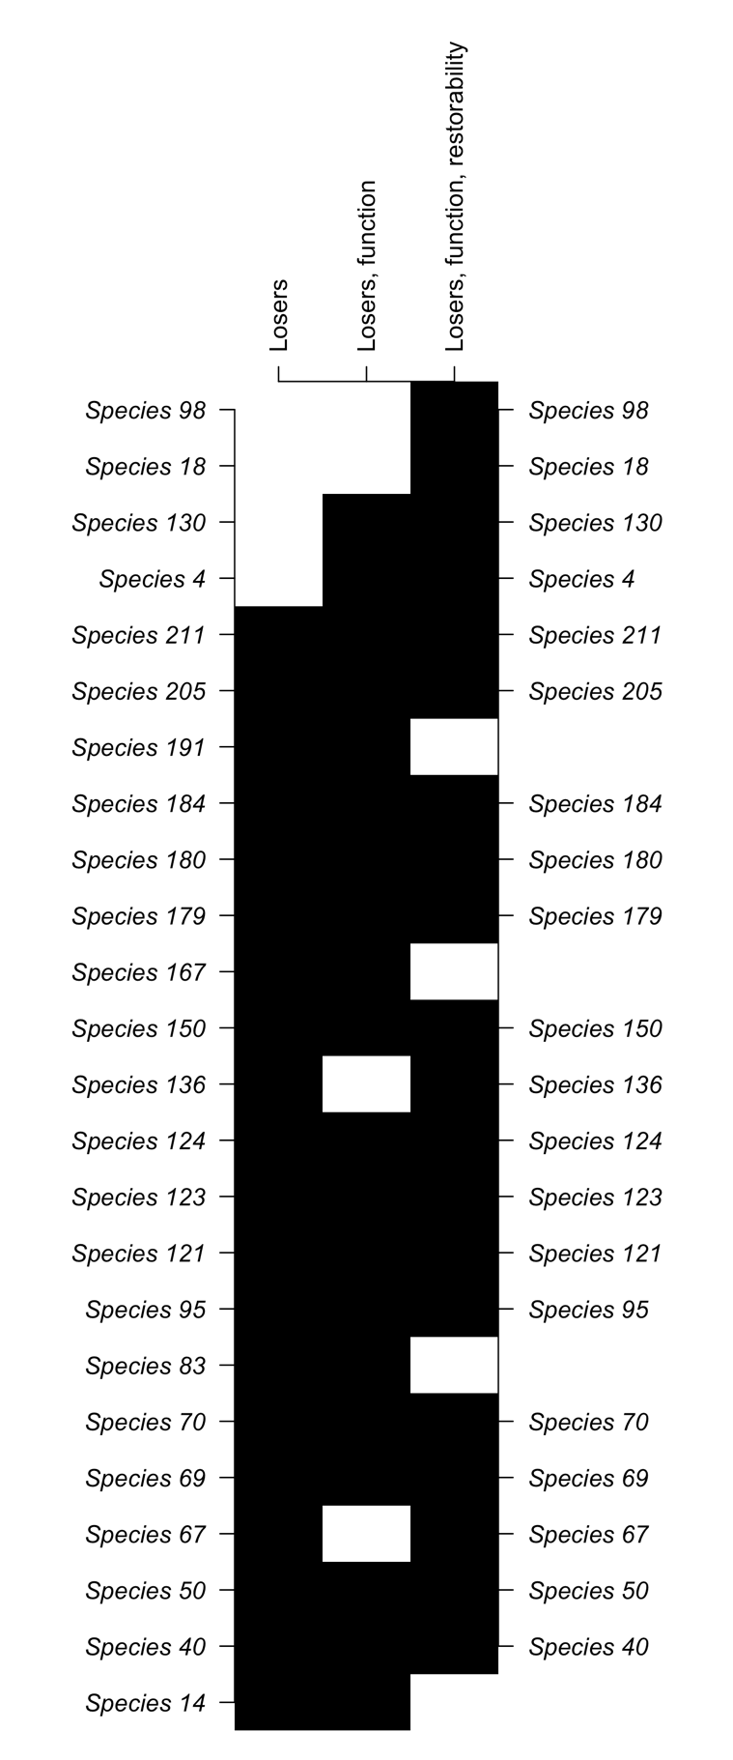

**Figure 4**. Changes in the species selection lists (*n*=20) at different stages of the process when focusing on ecological losers. If an initiative was only to focus on protection, and not restoration, then the middle list (“Losers, function”) might be the most appropriate.

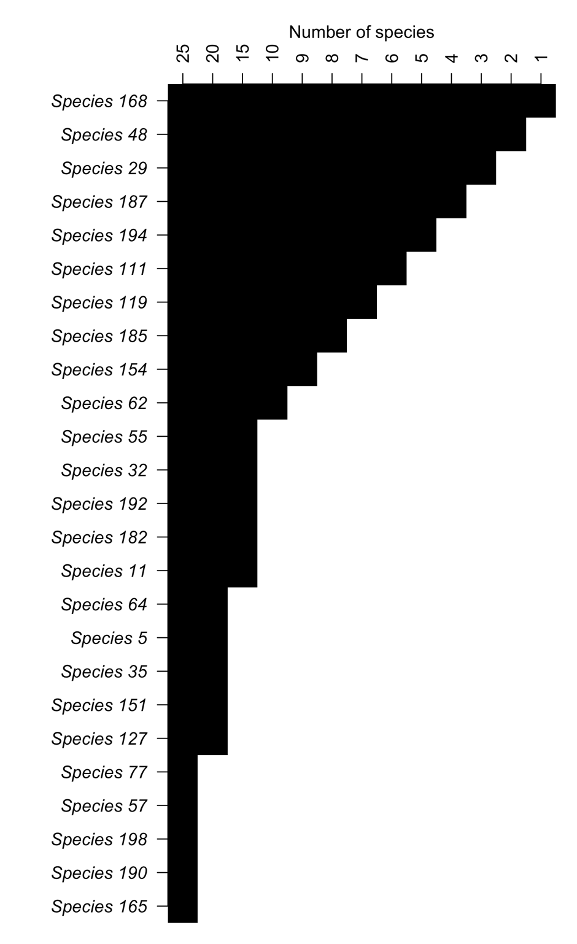

**Figure 5.** How species selection for “winners” changes based on the number *n* of species.