Selecting species for protection in foundational assemblages

Joshua S. Madin, Michael McWilliam, …

**Abstract**

Despite a long history of humans protecting species, little attention has been directed at how best to do so for rich foundation assemblages, such as rainforests and coral reefs, in which species play numerous ecosystem roles and are differentially impacted by disturbance. We present a triage approach that helps guide the selection of foundational species in order to protect ecosystem functions. The approach has two elements, the first of which ensures an even spread of life history strategies, given that inherent phenotypic trade-offs result in no single species having optimal fitness in every situation, and that different life histories tend to support particular ecosystem functions. The second element considers characteristics of species that are known to increase likelihood to resist, recover from, and adapt to adverse conditions—particularly those projected in a warming future. This element can also include species’ amenability to restoration, given that some species are easier to grow in nurseries, brood, propagate, and preserve via cryopreservation and in seed banks. We demonstrate the triage approach using a rich collation of ecological characteristics and phenotypic traits for scleractinian coral species found on the Great Barrier Reef and focus on the ecosystem function of reef building. Reef building corals are foundational for coral reef ecosystems, but like many foundational assemblages are declining due to environmental change. Our results show that

* That selecting species based on
* The number and identity of species protected depends on the coarseness of the trait diversity maintained. For example, protecting physical reef structure requires fewer species than protecting demographic breadth.

. We hope that our quantitative approach will help inform decisions for species protection and ecosystem restoration.

**Introduction**

There is a long history of protection and restoration of species populations by humans (Frankham; Bradshaw; other general refs).

* The objective of protection… (refs).
  + For example, …
* The objective of restoration is to repair disturbed ecosystems through human intervention.
  + Interventions can be direct, such as propagation and dispersal of habitat builders through seeds (e.g., seagrass Virginia) or propagules (e.g., oysters South Australia)
  + Interventions can be indirect, such as … return of hydrological regime for Spartina return (e.g., saltmarsh restoration Delaware)
  + Some interesting examples? (Orth et al. 2020; Williams et al. 2019)
* Protection initiatives, which sometimes include restoration, are easier when one focusing on one or few species, such as the loss of a keystone predator (Yellowstone wolves?) or removal of an invasive species (refs).
* However, climate change is now affecting the foundational species of ecosystem (forests, kelp forest, and coral reefs) forcing upon us a broadening of focus.
* Protection initiatives in species rich systems, like tropical rainforest and coral reefs, difficult to frame because species play numerous ecosystem roles, but their specific ecological roles are unknown, and are differentially impacted by disturbance.

Selecting species for protection or restoration in biodiverse ecosystems might happen in various ways. For instance,

* Focusing on species providing a certain function (carbon storage in rainforests [Strassburg et al. 2020] or mangrove forests [Adame et al. 2014], or reef accretion on coral reefs for coastal protection) (Bellwood et al. 2019; Wolfe et al. 2020).
* Focusing on keystone species to restore ecological service (species serving as habitat for endangered species or ecosystem engineers, structurally complex species particularly suited to restoring the biodiversity of associated biota hence ecosystem functions).
* Assembling combinations of species that facilitate each other’s existence
* Focusing on weedy pioneer species to maximise initial speed of restoration or on particularly persistent species to maximise long-term restoration success
* Focusing on one or two species that are doing poorly. For example, restoring staghorn corals in the Caribbean that declined dramatically since the 1980s and are at risk of functional extinction in many locations (Aronson & Precht 2001; Miller et al. 2016; Ladd et al. 2019).
* However, approaches for objectively selecting larger numbers of foundational species based on clear ecological and logistical criteria are rare (Lamb 2018; Suding et al. 2004).
* Some examples exist for plant restoration (Meli et al. 2013), and some have used functional traits in the process of selecting species (Giannini et al. 2017; Rayome et al. 2019).

Environmental change is manipulating the playing field for species protection and restoration.

* Humans are not simply repairing a known ecosystem that has been disturbed, but must also anticipate future ecosystem states (Rogers et al. 2015; Gaitán‐Espitia & Hobday 2021).
* We know that certain groups of species will struggle in coming years and decades. Therefore, ethical decisions must be made about supporting those most likely to do better to improve future persistence, or focus on those that will struggle and potentially push them through a period of elevated stress.
  + Pete Mumby: I’m wondering whether we should pose this as a dichotomy – essentially at its simplest to focus on ensuring survival of more resilient species vs helping more vulnerable but then pointing out that it’s more complex than this and leading to a clear statement of the key issues. Intrinsic importance of biodiversity (argues to be inclusive but may waste resources), focus on future ecosystem function (well known tension with biodiversity value), and the feasibility of achieving outcomes at affordable cost especially when trying to balance multiple objectives.

Preventing the collapse of coral reef ecosystems involves preserving ecosystem functioning and doing that involves protecting species diversity.

* Diversity underpins both the functioning and resilience of coral reef ecosystems because inherent variation in species responses to, and recovery after disturbances buffers ecosystems against change and increases stability and functioning (Nystrom et al., 2008; Loreau & de Mazancourt, 2013).
* Protecting and or restoring the entire complement of diversity is however a daunting task. By necessity, ecosystem management approaches adopt a triage approach that involves prioritizing the investment of scarce resources in a reduced set of factors that are more manageable.
* In the case of reef restoration, this means identifying which species will pilot the reconfiguration of future reefs under climate change and investing in those species in restoration programs.

New studies suggest there is some degree of functional redundancy in corals(McWilliam et al., 2018) hence, in order to identify which species provide lasting and novel contributions to ecosystem functioning (i.e. because they contribute to reef growth, the provision of habitat, phylogenetic diversity or other), is it necessary to consider which functions/ traits/ecological characteristics are most desirable….. (Bellwood et al. 2019).

* Need to discuss that in many cases we still don’t seem to know exactly which functions we want preserve or why (i.e. Bellwood et al. 2019). This question needs to be answered prior to species selection.

Selecting a group of foundational species for protection should capture at least two elements to be successful. The first element aims to capture phenotypic, demographic and phylogenetic variation.

* Indeed, species coexist because none are optimum in all situations and environments (Chesson, Grime, Wright et al. 2004), with a multitude of inter-specific co-dependencies. Moreover, species that contribute relatively more to ecosystem functions, like primary production and nutrient cycling, tend to have particular life history strategies (i.e., combinations of phenotypic and demographic traits; Darling et al. 2012, McWilliam et al. 2018; Goreau 1963).
* Many phenotypic traits are evolutionarily conserved, and so choosing an even spread of species across life history strategies will act to increase phylogenetic diversity (Westoby et al. ).

The second element aims to capture characteristics of species that are better equipped to avoid extinction and resist or recover from large-scale events like fires or marine heatwaves (refs). For example, species with larger range sizes are less likely to go extinct (Staude et al. 2020).

* Species with high local abundances tend to bounce back faster following an impact (Halford et al. 2004), but not always (Pete M: *Diadema antillarum*).
* Often there are synergistic relationships—e.g., extinction risk tends to be greater for geographically limited and locally rare species (Brown 1984)—yet range size and local abundance are not strongly associated for reef corals (Hughes et al. 2014).
* Meanwhile, some species are better at resisting the kinds of disturbances that are expected to become more regular or more intense in the future (e.g., coral bleaching; Loya et al. Hughes et al.).
* Meanwhile, if protection efforts are to include restoration, then species that are suited to restoration should be a consideration (Suggett et al. 2019). For example, restoration may be facilitated by the use of species that can be easily propagated in the laboratory via sexual reproduction, grown in nurseries and out-planted or manipulated in the field (Rinkevich 2020, Randall et al. 2020).
* Furthermore, some phenotypic traits and ecological characteristics of species make them better candidates for restoration than others. For example, it easier to generate coral nubbins from branching species than it is with mounding species, and so most restoration efforts on coral reefs have focused on branching corals (Bostrom-Einarsson et al. 2020). Similarly, restoring local areas of a species with a large geographical range would have a greater chance of improving meta-population connections and dynamics (ref?).

The aim of this paper was to develop a quantitative approach to select *n* species for protection and restoration based on the two elements outlined above: trait diversity and resistance to extinction. The triage approach we develop has a higher probability of maintaining ecosystem function and capturing high levels of phylogenetic diversity, and it therefore hedges for a range of sensitivities to future stressors. We demonstrate this approach with reef building corals on the Great Barrier Reef, which is a system that is likely to require increasing protection of coral species in the future (Richards and Day 2018). Although the data and results are only illustrative at this stage, and further scrutiny is required before making formal protection and restoration decisions, it provides a quantitative, reproducible and transparent basis for species selection.

**Methods**

*Spectrum of life histories*

The species triage approach starts with a list of species for a given region or habitat, which defines the scale of the protection or restoration initiative. Quantitative phenotypic traits are collated for these species that should capture as many life history trade-offs as possible to help discriminate the functional roles to be protected (Darling et al. 2012; something for other taxa). Examples for sessile taxa might include size, growth rate, fecundity, skeletal or wood density, photosynthetic capacity, nitrogen use, and so on (Diaz et al. Plants). Ideally, traits should capture well-known life history trade-offs, such as acquisition-conservation and seed size-number (Westoby et al. 2000 AREES). Trait lists for various taxonomic groups have grown rapidly over the last decade (Gallagher et al. 2020). However, trait data are still lacking or are unreliable for many of these groups; yet our view here is that any trait data that can discriminate species based on organismal function will help the species triage process and avoids potentially subjective expert opinion (Gretch? Madin et al TREE). Gaps in species trait datasets can be filled using various statistical methods, such as phylogenetic imputation (Kim et al. 2018; others).

For our demonstration we use the coral trait dataset from McWilliam et al. (2018) with the following traits: growth rate, corallite width, rugosity/branch spacing, surface area per unit volume, colony height, maximum colony size/diameter, and skeletal density. Admittedly, this dataset focused disproportionately on morphological traits and omits important physiological and reproductive traits, which a comprehensive future analysis should include for decision making. The trait space was calculated using the *princomp* function in R (R Core Team 2020) and is presented in Fig. 1A for the 396 species with sufficient trait data. To illustrate an ecosystem function that is highly correlated with the morphological traits in McWilliam et al. (2018), reef building, we classify corals as builders, fillers, and cementers as described in Goreau (1963). Within our trait space, builders are large in size (tall and wide) with voluminous skeleton, fillers are highly branching and large in size, and cementers are large and flat (Fig. 1B).

Species selection across trait space was done by iteratively removing the species closest to other species in the space defined by PC1 and PC2 until *n* species remained. We tried two approaches to measure the proximity of species: (1) the areas of Voronoi cells using the *voronoi.mosaic* function in the *tripack* package (Renka et al.), and (2) the nearest neighbor distances using the *nndist* function in the *spatstat* package (Baddeley et al. 2015).

*Ecological persistence*

Characteristics of these species are then collated that have been shown, or are expected, to improve population-level persistence; e.g., the ability of species to resist extinction, individuals to resist impacts, or populations to recover quickly after impacts. We use the term characteristic to distinguish from phenotypic trait. By way of demonstration, we focus broadly on three characteristics—ecological abundance, geographic range size and bleaching susceptibility—of reef building coral species on the Great Barrier Reef. We use GBR local abundance from Veron (2000) and geographic extents from Hughes et al. (2013). These estimates were downloaded for 396 species from the Coral Trait Database (Madin et al. 2016). Ecological abundance was categorized by Veron (2000) as common, uncommon and rare, which we normalized as 1, 0.5 and 0.1, respectively. Geographic extent was normalized to be between 0 and 1 by dividing each range size by the maximum range size for a GBR species.

Bleaching susceptibility is an important characteristic for corals; however, it can be context dependent and poorly understood (Suggest & Smith 2020). Nonetheless, we use the Coral Bleaching Index (BI) from Swain et al. (2016) to demonstrate how this variable might be included in our analysis. BI is a value between 0 and 100, where higher values correspond with more thermally vulnerable species. Therefore, we normalized the index by dividing by 100 and subtracting the result from 1 (i.e., species with values closers to 1 are more resistant to bleaching based on Swain et al. [2016]). Swain et al. (2016) only had species level BI for 212 of the GBR species (according to the Coral Trait Database), and so we used genus level BI for the remainder so as to retain all 396 species.

Weighting species by beneficial characteristics was done simply by multiplying normalized values. Species with values closer to 1—i.e., large ranges, common and resistant to bleaching—were considered those most likely to avoid extinction and resist or recover from change. To redirect focus of species selection to the most vulnerable species, normalized values were subtracted from 1 before proceeding.

Given the restoration of corals is a relatively new field (ref?), there is little knowledge of what makes species more or less amenable to restoration. A meta-analysis of coral restoration studies ranked the use of coral growth forms in restoration projects (Boström-Einarsson et al. 2020). While this ranking likely reflects specific situations, such as the demise of branching Acropora species in the Caribbean (ref), we nonetheless utilize this ranking as an index of amenable to restoration. Species growth form was downloaded from the Coral Trait Database and species were ranked from 1 to 6 like so: branching (6), massive (5), foliose (4), encrusting (3), tabular (2), columnar (1). This ranking was normalized by dividing values by size, suggesting that branching species are most suitable for restoration.

Ecological persistence weightings were included in the triage analysis by multiplying trait space proximity values (Voronoi cell areas or nearest neighbor distances) by the normalized characteristics during an iterative species removal process. That is, the first iteration started with all 396 species whose proximity values to each other were multiplied by each ecological weighting and the one species with the lowest value was removed; and this process repeated until the predetermined number *n* of species remained. Several metrics of trait space were measured during the iterative process. The area of trait occupied by the remaining species was calculated using the *chull* function in R (R Core Team 2021) and the *Polygon* fuction in the *sp* package (Pebesma & Bivand 2005). The region of occupancy was calculated using different sized grid superimpoased onto trait space—coarse scale of 5 by 5 cells, and fine scale of 10 by 10 cells—and counting the number of cells occupied at each iteration.

Finally, we contrast the results with Clipperton Atoll, which is a reef accreting ecosystem with only seven species with high levels of phenotypic redundancy.

**Results**

The nearest neighbor distance method gave the best even spread of species in trait space (Fig. 1B, points) given that the Voronoi method could not calculate cell areas for peripheral points (Fig. 1B, crosses) that were subsequently retained during the iterative species removal process. The spread of species captured the three reef building functions builders, fillers, and cementers, and also included areas of trait space made up of coral species centered in the functional space and those with high surface area to volume ratios that are likely to be important as habitat for associated species (Torres-Pulliza et al. 2020 OR Zawada et al. 2019).

Focusing on beneficial ecological characteristics alone tended to select for species in a partial region of functional space (Fig. 2A, crosses and dashed area). For example, filler species were not well represented. However, when combining with nearest neighbor distances, the spread of species in functional space increased by 36% (Fig. 2A, points and solid area). In doing so, some highly-ranked ecological species that were close to other highly ranked species in functional space were dropped in favor of less highly-ranked species in underrepresented parts of functional space.

Including the ranking of species’ amenability of restoration (here, based on growth forms only; Boström-Einarsson et al. 2020) resulted in some changes in selection of species (Fig. 2B, crosses), primarily due to switching species that are difficult to restore with those more easily restored while retaining an even spread of species in trait space and weighting for ecological characteristics. By switching the focus to species that are likely to suffer in the future, a distinct suite of new species was selected and represented those that are evenly distributed in functional space that are amenable to restoration (Fig. 2C, points). Species lists at different stages of the triage process when focusing on resilient and vulnerable species are presented in Fig. 3 and Fig. 4, respectively.

Fig. 5 shows the relationships between *n* and the functional space occupied for several scenarios. First, simply choosing species randomly had the lowest functional space occupied on overage (Fig. 5, black curve with 95% Cis based on 1000 subsamples with replacement). Choosing species based on least ecological vulnerability resulted in a similar occupation of trait space to random (Fig. 5, green curve). Selecting species based on functional evenness maintained the greatest functional occupancy (Fig 5, red curve). Selecting based on both function and least ecological vulnerability reduced functional occupancy, but maintained a level higher than both random and ecological vulnerability alone (Fig. 5, blue curve).

**Discussion**

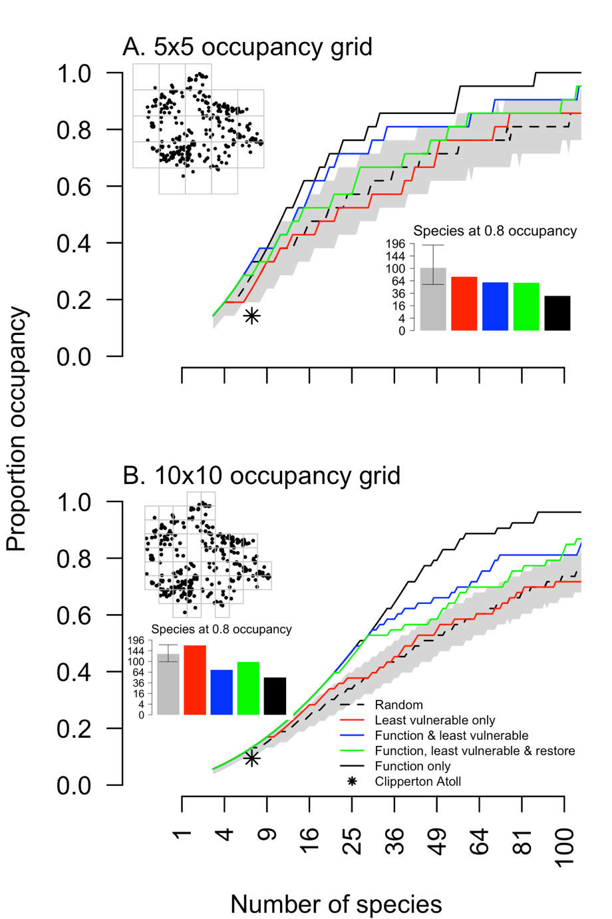

Figure. X.

Take home messages:

* Selecting species at random captures lowest trait diversity (Fig. 5, dashed line with grey 95% CI band).
* Selecting species based on beneficial ecological characteristics that might minimize extinction, like range size, captures levels of trait diversity no different than selecting species randomly (Fig. 5, red line), suggesting that these characteristics are independent of the traits captured in our analysis.
* Using nearest neighbor distances to select species based on even spread of life history traits, we show that approximately 20 species can capture 80% of coarse-scale trait diversity (Fig. 5A, black line and bar); while 50 species capture 80% of fine-scale trait diversity (Fig. 5B, black line and bar).
* There is not a good understanding of the scale at which to set the coarseness of trait diversity. However, it will depend on what is required by species to preserve an ecosystem function. Finer-scale trait diversity forces redundancy by selecting species closer together in trait space, but requires more species ultimately to be protected.
* For instance, reef growth (fillers, cementers, builders) depends on diversity of growth forms, which are relatively coarse groups, and so fewer species might be selected to maintain the necessary trait diversity. On the other hand, ecosystem functions related to demographic rates (e.g., production), might require a fine scale of trait diversity to be successful.
* By simultaneously focusing on specific beneficial characteristics (including amenability to restoration) and trait diversity, some trait diversity is lost. This can be reclaimed by selecting more species (approximately 50 for coarse-scale, and 65 for the fine-scale; Fig. 5).
* Clipperton Atoll shows

In this paper we have developed an approach for selecting species for protection that considers three key elements: species resistance to impacts, functional roles, and amenability to restoration.

*Key points*

* Selecting species based on beneficial ecological, biogeographical and evolutionary characteristics will likely miss important ecosystem functions. In this example, “fillers” would have been missed.
* The approach allows for protection and restoration initiatives that focus on either supporting those likely to survive or trying to save those more vulnerable or a balance of the two
* The approach considers broad data types that are useful for making protection and restoration decisions.
* **Reiterate**: this paper aimed to present a process for decision making using real data. However, the data and results presented here should not be used for decisions without further consideration and analysis.
* Clipperton Atoll is a depaupar

From Pete M: So implicitly our functional traits are based mostly on reef constructive processes. That’s OK in general but I think structural complexity and size are better linked to the facilitation of biodiversity and fisheries production – see recent papers by Rogers et al 2018 Ecology

Pete M: Multi-criteria decision analysis: this is just a possibility to suggest a pathway for making the decision. We are not qualified to do this ourselves as we’d likely need to include other stakeholders including managers and Traditional Owners. But for the purposes of the paper this could be shown as an example or perhaps provide a limited perspective without additional input (yet saying that broader views would be important).

Our objective might be to select a fixed number of species (n) that achieve the optimal outcome of attributes as weighted by the stakeholders. The table would list the species as columns and their trait scores under each category as columns: winners-losers, reef construction function, reef biodiversity functions, restorability.

The stakeholders (currently us) add their weights for the relative importance of each of the categories. We then select the best subset of species (n_max) that maximise our values. One wrinkle might be if we’re actually attempted to hedge our bets. In that case, we might prioritise a species selection achieves either high and low values of the ‘winners-losers’ axis or a broad range from high to low. That’s not too difficult but would require us to define our objective a little more carefully, ‘e.g., a set of species with even representation across high, medium, and low categories of ‘winners-losers’ but that also maximise the attributes of ecosystem function and restorability as weighted by stakeholders’.

Here, we’re assuming that restorability serves as a decent enough proxy for cost and feasibility. The alternative would have been to include these explicitly. Note that sampling species across the range of winners/losers should be a reasonable representation of prioritising biodiversity but we could test that explicitly or even even add phylogenetic complementarity as a category in its own right. Food for thought.

**References**

Aronson RB, Precht WF (2001) White-band disease and the changing face of Caribbean coral reefs. In: Porter J.W. (eds) The Ecology and Etiology of Newly Emerging Marine Diseases. Springer Netherlands, Dordrecht, pp 25–38

Baddeley A, Rubak E, Turner R (2015) Spatial Point Patterns: Methodology and Applications with R. London: Chapman and Hall/CRC Press, 2015.

Boström-Einarsson L, Babcock RC, Bayraktarov E, Ceccarelli D, Cook N, Ferse SCA, Hancock B, Harrison P, Hein M, Shaver E, Smith A, Suggett D, Stewart-Sinclair PJ, Vardi T, McLeod IM (2020) Coral restoration – A systematic review of current methods, successes, failures and future directions. PLoS ONE 15:e0226631

Chesson P (2000) Mechanisms of Maintenance of Species Diversity. Annual Review of Ecology and Systematics 31:343–366

Darling ES, Alvarez-Filip L, Oliver TA, McClanahan TR, Côté IM (2012) Evaluating life-history strategies of reef corals from species traits. Ecology Letters 15:1378–1386

Díaz S, Kattge J, Cornelissen JHC, Wright IJ, Lavorel S, Dray S, Reu B, Kleyer M, Wirth C, Colin Prentice I, Garnier E, Bönisch G, Westoby M, Poorter H, Reich PB, Moles AT, Dickie J, Gillison AN, Zanne AE, Chave J, Joseph Wright S, Sheremet’ev SN, Jactel H, Baraloto C, Cerabolini B, Pierce S, Shipley B, Kirkup D, Casanoves F, Joswig JS, Günther A, Falczuk V, Rüger N, Mahecha MD, Gorné LD (2016) The global spectrum of plant form and function. Nature 529:167–171

Gaitán‐Espitia JD, Hobday AJ (2021) Evolutionary principles and genetic considerations for guiding conservation interventions under climate change. Glob Change Biol 27:475–488

Giannini TC, Giulietti AM, Harley RM, Viana PL, Jaffe R, Alves R, Pinto CE, Mota NFO, Caldeira CF, Imperatriz-Fonseca VL, Furtini AE, Siqueira JO (2017) Selecting plant species for practical restoration of degraded lands using a multiple-trait approach. Austral Ecology 42:510–521

Goreau TF (1963) Calcium carbonate deposition by coralline algae and corals in relation to their roles as reef‐builders. Comparative Biology of Calcified Tissue, Volume 109, Issue1 pp. 127-167.

Halford A, Cheal AJ, Ryan D, Williams DMcB (2004) RESILIENCE TO LARGE-SCALE DISTURBANCE IN CORAL AND FISH ASSEMBLAGES ON THE GREAT BARRIER REEF. Ecology 85:1892–1905

Howlett L, Camp EF, Edmondson J, Henderson N, Suggett DJ (2021) Coral growth, survivorship and return-on-effort within nurseries at high-value sites on the Great Barrier Reef. PLoS ONE 16:e0244961

Hughes TP, Bellwood DR, Connolly SR, Cornell HV, Karlson RH (2014a) Double Jeopardy and Global Extinction Risk in Corals and Reef Fishes. Current Biology 24:2946–2951

Hughes TP, Bellwood DR, Connolly SR, Cornell HV, Karlson RH (2014b) Double Jeopardy and Global Extinction Risk in Corals and Reef Fishes. Current Biology 24:2946–2951

Hughes, T. P., Connolly, S. R., Keith, S. A. (2013) Geographic ranges of reef corals (Cnidaria: Anthozoa: Scleractinia) in the Indo-Pacific. Ecology 94, 1659

Ladd MC, Burkepile DE, Shantz AA (2019) Near‐term impacts of coral restoration on target species, coral reef community structure, and ecological processes. Restor Ecol 27:1166–1176

Lamb D (2018) Undertaking large-scale forest restoration to generate ecosystem services: Landscape restoration and ecosystem services. Restor Ecol 26:657–666

Madin JS, Anderson KD, Andreasen MH, Bridge TCL, Cairns SD, Connolly SR, Darling ES, Diaz M, Falster DS, Franklin EC, Gates RD, Hoogenboom MO, Huang D, Keith SA, Kosnik MA, Kuo C-Y, Lough JM, Lovelock CE, Luiz O, Martinelli J, Mizerek T, Pandolfi JM, Pochon X, Pratchett MS, Putnam HM, Roberts TE, Stat M, Wallace CC, Widman E, Baird AH (2016) The Coral Trait Database, a curated database of trait information for coral species from the global oceans. Scientific Data 3:160017

McWilliam M, Hoogenboom MO, Baird AH, Kuo C-Y, Madin JS, Hughes TP (2018) Biogeographical disparity in the functional diversity and redundancy of corals. Proceedings of the National Academy of Sciences 115:3084–3089

Meli P, Martínez-Ramos M, Rey-Benayas JM (2013) Selecting Species for Passive and Active Riparian Restoration in Southern Mexico: Selecting Species for Riparian Restoration. Restor Ecol 21:163–165

Midgley GF (2012) Biodiversity and Ecosystem Function. Science 335:174–175

Miller MW, Kerr K, Williams DE (2016) Reef-scale trends in Florida Acropora spp. abundance and the effects of population enhancement. PeerJ 4:e2523

Montero-Serra I, Garrabou J, Doak DF, Figuerola L, Hereu B, Ledoux J-B, Linares C (2018) Accounting for Life-History Strategies and Timescales in Marine Restoration: Life history and timescales in marine restoration. CONSERVATION LETTERS 11:e12341

Orth RJ, Lefcheck JS, McGlathery KS, Aoki L, Luckenbach MW, Moore KA, Oreska MPJ, Snyder R, Wilcox DJ, Lusk B (2020) Restoration of seagrass habitat leads to rapid recovery of coastal ecosystem services. Science Advances 6:eabc6434

Pebesma EJ, Bivand RS (2005) Classes and methods for spatial data in R. R News 5 (2), https://cran.r-project.org/doc/Rnews/

R Core Team (2020). R: A language and environment for statistical computing. R Foundation for Statistical Computing, Vienna, Austria. URL https://www.R-project.org/.

Rayome D, DiManno N, Ostertag R, Cordell S, Fung B, Vizzone A, Pante P, Tate R (2019) Restoring Ecosystem Services Tool (REST): a Computer Program for Selecting Species for Restoration Projects Using a Functional-Trait Approach. 58

Renka RJ, Gebhardt A, Eglen S, Zuyev S, White D (2020) tripack: Triangulation of Irregularly Spaced Data. R package version 1.3-9.1

Richards ZT, Day JC (2018) Biodiversity of the Great Barrier Reef—how adequately is it protected? PeerJ 6:e4747

Rogers A, Harborne AR, Brown CJ, Bozec Y-M, Castro C, Chollett I, Hock K, Knowland CA, Marshell A, Ortiz JC, Razak T, Roff G, Samper-Villarreal J, Saunders MI, Wolff NH, Mumby PJ (2015) Anticipative management for coral reef ecosystem services in the 21st century. Glob Change Biol 21:504–514

Staude IR, Navarro LM, Pereira HM (2020) Range size predicts the risk of local extinction from habitat loss. Global Ecol Biogeogr 29:16–25

Strassburg BBN, Iribarrem A, Beyer HL, Cordeiro CL, Crouzeilles R, Jakovac CC, Braga Junqueira A, Lacerda E, Latawiec AE, Balmford A, Brooks TM, Butchart SHM, Chazdon RL, Erb K-H, Brancalion P, Buchanan G, Cooper D, Díaz S, Donald PF, Kapos V, Leclère D, Miles L, Obersteiner M, Plutzar C, de M. Scaramuzza CA, Scarano FR, Visconti P (2020) Global priority areas for ecosystem restoration. Nature 586:724–729

Suding KN, Gross KL, Houseman GR (2004) Alternative states and positive feedbacks in restoration ecology. Trends in Ecology & Evolution 19:46–53

Suggett DJ, Camp EF, Edmondson J, Boström‐Einarsson L, Ramler V, Lohr K, Patterson JT (2019) Optimizing return‐on‐effort for coral nursery and outplanting practices to aid restoration of the Great Barrier Reef. Restor Ecol 27:683–693

Suggett DJ, Edmondson J, Howlett L, Camp EF Coralclip®: a low‐cost solution for rapid and targeted out‐planting of coral at scale. Restoration Ecology 8

Swain et al. ()

Veron, J. E. N. (2000) Corals of the World. Australian Institute of Marine Science and CCR Qld Pty Ltd.

Westoby M, Falster DS, Moles AT, Vesk PA, Wright IJ (2002) Plant Ecological Strategies: Some Leading Dimensions of Variation Between Species. Annual Review of Ecology and Systematics 33:125–159

Williams SL, Sur C, Janetski N, Hollarsmith JA, Rapi S, Barron L, Heatwole SJ, Yusuf AM, Yusuf S, Jompa J, Mars F (2019) Large-scale coral reef rehabilitation after blast fishing in Indonesia: Coral reef rehabilitation. Restor Ecol 27:447–456

Wolfe K, Anthony K, Babcock RC, Bay L, Bourne DG, Burrows D, Byrne M, Deaker DJ, Diaz-Pulido G, Frade PR, Gonzalez-Rivero M, Hoey A, Hoogenboom M, McCormick M, Ortiz J-C, Razak T, Richardson AJ, Roff G, Sheppard-Brennand H, Stella J, Thompson A, Watson S-A, Webster N, Audas D, Beeden R, Carver J, Cowlishaw M, Dyer M, Groves P, Horne D, Thiault L, Vains J, Wachenfeld D, Weekers D, Williams G, Mumby PJ (2020) Priority species to support the functional integrity of coral reefs. In: Hawkins S.J., Allcock A.L., Bates A.E., Evans A.J., Firth L.B., McQuaid C.D., Russell B.D., Smith I.P., Swearer S.E., Todd P.A. (eds) Oceanography and Marine Biology. CRC Press, pp 179–318

Yakob L, Mumby PJ (2011) Climate change induces demographic resistance to disease in novel coral assemblages. Proc Natl Acad Sci USA 108:1967–1969

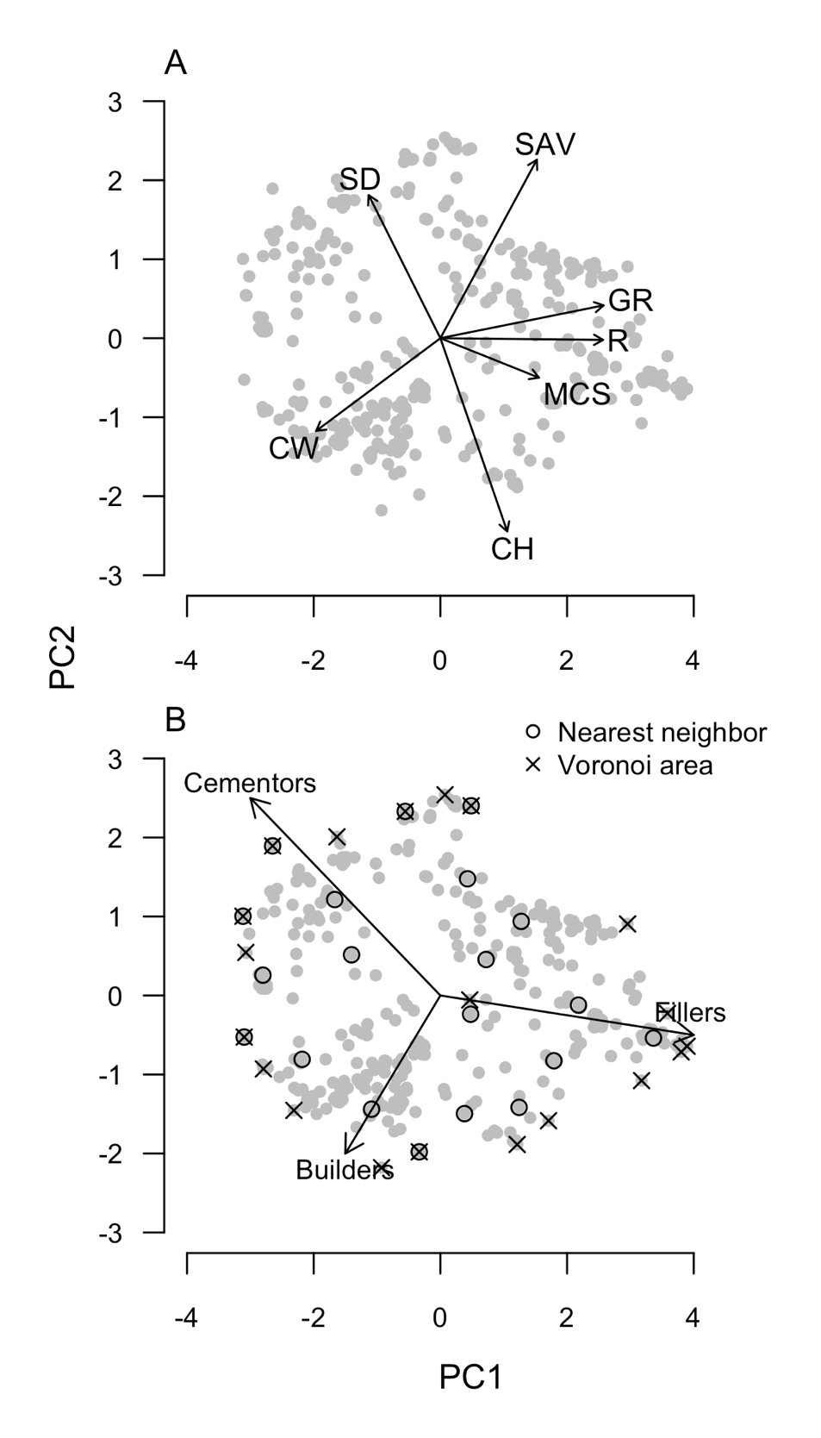

**Figure 1.** The phenotypic trait space for 396 coral species. (A) The trait loadings are as follows: growth rate (GR), corallite width (WD), rugosity/branch spacing (R), surface area per unit volume (SAV), colony height (CH), maximum colony size/diameter (MCS), and skeletal density (SD). (B) Goreau (1963) reef building categories superimposed onto selections of evenly spread species (*n*=20) calculated using Voronoi cell areas (red) and nearest neighbor distances (black).

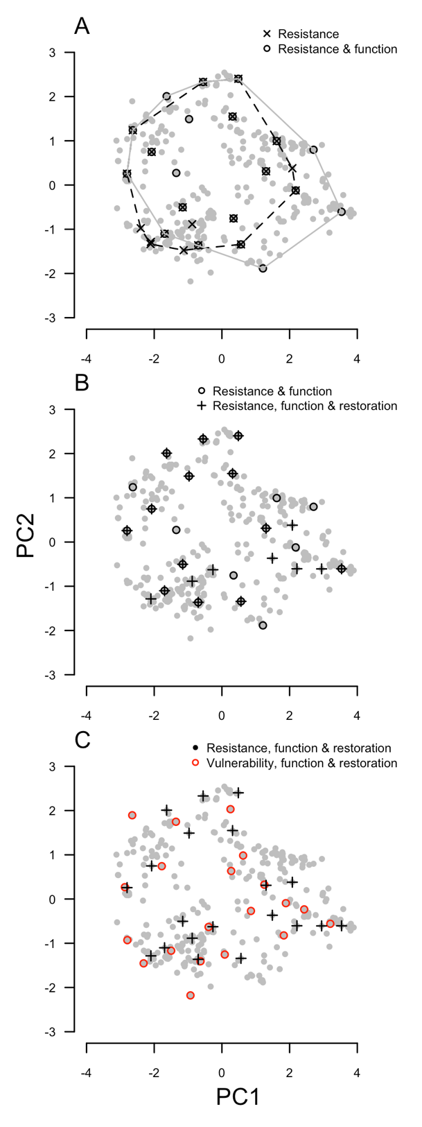

**Figure 2**. Species selection in trait space at different stages of the process. (A) Considering three beneficial ecological traits—ecological dominance, geographic range size and bleaching resistance—both alone (crosses) and by spreading species evenly based on their traits (points). Convex hulls (dotted lines) show difference in coverage of trait space. (B) Including restorability (pluses) to the process of species selection. (C) Comparing species selection for species with large ranges, high abundances and high bleaching resistance (pluses) with the opposite (red points).

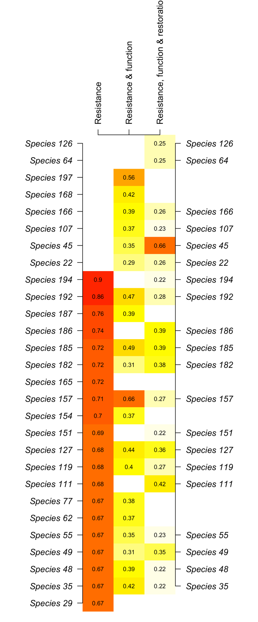

**Figure 3**. Changes in the species selection lists (*n*=20) for the three triage elements when focusing on ecologically resistant species. Values (and colors) correspond with a species triage score at each successive stage.

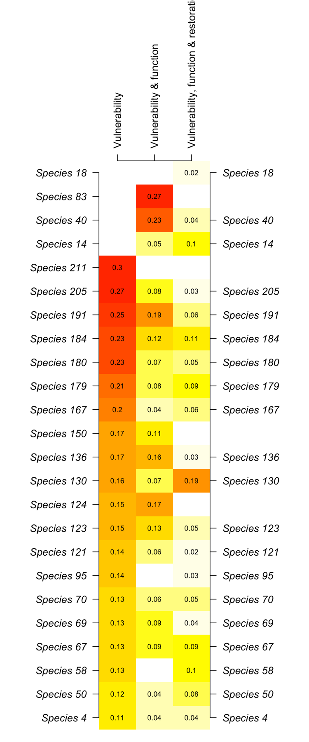

**Figure 4**. Changes in the species selection lists (*n*=20) for the three triage elements when focusing on ecologically vulnerable species. Values (and colors) correspond with a species triage score at each successive stage.

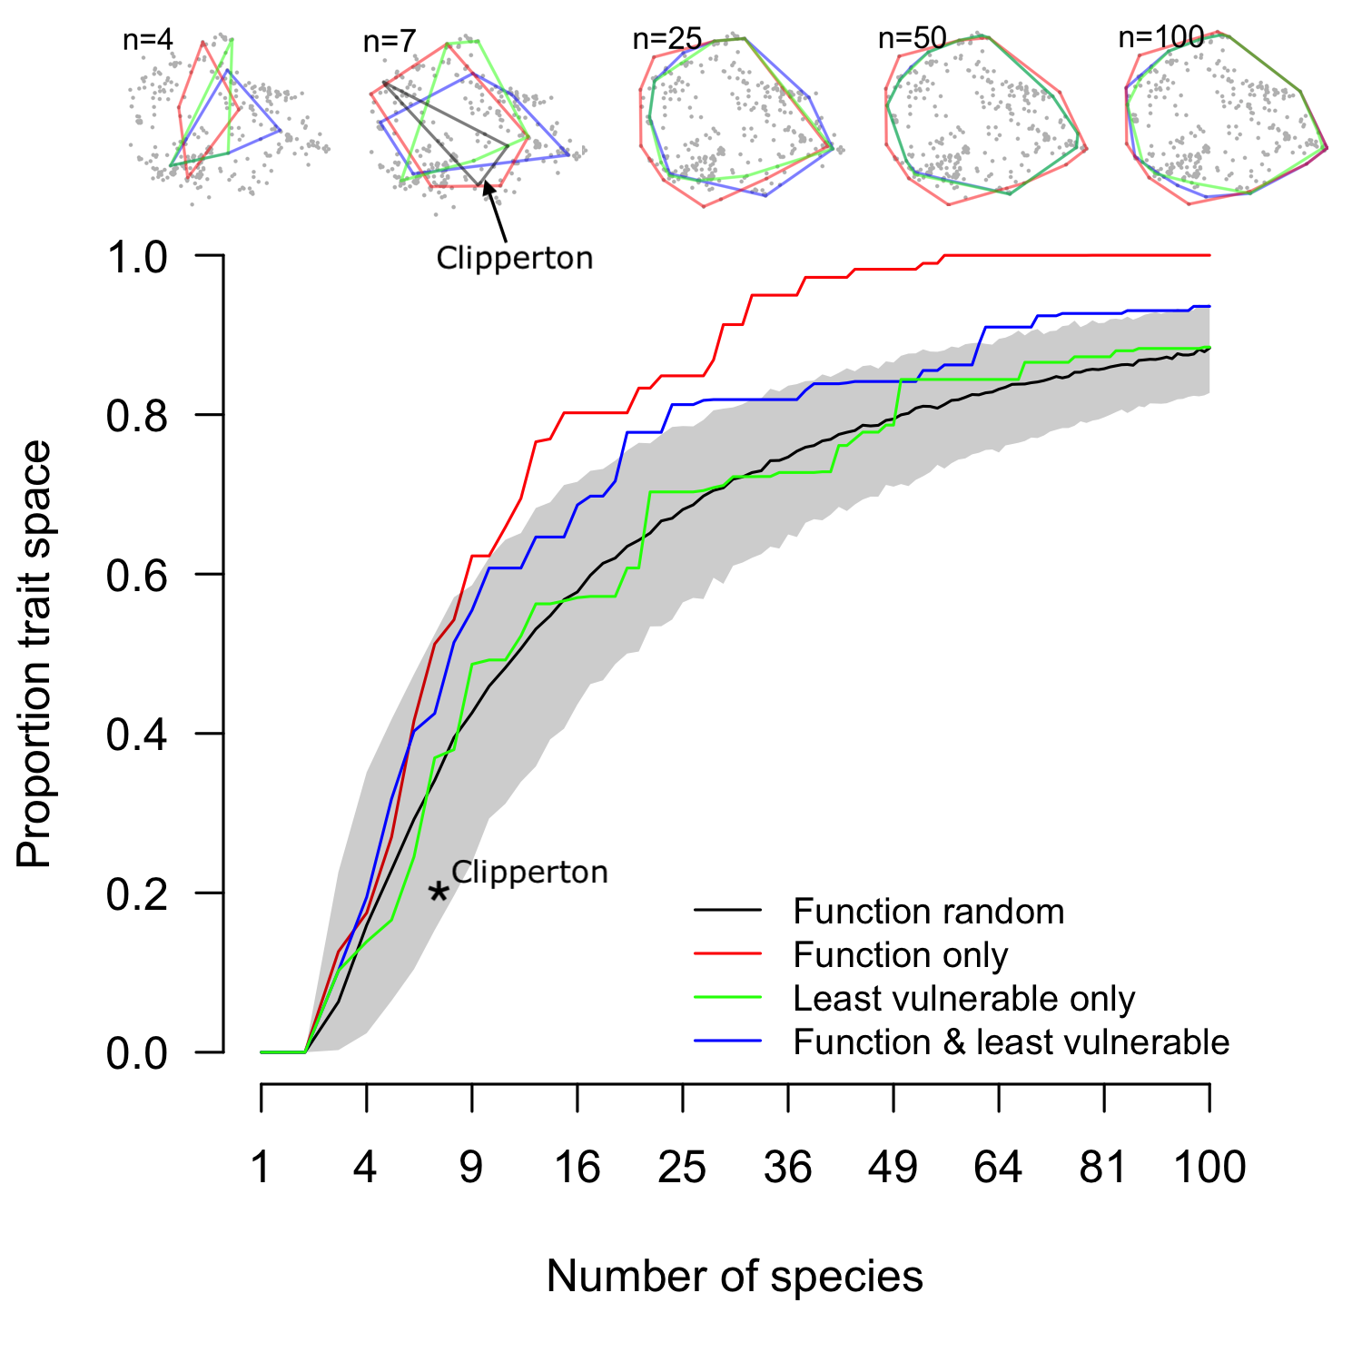

**Figure 5**. Proportion of total trait space occupied as a function of number of species *n* by (A) randomly selecting species, (B) based on maximizing functional spread only, (C) considering least ecologically vulnerable without considering traits, and (D) based on both function and least ecological vulnerability. The functional space occupied by the *n=*7 species at Clipperton Atoll are shown with a star.