**Fitzmaurice Circle Neighborhood**

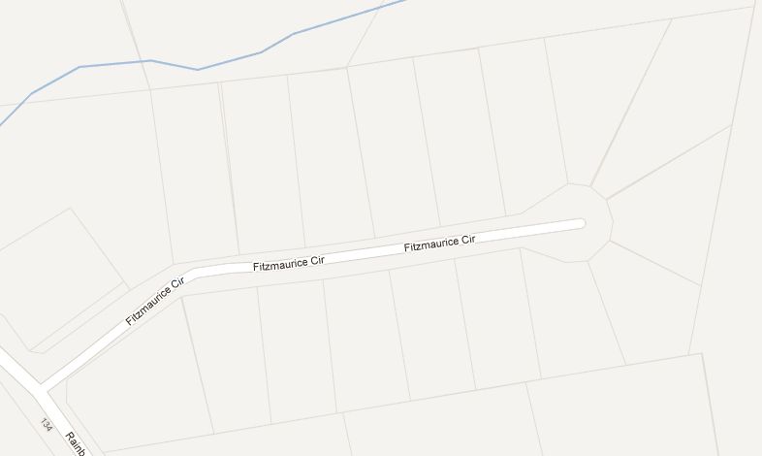

**25**

Kisha,

Richardo

**31**

Karla,

Jessie

**38**

Fran,

Nick,

Aniya,

Sage

**37**

Angie,

Derrick,

Austin,

Mike

**148**

Cherish,

Mike,

Moon

**26**

Cayla,

Josh

**1**

Anna,

Sean,

Joshua

**43**

Shelley,

Tim

**50**

Naiomi,

Tim

**49**

Dianne,

Glen

**13**

Maria,

Pedro,

Stephanie

**14**

Lacie,

Damon,

Kaeson

**8**

Jennifer,

James,

Jennifer,

Joshua,

Jacob

**20**

**2**

Nancy,

Bruce

**32**

**19**

**7**

**44**

No one's name is on this document without their permission. We maintain this document on the Internet that anyone can get to if they have the link, but we don't circulate the link or connect it to any web site, making it essentially undiscoverable. James, Anna, and Nancy are the main coordinators of the *Friends @ Fitzmaurice* group and welcome in-person visits if you have any questions. Email [JamesMadisonAtHome@gmail.com](mailto:JamesMadisonAtHome@gmail.com) with any enhancement requests.