KliMalasakit Online Document Updating System
(KODUS)
User Manual
Accessing KODUS
Use these steps to open the system and enter the selected workspace.
Step 1: Open the KODUS website and select the year to continue.
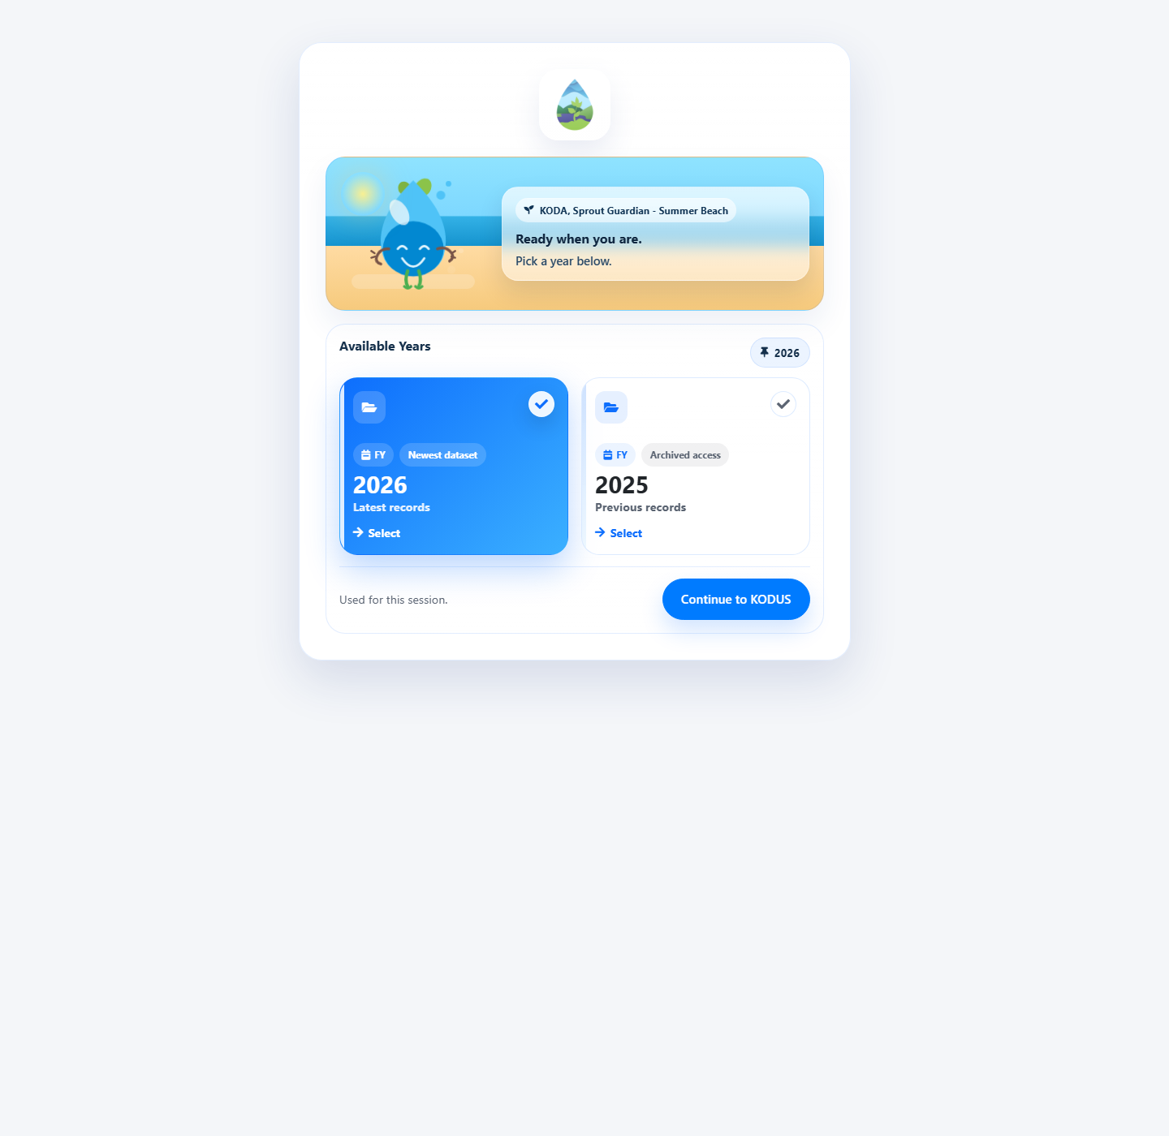
KODUS year selection page
Step 2: Click Continue to KODUS to open the selected workspace.
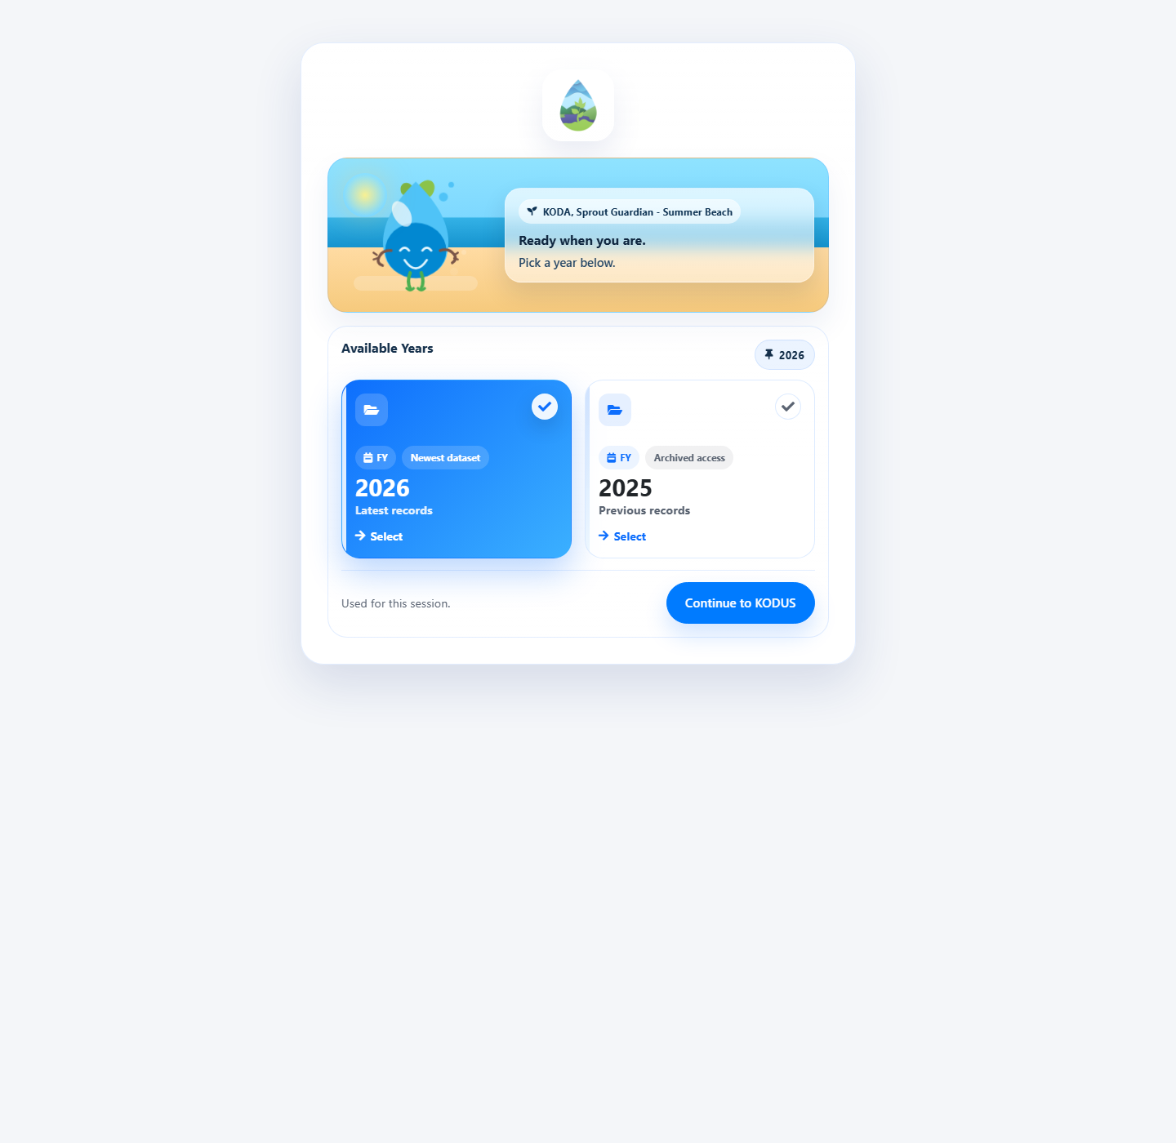
KODUS landing page
Administrator Guide
Primary tasks: full system control, user account management, notifications, security, recovery, and application settings.
Step 1: Log in and open the Dashboard to view system modules and administrative shortcuts.
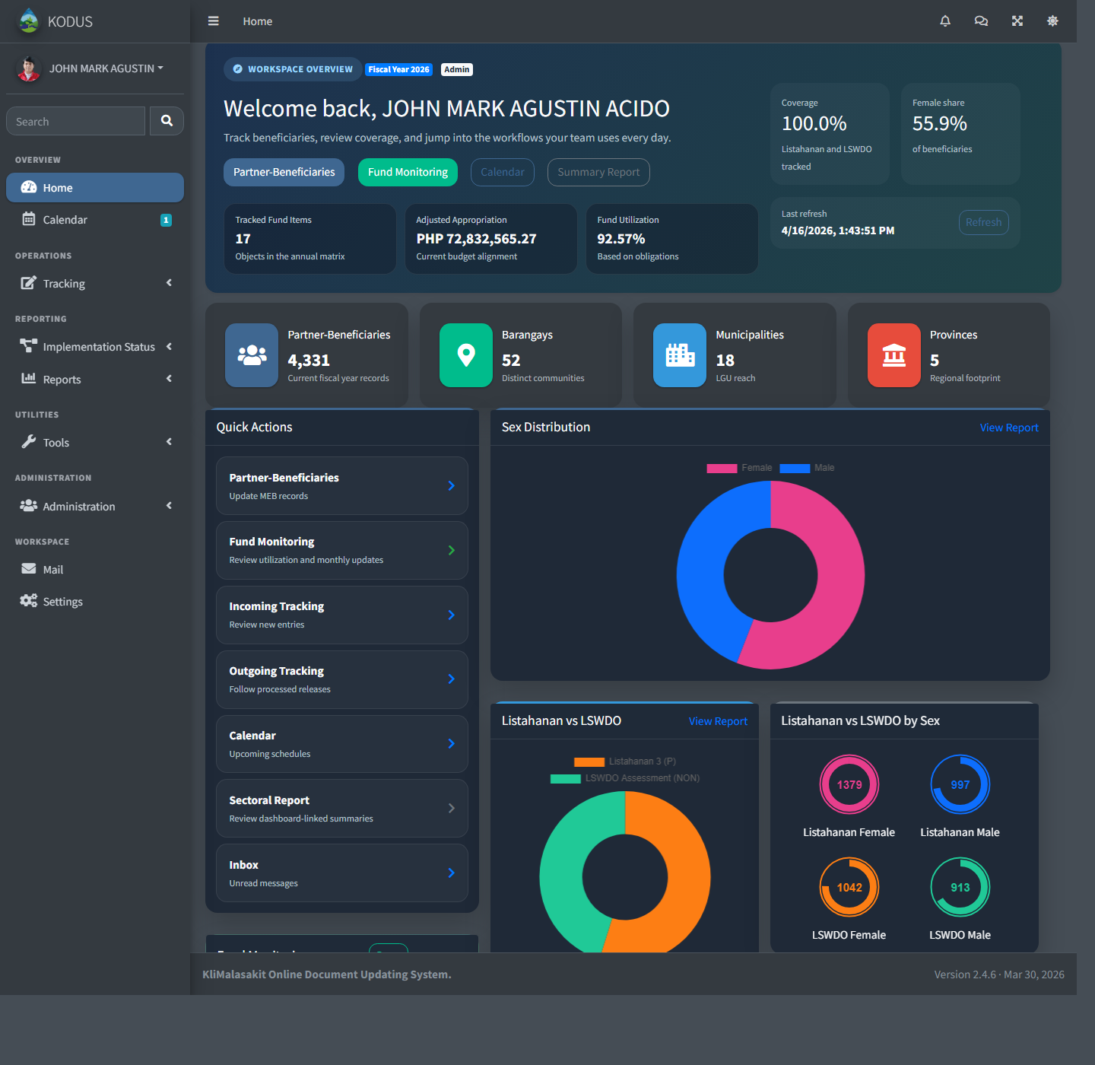
Administrator dashboard
Step 2: Click Users Management to view, classify, or update user accounts.
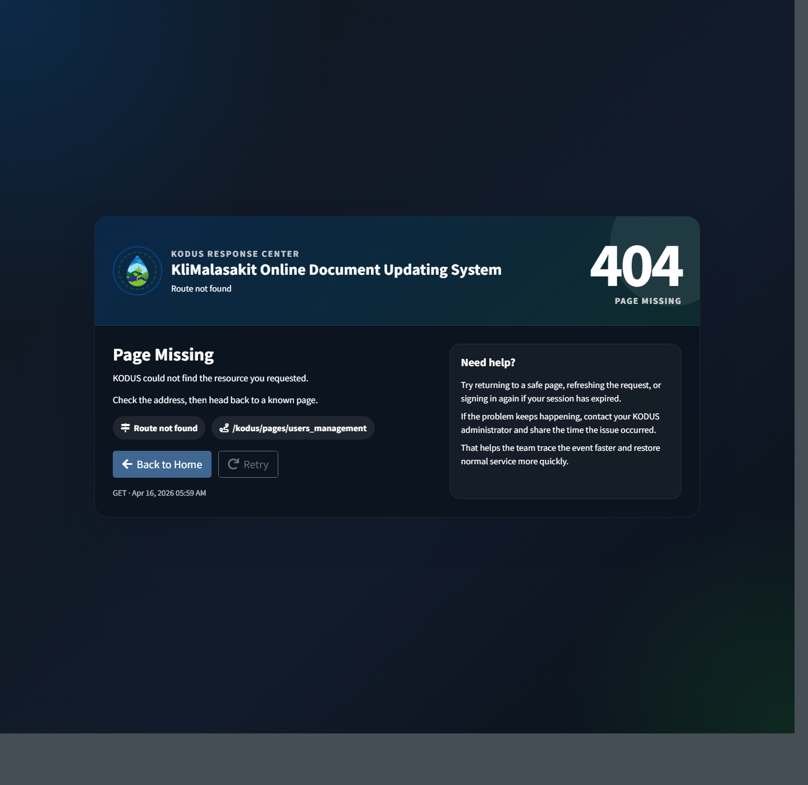
Users Management page
Step 3: Click Notifications to view recent alerts and updates.
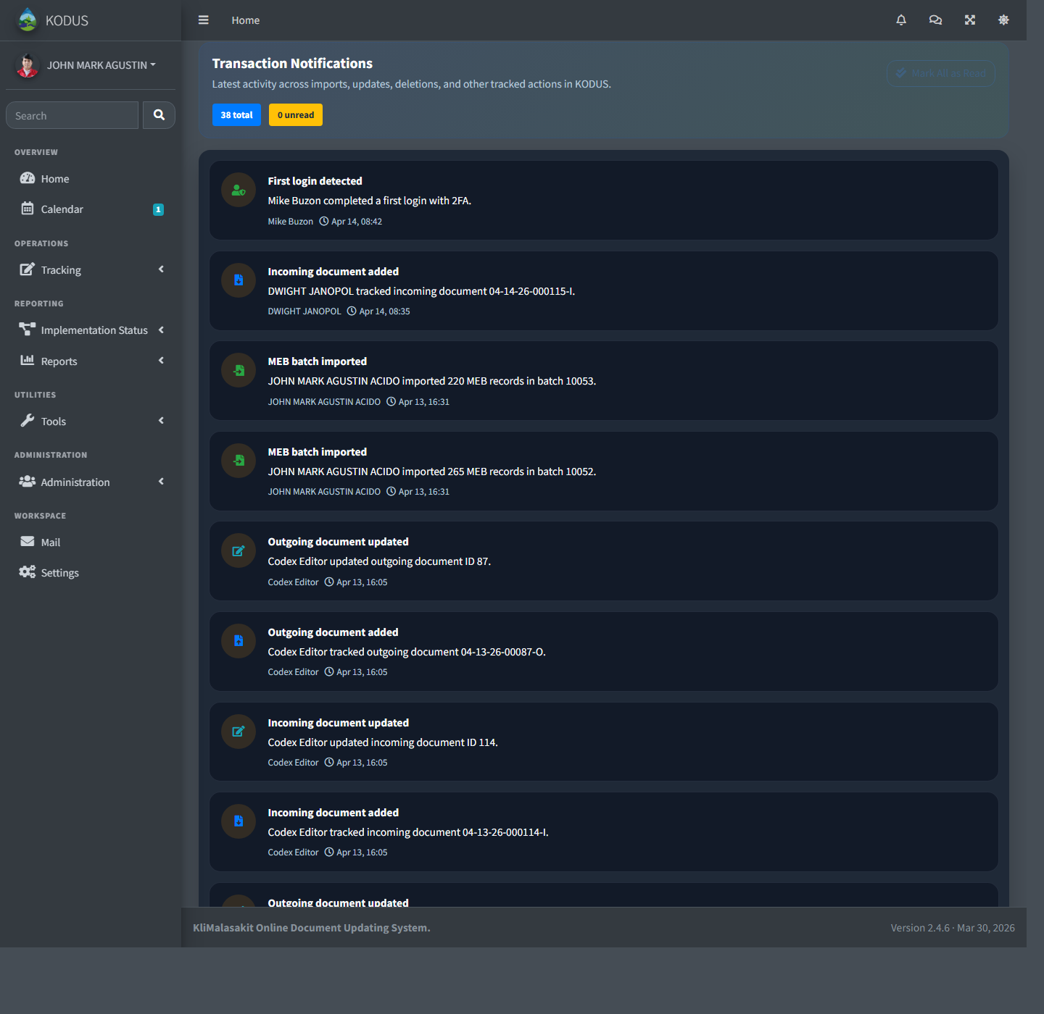
Notifications page
Step 4: Click Settings to update your profile, password, or two-factor authentication settings.
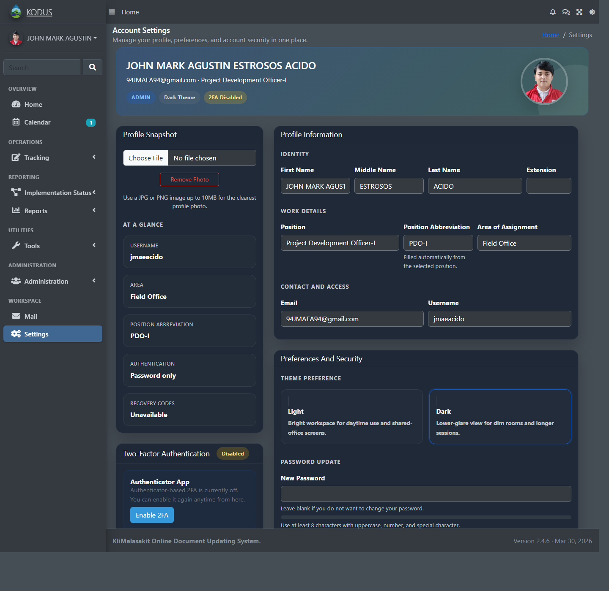
Settings page
Step 5: Click Restore Users to recover deleted user accounts when needed.
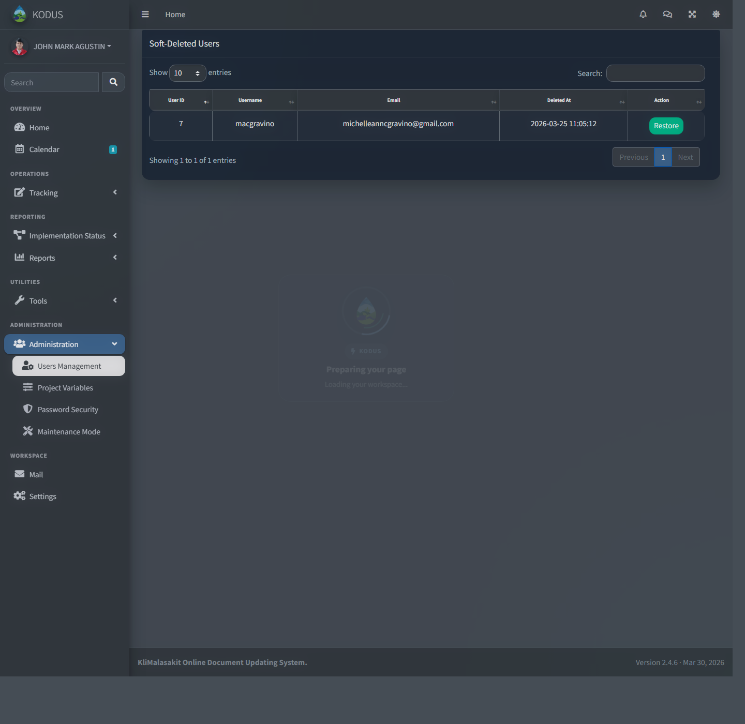
Restore Users page
Step 6: Click Maintenance under Administration to manage service gate and application settings.
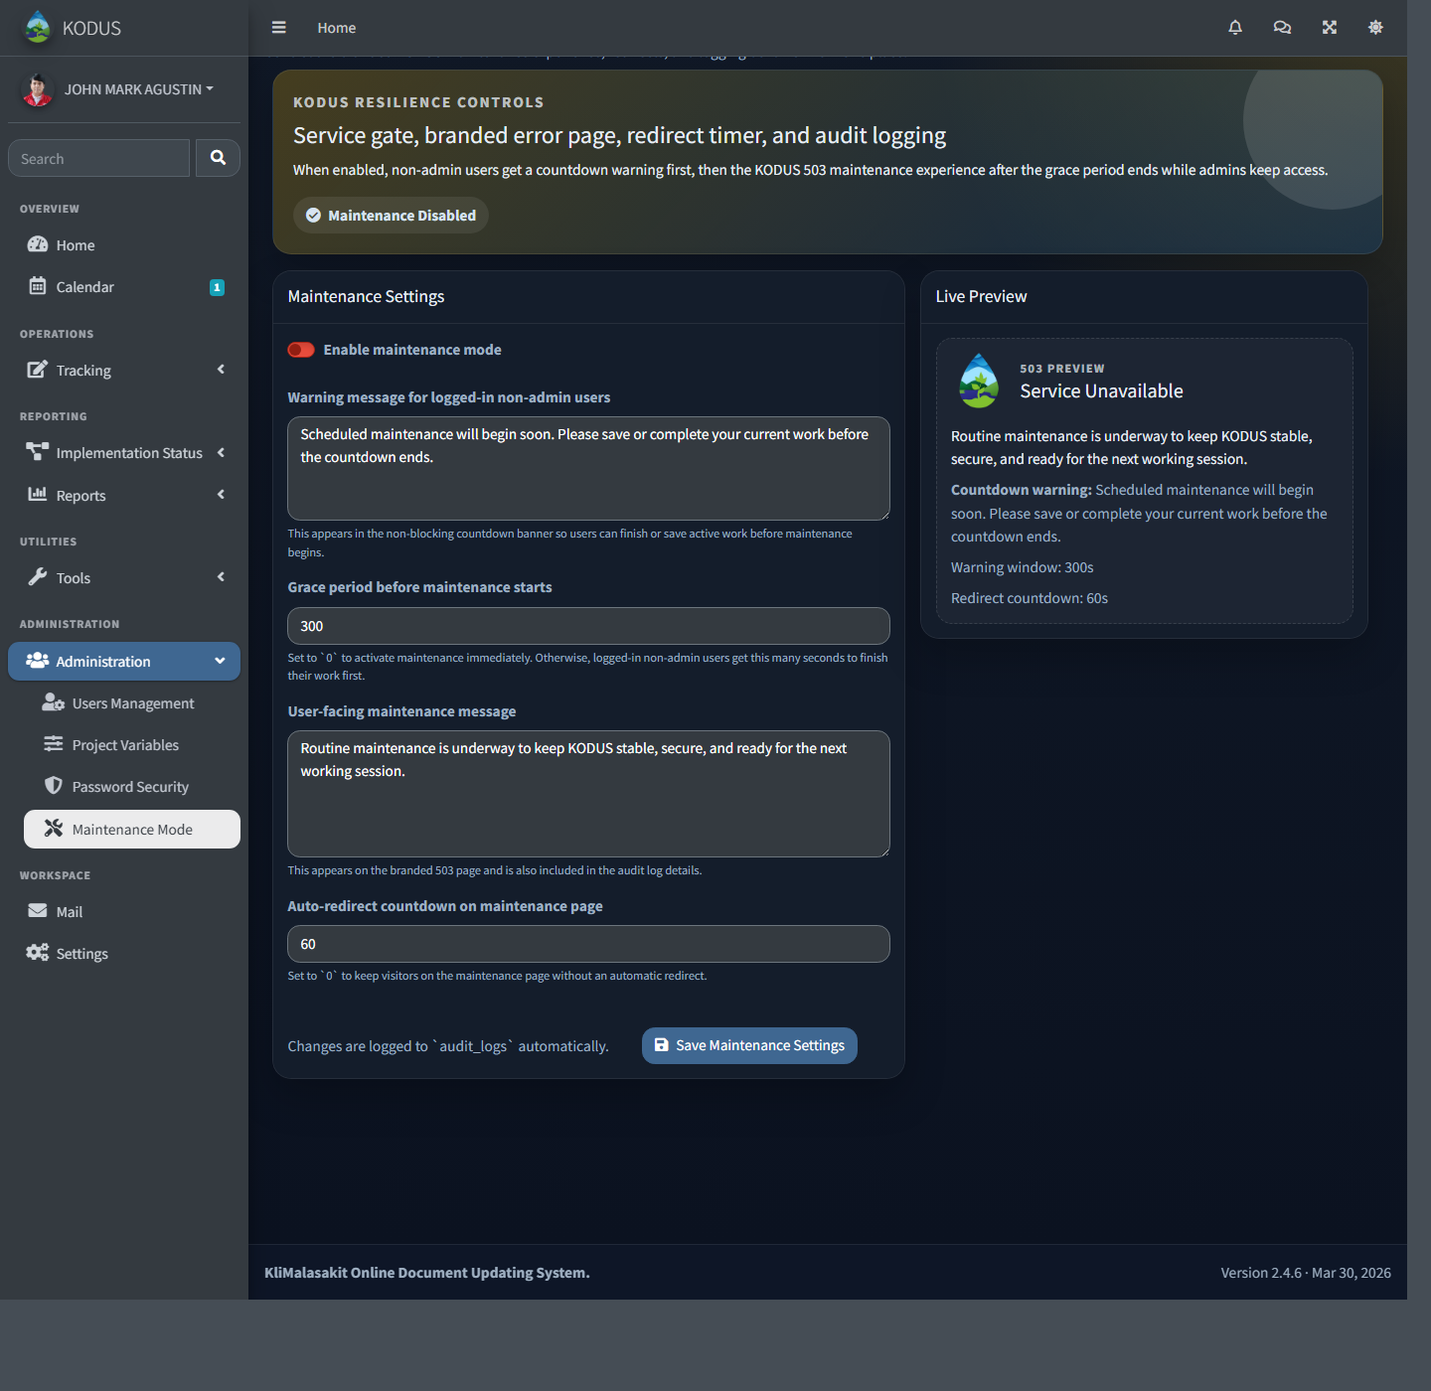
Maintenance settings page

Administrative Staff Guide
Primary tasks: operational support, inbox handling, notifications, limited viewing of implementation data, and allowed tracking-related transactions.
Step 1: Log in and open the Dashboard to access operations, reports, mail, and settings.
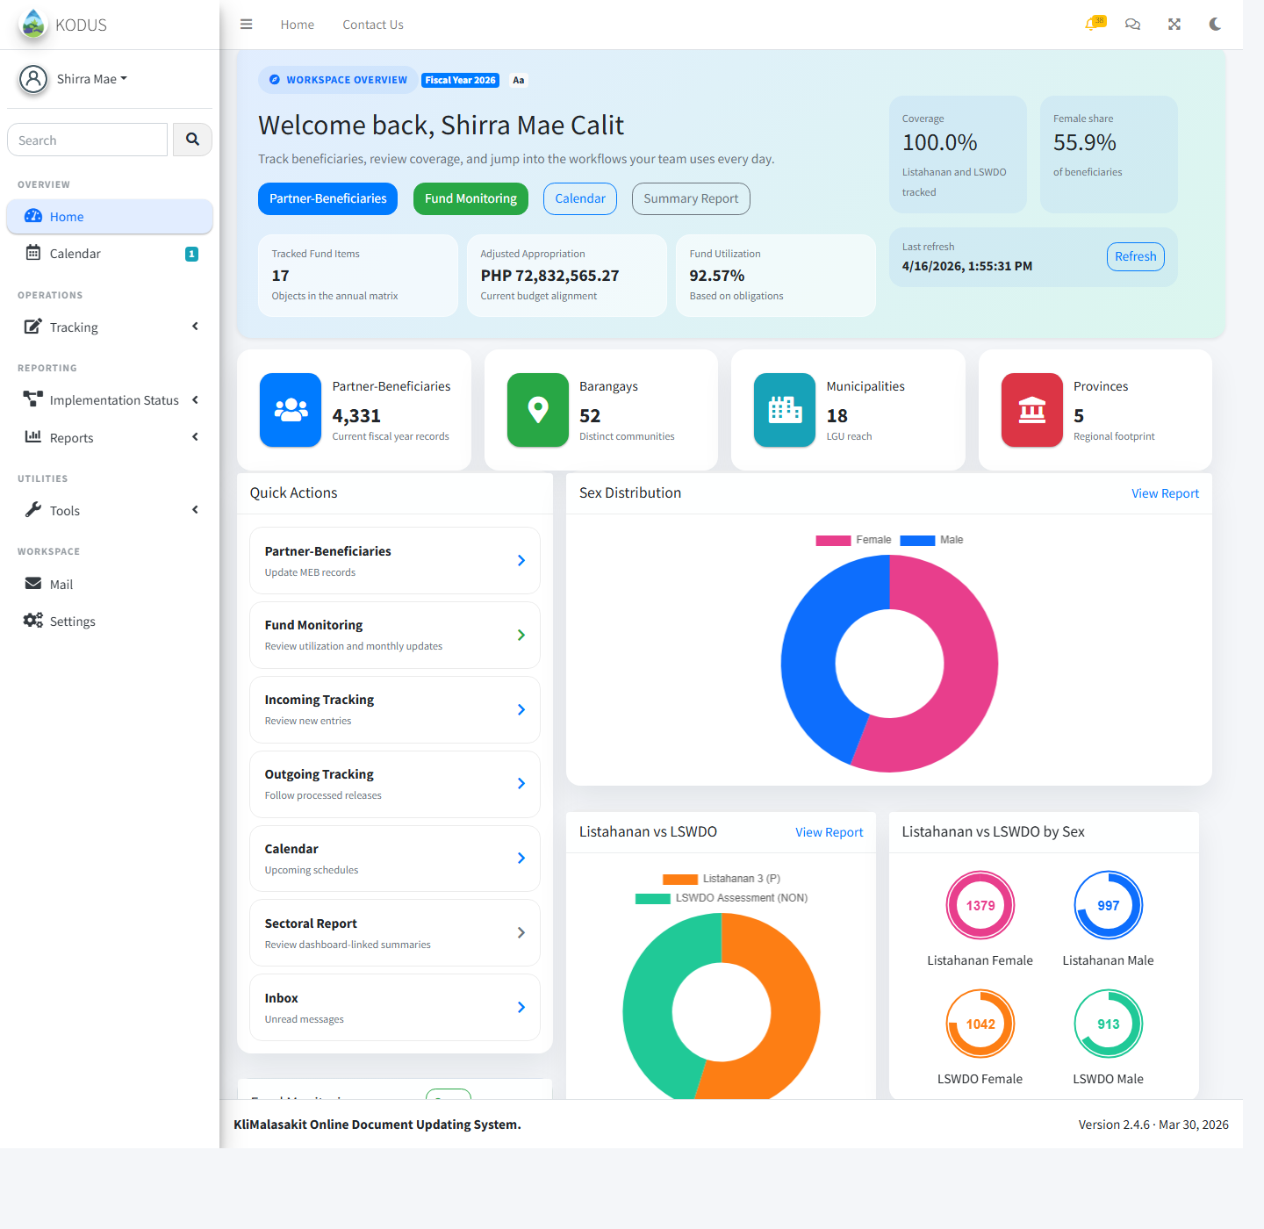
Administrative Staff dashboard
Step 2: Click Inbox to view received messages and send replies when needed.
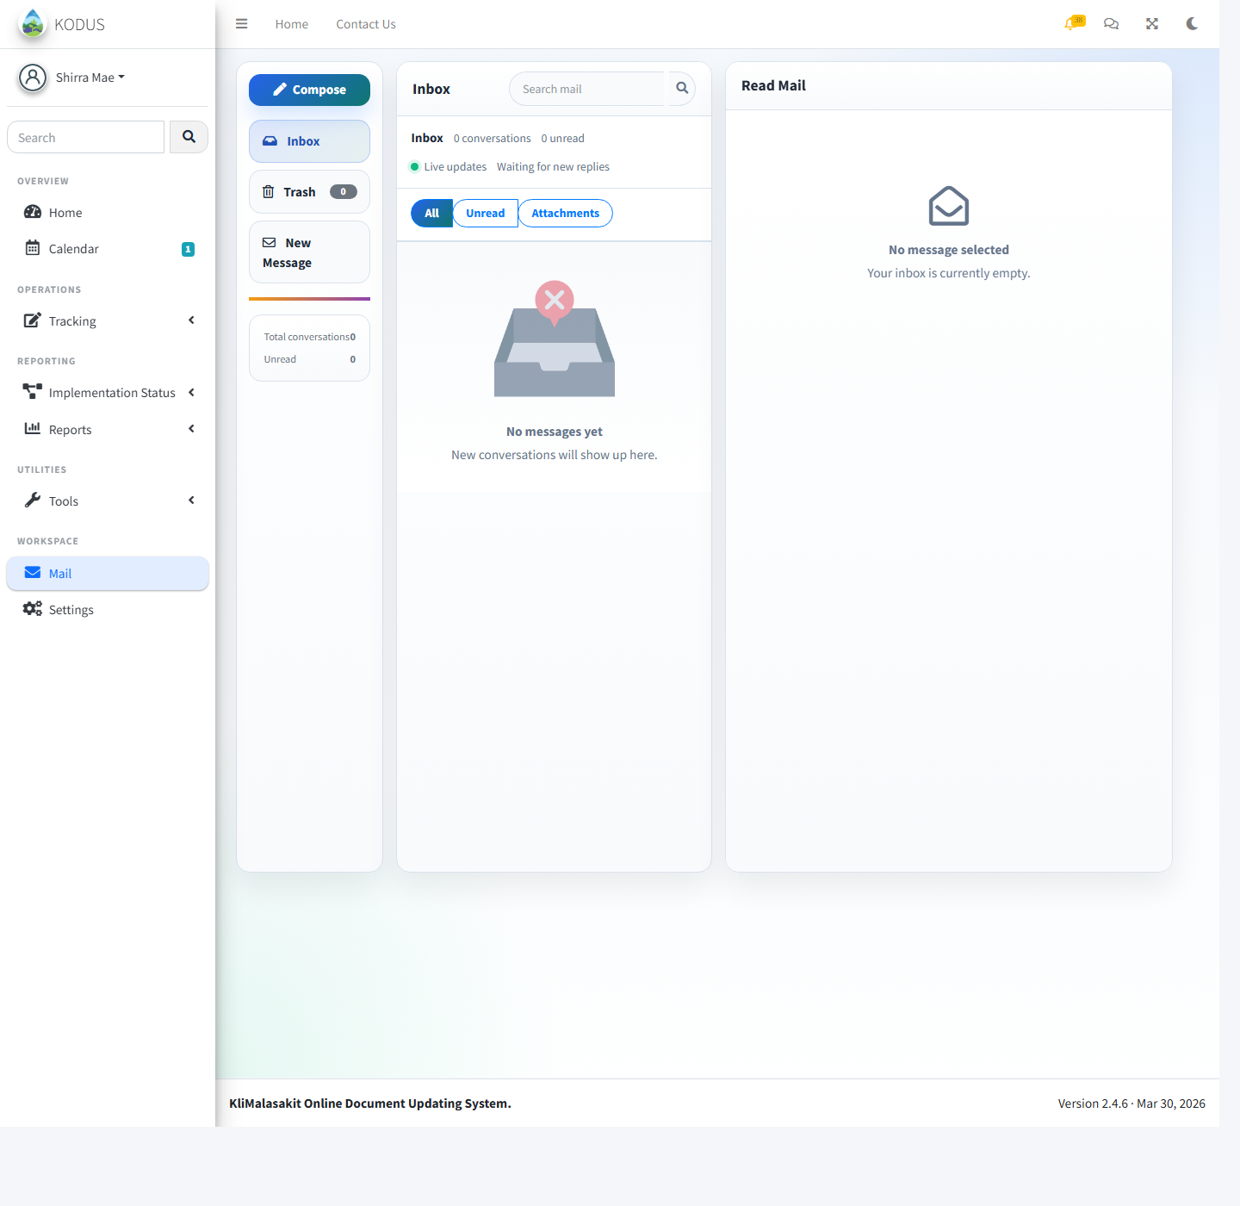
Inbox page
Step 3: Click Program Activities to review implementation records in view mode.
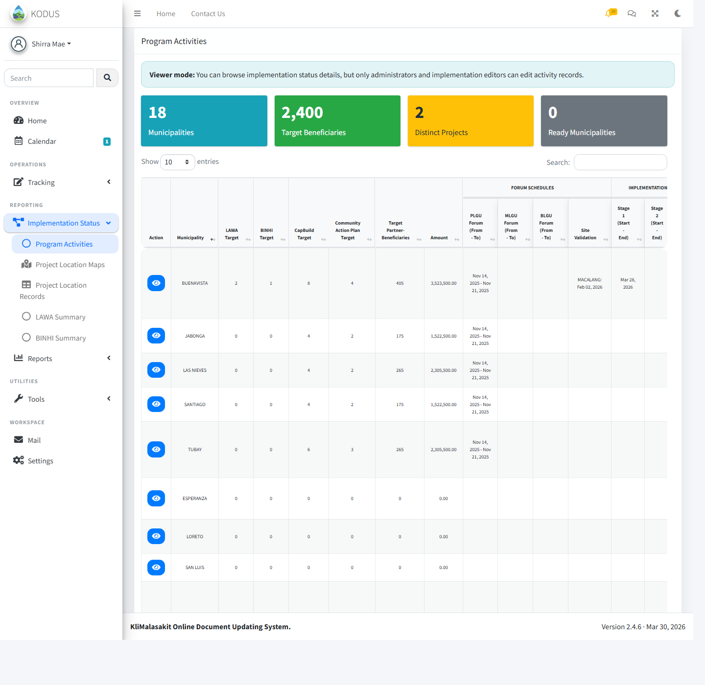
Program Activities page in view mode
Step 4: Click Payout to review or update allowed tracking-related transactions.
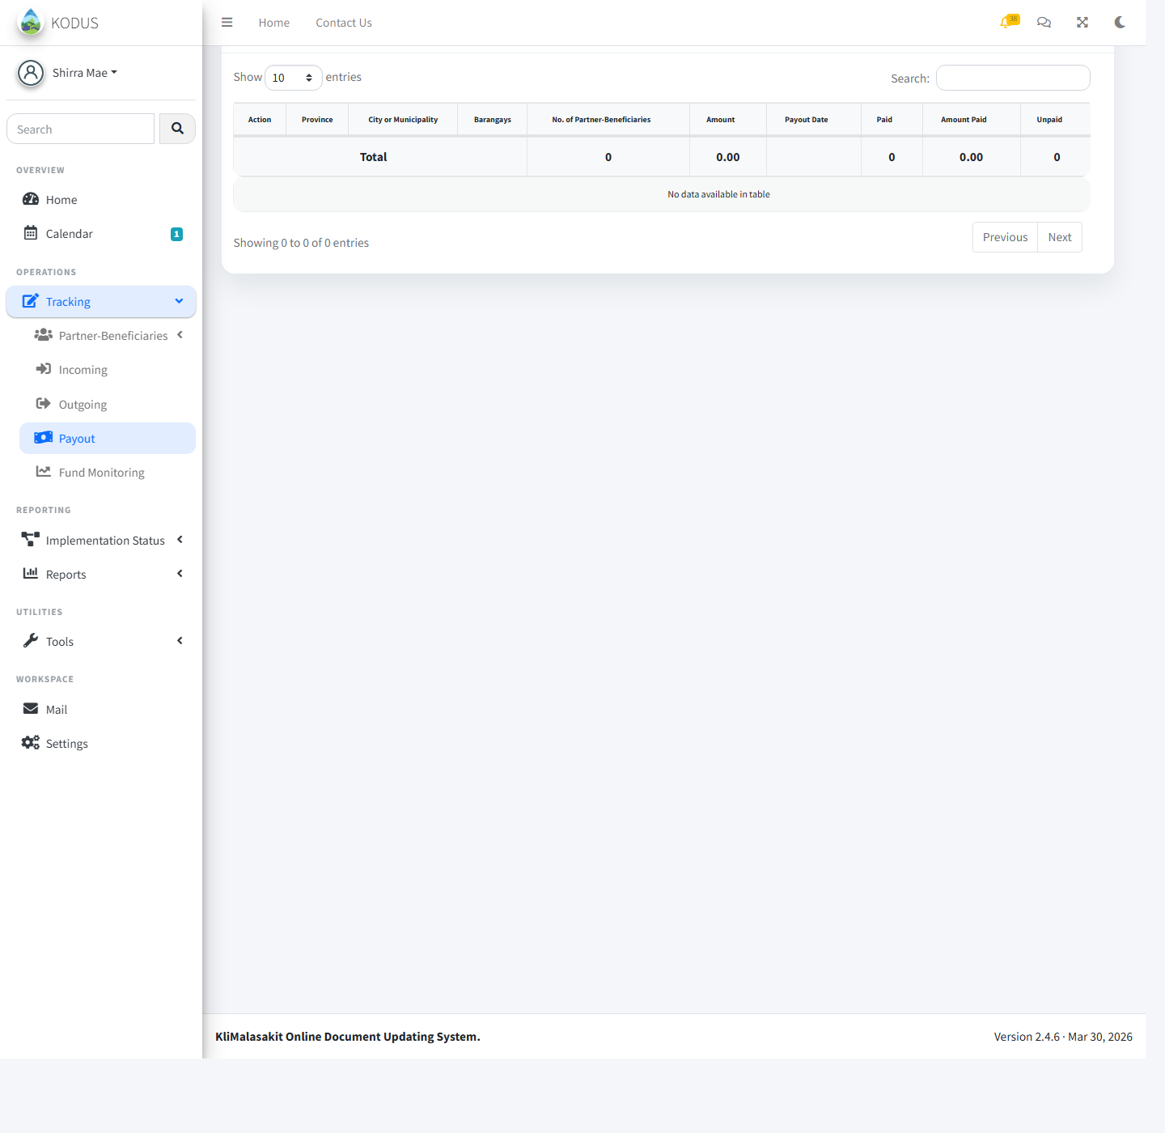
Payout page

Implementation Editor Guide
Primary tasks: manage baseline targets, update implementation activity data, maintain project variables, and review maps and reports.
Step 1: Log in and open the Dashboard to access implementation modules.
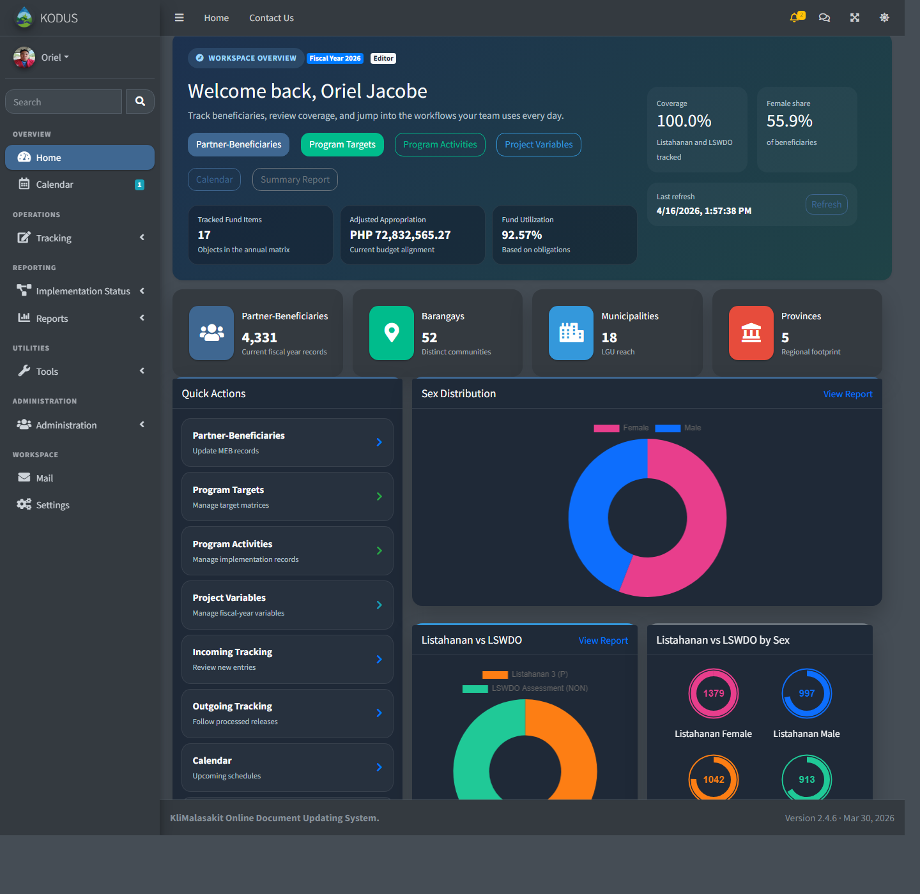
Implementation Editor dashboard
Step 2: Click Baseline Targets to add, edit, import, or review target records.
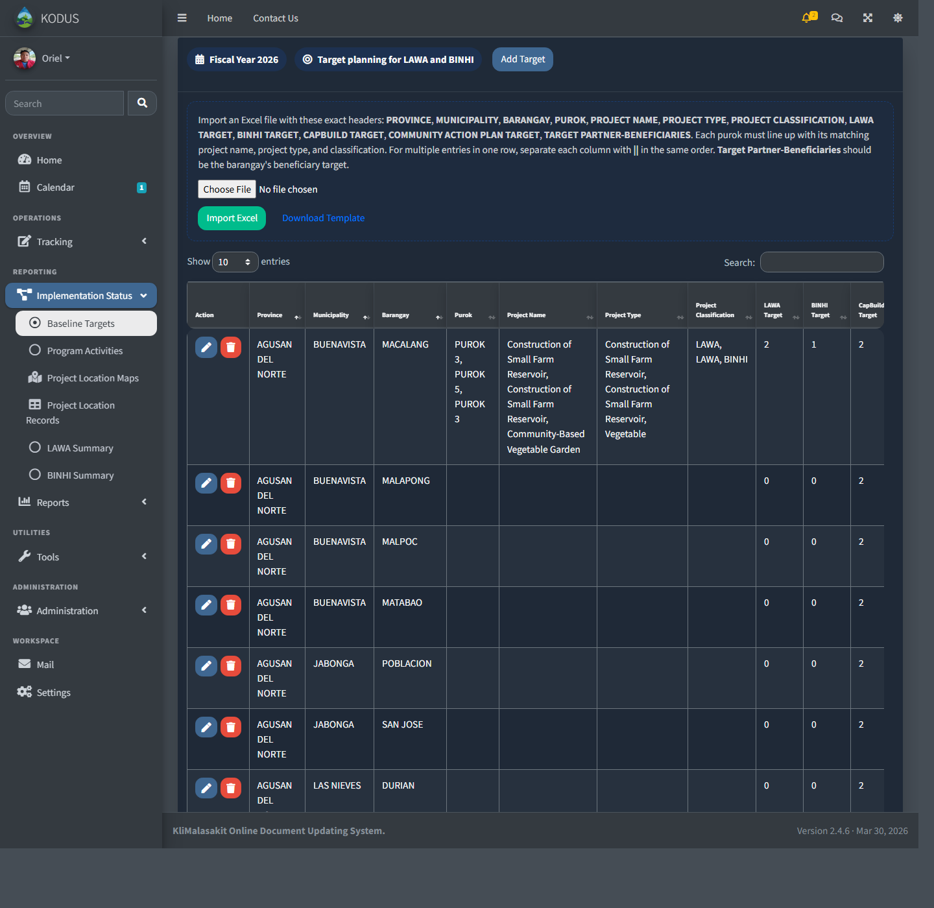
Baseline Targets page
Step 3: Click Program Activities to add or update implementation activity records.
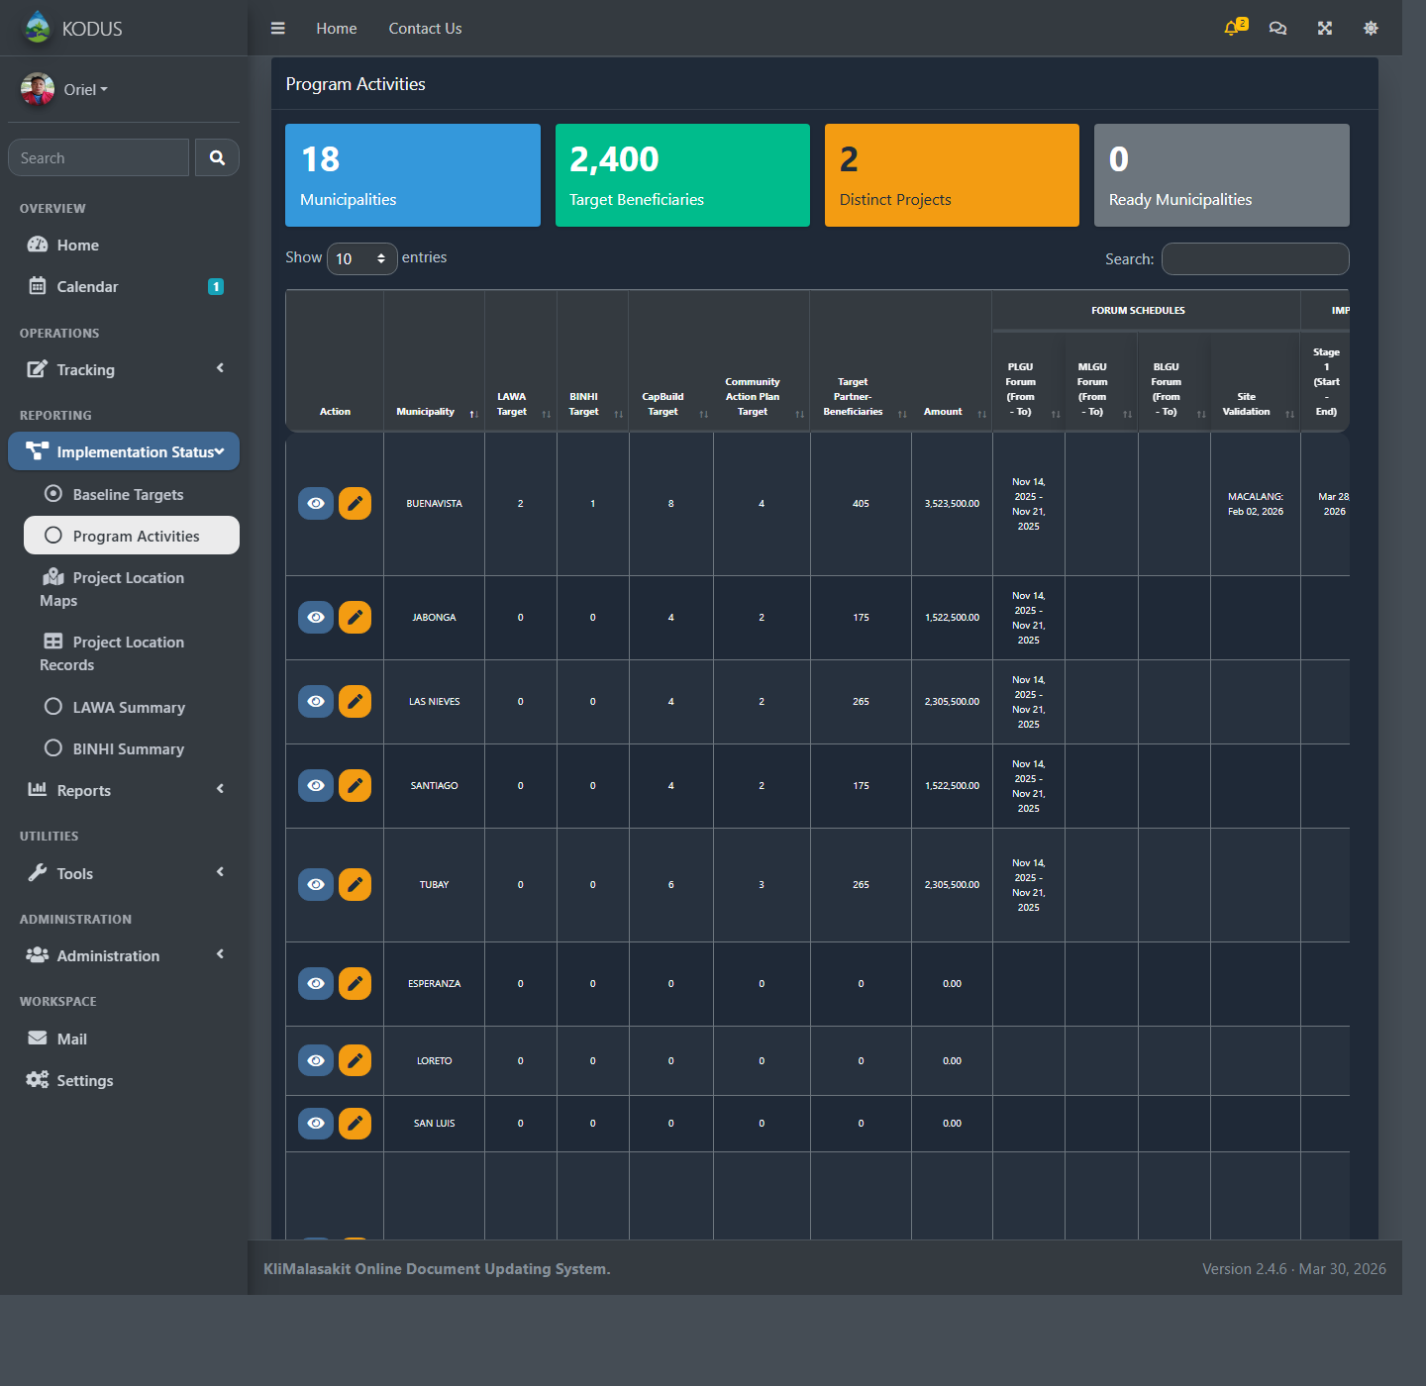
Program Activities page
Step 4: Click Project Variables to manage configurable project variables.
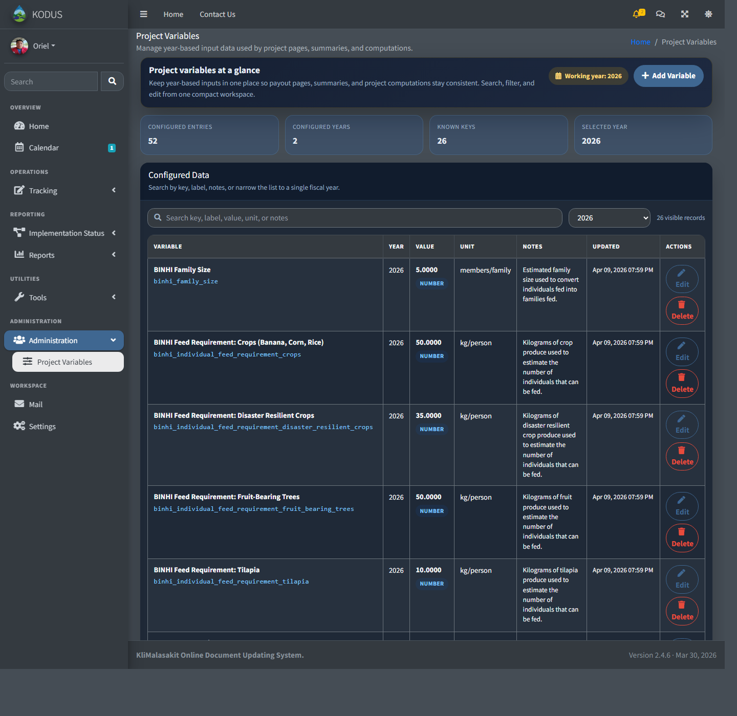
Project Variables page
Step 5: Click Project Location Maps to view project locations on the map.
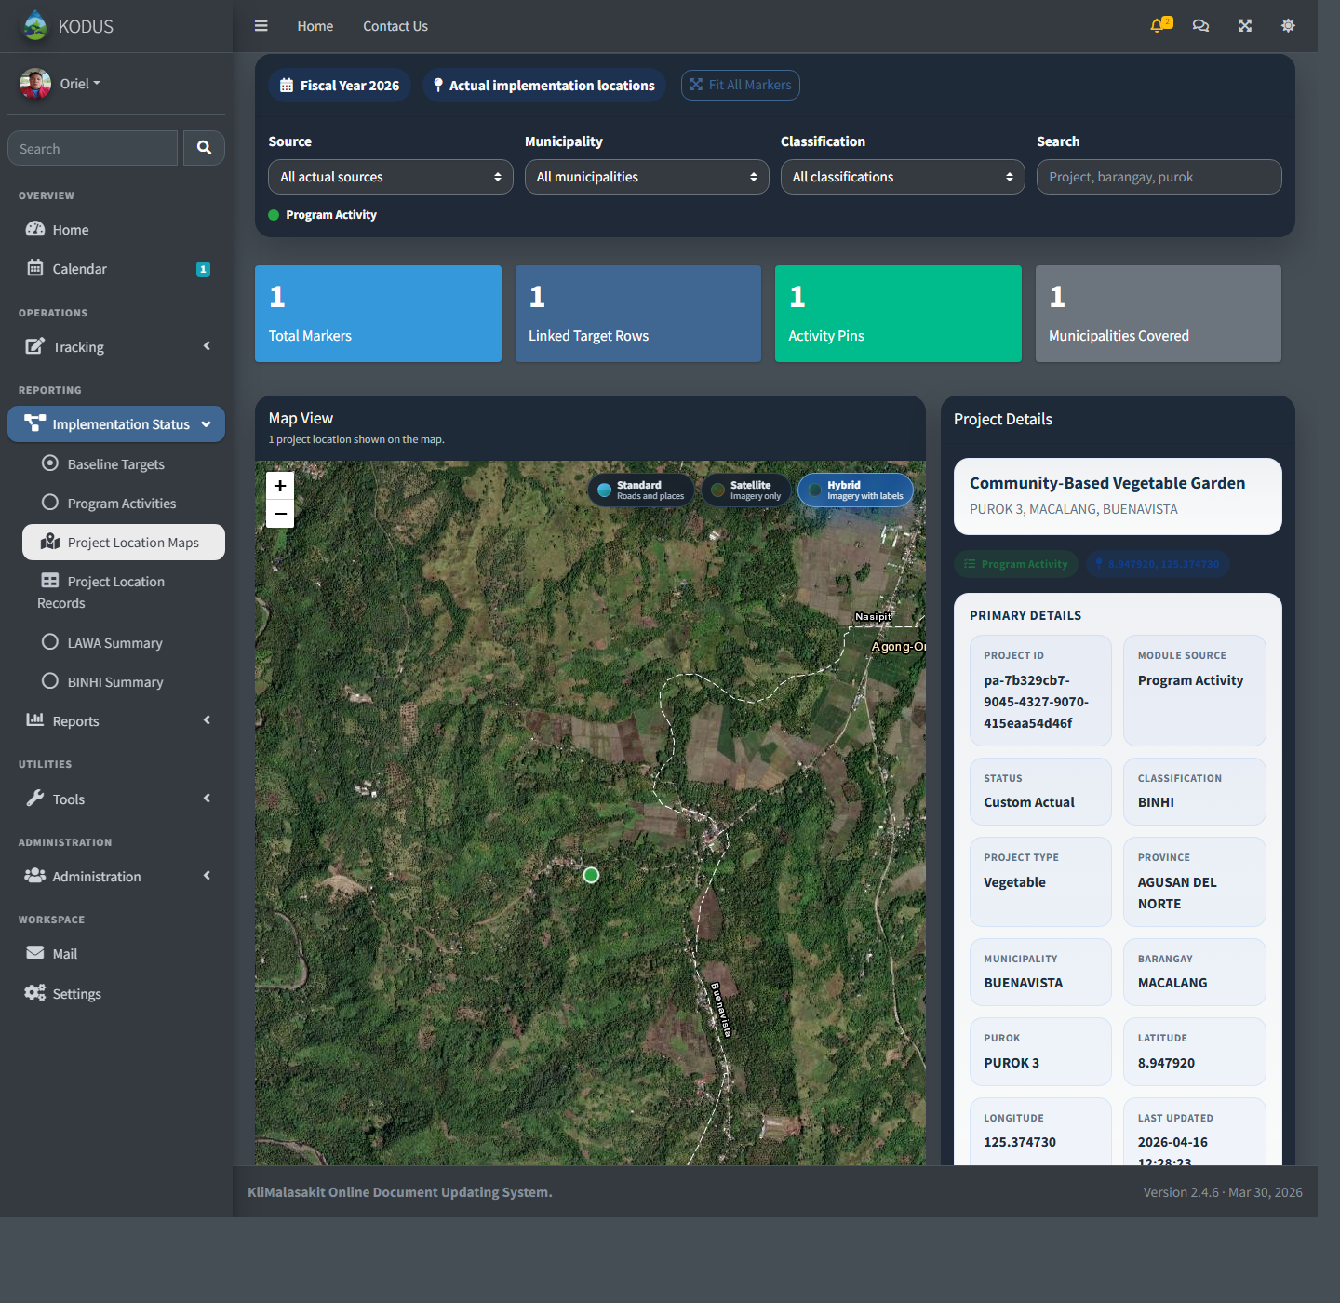
Project Location Maps page
Step 6: Click Reports to view or export available summary reports.
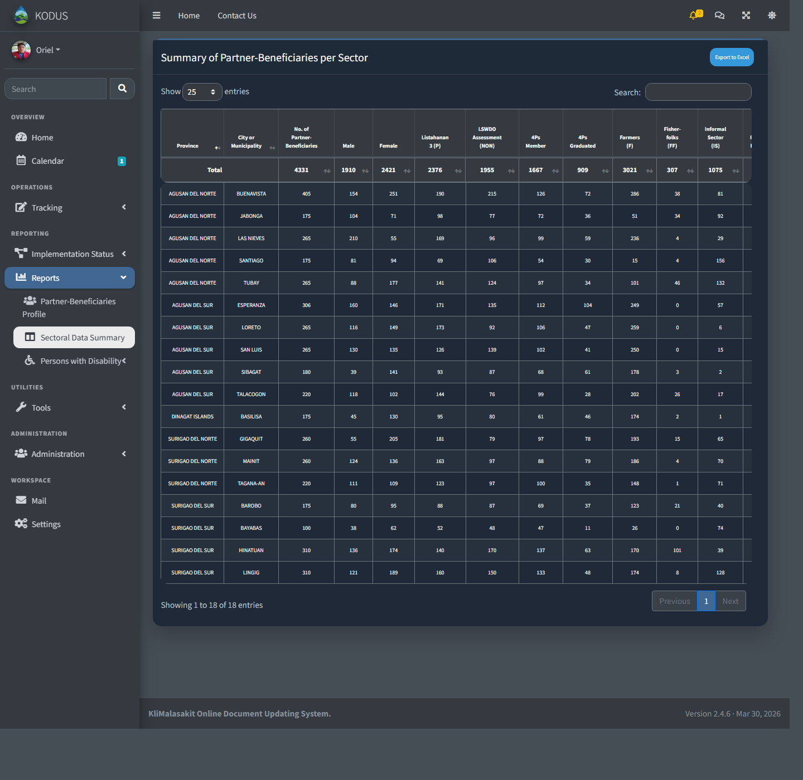
Reports page

User Guide
Primary tasks: view dashboard content, update personal settings, send messages, and view available summaries and maps.
Step 1: Log in and open the Dashboard to view available user modules.
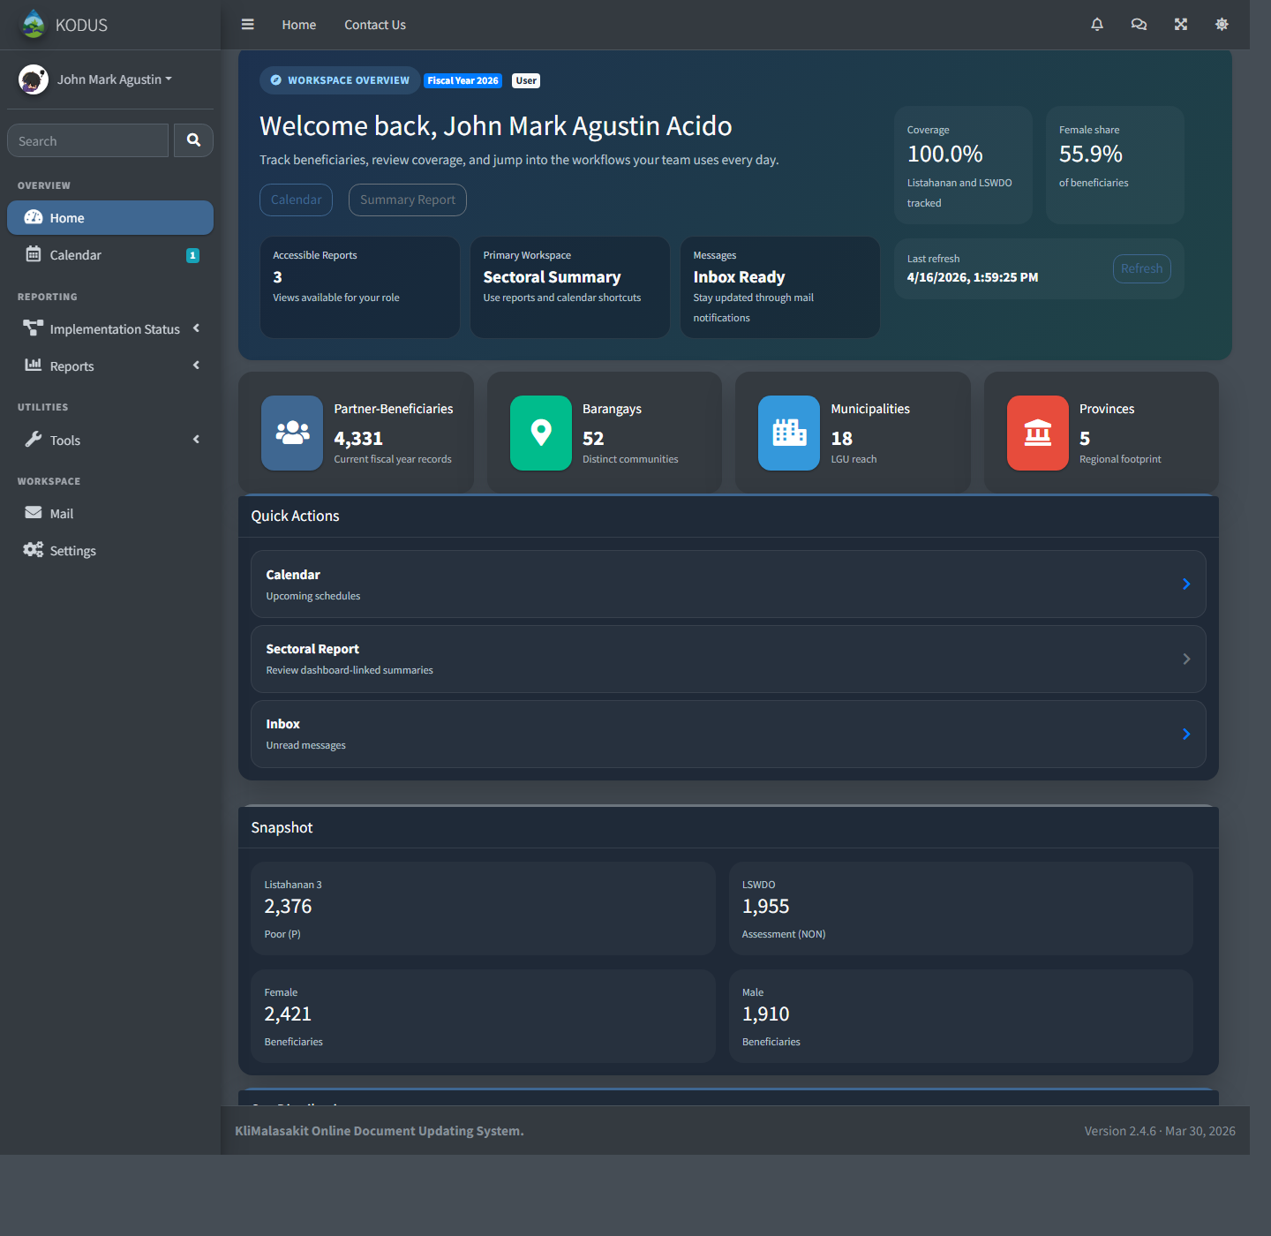
User dashboard
Step 2: Click Settings to update your profile, password, or two-factor authentication settings.
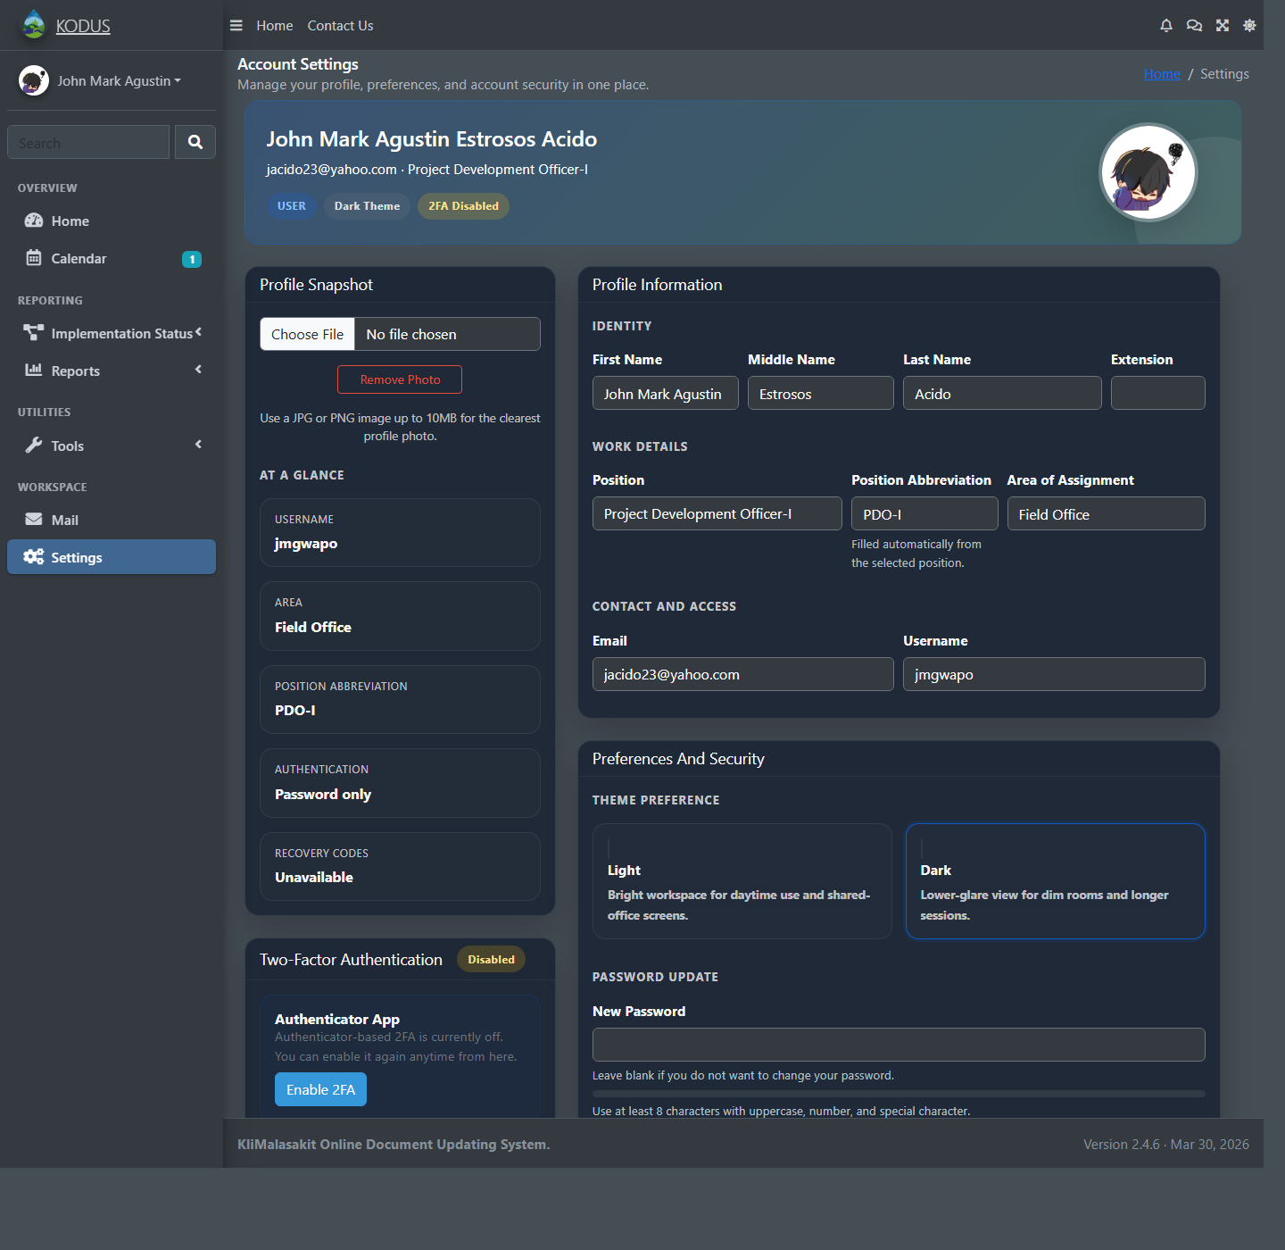
User settings page
Step 3: Click Contact Us to send a message to the KODUS team.
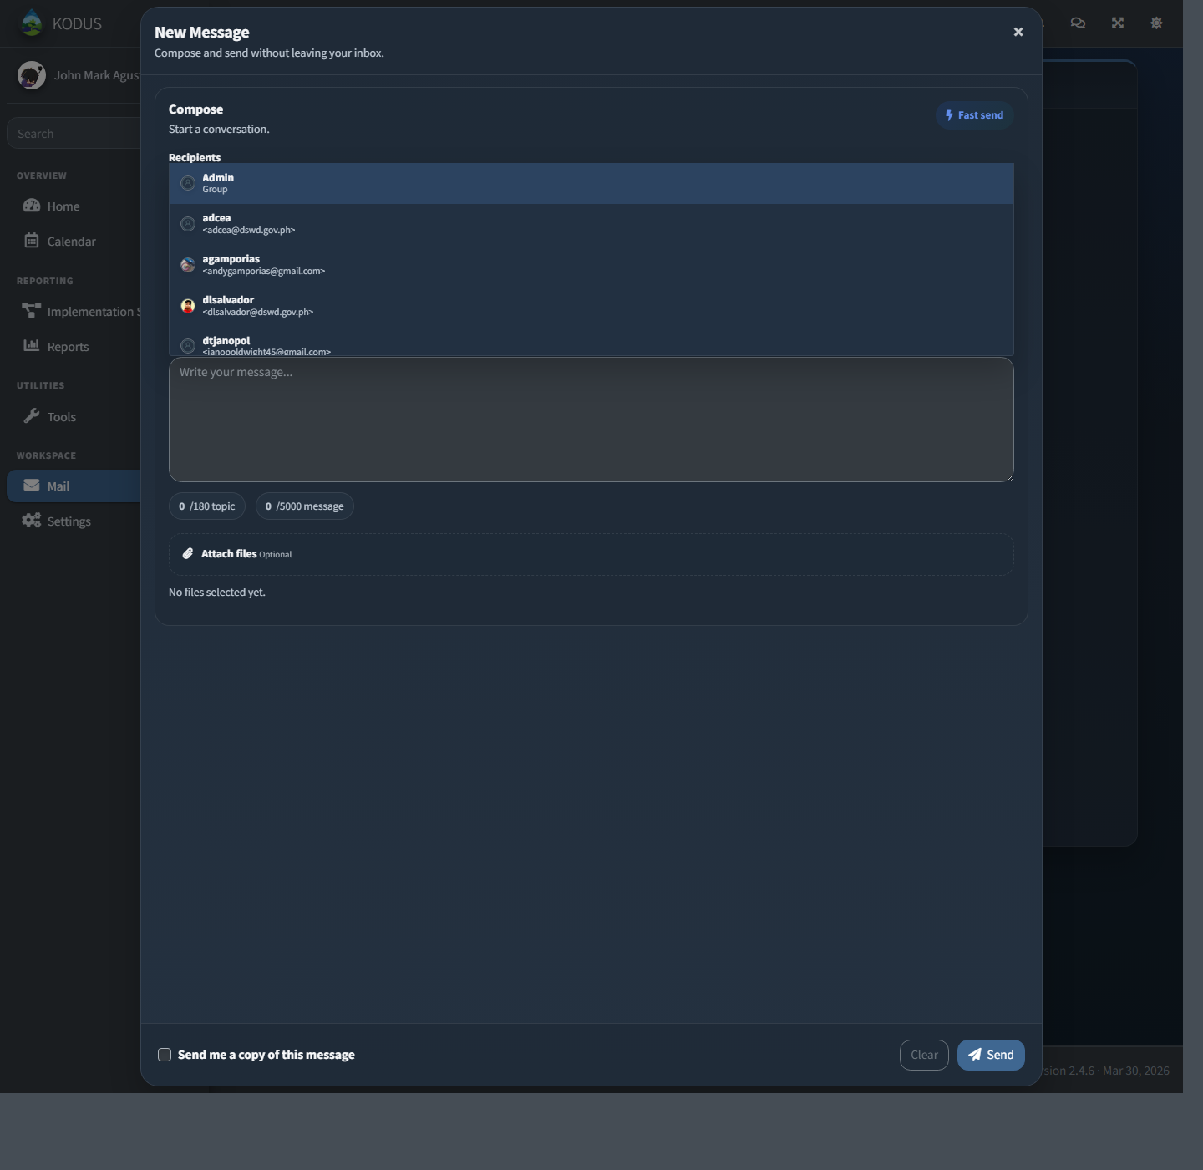
Contact page
Step 4: Click LAWA Summary to view available summary records.
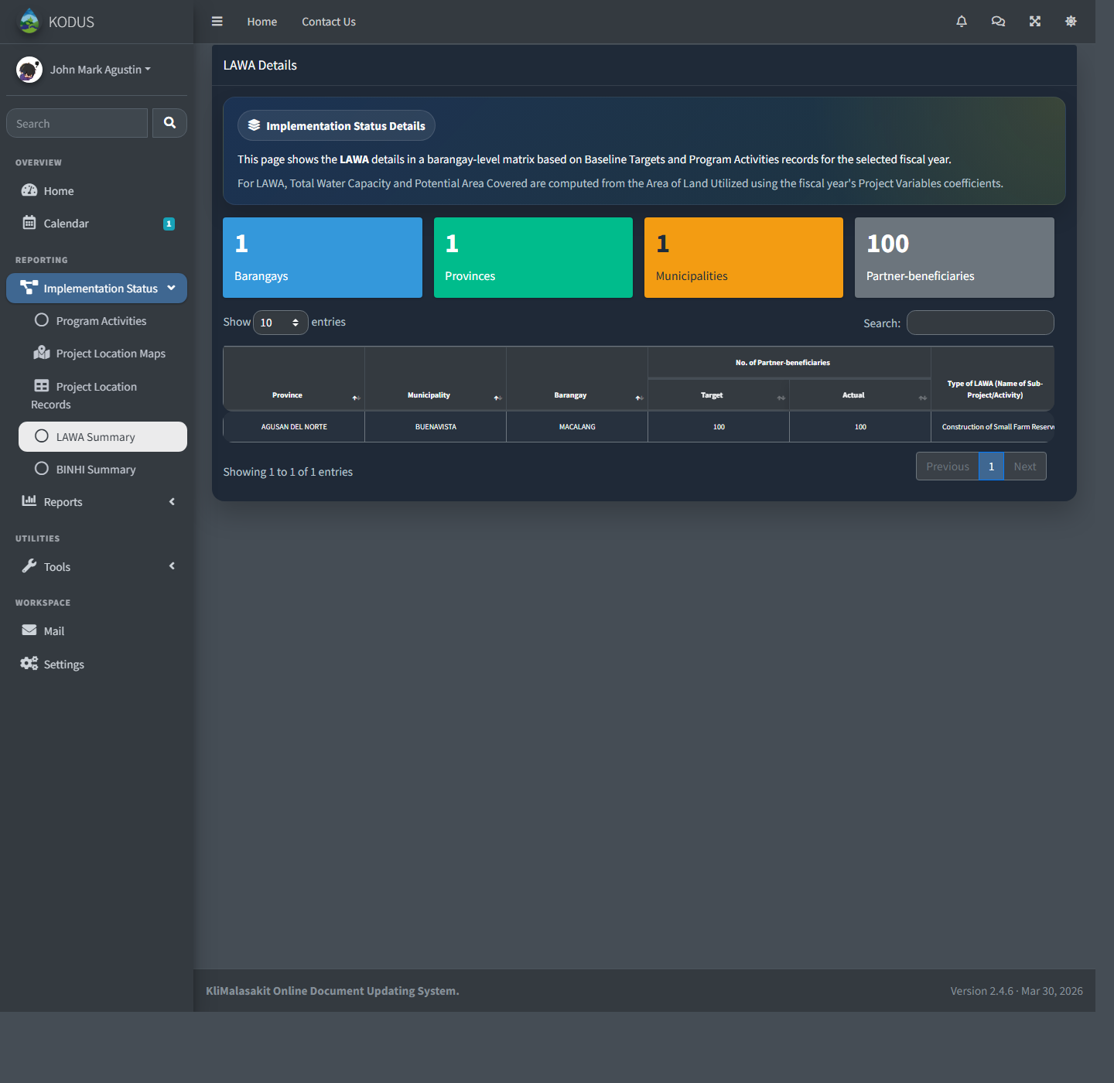
LAWA Summary page
Step 5: Click Project Location Maps to view project locations.
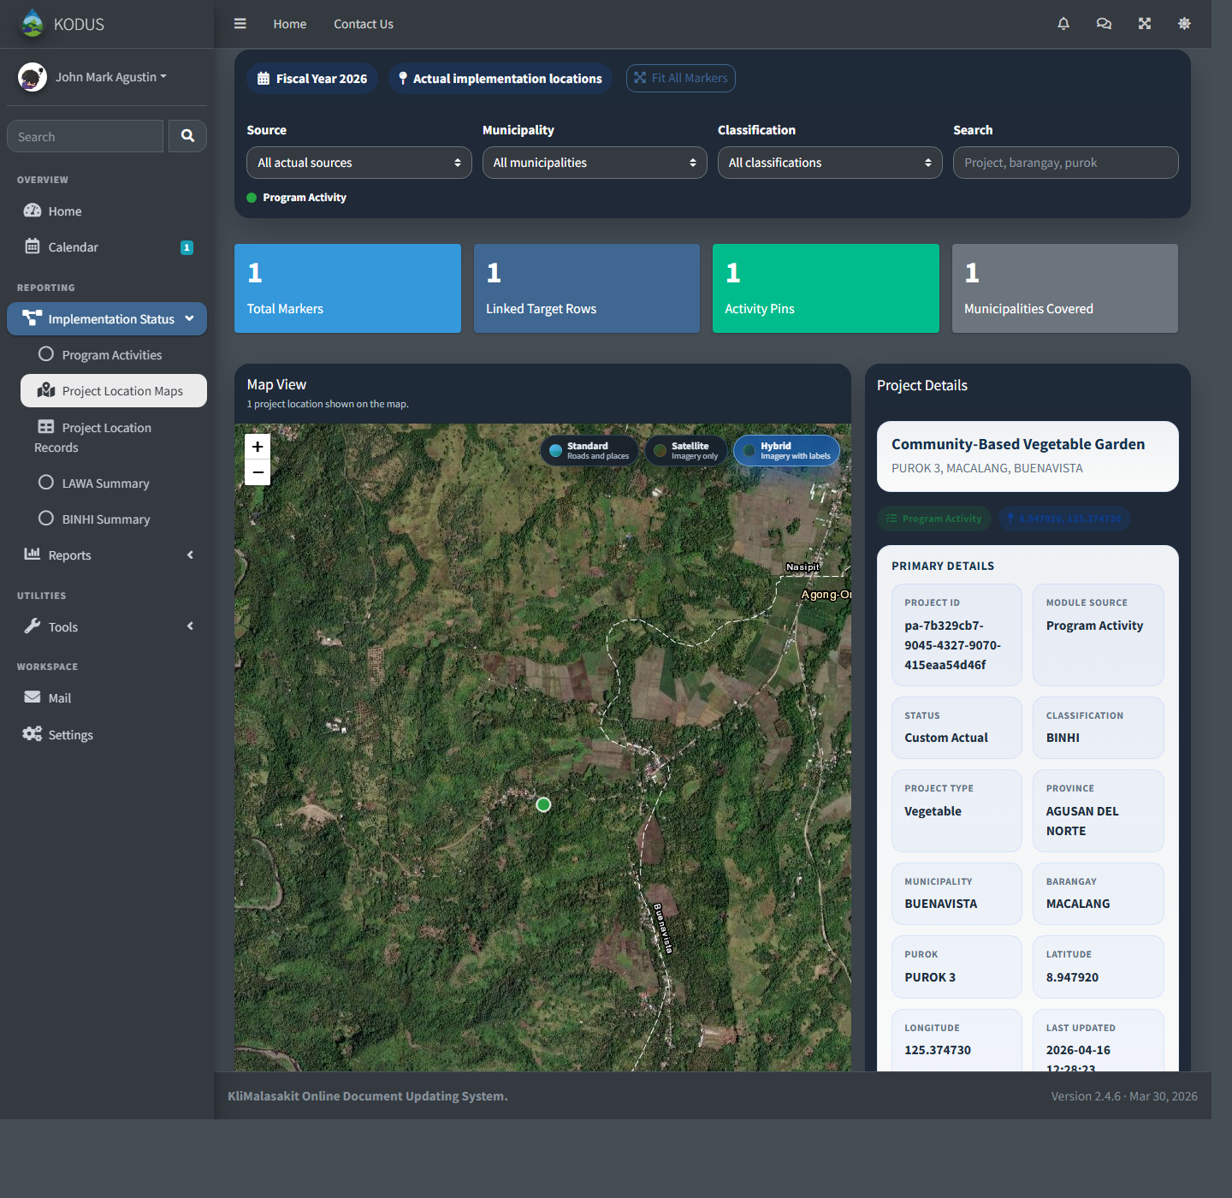
Project Location Maps page

