KliMalasakit Online Document Updating System
(KODUS)
User Manual Version 2
Accessing KODUS
Step 1: Go to the KODUS website and select the year to continue.
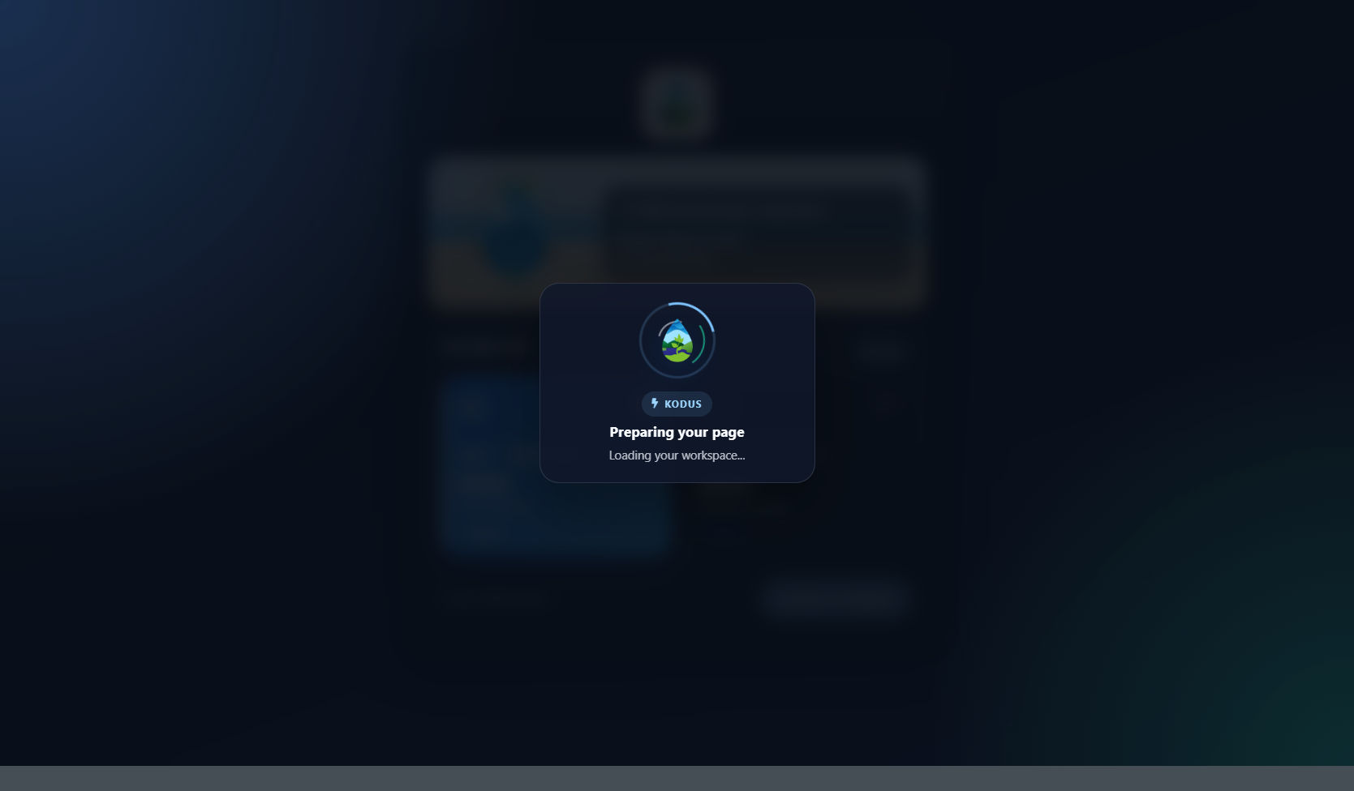
Year selection page
Step 2: Enter your username and password, then sign in to the system.
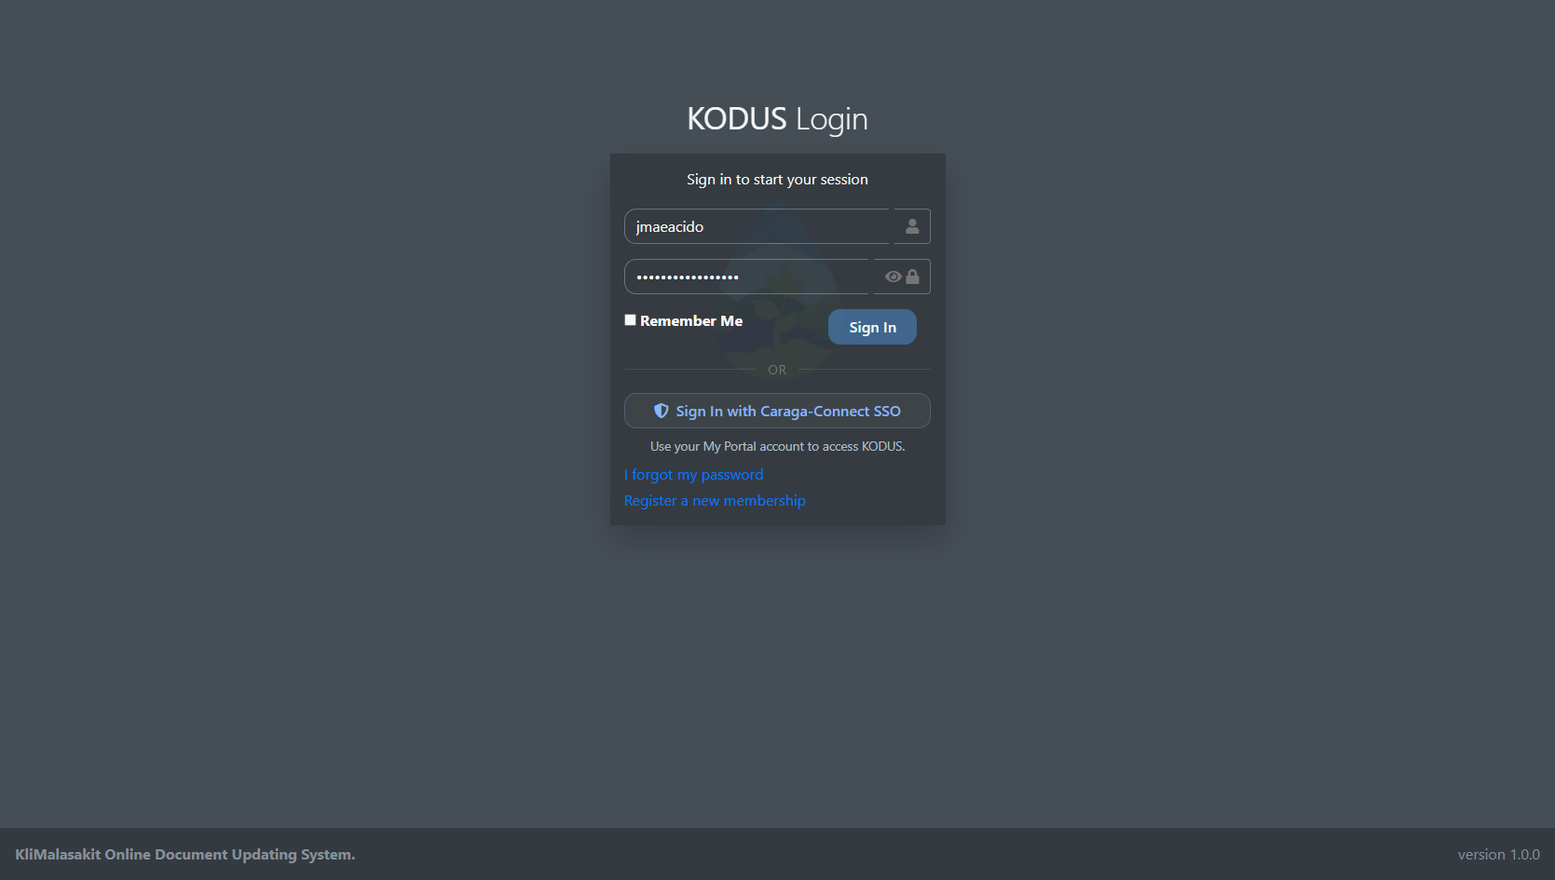
Login page
Administrator Guide
Step 1: Open the Dashboard to access administration, implementation, tracking, reports, and settings modules.
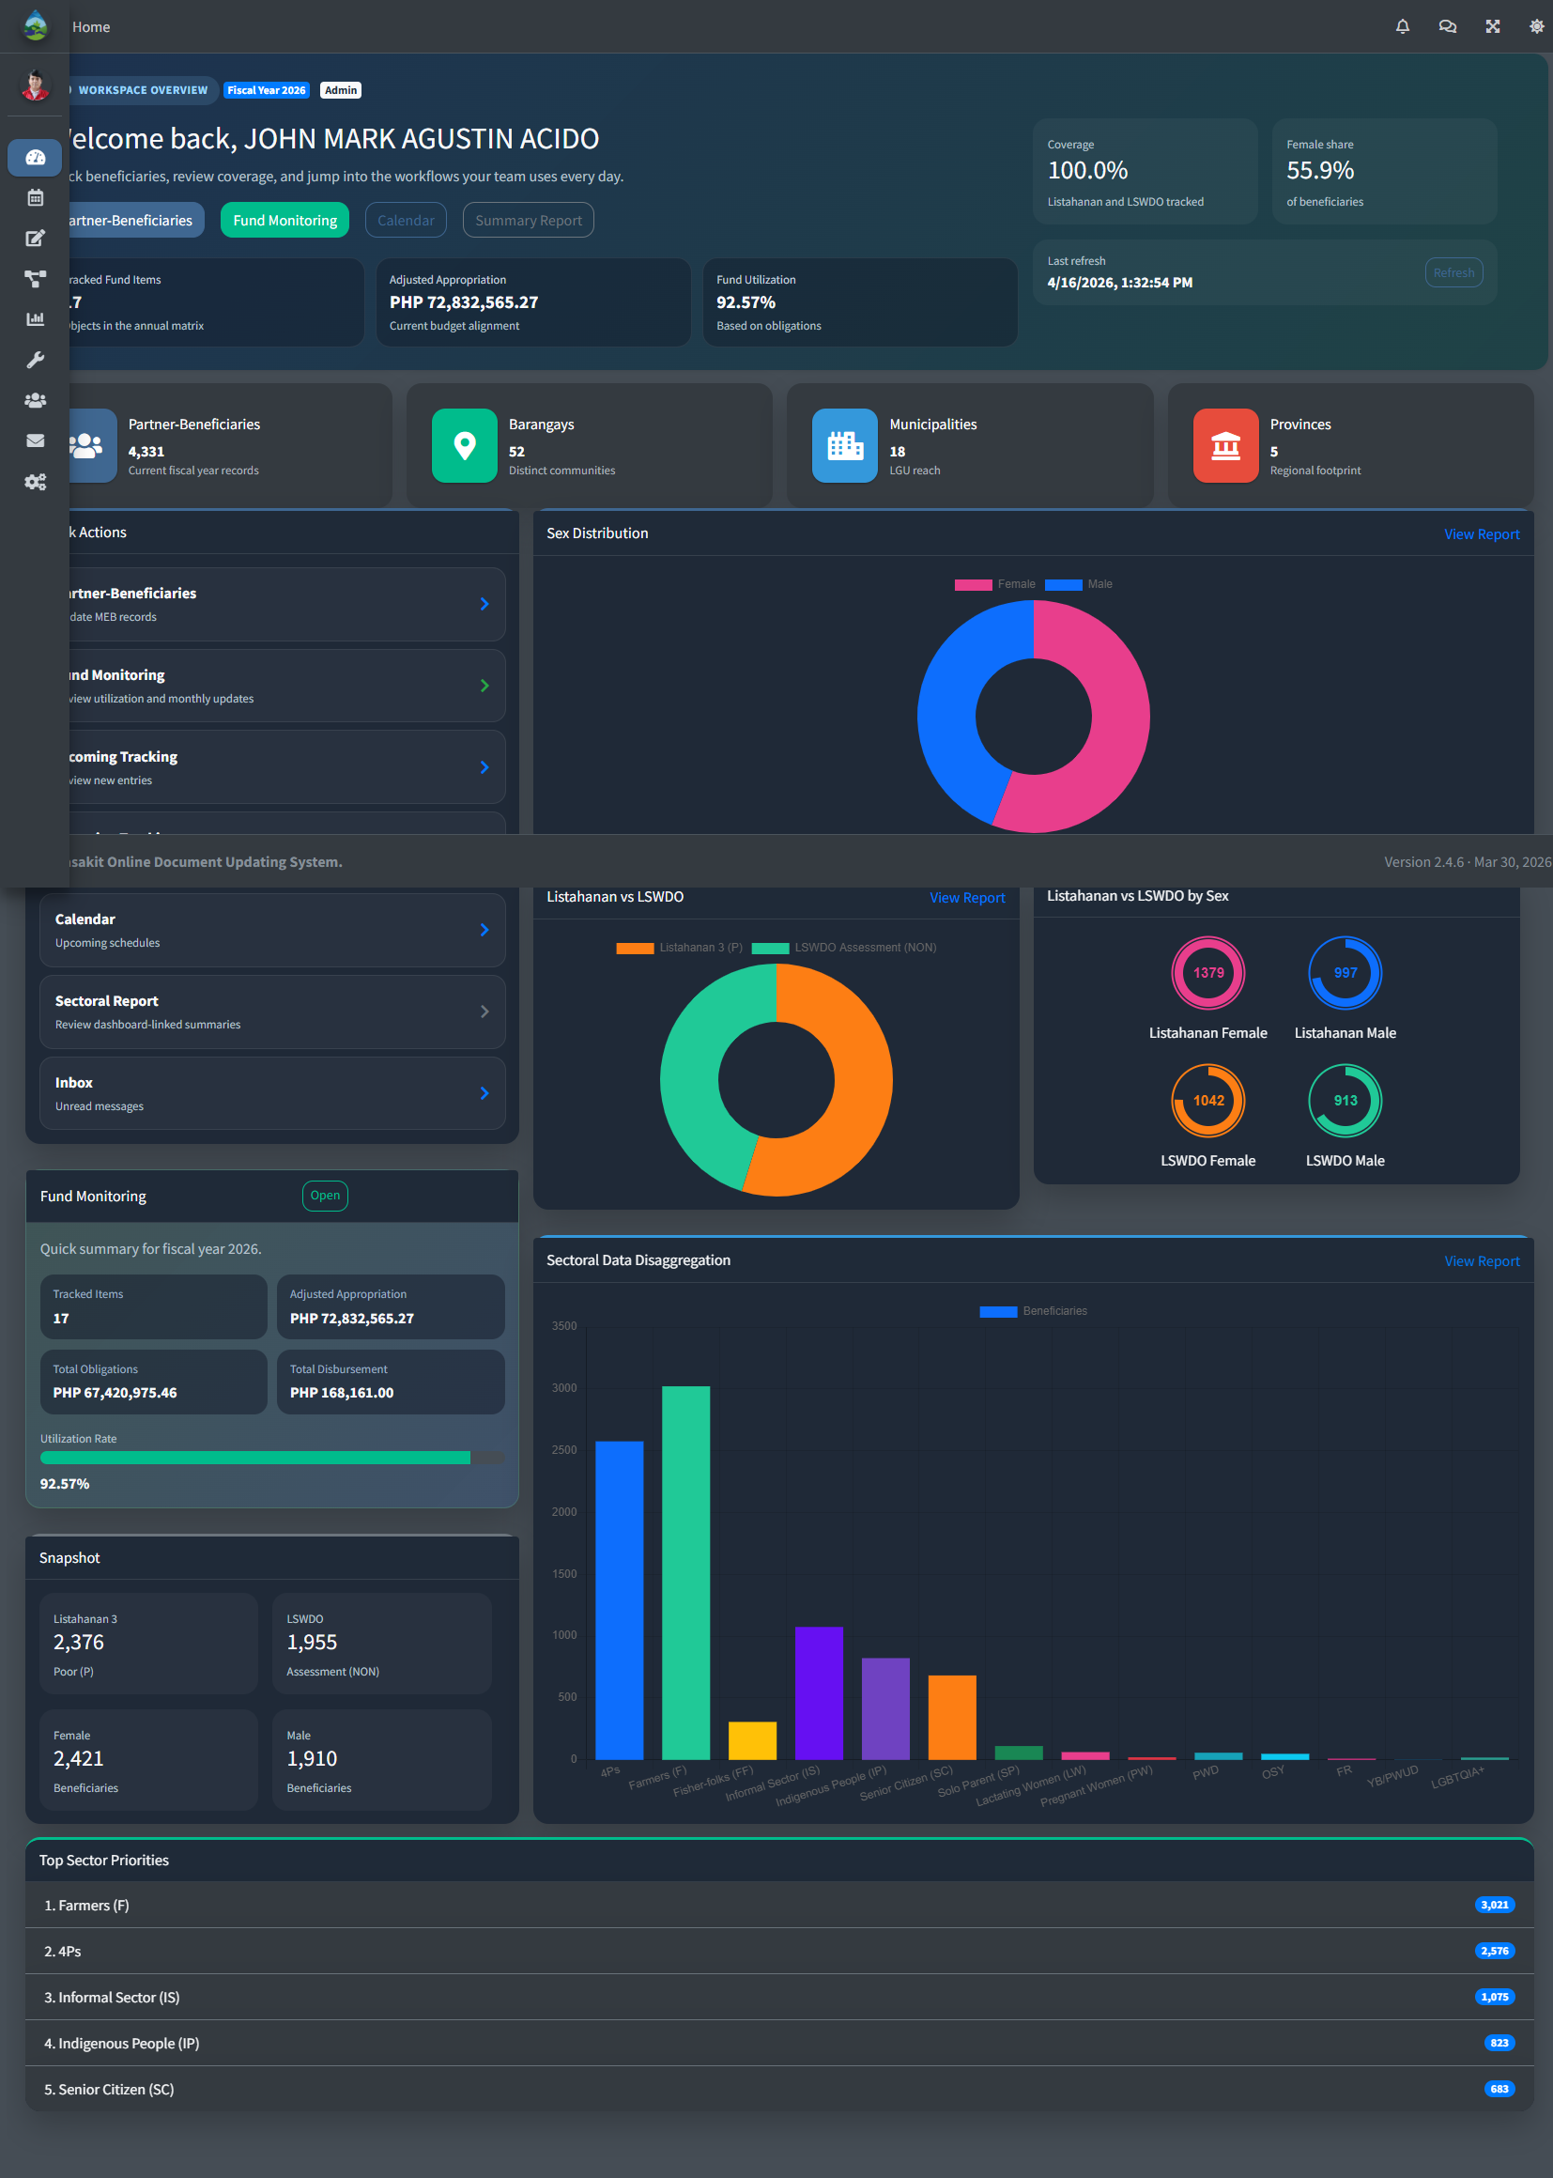
Administrator dashboard
Step 2: Click Users Management to view active user accounts.
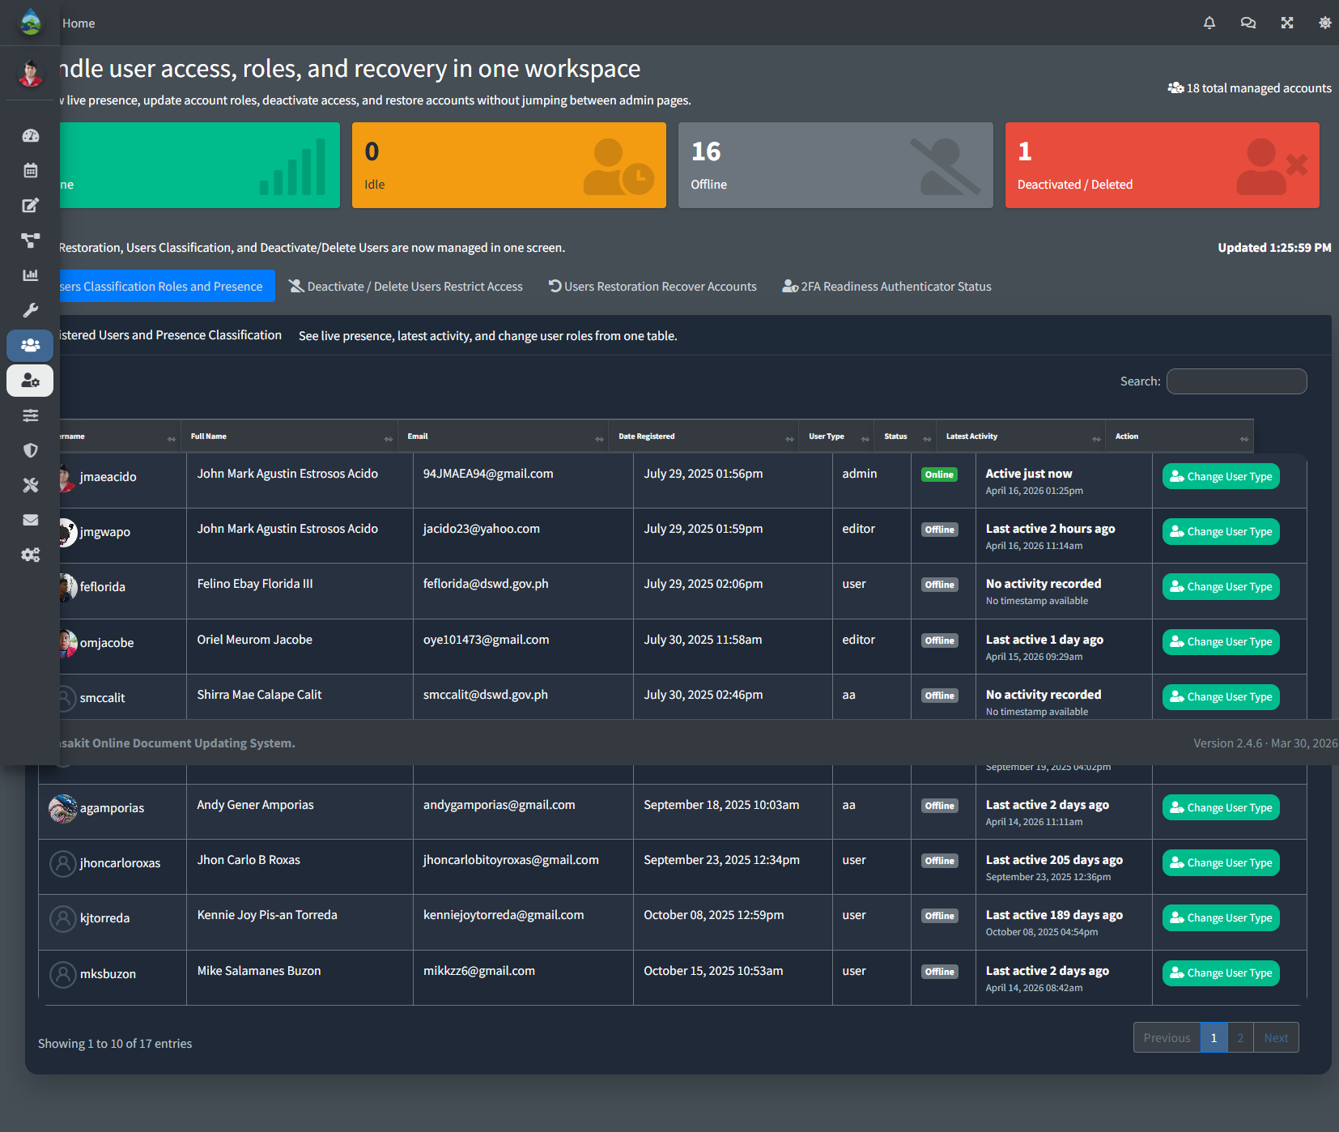
Users Management page
Step 3: Click the user action options to change a user role when needed.
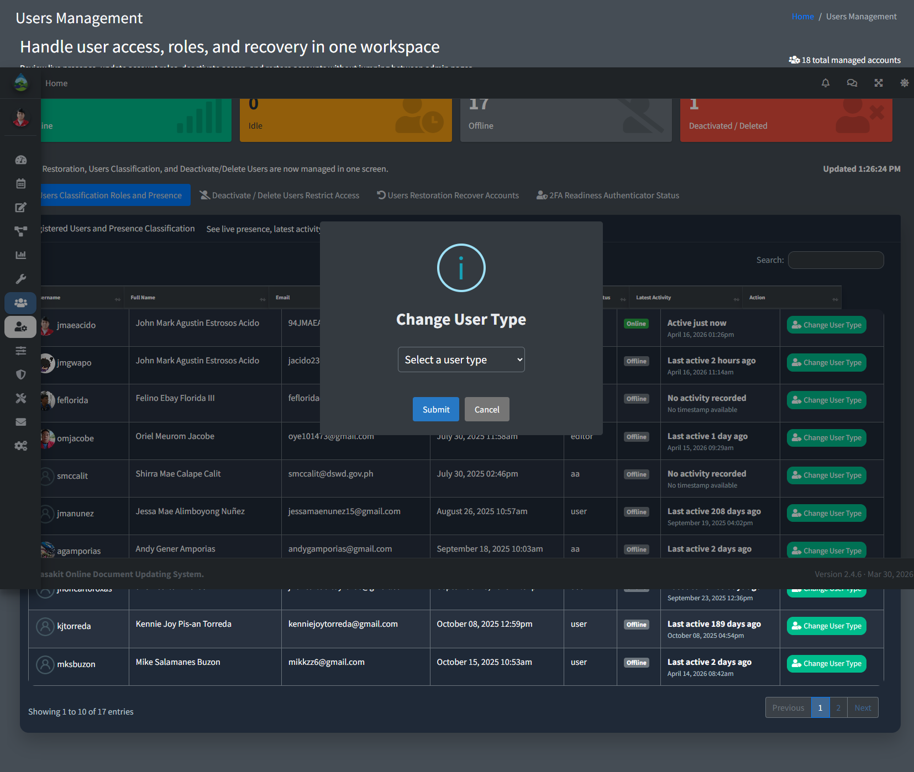
Change user type
Step 4: Click the user action options to reset a user two-factor authentication setup.
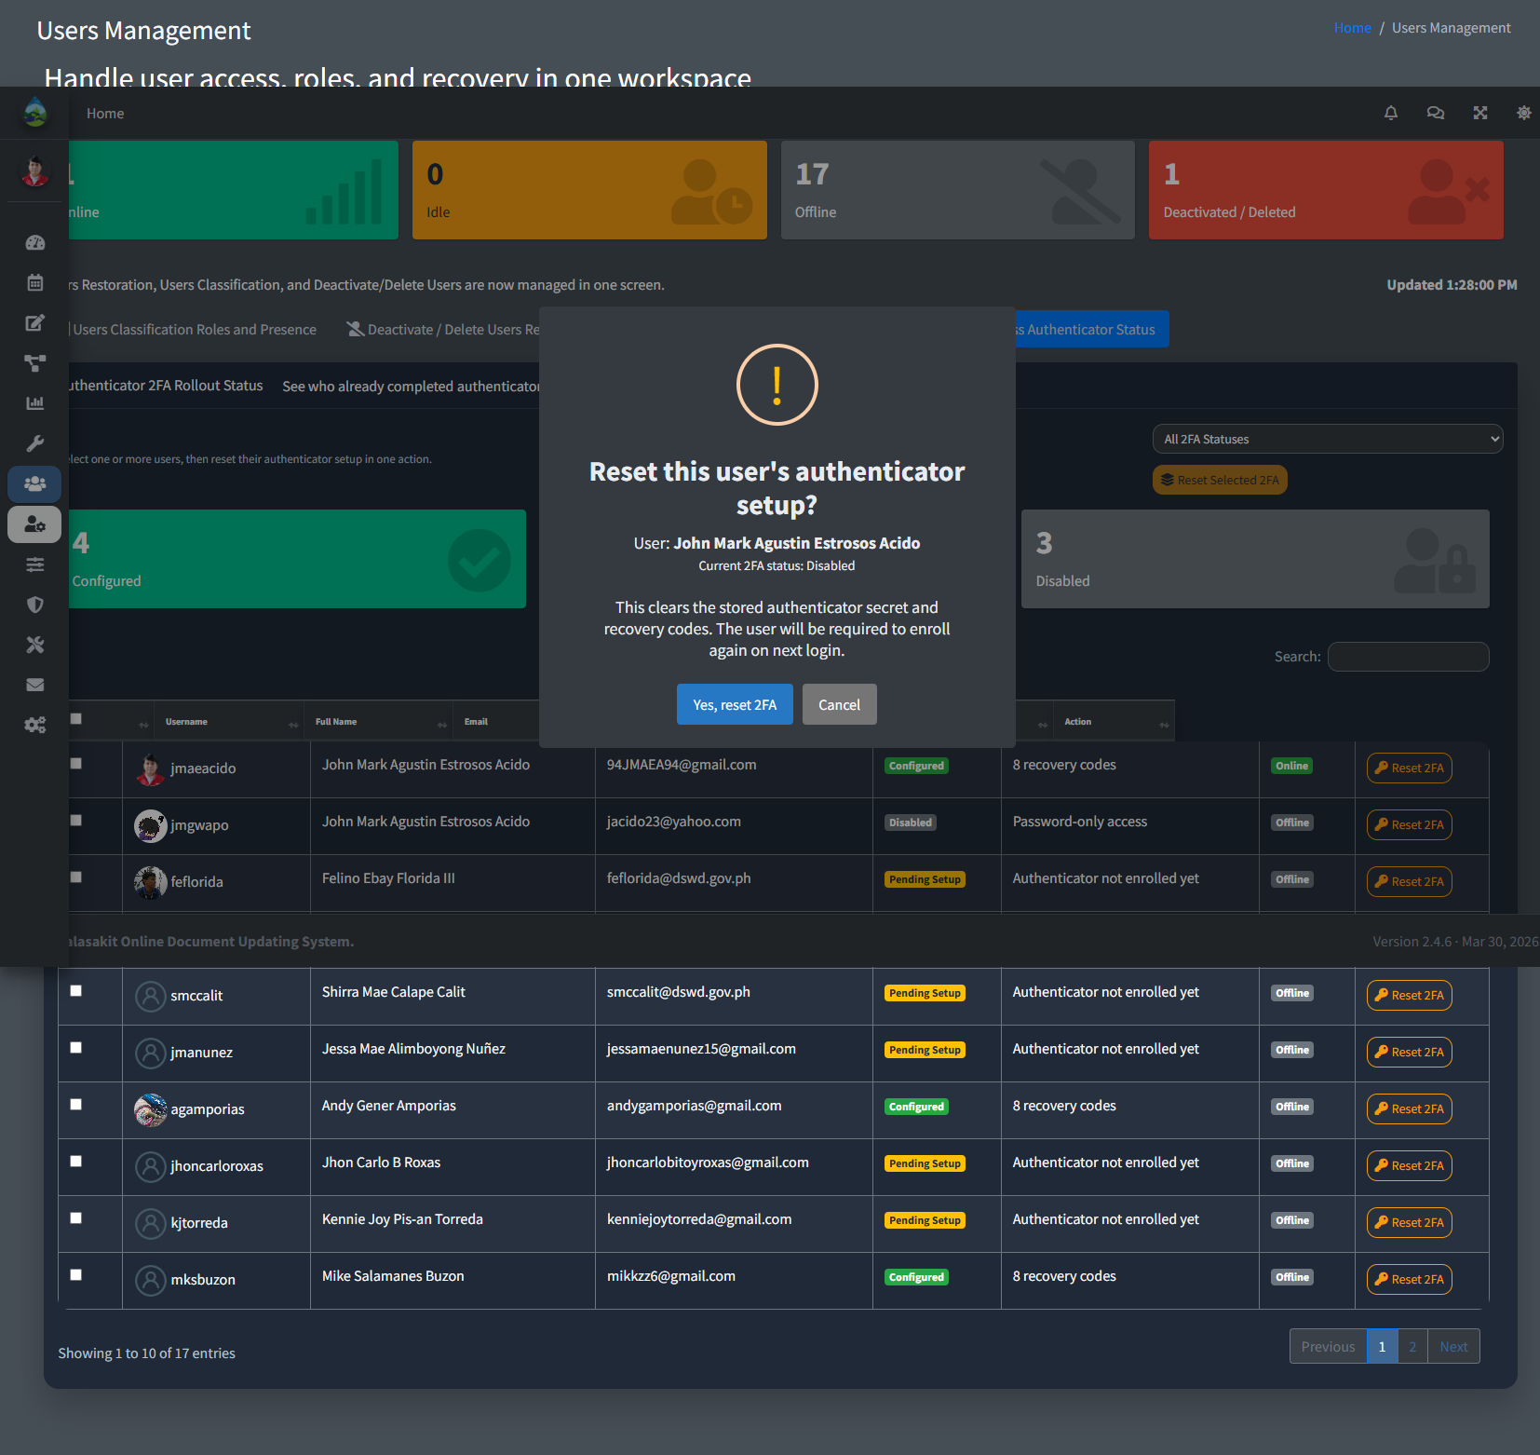
Reset user 2FA
Step 5: Click the restore action to recover a deactivated or deleted account.
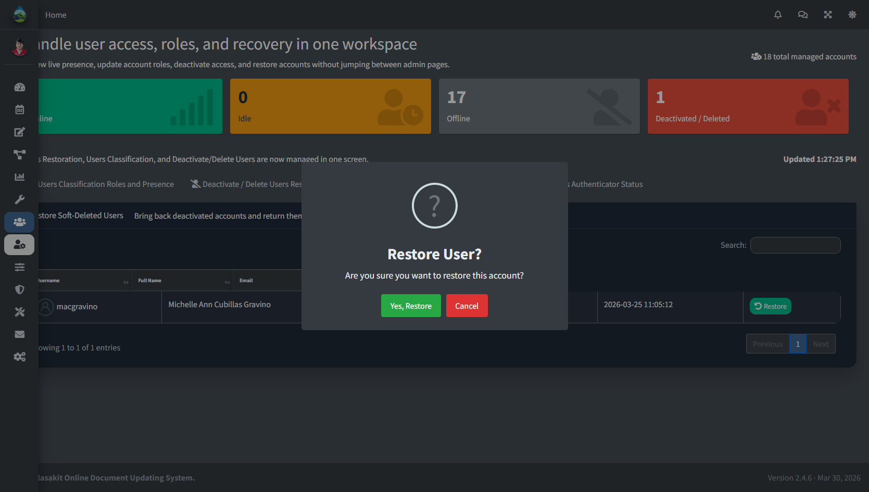
Restore user account
Step 6: Click Password Security to send reminders or require password reset actions.
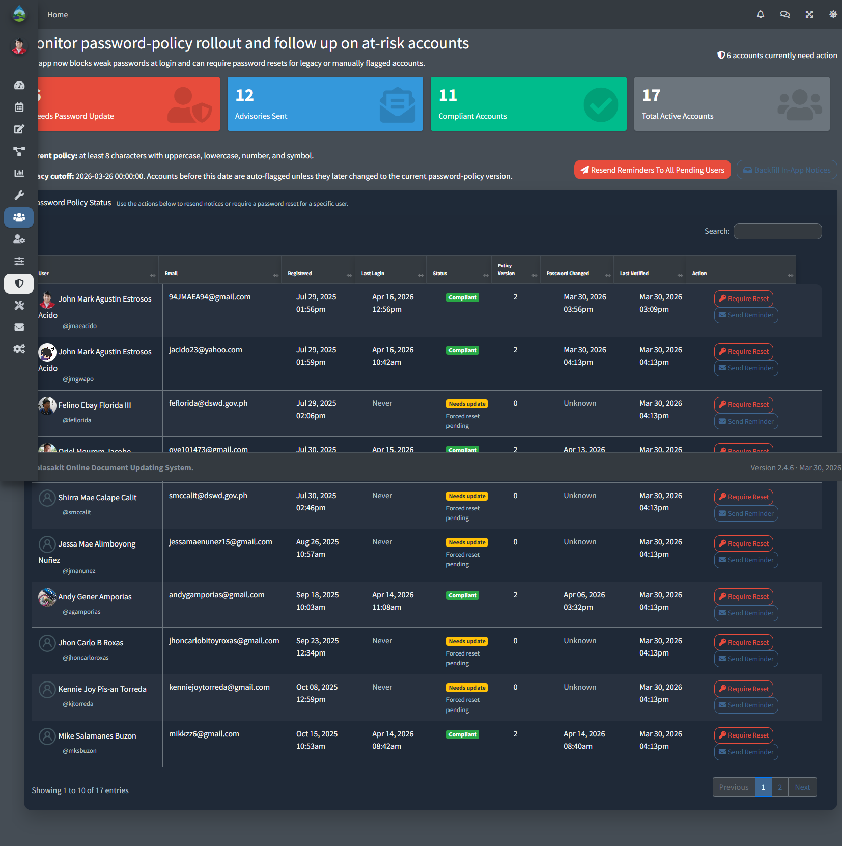
Password Security page
Step 7: Click Inbox to view or manage messages.
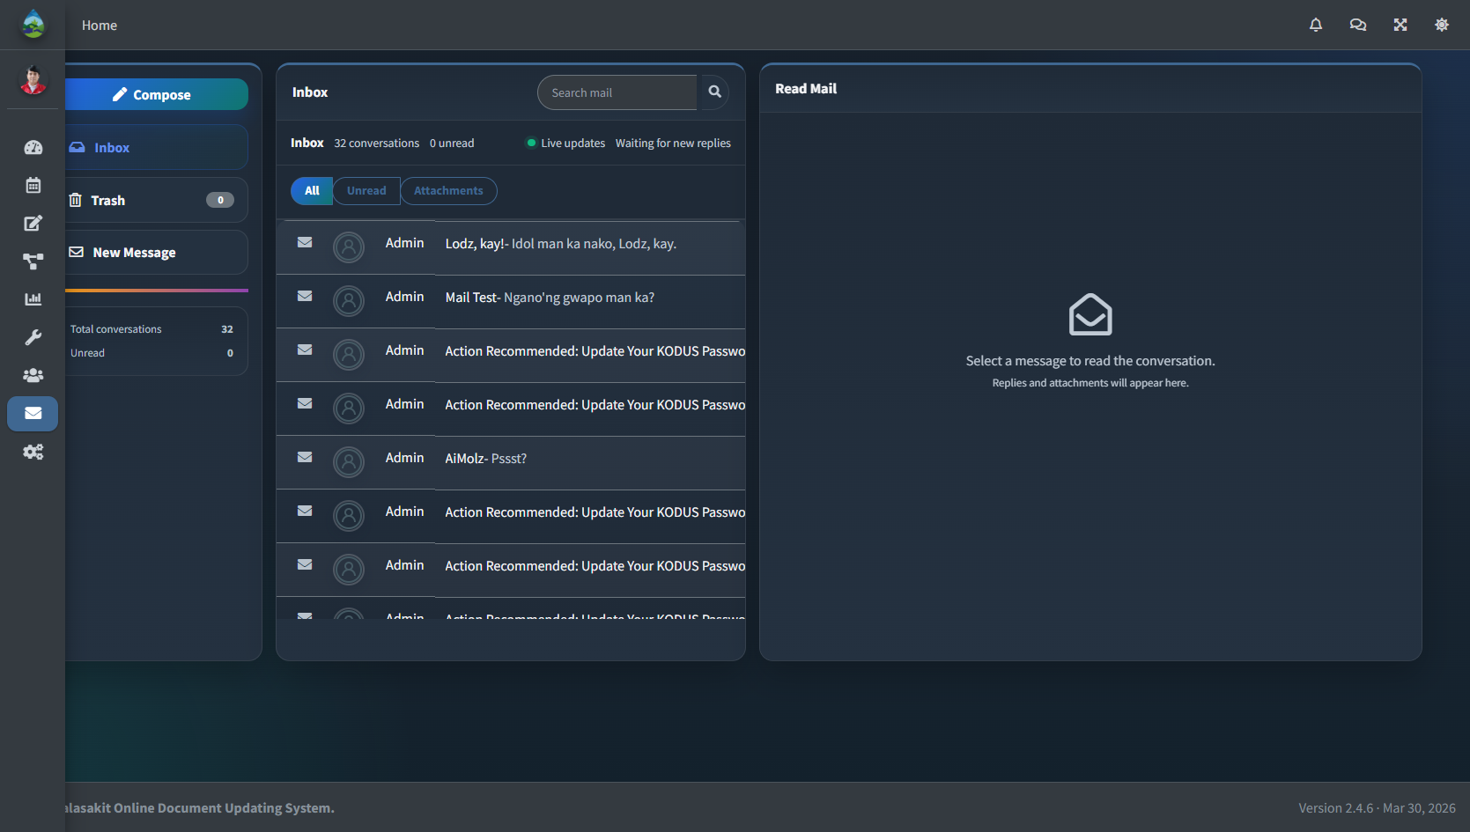
Inbox page
Step 8: Click Compose to create and send a new message.
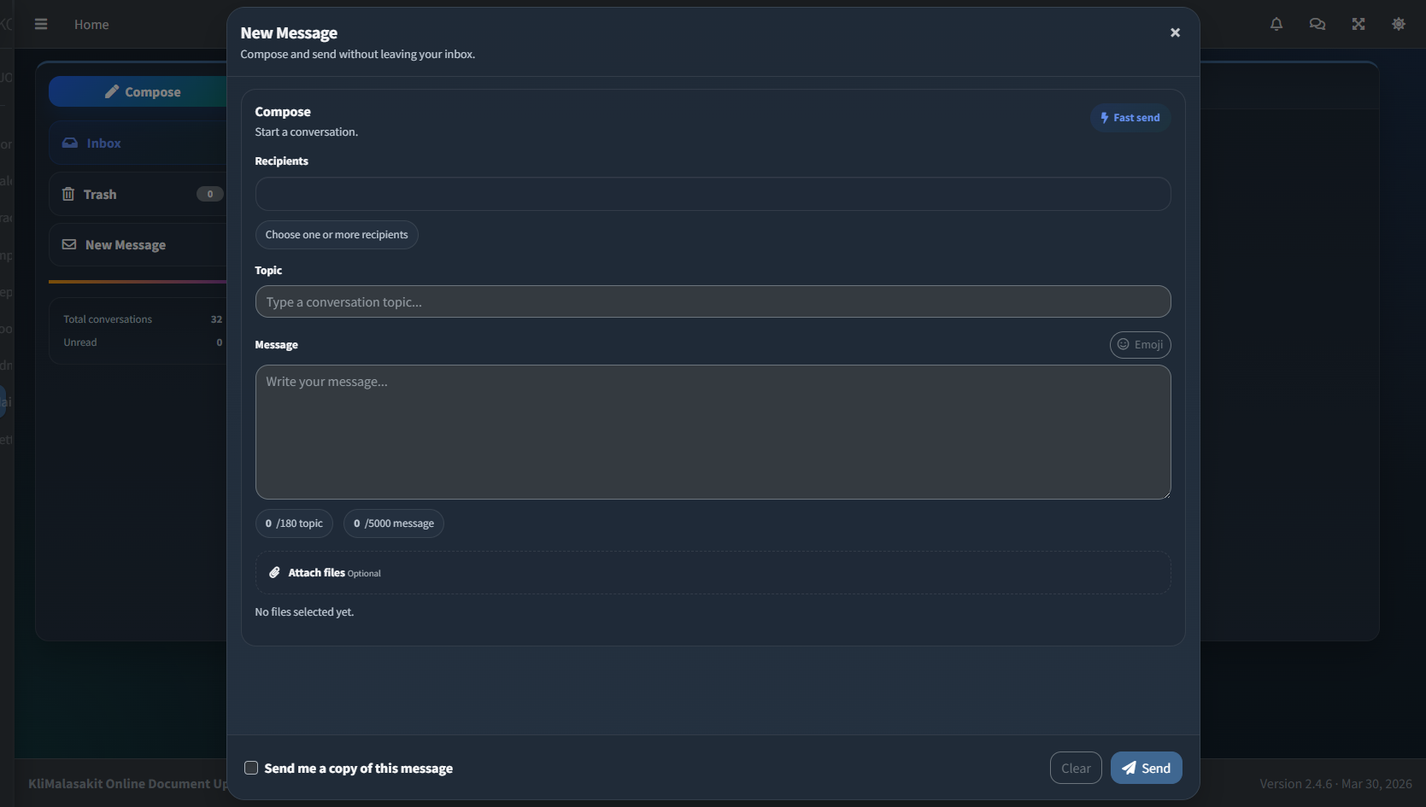
Compose message
Step 9: Click Maintenance to manage application availability and service gate settings.
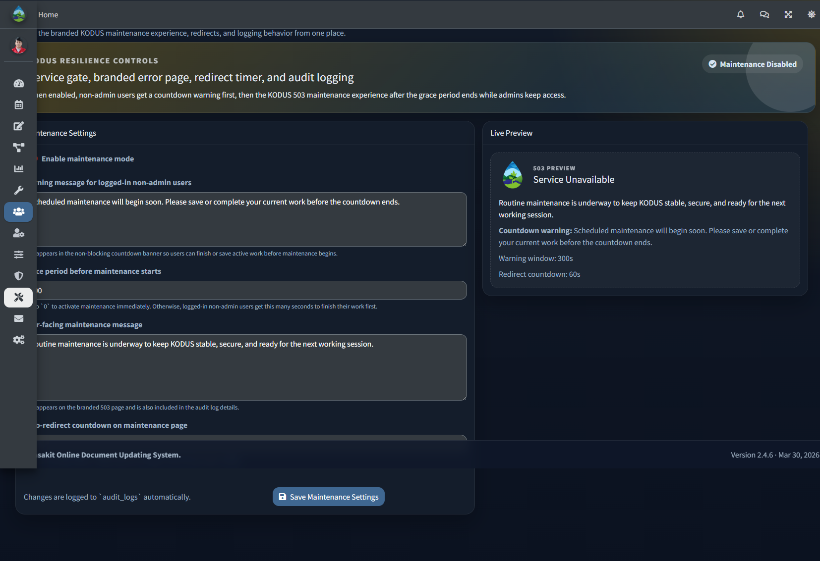
Maintenance settings page

Administrative Staff Guide
Step 1: Open the Dashboard to access operations, summaries, mail, and settings.

Operational dashboard layout
Step 2: Click Data Tracking In to record or track incoming documents allowed for Administrative Staff.
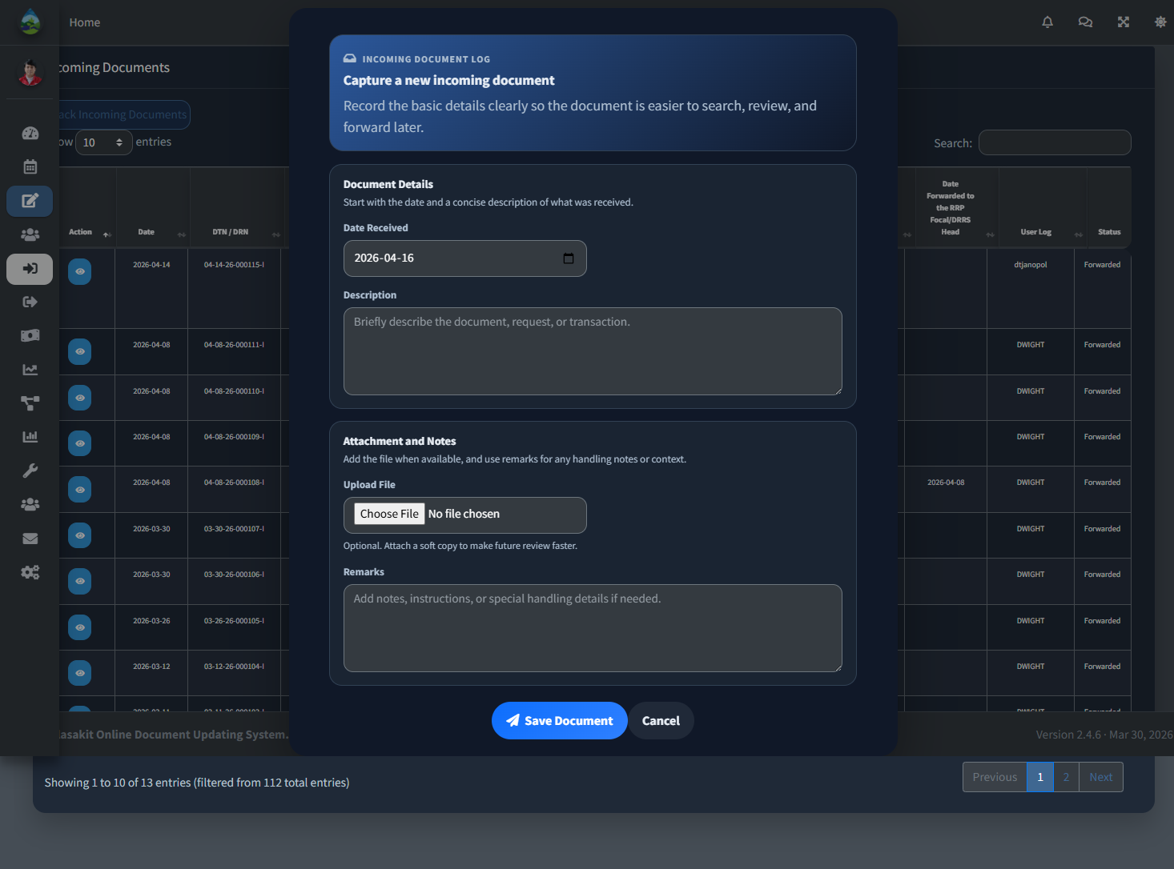
Track incoming document
Step 3: Click Data Tracking Out to record or track outgoing documents allowed for Administrative Staff.
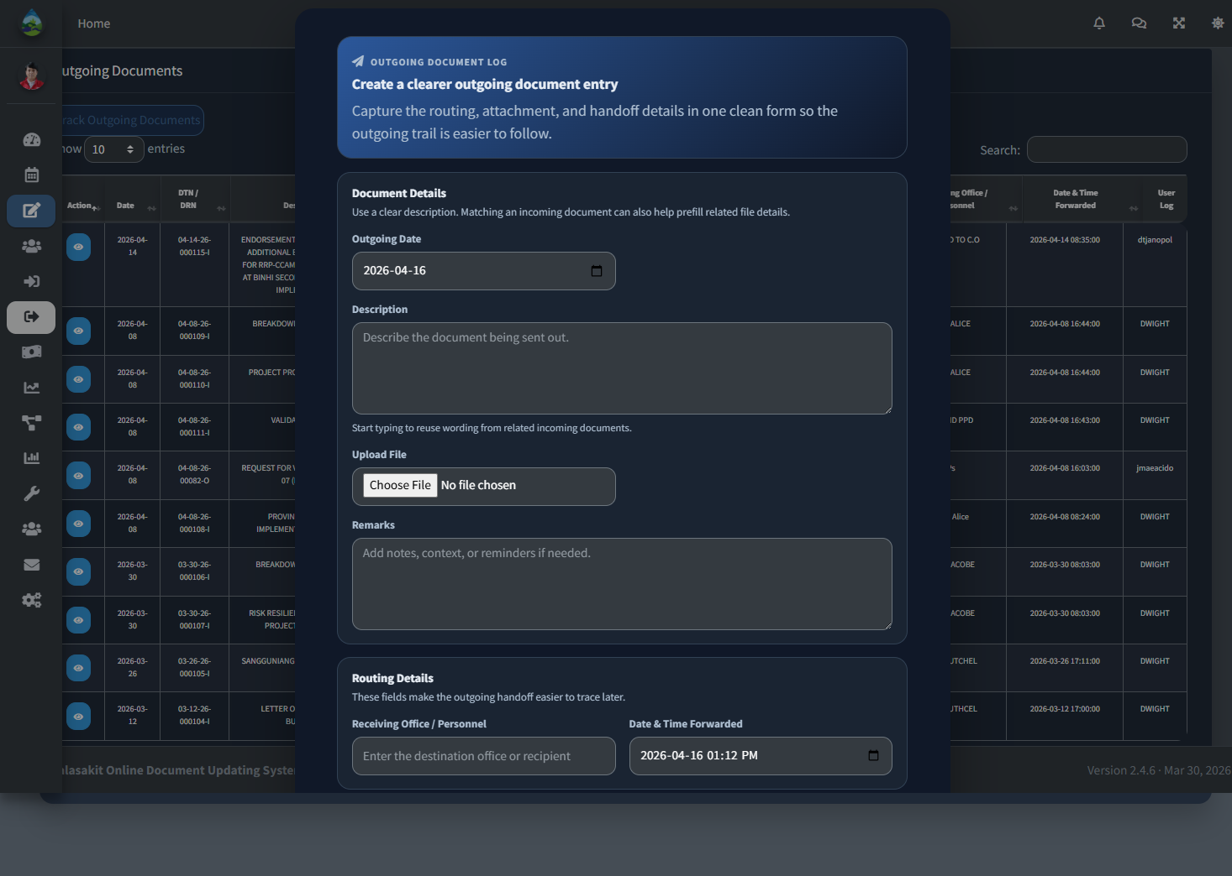
Track outgoing document
Step 4: Click Payout to review or update allowed payout transactions.
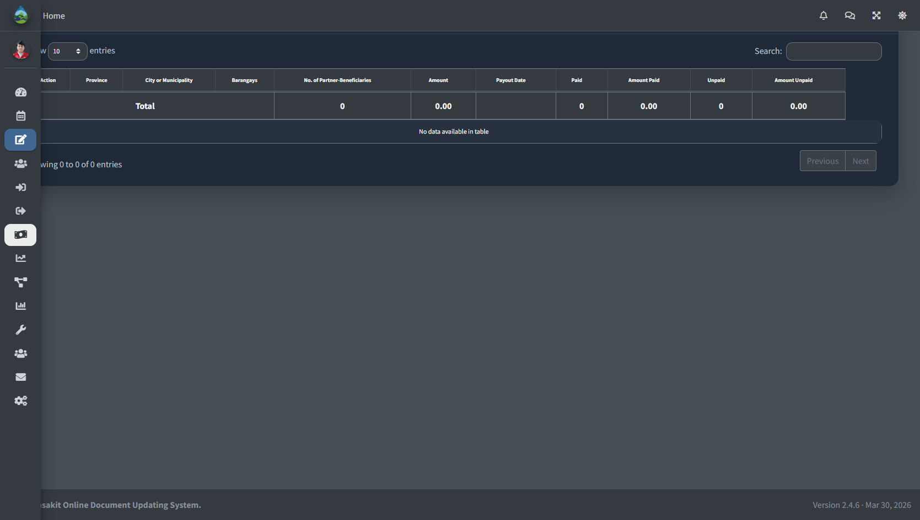
Payout page
Step 5: Click Program Activities to review implementation activity records in view mode.
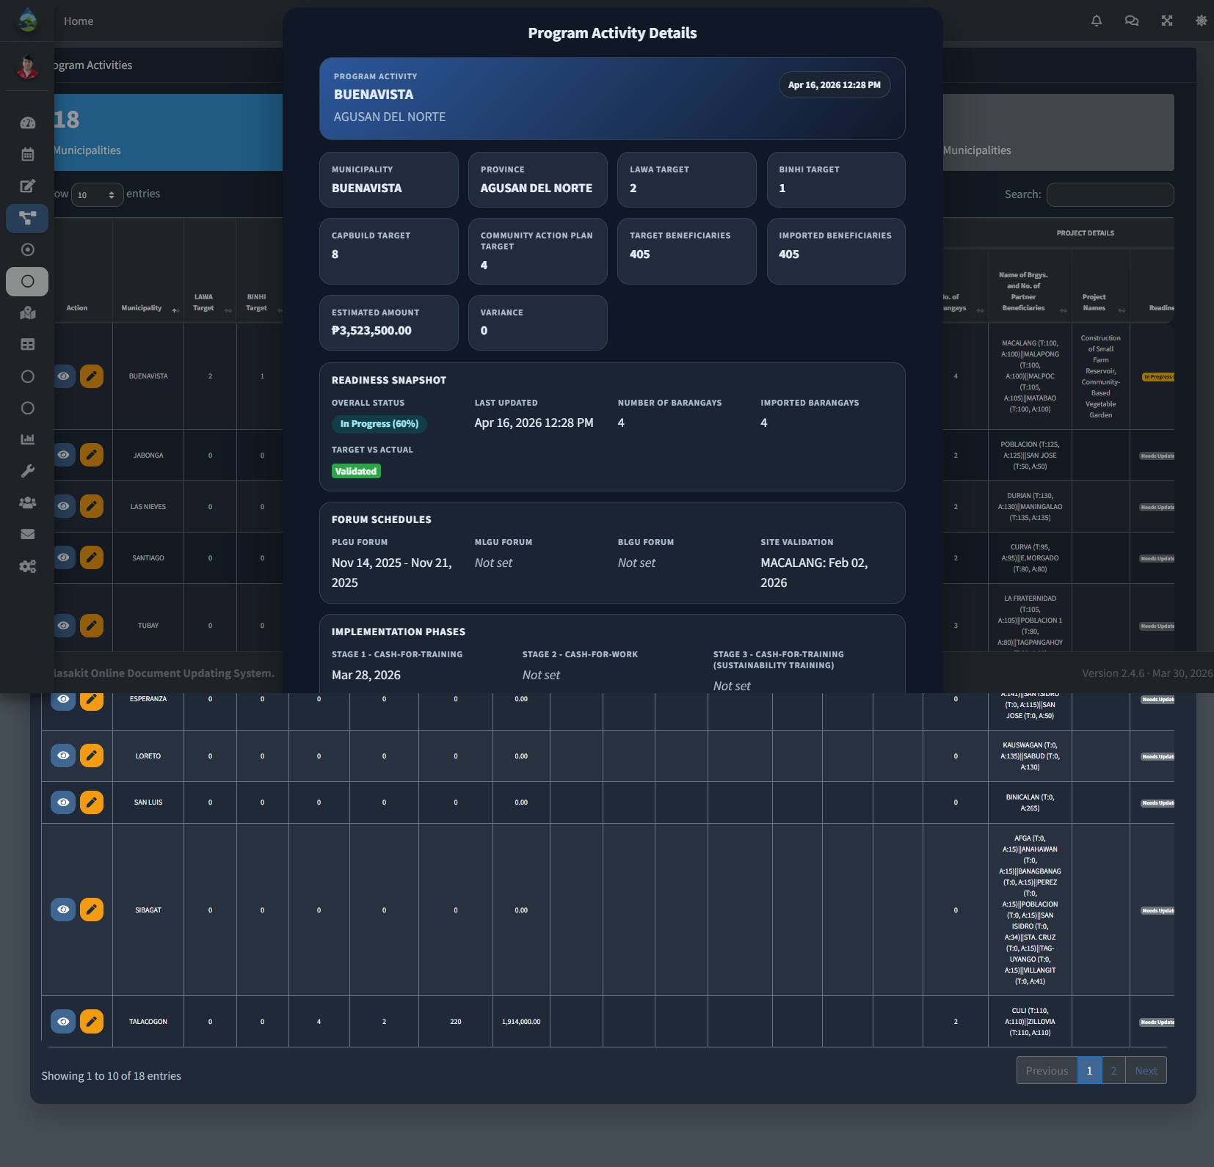
Program Activities view mode
Step 6: Click Inbox to view messages and send replies when needed.

Inbox page

Implementation Editor Guide
Step 1: Open the Dashboard to access implementation modules and reports.
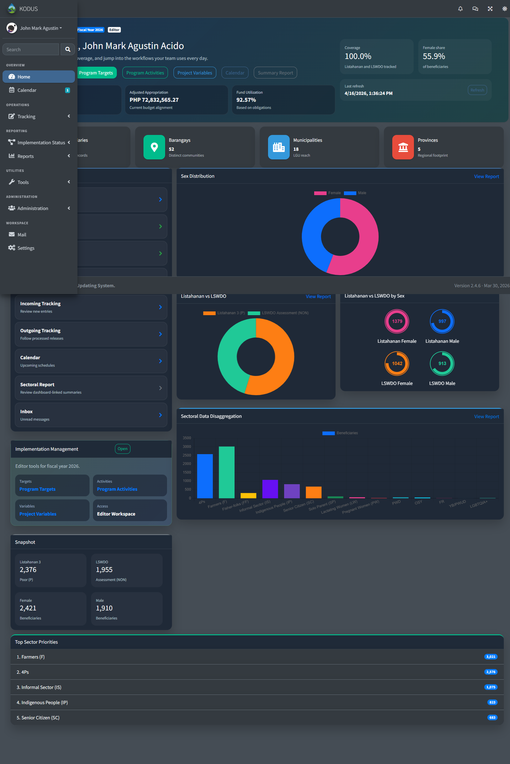
Implementation Editor dashboard
Step 2: Click Baseline Targets to add new target records.
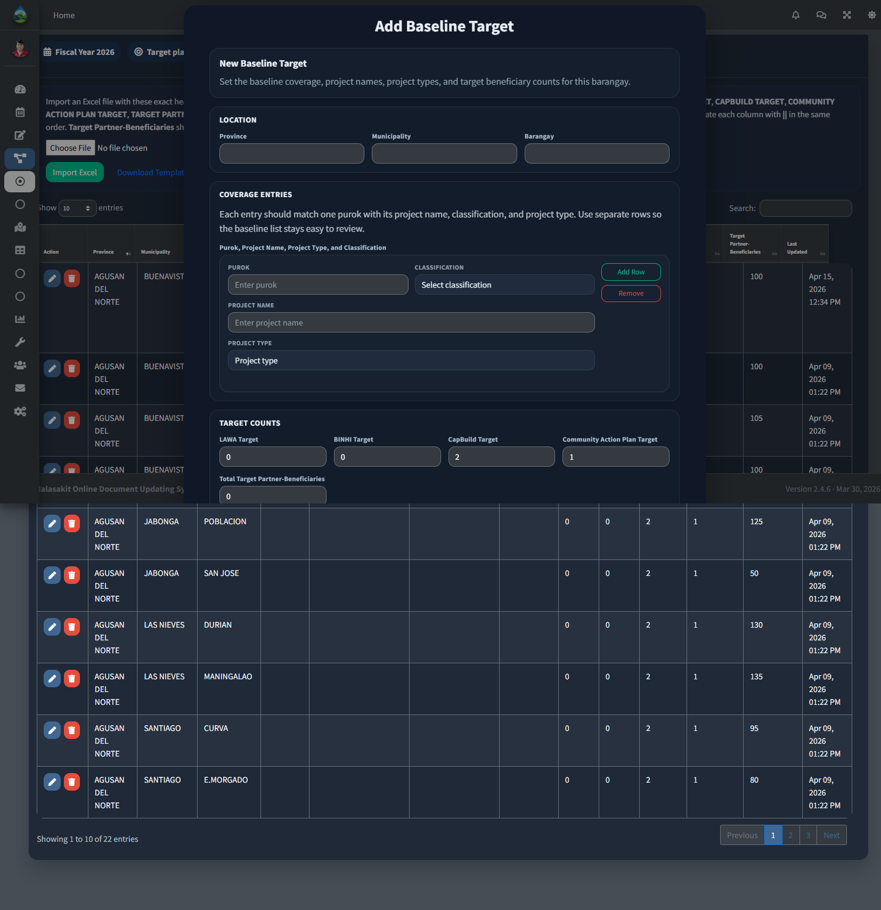
Add Baseline Target
Step 3: Click the edit action in Baseline Targets to update an existing target record.
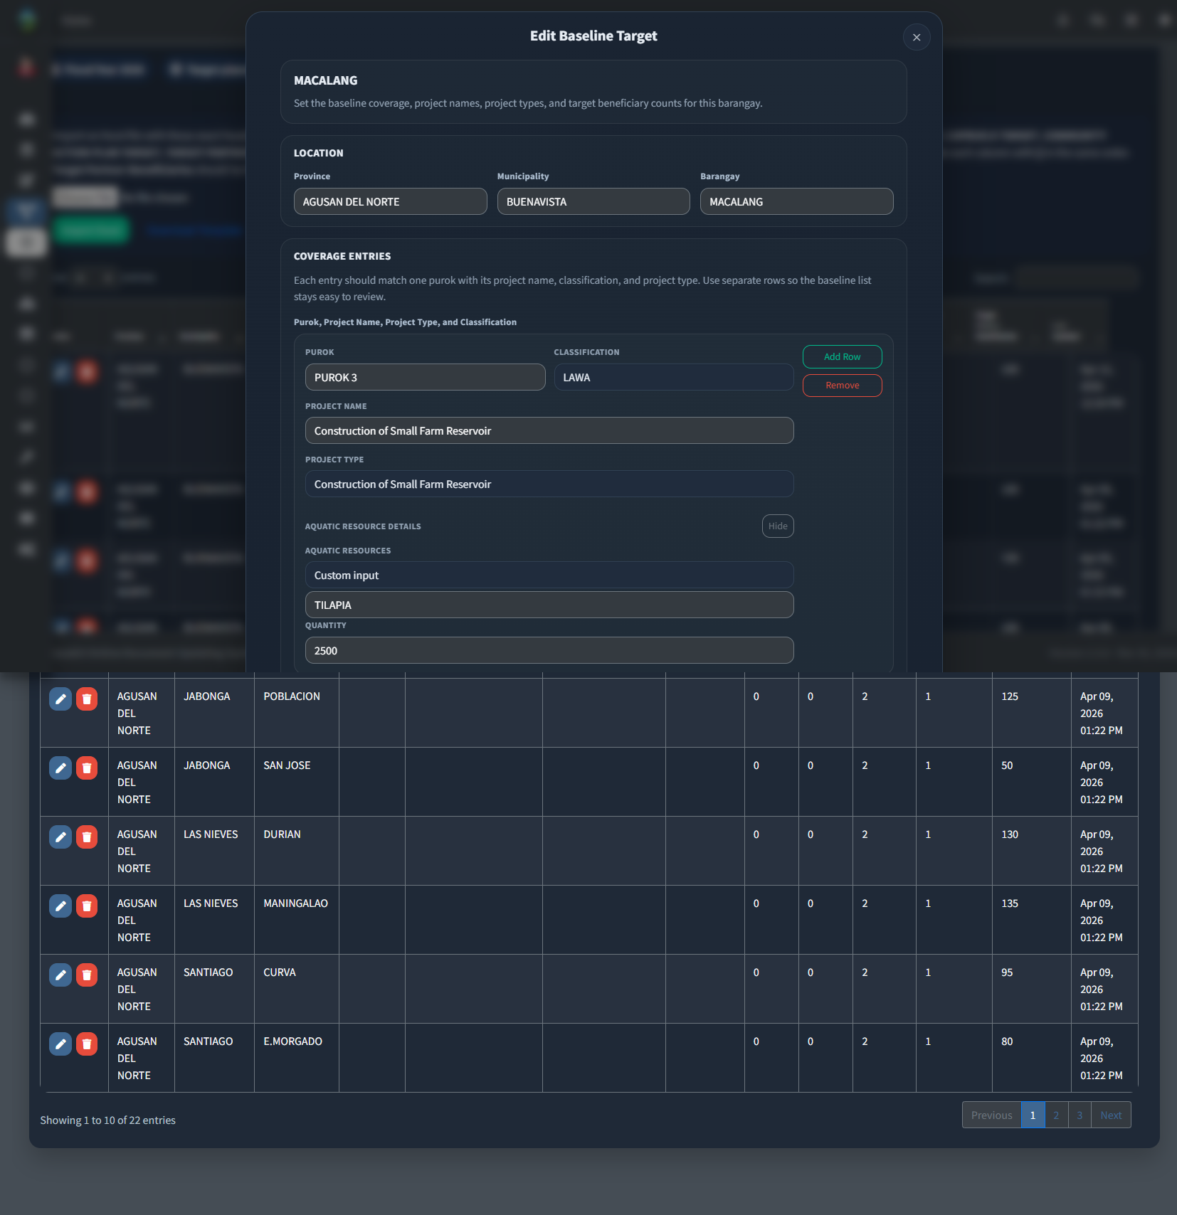
Edit Baseline Target
Step 4: Click Program Activities to update implementation activity records.
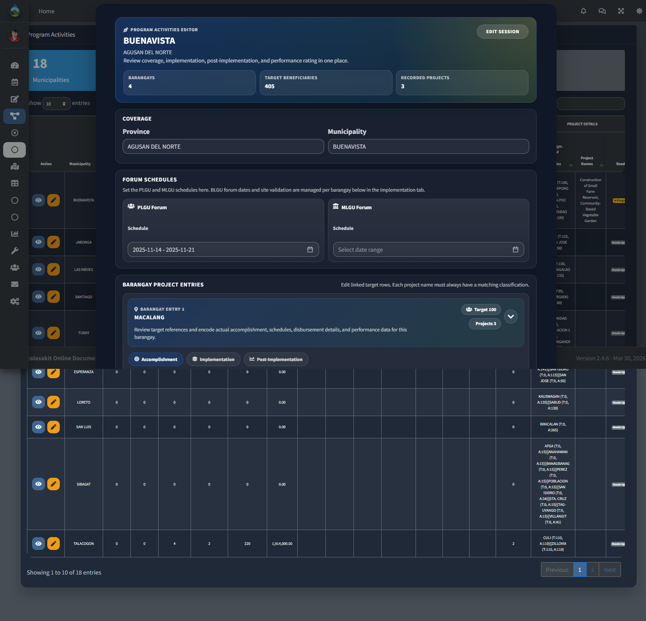
Edit Program Activities
Step 5: Click Project Variables to update configurable project variables.
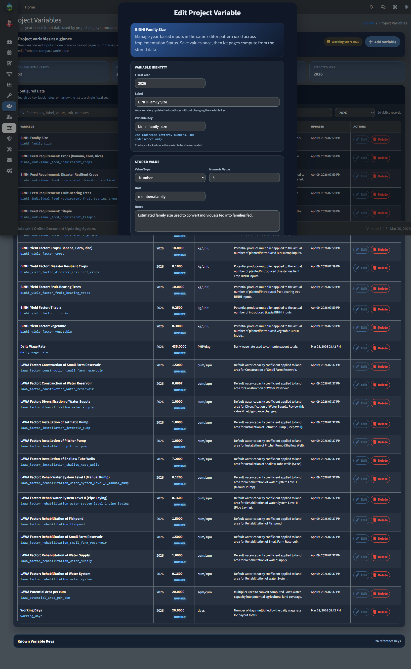
Edit Project Variables
Step 6: Click Project Location Maps to view project locations.
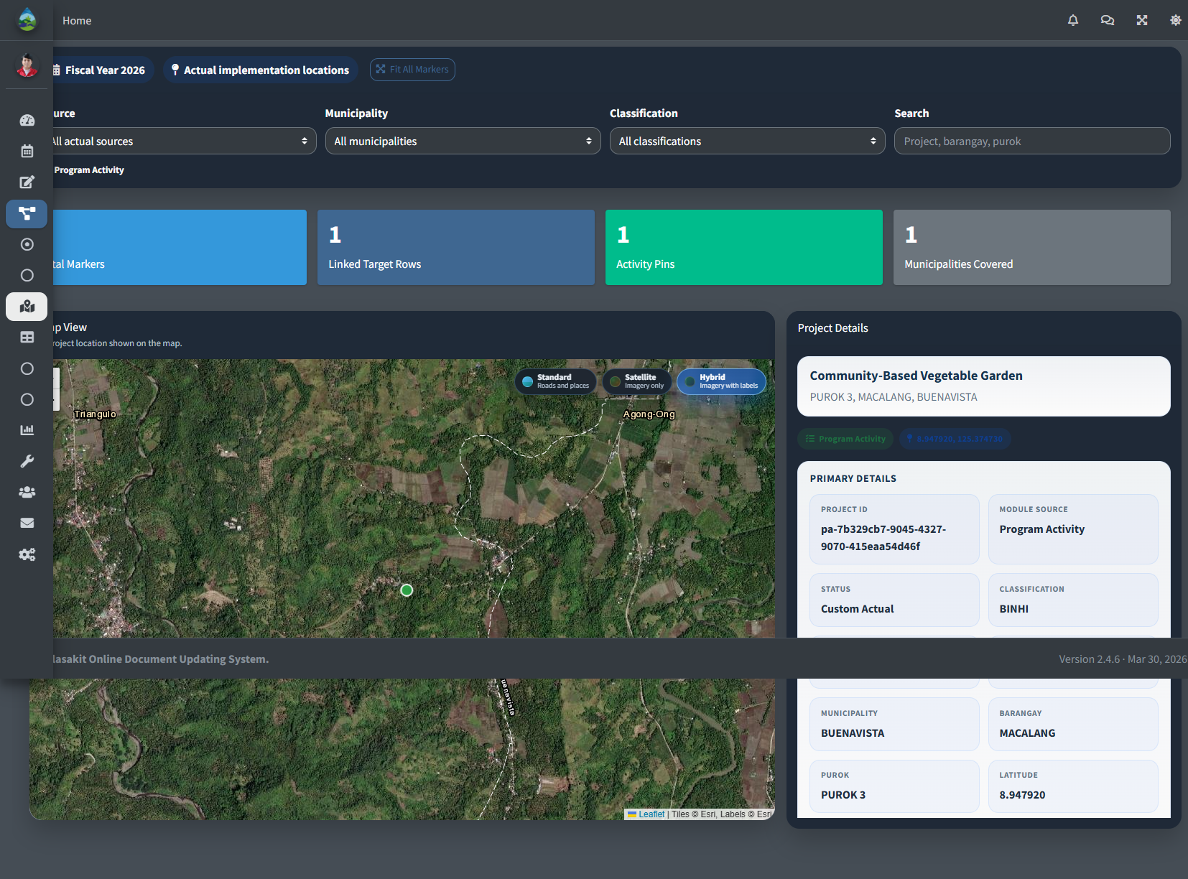
Project Location Maps
Step 7: Click Reports to view or export available summary reports.
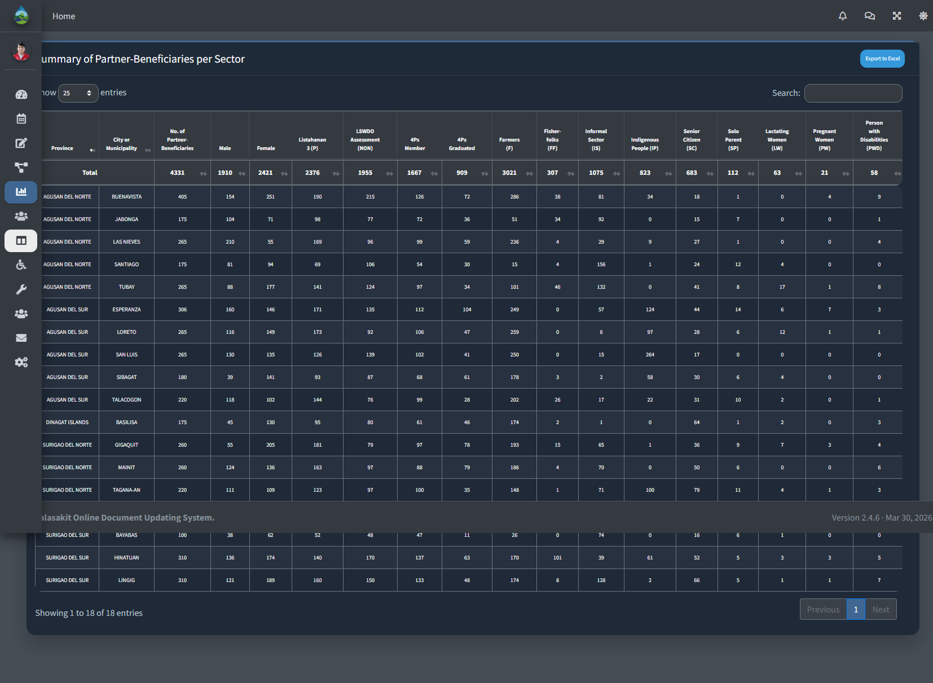
Sectoral report page

User Guide
Step 1: Open the Dashboard to view the modules available to your account.
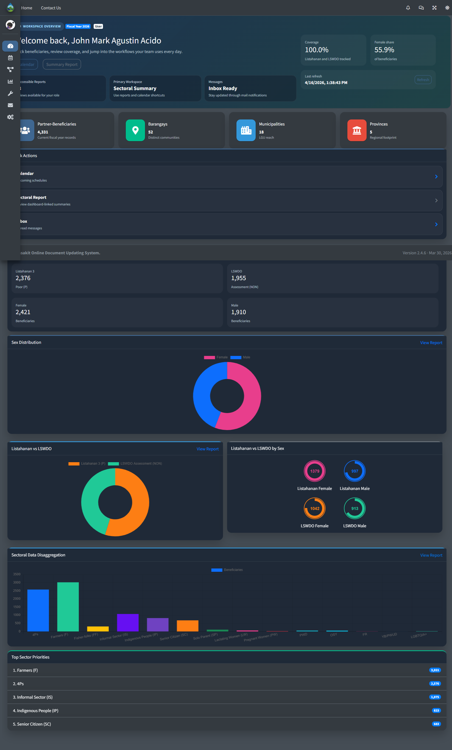
User dashboard
Step 2: Click Settings to update your profile, password, or two-factor authentication settings.
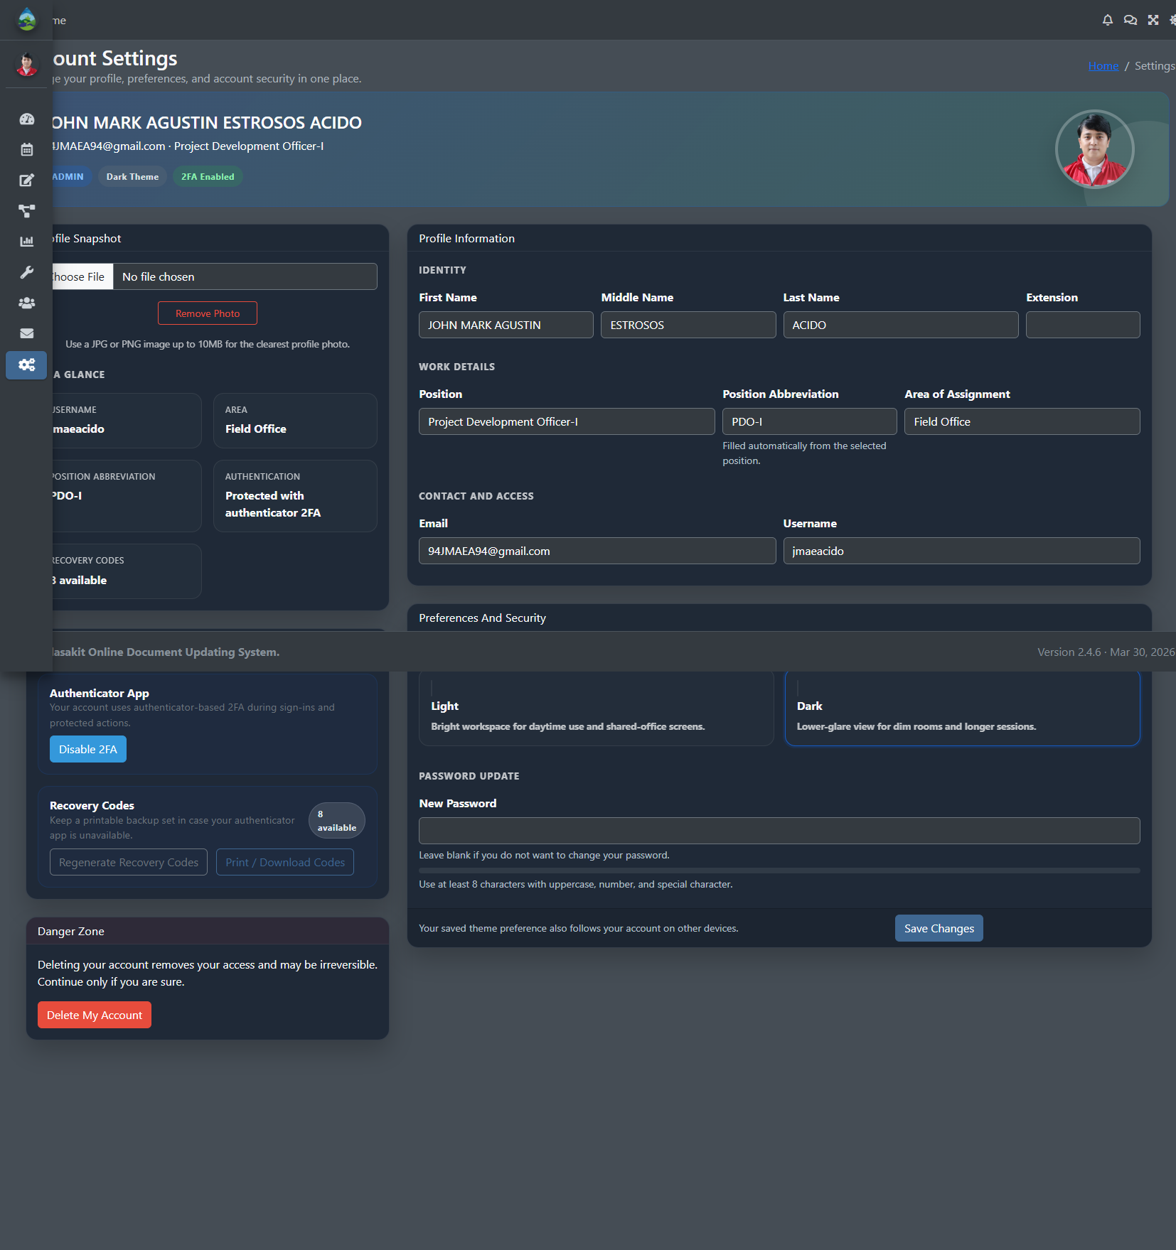
Settings page
Step 3: Click Inbox to view your messages.

Inbox page
Step 4: Click LAWA Summary to view available summary data.
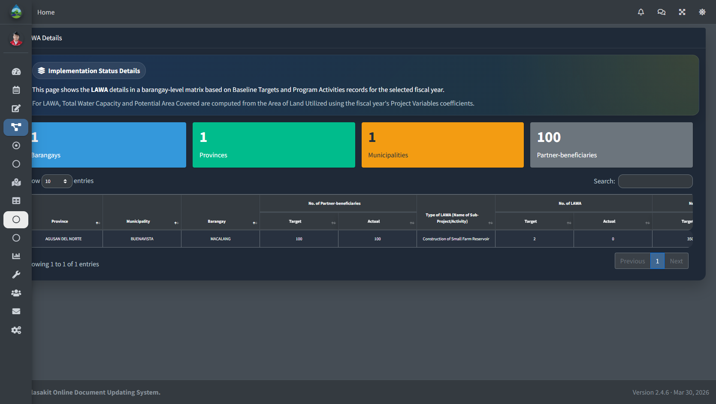
LAWA Summary page
Step 5: Click BINHI Summary to view available summary data.
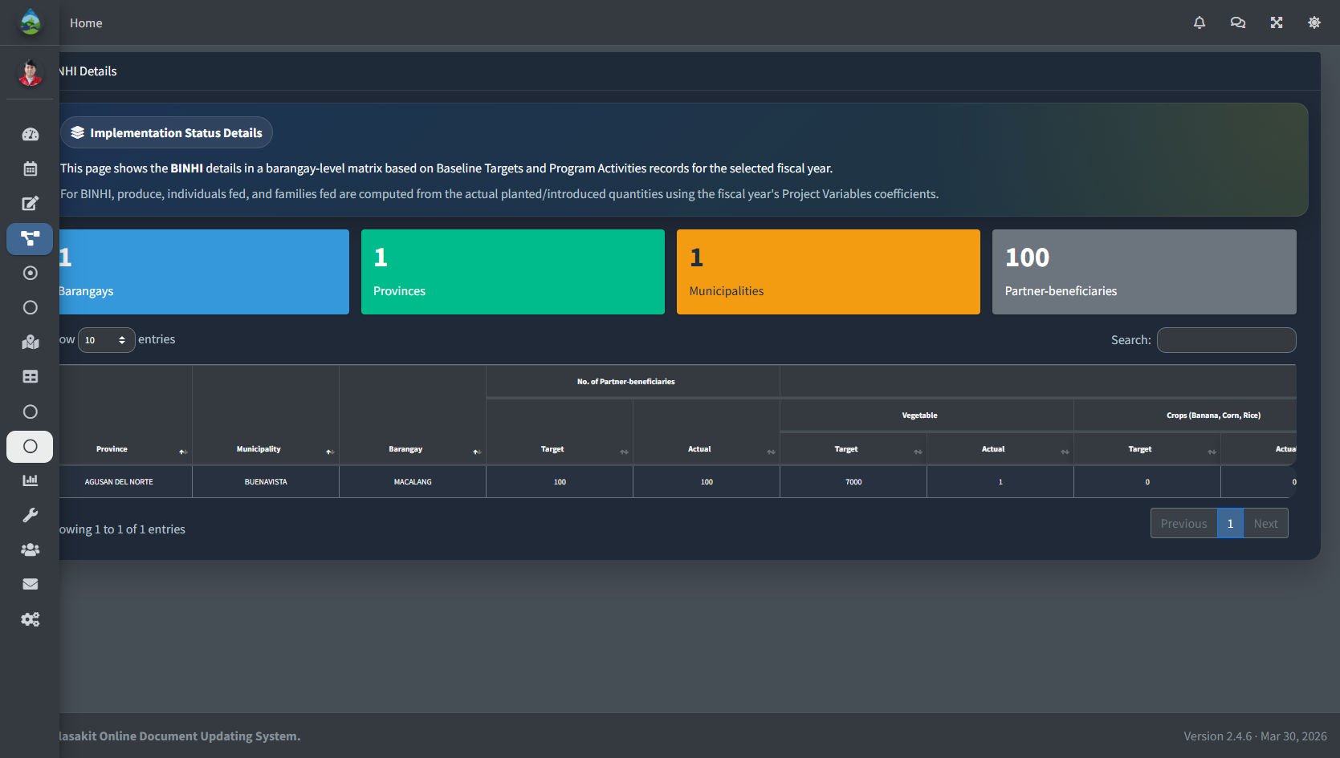
BINHI Summary page
Step 6: Click Project Location Maps to view project locations.
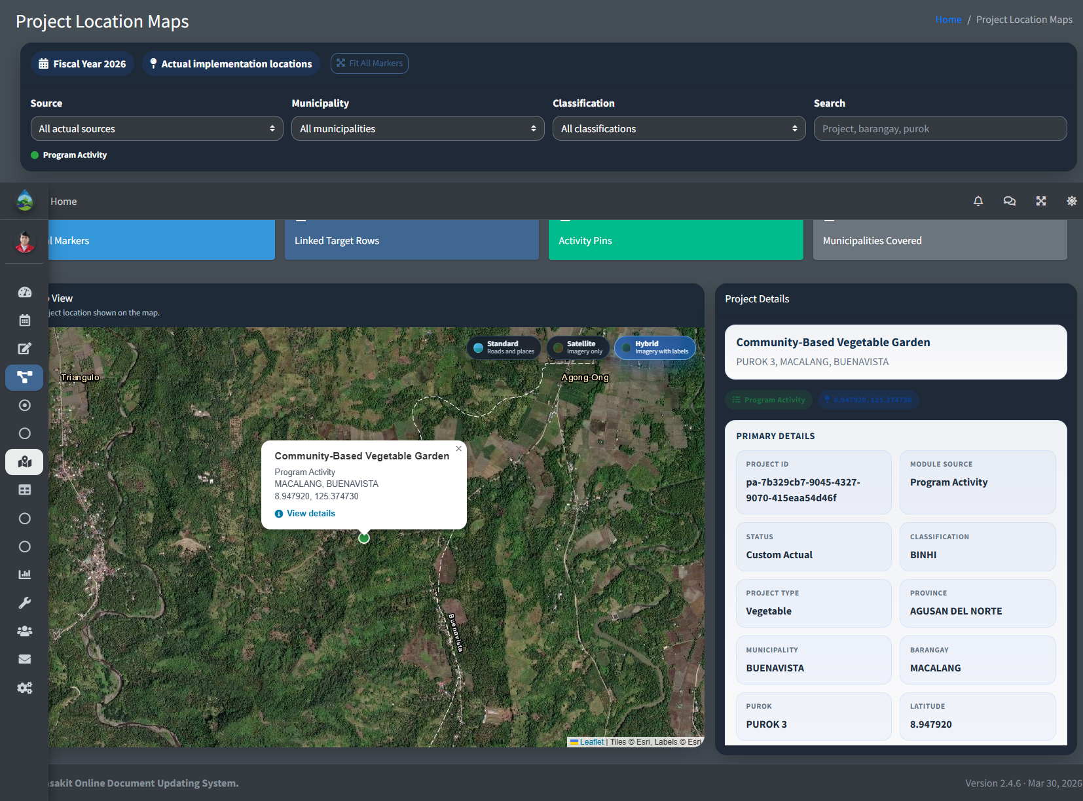
Project Location Maps view

