ANNEXES INDEX
KODUS GPD Annexes Index
KliMalasakit Operational Data Unified System (KODUS)
DSWD Field Office Caraga
[MANUAL INPUT REQUIRED: Insert official document date, reviewer, and approving official]

KODUS GPD Annexes Index
System: KliMalasakit Operational Data Unified System (KODUS)
Office/Program: DSWD Field Office Caraga
Prepared for: Governance, Privacy, Documentation, and Knowledge Management submission
Document status: Draft for document-owner validation
Last repository review: 2026-05-12

Document Control
Field | Entry
Prepared by | [MANUAL INPUT REQUIRED: Name/office of preparer]
Reviewed by | [MANUAL INPUT REQUIRED: KM/GPD reviewer]
Approved by | [MANUAL INPUT REQUIRED: Approving official/signatory]
Coverage period | Repository and documentation review through 2026-05-12; operational reporting period to be confirmed in the final signed transmittal
Source system version | KODUS v2.4.6, codename Control Center, release date 2026-03-30
Data protection note | All examples in these annexes are sanitized. No production beneficiary names, IDs, credentials, tokens, secret keys, or raw beneficiary records are included.

Annex Register
Annex | File | Purpose | Status | Required manual inputs
Annex A | `ANNEX_A_OPERATIONAL_WORKFLOW_SCREENSHOTS.md` | Provides screenshot inventory, capture instructions, captions, and purpose notes for major KODUS operational screens. | Draft; screenshot placeholders inserted | Login/SSO, dashboard, MEB, MEBIS, validation, name matching, deduplication, reports, inbox/messenger, notifications, settings/profile, audit/admin screenshots
Annex B | `ANNEX_B_MEB_VALIDATION_WORKFLOW.md` | Documents the end-to-end MEB validation workflow, controls, background job behavior, roles, and Mermaid diagram source. | Draft; workflow based on repository review | Document-owner confirmation of SOP, validation sign-off rules, external 4Ps/NHTS-PR handling, and final approval date
Annex C | `ANNEX_C_DEDUPLICATION_CROSSMATCH_OUTPUTS.md` | Provides sanitized sample structures and interpretation notes for deduplication, name matching, and crossmatch outputs. | Draft; samples are synthetic | Owner validation of thresholds, acceptance/rejection SOP, and preferred export sample format
Annex D | `ANNEX_D_SAMPLE_DISAGGREGATED_REPORTS.md` | Provides sanitized examples of disaggregated reports by sex, age, disability, location, program/activity, and implementation status. | Draft; synthetic examples only | Actual approved report extracts, reporting period, official totals, and signatory block
Annex E | `ANNEX_E_AUDIT_ACCOUNTABILITY_RECORDS.md` | Documents audit log coverage, session/account actions, data changes, import/export actions, deletion/restoration records, 2FA/email logs, and accountability controls. | Draft; samples are sanitized | Audit-retention policy, formal review schedule, accountable office, and sample redacted export if required
Annex F | `ANNEX_F_DEPLOYMENT_SUSTAINABILITY_DOCUMENTATION.md` | Summarizes deployment, hosting, backups, version control, documentation, background jobs, Socket.IO, PWA/offline status, and continuity measures. | Draft; based on repository docs | Host environment details, backup/restore evidence, continuity plan, maintenance roster, and PWA/offline decision

Repository Sources Reviewed
The annexes are aligned with the current KODUS source tree and documentation, including:
Area | Repository references
System overview | `README.md`, `docs/KODUS_DOCUMENTATION.md`
Deployment | `docs/LINUX_NGINX_DEPLOYMENT.md`, `docs/PRODUCTION_PACKAGE_GUIDE.md`, `deployment/nginx/crg-kodus.conf.example`
Privacy/data flow | `docs/PIA_DATA_FLOW_NOTES.md`, `docs/PIA_FINAL_DRAFT.md`, `docs/PIA_SCOPE_AUDIT.md`
MEB import and validation | `pages/data-tracking-meb.php`, `pages/meb_import_helpers.php`, `pages/meb_import_worker.php`, `pages/data-tracking-meb-validation.php`, `pages/fetch_data_validation_admin.php`, `pages/update_validation_status.php`
MEBIS utilities | `mebis-consolidator/`, `mebis-lgu-template/`
Deduplication/crossmatch | `deduplication/`, `crossmatch/`
Reports and exports | `pages/export_meb.php`, `pages/export_meb_validation.php`, `implementation-status/fetch-program-summary.php`, `pages/summary/`, `pages/fund-monitoring-export.php`, `pages/payout_export.php`
Audit/accountability | `audit_helpers.php`, `admin/audit_logs.php`, `meb_change_history_helpers.php`, `mail_config.php`, `app_notification_helpers.php`
Realtime and workers | `docs/LIVE_REFRESH_SOCKETIO_MIGRATION.md`, `dist/js/kodus-live-refresh.js`, `socket/README.md`, `socket_helpers.php`
Existing screenshots | `docs/manual_screens/`

Final Owner-Validation Checklist
- Annex A screenshot placeholders were replaced with repository screenshot references or explicit owner-validation notes; final submission should use only approved sanitized captures.
- Sanitized sample tables should be compared with the official report formats used for submission before signing.
- MEB validation statuses and escalation rules should be confirmed by the KODUS data owner for the reporting period.
- Authorized roles for MEB import/export, validation, MEBIS utilities, deduplication, crossmatch, and full exports should be confirmed through the user-management record.
- Official dates, names, office titles, and signatures should be applied on the final controlled copy.
- Retention periods for beneficiary data, generated outputs, upload folders, audit logs, mail logs, and job results should follow the approved DSWD records-management and privacy schedule.
- Backup/restore evidence and continuity procedures should be attached or filed by the hosting/system owner.
- PWA/offline-draft capability is documented as not implemented in the reviewed codebase unless the system owner issues a separate implementation requirement.

ANNEX A
KODUS Operational Workflow Screenshots
KliMalasakit Operational Data Unified System (KODUS)
DSWD Field Office Caraga
[MANUAL INPUT REQUIRED: Insert official document date, reviewer, and approving official]

Annex A - KODUS Operational Workflow Screenshots
Document status: Draft for screenshot capture and owner validation
System: KliMalasakit Operational Data Unified System (KODUS)
Scope: Major user-facing screens and administrative controls used for DSWD Caraga program operations
Privacy note: Screenshots must be captured using test accounts or sanitized/staging data only. Do not show production beneficiary names, IDs, contact details, credentials, tokens, live upload filenames containing personal data, or confidential operational details.

A.1 Screenshot Capture Standards
All screenshots shall be clear, current, and consistent with the approved production or staging build. Where real screenshots are not yet available, the placeholder below shall remain until the document owner inserts the approved image.
Caption format:
`Figure A-[number]. [Screen name] - [Short purpose/use note].`
Placeholder format:
[MANUAL INPUT REQUIRED: Insert screenshot for Screen Name. Capture path: module/page. Use sanitized or test data only.]

A.2 Screenshot Inventory
Figure | Screen | Repository route or module | Required capture note | Status
A-1 | Login / username-password access | `login.php`, `ajax_login.php` | Show login form without typed password. | [MANUAL INPUT REQUIRED]
A-2 | SSO / Caraga Connect access | `login-sso/index.php`, `login-sso/callback.php` | Show only non-secret SSO entry point. Do not show OAuth client values. | [MANUAL INPUT REQUIRED]
A-3 | Dashboard / home | `home.php` | Show role-appropriate home dashboard with sanitized counts. | [MANUAL INPUT REQUIRED]
A-4 | Implementation Status - Program Targets | `implementation-status/program-targets.php` | Show baseline target encoding or target list with test values. | [MANUAL INPUT REQUIRED]
A-5 | Implementation Status - Program Activities | `implementation-status/program-activities.php` | Show activity encoding/monitoring screen with sanitized activity details. | [MANUAL INPUT REQUIRED]
A-6 | Implementation Status - LAWA/BINHI Summary | `implementation-status/lawa-summary.php`, `implementation-status/binhi-summary.php` | Show summary page with aggregate values only. | [MANUAL INPUT REQUIRED]
A-7 | MEBIS Consolidator | `mebis-consolidator/index.php` | Show upload/history screen and output summary, not raw records. | [MANUAL INPUT REQUIRED]
A-8 | MEBIS LGU Template Generator | `mebis-lgu-template/index.php` | Show final validated MEB upload and generation status with test files. | [MANUAL INPUT REQUIRED]
A-9 | MEB Import / Master List | `pages/data-tracking-meb.php` | Show imported MEB list using blurred/sanitized rows or test data. | [MANUAL INPUT REQUIRED]
A-10 | MEB Validation | `pages/data-tracking-meb-validation.php` | Show target versus imported actual counts and validation badges. | [MANUAL INPUT REQUIRED]
A-11 | Name Matching / MEBIS Output | `mebis-consolidator/`, `mebis-lgu-template/` | Show name-matching output summary without individual identities. | [MANUAL INPUT REQUIRED]
A-12 | Deduplication Upload / Recent Jobs | `deduplication/index.php` | Show upload form, rule/threshold fields, and recent jobs table. | [MANUAL INPUT REQUIRED]
A-13 | Deduplication Results | `deduplication/results.php` | Show duplicate group layout using synthetic rows. | [MANUAL INPUT REQUIRED]
A-14 | Crossmatch Upload / Start | `crossmatch/index.php`, `crossmatch/start.php` | Show upload/start options with test files only. | [MANUAL INPUT REQUIRED]
A-15 | Crossmatch Results | `crossmatch/results.php` | Show uploaded record, top candidates, scores, and accept checkbox using synthetic rows. | [MANUAL INPUT REQUIRED]
A-16 | Reports / Export Screens | `pages/export_meb.php`, `pages/export_meb_validation.php`, `pages/summary/`, `pages/fund-monitoring-export.php` | Show report/export entry points and aggregate output only. | [MANUAL INPUT REQUIRED]
A-17 | Inbox / Messenger | `inbox/index.php`, `messenger/index.php`, `contact.php` | Show message list and thread using test conversations only. | [MANUAL INPUT REQUIRED]
A-18 | Notifications | `notifications/index.php`, `app_notification_helpers.php` | Show notification feed with non-sensitive titles. | [MANUAL INPUT REQUIRED]
A-19 | Settings / Profile | `settings.php`, profile helpers | Show profile settings without email, phone, recovery codes, or secret QR data. | [MANUAL INPUT REQUIRED]
A-20 | Audit Logs | `admin/audit_logs.php` | Show filtered log table using sanitized users/actions. | [MANUAL INPUT REQUIRED]
A-21 | Admin User Management | `admin/users_management.php` | Show user list with masked names/emails and role/status controls. | [MANUAL INPUT REQUIRED]
A-22 | Admin Maintenance / Password Security | `admin/maintenance.php`, `admin/password_security.php` | Show administrative control page without sensitive values. | [MANUAL INPUT REQUIRED]

A.3 Screen Notes and Captions

Figure A-1. Login / Username-Password Access
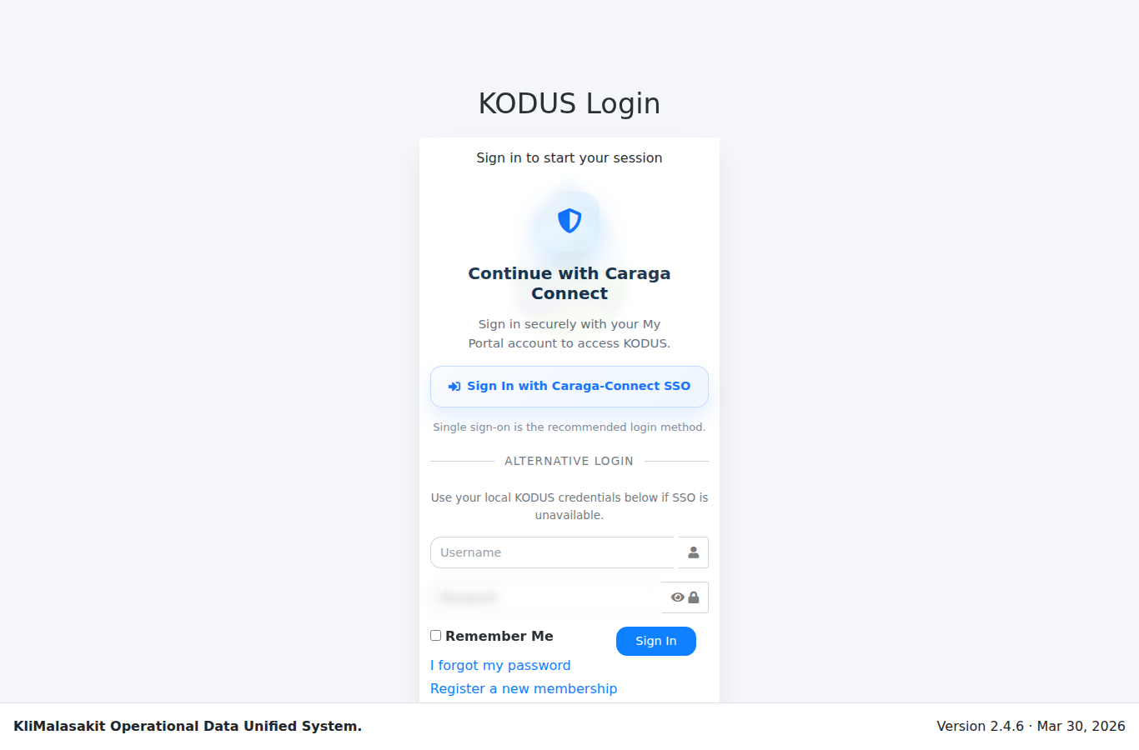
[MANUAL INPUT REQUIRED: Insert screenshot. Capture the login screen before entering credentials.]
Purpose/use: Provides authenticated entry to KODUS using standard username/password access. The login flow is supported by session regeneration, password policy controls, remember-me token handling, and optional two-factor verification.

Figure A-2. SSO / Caraga Connect Access
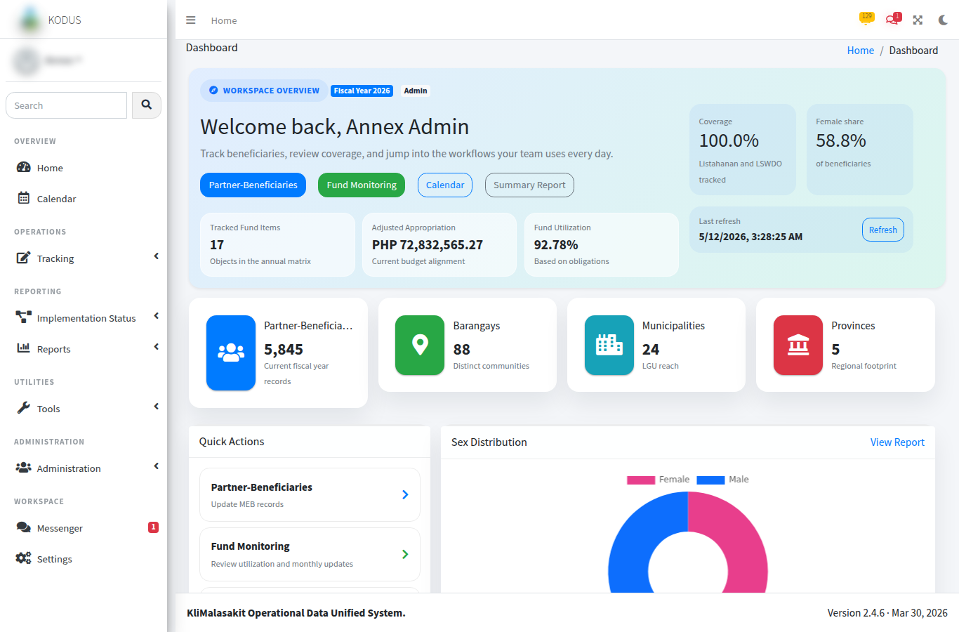
[MANUAL INPUT REQUIRED: Insert screenshot. Capture only the public SSO entry or redirect prompt; do not show client secrets, authorization codes, tokens, or callback parameters.]
Purpose/use: Supports optional Caraga Connect SSO integration for authorized users where configured by the system owner.

Figure A-3. Dashboard / Home
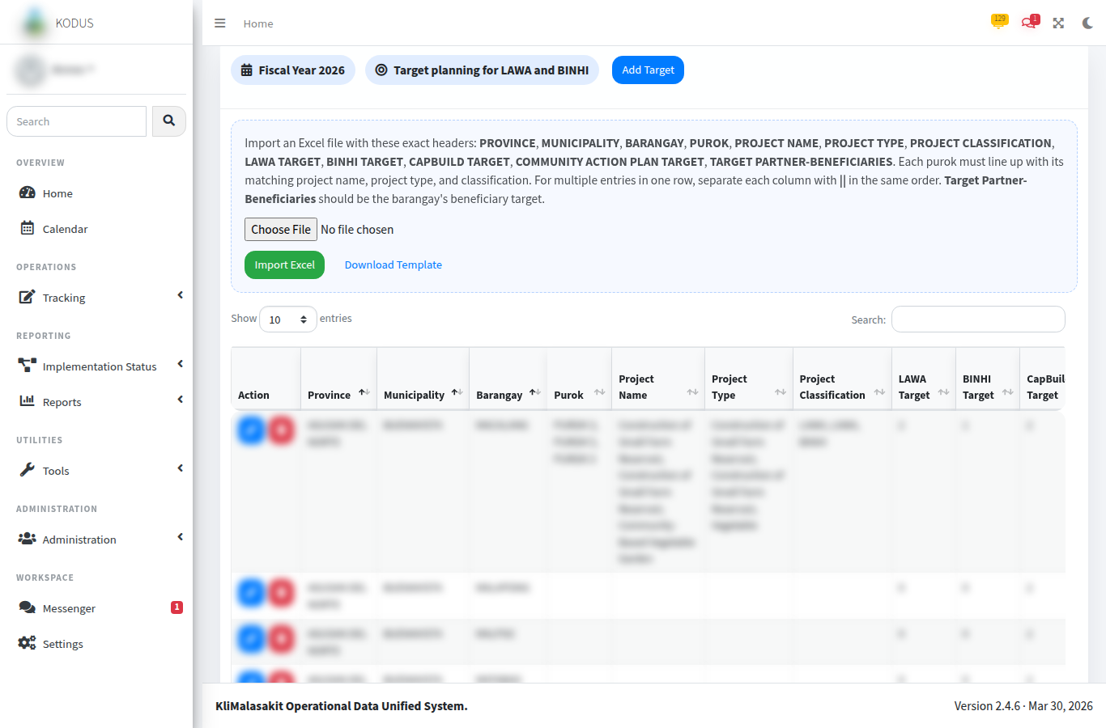
[MANUAL INPUT REQUIRED: Insert screenshot. Use a test account and sanitized counts.]
Purpose/use: Serves as the role-based landing page for users after login and provides navigation to operational modules such as MEB, implementation monitoring, reports, inbox, and administrative functions.

Figure A-4. Implementation Status - Program Targets
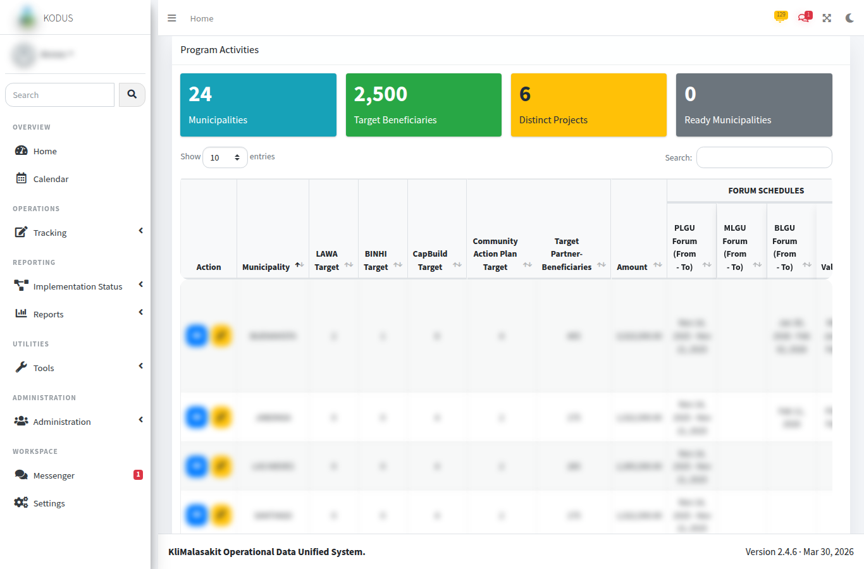
[MANUAL INPUT REQUIRED: Insert screenshot of target setup or target list with test values.]
Purpose/use: Records fiscal-year baseline targets for Project LAWA and BINHI, including province, municipality, barangay, target partner-beneficiaries, project classification, and project target entries.

Figure A-5. Implementation Status - Program Activities
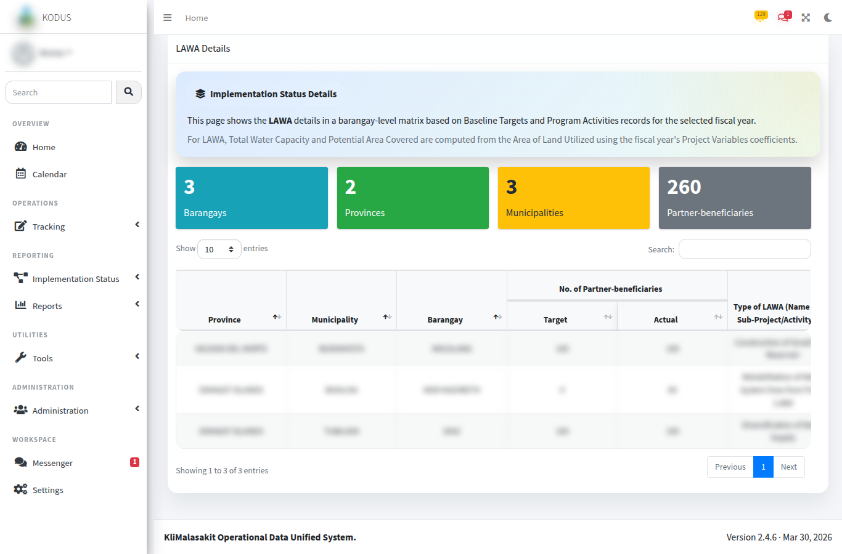
[MANUAL INPUT REQUIRED: Insert screenshot using sanitized program/activity entries.]
Purpose/use: Captures activity timelines, actual project/accomplishment entries, project classifications, location information, and evidence links for implementation monitoring.

Figure A-6. Implementation Status - LAWA/BINHI Summary
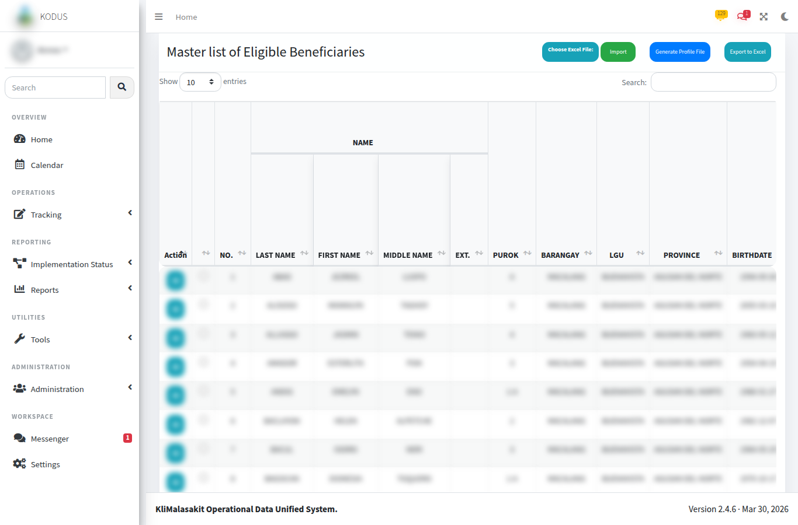
[MANUAL INPUT REQUIRED: Insert screenshot showing aggregate summary output only.]
Purpose/use: Presents target-versus-actual summaries for LAWA and BINHI implementation, supporting management review, planning, and reporting.

Figure A-7. MEBIS Consolidator
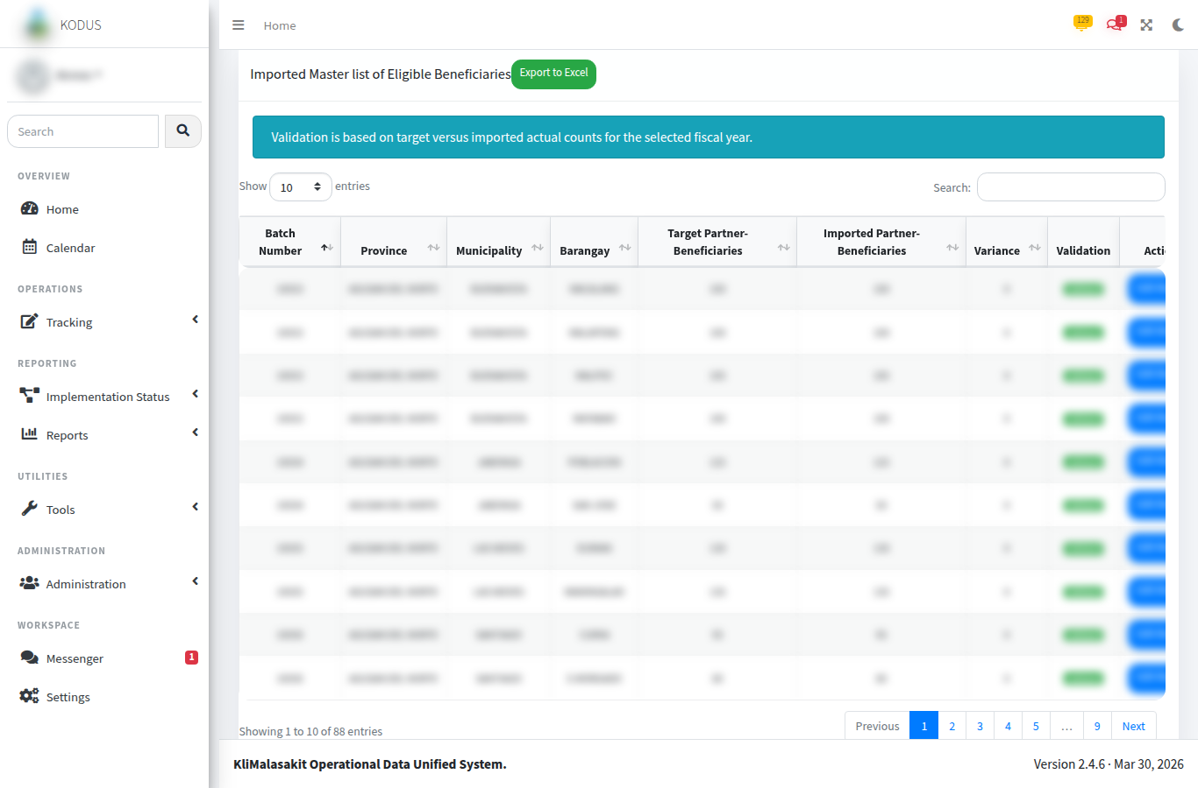
[MANUAL INPUT REQUIRED: Insert screenshot of the MEBIS consolidator upload/history screen. Use test files or blurred filenames.]
Purpose/use: Consolidates MEBIS workbooks and summarizes outputs by province and municipality/city. The module is intended to support preparation of name-matching and validation materials without exposing raw personal data in documentation.

Figure A-8. MEBIS LGU Template Generator
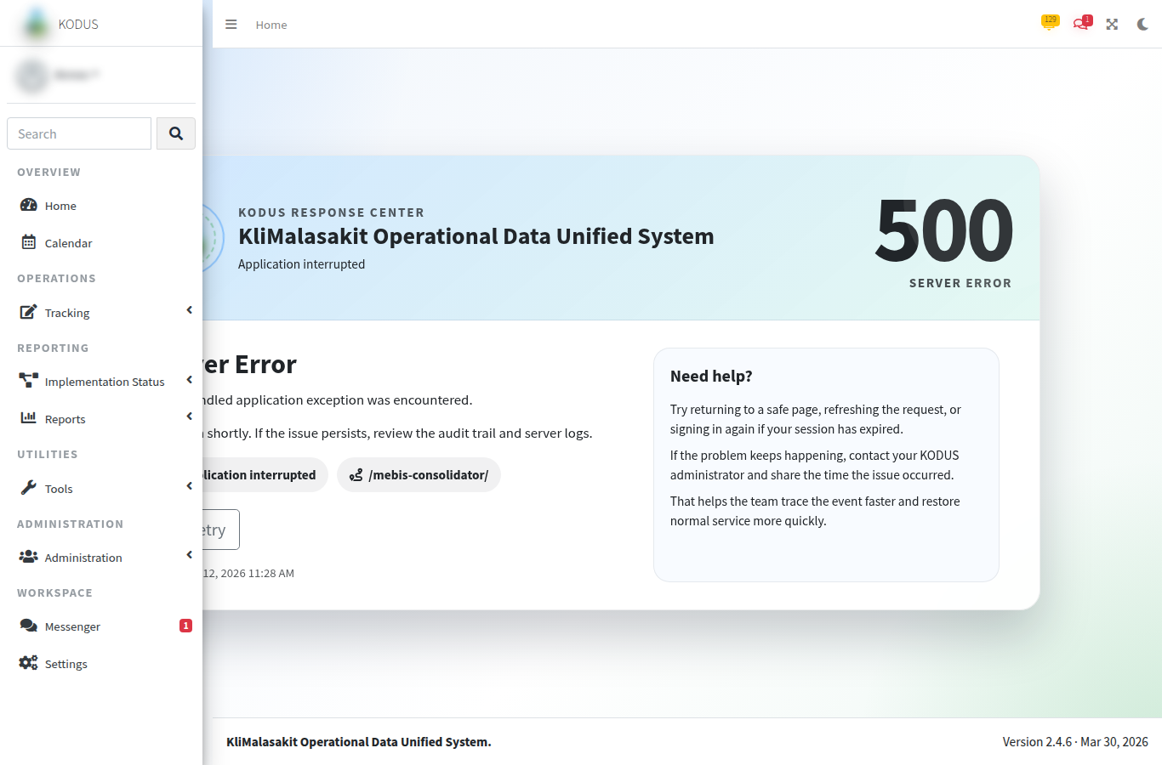
[MANUAL INPUT REQUIRED: Insert screenshot of final validated MEB upload and background generation status.]
Purpose/use: Converts approved MEBIS/MEB workbooks into import-ready templates and records background generation status for user follow-up.

Figure A-9. MEB Import / Master List
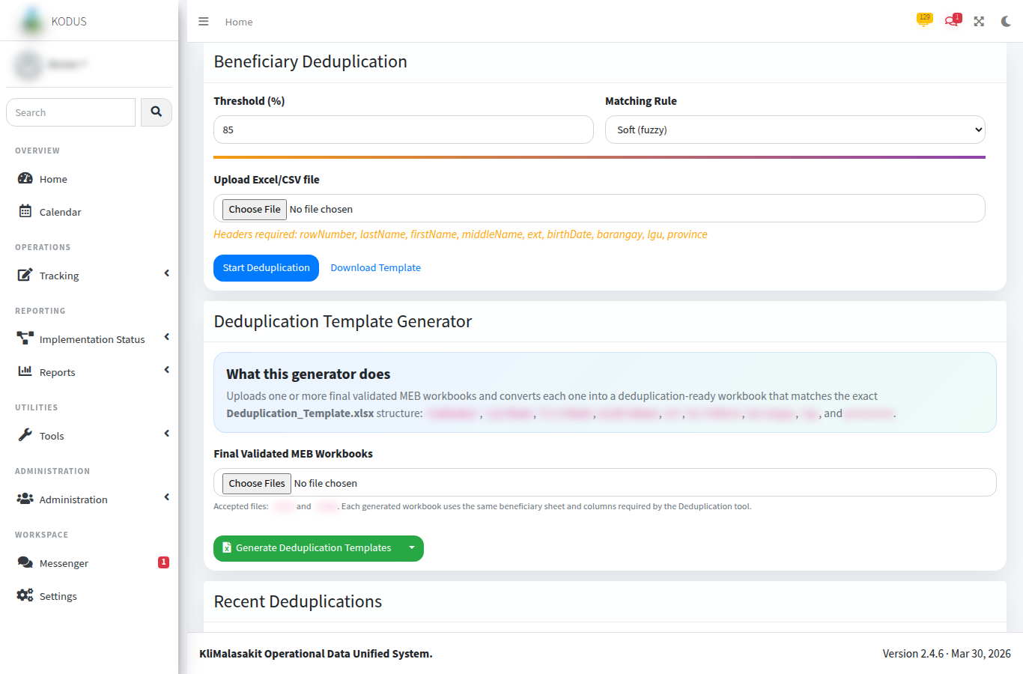
[MANUAL INPUT REQUIRED: Insert screenshot with all beneficiary names and granular identifiers blurred or replaced with test records.]
Purpose/use: Displays imported Master List of Eligible Beneficiaries records, batch information, and export functions. Access and editing are role- and area-controlled.

Figure A-10. MEB Validation
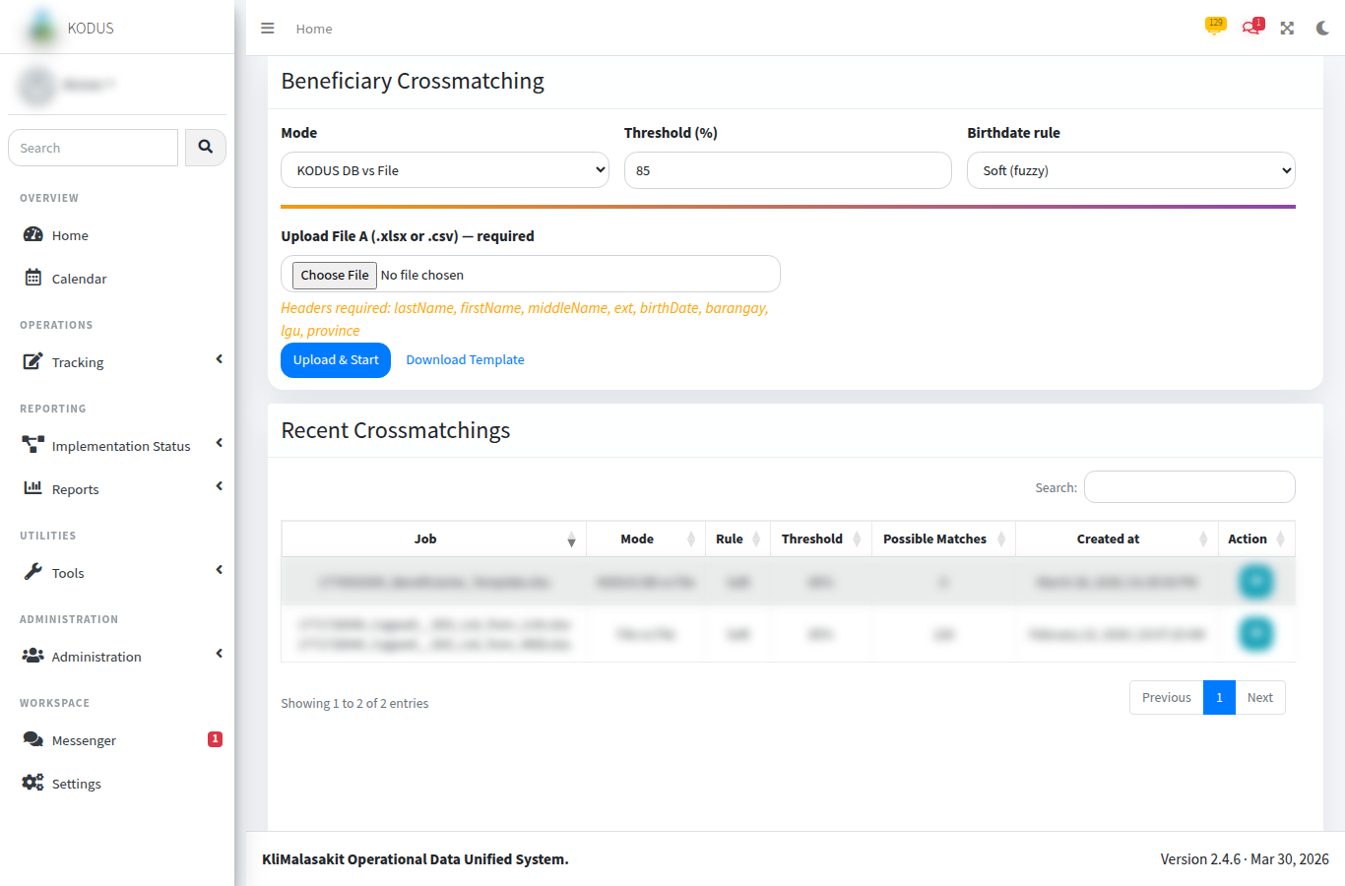
[MANUAL INPUT REQUIRED: Insert screenshot of target-versus-actual counts by location.]
Purpose/use: Compares imported MEB actual counts with baseline target partner-beneficiaries for the selected fiscal year. Statuses include No Target, No Import, Partial, Validated, Over Target, and Unplanned Import.

Figure A-11. Name Matching / MEBIS Output
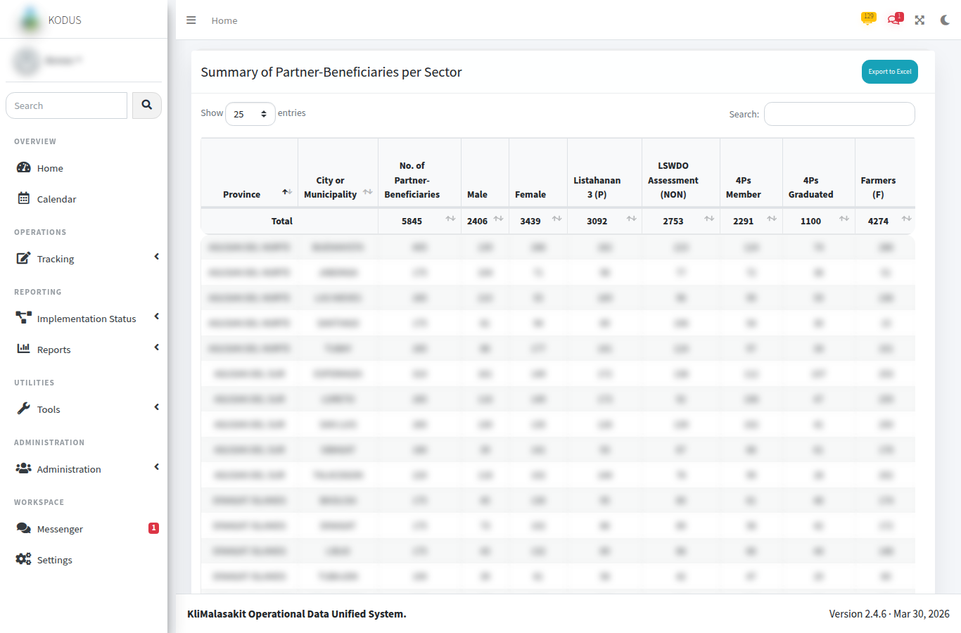
[MANUAL INPUT REQUIRED: Insert screenshot of sanitized output summary or generated template history.]
Purpose/use: Documents the system-supported preparation of MEBIS/name-matching outputs while preserving confidentiality of individual beneficiary identities.

Figure A-12. Deduplication Upload / Recent Jobs
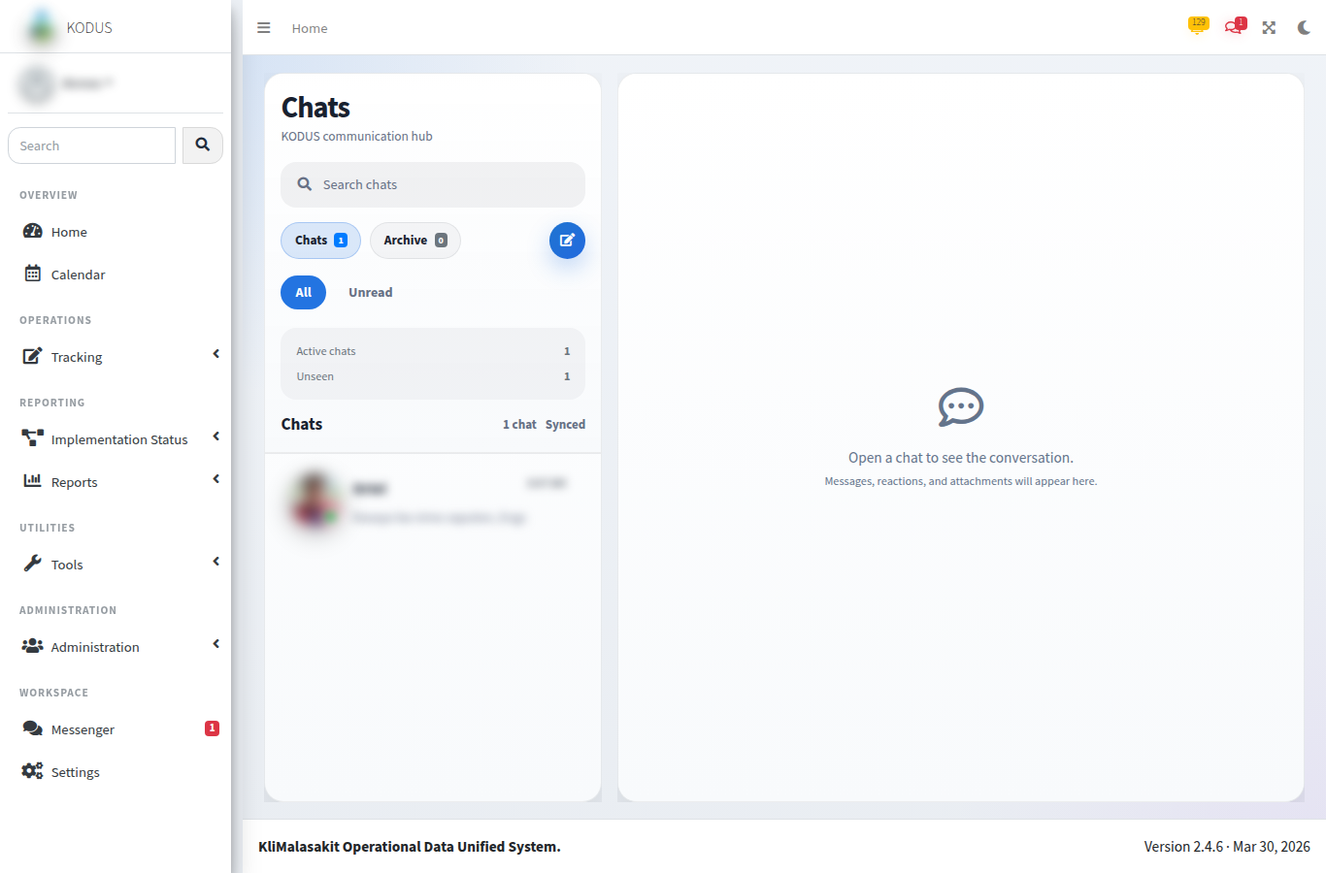
[MANUAL INPUT REQUIRED: Insert screenshot using test upload filename and synthetic data.]
Purpose/use: Allows authorized users to upload a beneficiary dataset, select duplicate-detection settings, and monitor recently processed jobs.

Figure A-13. Deduplication Results
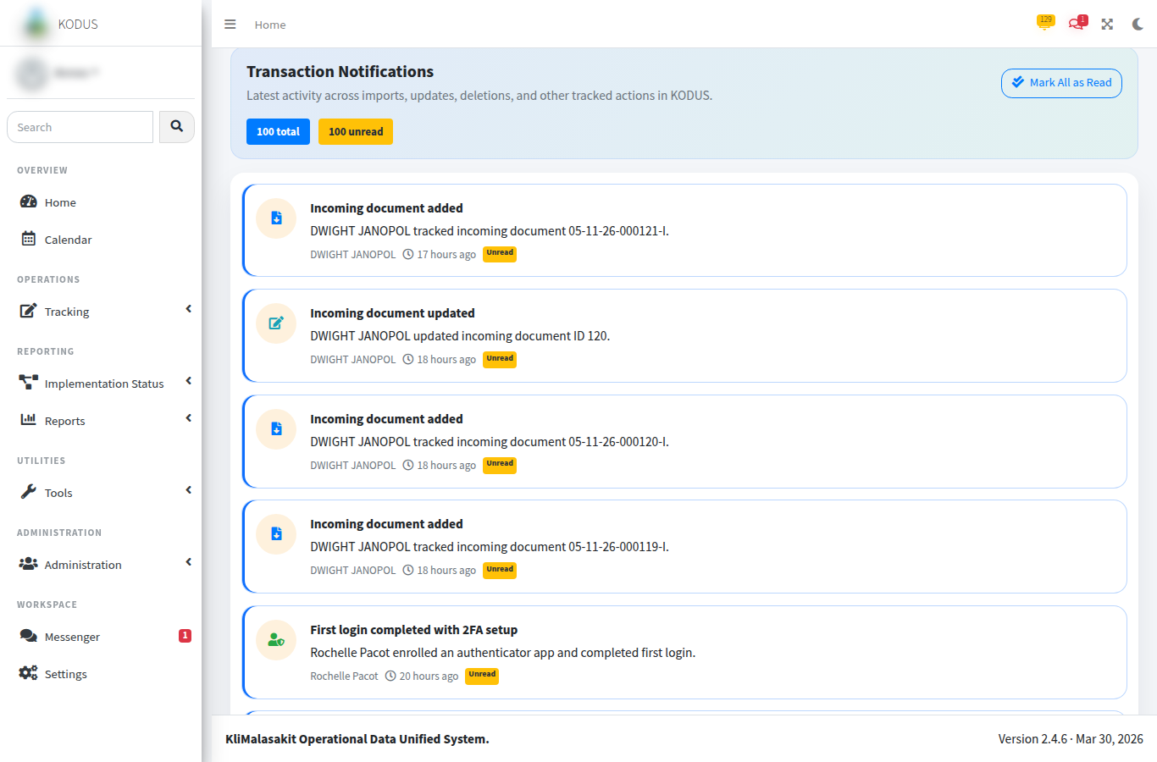
[MANUAL INPUT REQUIRED: Insert screenshot using synthetic duplicate groups only.]
Purpose/use: Displays grouped possible duplicates and similarity percentages for review, export, and exception handling.

Figure A-14. Crossmatch Upload / Start
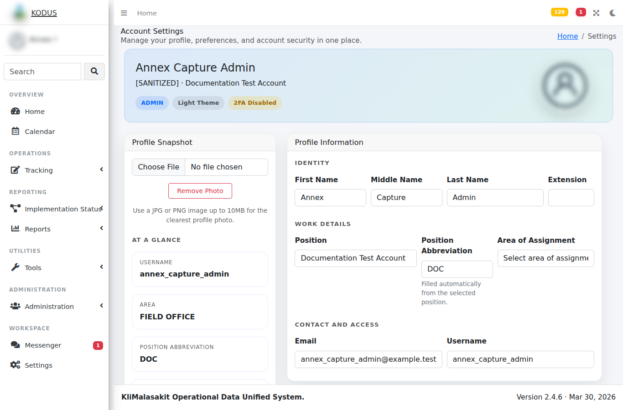
[MANUAL INPUT REQUIRED: Insert screenshot using test files and no production dataset names.]
Purpose/use: Starts crossmatching of uploaded beneficiary records against candidate records or the MEB dataset, subject to configured thresholds and authorized access.

Figure A-15. Crossmatch Results
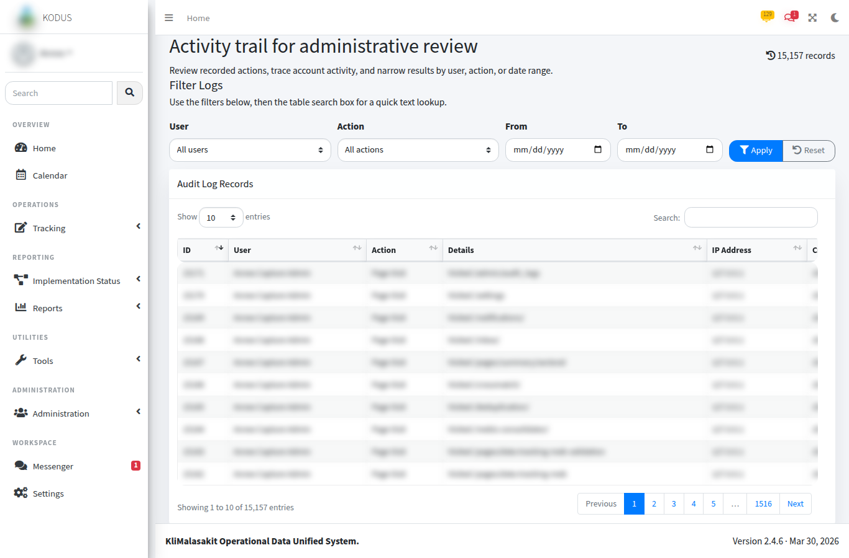
[MANUAL INPUT REQUIRED: Insert screenshot using synthetic uploaded records and candidate matches only.]
Purpose/use: Shows top candidate matches, score components, and review/accept controls for possible matches.

Figure A-16. Reports / Export Screens
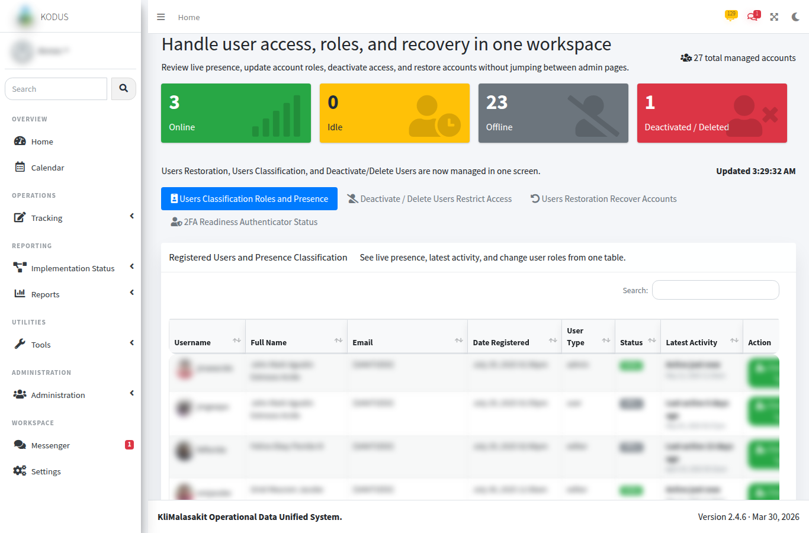
[MANUAL INPUT REQUIRED: Insert screenshot of report/export menus or aggregate report pages.]
Purpose/use: Supports production of MEB exports, validation reports, beneficiary profiles, implementation summaries, payout exports, and fund monitoring reports.

Figure A-17. Inbox / Messenger
[MANUAL INPUT REQUIRED: Insert screenshot from a test conversation only.]
Purpose/use: Supports staff coordination through inbox/messenger threads, replies, attachments, read state, reactions, group chats, and real-time notification updates.

Figure A-18. Notifications
[MANUAL INPUT REQUIRED: Insert screenshot of notification list with synthetic entries.]
Purpose/use: Displays application notifications generated by operational actions such as MEB imports, validation updates, messages, and background job results.

Figure A-19. Settings / Profile
[MANUAL INPUT REQUIRED: Insert screenshot with all personal details masked. Do not show 2FA QR secrets or recovery codes.]
Purpose/use: Provides account settings, profile information, and security controls such as two-factor setup/disablement where applicable.

Figure A-20. Audit Logs
[MANUAL INPUT REQUIRED: Insert screenshot of sanitized audit log table.]
Purpose/use: Provides admin-only review of recorded system actions, including user, action, details, IP address, and timestamp fields.

Figure A-21. Admin User Management
[MANUAL INPUT REQUIRED: Insert screenshot with masked user identities.]
Purpose/use: Enables authorized administrators to manage user roles, deactivation/restoration, password security, and 2FA reset controls.

Figure A-22. Admin Maintenance / Password Security
[MANUAL INPUT REQUIRED: Insert screenshot of maintenance/password policy controls without sensitive values.]
Purpose/use: Documents administrative safeguards for maintenance mode, password rules, and production readiness controls.

A.4 Screenshot Quality Checklist
- Screenshot uses staging/test or sanitized production data.
- No password, token, secret, OAuth code, 2FA QR secret, recovery code, or SMTP/SSO configuration value is visible.
- No raw beneficiary names, IDs, birthdates, addresses, contact information, or unredacted uploaded document names are visible.
- The active role and fiscal year context are clear where relevant.
- The caption and purpose/use note are present below each figure.
- The document owner has validated that each screenshot reflects the current approved KODUS workflow.

ANNEX B
MEB Validation Workflow
KliMalasakit Operational Data Unified System (KODUS)
DSWD Field Office Caraga
[MANUAL INPUT REQUIRED: Insert official document date, reviewer, and approving official]

Annex B - MEB Validation Workflow
Document status: Draft for validation by the KODUS document owner
System: KliMalasakit Operational Data Unified System (KODUS)
Workflow covered: Upload/import, preprocessing, duplicate and crossmatch checks, MEB validation review, correction/reupload, final validated output, and notifications/background job behavior
Privacy note: This annex describes workflow controls and sample structures only. It does not include production beneficiary records.

B.1 Purpose
This annex documents the current KODUS-supported process for receiving, importing, validating, correcting, and reporting the Master List of Eligible Beneficiaries (MEB). The workflow supports DSWD/KM documentation, internal monitoring, and data-quality review by linking uploaded MEB records with fiscal-year implementation targets and related validation utilities.

B.2 System Modules Used
Workflow area | KODUS module / route | Documentation note
MEB import and listing | `pages/data-tracking-meb.php`, `pages/import.php`, `pages/meb_import_helpers.php`, `pages/meb_import_worker.php` | Imports Excel workbooks into the `meb` table and assigns batch numbers.
MEB validation | `pages/data-tracking-meb-validation.php`, `pages/fetch_data_validation_admin.php`, `pages/update_validation_status.php` | Compares imported MEB actual counts with target partner-beneficiary counts.
Baseline targets | `implementation-status/program-targets.php`, `implementation-status/save-project-target.php`, `implementation-status/import-project-targets.php` | Provides target counts used for validation comparison.
MEBIS consolidation | `mebis-consolidator/` | Supports consolidation of MEBIS workbooks and output history.
MEBIS LGU import template | `mebis-lgu-template/` | Converts final validated workbooks into import-ready templates and supports background processing.
Deduplication | `deduplication/` | Detects possible duplicates within uploaded beneficiary datasets.
Crossmatch | `crossmatch/` | Scores uploaded records against candidate records or MEB records.
Notifications/live refresh | `app_notification_helpers.php`, `dist/js/kodus-live-refresh.js`, `socket_helpers.php` | Notifies requesting users and refreshes affected tables when supported.
Audit records | `audit_helpers.php`, `meb_change_history_helpers.php`, `admin/audit_logs.php` | Records state-changing requests and explicit validation updates.

B.3 End-to-End Workflow

Step 1. Prepare and Upload Source Workbook
Authorized personnel prepare the MEB workbook using the expected column structure. The current import helper expects fields covering name components, location, birthdate, age, sex, civil status, NHTS-PR/LSWDO indicators, 4Ps indicator, and sectoral/disability classifications.
Control notes:
- Only approved Excel formats are accepted for MEB import.
- Workbooks must be reviewed before upload to avoid loading personal data outside authorized purpose.
- Upload files and generated outputs are treated as sensitive operational data.
Approved MEB workbooks should originate from the authorized program/data owner for the applicable reporting period. Before upload, the accountable uploader confirms that the workbook follows the approved template, contains only records covered by the authorized purpose, and has been cleared by the responsible program focal or data owner.

Step 2. Preprocessing and Header Validation
KODUS checks the uploaded workbook for expected headers and rejects mismatched column structures. Birthdates are normalized where possible. The 4Ps field is normalized to recognized code values where applicable.
Expected MEB import categories include: name, purok/barangay/LGU/province, birthdate, age, sex, civil status, NHTS-PR, LSWDO assessment, 4Ps, farmers, fisher-folks, informal sector, Indigenous People, senior citizen, solo parent, lactating women, pregnant women, persons with disability, out-of-school youth, former rebel, YAKAP Bayan/person who used drugs, and LGBTQIA+.

Step 3. Background Import Job
For background import, KODUS creates an import job with status, progress, current step, source filename, requested user, row count, and timestamps. The worker processes the file, inserts valid rows into the `meb` table, assigns a batch ID, and removes the temporary source file after processing.
Observed job states: queued, processing, completed, failed.
Observed progress messages: queued, reading workbook, saving records, completed, failed.

Step 4. Duplicate Checks
The deduplication utility supports duplicate detection using required fields: last name, first name, middle name, extension, birthdate, barangay, LGU/municipality, and province. Results are grouped by duplicate group and include similarity percentages.
Control notes:
- Possible duplicate records must be reviewed by authorized personnel before any correction or exclusion.
- Duplicate findings are decision-support outputs and should not be treated as automatic deletion instructions.
Operational duplicate thresholds should follow the configured KODUS deduplication job settings for the reviewed run. Potential duplicates are routed for reviewer validation; final correction, exclusion, or retention decisions remain subject to the approved program/data-owner SOP and supporting source documents.

Step 5. 4Ps / NHTS-PR / Crossmatch Checks
KODUS imports and stores indicators for NHTS-PR/Listahanan 3, LSWDO assessment, and 4Ps. Crossmatch utilities can compare uploaded records with candidate records using weighted name, birthdate, and address scoring.
Control notes:
- External 4Ps or NHTS-PR confirmation must follow official DSWD validation protocol.
- Crossmatch scores require reviewer judgment, especially where spelling, suffix, birthdate, or address data are incomplete.
4Ps and NHTS-PR/Listahanan indicators should be confirmed only through authorized DSWD source systems or official validation records. Crossmatch outputs are used as decision-support evidence and should be documented through the approved validation memo or reviewer action record for the reporting period.

Step 6. Validation Results Review
The MEB validation screen compares location-level target partner-beneficiaries against imported actual beneficiaries for the selected fiscal year.
Validation status | System interpretation
No Target | No target count is encoded for the location and no imported actual is present.
No Import | Target exists, but no imported MEB rows are present.
Partial | Imported actual is less than target.
Validated | Imported actual equals target.
Over Target | Imported actual exceeds target.
Unplanned Import | Imported actual exists for a location with no encoded target.

Step 7. Correction and Reupload
Where the validation screen identifies Partial, Over Target, Unplanned Import, or other exceptions, authorized users review affected rows and correct source data or target data as applicable. KODUS supports editing MEB rows and returning to the validation screen.
Control notes:
- Corrections must be supported by approved source documents or official validation response.
- Changes to MEB rows should be reviewed through the change-history/audit mechanism.
- Reupload should be used only where correction by source workbook is the approved process.

Step 8. Final Validated Output
Once counts and exception handling are complete, authorized users may export validation outputs. The current validation export produces an Excel report titled `MEB Validation Target vs Actual` with province, municipality, barangay, target partner-beneficiaries, imported partner-beneficiaries, variance, and validation status.
[MANUAL INPUT REQUIRED: Insert final validation sign-off protocol, approving official, and reporting period.]

Step 9. Notification and Live Refresh Behavior
KODUS creates app notifications for MEB import success/failure and validation updates. It also broadcasts MEB change events to refresh affected tables where live refresh or the optional Socket.IO bridge is configured.
Relevant events include `meb.changed` and `meb.validation.changed` under the `kodus.meb` channel.

B.4 Workflow Diagram Source
The following Mermaid diagram source may be rendered for inclusion in DOCX/PDF submissions.
Rendered workflow equivalent for the Mermaid source:
MEB Validation Workflow
Prepare approved MEB workbook ->
Upload/import workbook in KODUS ->
Header and format validation ->
Create background import job ->
Insert MEB rows and assign batch ID ->
Run duplicate and crossmatch checks as required ->
Review validation page: target vs imported actual ->
Correct exceptions or export validated report ->
Document owner review and sign-off

B.5 Roles and Responsibilities
Role | Responsibility
System administrator | Manages users, access, maintenance settings, audit review, and system-level controls.
Authorized MEB uploader | Uploads approved MEB workbooks and monitors background import status.
MEB validator / reviewer | Reviews validation statuses, duplicate findings, crossmatch findings, and correction requirements.
Program focal / target owner | Confirms baseline target partner-beneficiaries and resolves target discrepancies.
Data protection / KM reviewer | Ensures documentation uses sanitized evidence and excludes personal data and secrets.
Approving official | Confirms final validation output and authorizes formal submission.
For the controlled submission copy, these generic roles map to the officially assigned KODUS system administrator, authorized MEB uploader, MEB validator/reviewer, program focal or target owner, KM/GPD reviewer, data-protection reviewer, and approving official designated by DSWD Field Office Caraga.

B.6 Validation Controls
Control | Implementation or documentation basis
Role-based access | KODUS implements admin/editor/AA/user roles and area-aware editing helpers.
Fiscal-year context | MEB validation requires selected fiscal year.
Header validation | Import helper checks expected MEB columns before saving records.
Batch traceability | Imported MEB records receive batch IDs.
Target-versus-actual comparison | Validation screen compares `project_lawa_binhi_targets` against imported `meb` rows.
Exception status | Validation badges identify no target, no import, partial, validated, over target, and unplanned import.
Audit trail | Validation updates and state-changing requests are recorded in audit logs.
Notifications | Import and validation changes generate app notifications and live refresh events.
Export formatting | Excel exports use common styling helpers and include report titles/fiscal year.

B.7 Owner Validation Notes
- Duplicate, crossmatch, 4Ps, and NHTS-PR findings are handled through reviewer validation and official source-document confirmation before any correction or exclusion is applied.
- [MANUAL INPUT REQUIRED] Insert official reviewer, approver, date, and signatory block.
- [MANUAL INPUT REQUIRED] Attach screenshots from Annex A after sanitization.
- The reviewed KODUS validation screen provides location-level target-versus-actual matching; individual-level external list confirmation, when required, is treated as an owner-controlled validation activity outside the annex sample data.

ANNEX C
Deduplication and Crossmatch Outputs
KliMalasakit Operational Data Unified System (KODUS)
DSWD Field Office Caraga
[MANUAL INPUT REQUIRED: Insert official document date, reviewer, and approving official]

Annex C - Deduplication and Crossmatch Outputs
Document status: Draft for data-owner validation
System: KliMalasakit Operational Data Unified System (KODUS)
Scope: Sanitized examples of deduplication outputs, name-matching results, crossmatch summaries, match confidence/statuses, and exception handling
Privacy note: All names, locations, dates, and row identifiers below are synthetic. Do not replace these examples with raw beneficiary records unless fully redacted and formally approved.

C.1 Purpose
This annex provides submission-ready sample structures for documenting how KODUS supports duplicate detection, name matching, and crossmatching of beneficiary datasets. The examples are designed for review and reporting without exposing personal information.

C.2 Deduplication Required Fields
The current deduplication parser maps required columns using accepted aliases for:
Canonical field | Example accepted labels
`lastName` | lastname, last, lname
`firstName` | firstname, first, fname
`middleName` | middlename, middle, mname
`ext` | ext, suffix
`birthDate` | birthdate, birth, dob, dateofbirth
`barangay` | barangay, brgy
`lgu` | lgu, city, municipality
`province` | province, prov

C.3 Sanitized Deduplication Output
Table C-1. Sample duplicate group output, sanitized.
Job no. | Duplicate group | Synthetic row reference | Sanitized name key | Birthdate key | Location key | Similarity | Reviewer status
DEDUP-2026-001 | 1 | ROW-A001 | PERSON ALPHA | 1985-XX-XX | BRGY-01 / LGU-01 / PROV-01 | 100.00% | Confirmed duplicate
DEDUP-2026-001 | 1 | ROW-A014 | PERSON ALPHA | 1985-XX-XX | BRGY-01 / LGU-01 / PROV-01 | 98.75% | Confirmed duplicate
DEDUP-2026-001 | 2 | ROW-B003 | PERSON BETA | 1979-XX-XX | BRGY-04 / LGU-03 / PROV-02 | 92.40% | For field verification
DEDUP-2026-001 | 2 | ROW-B022 | PERSON BETA VARIANT | 1979-XX-XX | BRGY-04 / LGU-03 / PROV-02 | 91.10% | For field verification
Interpretation note: Similarity values indicate possible duplicate relationships. The final action must be based on reviewer validation and official source documents, not on the score alone.

C.4 Deduplication Summary
Table C-2. Sample deduplication summary, sanitized.
Metric | Count | Note
Uploaded records | 1,250 | Synthetic count for documentation format only
Valid parsed records | 1,246 | Excludes blank or invalid rows
Duplicate groups detected | 18 | Groups requiring reviewer action
Records inside duplicate groups | 42 | Includes lead and possible duplicate rows
Confirmed duplicates | 16 | Confirmed through manual review
For field verification | 22 | Pending LGU/program focal confirmation
No action / false positive | 4 | Similarity did not represent same beneficiary
Synthetic counts are retained for the annex sample format. If the signed submission requires operational figures, use approved aggregate counts only and exclude raw beneficiary rows.

C.5 Crossmatch Scoring Structure
KODUS crossmatch scoring uses name, birthdate, and address components. The current helper applies weighted score components, with default weights observed in the code as name 60%, birthdate 20%, and address 20%, subject to configured options.
Table C-3. Sample crossmatch output, sanitized.
Uploaded record reference | Candidate rank | Candidate reference | Name score | Birth score | Address score | Overall score | Suggested status
UP-0001 | 1 | MEB-CAND-0104 | 96.25% | 100.00% | 93.30% | 96.25% | Probable match
UP-0001 | 2 | MEB-CAND-0342 | 86.10% | 100.00% | 80.00% | 87.66% | Possible match
UP-0002 | 1 | MEB-CAND-0711 | 74.00% | 0.00% | 90.00% | 62.40% | Below threshold / review only
UP-0003 | - | No candidate | - | - | - | - | No match found
Interpretation note: High name and address similarity may still require further review when birthdate is missing or inconsistent. A low or missing birthdate score does not automatically disprove identity where source records are incomplete.

C.6 Name-Matching / MEBIS Output Summary
Table C-4. Sample name-matching summary, sanitized.
Output batch | Province code | Municipality/city code | Input rows | Matched rows | Unmatched rows | Exceptions | Remarks
NM-2026-001 | PROV-01 | LGU-01 | 320 | 301 | 12 | 7 | For reviewer validation
NM-2026-001 | PROV-01 | LGU-02 | 285 | 270 | 9 | 6 | Minor spelling variants noted
NM-2026-001 | PROV-02 | LGU-03 | 410 | 388 | 15 | 7 | Requires external confirmation
The annex uses neutral documentation labels for MEBIS/name-matching outputs. If an operational export uses different configured labels, the signed submission should align the label names with the approved export while preserving the same reviewer-action meaning.

C.7 Match Confidence and Review Statuses
Table C-5. Recommended documentation labels for match review.
Label | Recommended meaning | Required action
Confirmed duplicate | Reviewer confirms same beneficiary appears more than once. | Retain official record according to SOP; document correction.
Probable match | Score and supporting fields strongly indicate same person. | Review source documents and confirm before action.
Possible match | Some fields match, but evidence is incomplete or mixed. | Field or program focal verification required.
Below threshold | Score is lower than the operational threshold. | No action unless separately flagged by reviewer.
No candidate | No match candidate returned by the system. | No duplicate/crossmatch action required from this job.
Exception | Data is incomplete, malformed, or requires manual handling. | Correct source data or document exception.

C.8 Exception Handling Log
Table C-6. Sanitized exception log format.
Exception no. | Source | Synthetic row reference | Issue type | Action taken | Responsible unit | Date resolved
EX-001 | Deduplication | ROW-X010 | Missing birthdate | Returned to source office for correction | MEB validation reviewer / source office focal | 2026-05-12 sample
EX-002 | Crossmatch | UP-0041 | Conflicting barangay | Validated against approved LGU list | Program focal / LGU validation focal | 2026-05-12 sample
EX-003 | Name matching | NM-0199 | Suffix mismatch | Marked for reviewer confirmation | MEBIS reviewer / data-quality focal | 2026-05-12 sample

C.9 Data Protection Controls
- Use synthetic row references instead of beneficiary IDs in annexes.
- Mask exact birthdates unless the data owner approves their inclusion.
- Show aggregate location labels or coded locations where possible.
- Do not include uploaded filenames that contain beneficiary names or confidential batch identifiers.
- Store full outputs only in authorized KODUS locations with approved retention and access controls.

C.10 Owner Validation Notes
- Operational score thresholds for deduplication and crossmatch should follow the configured job settings for the reviewed run and remain subject to reviewer validation.
- Reviewer status labels should preserve the meanings in Table C-5 unless the controlled export uses approved alternative label names.
- [MANUAL INPUT REQUIRED] Insert sanitized screenshot references from Annex A after capture.
- Aggregate summaries may be used in submission copies when approved by the data owner; detailed outputs and raw candidate records remain internal controlled records.

ANNEX D
Sample Disaggregated Reports
KliMalasakit Operational Data Unified System (KODUS)
DSWD Field Office Caraga
[MANUAL INPUT REQUIRED: Insert official document date, reviewer, and approving official]

Annex D - Sample Disaggregated Reports
Document status: Draft with sanitized sample tables
System: KliMalasakit Operational Data Unified System (KODUS)
Scope: Sample report structures by sex, age group, disability classification, LGU/barangay, program/activity, and implementation status
Privacy note: Tables below use synthetic aggregate figures only. No personal data or raw beneficiary rows are included.

D.1 Purpose
This annex presents sanitized examples of disaggregated reports that may be generated or supported through KODUS data captured in the MEB, implementation-status, payout/fund monitoring, and summary modules. The examples show how aggregate reporting supports monitoring, management review, and decision-making.

D.2 Source Modules and Relevant Fields
Reporting area | KODUS source | Representative fields
MEB beneficiary profile | `meb` records, `pages/export_meb.php`, `pages/summary/` | Sex, age, civil status, NHTS-PR, 4Ps, sectoral classifications, disability classification, location
MEB validation | `pages/export_meb_validation.php` | Province, municipality, barangay, target, imported actual, variance, validation status
Implementation status | `implementation-status/` | Fiscal year, program classification, project type, target, actual accomplishment, status, location, evidence links
LAWA/BINHI summaries | `implementation-status/lawa-summary.php`, `implementation-status/binhi-summary.php` | Target-versus-actual summaries and project metrics
Payout/fund monitoring | `pages/payout.php`, `pages/fund-monitoring.php` | Payout status, obligations, disbursements, utilization, object codes

D.3 Report by Sex
Table D-1. Sample MEB count by sex, sanitized.
Sex | Beneficiary count | Percent share
Female | 612 | 51.00%
Male | 582 | 48.50%
Not specified / for correction | 6 | 0.50%
Total | 1,200 | 100.00%
Monitoring note: Sex-disaggregated totals support gender-responsive monitoring, targeting review, and identification of records requiring correction.

D.4 Report by Age Group
Table D-2. Sample MEB count by age group, sanitized.
Age group | Beneficiary count | Percent share
18-30 | 240 | 20.00%
31-45 | 420 | 35.00%
46-59 | 330 | 27.50%
60 and above | 190 | 15.83%
Not specified / for correction | 20 | 1.67%
Total | 1,200 | 100.00%
Monitoring note: Age grouping supports vulnerability analysis and helps identify records with missing or inconsistent birthdate/age values.

D.5 Report by Disability and Sectoral Classification
Table D-3. Sample sectoral/disability indicators, sanitized.
Classification | Indicator field | Beneficiary count | Note
Persons with Disability | PWD | 86 | May overlap with other classifications
Senior Citizen | SC | 190 | Based on encoded classification/age validation
Solo Parent | SP | 74 | Subject to documentary validation
Indigenous People | IP | 128 | Requires culturally appropriate data handling
Farmers | F | 508 | Program relevance for livelihood/project monitoring
Fisher-folks | FF | 145 | Program relevance for LAWA and related activities
Out-of-School Youth | OSY | 33 | For targeted interventions
Monitoring note: Sectoral counts are not necessarily mutually exclusive. Reports should state whether counts are unique beneficiaries or indicator totals.

D.6 Report by LGU and Barangay
Table D-4. Sample location-disaggregated validation report, sanitized.
Province | Municipality / City | Barangay | Target partner-beneficiaries | Imported partner-beneficiaries | Variance | Validation status
PROV-01 | LGU-01 | BRGY-001 | 120 | 120 | 0 | Validated
PROV-01 | LGU-01 | BRGY-002 | 100 | 92 | -8 | Partial
PROV-01 | LGU-02 | BRGY-003 | 80 | 87 | 7 | Over Target
PROV-02 | LGU-03 | BRGY-004 | 0 | 12 | 12 | Unplanned Import
Decision-use note: Location-level validation highlights areas requiring correction, target review, or additional documentation before final submission.

D.7 Report by Program / Activity
Table D-5. Sample implementation status by program/activity, sanitized.
Fiscal year | Program classification | Project/activity type | Target | Actual accomplishment | Accomplishment rate | Remarks
2026 | LAWA | Construction / installation | 25 | 20 | 80.00% | Ongoing implementation
2026 | LAWA | Rehabilitation | 12 | 12 | 100.00% | Completed
2026 | BINHI | Communal garden | 35 | 30 | 85.71% | Pending final validation
2026 | BINHI | Nursery / seedling support | 18 | 15 | 83.33% | For monitoring
Decision-use note: Program/activity reports support progress tracking, bottleneck identification, resource allocation, and preparation of management briefs.

D.8 Report by Implementation Status
Table D-6. Sample implementation status summary, sanitized.
Status | Number of project/activity entries | Percent share | Management note
Not started | 8 | 10.00% | Requires schedule follow-up
Ongoing | 46 | 57.50% | Monitor implementation milestones
Completed | 22 | 27.50% | Validate supporting evidence
For correction | 4 | 5.00% | Resolve data or documentation issue
Total | 80 | 100.00%

D.9 Report by Validation Status
Table D-7. Sample MEB validation status summary, sanitized.
Validation status | Location count | Priority action
Validated | 42 | Include in final validated output
Partial | 9 | Review missing imports or target adjustment
Over Target | 4 | Review excess rows and source documentation
No Import | 5 | Follow up with responsible uploader/LGU
No Target | 3 | Confirm whether location should be covered
Unplanned Import | 2 | Validate target encoding or remove incorrect import

D.10 Report Use in Monitoring and Decision-Making
The above reports support:
- Regular review of target-versus-actual implementation status.
- Identification of geographic areas requiring follow-up or correction.
- Monitoring of beneficiary profile coverage by sex, age, disability, and sectoral classification.
- Prioritization of validation, deduplication, and crossmatch exceptions.
- Preparation of evidence-based management updates and GPD/KM submission materials.

D.11 Owner Validation Notes
- Synthetic sample figures are retained for documentation format only; approved aggregate report extracts may replace them in the controlled submission copy when authorized.
- The sample reporting period is aligned to the 2026 repository review context; the official reporting period, fiscal year, and program coverage should be stated in the final transmittal or report header.
- Sectoral counts should be treated as multi-indicator counts unless the exported report explicitly states that the figures are deduplicated unique-beneficiary counts.
- [MANUAL INPUT REQUIRED] Insert screenshot references from Annex A and official signatory block.

ANNEX E
Audit and Accountability Records
KliMalasakit Operational Data Unified System (KODUS)
DSWD Field Office Caraga
[MANUAL INPUT REQUIRED: Insert official document date, reviewer, and approving official]

Annex E - Audit and Accountability Records
Document status: Draft for audit-retention and accountability validation
System: KliMalasakit Operational Data Unified System (KODUS)
Scope: Audit log coverage, session/account actions, data changes, import/export actions, deletion/restoration records, 2FA/email logs where applicable, and administrative accountability controls
Privacy note: Sample records are synthetic and sanitized. Do not include real IP addresses, usernames, emails, user IDs, beneficiary names, or raw change details in submission copies unless formally redacted and approved.

E.1 Purpose
This annex documents the accountability records available in KODUS and the controls that support traceability of user actions, administrative decisions, imports, validation updates, notifications, and related system events.

E.2 Audit Log Coverage
KODUS includes an `audit_logs` mechanism and an admin-only audit log screen. The helper records the user, action, details, IP address, and timestamp. The configuration also logs authenticated state-changing requests for POST, PUT, PATCH, and DELETE methods, except selected skipped endpoints.
Table E-1. Audit and accountability coverage.
Area | Coverage | Representative files/modules
State-changing requests | Records method, path, posted field names, and user agent for authenticated users. | `config.php`, `audit_helpers.php`
Explicit business actions | Records formatted details for specific operational actions. | MEB validation, payout group updates, admin actions
MEB validation updates | Records rows affected, target status, and before/after validation value. | `pages/update_validation_status.php`
MEB change history | Captures before/after changes for MEB edits. | `meb_change_history_helpers.php`, `pages/update.php`
Admin audit review | Provides filterable audit log table for administrators. | `admin/audit_logs.php`
Account actions | Deactivation, restoration, role changes, 2FA resets, and account deletion actions where implemented. | `admin/`, `delete_account.php`, `disable_2fa.php`
Notifications | Stores app notifications and read state. | `app_notification_helpers.php`, `notifications/`
Email outcomes | Stores mail delivery outcomes where notification helpers are used. | `notification_helpers.php`, `mail_logs`
Import/background jobs | Stores job status, progress, source filename, requester, row count, and timestamps for applicable jobs. | MEB import, profile export, MEBIS, deduplication, crossmatch

E.3 Sanitized Audit Log Sample
Table E-2. Sample audit log records, sanitized.
Audit no. | Timestamp | User reference | Role | Action | Sanitized details | Source IP
AUD-000001 | 2026-05-12 09:15:22 | USER-ADMIN-01 | Admin | Update MEB Validation | Updated MEB validation for 12 row(s). Target status: validated. Row references masked. | 192.0.2.10
AUD-000002 | 2026-05-12 09:28:44 | USER-EDITOR-03 | Editor | Request POST | Method: POST; Path: implementation-status/save-project-target; Fields: fiscal_year, province, municipality, barangay, target | 192.0.2.11
AUD-000003 | 2026-05-12 10:04:31 | USER-ADMIN-01 | Admin | Payout Municipality Update | Updated grouped payout fields. Record references masked. | 192.0.2.10
AUD-000004 | 2026-05-12 10:20:18 | USER-ADMIN-02 | Admin | Account Restoration | Restored masked user account. | 192.0.2.12
Note: `192.0.2.0/24` addresses are documentation examples and are not production addresses.

E.4 Login and Session Tracking
KODUS supports username/password login, AJAX login, remember-me token hashing, password reset token flow, optional SSO callback handling, session regeneration at login, role-change safety checks, and account deactivation/restoration behavior. Last-login and last-activity fields are referenced in account/session flows and user status displays.
Control notes:
- Do not include session IDs, remember-me tokens, reset tokens, SSO authorization codes, or OAuth parameters in documentation.
- Login/session evidence should be summarized by aggregate counts or sanitized records only.
Login and session evidence should be retained and reviewed according to the approved DSWD records-management, privacy, and information-security schedule. Annex copies should summarize login/session activity only through aggregate or sanitized records and should not expose session identifiers, tokens, or OAuth parameters.

E.5 Account Actions
Administrative accountability controls include user management, role changes, deactivation/restoration, password security settings, 2FA reset, and maintenance mode.
Table E-3. Sample account action register, sanitized.
Action type | Minimum documentation | Responsible role | Evidence location
Role change | User reference, previous role, new role, approver, date/time | Admin | Audit log and user management record
Deactivation | User reference, reason, effective date, approving official | Admin | Admin action record and audit log
Restoration | User reference, reason, restoration date, approving official | Admin | Admin action record and audit log
2FA reset | User reference, reason, requesting official, reset date | Admin | Admin 2FA reset record and notification/email log where applicable
Password policy change | Policy field changed, previous/new setting, approving official | Admin | Password security page and audit log

E.6 Data Change, Import, Export, and Deletion Records
KODUS supports accountability for operational data changes through request logging, explicit audit entries, change history, and job records.
Table E-4. Sample data accountability register.
Activity | Record to retain | Sensitive details to exclude from annex
MEB import | Batch ID, uploader reference, row count, source filename if sanitized, start/finish timestamps, job status | Raw workbook, beneficiary names, exact birthdates, full address details
MEB validation update | Fiscal year, affected location or masked row references, previous/new validation status, reviewer | Full beneficiary row details
MEB edit | Before/after field summary, editor, timestamp, reason | Full personal data unless redacted and required
Export | Export type, requesting user, date/time, purpose | Downloaded raw file contents
Deletion/restoration | Record reference, action, reason, approving user, timestamp | Full deleted/restored record payload unless authorized
Deduplication/crossmatch | Job ID, requester, threshold/rule, aggregate result counts, reviewer status | Raw uploaded dataset and candidate personal records

E.7 2FA and Email Logs
KODUS includes TOTP-based 2FA setup/disable/reset flows and PHPMailer-backed notifications. Mail outcomes are logged through mail logging helpers where applicable.
Table E-5. Sample 2FA/email accountability fields.
Event | Sanitized evidence field | Note
2FA enabled | User reference, date/time, confirmation notice | Do not show QR code secret or recovery codes.
2FA disabled | User reference, date/time, action source | Confirm whether user-initiated or admin-initiated.
2FA reset | User reference, admin reference, reason, date/time | Requires admin accountability.
Password reset email | User reference, delivery status, timestamp | Do not show reset token or reset URL.
Operational notification email | Recipient reference, subject category, delivery status | Do not show confidential body content in annexes.

E.8 Retention and Accountability Purpose
Audit and accountability records support:
- Verification of authorized access and action history.
- Investigation of data-quality changes and validation outcomes.
- Review of import/export and background job activity.
- Accountability for administrative changes affecting users and security.
- Compliance with internal monitoring, privacy, and records management requirements.
Retention for audit logs, mail logs, notifications, uploads, generated outputs, and job result payloads should follow the approved DSWD records-management and privacy schedule. Until a stricter disposition is issued by the records or data-protection owner, these records should be treated as controlled operational records with access limited to authorized system, audit, and program personnel.

E.9 Owner Validation Notes
- Audit log retention, archival, and disposal should follow the approved records-management and privacy schedule for controlled operational records.
- Periodic audit review should be assigned to the KODUS system owner, system administrator, and designated audit/KM/GPD reviewer for the reporting period.
- [MANUAL INPUT REQUIRED] Insert approved screenshots from Annex A showing audit and admin pages.
- Export actions should be reviewed module by module; where explicit export audit entries are not present, the enhancement should be tracked as an accountability improvement.
- Login attempts, failed logins, and SSO events should be included in formal audit summaries where supported by available logs and privacy-approved reporting rules.

ANNEX F
Deployment and Sustainability Documentation
KliMalasakit Operational Data Unified System (KODUS)
DSWD Field Office Caraga
[MANUAL INPUT REQUIRED: Insert official document date, reviewer, and approving official]

Annex F - Deployment and Sustainability Documentation
Document status: Draft for host/system-owner validation
System: KliMalasakit Operational Data Unified System (KODUS)
Scope: Deployment setup, hosting environment, backup/restore approach, version control, documentation set, maintenance responsibilities, background jobs, Socket.IO/realtime components, PWA/offline-draft status, and continuity measures
Privacy note: This annex intentionally excludes credentials, tokens, production hostnames, private IPs, secret keys, database passwords, SMTP credentials, SSO secrets, and Socket.IO bearer tokens.

F.1 Purpose
This annex summarizes the deployment and sustainability arrangements for KODUS as reflected in the repository documentation and source code. It is intended to support GPD/KM submission while leaving production-specific details for the authorized host or system owner.

F.2 Current Application Profile
Item | Description
Application name | KliMalasakit Operational Data Unified System (KODUS)
Current repository-documented version | v2.4.6, codename Control Center
Release date in metadata | 2026-03-30
Application type | Server-rendered PHP/MySQL internal operations platform
Primary operational areas | MEB processing, validation, RRP-CFTW / Project LAWA and BINHI implementation monitoring, deduplication, crossmatch, payout/fund monitoring, messaging, notifications, reports, and audit/admin controls
Main technology stack | PHP with `mysqli`, MySQL/MariaDB, AdminLTE 3, Bootstrap, jQuery, DataTables, Chart.js, SweetAlert2, PhpSpreadsheet, PHPMailer, Dotenv, Google2FA, optional Socket.IO bridge

F.3 Deployment Setup
The maintained deployment guidance identifies Linux, Nginx, PHP-FPM, MySQL/MariaDB, Composer, PHP CLI for workers, SMTP access, and optional Socket.IO bridge service as the expected stack.
Repository references:
- `docs/LINUX_NGINX_DEPLOYMENT.md`
- `docs/PRODUCTION_PACKAGE_GUIDE.md`
- `deployment/nginx/crg-kodus.conf.example`
- `.env.example`
Table F-1. Deployment setup summary.
Component | Expected arrangement | Manual validation
Web server | Nginx or Apache with rules denying access to secrets, docs, logs, uploads, and executable files in upload paths | Validate against deployed server configuration before signing
PHP runtime | PHP-FPM for web requests and PHP CLI for background workers | Validate installed PHP version/extensions against deployment guide
Database | MySQL or MariaDB | Validate engine/version with host owner; do not include credentials
Dependencies | Composer install with optimized autoloading | Confirm `composer install --no-dev --optimize-autoloader` or equivalent package process
Environment file | `.env` created on server only; not committed or exposed | Confirm server-only storage and restricted permissions
Mail service | SMTP configured through server environment | Confirm operational mail relay without exposing SMTP secrets
SSO | Optional Caraga Connect SSO configuration | Enable only when approved client configuration is issued
Realtime | Optional Socket.IO bridge, configured only through environment values | Confirm enabled bridge or fallback-polling status for the deployment

F.4 Hosting Environment
The approved hosting summary should identify only non-secret deployment facts: environment type, operating system family, web server family, PHP runtime, database engine family, and accountable host office/vendor. Passwords, tokens, public attack-surface details, private IPs, and network diagrams must remain outside the annex.

F.5 Runtime Directories and Data Protection
The deployment documentation identifies writable runtime paths for uploads, outputs, and background jobs. These directories must be writable only where required and blocked from script execution.
Runtime area | Example paths
Crossmatch uploads/results | `crossmatch/uploads/`, `crossmatch/` job/result tables
Deduplication uploads/results/logs | `deduplication/uploads/`, `deduplication/logs/`
Inbox attachments | `inbox/uploads/`
Document uploads | `pages/uploads/`
MEBIS outputs/jobs | `mebis-consolidator/outputs/`, `mebis-lgu-template/jobs/`, `mebis-lgu-template/outputs/`
Profile exports | `pages/profile_exports/` and profile export job/output helpers
Control notes:
- Generated outputs may contain sensitive beneficiary or operational data.
- Upload/output folders must be included in backup scope only after retention and lawful purpose are confirmed.
- Server rules must prevent executable upload abuse.

F.6 Backup and Restore Approach
The repository states that the actual production backup process must be supplied by the host/system owner.
The official backup process should cover the database, required upload/output directories, deployment package reference, and non-secret configuration inventory. Backup frequency, storage category, encryption approach, retention period, restoration-test schedule, and responsible personnel should be maintained by the host/system owner in the controlled operations record.
Minimum backup scope for validation:
- Database tables for users, MEB, targets, activities, payout/fund monitoring, documents, audit logs, notifications, messages, calendar, and job metadata.
- Required upload/output directories after sensitivity and retention review.
- Environment configuration inventory without exposing actual secret values.
- Deployment package/version reference.

F.7 Version Control and Release Management
KODUS source should be maintained in version control with reviewed deployment packages. The production package guide recommends deploying reviewed application code, bundled assets, Composer dependencies, and required runtime scaffolding while excluding secrets, dumps, keys, local diagnostics, scratch files, test spreadsheets, and operational datasets.
Table F-2. Release evidence checklist.
Evidence | Status
Reviewed source version/tag/commit | KODUS v2.4.6, codename Control Center; repository review date 2026-05-12
Deployment date | To be recorded in deployment log for the controlled release
Deployment approver | [MANUAL INPUT REQUIRED: official deployment approver/signatory]
Smoke test result | Required checks: login, dashboard load, MEB import/validation access, exports, notifications, audit page, background worker status
Rollback plan | Retain previous reviewed package, database backup, and restore procedure before release activation

F.8 Documentation Set
Repository documentation available for sustainability and turnover includes:
Document | Purpose
`README.md` | Current system overview, modules, scope, and configuration reminders
`docs/KODUS_DOCUMENTATION.md` | Full codebase-aligned documentation
`docs/LINUX_NGINX_DEPLOYMENT.md` | Linux/Nginx deployment guidance
`docs/PRODUCTION_PACKAGE_GUIDE.md` | Production package inclusion/exclusion rules
`docs/KODUS_DATA_DICTIONARY.md` | Data dictionary reference
`docs/ERD_SCHEMA_SUMMARY.md`, `docs/KODUS_ERD.*` | Database/entity relationship references
`docs/PIA_*` | Privacy impact/data-flow evidence
`docs/LIVE_REFRESH_SOCKETIO_MIGRATION.md` | Realtime/live refresh behavior and Socket.IO migration notes
`docs/KODUS_User_Manual*`, `docs/manual_screens/` | User documentation and screenshot evidence

F.9 Maintenance Responsibilities
Table F-3. Suggested maintenance responsibility matrix.
Area | Responsible party | Frequency | Evidence
User and role review | KODUS system owner / system administrator | At least per reporting cycle and after personnel changes | User list review record
Audit log review | System administrator with audit/KM/GPD reviewer | At least per reporting cycle or incident review | Audit review sheet
Backup verification | Host/system owner | Per approved backup and restoration-test schedule | Backup and restore test record
Dependency/security review | Technical maintainer / system owner | Per release or security advisory | Patch/release notes
Worker/job monitoring | System administrator / technical maintainer | Routine operations review and after failed jobs | Job status and error review
Documentation update | KODUS documentation owner / KM reviewer | Per release or policy cycle | Updated manuals/annexes

F.10 Background Jobs and Workers
KODUS uses PHP CLI/background workers for long-running or generated-output tasks.
Worker area | Representative files | Purpose
MEB import | `pages/meb_import_worker.php`, `pages/meb_import_helpers.php` | Background import of MEB workbooks with progress/status updates
Profile export | `pages/profile_export_worker.php`, `pages/profile_export_job_helpers.php` | Background generation of profile exports
Deduplication | `deduplication/worker.php`, `deduplication/worker_v2.php` | Duplicate detection and result storage
Crossmatch | `crossmatch/run_job.php` | Match scoring and result storage
MEBIS LGU template | `mebis-lgu-template/worker.php` | Background generation of import-ready templates
Control note: PHP CLI path and worker permissions must be verified during deployment. Worker folders and output locations must not expose executable files or sensitive output publicly.

F.11 Socket.IO and Realtime Components
KODUS centralizes realtime browser wiring in `dist/js/kodus-live-refresh.js` and supports an optional Socket.IO bridge. Channels include mailbox, notifications, incoming, outgoing, MEB, and MEB validation events, with fallback polling retained for selected job-progress and safety checks.
Repository references:
- `docs/LIVE_REFRESH_SOCKETIO_MIGRATION.md`
- `socket/README.md`
- `socket/SSO_CONFIG.md`
- `socket_helpers.php`
Security note: Socket.IO server URLs, broadcast URLs, client script URLs, and bearer tokens must be configured through environment values and must not appear in annexes.

F.12 PWA / Offline-Draft Sustainability Status
Repository review found no first-class PWA/offline implementation in the current source tree. No app manifest or service-worker registration was identified. The word “offline” appears mainly in inbox/messenger presence labels and Socket.IO client internals. The inbox UI preserves draft text during thread refresh in the current browser session, but this is not equivalent to a formal offline-draft PWA capability.
Formal PWA/offline-draft capability is not implemented in the reviewed source tree. If the system owner later requires offline operation, it should be handled as a separate approved implementation plan covering service worker behavior, manifest, offline queueing, conflict handling, storage encryption, and privacy review.

F.13 Continuity Measures
Minimum continuity measures for KODUS should include:
- Documented backup and restore process with periodic restoration testing.
- Named technical and program owners.
- Release and rollback procedure.
- Worker/job monitoring and failure notification review.
- Access review for admin/editor/AA/user roles.
- Audit log review and retention schedule.
- Server hardening for upload/output directories and secret files.
- Updated user manuals, screenshots, and annexes after material workflow changes.

F.14 Owner Validation Notes
- Approved host environment details should be summarized using non-secret facts only and filed with the accountable office/vendor record.
- Backup and restoration evidence should be attached to the controlled operations record or referenced by evidence number.
- Release/version evidence should cite the reviewed source version, package, tag, commit, or deployment log entry used for the deployed build.
- Maintenance roster and review schedules should follow Table F-3 unless superseded by a signed operations plan.
- Socket.IO deployment status should be recorded as enabled with environment-based configuration or as fallback-polling only.
- Formal PWA/offline-draft capability is documented as not implemented in the reviewed codebase unless a separate approved implementation plan is issued.

