Appendix A
KODUS Operational Workflow Screenshots
KliMalasakit Operational Data Unified System (KODUS)
Good Practice Documentation Appendix Package
DSWD Field Office Caraga
Prepared for Knowledge Management documentation review
[MANUAL INPUT REQUIRED: Insert official document date, version, reviewer, and approving official]

Table of Contents

Appendix A - KODUS Operational Workflow Screenshots
This appendix forms part of the KODUS Good Practice Documentation package. It is prepared in formal DSWD Knowledge Management style to provide organized evidence, process notes, and documentary references for review, replication, and institutional learning.
Scope: Major KODUS operational screens, including login, dashboard, implementation monitoring, MEB processing, reports, communications, and administrative controls.
Confidentiality notice: All examples in this appendix use sanitized, aggregate, or synthetic data. Screenshots pending owner validation are marked with manual insertion notices. Passwords, tokens, OAuth secrets, beneficiary data, contact details, private host identifiers, and other sensitive values are excluded.

A.1 Screenshot Capture Standards
Screenshots shall be captured from staging, test accounts, or sanitized production views only. Images must be inserted in line with text, retain readable resolution, and show only information required to demonstrate the workflow.
Table A-. Operational screenshot inventory
Figure | Screen or module | Route/reference | Required capture control
A-1 | Login | login.php | Show the login form before credentials are entered.
A-2 | Dashboard | home.php | Use sanitized counts and role-appropriate widgets.
A-3 | Program Targets | implementation-status/program-targets.php | Show target setup using test location values.
A-4 | Program Activities | implementation-status/program-activities.php | Show activity monitoring with synthetic activity details.
A-5 | LAWA/BINHI Summary | implementation-status summary pages | Show aggregate outputs only.
A-6 | MEB Import | pages/data-tracking-meb.php | Blur or replace row-level beneficiary records.
A-7 | MEB Validation | pages/data-tracking-meb-validation.php | Show target-versus-actual counts by location.
A-8 | MEBIS Consolidator | mebis-consolidator/index.php | Use test upload filenames only.
A-9 | Deduplication | deduplication/index.php | Use synthetic duplicate job names and rows.
A-10 | Crossmatch | crossmatch/index.php | Use synthetic records and candidate scores.
A-11 | Reports | pages/export and summary modules | Show aggregate reporting entry points.
A-12 | Inbox/Messenger | inbox/ and messenger/ | Use test conversation content only.
A-13 | Notifications | notifications/ | Use non-sensitive notification entries.
A-14 | Settings/Profile | settings.php | Mask personal information and security artifacts.
A-15 | Audit Logs | admin/audit_logs.php | Show sanitized actions and users.
A-16 | User Management | admin/users_management.php | Mask user identities and contact details.
A-17 | Maintenance/Password Security | admin/maintenance.php; admin/password_security.php | Do not show secrets or sensitive configuration values.

A.2 Screen Evidence
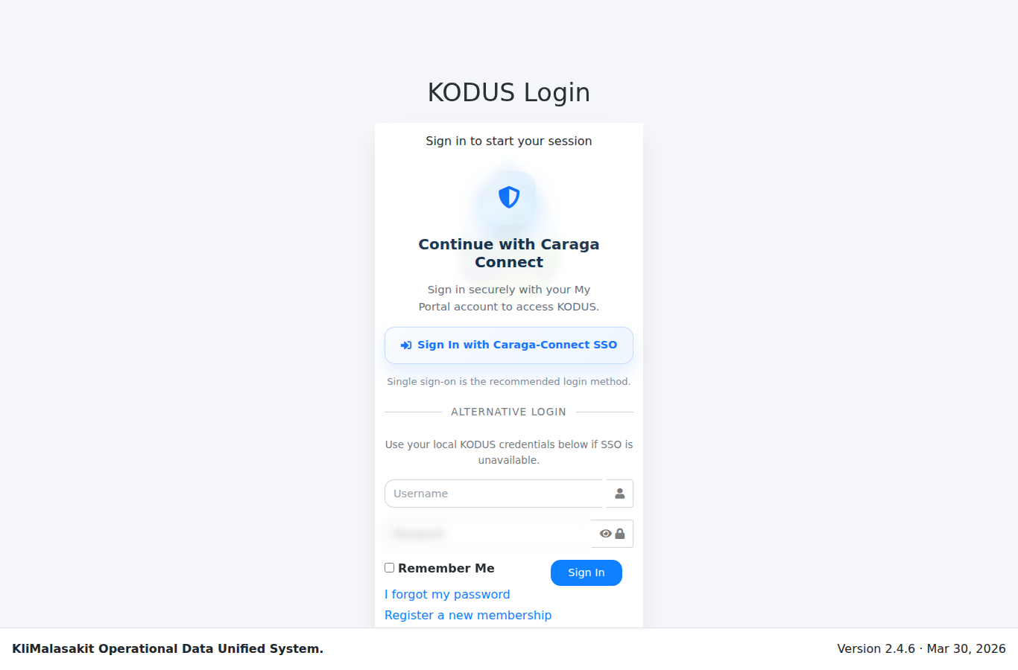
Figure A-. Login / Username-Password Access
Purpose/use: Shows authenticated entry to KODUS without exposing credentials.
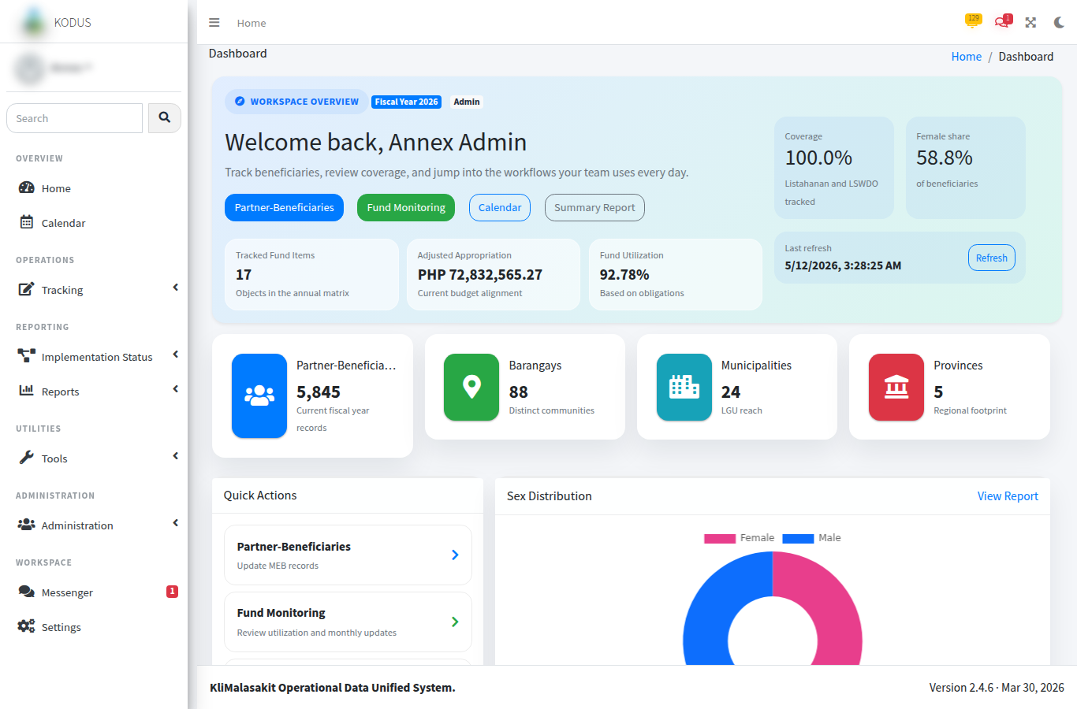
Figure A-. Dashboard / Home
Purpose/use: Provides the role-based landing page for operational monitoring and navigation.
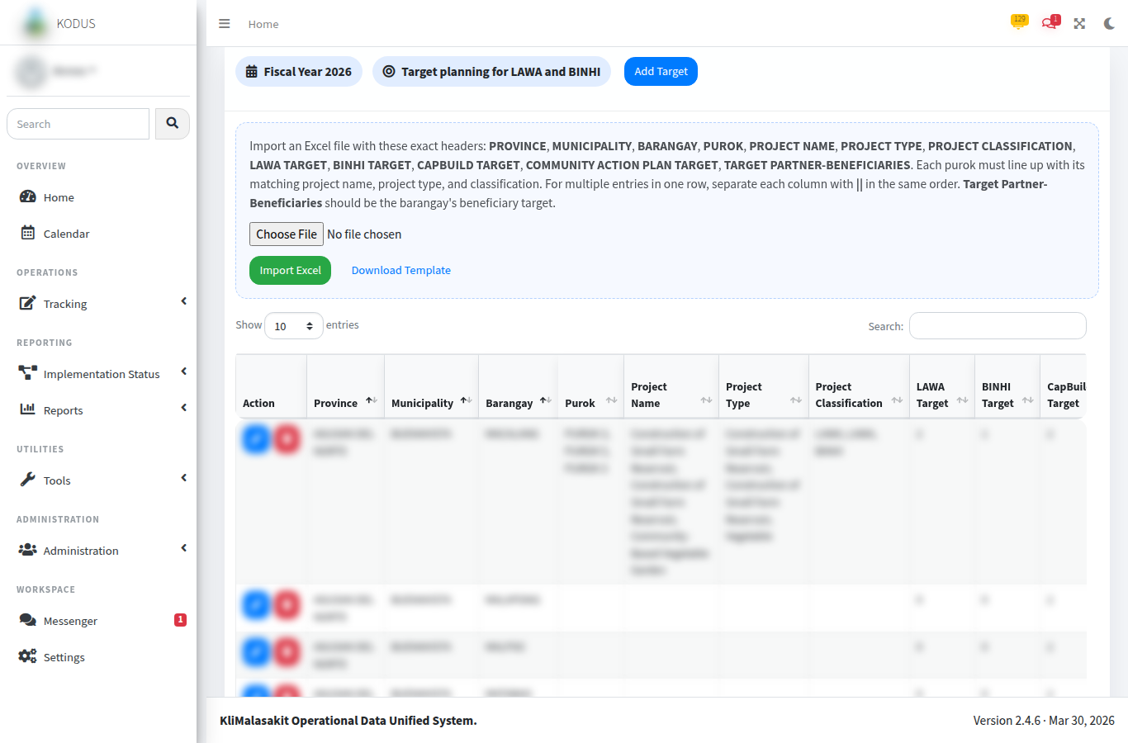
Figure A-. Implementation Status - Program Targets
Purpose/use: Documents target setup and monitoring reference points for implementation tracking.
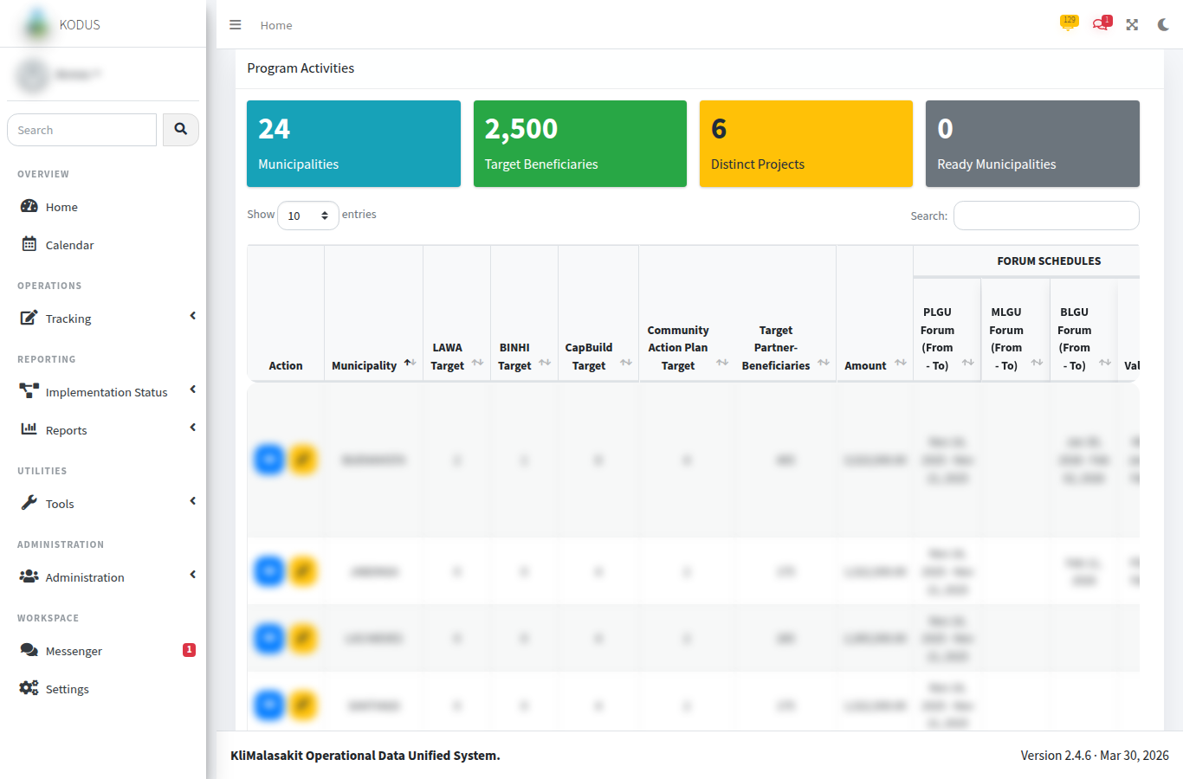
Figure A-. Implementation Status - Program Activities
Purpose/use: Shows the activity monitoring surface for timeline and accomplishment updates.
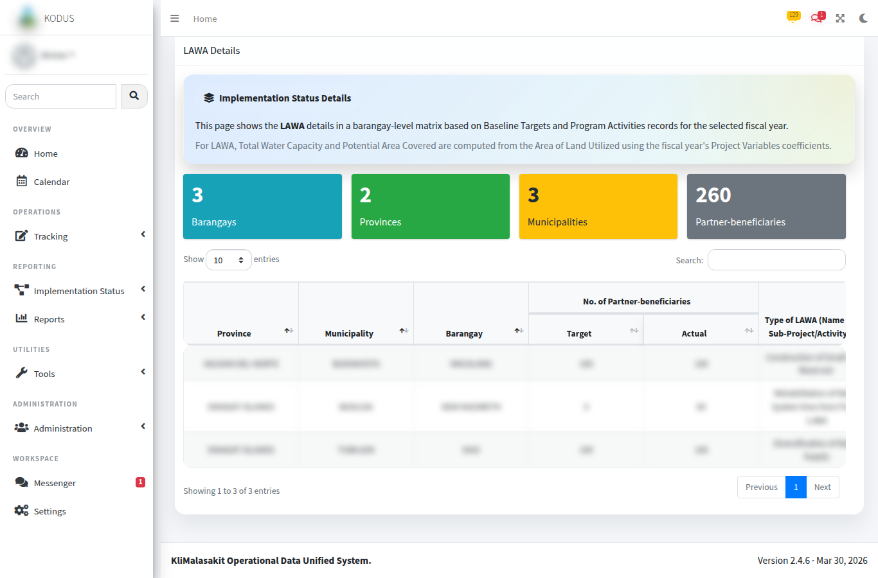
Figure A-. Implementation Status - LAWA/BINHI Summary
Purpose/use: Presents aggregate target-versus-actual summaries for management review.
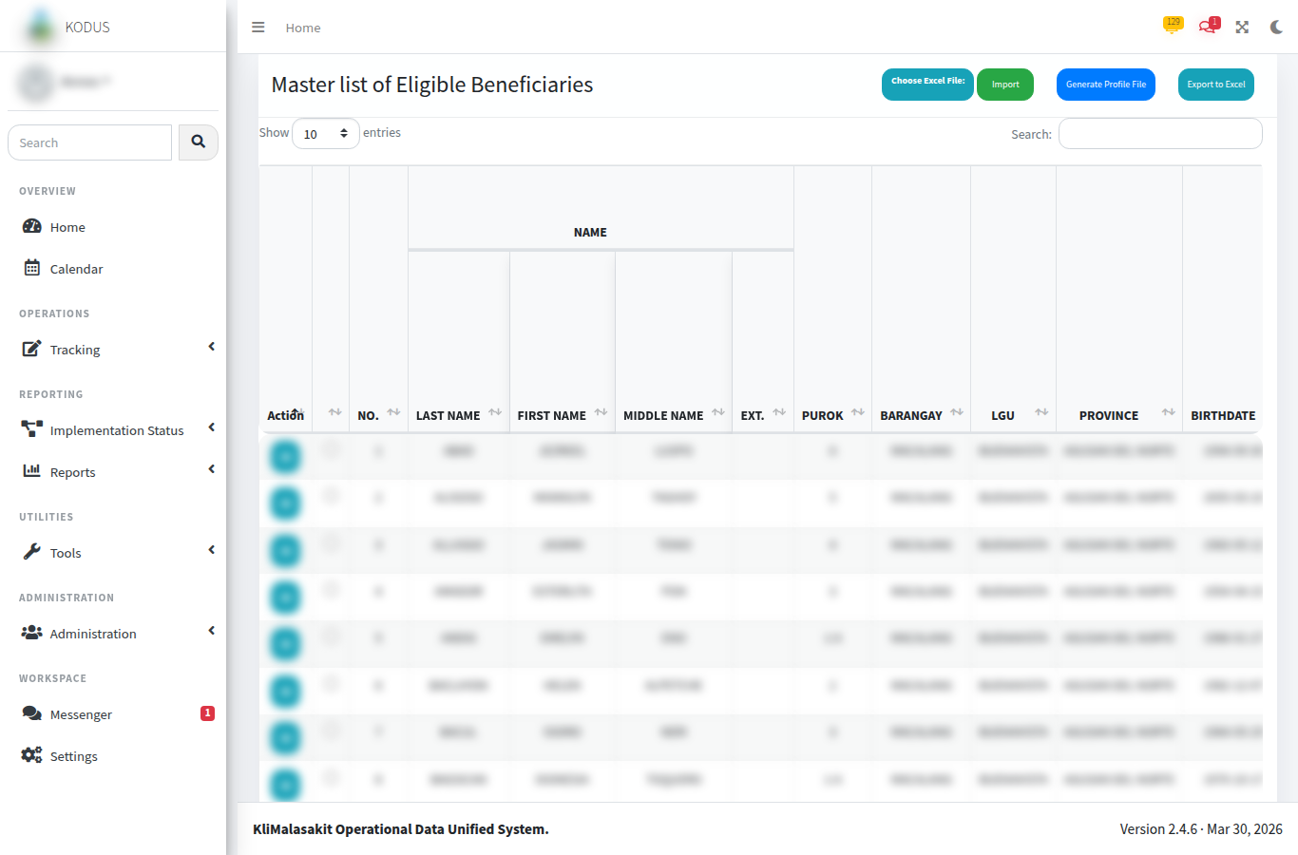
Figure A-. MEB Import / Master List
Purpose/use: Shows the MEB import/list workflow using sanitized or test records.
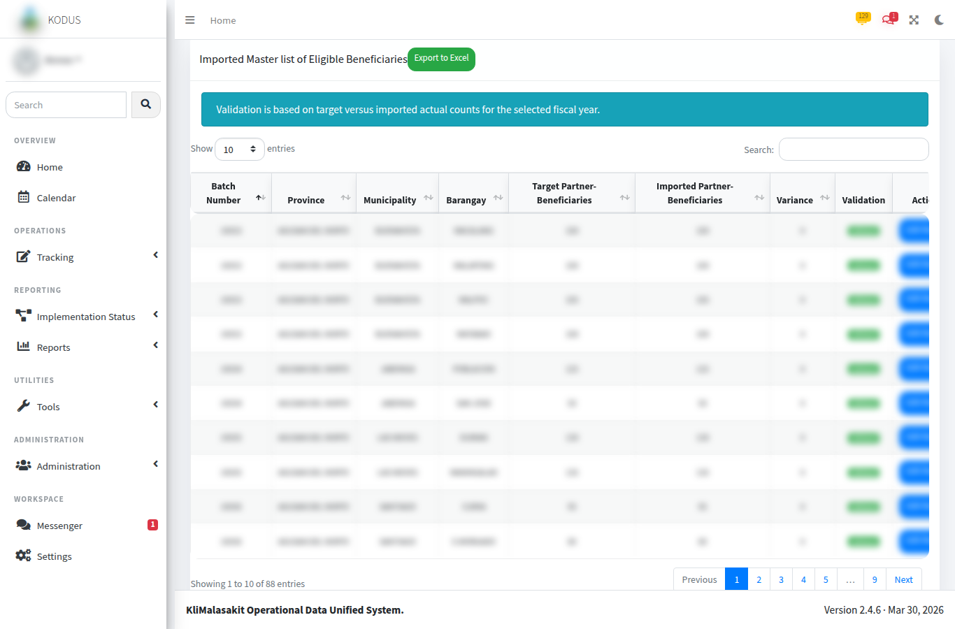
Figure A-. MEB Validation
Purpose/use: Documents validation status review and count comparison by location.
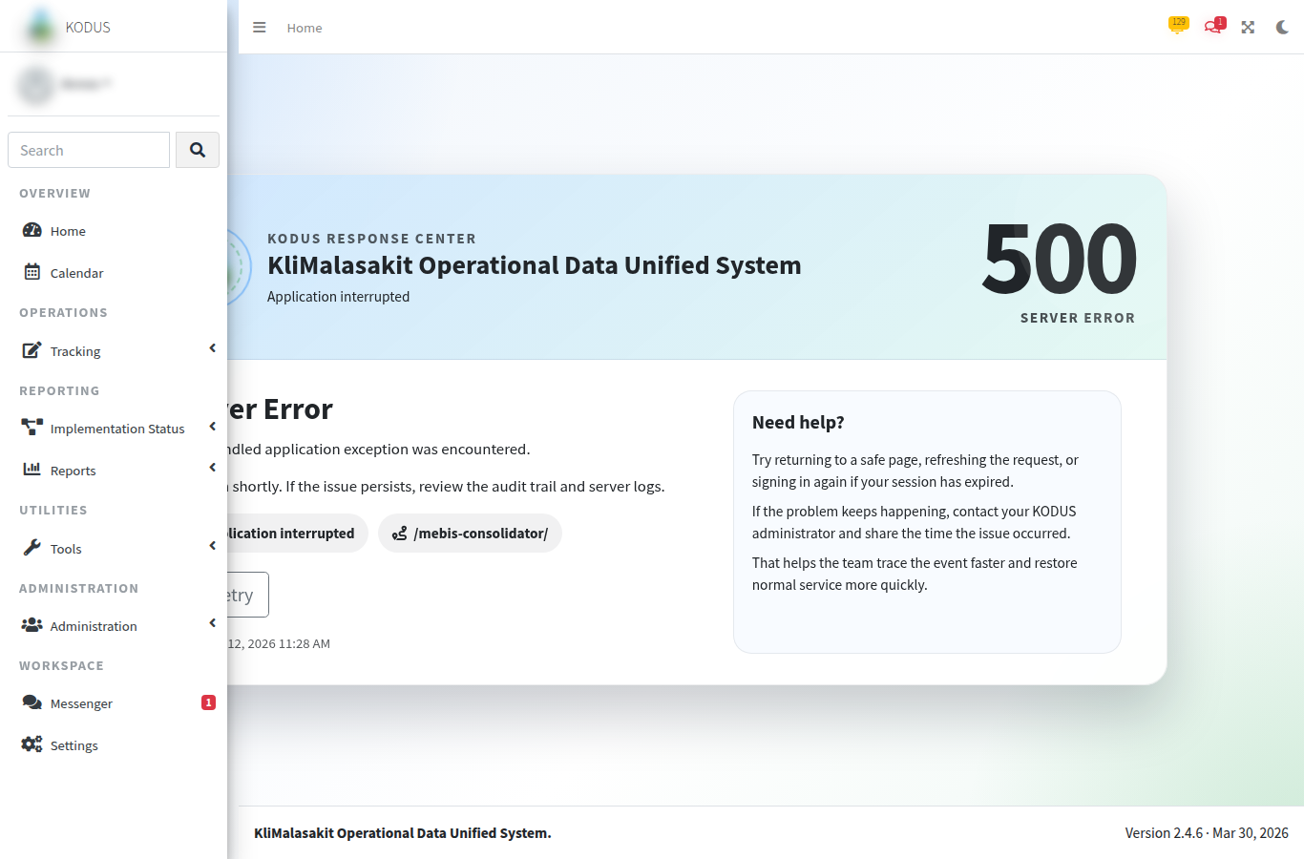
Figure A-. MEBIS Consolidator
Purpose/use: Shows consolidated workbook processing without exposing raw personal records.
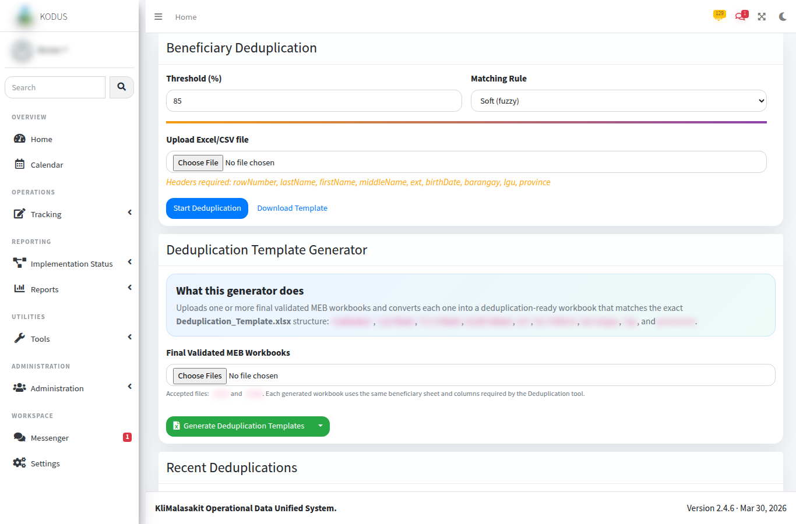
Figure A-. Deduplication Upload / Recent Jobs
Purpose/use: Documents the duplicate-detection entry point and job review surface.
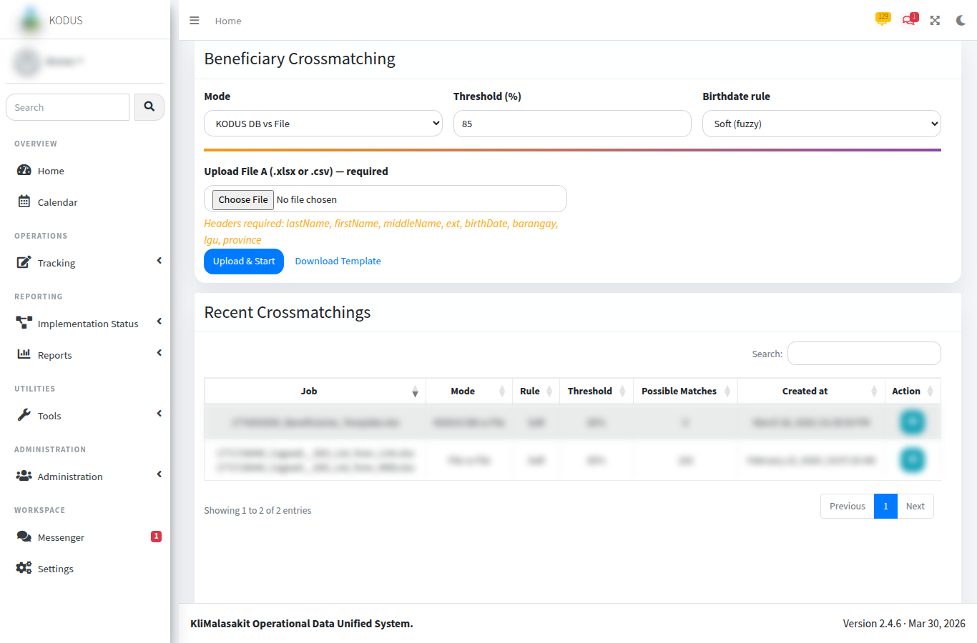
Figure A-. Crossmatch Upload / Start
Purpose/use: Shows the crossmatch workflow using test files or synthetic records only.
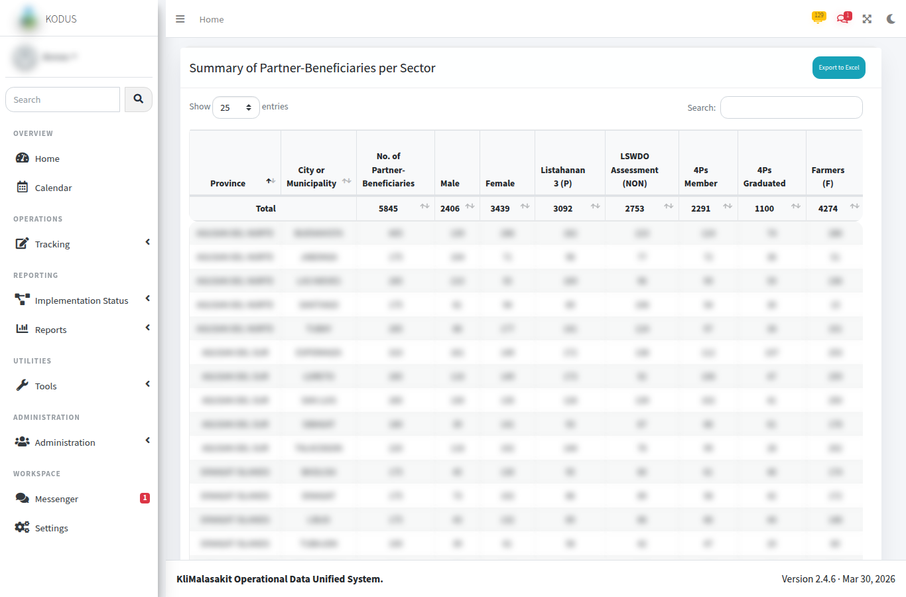
Figure A-. Reports / Export Screens
Purpose/use: Documents report and export entry points for aggregate or approved outputs.
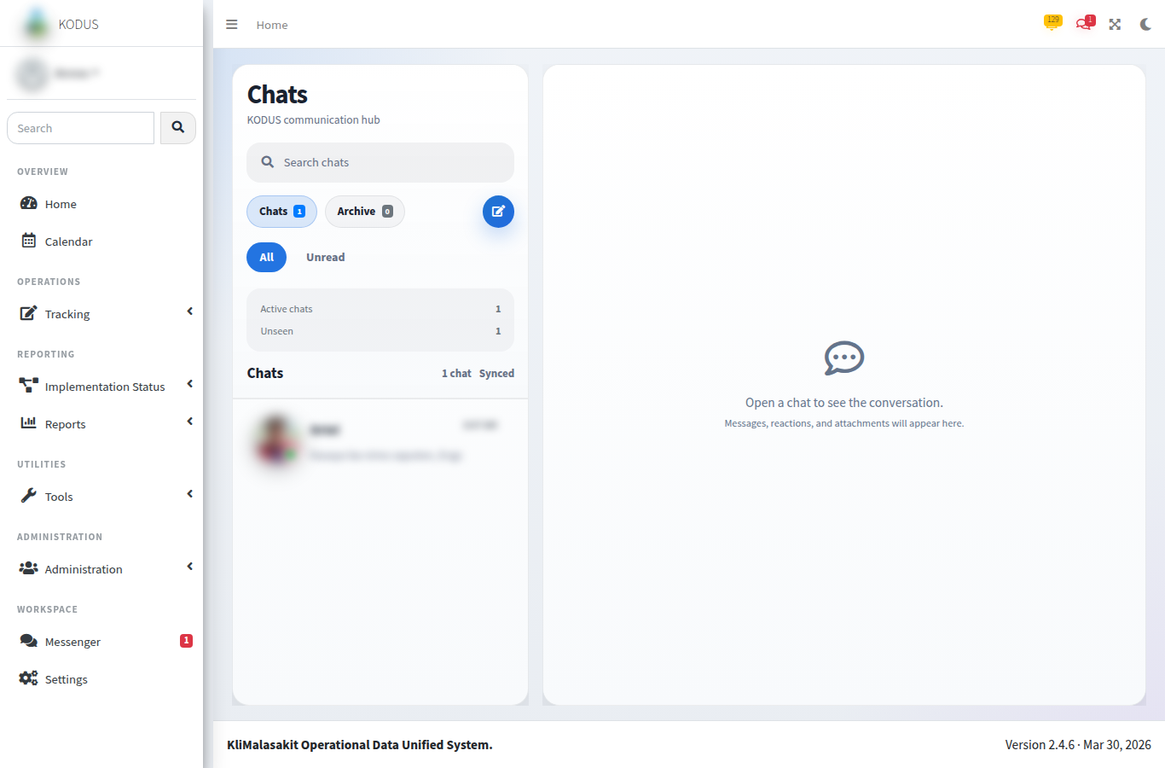
Figure A-. Inbox / Messenger
Purpose/use: Shows staff coordination features using test conversation content only.
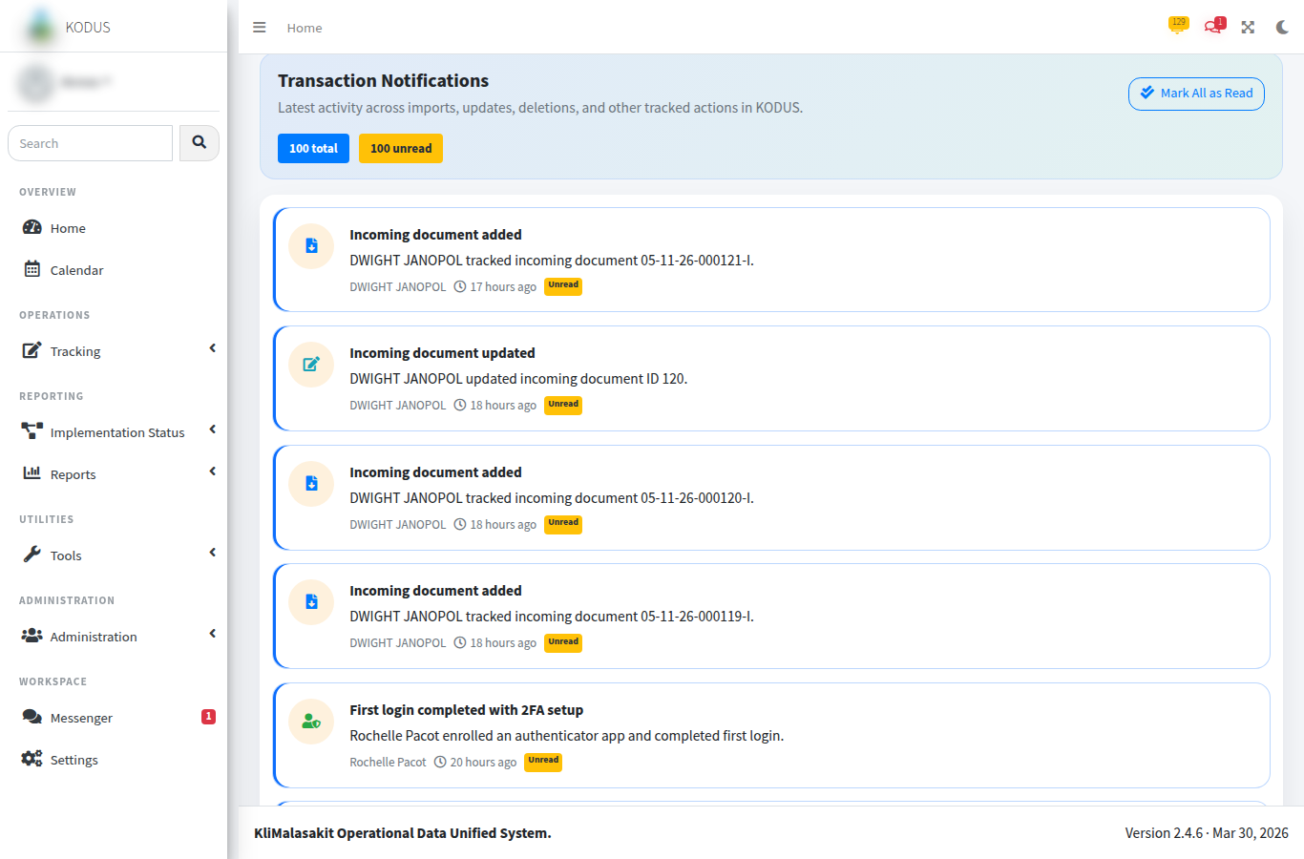
Figure A-. Notifications
Purpose/use: Documents operational notification delivery with non-sensitive sample entries.
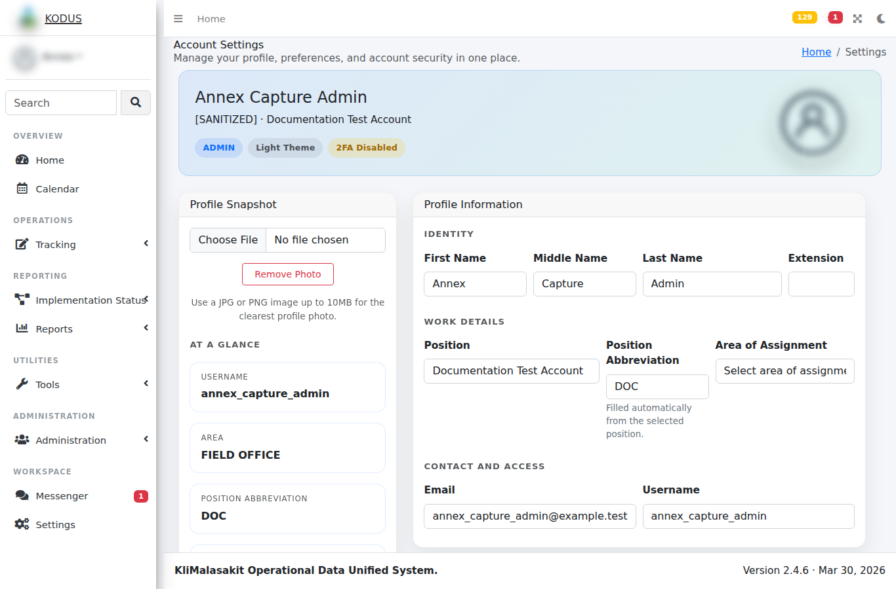
Figure A-. Settings / Profile
Purpose/use: Shows account settings while excluding personal contact details and security secrets.
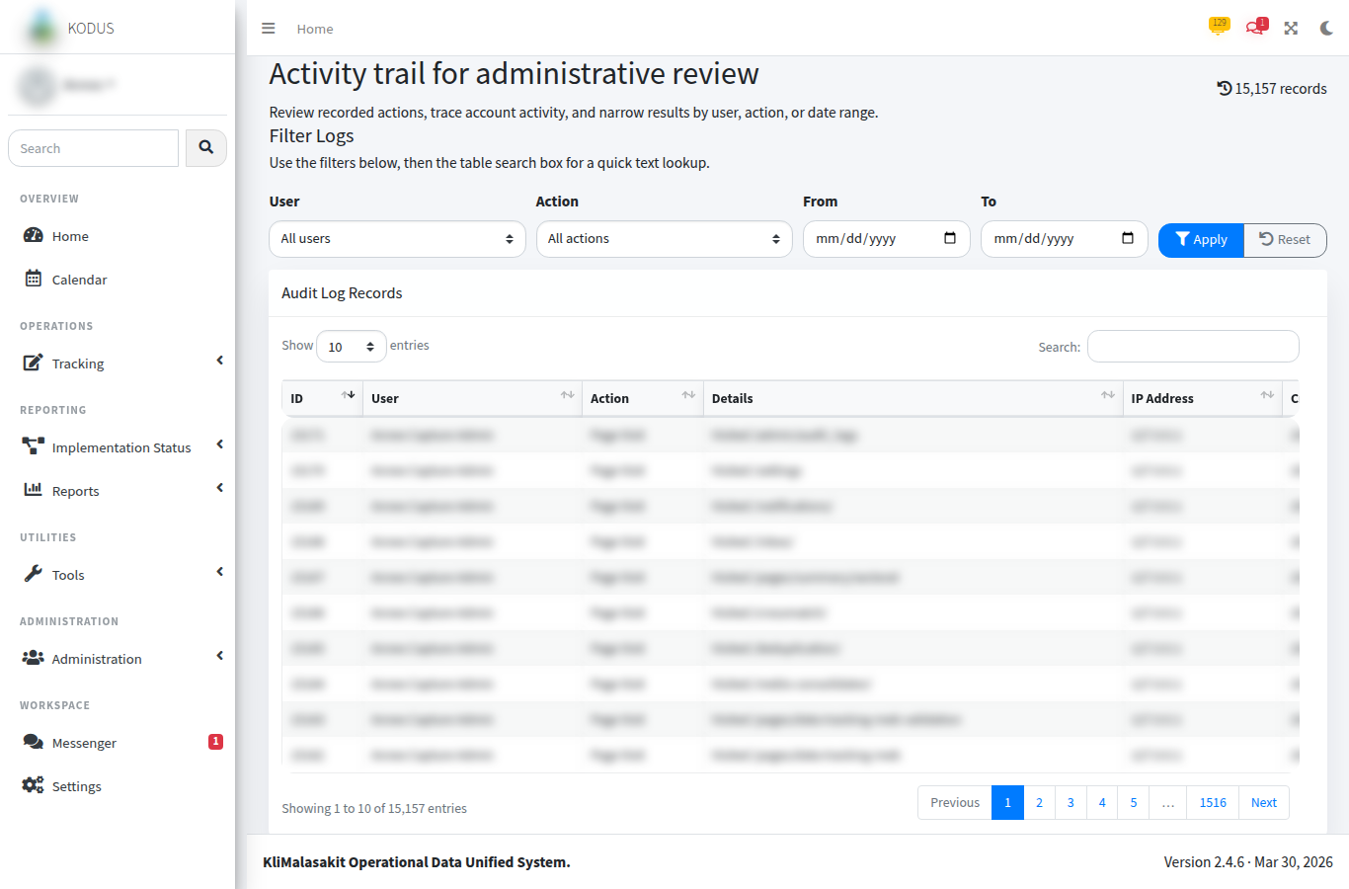
Figure A-. Audit Logs
Purpose/use: Shows accountability monitoring through sanitized action logs.
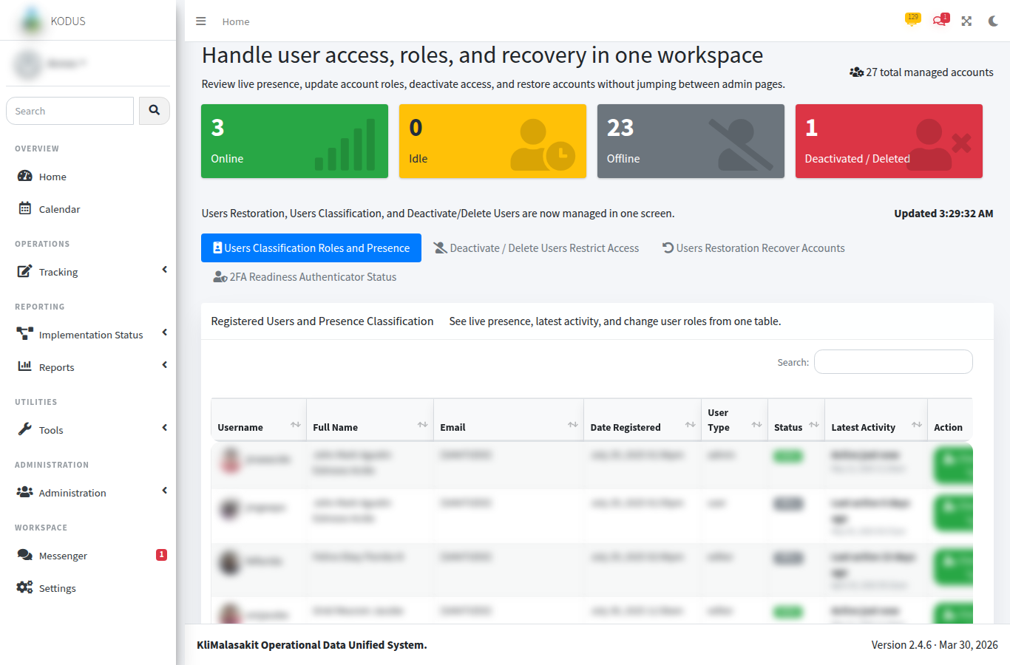
Figure A-. Admin User Management
Purpose/use: Documents user administration controls with masked or test identities.
[MANUAL SCREENSHOT INSERT REQUIRED]
Admin Maintenance / Password Security
Use sanitized or synthetic data only.
Figure A-. Admin Maintenance / Password Security
Purpose/use: Records maintenance and password security controls once an approved sanitized screenshot is available.

A. Owner Validation Checklist
Table A-. Owner validation checklist
Validation item | Required action | Status
Sanitization | Confirm no beneficiary-level personal information, account secret, token, or password is visible. | [MANUAL INPUT REQUIRED]
Currency | Confirm screenshots, tables, and process notes reflect the approved KODUS build. | [MANUAL INPUT REQUIRED]
Sign-off | Record reviewer, date reviewed, and approving official in the title page. | [MANUAL INPUT REQUIRED]
Retention | File the validated appendix with the controlled GPD/KM documentation set. | [MANUAL INPUT REQUIRED]

