Appendix B
MEB Validation Screenshots
KliMalasakit Operational Data Unified System (KODUS)
Good Practice Documentation Appendix Package
DSWD Field Office Caraga
Prepared for Knowledge Management documentation review
[MANUAL INPUT REQUIRED: Insert official document date, version, reviewer, and approving official]

Table of Contents

Appendix B - MEB Validation Screenshots
This appendix forms part of the KODUS Good Practice Documentation package. It is prepared in formal DSWD Knowledge Management style to provide organized evidence, process notes, and documentary references for review, replication, and institutional learning.
Scope: MEB import, validation status review, exception handling through the MEB validation table, and validation-report surfaces used to compare imported actuals with approved target partner-beneficiary counts.
Confidentiality notice: All examples in this appendix use sanitized, aggregate, or synthetic data. Screenshots pending owner validation are marked with manual insertion notices. Passwords, tokens, OAuth secrets, beneficiary data, contact details, private host identifiers, and other sensitive values are excluded.

B.1 Validation Evidence Requirements
MEB validation screenshots shall show only aggregate counts, status labels, batch references, and sanitized workbook names. Row-level beneficiary names, addresses, IDs, contact information, and birthdates shall be excluded or replaced with synthetic values.
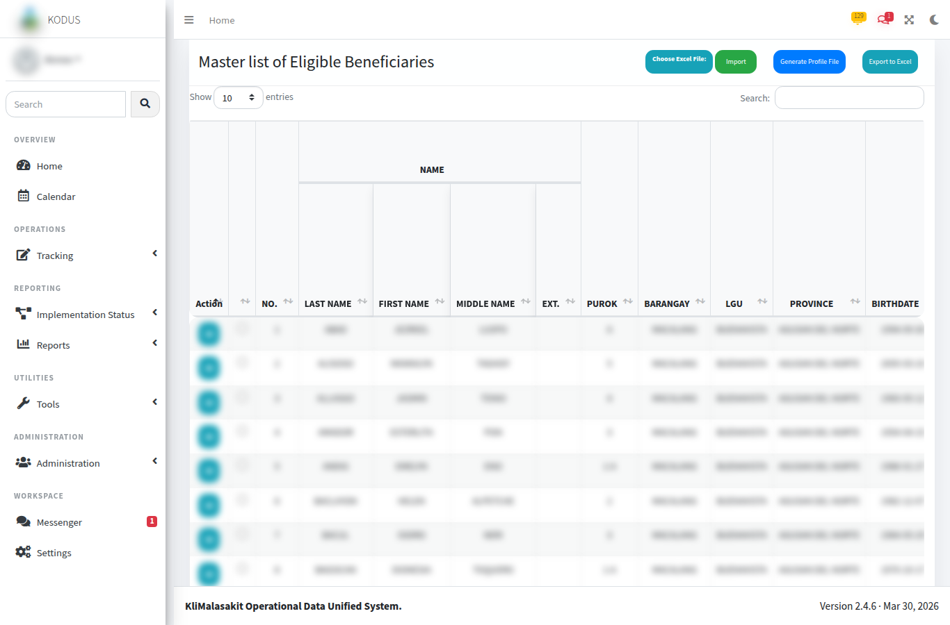
Figure B-. MEB Import Queue / Batch Processing
Purpose/use: Shows the controlled entry point for uploaded MEB workbooks and import status review.
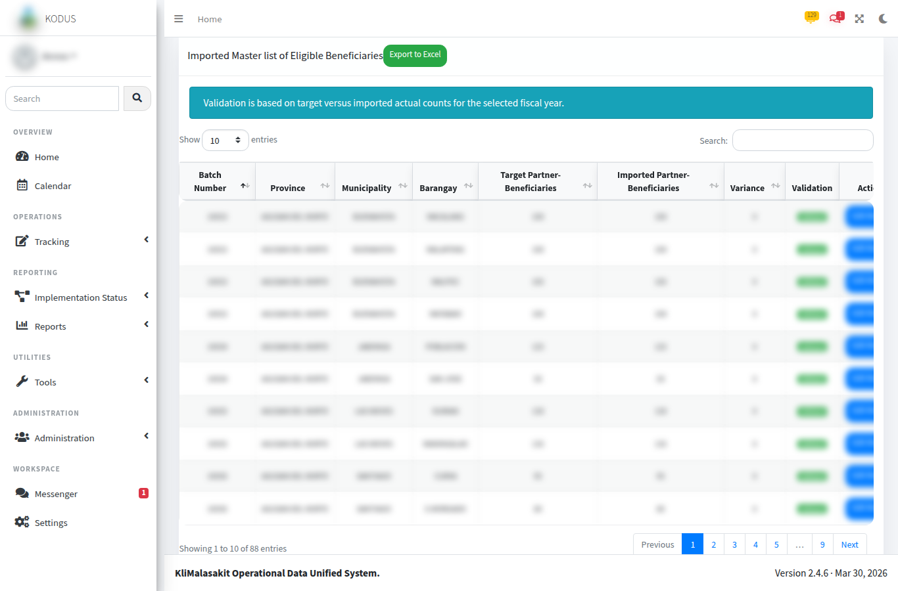
Figure B-. MEB Validation Count Comparison
Purpose/use: Shows location-level target and actual counts used for validation status review.
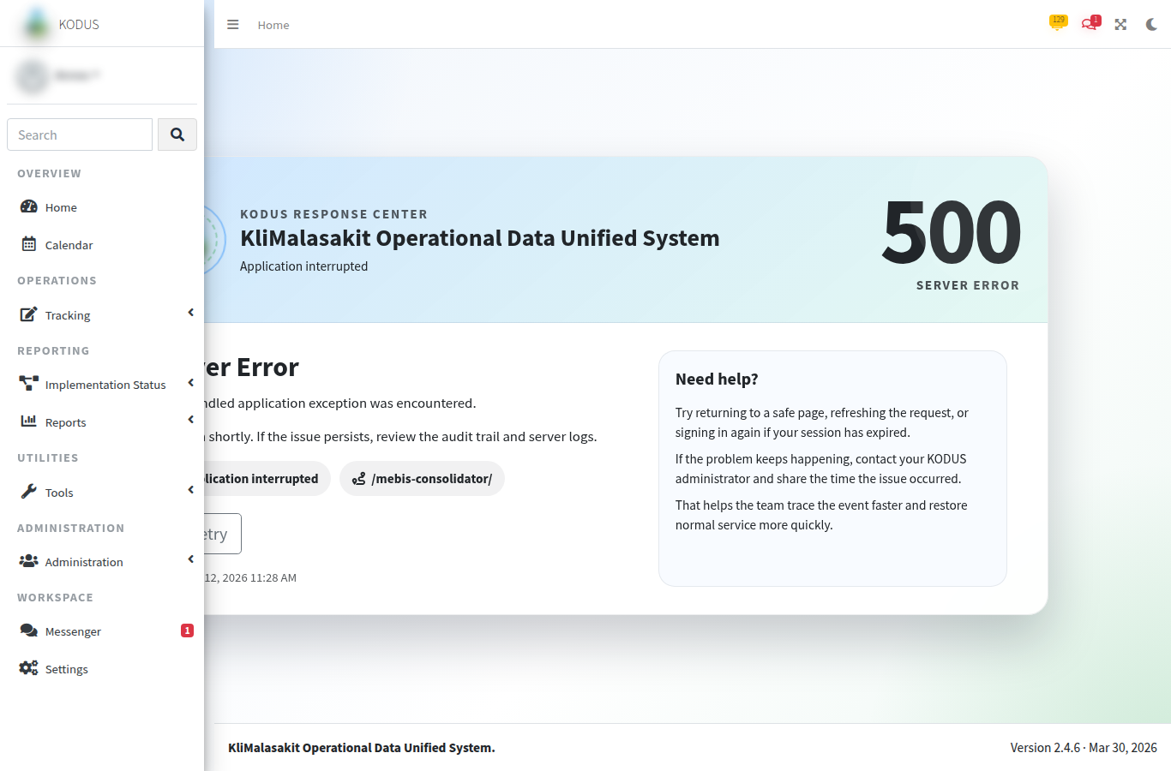
Figure B-. MEBIS Consolidator Support Screen
Purpose/use: Documents related workbook consolidation support for MEB validation preparation.

B.2 Validation Status and Exception Handling
KODUS does not have a separate screen named Validation Exception Review. Exception handling is performed through the MEB validation screen, its status labels, the DataTables search/filter function, the Edit Rows action for imported records, and the validation Excel export.

B.3 Validation Status Reference
Table B-. MEB validation status reference
Status | Meaning | Expected reviewer action
No Target | Imported or reviewed location has no approved target record. | Confirm target setup or mark as out of scope.
No Import | Target exists but no corresponding MEB import has been recorded. | Follow up with responsible operating unit.
Partial | Imported actual count is below approved target count. | Review missing entries and reconcile with field office source.
Validated | Imported actual count matches approved target count. | Record validation and proceed to approved reporting output.
Over Target | Imported actual count exceeds approved target count. | Review excess entries and correct source workbook or target reference.
Unplanned Import | Import exists for a location outside the approved target plan. | Confirm whether the record should be reclassified, corrected, or excluded.

B.4 Validation Trail Notes
The validation reviewer should retain the sanitized screenshot, source-batch reference, date reviewed, and reviewer name in the controlled evidence file. Sensitive source workbooks and raw beneficiary-level exports shall remain in authorized operational storage only.

B. Owner Validation Checklist
Table B-. Owner validation checklist
Validation item | Required action | Status
Sanitization | Confirm no beneficiary-level personal information, account secret, token, or password is visible. | [MANUAL INPUT REQUIRED]
Currency | Confirm screenshots, tables, and process notes reflect the approved KODUS build. | [MANUAL INPUT REQUIRED]
Sign-off | Record reviewer, date reviewed, and approving official in the title page. | [MANUAL INPUT REQUIRED]
Retention | File the validated appendix with the controlled GPD/KM documentation set. | [MANUAL INPUT REQUIRED]

