Appendix D
Audit-Log Screenshots
KliMalasakit Operational Data Unified System (KODUS)
Good Practice Documentation Appendix Package
DSWD Field Office Caraga
Prepared for Knowledge Management documentation review
[MANUAL INPUT REQUIRED: Insert official document date, version, reviewer, and approving official]

Table of Contents

Appendix D - Audit-Log Screenshots
This appendix forms part of the KODUS Good Practice Documentation package. It is prepared in formal DSWD Knowledge Management style to provide organized evidence, process notes, and documentary references for review, replication, and institutional learning.
Scope: Audit log views, accountability controls, and sanitized sample audit fields used to document traceability of KODUS actions.
Confidentiality notice: All examples in this appendix use sanitized, aggregate, or synthetic data. Screenshots pending owner validation are marked with manual insertion notices. Passwords, tokens, OAuth secrets, beneficiary data, contact details, private host identifiers, and other sensitive values are excluded.

D.1 Audit-Log Evidence Standards
Audit-log evidence shall demonstrate accountability controls without exposing private user details, IP addresses, session identifiers, tokens, or beneficiary-level data. Where screenshots contain sensitive values, the document owner shall redact or replace them before insertion.
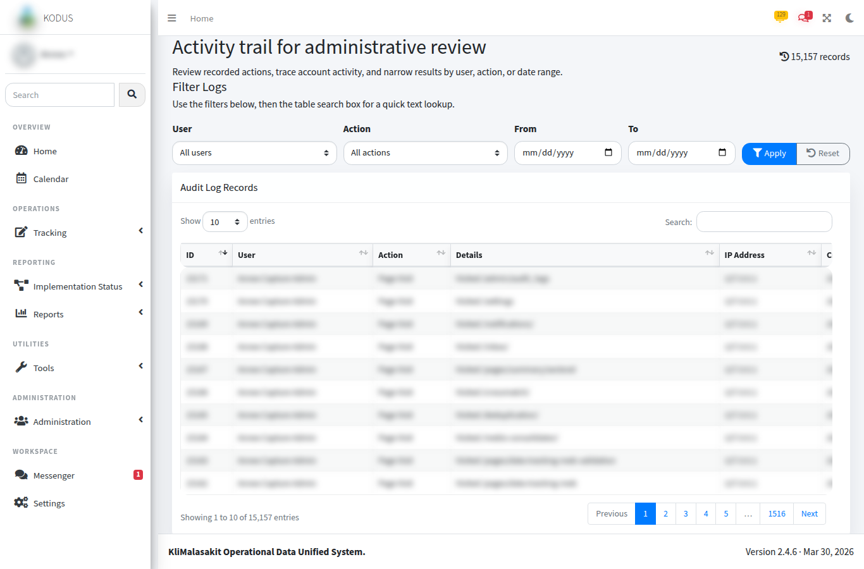
Figure D-. Audit Logs Administrative View
Purpose/use: Shows administrative review of user actions, timestamps, and system event details using sanitized values.
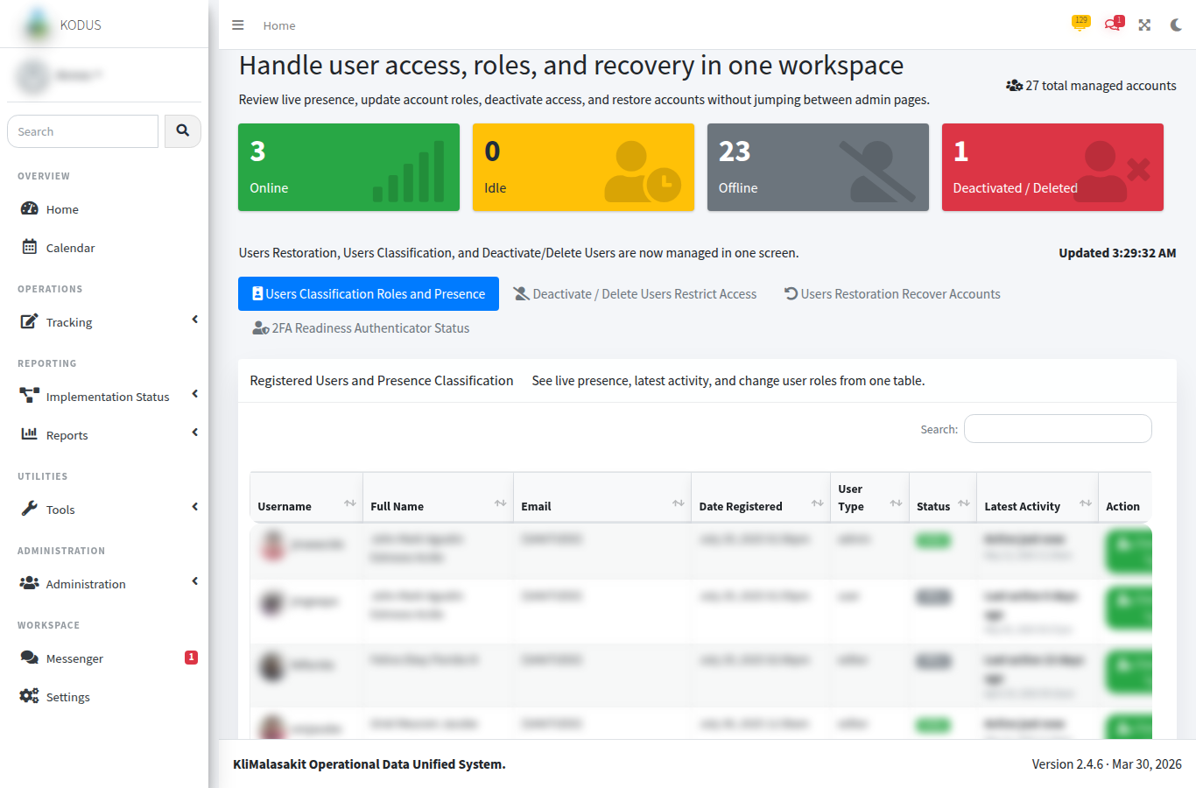
Figure D-. User Management Accountability Context
Purpose/use: Shows the administrative context for role and account actions that may be reflected in the audit trail.
[MANUAL SCREENSHOT INSERT REQUIRED]
Filtered Audit Search Result
Use sanitized or synthetic data only.
Figure D-. Filtered Audit Search Result
Purpose/use: Reserved for a sanitized screenshot showing filtered audit results for a selected action category and date range.

D.2 Synthetic Audit-Log Sample
Table D-. Synthetic audit-log sample
Timestamp | Role | Action category | Object reference | Sanitized details
2026-05-01 09:15 | System Administrator | User status update | USER-TEST-014 | Test account status changed from Active to Inactive.
2026-05-01 10:42 | Editor | MEB import | BATCH-SYN-2026-004 | Synthetic workbook import completed with 120 rows.
2026-05-02 14:05 | Authorized AA | Validation review | VAL-SYN-2026-011 | Location status updated to Validated after count reconciliation.
2026-05-03 08:55 | System | Background job | DEDUP-SYN-2026-002 | Deduplication job completed; output stored in controlled area.

D.3 Audit Review Note
Audit-log extracts included in documentation shall be limited to the minimum fields required to demonstrate the control. Full audit-log exports remain operational records and shall be handled under applicable information security, records management, and privacy requirements.

D. Owner Validation Checklist
Table D-. Owner validation checklist
Validation item | Required action | Status
Sanitization | Confirm no beneficiary-level personal information, account secret, token, or password is visible. | [MANUAL INPUT REQUIRED]
Currency | Confirm screenshots, tables, and process notes reflect the approved KODUS build. | [MANUAL INPUT REQUIRED]
Sign-off | Record reviewer, date reviewed, and approving official in the title page. | [MANUAL INPUT REQUIRED]
Retention | File the validated appendix with the controlled GPD/KM documentation set. | [MANUAL INPUT REQUIRED]

