Appendix E
Deduplication and Crossmatch Result Samples
KliMalasakit Operational Data Unified System (KODUS)
Good Practice Documentation Appendix Package
DSWD Field Office Caraga
Prepared for Knowledge Management documentation review
[MANUAL INPUT REQUIRED: Insert official document date, version, reviewer, and approving official]

Table of Contents

Appendix E - Deduplication and Crossmatch Result Samples
This appendix forms part of the KODUS Good Practice Documentation package. It is prepared in formal DSWD Knowledge Management style to provide organized evidence, process notes, and documentary references for review, replication, and institutional learning.
Scope: Synthetic duplicate-detection and crossmatch result formats for demonstrating KODUS matching outputs while preserving confidentiality.
Confidentiality notice: All examples in this appendix use sanitized, aggregate, or synthetic data. Screenshots pending owner validation are marked with manual insertion notices. Passwords, tokens, OAuth secrets, beneficiary data, contact details, private host identifiers, and other sensitive values are excluded.

E.1 Result Interpretation Note
The following samples use synthetic record codes, synthetic names, and non-production scores. They demonstrate how reviewers may interpret possible duplicate groups and crossmatch candidates. No real beneficiary identifiers are included.
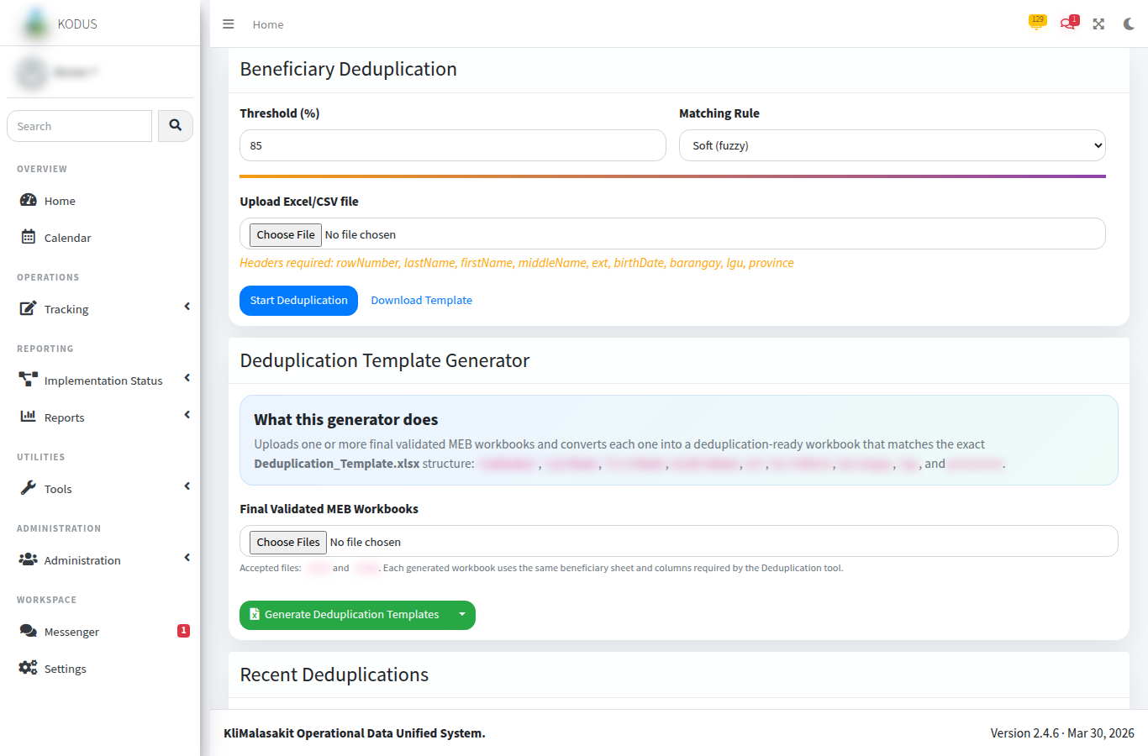
Figure E-. Deduplication Upload / Recent Jobs
Purpose/use: Shows the entry point for deduplication processing using synthetic or test upload references.
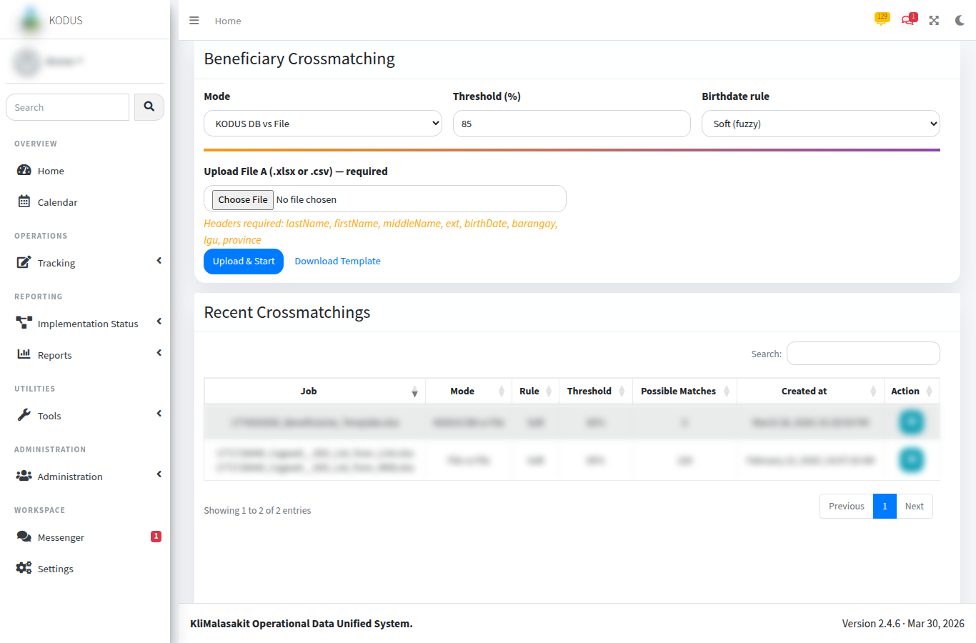
Figure E-. Crossmatch Upload / Candidate Review
Purpose/use: Shows crossmatch setup and candidate review controls using synthetic references.
Table E-. Synthetic deduplication group sample
Group ID | Synthetic record code | Synthetic display name | Location hint | Similarity score | Reviewer disposition
DG-001 | REC-SYN-00041 | Person Alpha | Municipality A | 96% | Probable duplicate; confirm source workbook.
DG-001 | REC-SYN-00077 | Person Alfa | Municipality A | 96% | Probable duplicate; same group as REC-SYN-00041.
DG-002 | REC-SYN-00118 | Person Beta | Municipality B | 88% | Possible duplicate; review supporting fields.
DG-002 | REC-SYN-00204 | Person B. | Municipality B | 88% | Possible duplicate; review supporting fields.
Table E-. Synthetic crossmatch candidate sample
Uploaded record | Top candidate | Name score | Location score | Overall score | Recommended action
UP-SYN-0031 | MEB-SYN-0881 | 92% | 100% | 95% | Review as likely match.
UP-SYN-0032 | MEB-SYN-1024 | 76% | 100% | 83% | Review before acceptance.
UP-SYN-0033 | No candidate above threshold | N/A | N/A | N/A | Treat as no automated match.

E.2 Reviewer Handling Guidance
Automated scores are decision-support outputs and do not by themselves establish identity or eligibility. The accountable reviewer shall examine source-authorized evidence, document the basis for acceptance or rejection, and retain only the minimum necessary evidence in the controlled operational record.

E. Owner Validation Checklist
Table E-. Owner validation checklist
Validation item | Required action | Status
Sanitization | Confirm no beneficiary-level personal information, account secret, token, or password is visible. | [MANUAL INPUT REQUIRED]
Currency | Confirm screenshots, tables, and process notes reflect the approved KODUS build. | [MANUAL INPUT REQUIRED]
Sign-off | Record reviewer, date reviewed, and approving official in the title page. | [MANUAL INPUT REQUIRED]
Retention | File the validated appendix with the controlled GPD/KM documentation set. | [MANUAL INPUT REQUIRED]

