Appendix F
Workflow Diagrams and Process Maps
KliMalasakit Operational Data Unified System (KODUS)
Good Practice Documentation Appendix Package
DSWD Field Office Caraga
Prepared for Knowledge Management documentation review
[MANUAL INPUT REQUIRED: Insert official document date, version, reviewer, and approving official]

Table of Contents

Appendix F - Workflow Diagrams and Process Maps
This appendix forms part of the KODUS Good Practice Documentation package. It is prepared in formal DSWD Knowledge Management style to provide organized evidence, process notes, and documentary references for review, replication, and institutional learning.
Scope: Clean process maps and workflow diagrams for KODUS operational modules, prepared as editable Word tables for stable Microsoft Word compatibility.
Confidentiality notice: All examples in this appendix use sanitized, aggregate, or synthetic data. Screenshots pending owner validation are marked with manual insertion notices. Passwords, tokens, OAuth secrets, beneficiary data, contact details, private host identifiers, and other sensitive values are excluded.

F.1 KODUS Operational Workflow
Figure F-. High-level KODUS operational workflow
Process stage | Program/field user | KODUS module | Reviewer/administrator
Stage 1 | Prepare approved source data | Authenticate and apply role/area controls | Confirm authorization and data quality
Stage 2 | Encode or upload operational records | Process MEB, target, activity, and job records | Review exceptions and validation status
Stage 3 | Review module outputs | Generate summaries, exports, and notifications | Approve aggregate outputs
Stage 4 | Submit corrected/validated data | Record audit trail and validation status | Maintain users, audit logs, and deployment controls
Purpose/use: Provides an editable process-map overview of how authorized users, KODUS modules, and reviewers interact during routine operations.

F.2 MEB Validation Process Map
Table F-. MEB validation process map
Step | Responsible office/user | Control or output
1. Prepare approved MEB workbook | Program/field focal | Workbook prepared using authorized source and sanitized documentation copy.
2. Upload/import workbook | Authorized KODUS user | Import job created and logged.
3. Validate headers and counts | KODUS MEB module | Batch status, row count, and target comparison generated.
4. Review exceptions | Reviewer/AA/editor | No Target, Partial, Over Target, or Unplanned Import items reviewed.
5. Correct or confirm | Program owner/reviewer | Source workbook or target reference corrected where needed.
6. Export approved output | Authorized user | Aggregate or approved report generated and filed.
Purpose/use: Shows the review path from source workbook preparation to approved MEB validation output.

F.3 Deduplication and Crossmatch Process Map
Table F-. Deduplication and crossmatch process map
Step | Responsible office/user | Control or output
1. Upload synthetic/test-ready dataset | Authorized user | Dataset accepted only through controlled upload path.
2. Run matching job | KODUS worker | Matching scores and candidate groups generated.
3. Review candidates | Reviewer | Possible duplicate or crossmatch findings assessed.
4. Record disposition | Reviewer/program owner | Accepted, rejected, or pending status documented.
5. Retain evidence | System owner | Only minimum necessary evidence retained in controlled records.
Purpose/use: Documents how matching outputs are used as review support while maintaining human validation and confidentiality controls.

F.4 Deployment and Operations Process Map
Table F-. Deployment and operations process map
Step | Responsible office/user | Control or output
1. Prepare reviewed package | Technical maintainer | Reviewed application code and dependencies identified.
2. Configure server environment | Host/system owner | Environment file, database, PHP runtime, and web-server rules configured without exposing secrets.
3. Run smoke tests | Technical maintainer/system owner | Login, modules, workers, exports, notifications, and audit logs verified.
4. Activate release | Approving official/system owner | Deployment date, version, and approver recorded.
5. Monitor and maintain | Administrator/technical maintainer | Backups, audit review, worker monitoring, and access review performed.
Purpose/use: Provides a non-secret operational map for controlled deployment and sustainment.

F.5 Reference Diagrams
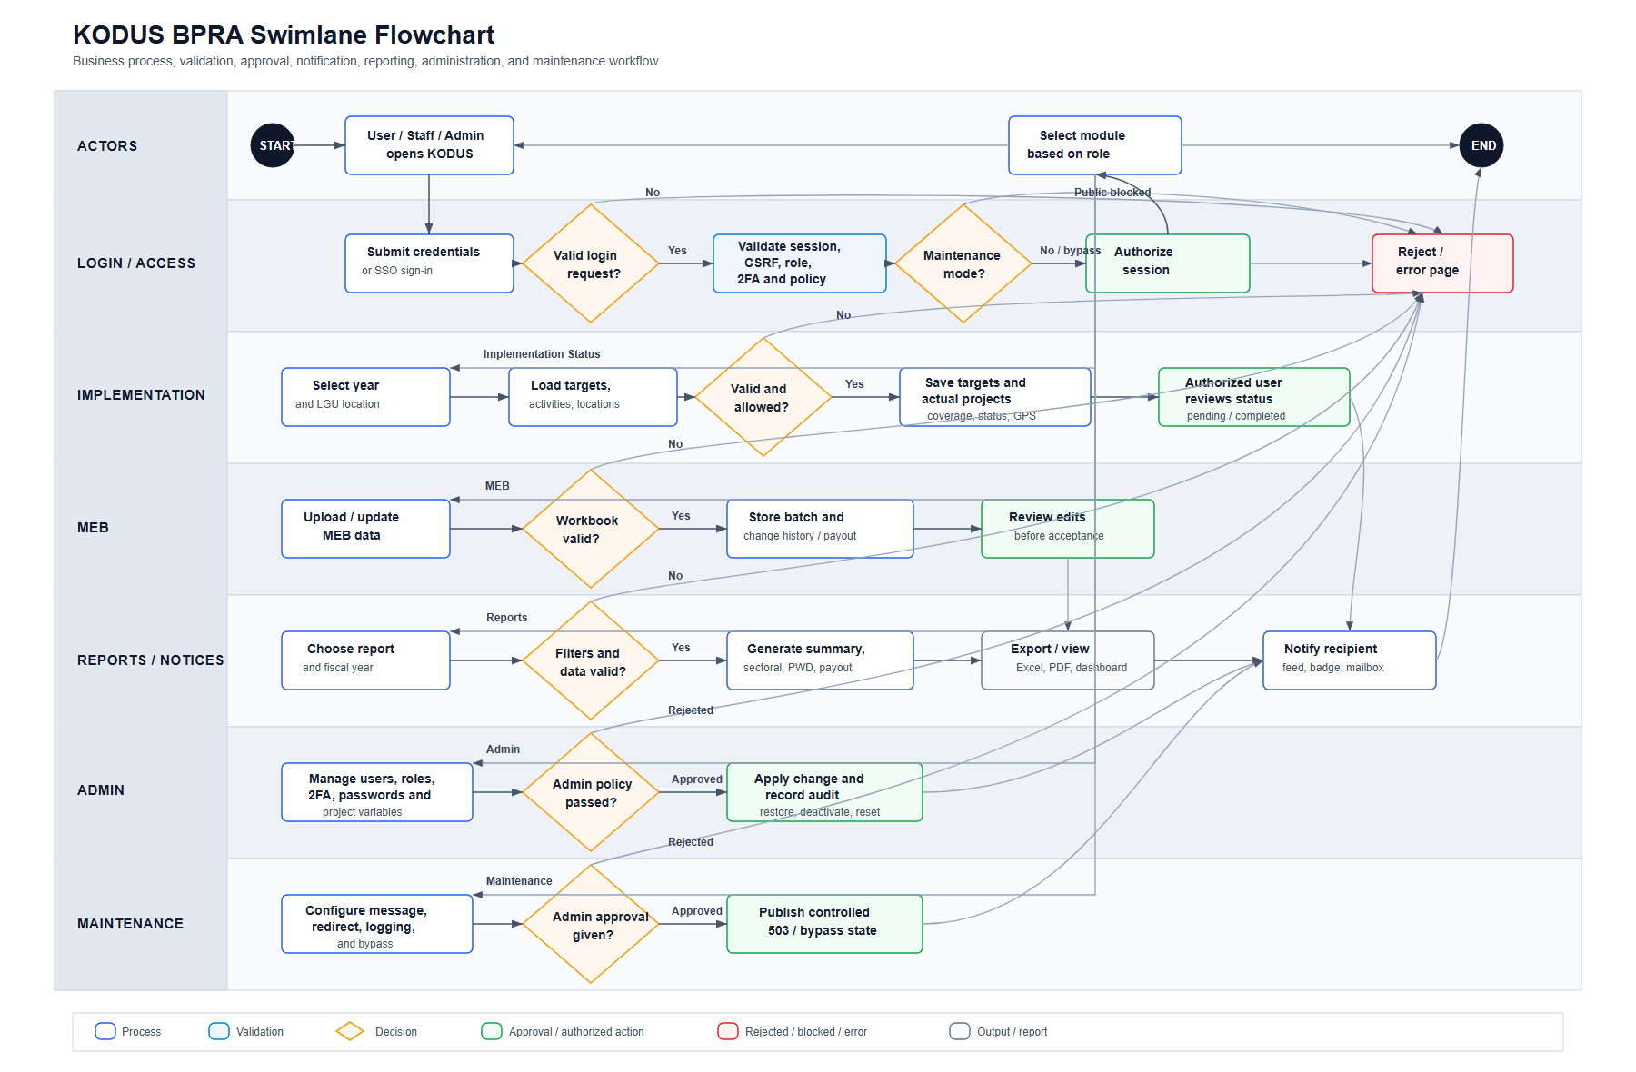
Figure F-. KODUS Business Process Reference Architecture
Purpose/use: Provides a repository-generated process reference diagram for architecture and workflow orientation.
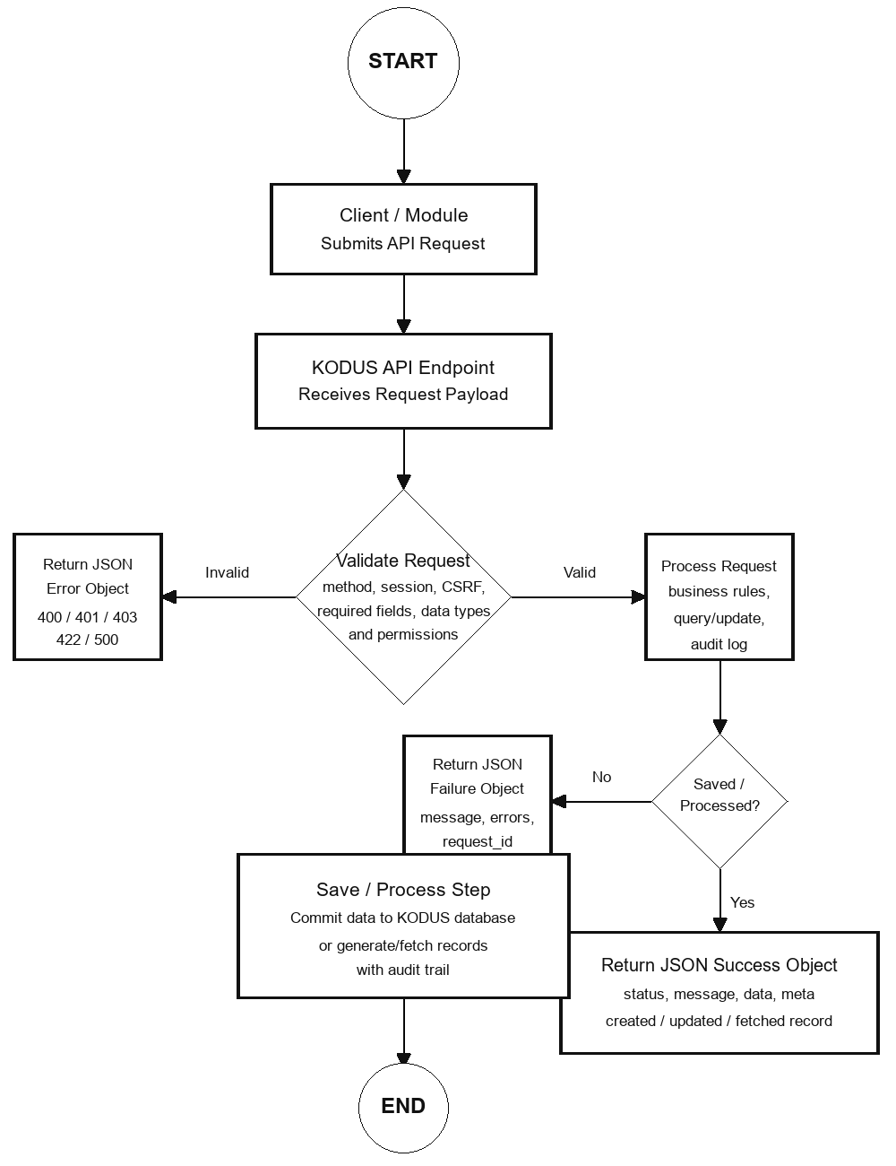
Figure F-. KODUS API/Data Exchange Reference
Purpose/use: Provides a repository-generated reference for API/data exchange orientation where applicable.

F. Owner Validation Checklist
Table F-. Owner validation checklist
Validation item | Required action | Status
Sanitization | Confirm no beneficiary-level personal information, account secret, token, or password is visible. | [MANUAL INPUT REQUIRED]
Currency | Confirm screenshots, tables, and process notes reflect the approved KODUS build. | [MANUAL INPUT REQUIRED]
Sign-off | Record reviewer, date reviewed, and approving official in the title page. | [MANUAL INPUT REQUIRED]
Retention | File the validated appendix with the controlled GPD/KM documentation set. | [MANUAL INPUT REQUIRED]

