MINUTES OF MEETING

DRMD RISES: RRP-CFTW 4th BI-MONTHLY STAFF MEETING
August 22, 2025
Watergate Hotel, Butuan City

- Attendance

NAME | POSITION | OFFICE
Alica T. Marquiso | DRRS Head/ RRP Program Focal | DRMD
Rutchel R. Molino | PDO-III/ MER Focal | DRMD
Engr. Oriel M. Jacobe | PDO-III/ Monitoring and Technical Support | DRMD
Faith N. Pingoy | PDO-II/ FO Provincial Focal for Surigao del Sur | DRMD
Sheba Mae G. Monte | PDO-II/ FO Provincial Focal for Surigao del Norte | DRMD
Karin Louise Q. Nietes | PDO-II/ FO Provincial Focal for Agusan del Norte | DRMD
Charina L. Genosolango | PDO-II/ FO Provincial Focal for Province of Dinagat Islands | DRMD
Leo Tristan S. Bagcat | PDO-II/ FO Provincial Focal for Agusan del Sur | DRMD
Felino E. Florida | PDO-I/ Alternate Provincial Focal for Province of Dinagat Islands | DRMD
Joseph Bien Conrad V. Calo | PDO-I/ Alternate Provincial Focal for Agusan del Sur | DRMD
Maria Diovelle P. Salvan | PDO-I/ Alternate Provincial Focal for Surigao del Sur | DRMD
Rachelle B. Pacot | PDO-I/ Alternate Provincial Focal for Surigao del Norte | DRMD
Gilbert D. Comandante | PDO-I/ Alternate Provincial Focal for Agusan del Norte | DRMD
John Mark Agustin A. Acido | PDO-I/ Budget Focal | DRMD
Shirra Mae C. Calit | Administrative Assistant III/ Administrative Support | DRMD
Andy G. Amporias | Administrative Aide IV/ Administrative Support | DRMD

- Call to Order

The meeting was called to order at 10:00 AM and was chaired by Ms. Alicia T. Marquiso, DRRS Head and Program Focal for RPP-CFTW. The 16 staff members of the Risk Resiliency Program through Cash-for-Training and Work (RRP-CFTW) were in attendance.

Ms. Marquiso began by outlining the agenda for the meeting. She then invited participants to propose any additional items for discussion. With no further concerns raised, Ms. Marquiso proceeded with the following agenda items:

- Contractor Commitment and Evaluation Form (CCEF)
- RRP Narrative Accomplishment Report
- Status of RDRMC Preparation (Tasking)
- Update on Preparation of Project Site Visit in Buenavista, ADN
- MATA Cum Learning Visit
- Update on Fund Utilization
- RRP Innovations
- Feedback of Learning Visit in Cagayan de Oro City last August 4-8, 2025
- Food for Work for Project LAWA and BINHI
- Schedule of Activities
- Other Matters
- Issues and Concerns
- Agreements Reached/Ways Forward

Highlights of Discussion

      - Clarifications of Contractor Commitment and Evaluation Form (CCEF)

Ms. Maquiso began the day by raising some concern regarding consistency of the Success indicators and Mode of verification of the CCEF of the Project Development Officers (PDOs). She then emphasized the following:

- Feedback reports should be submitted after 5 working days
- Monitoring Tool/Site validation Tool are required
- Photo documentation should be uploaded to the G-drive as soon as possible
- Submission of Feedback report after the 1st draft of revisions will be considered 1 revision
- All Project Development Officer (PDO) II should countersign in the Work Accomplishment Report, below the name of Ms. Molino

2. RRP Narrative Accomplishment Report

Ms. Marquiso instructed the Project Development Officers (PDOs) to give the LGUs Technical assistance on drafting the narrative report. Then she requested the PDOs for the updates regarding the submission of Narrative Accomplishment Report by the LGUs. The PDOs then one-by-one gave their updates:

Ms. Nietes gave the update for the province of Agusan del Norte
- Narrative report of LGUs Jabonga, Buenavista, and Tubay was submitted on July 29, 2025
- LGUs Santiago, and Las Nieves submitted theirs on August 1, 2025

Ms. Pinggoy then followed with the updates for the Province of Surigao del Sur
- LGU Hinatuan submitted their Narrative report on July 13, 2025
- The rest of the LGUs will be followed up

Ms. Monte of Surigao del Norte, Mr. Bagcat of Agusan del Sur, and Ms. Genosolango of Province of Dinagat Islands then gave their assurance to follow-up their respective LGUs regarding the submission of Narrative report

Ms. Marquiso finished by setting the deadline of the submission of the Narrative Report on September 12, 2025.

3. Status of RDRMC Preparations

Ms. Marquiso asked for the updates on the confirmation of the invited LCEs for the RDRMC. Ms. Nietes then responded that out of the 5 LGUs, only LGU Jabonga has no response on the invitation. She then requested the heads for intervention regarding this matter.
Ms. Marquiso then continues to discuss other preparations for the upcoming RDRMC and she then highlighted the following:
- Mr. Calo together with the capbuild team to visit Watergate hotel regarding room assignments
- Leighs for the attending LCEs should be color coded for easy identification
- Diorama to be upgraded c/o Mr. Comendante

4. Update on the Preparations of Project Site Visit in Buenavista, Agusan del Norte

Ms. Nietes discussed the preparations made by them together with the B/MLGU for the Project Site Visit. She then highlighted some of the following:
- Courtesy call by DSWD personnels will be done on the project site
- BLGU can only provide snacks for the visitors, and cannot accommodate them for Lunch
- Since there are two (2) different project sites, Project LAWA site will be prioritized for the visit

After Ms. Nietes gave her update, Ms. Maquiso told Ms. Nietes that there will be no program that will be held on site during the visit. She then instructed the PDOs (Ms. Nietes and MR. Comendante) to give short informational introduction about the projects made on the site.

5. MATA cum Learning Visit

Ms. Molino presented the proposed program flow and itinerary for the upcoming MATA cum Learning visit together with CO and FO RRP workforce. She discussed some of the following arrangements to be done during the said activity:
- Courtesy call in LGU Basilisa will be done in Brgy. Rita Glenda project site
- Team will rest in LGU San Jose
- Side trip will be possibly done in LGU Dinagat
- Certificate of Appearance will be provided by the LGU, while Annex D will be provided by FO CARAGA

6. Fund Utilization updates

Mr. Acido, the Budget Focal Person of RRP-CFTW, presented the remaining program funds that need to be fully utilized within the year.
During the presentation, he discussed that there are some funds that are earmarked under office supplies, other MOOEs, and rents – motor vehicle, and ICT Equepment.
After the discussion of Mr. Acido, Ms. Marquiso then instructed him to clarify the earmarked funds under office supplies, other MOOEs, and rents; while the earmarked fund under ICT to be returned back to OBS.

7. RRP Innovations

Ms. Marquiso opened the discussion by encouraging Mr. Bagcat and Mr. Acido to comply the necessary documents for MEBIS and KODUS. She then instructed both of them to ask Mr. Arvin Edubas, Section Head of DRIMS, for the copy of Knowledge Management (KM). She also instructed Mr. Bagcat to enhance the Masterlist of Eligible Beneficiaries Information System (MEBIS). Both Mr. Bagcat and Mr. Acido is also instructed to prioritize the concept papers of their innovations, and submit the concept papers to Ms. Molino. Ms. Marquiso then instructed Ms. Molino to review and furnish the submitted concept papers. Lastly, Ms. Marquiso finished the discussion by setting the deadline of the concept paper to September 30, 2025.

8. Feedback of Learning Visit in Cagayan de Oro City last August 4-8, 2025

Due to shortage of time, the PDOs didn’t had the time to share their personal insights during the Learning Visit done in FO XO. Thus, Ms. Marquiso instructed all the PDOs to make feedback report to be submitted on August 30, 2025

9. Food for Work for Project LAWA and BINHI

To start the discussion on FFW, Ms. Marquiso presented the LGUs that will be having Food for Work, and the source of Family Food Packs to be distributed, that will be expiring in the month of November and December.
- LGU Basilisa (Libjo Warehouse)
- LGU Bayabas (Tandag Warehouse)
- LGU Talacogon (Preposition)
- LGU Cagdianao (Preposition)
- LGU Dinagat (Preposition)
- LGU Libjo (Preposition)
- LGU Taganaan (Preposition)
- LGU Hinatuan (Preposition)
- LGU Lingig (Preposition)
- LGU Madrid (Preposition)
After Ms. Marquiso presented the said LGUs, she then instructed the concerned PDOs together with the assigned DRRS Social Workers to follow-up the proposals, having the deadline of August 30, 2025.
10 . Other Matters
For the last agendum, Ms. Marquiso reminded the RRP workforce to continue the compliance of the SIBYA initiative. She then cleared some of the changes on the said initiative based on their latest meeting with the Division Chief.
- Screenshots of facebook engagements are no longer required.
- Encourage workforce to engage more on the Division Facebook page (AAA)
After the discussion of SIBYA, Ms. Marquiso then asked the pax for additional concerns that needed to be raised. Mr. Calo and Mr. Bagcat then reminded Ms. Maqruiso on the provision of Tables and Chairs for them to use in the DRMD Warehouse office in San Francisco, ADS. She then replied that she will continue to look for available tables and chairs that will be provided to the PDOs of ADS

- Action Points and Deliverables

Area of Concern | Agreements/Targets/ Deliverables | Responsible Person | Timeframe
- Feedback Report | PDOs to submit the said report 5 working days after the succeeding from last activity implemented within the week; attachment of photos from attended activities are required. | Field-Based PDOs | 2025 implementation
- Number of Revisions of submitted Reports | Submission of documents upon the non-compliance of the initial inputs/comments of the reviewer, shall be considered a revision | RRP-CFTW workforce | 2025 implementation
- Use of Site Validation tool/monitoring tool | * Use of Site Validation tool and Monitoring Tool are required with photo documentation to be uploaded in the provided G-drive  * Feedback reports on attended activity will be no longer required given that monitoring/site validation tool captured all required/needed information | RRP-CFTW workforce | 2025 implementation
- Submission of Post-implementation documents | * Payout documents shall be prioritized 10 days after the implementation  * other non-payout documents shall be submitted during liquidation | Field-Based PDOs | 2025 implementation
- Submission of Narrative Report | Deadline extended until September 12, 2025 | Field-Based PDOs | On/before September 12, 2025
- Submission of Concept paper of MEBIS and KODUS | * Drafting of Concept Paper c/o Mr. Bagcat and Mr. Acido  * Polishing of Concept Paper c/o Ms. Moino | Mr. Bagcat, Mr. Acido  Ms. Molino | On/before August 30, 2025
- Food for Work | * Project LAWA at BINHI should be prioritized  * LGUs to submit Project Proposal | Field-Based PDOs | August 30, 2025
- Workshop template for RDRMC | Ms. Molino to furnish copy to PDOs within the day thru G-drive | Ms. Molino | August, 22, 2025
- Submission of Feedback report re: Learning Visit at FO X | Submit feedback report re: Learning Visit held at FO X | RRP-CFTW workforce | August 30, 2025
- Crafting of RSO for August 25, 2025 | Make RSO for all RRP Workforce to render overtime on August 25, 2025 for the preparation of RDRMC 2025 | Ms. Calit | Before August 25, 2025

- Adjournment

Having no other matters for discussion, the meeting was adjourned at 5:00 PM.

Prepared by: |  | Recommending Approval:
JOSEPH BIEN CONRAD CALO  PDO-I |  | ALICIA T. MARQUISO, RSW  DRRS Head
Approved by:

MARI-FLOR A. DOLLAGA-LIBANG
Regional Director

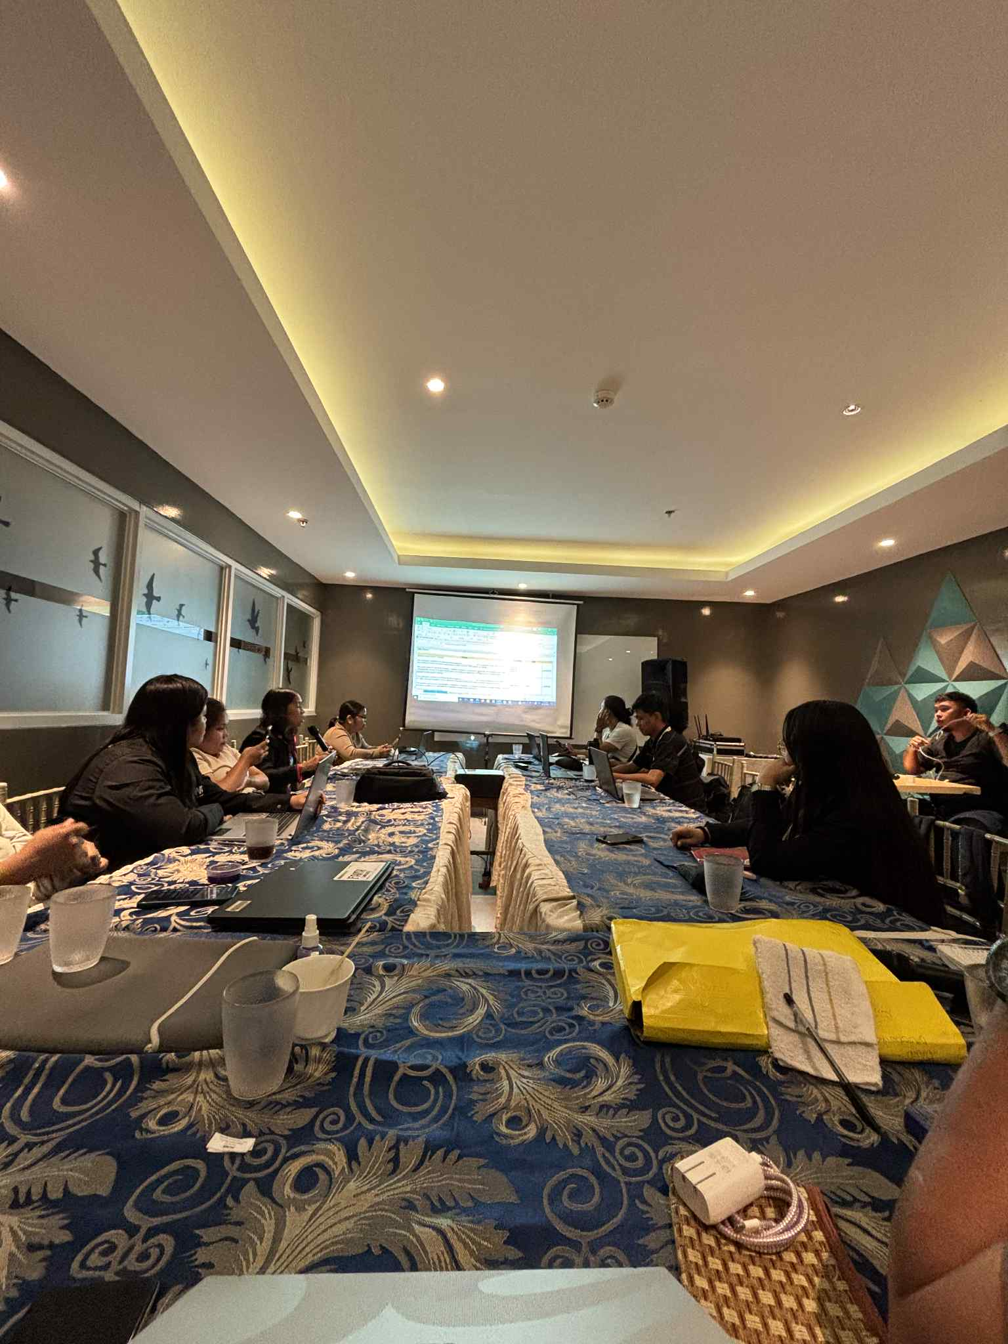
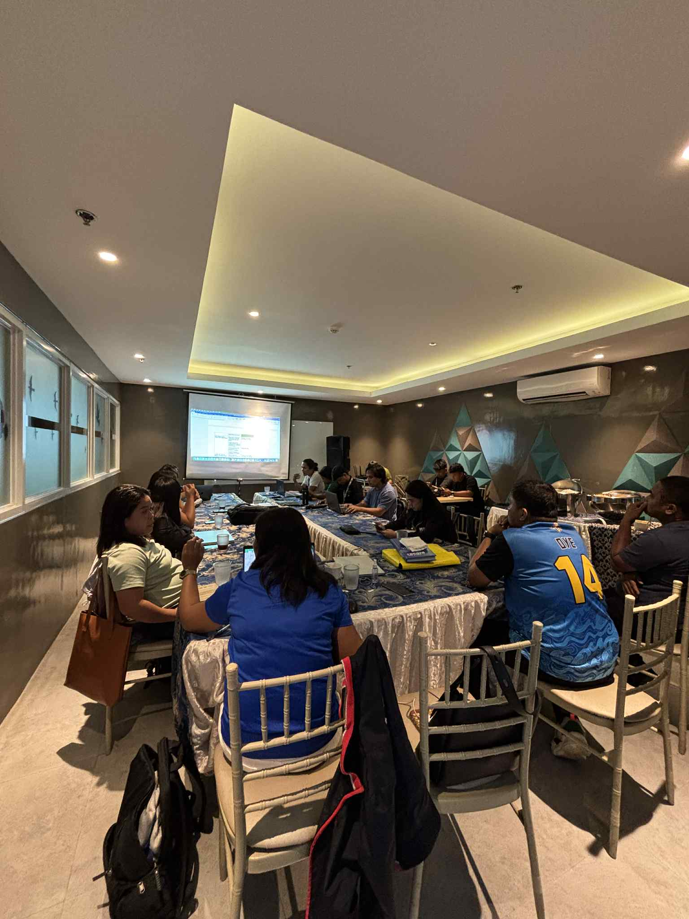
PHOTO DOCUMENTATION

