MINUTES OF MEETING

DRMD RISES: RRP-CFTW 4th BI-MONTHLY STAFF MEETING
August 22, 2025
Watergate Hotel, Butuan City

- Attendance

NAME | POSITION | OFFICE
Aldie Mae A. Andoy | OIC-Chief, DRMD | DRMD
Alica T. Marquiso | DRRS Head/ RRP Program Focal | DRMD
Rutchel R. Molino | PDO-III/ MER Focal | DRMD
Engr. Oriel M. Jacobe | PDO-III/ Monitoring and Technical Support | DRMD
Faith N. Pingoy | PDO-II/ FO Provincial Focal for Surigao del Sur | DRMD
Sheba Mae G. Monte | PDO-II/ FO Provincial Focal for Surigao del Norte | DRMD
Karin Louise Q. Nietes | PDO-II/ FO Provincial Focal for Agusan del Norte | DRMD
Charina L. Genosolango | PDO-II/ FO Provincial Focal for Province of Dinagat Islands | DRMD
Leo Tristan S. Bagcat | PDO-II/ FO Provincial Focal for Agusan del Sur | DRMD
Felino E. Florida | PDO-I/ Alternate Provincial Focal for Province of Dinagat Islands | DRMD
Joseph Bien Conrad V. Calo | PDO-I/ Alternate Provincial Focal for Agusan del Sur | DRMD
Maria Diovelle P. Salvan | PDO-I/ Alternate Provincial Focal for Surigao del Sur | DRMD
Rachelle B. Pacot | PDO-I/ Alternate Provincial Focal for Surigao del Norte | DRMD
Gilbert D. Comandante | PDO-I/ Alternate Provincial Focal for Agusan del Norte | DRMD
John Mark Agustin A. Acido | PDO-I/ Budget Focal | DRMD
Shirra Mae C. Calit | Administrative Assistant III/ Administrative Support | DRMD
Andy G. Amporias | Administrative Aide IV/ Administrative Support | DRMD

- Call to Order

The meeting was called to order at 09:00 AM and was chaired by Ms. Alicia T. Marquiso, DRRS Head and Program Focal for Risk Resiliency Program through Cash for Training and Work (RRP-CFTW). The 16 staff members of the Risk Resiliency Program through Cash-for-Training and Work (RRP-CFTW) were in attendance.

Ms. Marquiso began by outlining the agenda for the meeting. She then invited participants to propose any additional items for discussion. With no further concerns raised, Ms. Marquiso proceeded with the following agenda items:

- Checkpointing/Revisioning of Contractor Commitment and Evaluation Form (CCEF) of the Project Development Officers
- Submission of RRP Narrative Accomplishment Report
- Status of Regional Disaster Risk Management Conference (RDRMC) Preparation (Tasking)
- Update on Preparation of Project Site Visit in Buenavista, ADN
- Conduct of Monitoring and Technical Assistance (MATA) Cum Learning Visit
- Update on Fund Utilization
- RRP Innovations
- Feedback on Learning Visit in Cagayan de Oro City last August 4-8, 2025
- Food for Work implementation for Project LAWA and BINHI
- Schedule of Activities for the month of September
- Other Matters
- Issues and Concerns
- Agreements Reached/Ways Forward

Highlights of Discussion

      - Revisiting of Contractor Commitment and Evaluation Form (CCEF)

Ms. Maquiso began the day by raising some concern regarding consistency of the Success indicators and means of verification (MOV) of the CCEF of the PDOs. She then emphasized the following:

- Feedback reports should be submitted within 5 working days from the activity
- Monitoring Tool/Site validation Tool are required for every after conduct of monitoring and site validation activities and shall serve as MOV.
- Photo documentation should be uploaded to the G-drive as soon as possible
- Number of revisions is counted upon return of non-compliance of initial input/comments of the reviewer
- All PDO II should countersign in the Work Accomplishment Report (WAR), below the name of Ms. Molino, the MER focal

2. RRP Narrative Report

Ms. Marquiso instructed PDOs to provide the LGUs with Technical assistance on drafting the narrative report. Then she requested the PDOs for the updates regarding the submission of Narrative Accomplishment Report by the LGUs. The PDOs then one-by-one gave the updates:

Ms. Nietes, PDO II/Provincial Focal for Agusan del Norte reported that all recipient LGUs of Project LAWA at BINHI have already submitted their report. LGUs Jabonga, Buenavista, and Tubay submitted on July 29, 2025, while LGUs Santiago and Las Nieves submitted on August 1, 2025 respectively.

Ms. Pinggoy, PDO II/Provincial Focal for Surigao del Sur then reported that LGU Hinatuan submitted their Narrative report on July 13, 2025 and the rest of the LGUs will be followed up

Ms. Monte, PDO II/Provincial Focal for Surigao del Norte, Mr. Bagcat, Provincial Focal for Agusan del Sur, and Ms. Genosolango, Provincial Focal for the Province of Dinagat Islands then gave their assurance to follow-up their respective LGUs regarding the submission of Narrative report

Ms. Marquiso finished by setting the deadline of the submission of the Narrative Report on September 12, 2025.

3. Status of RDRMC Preparations

Ms. Marquiso asked for the updates on the confirmation of the invited Local Chief Executives (LCEs) for the RDRMC. Ms. Nietes then responded that out of the 5 LGUs, only LGU Jabonga has no response on the invitation. She then requested the heads for intervention regarding this matter.
Ms. Marquiso then continued to discuss other preparations for the upcoming RDRMC and she then highlighted that Mr. Calo, PDO I/Alternative Focal for Agusan del Sur, together with the capbuild team will visit Watergate hotel regarding room assignments. The leighs for the attending LCEs should be color coded for easy identification. And lastly, diorama will be upgraded c/o Mr. Comendante, PDO I/Alternative Focal for Agusan del Norte.

4. Update on the Preparations of Project Site Visit in Buenavista, Agusan del Norte

Ms. Nietes discussed the preparations made by them together with the Barangay and Municipal LGUs for the project site visit. She then highlighted some of the following.

First, courtesy call by DSWD personnels will be done on the project site. Second, BLGU can only provide snacks for the visitors, and cannot accommodate them for Lunch. And lastly, since there are two (2) different project sites, Project LAWA site will be prioritized for the visit

After Ms. Nietes gave her update, Ms. Maquiso directed Ms. Nietes and Mr. Comendante to give short informational introduction about the projects implemented on the site.

5. MATA cum Learning Visit

Ms. Molino, PDO III/Monitoring, Evaluation and Reporting (MER) Focal, presented the proposed program flow and itinerary for the upcoming MATA cum Learning visit together with Disaster Response and Management Bureau (DRMB) Central Office and Field Office’s workforce. She emphasized that the visit will be done only in three provinces out of five, namely; Dinagaat Islands, Surigao del Sur, and Agusan del Sur to accommodate the availability of the participants from Central Office.

6. Fund Utilization updates

Mr. Acido, PDO I/Budget Focal Person of RRP-CFTW, presented the remaining program funds that need to be fully utilized within the year. During the presentation, he discussed that there are some funds that are earmarked under office supplies, other MOOEs, and rents – motor vehicle, and ICT Equipment. Ms. Marquiso then instructed him to clarify the items under earmarked funds under office supplies, other MOOEs, and rents; while the earmarked fund under ICT will be returned back to Obligation Status OBS).

7. RRP Innovations

Ms. Marquiso opened the discussion by encouraging Mr. Bagcat and Mr. Acido to comply the necessary documents to showcase the innovations made for Masterlist of Eligible Beneficiaries Information System (MEBIS) and KliMalasakit Online Document Updating System (KODUS). She then instructed both of them to ask Mr. Arvin Edubas, DRIMS Section Head, for the copy of Knowledge Management (KM). She also instructed Mr. Bagcat to enhance the MEBIS based on the additional data needed to be present in the system like the disaggregation of informal sectors. Both Mr. Bagcat and Mr. Acido is also instructed to prioritize the concept papers of their innovations, and submit the concept papers to Ms. Molino. Ms. Marquiso then instructed Ms. Molino to review and furnish the submitted concept papers. Lastly, Ms. Marquiso finished the discussion by setting the deadline of the concept paper to September 30, 2025.

8. Feedback of Learning Visit in Cagayan de Oro City last August 4-8, 2025

Due to shortage of time, the PDOs didn’t had the time to share their personal insights during the Learning Visit done in FO XO. Thus, Ms. Marquiso instructed all the PDOs to make feedback report to be submitted on August 30, 2025

9. Food for Work (FFW) for Project LAWA and BINHI

To start the discussion on FFW, Ms. Marquiso presented the LGUs that will be having Food for Work, and the source of Family Food Packs to be distributed, that will be expiring in the month of November and December.
- LGU Basilisa (Libjo Warehouse)
- LGU Bayabas (Tandag Warehouse)
- LGU Talacogon (Prepositioned at their LGU)
- LGU Cagdianao (Prepositioned at their LGU)
- LGU Dinagat (Prepositioned at their LGU)
- LGU Libjo (Prepositioned at their LGU)
- LGU Taganaan (Prepositioned at their LGU)
- LGU Hinatuan (Prepositioned at their LGU)
- LGU Lingig (Prepositioned at their LGU)
- LGU Madrid (Prepositioned at their LGU)
After Ms. Marquiso presented the said LGUs, she then instructed the concerned PDOs together with the assigned DRRS Social Workers to follow-up the proposals, having the deadline of August 30, 2025.
- Other Matters
For the last agendum, Ms. Marquiso reminded the RRP workforce to continue the compliance of the SIBYA initiative. She then clarified some of the changes on the said initiative based on their latest meeting with the Division Chief. First, screenshots of facebook engagements are no longer required, and she lastly encouraged workforce to engage more on the Division Facebook page (AAA)
After the discussion of SIBYA, Ms. Marquiso then asked the pax for additional concerns that needed to be raised. Mr. Calo and Mr. Bagcat then reminded Ms. Maqruiso on the provision of tables and chairs for them to use in the DRMD Warehouse office in San Francisco, Agusan del Sur. She then replied that she will continue to look for available tables and chairs that will be provided to them

- Action Points and Deliverables

Area of Concern | Agreements/Targets/ Deliverables | Responsible Person | Timeframe
- Feedback Report | PDOs to submit the said report within 5 working days from the last activity implemented within the week; attachment of photos from attended activities are required. | Field-Based PDOs | September 2025 and onwards
- Number of Revisions of submitted Reports | Number of revisions is counted upon return of non-compliance of initial input/comments of the reviewer | RRP-CFTW workforce | September 2025 and onwards
- Use of Site Validation tool/monitoring tool | * Use of Site Validation tool and Monitoring Tool are required with photo documentation to be uploaded in the provided G-drive  * Feedback reports on attended activity will be no longer required given that monitoring/site validation tool captured all required/needed information | RRP-CFTW workforce | September 2025 and onwards
- Submission of Post-implementation documents | * All PDO II should countersign in the WAR, below the name of Ms. Molino  * Payout documents shall be prioritized 10 days after the implementation  * other non-payout documents shall be submitted during liquidation | Field-Based PDOs | September 2025 and onwards
- Submission of Narrative Report | Deadline extended until September 12, 2025 | Field-Based PDOs | On/before September 12, 2025
- Submission of Concept paper of MEBIS and KODUS | * Drafting of Concept Paper c/o Mr. Bagcat and Mr. Acido  * Polishing of Concept Paper c/o Ms. Moino | Mr. Bagcat, Mr. Acido  Ms. Molino | On/before August 30, 2025
- Food for Work | * Project LAWA at BINHI should be prioritized  * LGUs to submit Project Proposal | Field-Based PDOs | August 30, 2025
- Workshop template for RDRMC | Ms. Molino to furnish copy to PDOs within the day thru G-drive | Ms. Molino | August, 22, 2025
- Submission of Feedback report re: Learning Visit at FO X | Submit feedback report re: Learning Visit held at FO X | RRP-CFTW workforce | August 30, 2025
- Crafting of RSO for August 25, 2025 | Make RSO for all RRP Workforce to render overtime on August 25, 2025 for the preparation of RDRMC 2025 | Ms. Calit | Before August 25, 2025

- Adjournment

Having no other matters for discussion, the meeting was adjourned at 5:00 PM.

Prepared by: |  | Recommending Approval:
JOSEPH BIEN CONRAD V. CALO  PDO-I |  | ALICIA T. MARQUISO  DRRS Head
Approved by:

MARI-FLOR A. DOLLAGA-LIBANG
Regional Director

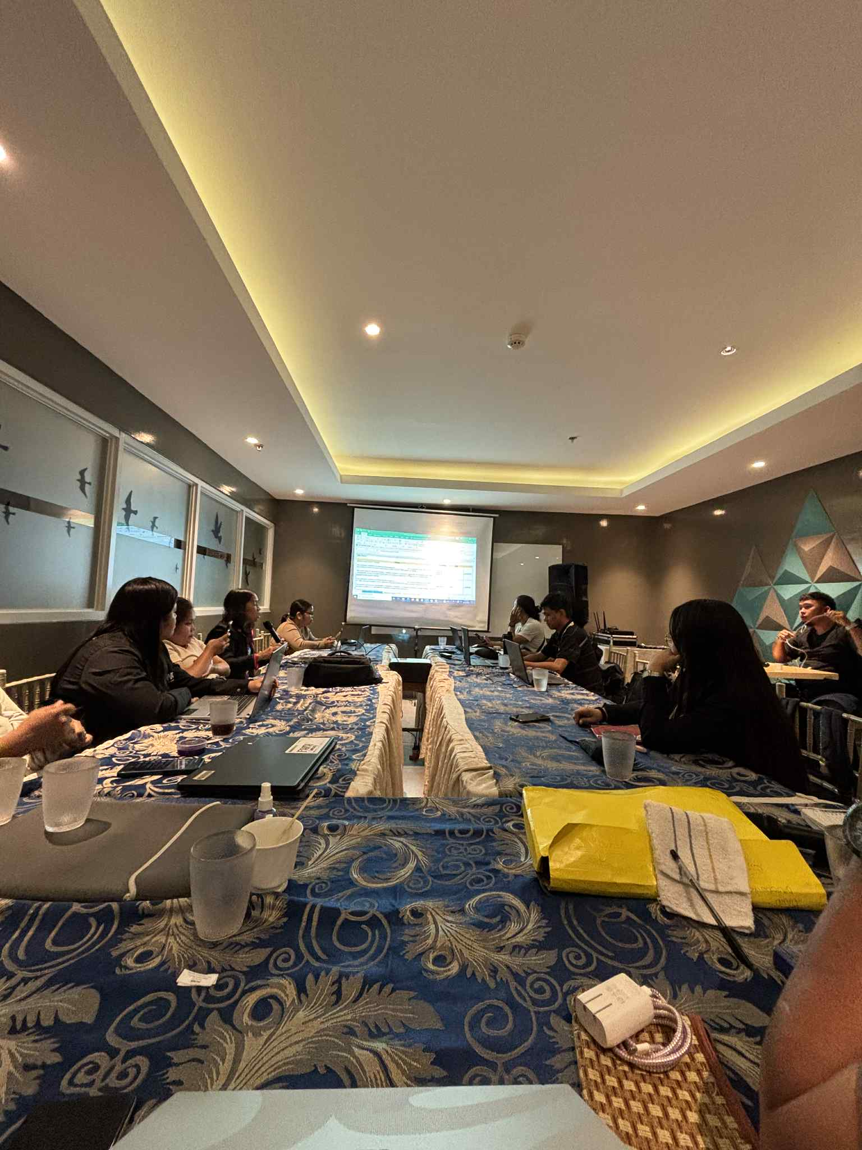
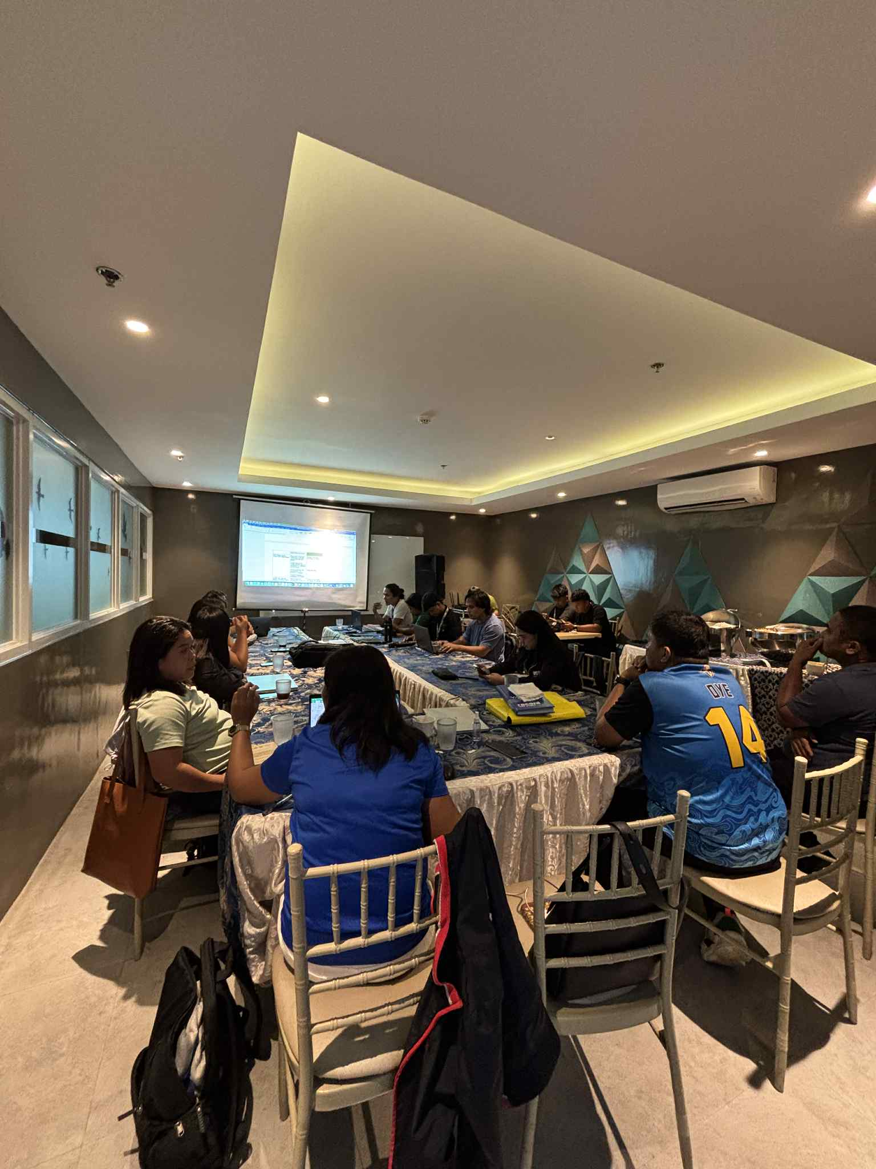
PHOTO DOCUMENTATION

