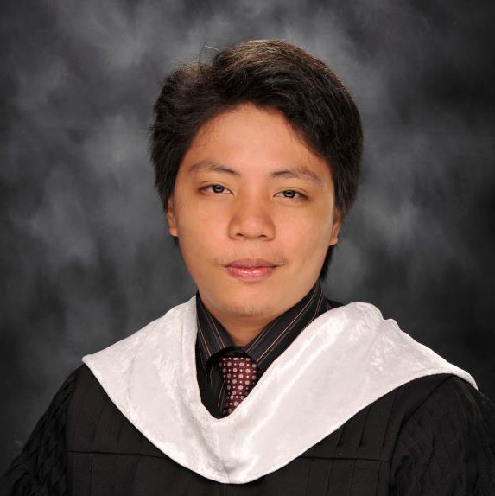Blk 8 lot 16 Westwood 5, Pasong Camachile 1 Lancaster

GENERAL TRIAS CITY, CAVITE

(+63) 9078860887 (smart) / (+63) 9166834631

**Email**: magsajo.joseph@gmail.com

**Site**: [https://jmagsajo.github.io/](https://jmagsajo.github.io/#/)

Joseph G. MagsajoA long, thin rectangle to divide sections of the document

# SKILLS

HTML5, PHP, laravel/Lumen 5.* and up, Yii 1.*, CakePHP 2/3, Codeigniter 2/3, Javascript, JQuery, VueJS, AngularJS 1, Reactjs, CSS3, Bootstrap 2/3/4, LAMP, XAMPP, WAMP, Docker, Git, ASP.NET, AWS, Nodejs, Wordpress

# EXPERIENCE

## Vinta Tech, Alabang *— Sr. Software Developer*

Jan. 18, 2023 – PRESENT

**Mella Hotel**

* Made the Hotel Site using wordpress, CSS and Jquery

**GRB – CRM and LMS**

* Maintaining/Modifying App Using Laravel, CSS and jquery

## Sweet Onion Media Group, Omaha, NE *— Sr. Software Developer*

March. 29, 2022 – Jan. 13, 2023

**VPP (Vision Plus Pro) and KMK Optometry LMS/KMK Careers**

* Maintaining/Modifying App Using CI3, CSS and jquery

## Yondu Inc, 7th Floor Panorama Building, BGC *— Sr. Software Engr*

Nov. 5, 2018 – June 3, 2022

**GMovies (gmovies.ph) /Upstream ph**

* Maintaining/Modifying Legacy Website and API (REST) using Laravel/lumen, CSS, VueJS, Jquery and Socket.io
* Revamp using lumen (microservices), MongoDB, Node (express and socket.io) and react/redux on the front-end

**Sureseats (sureseats.com)**

* Maintaining/Modifying Website and API (REST) using Laravel, CSS, VueJS, Jquery

**GCash Proxy Server**

* Implementing GCash payment API exclusive for Gmovies and Sureseats App.

**Ayala zing App**

* Back-end Dev using Laravel
* aws url masking

## Cloudstaff Phil Inc, MacArthur Highway,

## Angeles Pampanga *— Sr. Software Engr*

June 5, 2017 - Nov. 2, 2018

**Mystaff project (Staff monitoring system - Internal Project)**

* Maintaining Existing System using cakePHP, CSS, and Jquery
* Responsible for bug fixing mostly in frontend

**Workpattern Project (HR ticketing system - Internal Project)**

* Maintaining Existing System using Codeigniter, CSS, Jquery, bootstrap, materialize css and nodejs (socket.io).
* Revamp using .net and reactjs

**Capital Research International (Sales Tracker - Client June 5, 2017 – August 5, 2017)**

* Maintaining Existing System using Laravel, CSS, Jquery, Vuejs
* Integrating Twilio API for texting the customers

## Yondu Inc, 7th Floor Panorama Building, BGC *— Software Engr*

Sept. 5, 2016 - June 2, 2017

**GMovies**

* Maintaining/Modifying Website and API (REST) using Laravel, CSS, AngularJS, Jquery

## Info Alchemy, AIC Burgundy Empire Tower

## 16F Unit 607 ADB Ave, Ortigas Center Pasig City *— Web App Dev*

March 5, 2014 - Sept 2, 2016

**iHotel**

* Created using Yii Framework, CSS3, HTML5, JQuery, Bootstrap and NodeJs
* Real time notification using nodeJS Socket.io
* Responsive Web Design using Bootstrap

**iWMS (Warehouse Management System)**

* Created using ASP.NET MVC 5, CSS3, HTML5, JQuery and Bootstrap
* Real time notification using SignalR Plugin (Web Socket)
* Responsive Web Design using Bootstrap

## LiFEDATA Systems Inc, 17F Strata 100 Emerald Ave,

## Pasig City *— PHP Developer*

July 15, 2013 - March 4, 2014

**IMD**

* Maintaining the existing project including Functionality Enhancement and Bug fixing

**RMP (PORTAL REGISTRATION)**

* Registration page for the client of the IMD.
* Created using PHP5, JQuery, Bootstrap

**GLAM**

* Approving the request registration of Doctor from Portal Registration.
* Maintaining the existing project including Functionality Enhancement and Bug fixing

## Information Capital Technology Ventures INC, 2244 Espana Ave.

## Sampaloc, Manila *— PHP Developer*

April 26, 2012 - June 14, 2013

**Somocrm**

* modifying the functionality of Vtiger CRM (customer relationship management)

**ICTV Website**

* maintaining and modifying the functionality of ICTV Website using ASP.NET

# Personal Background

**Birth date**: March 3, 1991

**Civil status**: Single

**Citizenship**: Filipino

# EDUCATION

## Jose Rizal University *— BSIT*

2007 - 2012, Mandaluyong City, Philippines

## Sagad High School *— High School*

2003 - 2007, Brgy. Sagad, Pasig City, Philippines

## Palatiw Elementary School *— Elementary*

1996 - 2003, Brgy. Palatiw, Pasig City, Philippines

# References

**Josh Torio**

Project Manager (Yondu Inc)

0917 564 6109

**John Oscar Cruz**

Project Manager (Yondu Inc)

0917 871 1792