**Checkpoint Objective**

* Create a database called "contact".
* Create a collection called "contactlist"

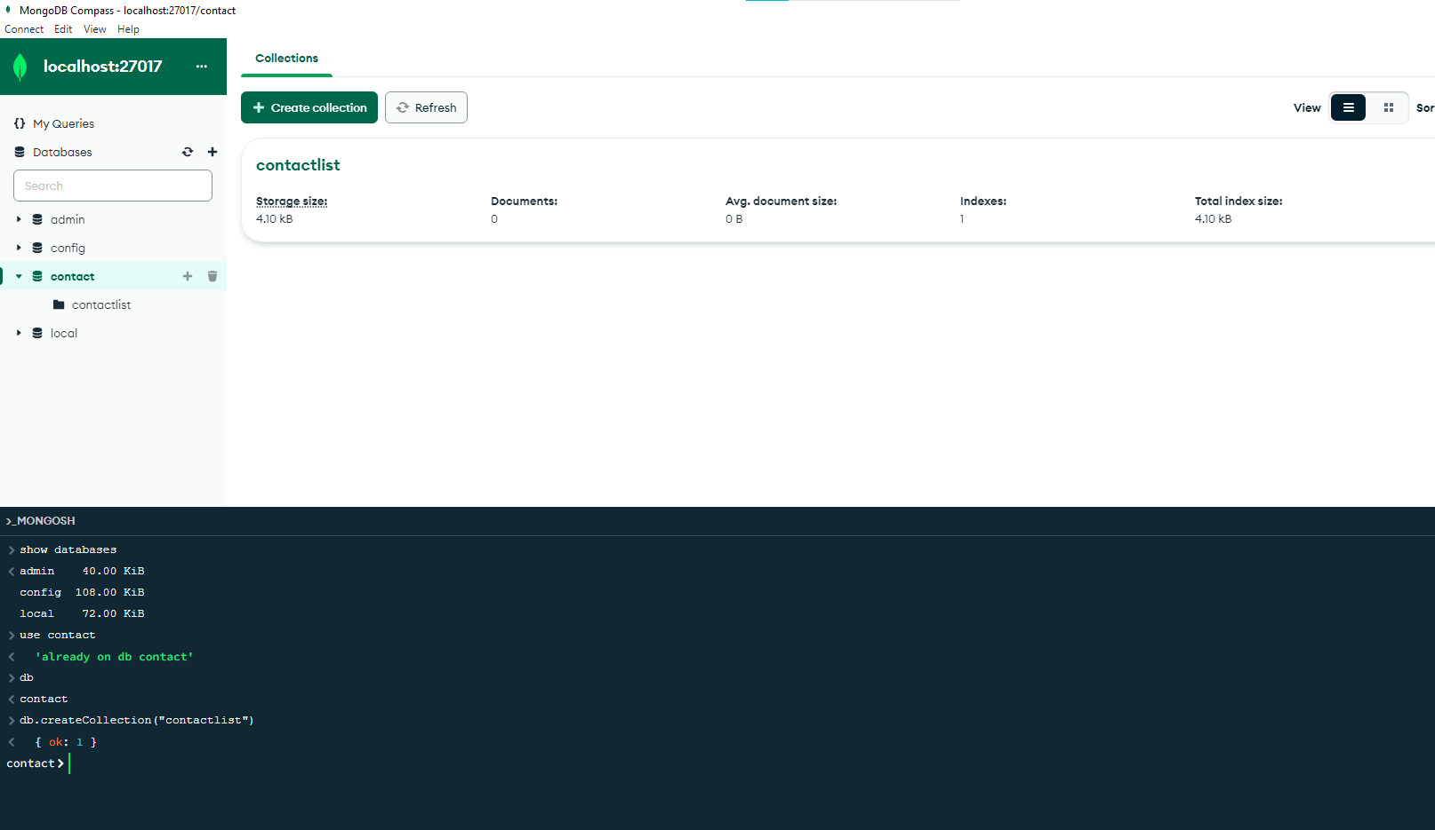

* Insert these documents  in "contactlist" :

Last name: Ben Lahmer, First name: Fares, Email: fares@gmail.com, age:26

Last name: Kefi, First name: Seif, Email: kefi@gmail.com, age:15

Last name: Fatnassi, First name: Sarra, Email: sarra.f@gmail.com, age:40

Last name: Ben Yahia, First name: Rym, age:4

Last name: Cherif, First name: Sami, age:3

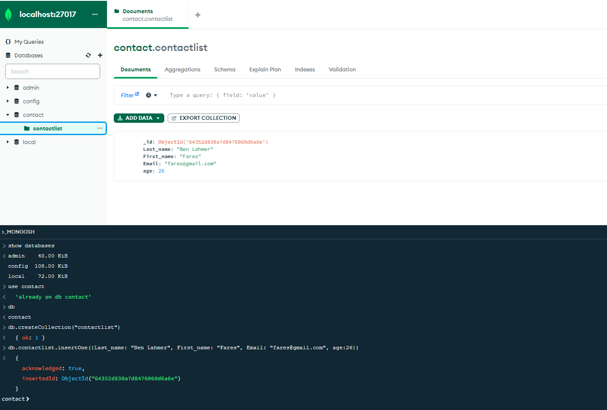

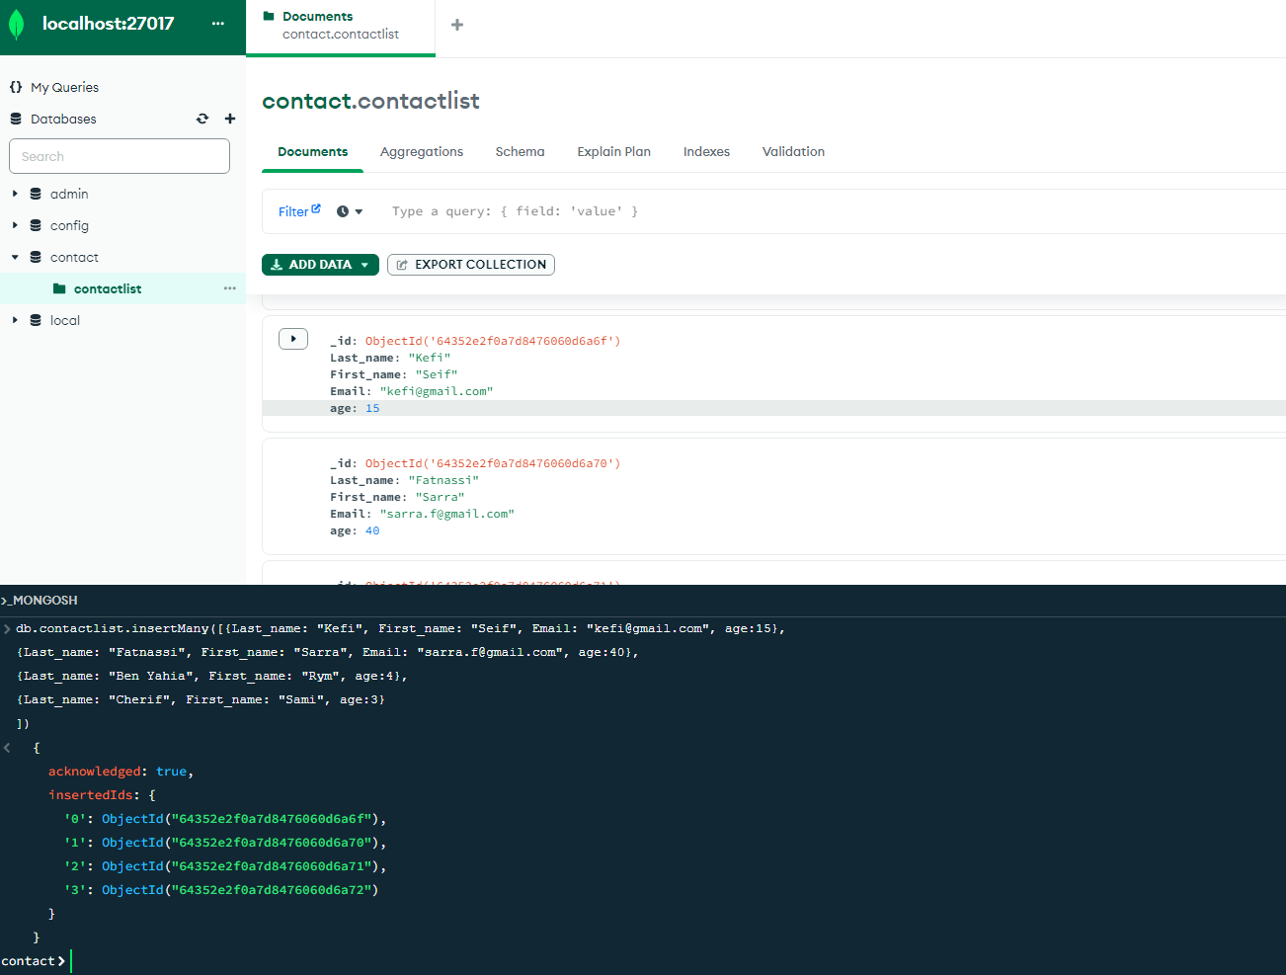

**Instructions**

* Display all of the contacts list.
  + Display all the information about only one person using his ID.
  + Display all the contacts with an age >18.
  + Display all the contacts with an age>18 and name containing "ah".
  + Change the contact's first name from"Kefi Seif" to "Kefi Anis".
  + Delete the contacts that are aged under <5.
  + Display all of the contacts list.

