Recursion

* + Based on my understanding. Recursion uses itself to complete a certain algorithm. Recursion is solving a problem with a function that calls itself. A good example of this are the code below.

Recursion - Triangular Number

A **triangular number** or **triangle number** counts the objects that can form an equilateral triangle.

Equilateral triangle means a triangle in which all three sides are equal

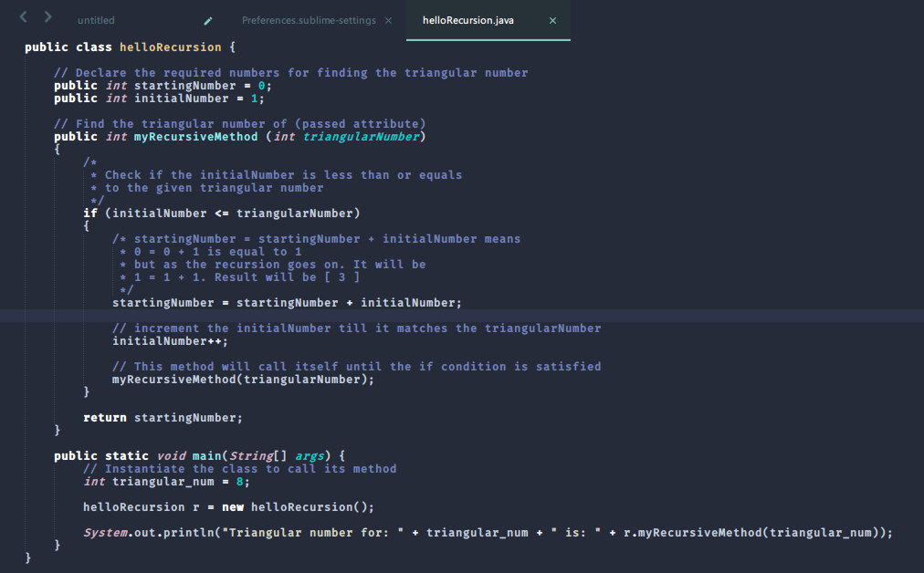

Output:



Recursion – Factorial Number

The product of all of the positive integers from 1 to a given positive integer. It is written as the given integer followed by an exclamationpoint. For example, the factorial of 4 (written 4!) is 1 × 2 × 3 × 4, or 24.

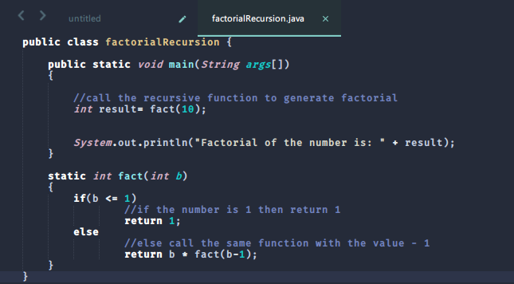

Output:



Recursion – Tower of Hanoi

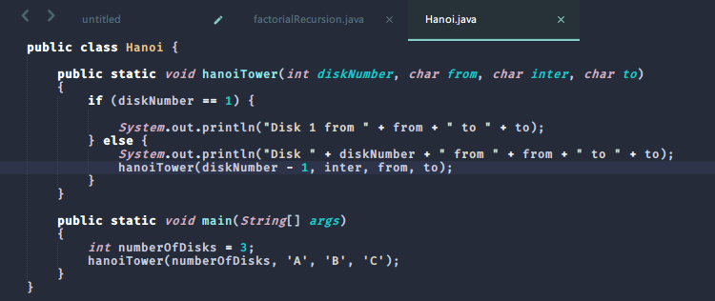

Output:



Recursion – Binary Search

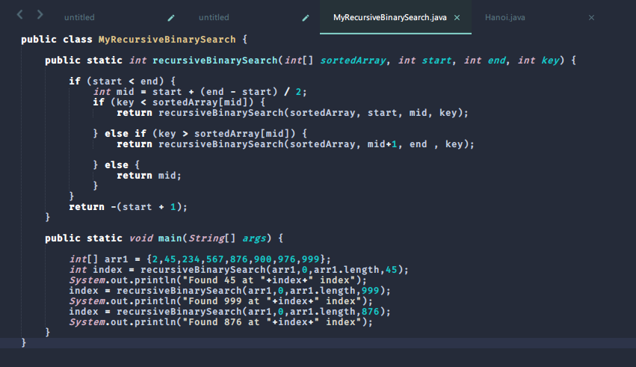

Output:

