8.25. Model: Model the ball as a particle which is in a vertical circular motion.
Visualize:

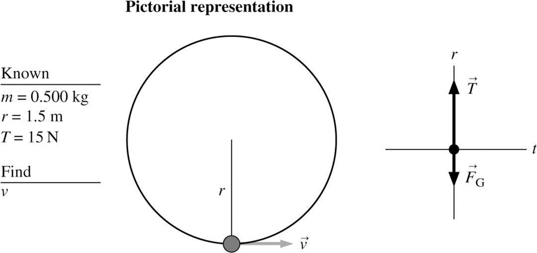
Solve: At the bottom of the circle,

8.26. Model: The ball is a particle on a massless rope in circular motion about the point where the rope is attached to the ceiling.
Visualize:

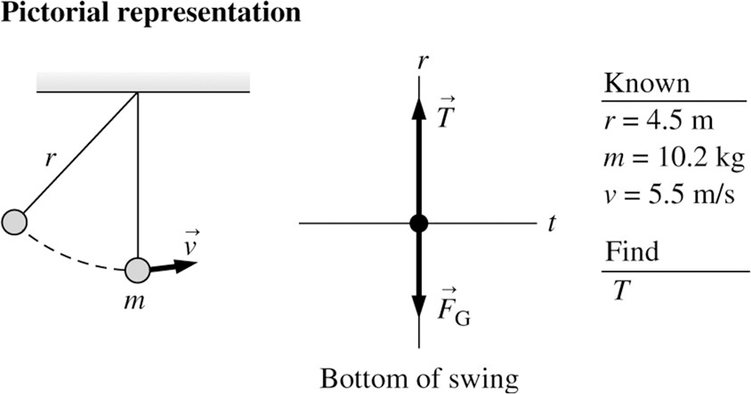

Solve: Newton’s second law in the radial direction is

Solving for the tension in the rope and evaluating,

Review: The tension in the rope is greater than the gravitational force on the ball in order to keep the ball moving in a circle.

8.49. Model: Assume uniform circular motion.
Visualize: We expect the centripetal acceleration to be very large because is large. This will produce a significant force even though the mass difference of 10 mg is so small.
A preliminary calculation will convert the mass difference to kg: If the two samples are equally balanced then the shaft doesn’t feel a net force in the horizontal plane. However, the mass difference of 10 mg is what causes the force.
We’ll do another preliminary calculation to convert

Solve: The centripetal acceleration is given by Equation 6.9 and the net force by Newton’s second law.

Review: As we expected, the centripetal acceleration is large. The force is not huge (because of the small mass difference) but still enough to worry about. The net force scales with this mass difference, so if the mistake were bigger it could be enough to shear off the shaft.

8.61. Model: Model the car as a particle on a circular track.
Visualize:

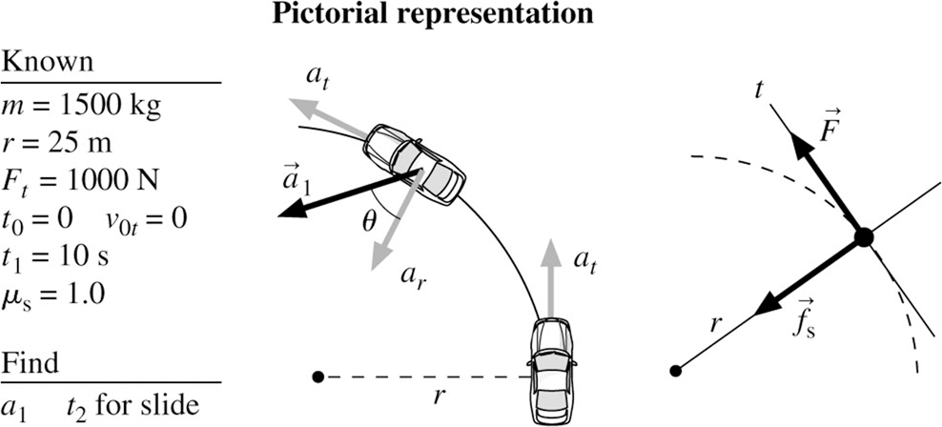

Solve: (a) Newton’s second law along the t-axis is

With this tangential acceleration, the car’s tangential velocity after 10 s will be

The radial acceleration at this instant is

The car’s acceleration at 10 s has magnitude

where the angle is measured from the r-axis.
12.20. Model: The pulley acts as if all of its mass were concentrated at its center of mass.
Visualize: There are three torques: two clockwise and one counterclockwise. All of the forces that produce torques act straight down.

Solve:

Review: The answer is negative because the clockwise torques are greater than the counterclockwise torques.

12.26. Model: Two balls connected by a rigid, massless rod are a rigid body rotating about an axis through the center of mass. Assume that the size of the balls is small compared to 1 m.
Visualize:

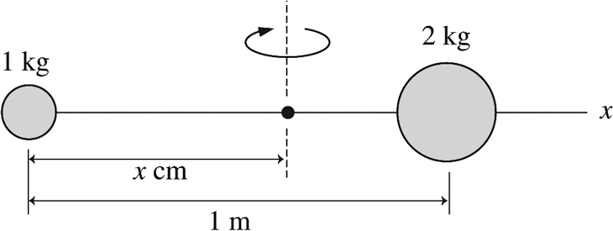

We placed the origin of the coordinate system on the 1.0 kg ball.
Solve: The center of mass and the moment of inertia are

We have and so becomes

Having found I and we can now find the torque τ that will bring the balls to a halt in 5.0 s:

The magnitude of the torque is 0.28 N m, applied in the counterclockwise direction.

12.29. Model: The object is in equilibrium, so
Visualize: There are three torques:
Solve:

Take the torques around the left end.

Plug back into the force equation to get
Review: This can be checked by taking torques around another convenient axis.

We have and so becomes

Having found I and we can now find the torque τ that will bring the balls to a halt in 5.0 s:

The magnitude of the torque is 0.28 N m, applied in the counterclockwise direction.

12.58. Model: Assume the woman is in equilibrium, so and
Visualize: Choose the axis to be the left end of the board.

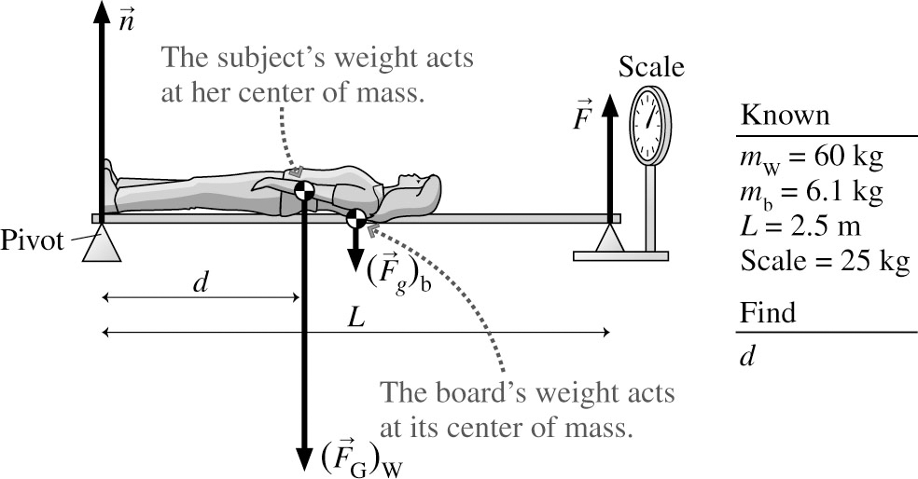
Solve: Use

Review: This is a little more than halfway up the body of a woman of average height.

12.67. Model: Assume there are no other forces or torques other than the brake pad.
Visualize: The friction force is tangent to the shaft. The initial angular momentum is

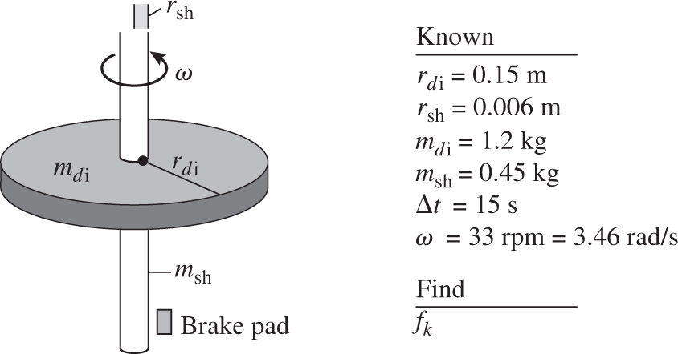

Solve:

Review: This is not a large force, but it took 15 s to slow down the disk, so it is reasonable.

