11.4. Model: The particle is subjected to an impulsive force.
Solve: The impulse is the area under the force-time curve. From 0 to 2 ms the impulse is zero, as with the interval between 8 ms and 12 ms. The only non-zero contribution to the impulse is between 2 ms and 8 ms.
From 2 to 8 ms the impulse is

This is the entire impulse.

11.12. Model: Model the ball as a particle, and its interaction with the wall as a collision in the impulse approximation.
Visualize: Please refer to Figure EX11.12.
Solve: Using the equations
and area under force curve

Review: The ball’s final velocity is positive, indicating it has turned around.
11.19. Model: Because of external friction and drag forces, the car and the blob of sticky clay are not exactly an isolated system. But during the collision, friction and drag are not going to be significant. The momentum of the system will be conserved in the collision, within the impulse approximation.
Visualize:

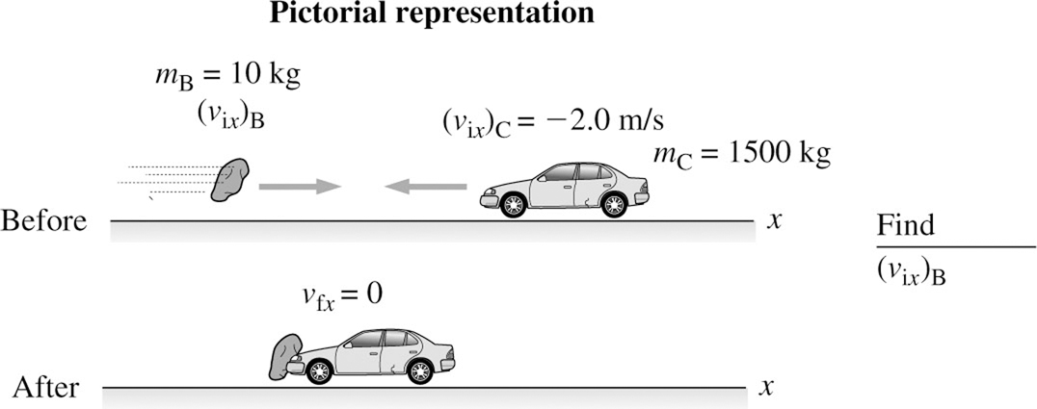
Solve: The conservation of momentum equation gives

Review: This speed of the blob is around 600 mph, which is very large. However, a very large speed is expected in order to stop a car with only 10 kg of clay.

11.28. Model: We will define our system to be Dan + skateboard, and their interaction as an explosion. While friction is present between the skateboard and the ground, it is negligible in the impulse approximation.
Visualize:

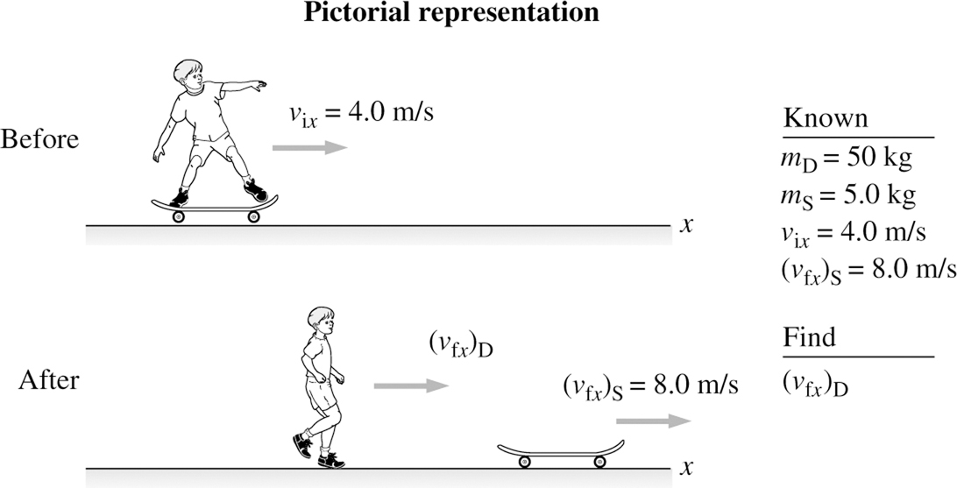

The system has nonzero initial momentum As Dan (D) jumps backward off the gliding skateboard (S), the skateboard will move forward so that the final total momentum of the system is equal to
Solve: We have Thus,

11.41. Model: Model the ball as a particle that is subjected to an impulse when it is in contact with the floor. We shall also use constant-acceleration kinematic equations. During the collision, ignore any forces other than the interaction between the floor and the ball in the impulse approximation.
Visualize:

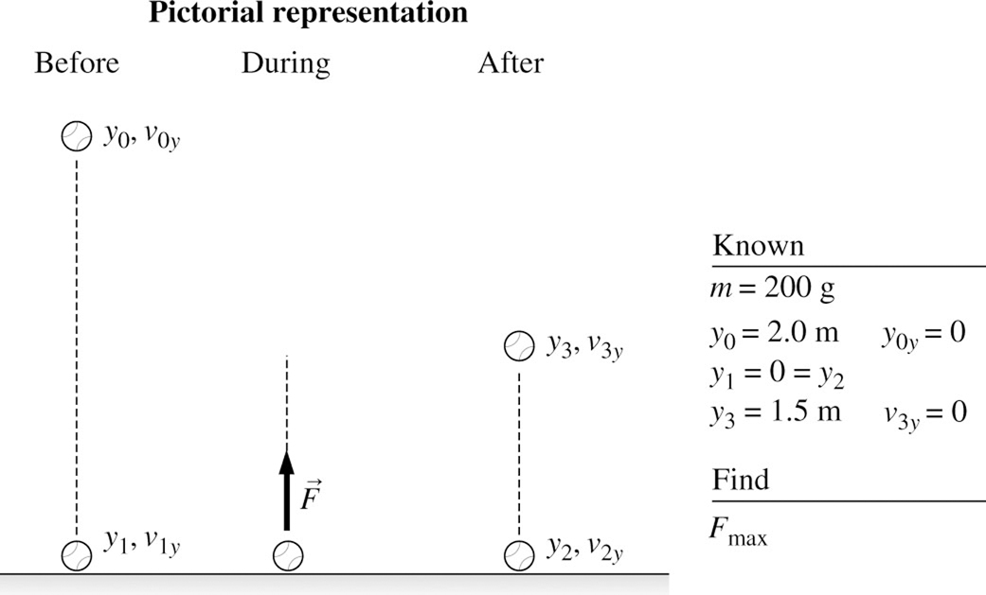

Solve: To find the ball’s velocity just before and after it hits the floor:

The force exerted by the floor on the ball can be found from the momentum principle:

Review: A maximum force of exerted by the floor is reasonable. This force is the same order of magnitude as the force of the racket on the tennis ball in the Problem 11.38.
Review: Launching from earth achieves a significantly lower final speed than doing so in deep space.

