12.37. Solve: (a) The magnitude of is The direction of is given by the right-hand rule. To curl our fingers from to we have to point our thumb into the page. Thus,
(b)
12.45. Model: Model the turntable as a rigid disk rotating on frictionless bearings. As the blocks fall from above and stick on the turntable, the turntable slows down due to increased rotational inertia of the (turntable + blocks) system. Any torques between the turntable and the blocks are internal to the system, so angular momentum of the system is conserved.
Visualize: The initial moment of inertia is and the final moment of inertia is
Solve: The initial moment of inertia is and the final moment of inertia is

Let and be the initial and final angular velocities. Then

12.78. Model: For the system, the angular momentum is conserved in the collision.
Visualize:

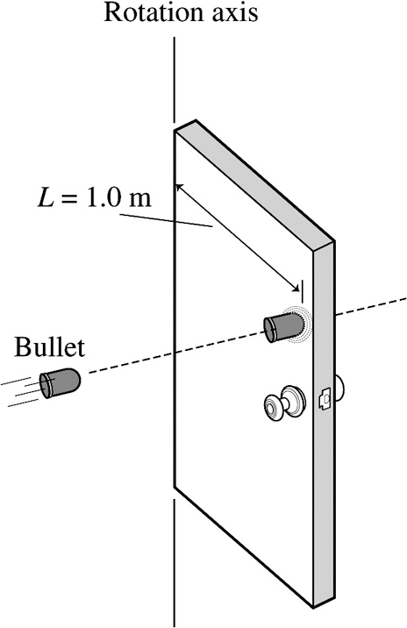

Solve: As the bullet hits the door, its velocity is perpendicular to Thus the initial angular momentum about the rotation axis, with is

After the collision, with the bullet in the door, the moment of inertia about the hinges is

Therefore, Using the angular momentum conservation equation and thus

