9.16. Model: Model the bug as a particle whose increase in speed is due entirely to the wind.
Visualize: We are given
Solve: (a)

(b) Recall that

Review: This seems like a good speed for a bug.

9.19. Model: Model the piano as a particle and use where W is the work done by the force through the displacement
Visualize:

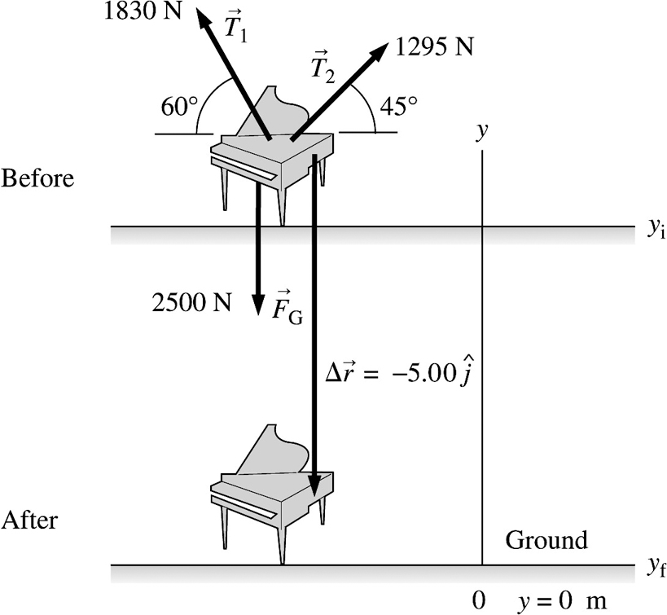

Solve: For the force

For the tension

For the tension

Review: Note that the displacement in all the above cases is directed downward along

9.30. Model: Assume the box is a particle.

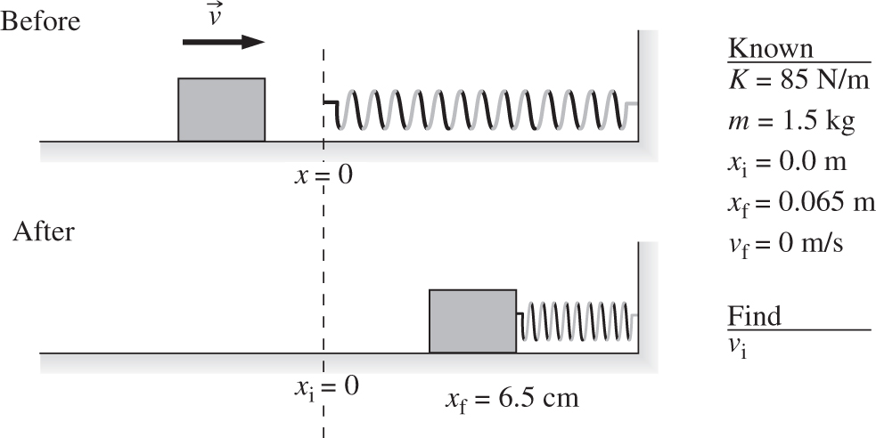
Visualize: Use the energy principle. The work comes from integrating a variable force.
Solve:

Cancel 1/2 and a negative and solve for v_{i}.

Review: This seems like a reasonable speed.

9.35. Model: Use the particle model, the definition of work and the model of kinetic friction.
Visualize: We place the coordinate frame on the incline so that its x-axis is along the incline.

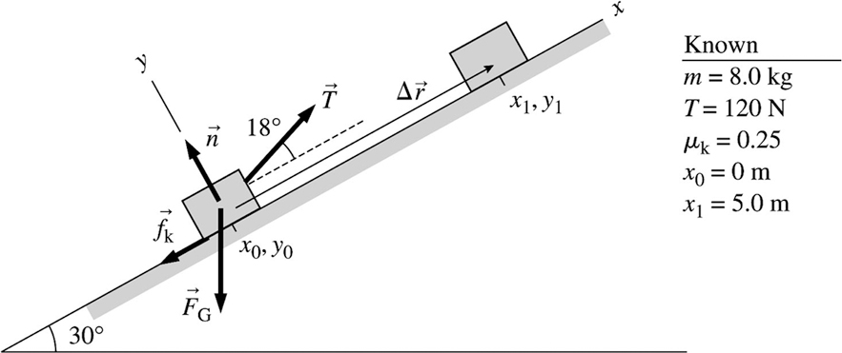

Solve: (a)

(b) The amount of energy transformed into thermal energy is
To find n, we write Newton’s second law as follows:

Thus,
Review: Any force that acts perpendicular to the displacement does no work.

10.6. Model: Model the skateboarder as a particle. Assuming that the track offers no rolling friction, the sum of the skateboarder’s kinetic and gravitational potential energy does not change during his rolling motion.
Visualize:

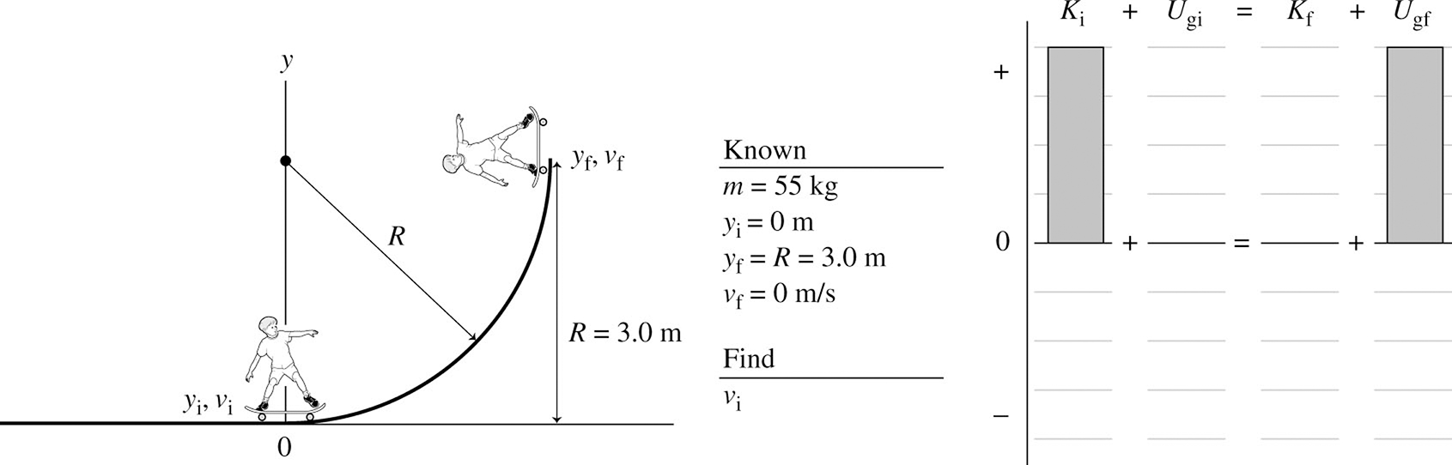

The vertical displacement of the skateboarder is equal to the radius of the track.
Solve: The quantity is the same at the upper edge of the quarter-pipe track as it was at the bottom. The energy conservation equation is

Review: Note that we did not need to know the skateboarder’s mass, as is the case with free-fall motion.

10.16. Model: Assume an ideal spring that obeys Hooke’s law. There is no friction, so the mechanical energy is conserved. Also model the book as a particle.
Visualize:

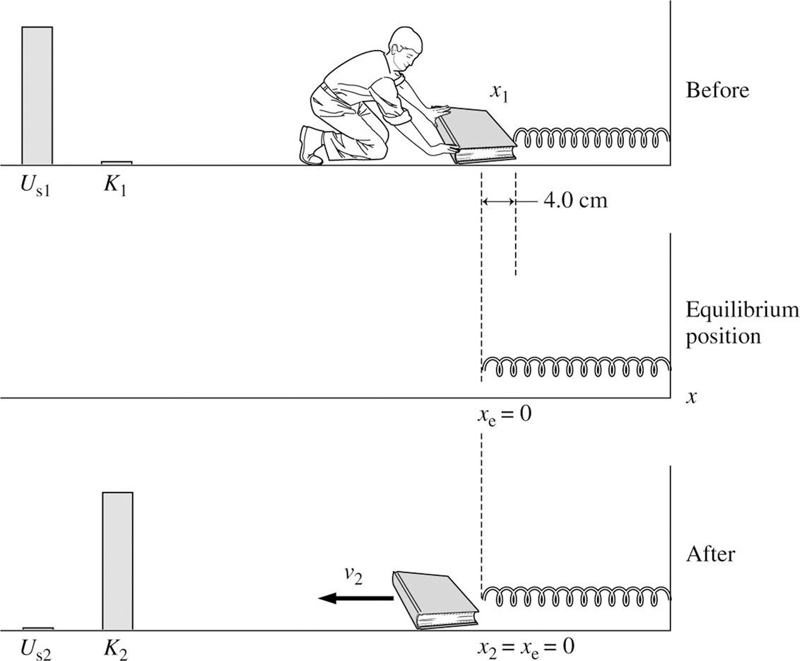

The figure shows a before-and-after pictorial representation. The compressed spring will push on the book until the spring has returned to its equilibrium length. We put the origin of our coordinate system at the equilibrium position of the free end of the spring. The energy bar chart shows that the potential energy of the compressed spring is entirely transformed into the kinetic energy of the book.
Solve: The conservation of energy equation is

Using and this simplifies to

Review: This problem cannot be solved using constant-acceleration kinematic equations. The acceleration is not a constant in this problem, since the spring force, given as is directly proportional to or

10.44. Model: This is a two-part problem. In the first part, we will find the critical velocity for the block to go over the top of the loop without falling off. Since there is no friction, the sum of the kinetic and gravitational potential energy is conserved during the block’s motion. We will use this conservation equation in the second part to find the minimum height the block must start from to make it around the loop.
Visualize:

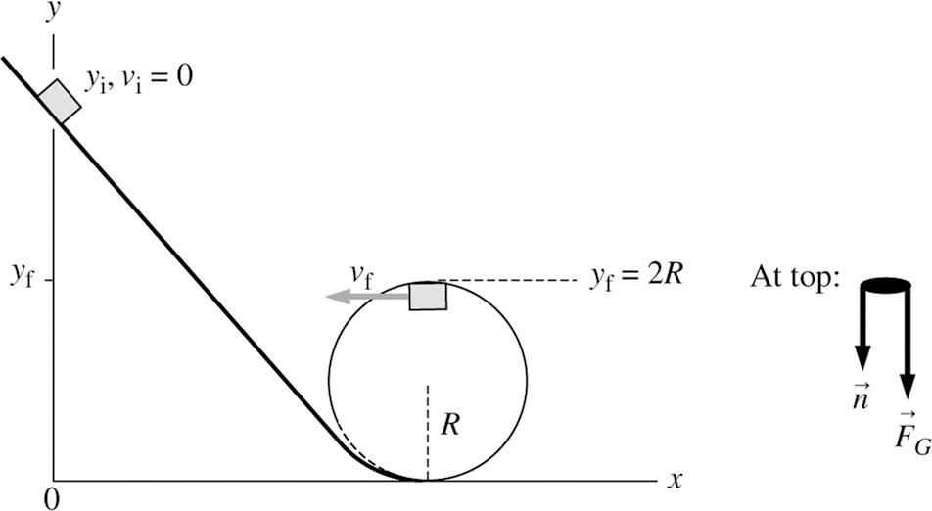

We place the origin of our coordinate system directly below the block’s starting position on the frictionless track.
Solve: The free-body diagram on the block implies

For the block to just stay on track, Thus the critical velocity is

The block needs kinetic energy to go over the top of the loop. We can now use the conservation of mechanical energy equation to find the minimum height h.

Using and we obtain

10.48. Model: Assume an ideal spring that obeys Hooke’s law. Model the box as a particle and use the model of kinetic friction.
Visualize:

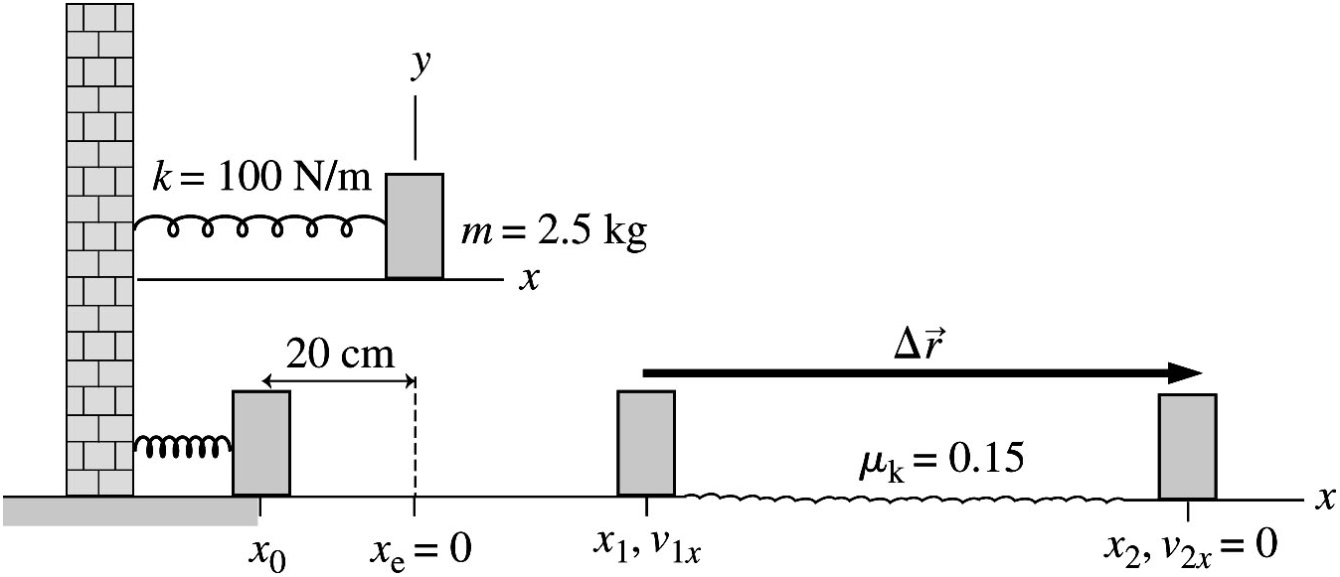

Solve: When the horizontal surface is frictionless, conservation of energy means

That is, the box is launched with 2.0 J of kinetic energy. 2.0 J of kinetic energy will be converted to thermal energy as it crosses the rough surface. The net force on the box is The energy principle is

Review: Because the force of friction transforms kinetic energy into thermal energy, energy is transferred out of the box into the environment. In response, the box slows down and comes to rest.

10.71. Model: Assume an ideal spring that obeys Hooke’s law. The mechanical energy is conserved during the launch of the ball.
Visualize:
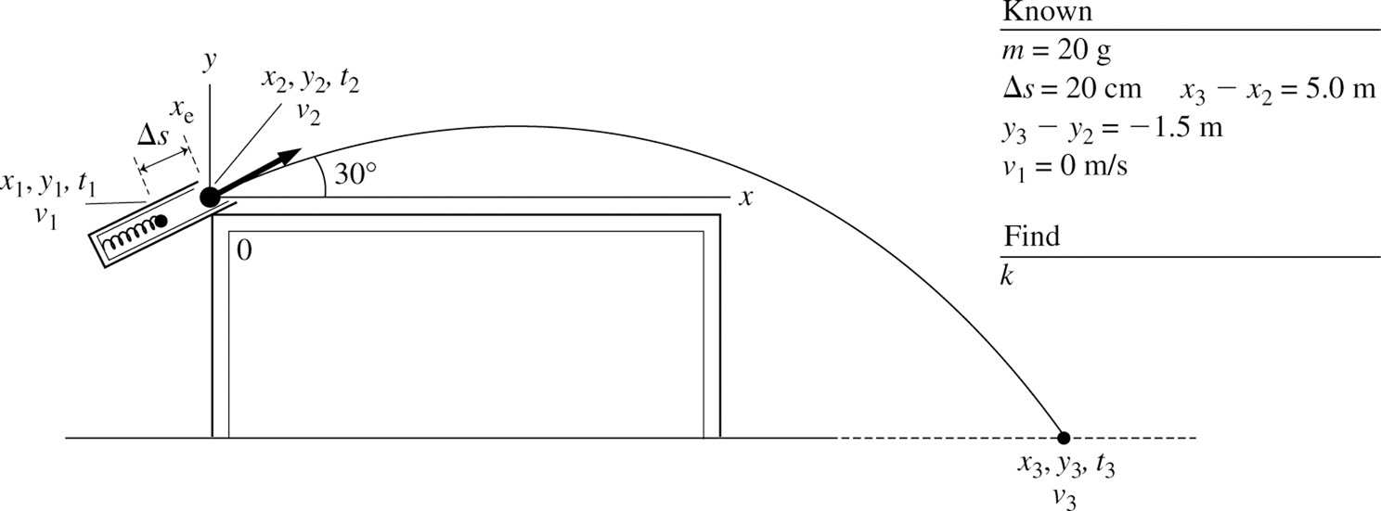

This is a two-part problem. In the first part, we use projectile equations to find the ball’s velocity as it leaves the spring. This will yield the ball’s kinetic energy as it leaves the spring.
Solve: Using the equations of kinematics,

Substituting the value for

The conservation of energy equation is

Using and we get

The final answer rounds to 20 N/m.
Review: Note that is with a minus sign and hence the gravitational potential energy is

