**What the Bureaucracy Does for You**

**Analysis of Organizations**

**Your Name** __________________________________

A creative presentation format, such as a slideshow, is encouraged for this assessment. This template will help you organize and ensure your work is complete.

1. **Select two bureaucratic organizations from the list, which could be one of the Cabinet departments, executive offices, or independent regulatory agencies. Your choices can be from the same or different parts of the bureaucracy. Research each organization using its own website. Use this information to respond in a complete paragraph to each of the following prompts:**

**First Organization Name**: U.S. Department of Education

* + What does this organization do? Include at least one image that represents this organization's responsibilities. Be sure to explain how the image represents the organization's responsibilities.

The U.S. Department of Education develops policies for federal financial education aid, distributes and monitors those funds, collects data on America's schools, and addresses national educational concerns. It also enforces federal laws related to privacy and civil rights in education.

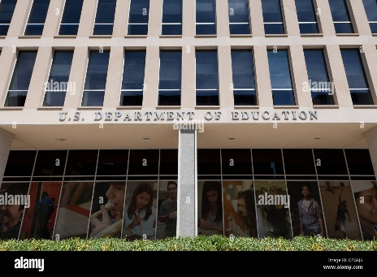

* + How does this organization help fulfill the duties of the executive branch under the Constitution?  
    The seal of the U.S. Department of Education symbolizes its commitment to promoting student achievement and ensuring equal access to education.

The seal of the U.S. Department of Education fulfills its mission to promote student achievement and equal access to education. The Department of Education aids the executive branch in executing federal education laws and policies, supporting the President's constitutional duty to ensure laws are faithfully executed. By managing federal funds and implementing educational standards, it aligns with the government's role to promote the general welfare as outlined in the Constitution.

* + Summarize a news event related to this office/agency from within the last year.

In January 2025, the White House issued a directive requiring all federal employees, including those at the Department of Education, to return to in-person work or resign. It was part of broader efforts to resume normal government operations post-pandemic. The directive included an option for employees to accept a buyout equivalent to seven months' salary if they chose to resign. This policy has sparked discussions about the future of remote work in federal agencies.

* + How does this organization affect your life and community? Include two specific examples in your response.

Student Financial Aid: The federal financial aid programs, such as Pell Grants and student loans, overseen by the U.S. Department of Education, enable students in my district to attend college. This aid makes college more affordable for many families.

Educational Standards and Accountability: Through policies like the Every Student Succeeds Act (ESSA), the Department sets educational standards and ensures schools are accountable for student learning. This ensures schools in my area maintain high standards, preparing students for future success.

**Second Organization Name**: **Environmental Protection Agency (EPA)**

* + What does this organization do? Include at least one image that represents this organization's responsibilities with your written response.

The Environmental Protection Agency (EPA) safeguards human health and the environment. It develops and enforces regulations for implementing environmental laws enacted by Congress. The agency conducts environmental research, provides grants for environmental programs, and educates people about environmental stewardship.

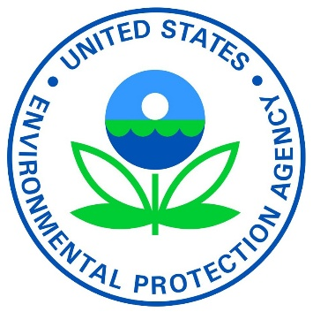

* + How does this organization help fulfill the duties of the executive branch under the Constitution?

The EPA helps the executive branch implement and enforce environmental laws, ensuring compliance with legislation passed by Congress. This enforcement supports the President's constitutional mandate to faithfully execute laws. Through pollutant regulation and enforcement of standards, the EPA also protects public health and welfare, aligning with the government's role in promoting the general welfare.

* + Summarize a news event related to this office/agency from within the last year.

In December 2024, the EPA introduced new regulations to reduce greenhouse gas emissions from power plants. The regulations are part of a comprehensive strategy to combat climate change and encourage clean energy adoption. Environmentalists praised the proposal, while some industry leaders expressed concerns about potential economic impacts.

* + How does this organization affect your life and community? Include two specific examples in your response.

Air Quality Standards: The EPA establishes and enforces standards that limit pollutants, making the air in my community cleaner and healthier to breathe. This reduces the risk of issues like asthma and other respiratory problems.

Water Quality Protection: By preventing pollutants from contaminating streams, rivers, and lakes and enforcing the Safe Drinking Water Act, the EPA ensures my community has access to clean and safe drinking water, while also enabling recreational activities and protecting public health.

1. **Organize your work. A creative presentation format, such as a slideshow, is encouraged. Cite all of your sources of information in MLA format.**

**Citation Format:**

Author last name, First name. “Title of Article.” Website name, Day Month Year, URL address.

**"About Us." *U.S. Department of Education*, https://www.ed.gov/about**

**"EPA at a Glance." *U.S. Environmental Protection Agency*, https://www.epa.gov/.**

**"White House orders all federal staff to return to in-office work or resign." *The Guardian*, 28 Jan. 2025,** [**https://www.theguardian.com/us-news/live/2025/jan/28/donald-trump-executive-orders-transgender-troops-dei-covid-us-politics-live**](https://www.theguardian.com/us-news/live/2025/jan/28/donald-trump-executive-orders-transgender-troops-dei-covid-us-politics-live)**.**

**"EPA Announces New Greenhouse Gas Emissions Standards." *Environmental News Network*, 15 Dec. 2024, https://www.enn.com/articles/71892-epa-announces-new-greenhouse-gas-emissions-standards.**