|  |
| --- |
| **Hand Gesture Recognition System** |

**Jeevitha Meyyappan**

Department of Computer Science

Georgia State University, Atlanta, GA

[Jmeyyappan1@student.gsu.edu](mailto:Jmeyyappan1@student.gsu.edu)

**Abstract**

This project focuses on the recognition of the hand gesture shown in front of the camera. Here we have used the laptop camera to detect the hand gesture. The challenging and most interesting part of this project is the algorithm deviced to recognise the gesture. The algorithm used here is simple but effective, Thus providing a good accuracy rate of >98%.

1. **Objective**

The goal of this application is to detect the Hand Gesture via the Web cam, and then making the recognition with the pattern. This application works in a scenario when a camera is placed and when someone makes an hand gesture, the application interprets the gesture and further displays that in the screen. The classes used in this are based on the OpenCV Library - CV2.

In this 6 different gestures of Right and Left hands are detected –

* No Hand
* One Finger shown
* Two Finger shown
* Three Finger shown
* Four Finger shown
* Five Finger shown

Tried to implement Guesture Recognition with the below Libraries,

* AForge.Net - C# - No Clarity in the end Histogram part for recognizing the Guesture - Failure
* Emgu CV - C# - Struck with the Skin color extraction of the hand - Failure
* CV2 - Python - I was able to implement the entire functionality, though faced a few difficulties in the beginning. - Success

**2. Proposed Model**

The Live video is captured with the Webcam.

A rectangular area is defined for the video and the region parameter is declared where the hand is placed.

A Grey image of the hand is generated and a guassian blur is applied. Further a threshold of this image is made to remove the extra noises.

Extract contour of the max area which is of the hand.

Make a bounding rectangle of the contour and a convex hull around the hand. By deducing the area of these we will have the area of the rectangle around the hand and area of the convex hull.

The gap between the fingers are counted here and they are determined by figuring out the angle between each fingers.

And accordingly the count of fingers is displayed in the screen.

1. **Algorithm Proposed**

The angle between the fingers is found by figuring out the lenght of the fingers, to segregate the fingers and inturn count them.



1. **Formulas used**

Angle Formula - To find the angle between the fingers(To segregate the fingers).

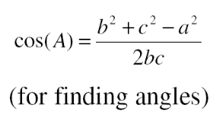

Distance Formula - To Calculate the length of the inner sides of both the fingers and the distance between the finger tips.

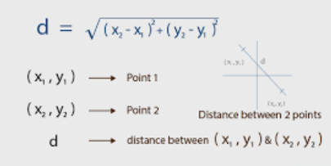

Area Formula - To Calculate the area of the hand.

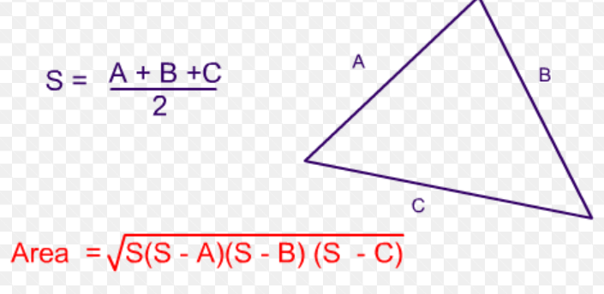

1. **Demos:**

**Showing the value 3:**

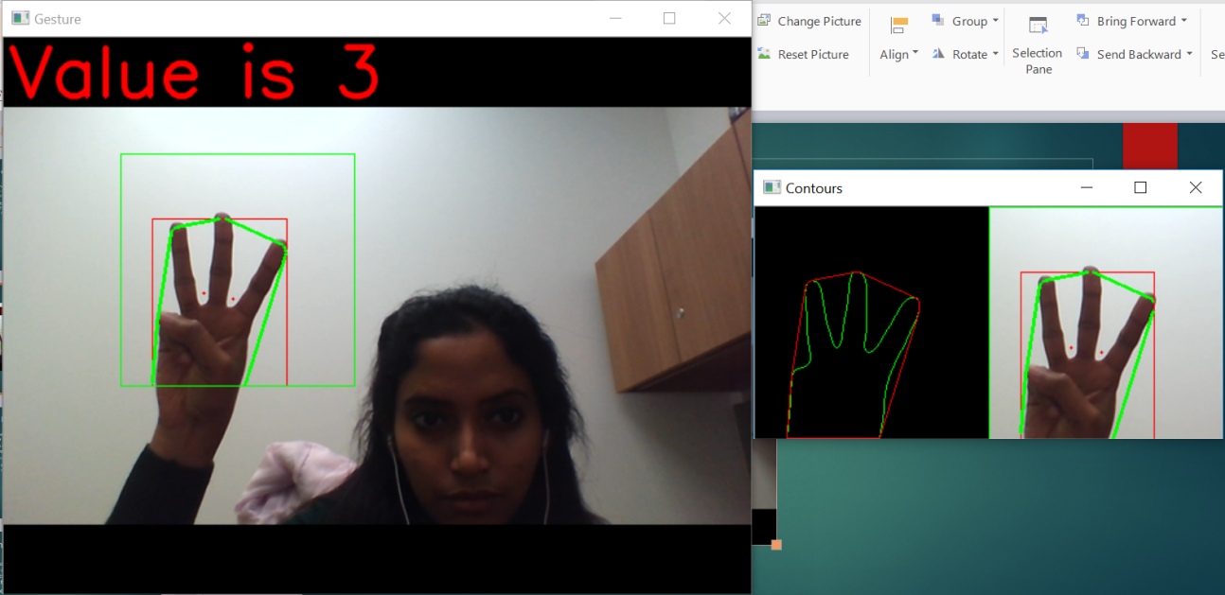

**Showing the value 5:**

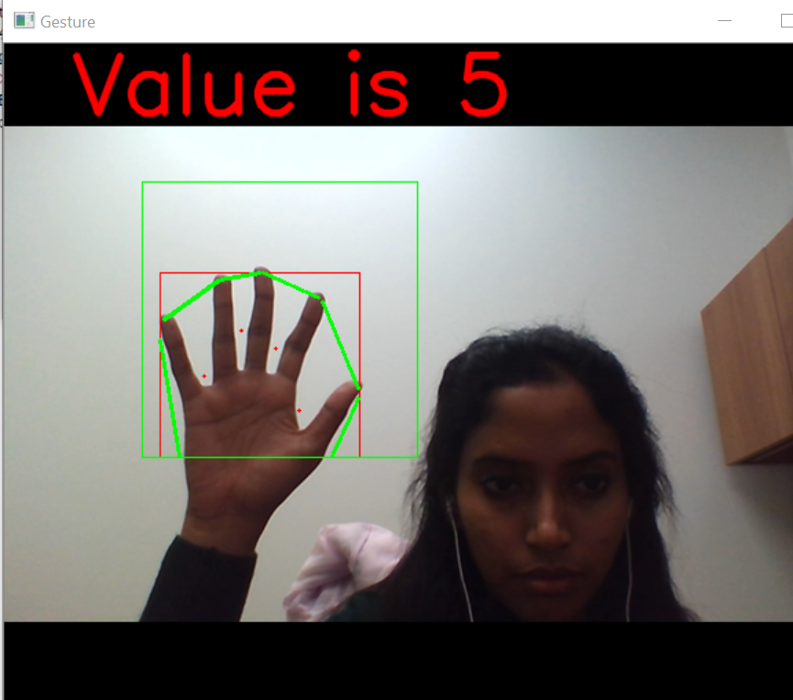

**Showing the value 2:**

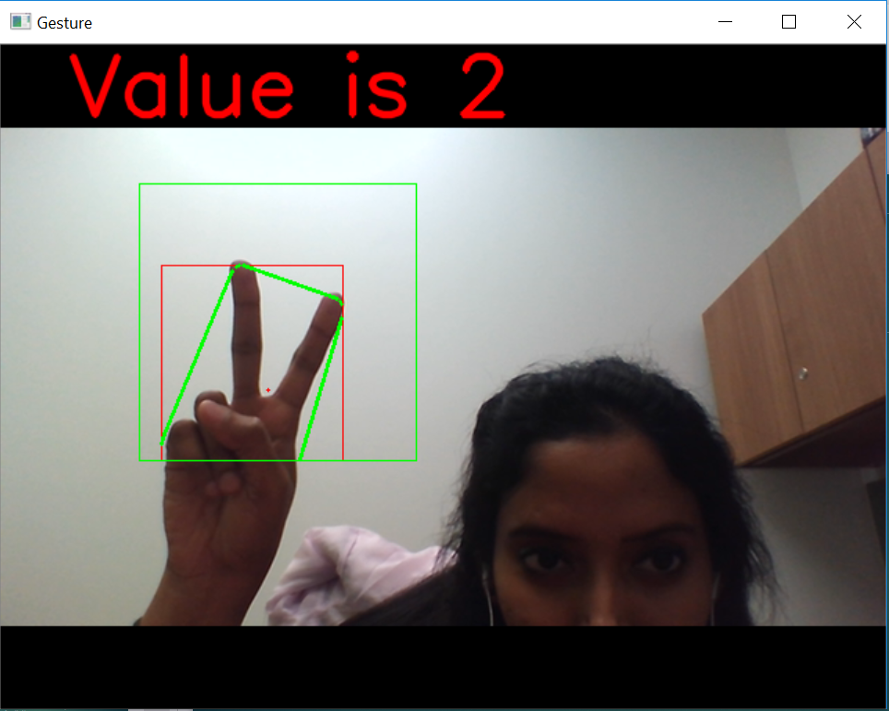

**Contour Images:**

These images are generated to find the outline of the hand after the feature extraction.



**5. Conclusion**

We conclude that this model is a success with an accuracy rate of about 98% when the expected gestures are tested. It can be widely used in any apps to recognize a given hand gesture. This can be further extended to Sign Language recognition by calculating the position of fingers for each alphabets. For a different approach Haar cascade classifiers or Test and Train datasets can be used.

**6.** **References**

* Reference taken from - <https://opencv-python-tutroals.readthedocs.io/en/latest/py_tutorials/py_gui/py_image_display/py_image_display.html>
* Python Library used - CV2, Numpy, Math