SHELF-LIFE PREDICTION OF A PEAR

|  |  |
| --- | --- |
| Om Satya Sai Ram Gadde |  |
| *Department of Computer Science* |  |
| *Georgia State University* |  |
| *Atlanta 30303, USA* |  |
| ogadde1@student.gsu.edu |  |

***Abstract* – This project uses image processing to achieve the primary goal. An algorithm that detects the shelf-life of pear has been developed. It uses the features like color, different patches and the size of the spots to determine the living time of the pear.**

**I.** **Problem statement**

Food wastage has been one of the major concerns for over a long period. Manufactured or processed foods have an expiry data but predicting when a natural product is no longer useful is a hypothetical question. The expiry of a natural product depends on many factors like place of storage, temperature, and many other biological factors. Not just the wastage, not knowing when fruit goes bad will also result in wastage of capital. A farmer or a store, knowing the shelf-life of fruit can sell the fruits that are going to expire soon for lesser prices rather than stocking them and finally trashing them. Likewise, a customer purchasing a fruit with the knowledge of its deadline can prevent wastage of money and food as well. Based on the usage requirements a customer can also make use of the fruits that are having the less shelf-life period for lower costs which would fulfill the need and with investment lesser than actual.

**II. Approach**

***Dataset creation***A pear has been bought from a store and hanged over a wall with a white background. Images of pear have been captured every day around the same time by manually rotating it and capturing the body. Around five to six models ar recorded each day. Unique spots are also obtained. This process ended with a dataset of approximately 39 images.

***Background removal*** The images captured has a white background when looked from a standard eye. Due to light falling from different directions on the fruit a dark shadow is recorded in the image. It would affect the image processing when we try to identify the patches on the fruit. So, using an application called color threshold in MATLAB the background has been successfully removed. This in-built method provides two images as output. One, color image with only the foreground part, i.e., the fruit and the second image has binary values with background black and foreground white.

***Conversions***Necessary conversions like converting the color image into a gray image, separating and storing the red, green and blue color channels of the input image into three different models are done by using commands in MATLAB for further usage in the algorithm.

***Identification*** Using the converted and stored gray image and the binary image obtained from the background removal function we can filter the background from the gray image by using the binary image as a mask rather than using the background removal function again. Now that the fruit part has been identified in the picture, patches on the image have to be determined. Every pear has a unique combination of colors, to identify the patches you need to know the thresholds for which the patches can be spotted from the image. The ranges of the colors are from 0 – 255 in the photos. All the 256 values need not to be tested. Using an interval, we check which values give us the positive/better results for our fruit and store the value.

***Count*** Now that the images which contain only the fruit part and only the patches parts on the fruit are identified, the number of pixels each factor occupies are counted. That is, the number of white pixels in the binary image obtained from the background removal function gives you the fruit part count is stored in a variable and using the thresholds that are found earlier, we strictly get an image with only the patches on the fruit in white and everything else in black. We count the number of white pixels present in the image and store them into another variable.

***Health percentage*** Using the variables that have the fruit part count and the patch part count, we use a basic percentage formula to calculate the health part percentage of the fruit. This result gives an idea of the spoiled part percentage as well.

***Thresholds*** To identify the changes in the color of pear each day in the images, limits are taken into consideration. For finding the thresholds, we use the three-color channel images and find the maximum and minimum values in each color. The output variables would later help us identify which day the picture of the fruit was recorded.

***Average*** Only knowing the thresholds will not be sufficient, to find which particular day the image was captured. The average of the gray image is also calculated and stored into a variable.

***Prediction*** All the above found and stored factors like health percentage, thresholds and average all together produce a result which predicts the number of days the fruit stays well.

**III. Contribution**

* Over the days, the rate at which the fruit is being rotten is shown based on a unique spot that has been identified. Because a pear does not get patches all over as a banana does, this unique patch has become the point of interest to calculate the rate of increase in that particular patch.
* To remove the background from all the images with one function it has to be created based on the pictures of the final day because the earlier models contain different colors on fruit when compared to that on the further days. If background removal function is generated based on the previously recorded fruit images, it results in the removal of patches assuming that they are part of the background.
* Plain color backgrounds will make things easier for background removal because a color that closely matches to the color of the fruit in background results loss in fruit during background removal. Multiple trials have been performed to remove a multi-color background, and the results were inappropriate. So, a plain background is considered.
* Health percentages, averages, and thresholds of the fruit are calculated based on the image because, solely depending on an individual factor to identify either the day the image is captured or the number of days the fruit is left to stay healthy may lead to wrong results, i.e., less accuracy for prediction in the algorithm.
* Because thresholds need not necessarily change the same way in all the body of the fruit, it depends on what part of the fruit is exposed to light or the temperature or the place the fruit is stored. Since this is a pear, the patches may not be formed on a side which results in a higher healthy percentage of fruit in that view, which is not true. When thresholds are stored only the most senior and least values are considered. An image might have many numbers of high pixel intensities and vice versa. So, the prediction may go wrong.
* That is why all these three factors are considered to predict the shelf-life of pear in this project.

**IV. Results**

***Accuracy***

Depending on individual factors the efficiencies are:

* *21.0%* (**Health Percentages**)
* *36.8%* (**Averages**)
* *39.4%* (**Thresholds**)

Final skill with all three elements combined: ***63.15%***

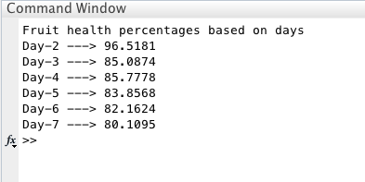

The rate of change in healthy percentage day to day

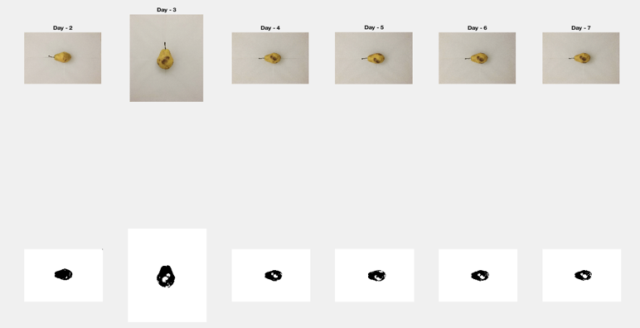

Images of increase in the size of a unique patch each day

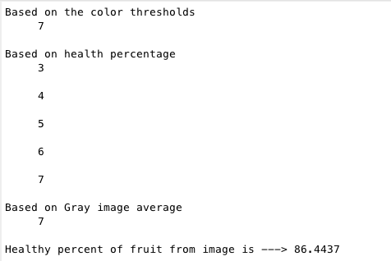

Shelf-life prediction of fruit and its health percentage

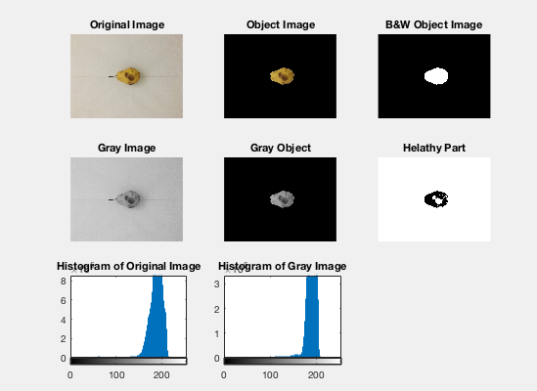

Image processing to calculate the above-obtained results

**References**

1. M. King, B. Zhu, and S. Tang, “Optimal path planning,” *Mobile Robots*, vol. 8, no. 2, pp. 520-531, March 2001.
2. H. Simpson, *Dumb Robots*, 3rd ed., Springfield: UOS Press, 2004, pp.6-9.
3. M. King and B. Zhu, “Gaming strategies,” in Path Planning to the West, vol. II, S. Tang and M. King, Eds. Xian: Jiaoda Press, 1998, pp. 158-176.
4. B. Simpson, et al, “Title of paper goes here if known,” unpublished.
5. J.-G. Lu, “Title of paper with only the first word capitalized,” *J. Name Stand. Abbrev.*, in press.
6. Y. Yorozu, M. Hirano, K. Oka, and Y. Tagawa, “Electron spectroscopy studies on magneto-optical media and plastic substrate interface,” *IEEE Translated J. Magn. Japan*, vol. 2, pp. 740-741, August 1987 [*Digest 9th Annual Conf. Magnetics Japan*, p. 301, 1982].
7. M. Young, *The Technical Writer’s Handbook*, Mill Valley, CA: University Science, 1989.